Object Oriented Programming

Assignment1_document

2016025469 서건식



1. Description of the implementation methodology as well as an explanation.
2. Subject class

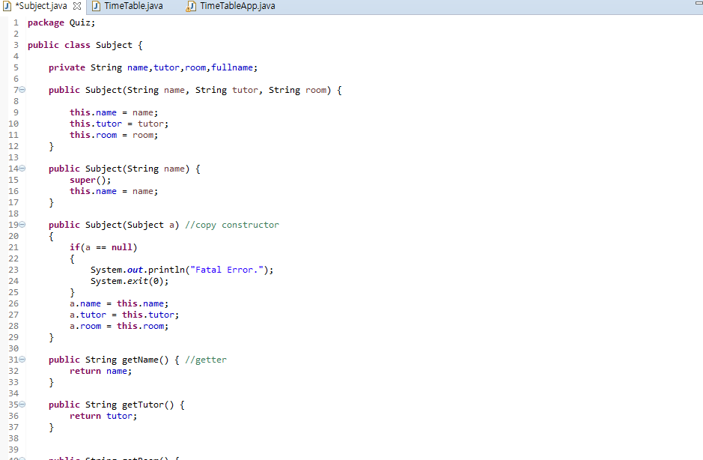

1. First, I declare 4 private string variable name, tutor, room, fullname. The usage of fullname is to print timetable in 9 words.
2. The constructors are 3. Two of them are to set variable, one is to set 3 variable(name, tutor, room) and the other is to set name. and the other one is copy constructor, So this copy the object.

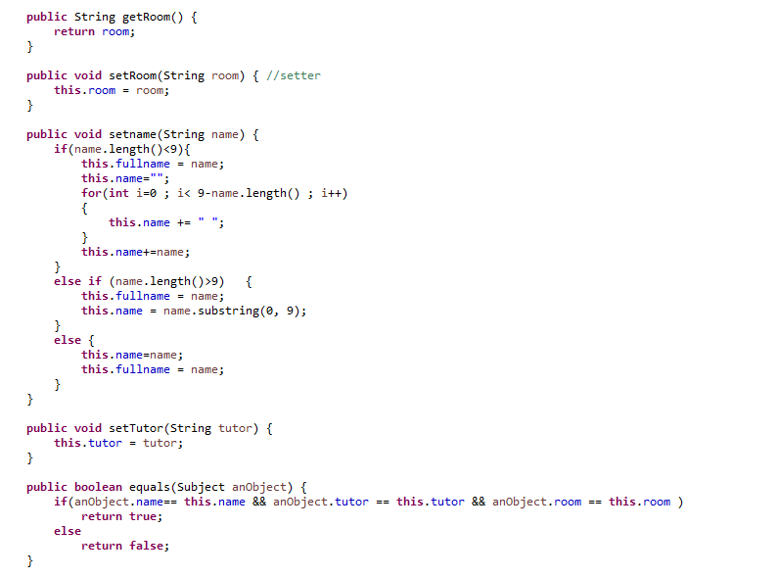

1. Each getter gets the values.
2. Each setter sets the values. But the setname method is different to other setter.

If name’s length is less than 9, then save the parameter in fullname, and to set the gap, using a for loop until 9-name’s length name+= “ “.

Else if name’s length is more than 9, then save the parameter in fullname, and save name’s the substring in name. It is to print timetable.

1. Equals method check the value of object.

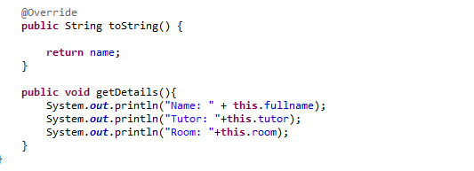

1. toString and getDetails. In getDetails method, print fullname.
2. TimeTable class

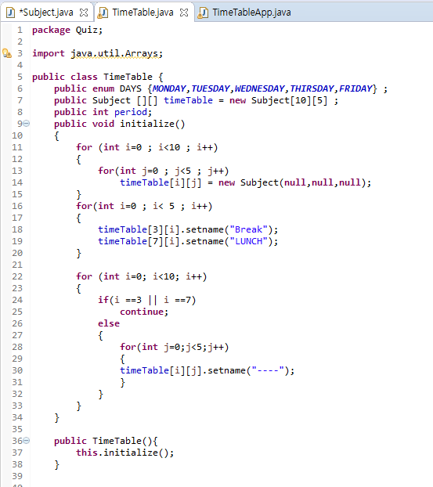

1. In this class, declare 3 value (enum Days, array (type of Subject) , period).
2. In initialize method, initialize each index’s space to null (to make space) and in column 3,7, set name to “Break” and “LUNCH” . else , set name to “----“. And in constructor, using this method.

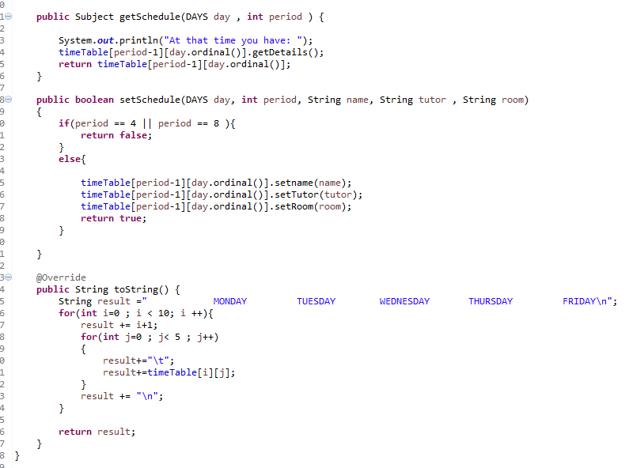

1. In getSchedule method, receive the Day and period(location of array) and print the contents.
2. In setSchedule method, except the location of break and lunch, set the name and tutor and room. And this is Boolean function. The reason of this is revealed in main class.
3. In toString, declare string result value, and using for loop add the contents of timetable array. In this, print the name (not fullname.)
4. Main Class

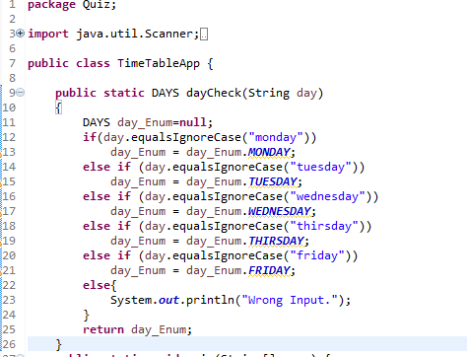

1. In main class, there exist dayCheck method to check string of day. (ignore case)

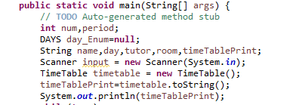

1. These are the main method’s variable. The last sentence of this capture, print timetable.

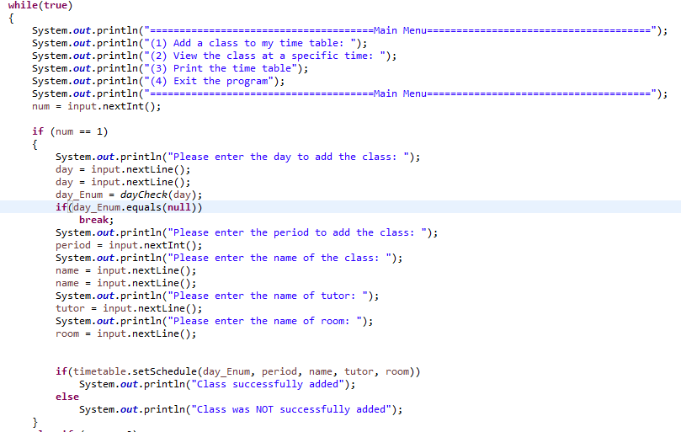

1. This is while loop.
2. Case 1, add a class. Using scanner, input the value in variable. After receiving the value, using method of setSchedule, check whether it is success or not. (this is the reason why the setSchedule method is boolean method.)

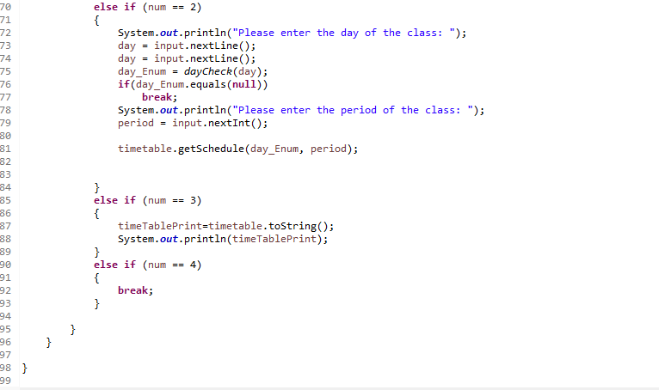

1. Case 2, view the class at a specific time.
2. Case 3, print the time table.
3. Case 4, exit the while loop.
4. The output

