**Object Oriented Programming**

Assignment2



2016025469 Seo geonsik

1. The snapshot and description of program source code
2. 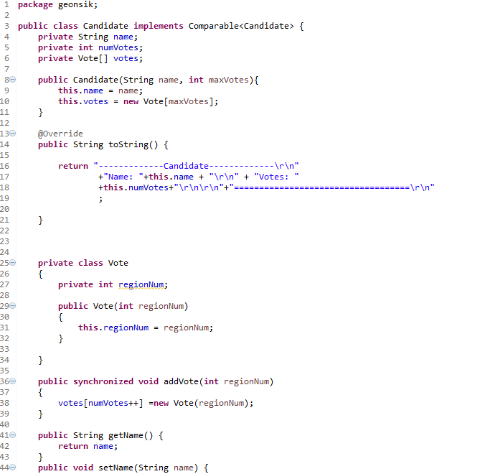Candidate Class
3. Candidate constructor

This receive two instance : name, votes

1. toString

return the string in the given form.

1. Inner class Vote

It have one constructor setting the one instance.

1. addVote

It is declared into synchronized because to run multi thread smoothly and plus the value of numVotes, and create Vote object.

1. Getter, setter

Has no meaning

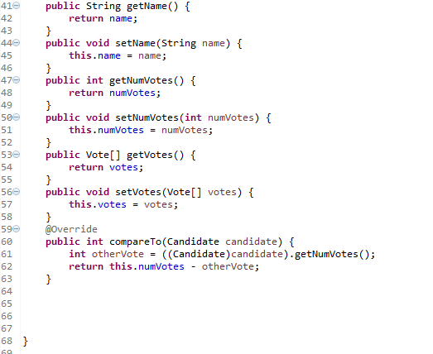

1. compareTo

get the difference between numVotes of two object

1. 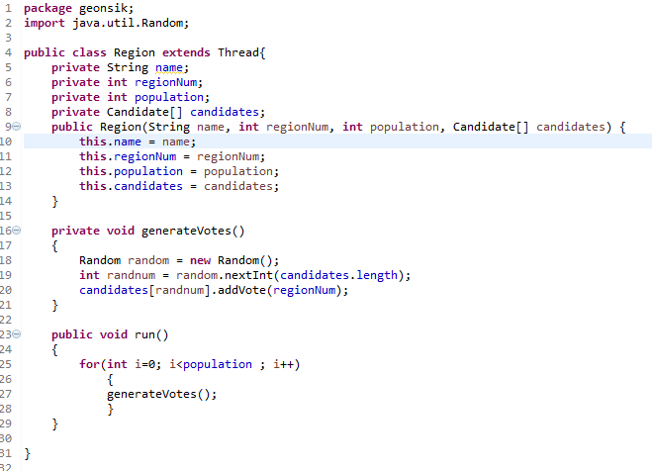Region Class
2. generateVotes

get the random number (random region) and set the index of array of type candidate.

1. Run

Run the generateVotes method repeatedly in population number

1. 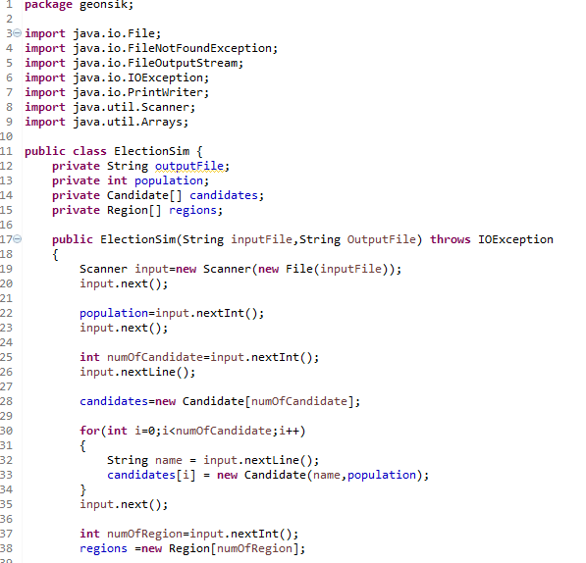ElectionSim Class
2. ElectionSim constructor

Get input values following the given form. First, get the input File. And, population, number of candidate, number of region. And create the object of candidate and regions size of input size.

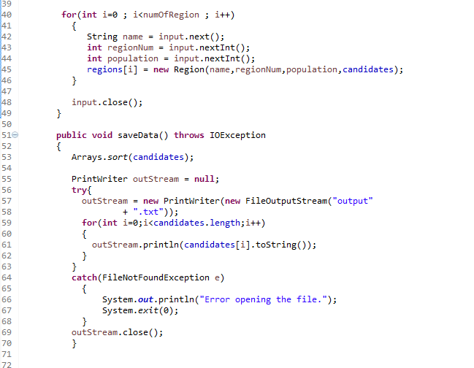

Each array type of candidate and region, generate constructor. And get the input value. And last, add input.close()

1. saveData()

first, sort the candidate array. And create object type of PrintWriter named outStream, and set null. Using try – catch, get the error. (error handling) and save the output using toString. And last, add outStream.close()

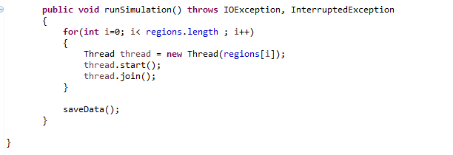

1. runSimulation

create region’s number of thread and create the object. And using method start(), join() ,each thread run. The reason I use join is that by using join method until the threads end, the main thread doesn’t end. (to save the output in text file collectly.

1. The output of program ( variable input.)
2. Given input

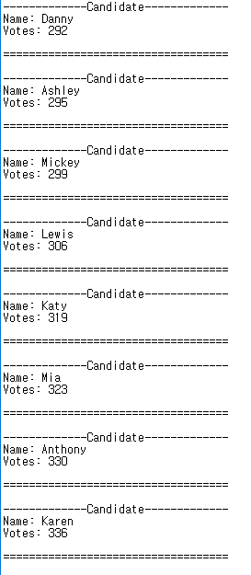

1. Different input

