### Exercise 1: Create a Virtual Machine using the Azure Portal

1. Launch a browser and navigate to https://portal.azure.com. Once prompted, login with your Microsoft Azure credentials. If prompted, choose whether your account is an organization account or just a Microsoft Account.

Note: You may need to launch an "in-private" session in your browser if you have multiple Microsoft Accounts.

1. Click on **+NEW**, and in the search box type in **Visual Studio Community 2015** and press enter. Click the Visual Studio Community 2015 image running on Windows Server 2012 R2 and with the latest update.
2. In the returned search results click the image name.

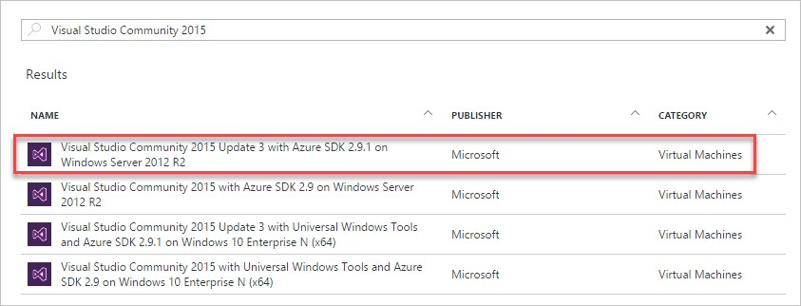

1. In the Marketplace solution blade, at the bottom of the page keep the deployment model set to **Resource Manager** and click **Create**.

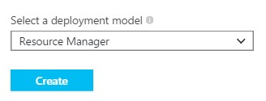

1. Set the following configuration on the Basics tab and click **OK**.
   * Name: **LABVM**
   * VM disk type: **SSD**
   * User name: **demouser**
   * Password: **demo@pass123**
   * Subscription: **If you have multiple subscriptions choose the subscription to execute your labs in.**
   * Resource Group: **OPSLABRG**
   * Location: **Choose the closest Azure region to you.**

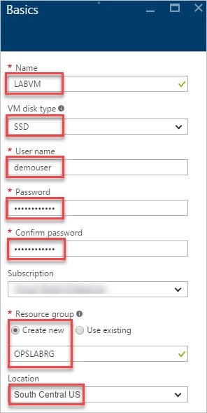

1. Choose the **DS1_V2 Standard** instance size on the Size blade.

Note: You may have to click the View All link to see the instance sizes.

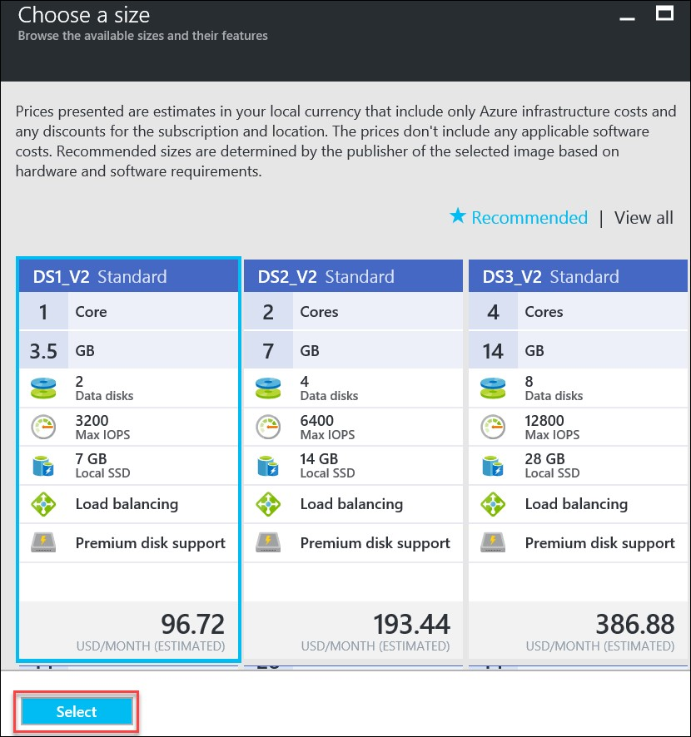

Note: We could use one of the recommended configurations, but if you are using a trial Azure subscription there is a restriction of 4 cores per region. Hence we are choosing a lower configuration. Make sure to not chose a VM from a different family. Use the DS1_V2 Standard as directed.

1. Accept the default values on the Settings blade and click **OK**. On the Summary page click **OK**. The deployment should begin provisioning. It may take 10+ minutes for the virtual machine to complete provisioning.

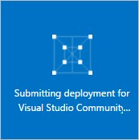

1. Once the deployment is complete move on to the next exercise.

### Exercise 2: Download and Unzip Student Files

1. Move back to the Portal page on your local machine and wait for **LABVM** to show the Status of **Running**. Click **Connect** to establish a new Remote Desktop Session.

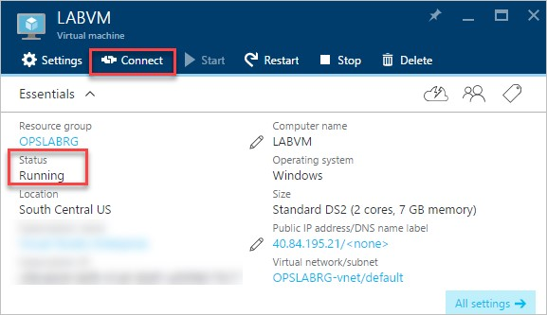

1. Depending on your remote desktop protocol client and browser configuration you will either be prompted to open an RDP file or you will need to download it and then open it separately to connect.
2. Login with the credentials specified during creation:
   1. User: **demouser**
   2. Password: **demo@pass123**
3. You will be presented with a Remote Desktop Connection warning because of a certificate trust issue. Click **Yes** to continue with the connection.

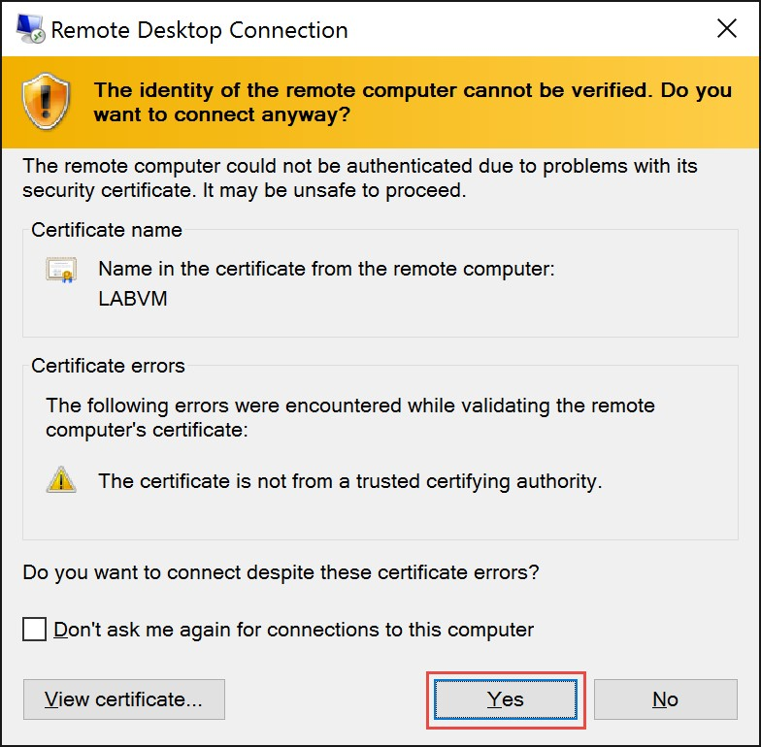

1. When logging on for the first time you will see a prompt on the right asking about network discovery. Click **No**.

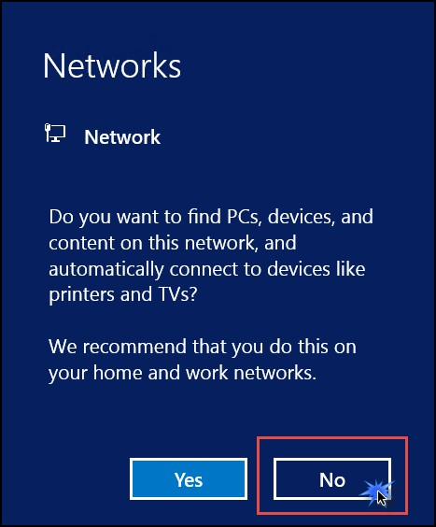

1. Notice that Server Manager opens by default. On the left, click **Local Server**.

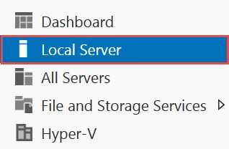

1. On the right side of the pane, click **On** by **IE Enhanced Security Configuration**.

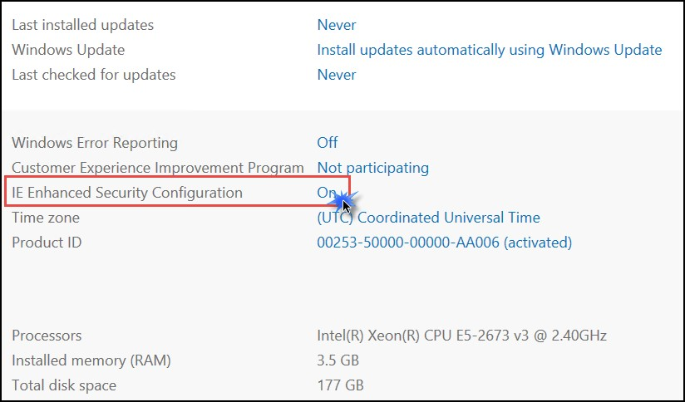

1. Change to **Off** for Administrators and click **OK**.

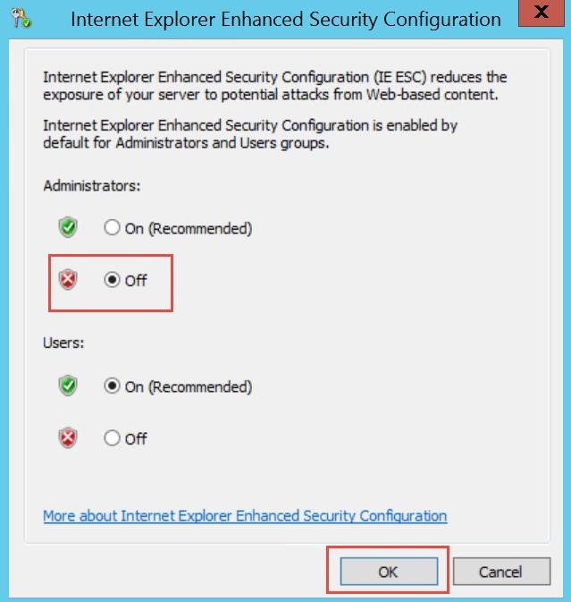

1. In the lower left corner, click on the **Windows** button to open the **Start Screen**. Then click Internet Explorer to open it. On first use you will be prompted about security settings. Accept the defaults by clicking **OK**.

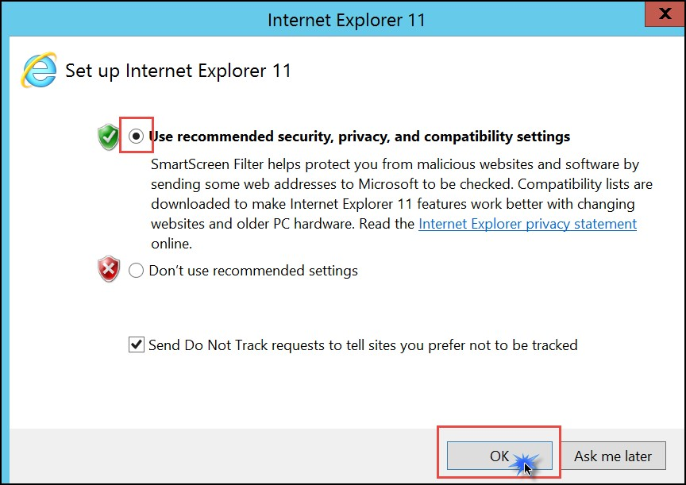

1. If prompted, choose to Turn Protected mode on



1. In the address window enter the below URL and hit the Enter key. This will download the class files (in a .zip format) needed for the remaining labs. **Note that the link is case sensitive.**

https://www.dropbox.com/s/pdhuouv2mn8gnze/Student%20Files.zip?dl=0

1. You will be prompted about what you want to do with the file. Select **Save**.

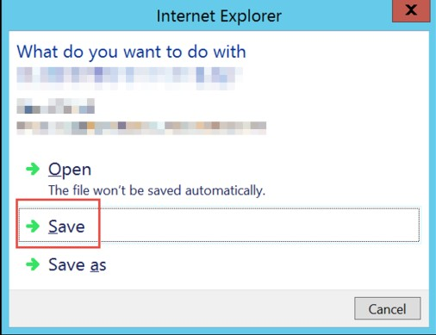

1. Download progress is shown at the bottom of the browser window. When the download is complete, click **Open folder**.



1. The **Downloads** folder opens. **Right-click** the zip file and click **Extract All**.In the **Extract Compressed (Zipped) Folders** window enter **C:\OpsgilityTraining** in the **Files will be extracted to this folder** dialog. Click the **Extract** button.

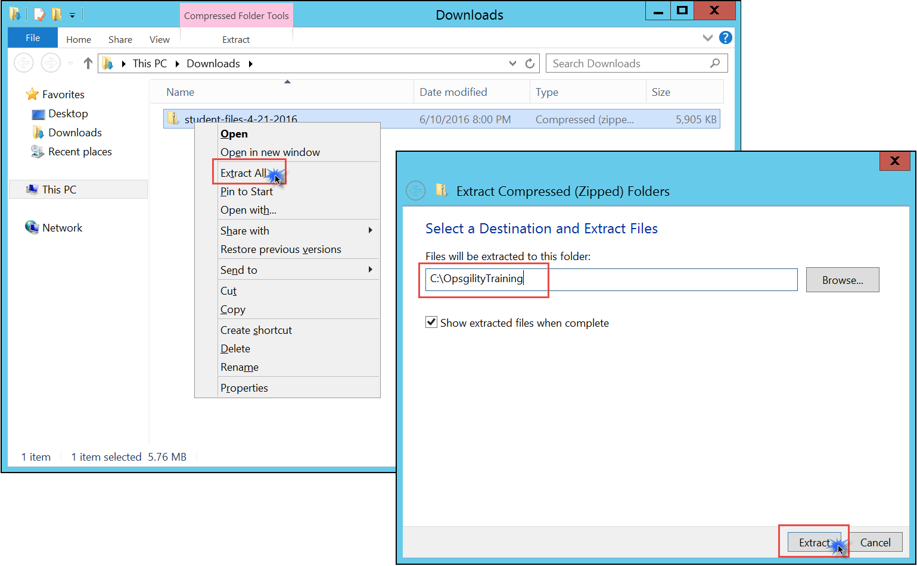

### Exercise 3: Configure the Azure PowerShell cmdlets for your Subscription

Note: The lab VM you created already has the Azure PowerShell cmdlets installed but we will update the version to ensure the labs work well.

1. In Internet Explorer navigate to https://azure.microsoft.com/en-us/downloads/. Click the link for the **Windows install** in the **PowerShell** section of the page and choose **Run.**

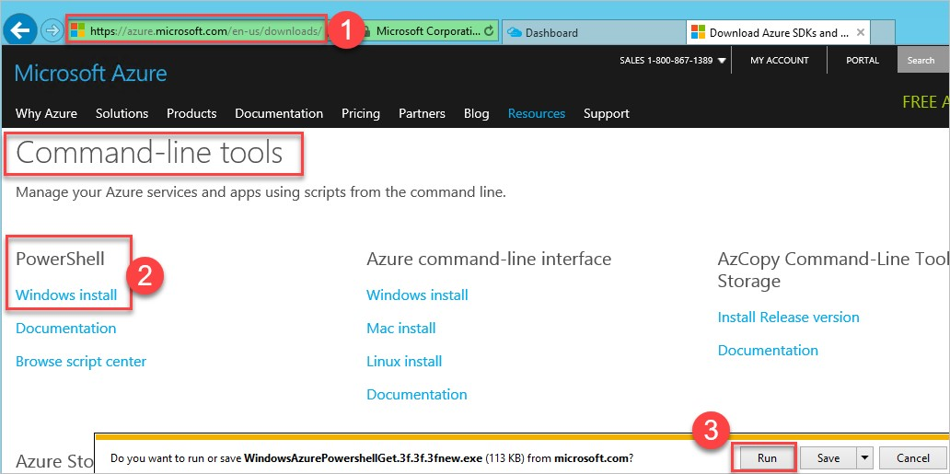

1. A Web Platform Installer dialog box will open. Click **Install** to install the latest version of the Azure PowerShell module.

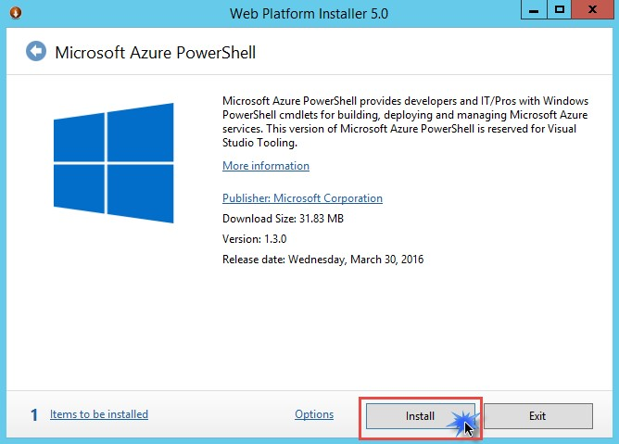

1. On the next dialog, click **I Accept** to accept the license terms for Azure PowerShell.

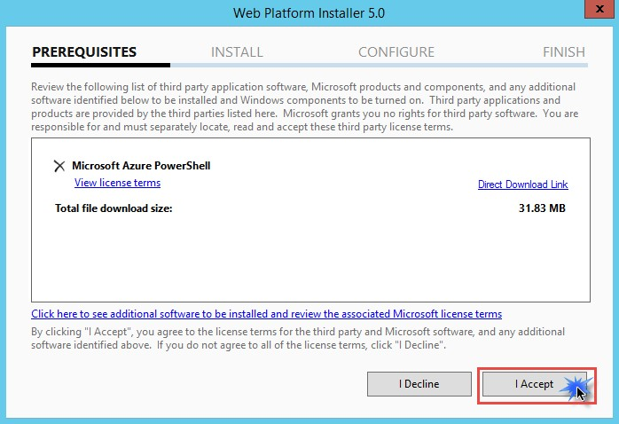

1. When the install is completed, click **Finish**.

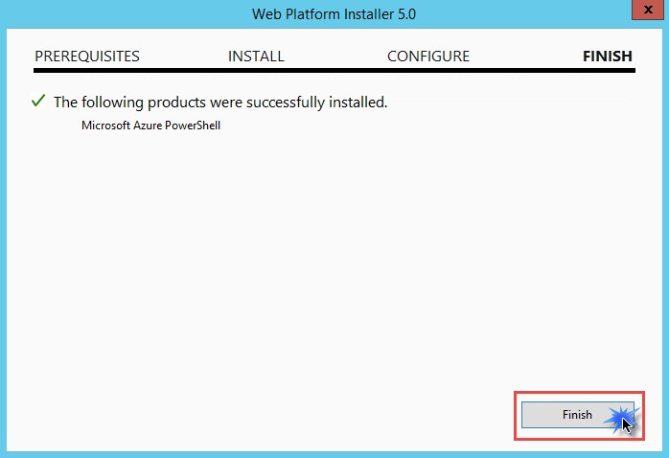

1. Within the Web Platform Installer screen, click **Add** to also install the Microsoft Azure Crossplatform Command Line Tools.

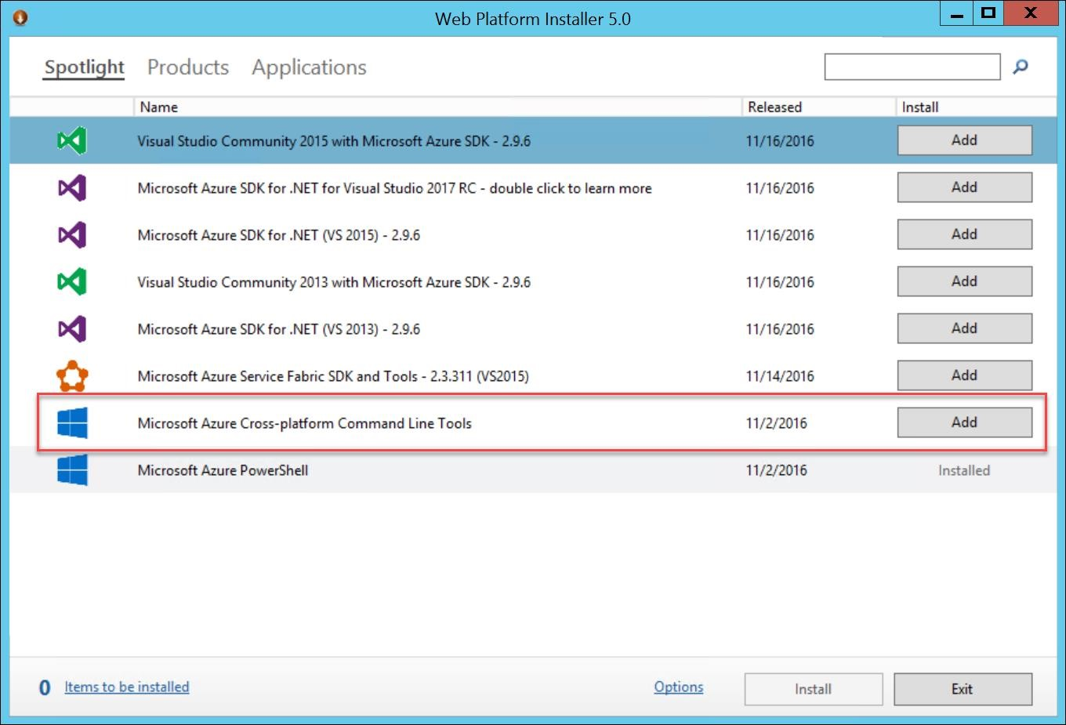

1. Click **Install** and accept the license agreement for this item as well.

1. Once the installations for both the Azure PowerShell and Command line tools are complete, **restart the LABVM and reconnect after it has been restarted and continue.**

1. Launch the PowerShell Integrated System Environment (ISE), by opening a Windows run prompt. To do this, **Right-click** on the **Start** button and choose **Run**

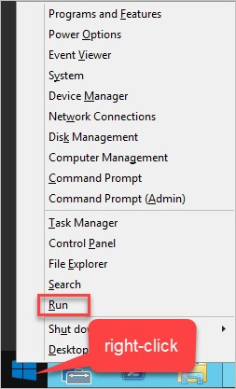

1. Launch the PowerShell Integrated System Environment (ISE) by typing in **PowerShell_ISE** in the Windows run prompt.

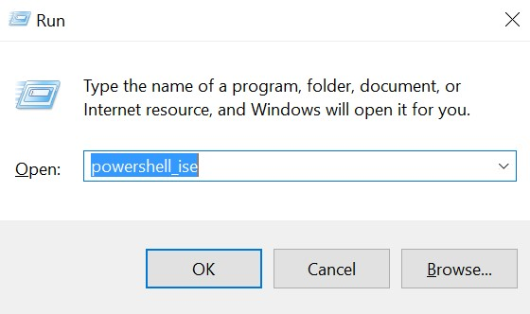

The ISE consists of two windows, the Script Pane and the Console Pane. If the Script Pane is not visible click the **^** icon towards the top right of the window. The Console Pane is where you can execute individual commands with immediate results and the script pane is designed for authoring complete scripts.

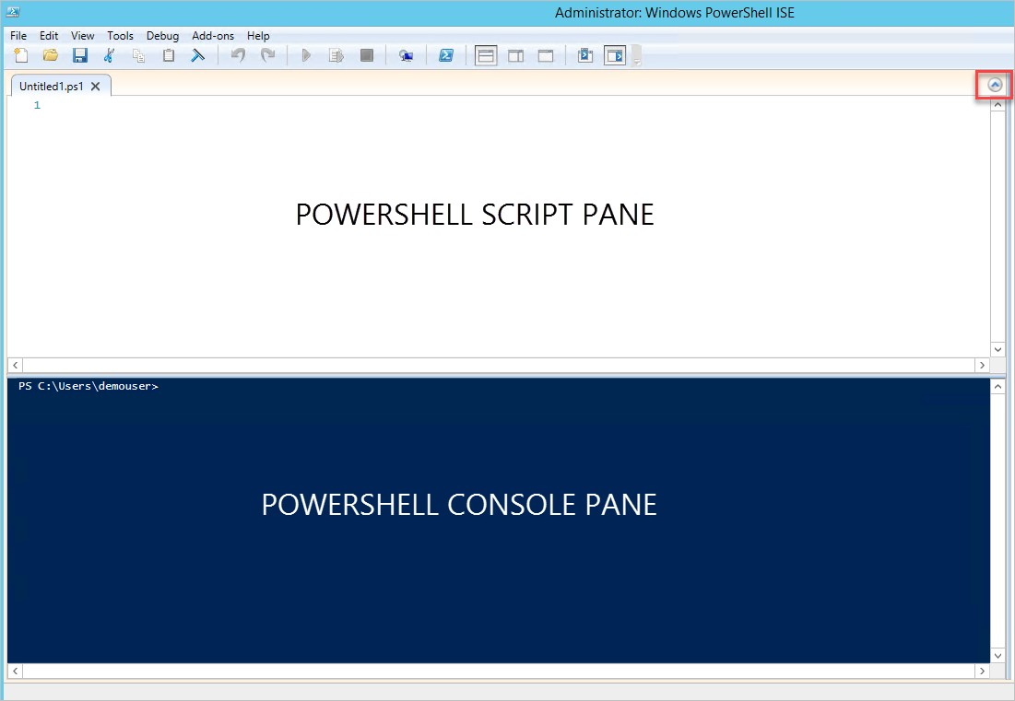

1. In the console pane execute the following command:

Set-ExecutionPolicy –ExecutionPolicy ByPass –Scope CurrentUser

Note: This is a security change to your system in order to execute local scripts. To reset the permissions back to default run the following: Set-ExecutionPolicy –ExecutionPolicy Default –Scope CurrentUser

1. Click Yes at the Execution Policy Change Prompt

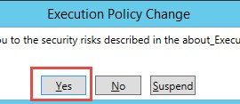

### Exercise 4: Configure the Azure Command Line Interface (CLI)

1. Launch a PowerShell prompt in Administrator mode by first right-clicking on the PowerShell icon on the task bar choosing **Run as Administrator**.

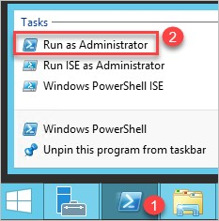

1. Confirm that the Azure CLI was installed by simply typing ‘azure’ and choosing ‘y’ for data collection.

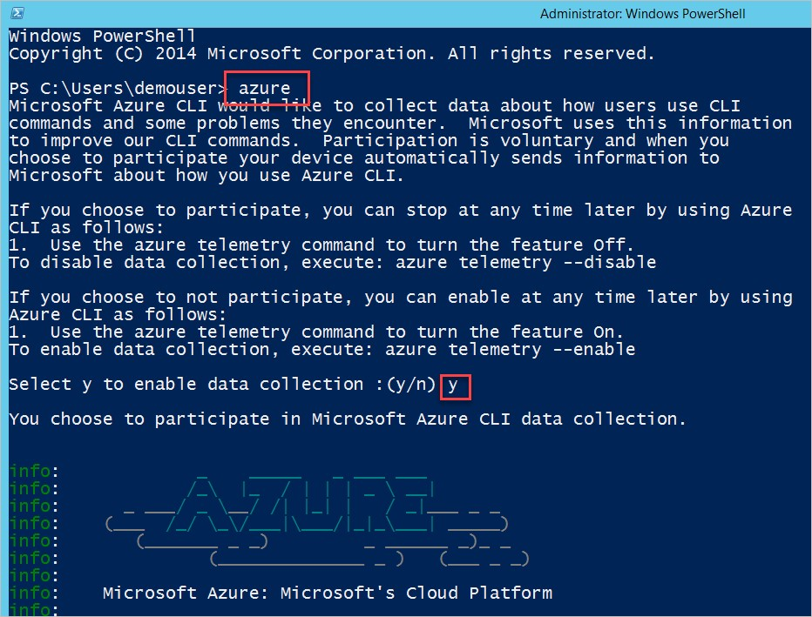

1. Type the following command to login

azure login

The Command will return with devicelogin url and authentication code for your device.

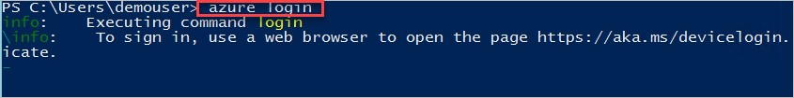

1. Browse to Devicelogin URL https://aka.ms/devicelogin and Enter code into textbox. The Portal would identify the application publisher as Microsoft Azure CLI. Click **Continue**.

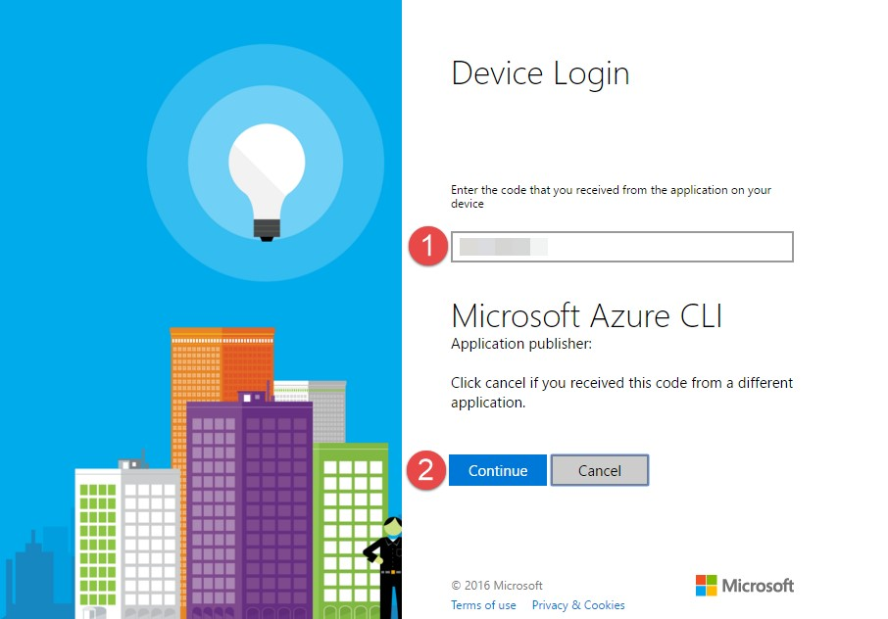

1. Login with your Microsoft Azure account credentials. After a successful authentication, the device login portal would return as below:

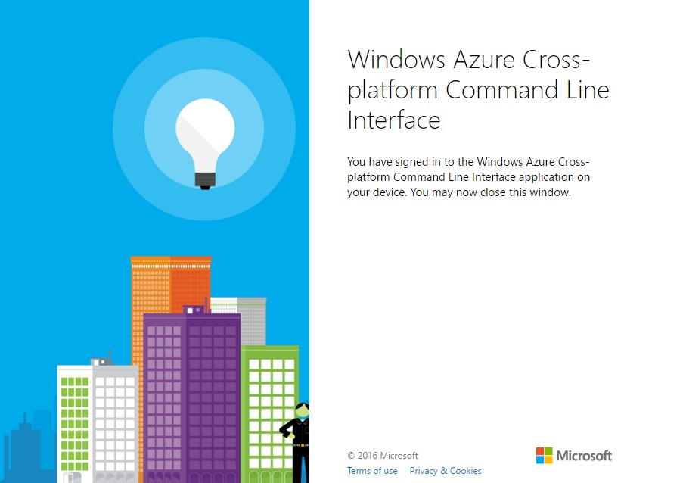

1. Also, the Azure CLI console returns with message **login command OK**.

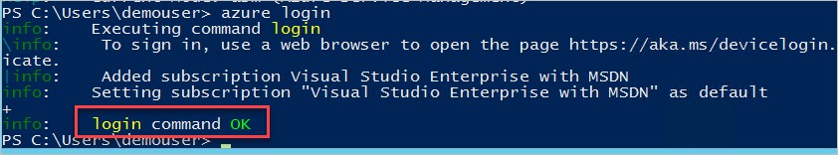

1. To list all the subscriptions associated with your account, enter command

azure account list

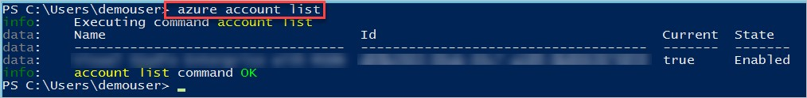

1. Select the subscription that you will use throughout this course. Enter the command (the quotes are required), where the “[subscription_name]” is the name of the subscription you would like to use.

azure account set "[subscription_name]"

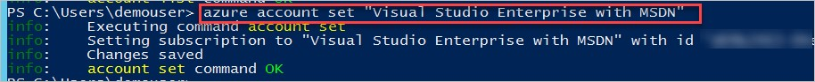

1. To select azure mode (classic/arm) for your session, enter the command

azure config mode arm

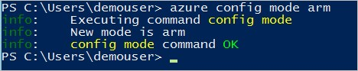

1. Refer to the following URL for the Azure CLI commands in Resource Manager mode https://azure.microsoft.com/en-us/documentation/articles/azure-cli-arm-commands/

### Exercise 5: Download Putty and PuttyGen

In this exercise, you will download two tools needed for SSH connections in the labs that follow.

1. In Internet Explorer navigate to http://www.chiark.greenend.org.uk/~sgtatham/putty/download.html
2. From this page, you will download **putty.exe** and **puttygen.exe** to your **c:\OpsgilityTraining folder**

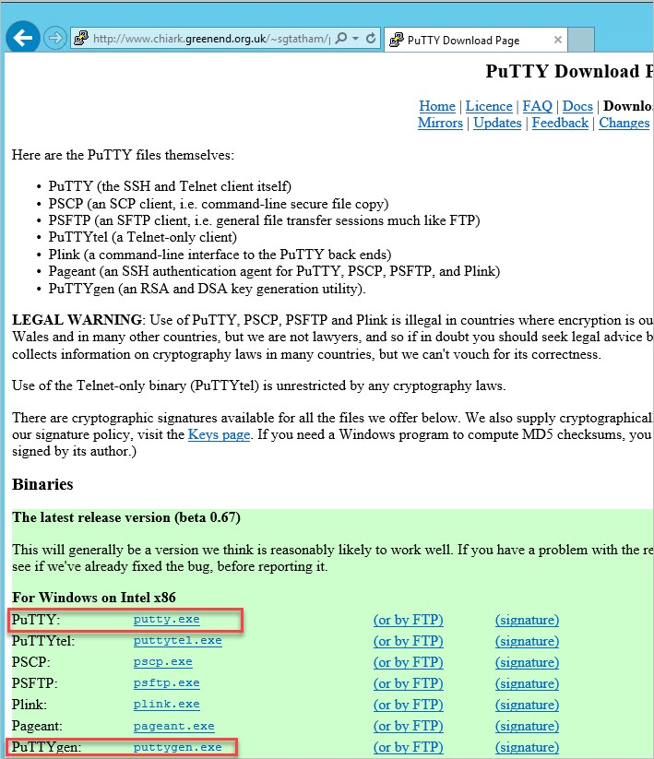

1. For PuTTY, click the link for **putty.exe** and chose Save as and browse to **c:\OpsgilityTraining**

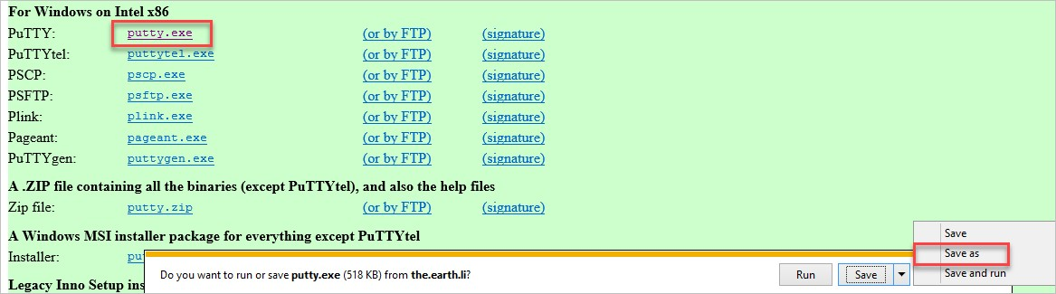

1. Do the same for the **puttygen.exe** link.