GBS Service Health Dashboard
Architecture Document
Wireless (Aruba) + LAN (SolarWinds) Pillars — As-Built, Codebase Reverse-Engineered
Document version | 1.0
Date | 20 July 2026
Scope | backend/, frontend/, infra/, docker-compose*.yml
Prepared for | Karthik
Status | POC — Phase 1 (Wireless) + Phase 1.1 (LAN) as implemented in code

Contents
- 1. Overview
- 2. Architecture Overview
- 3. Frontend
- 4. Backend
- 5. Data Flow
- 6. Data Model (MS SQL Server)
- 7. API Reference
- 8. Security Posture
- 9. Technology Stack
- 10. Deployment Architecture
- 11. Roadmap (per project documents)
- 12. Testing

1. Overview
The GBS Service Health Dashboard is a real-time infrastructure monitoring application built for a Global Business Service (GBS) environment. It presents a single-pane-of-glass view of network health across two independent pillars: Wireless (HPE Aruba access points, ingested via CSV/JSON in the current build) and LAN (SolarWinds Orion, ingested live via the SWIS REST API).
The system computes a composite Green/Amber/Red health score per site (wireless) or per node/country (LAN), stores a time-series history in MS SQL Server, and serves both a REST API and a React single-page dashboard with 30-second auto-refresh.
This document describes the architecture as implemented in the connected codebase (backend/, frontend/, infra/) rather than as originally scoped — see Section 9 for points where the code has diverged from the project's own README and SOW documents.

1.1 Two independently evolving pillars
- Wireless — reads Aruba health data from a CSV/JSON file on disk (POC data source). A second connector class, ArubaAPIConnector, exists as a working OAuth2 client for HPE Aruba Central's REST API but is not the active path until DATA_SOURCE_TYPE=api is set.
- LAN — connects live to a SolarWinds Orion server via the SWIS REST API (SWQL queries over HTTPS Basic Auth) and is fully operational, not a stub.
Both pillars run as independent asyncio polling loops inside the same FastAPI process, with isolated failure handling — a SolarWinds outage does not affect wireless data, and vice versa.

2. Architecture Overview
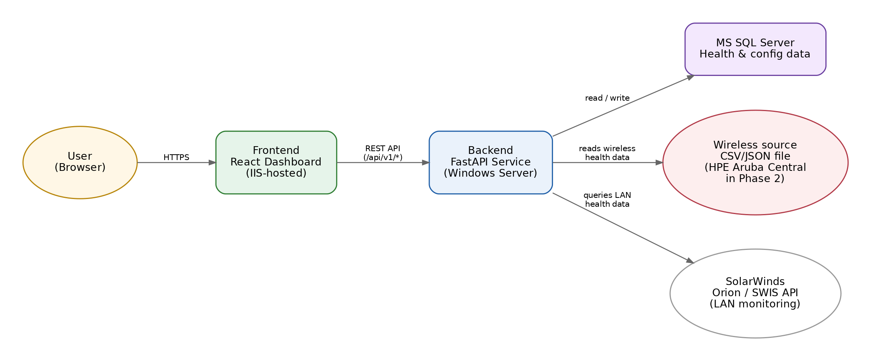
The diagram below shows every component in the current codebase and how they connect, including the external systems each connector talks to.
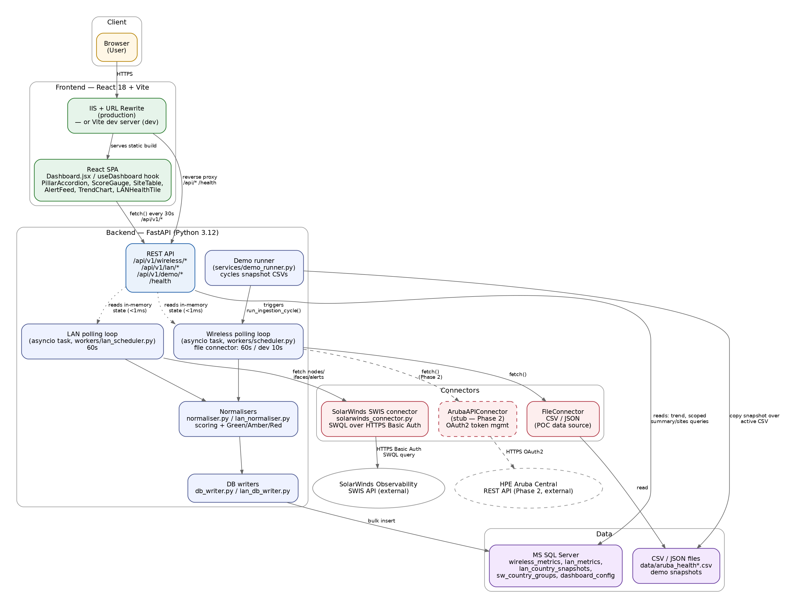
Figure 1 — Component and integration diagram

2.1 Architecture style
- Layered monolith: a single FastAPI process hosts the REST API, two background ingestion workers, and a demo simulation service. There is no message queue or separate worker process — polling loops run as asyncio tasks in the same event loop as the web server.
- Pluggable connector pattern: each pillar's data source is abstracted behind a small interface (BaseConnector for wireless; free functions for SolarWinds), so the file-based POC source can be swapped for a live API with no change to normalisation, storage, or API layers.
- In-memory cache + durable store: each polling cycle updates an in-process dict (served in under 1ms for /summary, /sites, /alerts) and also bulk-writes every row to MS SQL Server for trend history and cross-scope queries.
- Stateless REST API: FastAPI routers under /api/v1/wireless, /api/v1/lan, and /api/v1/demo; no server-side sessions or auth layer is present in the code (see Section 8, Security).

3. Frontend
React 18 single-page application built with Vite. Key files: frontend/src/App.jsx (root layout), frontend/src/pages/Dashboard.jsx (main page), frontend/src/hooks/useDashboard.js (all data-fetching and polling logic), frontend/src/utils/api.js (single API client module).

3.1 Components
Component | Responsibility
PillarAccordion | Expand/collapse container for the Wireless and LAN pillar sections
ScoreGauge | Renders the overall composite score with Green/Amber/Red styling
KpiCard | Individual KPI tile (APs online, clients, alerts, sites healthy, etc.)
SiteTable | Sortable per-site health table for the wireless pillar
AlertFeed | Severity-sorted active alert list, shared pattern for both pillars
TrendChart | Recharts-based 7-day (default) time series for score / availability / clients
LANHealthTile | LAN pillar view: country/group scope selector, country table or node drill-down
CountrySelector | Combo box populated from /api/v1/lan/groups and /api/v1/lan/countries
PocBanner, Header, Footer, ErrorBoundary | Shared chrome and error containment

3.2 Data fetching model
useDashboard() is the single hook driving the whole page. It polls both pillars every 30 seconds (dropping to 3 seconds while demo mode is running), fetches LAN combo-box options (groups/countries) hourly, and exposes a lanScopeRef alongside React state specifically so that in-flight interval callbacks always read the current scope rather than a stale closure — a deliberate fix for a scope/staleness race condition.
All HTTP calls funnel through frontend/src/utils/api.js, which throws a descriptive Error on any non-2xx response; callers catch this into per-pillar error state so a wireless outage never blanks the LAN view or vice versa.

4. Backend
Python 3.12, FastAPI 0.111, SQLAlchemy 2.0 (core + a minimal ORM), Pydantic 2.7 for all data validation. Entry point: backend/app/main.py.

4.1 Application startup (main.py)
- FastAPI lifespan context creates DB tables if missing (Base.metadata.create_all), then starts two asyncio background tasks: the wireless polling loop and the LAN polling loop.
- Security response-header middleware runs on every request (HSTS-style headers, CSP, X-Frame-Options, no-store cache control).
- CORS is currently wide open (allow_origins=["*"]) — commented in code as acceptable for POC, flagged for tightening in production.
- GET /health reports DB connectivity and both pillars' last-ingest time/error state without leaking credentials or paths.

4.2 Module layout
Path | Purpose
app/core/config.py | Pydantic Settings — loads .env, fails fast on missing required vars (DB + SolarWinds credentials have no defaults)
app/core/database.py | SQLAlchemy engine/session factory, targets MS SQL Server via pyodbc
app/core/security.py | Log/credential scrubbing, scope-input sanitisation, security response headers
app/models/schemas.py, lan_schemas.py | Pydantic models — raw ingested records, normalised records, summaries, alerts, trend points
app/models/orm.py | SQLAlchemy ORM classes for wireless_metrics and dashboard_config
app/services/ingestion.py | Wireless connectors: FileConnector (active) and ArubaAPIConnector (OAuth2 client, Phase 2)
app/services/solarwinds_connector.py | SolarWinds SWIS/SWQL client: nodes, interfaces, alerts, countries, with retry + backoff
app/services/normaliser.py, lan_normaliser.py | Scoring formulas, Green/Amber/Red thresholds, summary/alert builders
app/services/db_writer.py, lan_db_writer.py | Bulk persistence and read queries (latest snapshot, trend, scope resolution)
app/services/demo_runner.py | Cycles pre-built CSV snapshots to drive a live outage/recovery demo
app/workers/scheduler.py, lan_scheduler.py | asyncio polling loops, one per pillar, each with its own in-memory state dict
app/api/wireless.py, lan.py, demo.py | FastAPI routers

4.3 Health scoring
Wireless composite score (app/services/normaliser.py):
composite_score = (site_health_score / 100 * 50)
+ (ap_online / ap_total * 30)
+ alert_penalty
alert_penalty: none = 0 info = -2 warning = -10 critical = -20
Status: score >= 80 -> Green | 60-79 -> Amber | < 60 -> Red
LAN composite score (app/services/lan_normaliser.py), computed per node then aggregated per country weighted by node count:
composite = (availability * 0.50) # Up=100 / Warning=60 / Down=0
+ (packet_quality * 0.30) # 100 - percent_loss
+ (throughput_hdr * 0.20) # 100 - max(in_util, out_util)
- alert_penalty # none=0 info=2 warning=10 critical=20
Status: score >= 75 -> Green | 55-74 -> Amber | < 55 -> Red
Both threshold sets are seeded into the dashboard_config SQL table and can be tuned at runtime without a code change or restart.

5. Data Flow
Each pillar runs its own fetch → validate → normalise → classify → persist → cache cycle, independently scheduled and isolated from the other's failures.
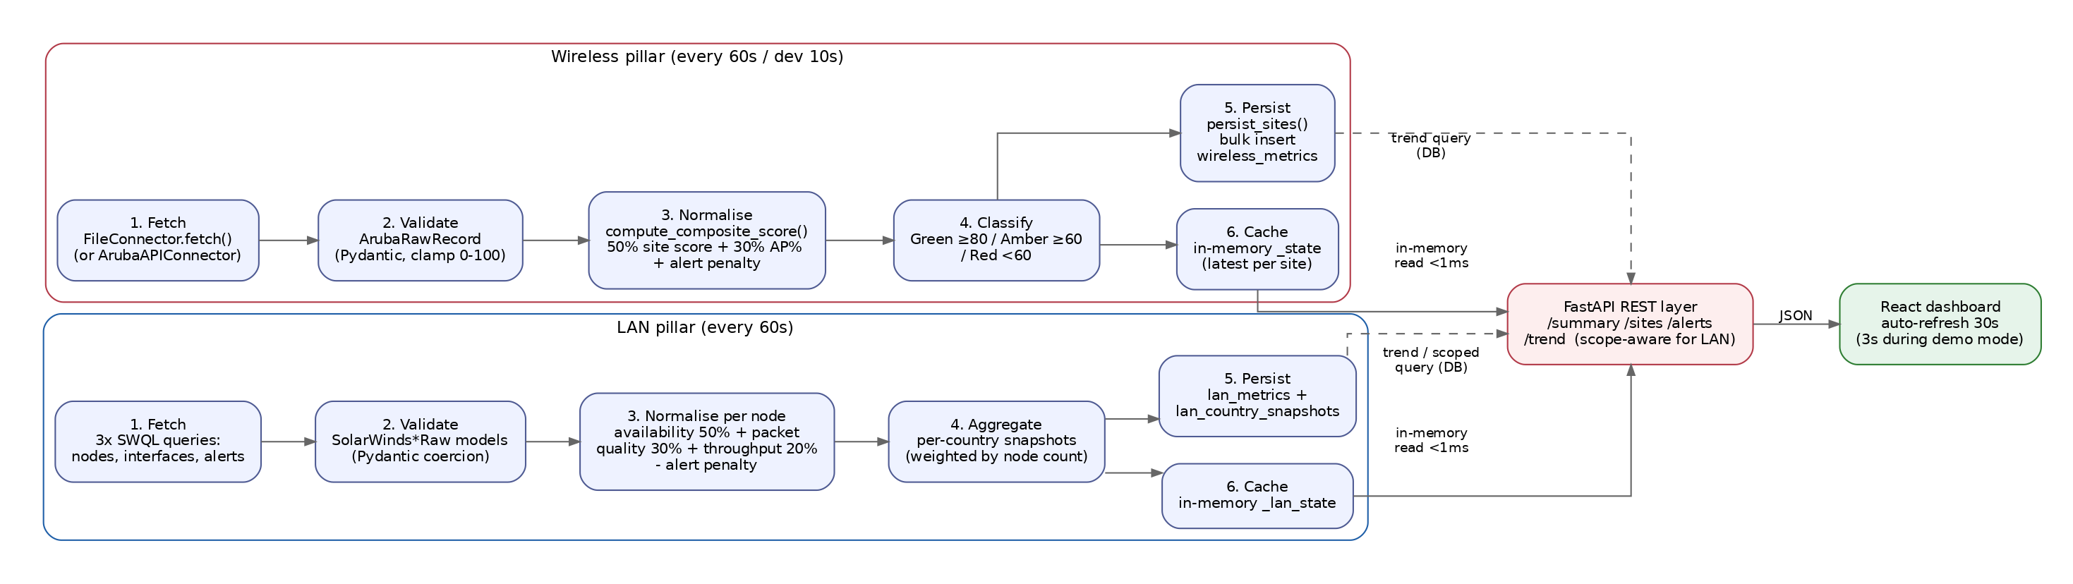
Figure 2 — Per-pillar ingestion pipeline

5.1 Wireless cycle (workers/scheduler.py)
- Runs every POLL_INTERVAL_SECONDS (60s customer default, 10s in the developer compose overlay). Fires immediately on startup, then on the interval.
- Every row read from the CSV/JSON source is persisted (deduplicate=False) so the 7-day trend chart has full history; a separate deduplicated "latest per site" set drives the live dashboard view and is held in the in-process _state dict.
- On zero records returned, the cycle sets an error flag but does not crash the loop; the previous good state remains visible to the API.

5.2 LAN cycle (workers/lan_scheduler.py)
- Runs every SW_POLL_INTERVAL_SECONDS (60s). Performs a lightweight connectivity test on startup, logs but does not abort on failure.
- Each cycle issues three SWQL queries (nodes, interface utilisation, alerts), loads current thresholds and alert limit from dashboard_config, normalises, aggregates to per-country snapshots, then bulk-writes both node-level and country-level rows.
- Alert-to-node matching prefers an exact RelatedNodeId integer match and falls back to a node-name string match only when SolarWinds omits the ID — avoiding hostname/FQDN ambiguity.

5.3 Demo mode (services/demo_runner.py)
An operator-triggered simulation (POST /api/v1/demo/start) that copies pre-scripted CSV snapshots (data/realtimesamples/) over the active data file on a timer and calls the same run_ingestion_cycle() used in production — so the demo exercises the real pipeline, not a mock. The frontend detects demo mode and speeds up its own poll interval to 3 seconds for a responsive walk through.

5.4 Read path
- /summary, /sites, /alerts (both pillars, scope=all for LAN) are served straight from the in-memory state dict — no DB round trip, sub-millisecond.
- /trend and any LAN request scoped to a specific country or group query MS SQL Server directly, using window functions (ROW_NUMBER, MAX() OVER()) to get the latest-per-key row without a slower GROUP BY join.

6. Data Model (MS SQL Server)
Schema defined in infra/init.sql (idempotent — guarded by IF NOT EXISTS, safe to re-run). Target: SQL Server 2017+.
Table | Grain | Purpose
wireless_metrics | 1 row / site / ingest cycle | Full wireless time-series history — feeds the 7-day trend chart
lan_metrics | 1 row / node / ingest cycle | Full LAN node-level time-series history
lan_country_snapshots | 1 row / country / ingest cycle | Pre-aggregated country rollups — avoids re-aggregating ~700 node rows on every API call
sw_country_groups | 1 row / group | Client-editable region groupings (e.g. Asia Pacific) for the scope selector — edited directly in SSMS, no restart needed
dashboard_config | 1 row / key | Runtime-tunable thresholds and poll intervals for both pillars
Indexing is purpose-built for the read patterns above: composite (site_id/node_id, ingested_at DESC) indexes for latest-snapshot lookups, and (ingested_at ASC) covering indexes for the trend queries. A commented-out retention job (90-day DELETE) is documented in the script but not yet wired into a scheduled job.

7. API Reference
All endpoints are unauthenticated in the current code (see Section 8). Interactive OpenAPI docs are served at /docs.

7.1 Wireless — /api/v1/wireless
Method & path | Description
GET /summary | Overall score, status, KPI aggregates
GET /sites | Per-site health breakdown (latest snapshot)
GET /alerts | Active alerts, severity-sorted
GET /trend?hours=168 | Hourly trend — score, AP %, client count
POST /ingest/trigger | Manually fire an ingestion cycle

7.2 LAN — /api/v1/lan (scope-aware: all | group:<slug> | country:<name>)
Method & path | Description
GET /summary?scope= | Overall LAN score/KPIs for the given scope
GET /sites?scope= | Country rollups (scope=all) or node-level drill-down (scoped)
GET /alerts?scope= | Alert feed, filtered to scope
GET /trend?scope=&hours= | Hourly trend, max 720h (30 days)
GET /groups | Region group definitions for the selector
GET /countries | Distinct countries with node counts
GET /status | SolarWinds connectivity and last-ingest state

7.3 Demo & health
Method & path | Description
POST /api/v1/demo/start, /stop | Start/stop the scripted outage simulation
GET /api/v1/demo/status | Current demo step and state
GET /health | App/DB/pillar health — no credentials or paths exposed

8. Security Posture
The codebase includes deliberate, documented security measures appropriate to a POC, alongside gaps that are explicitly called out in comments as needing attention before wider production use.

8.1 Implemented
- Credential scrubbing — Basic Auth headers, connection-string passwords, and pyodbc PWD= values are regex-redacted before anything reaches a log line (app/core/security.py, ingestion.py, solarwinds_connector.py).
- SQL injection defence in depth — all LAN scope values (country/group names) are validated against an allow-list regex, then re-validated by exact-match DB lookup, then always bound as query parameters, never string-interpolated. The one exception is the SolarWinds custom-property field name, which is validated against a strict alnum/underscore charset before being interpolated into a SWQL template (SWQL has no parameter binding).
- Security response headers — HSTS-style headers, X-Frame-Options: DENY, X-Content-Type-Options: nosniff, a Content-Security-Policy, and Cache-Control: no-store are applied to every response.
- Secrets management — all credentials (DB, SolarWinds) are required environment variables with no defaults; the app fails fast at startup rather than running with blank credentials.
- Aruba OAuth2 token handling — access tokens are held in memory only, refreshed proactively (30-minute margin) and on 401, with a thread lock protecting concurrent refreshes.

8.2 Gaps to address before broader rollout
- No authentication or authorization on any REST endpoint — anyone who can reach the API can read all wireless/LAN data and trigger ingestion or demo mode.
- CORS is set to allow_origins=["*"] — the code comments flag this as a POC shortcut, with the fix (restrict to the IIS frontend origin) already identified.
- SolarWinds SSL verification is disabled (SW_VERIFY_SSL=false) to accommodate a self-signed certificate — documented in code as POC-only, with the production remediation (point at a real CA cert path) already built into the config.
- No rate limiting is implemented despite a mention in security.py's module docstring.

9. Technology Stack
Layer | Technology
Backend framework | FastAPI 0.111.0, Uvicorn 0.29.0 (Python 3.12)
Data validation | Pydantic 2.7.1 / pydantic-settings 2.2.1
ORM / DB driver | SQLAlchemy 2.0.30, pyodbc 5.1.0 (ODBC Driver 18 for SQL Server)
Database | Microsoft SQL Server 2017+ (Windows Server deployment target)
HTTP client | httpx 0.27.0 (Aruba + SolarWinds connectors)
Frontend framework | React 18.3.1, Vite 5.3.1
Charting | Recharts 2.12.7
Frontend hosting (prod) | IIS with URL Rewrite (web.config) proxying /api/* and /health to the FastAPI backend on :8000
Frontend hosting (dev / Docker) | Vite dev server, or containerised via Dockerfile (node:20-alpine)
Containerisation | Docker + docker-compose (dev and customer overlays) — see Section 10 for current status
Testing | pytest, 20 smoke tests (backend/tests/test_pipeline.py) covering schema validation, scoring, normaliser, and connectors

10. Deployment Architecture
The repository currently contains two deployment paths that target different databases. This is flagged here rather than glossed over, since it affects which files are authoritative.

10.1 Current / active path — Windows Server, native processes
The live .env, backend/app/core/config.py, and infra/init.sql all point at MS SQL Server on a Windows Server host, with the frontend built and served through IIS (frontend/web.config performs the /api and /health reverse proxy; SPA fallback routes all other paths to index.html). DATA_SOURCE_PATH and DEMO_SAMPLES_PATH in .env resolve to Windows filesystem paths (C:/CustomProjects/dashboard/gbs/gbs-poc/...), confirming this is the environment actually being run today.

10.2 Legacy / alternate path — Docker Compose
docker-compose.yml, docker-compose.dev.yml, and docker-compose.customer.yml define a three-container stack (TimescaleDB/PostgreSQL, FastAPI backend, Vite-served frontend) matching an earlier Phase 1 (wireless-only) POC design described in README.md. This overlay set still references postgresql:// connection strings, whereas config.py now requires MS SQL Server settings (DB_DRIVER, mssql+pyodbc) with no PostgreSQL fallback — so docker-compose.yml as written will not start the backend successfully against current config.py without modification. It is retained in the repo and Makefile but is not the environment the SolarWinds/LAN pillar or the current .env file were built against.

10.3 Recommendation
Treat the Windows Server + MS SQL Server + IIS path as the system of record for architecture and operations going forward. Either update the Docker Compose files to match (SQL Server container + mssql+pyodbc) or retire them and update README.md/Makefile accordingly, so the two do not silently drift further apart.

11. Roadmap (per project documents)
The following phases are described in the project's SOW/capability documents and are reflected as forward-looking hooks already present in the code (e.g. the ArubaAPIConnector stub, the DATA_SOURCE_TYPE=api switch):
Phase | Scope
Phase 2 | Switch wireless ingestion to the live HPE Aruba Central API — a configuration change plus finishing ArubaAPIConnector; normaliser, DB, and frontend are designed to need no changes
Phase 3 | Add an Azure Virtual Desktop (AVD) health pillar
Phase 4 | Add SAP S/4HANA, ECC, and M3 application availability pillars
Phase 5 | Add Printing Services monitoring via Zabbix
Phase 6 | Automated PDF reporting, alerting integration, HA/DR, role-based access control, operations handover

12. Testing
backend/tests/test_pipeline.py contains 20 smoke tests run with pytest, covering: Pydantic schema validation and clamping, composite score computation across edge cases, the normaliser's status classification, summary/alert builders, and the FileConnector against both CSV and JSON sample data (including a missing-file case). There is no equivalent automated test coverage yet for the SolarWinds/LAN pillar, the REST API layer, or the frontend.

