1. Modify the links in the header and footer
   1. Place all links inside unordered lists
   2. Should look like these
      1. 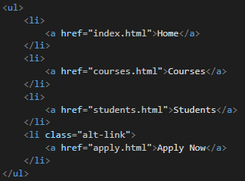
2. Create a new class called **alt-link**
   1. Assign the class to the last **<li>** element in the list inside the header
   2. Style properties
      1. Background-color: black
   3. Style the **<a>** element inside it
      1. Color: white
3. Remove the color: black property from **<a>** inside the header
4. Remove the anchor hover inside the **header** element style previously added
5. Create new style for **li** elements inside the header when it gets hovered
   1. Style properties
      1. Box-shadow: inset 0 3px 0 0 #45a2da;
      2. Color: #45a2da;
6. Create new style for **li** elements inside the header
   1. Style properties
      1. Display: inline-block
   2. Style the **<a>** element inside the **li** element
      1. Color: black
7. Remove **text-align** from the header **nav** element