**Project Documentation**

As the market-leading choice for modern business intelligence, our analytics platform makes it easier for people to explore and manage data, and faster to discover and share insights that can change businesses and the world.

Everything we do is driven by our mission to help people see and understand data, which is why our products are designed to put the user first—whether they’re an analyst, data scientist, student, teacher, executive, or business user. From connection through collaboration, Tableau is the most powerful, secure, and flexible end-to-end analytics platform.

**My Dashboard:**

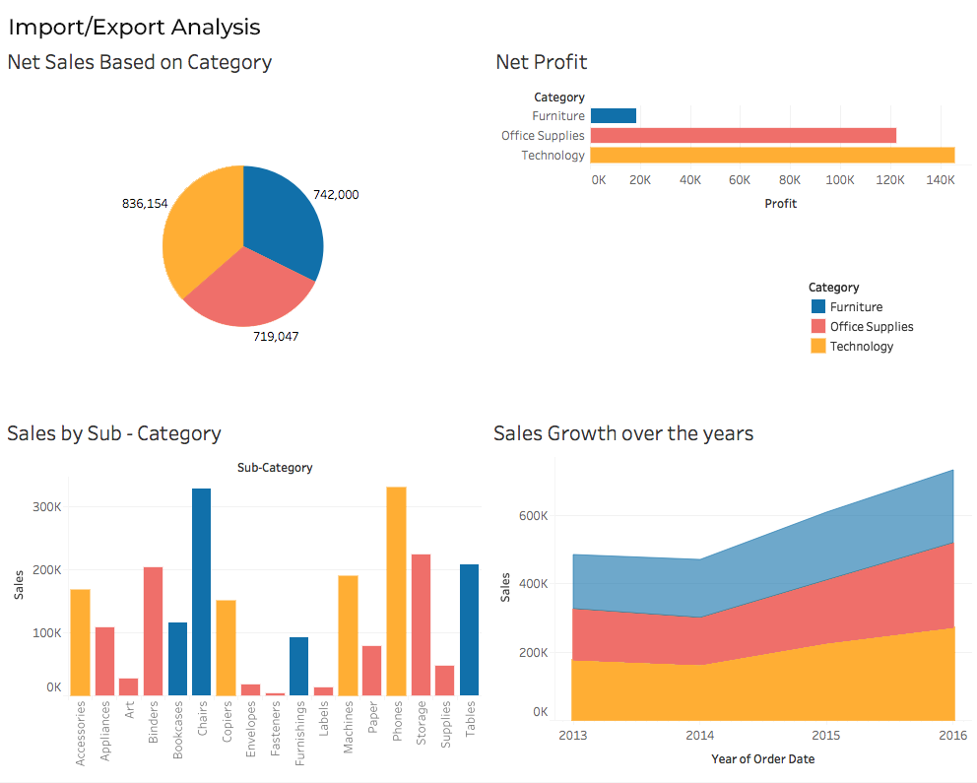

Data has limitless potential to transform businesses and the world—as long as people are empowered to use it. Our community is using Tableau to build a [data culture](https://www.tableau.com/data-culture) and to change lives.

**About:**

Tableau was founded in 2003 as a result of a computer science project at Stanford that aimed to improve the flow of analysis and make data more accessible to people through visualization. Co-founders Chris Stolte, Pat Hanrahan, and Christian Chabot developed and patented Tableau's foundational technology, VizQL—which visually expresses data by translating drag-and-drop actions into data queries through an intuitive interface.

Since our foundation, we’ve continuously invested in research and development at an unrivalled pace, developing solutions to help anyone working with data to get to answers faster and uncover unanticipated insights.

This includes making machine learning, statistics, natural language, and smart data prep more useful to augment human creativity in analysis. And we not only offer a complete, integrated analytics platform, but also proven enablement resources to help customers deploy and scale a data-driven culture that drives resilience and value through powerful outcomes.

Tableau was acquired by [Salesforce](https://www.salesforce.com/) in 2019, and our mission remains the same: to help people see and understand their data. Today, organizations everywhere—from non-profits to global enterprises, and across all industries and departments—are empowering their people with Tableau to drive change with data.