Jerry Sandhu
21 Transfer St
Network, SH, 12345
111-222-3333

07/19/2023
Chris Nelson
President
Greenfield Properties
123 Sophia Way
Minneapolis, MN 55000

Dear Mr. Nelson:
I have completed the network proposal for Greenfield properties that you have requested. It was my privilege to work with you and your staff on coming up with the best plan of action to create a secure and well structured network for your merger between Bluegrass Rentals and Redstone Property Management.
I have enclosed in this document my initial recommendations for how the network should be laid out in your new building. My recommendations come from my evaluation of Greenfields needs based on the current number of staff and devices used, along with a projection of the future needs of the business. A network that is secure, reliable in up time and easy to manage for the smaller IT staff.
If you find the proposal to be satisfactory, I will move on to meeting with IT to discuss the budget and create a more detailed scope of the project. If you have any questions or concerns, reach out to me at any time. I look forward to hearing back from you.

Sincerely,

Jerry Sandhu

Introduction
The goal is to design and deploy a network that’s efficient, secure and ensures seamless data management and communication for your business. This proposal outlines my recommendations for a new network infrastructure for Greenfield Properties.

Network Infrastructure
The type of network architecture I recommend is a client server network, which allows both client and server to share data and resources. For example, a client such as a desktop PC sends a request to the server to access a file and the server decides how to process it. This would be a big upgrade for the company as the number of employees continues to grow.
It’s important to use cabling that will fit the business needs now and in the future. My recommendation is to use Cat6 cables for network connections between the router and the switch, then from the switch to the desktop PCs, printers, servers and wifi access points. The Cat6 cables will use a T568B wiring scheme that attach to RJ45 jacks on both ends, which will make the connections to devices.
The network should use the following servers:
1. Web server – This server will host an offline Greenfields website for IT to test and make changes on, then submit a working version to an Amazon cloud server (AWS), which will run the actual website that customers use. It will use data from the database server to access client information. I recommend the cloud server to use Apache HTTP to handle the internet requests.
2. Mail server – This server will host the companies mail system. It will hold and control both outgoing and incoming mail.
3. File server – This server will hold the companies files for employees to access and share with each other. I recommend a versioning system for files, so the last 3 copies of file changes are kept.
4. Print server – This server will contain the management of all the companies printers.
5. Database server – This server will contain client data from a database application such as MySQL. It will allow access and changes to be made by the file and web server.
6. Backup server – This server will be cloud based and contain encrypted daily backups of data in case of a local disaster such as a hardware failure or earthquakes.
5 of the 6 servers will be onsite, with the exception of the backup server and the other half of the webserver. While onsite servers require more maintenance and overall work for the IT staff, the business can still operate in case of internet downtown time locally or from the cloud provider.
The servers should run on Windows Server 2022 Database Azure Edition. This version of Windows Server allows for a virtual machine only operating system. This allows for all servers to be virtualized on 1 server locally and gives the option to move features to Microsoft Azure cloud server if needed. Having just 1 server saves space and keeps costs down, while the Azure server allows for seamless future proofing if the company decides to fully move to the cloud in the future. While there are drawbacks such as the virtual machines having a single point of failure and the hypervisor adding overhead to resources used, I recommend this method for the servers.

Network Segmentation and Printing
The network should use subnets (subnetworks), where the range of IP addresses are divided into segments, each segment having its own subnet address. This should be utilized because it will allow IT staff to efficiently allocate IP addresses, network resources and implement security policies easily. Considering that Greenfield has departments with few staff, it’s best to subnet the network by device usage than by department or floor.
The subnets I recommend are as follows:
1. Wifi – This subnet will be for the devices that connect wirelessly such as phones and tablets. There should be room for 104 devices.
2. Workstations – This subnet will be for the desktop PCs. There should be room for 40 devices
3. Network devices – This subnet will be for the wifi access points, servers and potentially cameras in the future. There should be room for 60 devices
4. Printers – This subnet will be for the printers. There should be room for 20 devices.
5. Spare – This subnet will be a temporary place for devices that don’t fit into the first 4 subnets or for IT to run tests. There should be room for 10 devices.
Virtual LANs (VLANs) segment networks and offer management and performance. I recommend Greenfields networks use VLANS because they offer the ability to have different security policies for various devices and offer flexibility in network expansions, which is important as the network will be subnet by device.

Printing
There are 2 methods that we can use to allow user access to printers; a print server or direct printing. To get the best printing infrastructure for the business, it is essential to evaluate the pros and cons of each option to make an informed decision. I have a table below that lists the pros and cons of each print method.

 | Print Server | Direct IP Printing
Pros | +Centralized management: Able to manage all printers from a central location  +Resource sharing: Multiple users can share the same printer without a direct connection. Loads can be balanced across several printers, making the load balancing efficient  +Improved security: Possible to manage print queues and access control (user authentication) | +Simple to use: There is no server to configure or maintain.  +No 1 point of failure: Each printer runs independently, 1 system failing doesn’t affect all printers  +Cost: A server isn’t needed. Much lower upfront cost
Cons | -1 point of failure: Any failure to the server will cause the entire printing service to go down  -Cost: Requires dedicated hardware and software, however this is mostly an upfront cost  -Maintenance: IT staff are required to maintain the servers | -Lack of resource sharing: print jobs will not be balanced, some printers will have larger queues than others  -Security: confidential documents may be left at printers with no way to track them  -No Management: Not able to monitor print jobs

My recommendation is to implement a print server. While direct printing may seem simpler for the smaller IT staff to use and more cost effective, it’s important to consider the growth of the business as well as the security requirements. Being able to manage all printers in 1 location, have security in access controls and the ability to manage resource queues will be instrumental in handling the businesses reliability and performance with print jobs.

Wi-Fi Networking
It’s important to have wifi coverage throughout the entirety of Greenfields office building, because there are 69 devices that will use wifi and all of them need to stay connected. My recommendation is that the network support should cover for 50% more than the current number of devices, meaning the total will be 104. This is to cover for future expansions of the business and prevent issues of device support in the future.
My strategy for planning the wifi coverage is shown in the below image, along with a number indicating the wifi channel used. There will be 12 access points in the building, placed strategically to cover the most area. Each access point will be on either channel 1,6 or 11 with no channel overlapping with itself. The access points will be located on the ceilings and powered by cat6 cables running above the ceilings to a Power over Ethernet (POE) switch located in the server room, which will connect to the router.

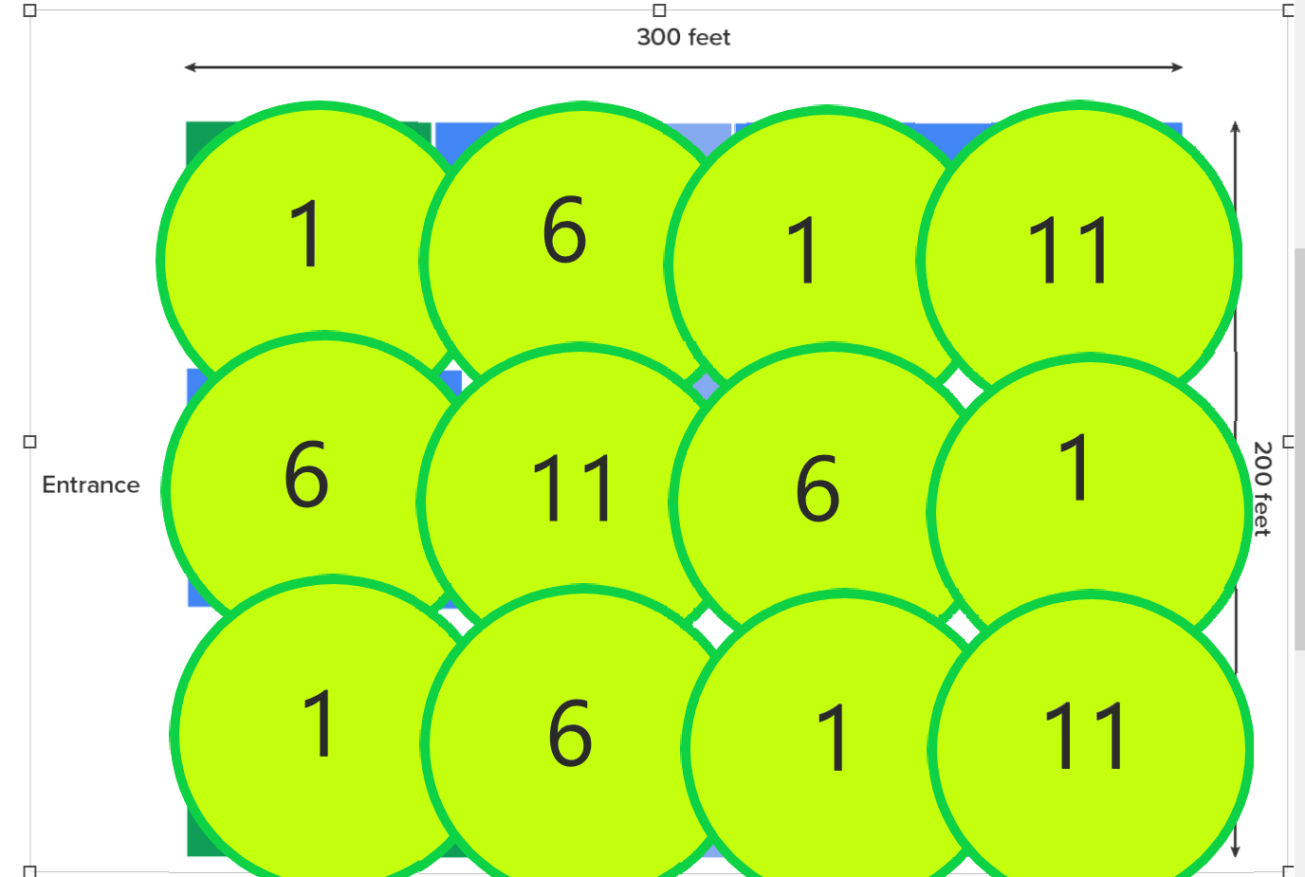
I recommend using a wireless LAN controller because it offers central management over all the wifi access points (AP) in the building. It also allows updates and changes in configurations to be applied to all access points at once, reducing the possibility that an access point is configured incorrectly. As the IT staff is small, this controller makes the most sense for the business as it streamlines control over the wifi network.
The newest and most secure encryption standard for wifi networks is WPA3 (wifi protected access 3). It offers enhanced security features over previous standards and uses SAE (simultaneous authentication of equals) to create keys for connections, making it difficult for dictionary hacking attempts. Another feature is individual data encryption, letting each device have a unique encryption key. So even if the key on 1 device is hacked or compromised, every other devices key on the network will still be protected. As WPA3 is the current IT industry standard of protection, it’s the best encryption method to handle current and new threats to networks.

Security Measures
Greenfield is a business that relies on its network infrastructure for its daily operations. It is of upmost importance to fortify and secure the network against unauthorized access (both inside and outside the organization), malware and data breaches. I have below some recommendations to ensure a secure and optimal running network.

Physical Security
Physical access to the server rooms should be limited to a strict access control policy. The use of key codes with 6 digits is recommended. Access cards and RFID (radio frequency ID) badges can be duplicated by hacking devices such as a Flipper Zero and so I cannot recommend them. Server rooms should also have CCTV surveillance to monitor activities. CCTV recordings should be saved to a hard drive and not overwritten for 30 days. 1080P resolution recording will be optimal in terms of video quality and space used. The servers themselves should be in a locking cabinet that’s at least 1 ft off the ground to protect them from flood damage.

Infrastructure Access
Greenfields network access should only be limited to the tablets, phones and PC workstations used for its business. The access to this infrastructure should be made secure by implementing network access by each devices unique hardware identifier, called the media access control (MAC). Which is assigned by the manufacturer of the device. The IT staff can allow or refuse access to the network to certain devices based on their MAC address. This means devices can’t access the network if they’re not on the MAC allowed list.

Authentication
My recommendation for authenticating users is by multi-factor authentication (MFA). Staff will login into the network with their password and then authenticate themselves with a 1 time use; 4 digit code that will be prompted on their phones. This will be done through the application Microsoft Authenticator. This method is secure as it provides protection against password hacking, phishing and data breeches. Staff being able to use their own phones makes it convenient and simple for those not in IT.

Lockout Policy
Workstations should be locked by employees when they’re way from them (lunch break, washroom, meeting, heading home). Workstations should automatically lock and require a login after 30 minutes of inactivity. To protect critical assets, workstations should also automatically lock when 5 incorrect password attempts have been made.

Password Complexity Requirements
Employees should be educated about the importance of security and how they can protect network assets. I recommend that employees use an individual password of 8 to 12 characters. These passwords will include: 1 upper case letter, 1 lower case letter, 1 number and 1 special character (e.g. ?, /,+,-,<) to login into workstations and the network. Employees should refrain from using passwords that include real words to prevent hackers from from guessing them.

Firewall
Firewalls are critical in protecting networks, I recommend a system of a stateful firewall. This will inspect and track all packets (information) and will filter data connections that should not be there. The firewall will take actions against it as a threat and allow IT staff to monitor incoming and outgoing data.

Anti-Malware
Having anti-malware protection is very important to protect the network and ensure the confidentiality and integrity of all company assets. It defends computers, phones and networks from malicious software such as viruses, trojans, spyware and adware. Malicious software can lead to breaches of sensitive information, data loss and financial losses. I recommend a server based anti-malware, which has centralized management. This allows IT staff to control updates, virus scans and policies for every device from 1 control panel. This ensures integrity and consistent protection across the network.

