**Project Title: Employee Onboarding System**

**Business Requirement Document [BRD]**

|  |  |
| --- | --- |
| **Author Name:** | **JAYASURIYA J** |
| **Date:** | **24-03-2024** |
| **Version:** | **1.1** |
| **Status:** | **IN PROGRESS** |

# Table of Contents

1. Introduction …………………………………………………………………………………………………………….*03*

1.1 Project Overview …………………………………………………………………………………………………...*03*

1.2 Purpose …………………………………………………………………………………………………………………*03*

1.3 Scope …………………………………………………………………………………………………………………… *03-04*

1.4 Definitions, Acronyms, and Abbreviations …………………………………………………………….*04-05*

2. Business Objectives …………………………………………………………………………………………………*05-06*

3. Stakeholders ………………………………………………………………………………………………………......*06*

3.1 Stakeholder Identification …………………………………………………………………………………….*06-07*

3.2 Stakeholder Roles and Responsibilities …………………………………………………………………*07-10*

4. Requirements ………………………………………………………………………………………………………*…11*

4.1 Functional Requirements …………………………………………………………………………………….*11-19*

4.2 Non-Functional Requirements …………………………………………………………………………….*19-20*

5. Assumptions and Constraints …………………………………………………………………………………*20-21*

6. Glossary …………………………………………………………………………………………………………………*21*

7. Approval …………………………………………………………………………………………………………………*22*

7.1 Sign-Off …………………………………………………………………………………………………………………*22*

**1. Introduction**

**1.1 Project overview**

Employee onboarding is essential for integrating new hires smoothly into an organization. Traditional methods can be slow, error-prone, and hard to track.This project aims to develop a digital Employee Onboarding System to automate profile creation, document verification, task assignment, IT setup, training, and compliance tracking. It will also provide HR with real-time reports, ensuring a seamless and efficient onboarding experience.

**1.2 Purpose**

The primary goal of this system is to simplify and optimize the employee onboarding process through automation. By replacing manual paperwork and fragmented processes, the system ensures a structured, efficient, and engaging onboarding experience.

**1.3 Scope**

**In-scope**

* **User Interface & Design** – Create a simple and easy-to-use website for onboarding. Employees and HR can navigate smoothly.
* **User Registration & Login** – Employees, HR, and IT staff can sign up and log in. Each user gets a personal dashboard.
* **Employee Profile Creation** – New hires can fill in their details online. They can update their profiles anytime.
* **Document Submission & Verification** – Employees upload required documents. The system checks and verifies them automatically.
* **Onboarding Task Assignment & Tracking** – HR assigns tasks to new employees. Employees can see and track their progress.
* **IT Setup & Access Provisioning** – System access and required software are set up automatically. New hires get the necessary tools.
* **Training & Compliance Tracking** – Employees get assigned training courses. The system tracks completion to ensure compliance.
* **HR Reporting & Analytics** – HR gets reports on onboarding progress. They can check pending tasks and employee status.
* **Notifications & Reminders** – Employees get alerts for pending tasks. The system sends reminders for important deadlines.

**Out-scope**

* **Mobile Application** – The project will only create a website for onboarding. A mobile version is not included.
* **Recruitment & Hiring Process** – The system will not handle job postings, interviews, or hiring decisions. It begins after hiring.
* **Payroll & Benefits Management** – The system will not process salaries, taxes, or employee benefits. Payroll is managed separately.
* **Third-Party Background Verification** – The system will not check criminal records or past employment. External verification is not included.
* **Employee Offboarding** – The system focuses only on new hires joining the company. It will not manage resignation or exit steps.

**1.4 Definitions, Acronyms, and Abbreviations**

**Definitions**

* **End User**: The employee, HR staff, or IT staff who interacts with the Employee Onboarding System.
* **Employee Profile**: The digital record containing personal details, contact information, and employment history of a new hire.
* **Onboarding Task**: A task assigned to new hires or HR staff to complete specific steps in the onboarding process (e.g., document submission, training).
* **IT Access Provisioning**: The process of providing necessary system access and tools for new employees.
* **Compliance Tracking**: Monitoring and ensuring employees complete required training and adhere to company policies during onboarding.

**Acronyms**

* **BRD**: Business Requirement Document
* **UI/UX**: User Interface/User Experience
* **SDLC**: Software Development Life Cycle
* **RTM**: Requirement Traceability Matrix
* **HRMS**: Human Resource Management System
* **IT**: Information Technology

**Abbreviations:**

* **Zip**: Zip Code (a postal code used to identify geographic areas in the U.S. or India)
* **SaaS**: Software as a Service
* **API**: Application Programming Interface
* **HR**: Human Resources
* **IT**: Information Technology
* **ID** – Identification
* **OTP** – One-Time Password
* **DB** – Database

**2. Business Objectives**

* **Enhanced Employee Experience** – A smooth onboarding process helps new hires feel welcomed and prepared for their roles. By automating tasks and providing clear instructions, the system reduces confusion and ensures employees start with confidence.
* **Operational Efficiency** – Manual onboarding processes can be time-consuming and error-prone. Automating tasks such as document submission, IT setup, and training assignments helps HR teams work more efficiently and focus on strategic initiatives rather than administrative tasks.
* **Regulatory Compliance** – Ensuring that all necessary documents are submitted, verified, and stored correctly is critical for compliance. The system keeps track of legal requirements, company policies, and training completions, reducing the risk of non-compliance.
* **Data-Driven Decision Making** – HR teams can access real-time insights into onboarding progress, completion rates, and bottlenecks. This allows organizations to refine their processes, identify areas for improvement, and ensure new employees are fully prepared for their roles.
* **Cost Savings** – By eliminating paperwork, reducing manual errors, and minimizing delays, the system helps organizations save time and money. Faster onboarding means employees become productive sooner, contributing to overall business success.

**3. Stakeholders**

**3.1 Stakeholder Identification**

* **Business Owners** – These are the decision-makers who fund and approve the project. They ensure the system aligns with the company’s strategic goals and improves overall efficiency.
* **HR Team** – Responsible for managing the onboarding process, assigning tasks, verifying documents, and ensuring new employees complete all required steps. They will be the primary users of the system.
* **IT Team** – Ensures new employees receive system access, email accounts, and necessary hardware/software. They also help maintain the platform and troubleshoot technical issues.
* **Hiring Managers** – Oversee the onboarding of employees in their respective departments. They track progress, provide role-specific guidance, and ensure a smooth transition into the team.
* **Developers** – Responsible for building and implementing the system, ensuring all features work correctly, from user registration to document verification and task tracking.
* **Quality Assurance (QA) Team** – Tests the system before deployment, ensuring that all functionalities work as expected, security standards are met, and the user experience is smooth.
* **UI/UX Designers** – Design an intuitive and user-friendly interface for both employees and HR teams, making it easy to navigate and complete onboarding steps.
* **Compliance & Legal Team** – Ensures the onboarding system meets company policies and legal requirements, such as document storage, data security, and regulatory compliance.
* **New Employees (End Users)** – The primary users of the system who will complete their onboarding process through the platform. Their feedback will help improve usability and efficiency.  
  1. **Stakeholder Roles & Responsibilities**

|  |  |  |  |
| --- | --- | --- | --- |
| **Name** | **Role** | **Responsibilities** | **Email ID** |
| Krishnan | |  | | --- | |  |  |  | | --- | | Business Owner | | Ensures the onboarding system aligns with company goals, approves funding, and provides strategic direction. Oversees the project's progress to ensure it delivers value to the organization. | <krishnan@gmail.com> |
| Keerthana | HR Manager | Manages the entire onboarding process, ensuring new hires complete required steps. Assigns tasks, tracks progress and ensures compliance with company policies. | [keerthana26@gmail.com](mailto:keerthana26@gmail.com) |
| Ebison Infant Raj | IT Manager | Ensures all technical aspects of the onboarding system function smoothly. Manages access provisioning, system security, and resolves IT-related issues for new hires. | <ebisonraj@gmail.com> |
| yuvashree | Hiring Manager | Ensures a smooth transition for new employees into their respective teams. Provides role-specific guidance and collaborates with HR to track onboarding progress. | <yuvashreeraja@gmail.com> |
| Jayasuriya | Business Analyst | Gathers and analyzes requirements from stakeholders, ensuring the onboarding system meets business needs. Works with developers, HR, and IT to ensure seamless functionality. | <Jsuriya454@gmail.com> |
| Selva Sekar | Developer | Builds and maintains the onboarding system, ensuring all features work seamlessly. Fixes bug, implements updates, and optimizes performance for a smooth user experience. | <Selvasekar53@gmail.com> |
| Mohamad Sheik | QA Tester | Tests the system to identify and resolve bugs before deployment. Ensures a seamless experience by verifying that all onboarding functions work correctly. | <sheikm@gmail.com> |
| Sowmiya | UI/UX Designer | Designs an intuitive and engaging interface for the onboarding system. Focuses on user experience, making the platform easy to navigate for employees and HR. | <sowmiya@gmail.com> |
| Vasumathi | Compliance & Legal Team | Ensures the system meets legal and regulatory requirements. Verifies data privacy measures, document security, and compliance with company policies. | <vasu@gmail.com> |
| Priya Dharshini | New Employee (End User) | Uses the system to complete onboarding tasks, upload documents, and complete required training. Provides feedback to improve the experience for future hires. | <Dharshini03@gmail.com> |

**4. Requirements**

**4.1 Functional Requirements**

**1.** **Employee Profile Creation**

**Description:**

This functionality allows new employees to create and update their profiles with personal and job-related details.

**Assumptions:**

* Employees must have an active email to receive login details.
* Employees should have a stable internet connection.

**Dependencies:**

* Employee login functionality.
* HR approval process.

**Preconditions:**

* HR must send a login link to the employee.
* Employee must have received the login credentials.

**Postconditions:**

* Employee profile is created and stored in the database.
* HR receives a notification to review and approve the profile.

**Acceptance Criteria:**

* Employees should be able to enter and edit personal details.
* The system should validate mandatory fields before submission.
* HR should receive an approval request once the profile is saved.
* If data is incomplete, the system should prompt for missing details.

**Priority:** High

**Process Flow Diagram**  
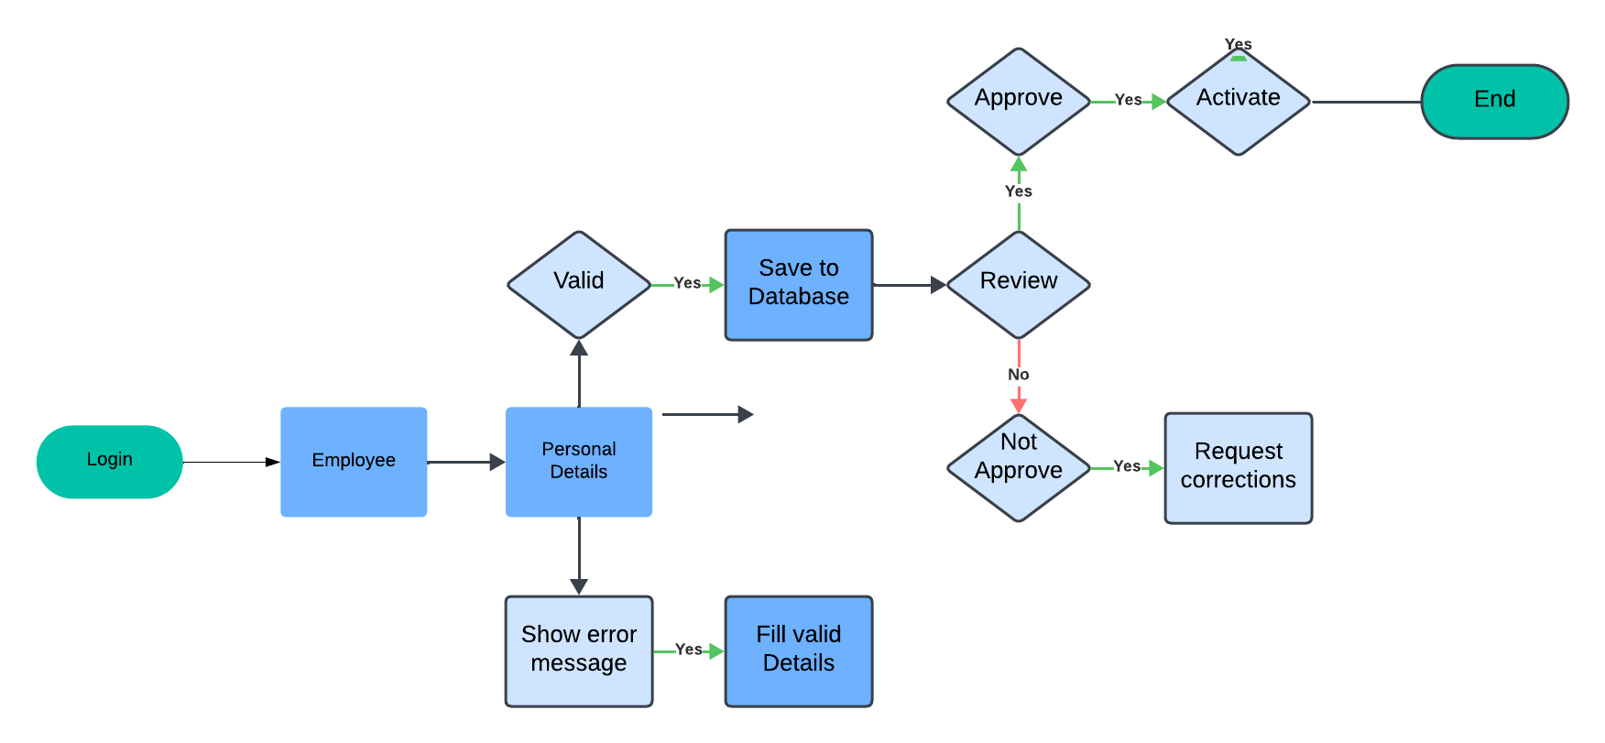

**2.Automated Document Submission & Verification**

**Description:**

This functionality enables employees to upload, e-sign, and verify onboarding documents.

**Assumptions:**

* Employees should have access to an e-signature tool.
* HR uploads all required documents before sending them to employees.

**Dependencies:**

* Document management system.
* Secure cloud storage for document archiving.

**Preconditions:**

* HR must upload required document templates.
* Employee must have access to the document submission portal.

**Postconditions:**

* Employee has successfully uploaded and signed all required documents.
* HR receives notification of document completion.

**Acceptance Criteria:**

* Employees should be able to upload and sign documents digitally.
* The system should verify e-signatures before storing them.
* HR should be able to track document submission status.
* If any document is missing, the system should notify the employee.

**Priority:** High

**Process Flow Diagram**

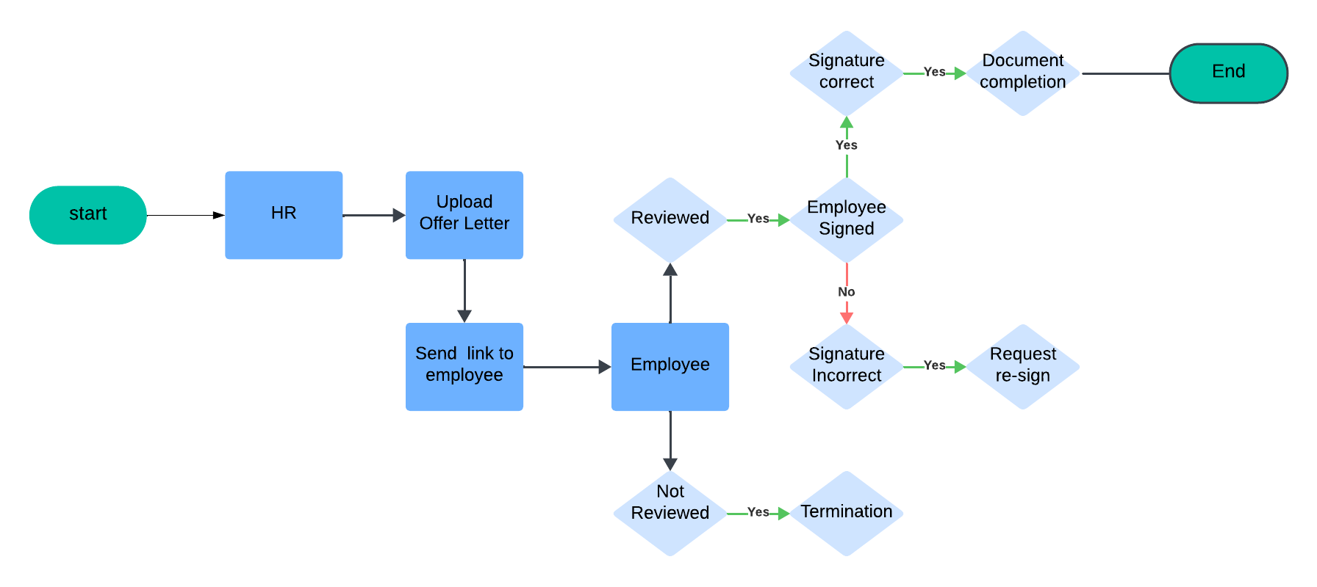

**3.Onboarding Task Assignment & Tracking**

**Description:**

HR can assign onboarding tasks with deadlines, and employees can track their progress.

**Assumptions:**

* Tasks are predefined and mapped to job roles.
* Employees have access to the onboarding portal.

**Dependencies:**

* Employee profile creation.
* IT setup process for access provisioning.

**Preconditions:**

* HR assigns onboarding tasks to employees.
* The system must notify employees of assigned tasks.

**Postconditions:**

* Employees complete and mark tasks as done.
* HR verifies and approves task completion.

**Acceptance Criteria:**

* Employees should see assigned tasks with due dates.
* System should send reminders for incomplete tasks.
* HR should be able to monitor progress through a dashboard.
* If tasks are overdue, the system should escalate notifications**.**

**Priority:** Medium

**Process Flow Diagram**

**4. IT Setup & Access Provisioning**

**Description:**

IT ensures new employees receive system access, email credentials, and workstation setup.

**Assumptions:**

* IT team must have a list of required accesses based on job roles.
* System-generated requests should trigger IT setup workflows.

**Dependencies:**

* Employee profile must be created.
* IT support system for managing access requests.

**Preconditions:**

* System sends an IT setup request once an employee is onboarded.
* IT team receives the task and initiates access provisioning.

**Postconditions:**

* Employee receives login credentials and software access.
* System updates onboarding status as IT setup is completed.

**Acceptance Criteria:**

* IT should receive automatic notifications for new onboarding requests.
* Employees should get access to necessary tools and systems.
* System should confirm and log successful IT setup completion.
* If access is denied or delayed, HR should receive an alert.

**Priority:** High

**Process Flow Diagram**

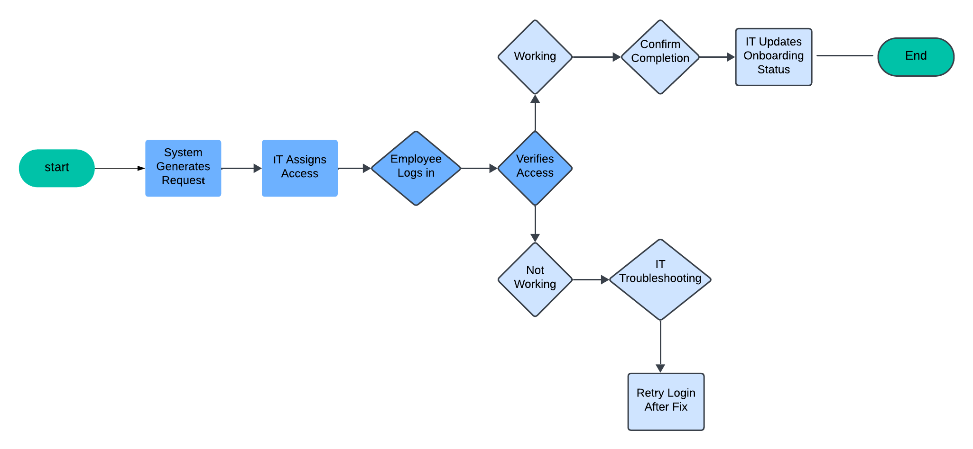

**5. Training & Compliance Tracking**

**Description:**

Employees must complete mandatory training as part of the onboarding process.

**Assumptions:**

* Training modules are available in the system.
* Employees must complete training within a defined timeframe.

**Dependencies:**

* Learning management system (LMS).
* Compliance reporting system.

**Preconditions:**

* Employee must be assigned required training based on their job role.
* Training modules must be available and accessible.

**Postconditions:**

* Employee completes training and passes the quiz (if applicable).
* System updates compliance records and sends reports to HR.

**Acceptance Criteria:**

* **Employees should be able to access and complete training modules.**
* **System should track progress and notify HR upon completion.**
* **Quiz scores (if required) should be recorded in the system.**
* **If training is incomplete, system should send automated reminders.**

**Priority:** Medium

**Process Flow Diagram**

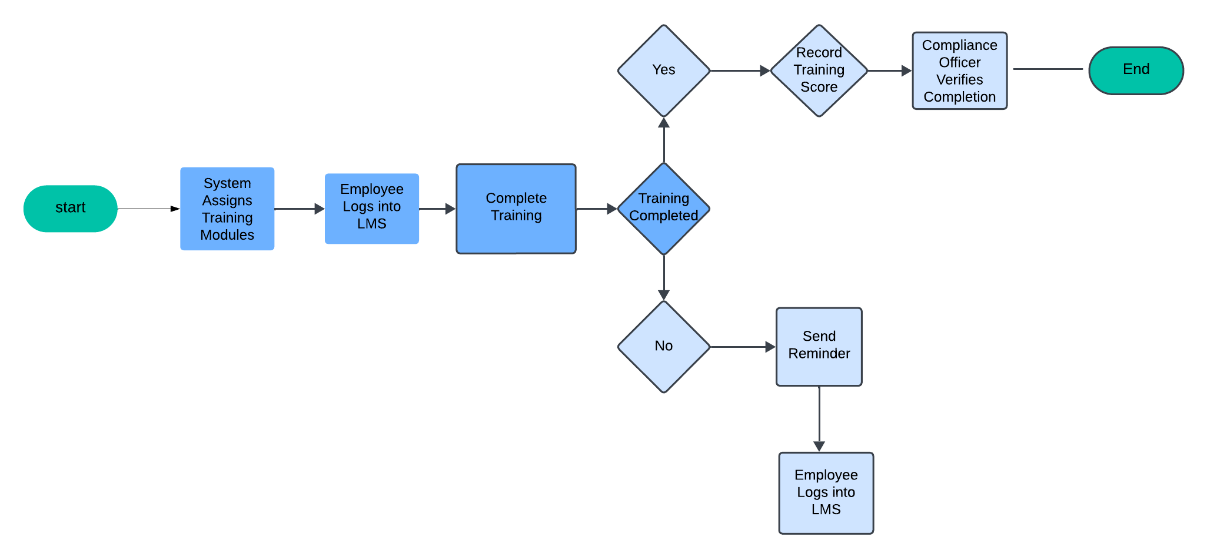

**6. Report Generation for HR**

**Description:**

HR should be able to generate onboarding progress and compliance reports.

**Assumptions:**

* Reports should be available in multiple formats (PDF, Excel).
* System should support filtering based on different criteria.

**Dependencies:**

* Data from employee profiles, document submission, and training modules.
* Reporting module with dashboard capabilities.

**Preconditions:**

* HR selects required filters (e.g., completed vs. pending tasks).
* System fetches real-time data from the onboarding database.

**Postconditions:**

* Reports are generated and available for download.
* HR can review onboarding trends and take necessary actions.

**Acceptance Criteria:**

* Reports should be generated accurately with up-to-date data.
* System should allow HR to export reports in different formats.
* HR should be able to track overall onboarding efficiency.
* If data is missing, system should prompt for corrections.

**Priority:** Medium

**Process Flow Diagram**

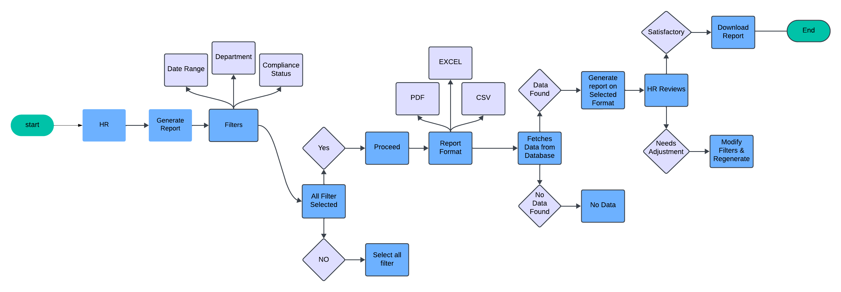

**4.2 Non – Functional Requirements**

**Performance**

The system should generate HR reports within seconds, ensuring smooth operation without delays. Optimized queries and caching will enhance efficiency during peak usage.

**Usability**

A user-friendly interface should allow HR teams to generate reports effortlessly. Input fields must be flexible, with clear error messages for better user experience.

**Security**

Sensitive HR data must be encrypted both in transit and at rest. Role-based access controls, multi-factor authentication, and audit logs will ensure data security.

**Scalability**

The system must support increasing users and data without performance issues. A scalable architecture ensures smooth operation as business needs grow.

**Compliance**

The system must follow legal standards like GDPR and HIPAA to protect employee data. Audit logs should track report access for transparency and accountability.

**Interoperability**

Seamless integration with payroll, attendance, and analytics tools is essential. Reports must be exportable in multiple formats (PDF, Excel, CSV) for flexibility.

**5. Assumptions and Constraints   
Assumptions**

* **Resource Availability:** It is assumed that HR personnel, IT support, and necessary software tools will be available throughout the onboarding process.
* **Stakeholder Engagement:** Managers and HR teams will actively participate in reviewing and approving new employee documentation on time.
* **System Accessibility:** It is assumed that employees will have access to the required devices and internet connectivity to complete their onboarding process smoothly.

**Constraints**

* **Budget**: The onboarding system must be developed and implemented within the allocated budget.
* **Time**: The system must be fully operational within a fixed timeline to align with recruitment cycles.
* **Technology**: The platform must integrate with existing HR management software and IT infrastructure.
* **Compliance**: The system must adhere to labor laws, data privacy regulations, and company policies for employee records.
* **Scope**: The system will cover onboarding processes such as document submission, training schedules, and role assignments without exceeding defined functionalities.

**6. Glossary for Employee Onboarding System**

* **Employee Onboarding**: The structured process of integrating new employees into an organization.
* **HR Management System (HRMS)**: A software platform used to manage employee records, payroll, and benefits.
* **Stakeholder**: Any individual or department involved in the onboarding process, such as HR, IT, or department managers.
* **Compliance**: Adherence to legal and organizational policies regarding employee data and labor regulations.
* **User Experience (UX)**: The overall experience of employees interacting with the onboarding system.
* **Workflow Automation**: The use of technology to streamline onboarding steps like document verification and approvals.

# **7. Approval**

**7.1 Sign-Off**

**Krishnan  
Business owner**