**BUSINESS REQUIREMENT DOCUMENT**

**Smart Campus Hiring Automation System**

Table of Contents

**Document Control** 2

**1.Executive Summary** 3

**2. Business Objectives & Problem Statement** 3

**2.2 Business Objectives** 3

**3. Project Scope** 4

**3.1 In-Scope** 4

**3.2 Out-of-Scope** 4

**4. Stakeholder Identification** 5

**5. Assumptions & Constraints** 5

**5.1 Assumptions** 5

**5.2 Constraints** 6

**6. Business Requirements** 6

**7. Requirements** 7

**7.1 Functional Requirements** 7

**7.2 Non-Functional Requirements** 8

**8. User Roles & Access Rights** 9

**8.1 Student** 9

**8.2 Placement Officer (TPO)** 9

**8.3 Company HR** 9

**8.4 System Administrator** 9

**8.5 Technical / Support Team (Internal)** 10

**9. Process Flow Diagram** 10

**9.1 Student Registration & Job Application** 10

**9.2 TPO – Job Posting & Interview Scheduling** 10

**9.3 Company HR – Job Posting to Offer Upload** 11

**10.1 Student Registration Page** 11

**10.2 Training & Placement Officer Dashboard** 12

**10.3 Company HR – Job Posting Form** 12

**11. Glossary of Terms** 13

**12. Approval & sign-off** 13

# **Document Control**

|  |  |
| --- | --- |
| **Field** | **Details** |
| Document Title | Business Requirement Document (BRD) |
| Project Name | Smart Campus Hiring Automation system |
| Prepared By | Jayasuriya J |
| Date Created | 27-06-2025 |
| Version | 1.0 |
| Last Updated | - |
| Status |  |
| Approved By | N/A |

# **1.Executive Summary**

The Smart Campus Hiring Automation System is a digital platform designed to manage the entire campus placement process more efficiently. Today, many colleges still handle placements using spreadsheets, phone calls, and emails which leads to delays, confusion, and mistakes.

This system helps centralize all activities related to student hiring, such as student registration, resume submission, eligibility checks based on company criteria, scheduling interviews, and tracking offer letters. The platform allows different users like placement officers, students, and company representatives to log in and manage their specific tasks.

With features like dashboards, notifications, and automated filtering, this tool will reduce manual effort, improve accuracy, and provide real-time updates. Overall, the system aims to make campus recruitment more organized, faster, and easier for everyone involved.

# **2. Business Objectives & Problem Statement**

This section highlights the key challenges faced in the current campus hiring process and outlines the primary business goals of implementing the Smart Campus Hiring Automation System. It explains why the project is needed and what it aims to achieve.  
 **2.1 Problem Statement**

Most colleges manage their campus placement activities manually using spreadsheets, email threads, and phone calls. This often leads to delays in communication, missed opportunities, and difficulties in tracking the progress of student applications.

Placement officers spend a lot of time performing repetitive tasks like checking student eligibility, following up for resumes, or scheduling interviews. There is also no centralized system for companies to post job details or track which students are applying. This lack of automation and visibility reduces the efficiency and success of the placement process.

## **2.2 Business Objectives**

* To digitize and centralize the campus placement process across all users (students, TPOs, and companies)
* To enable automatic eligibility filtering based on company-defined criteria (CGPA, department, etc.)
* To allow companies to post job openings and schedule interviews within the portal
* To improve communication through automated notifications and dashboards
* To reduce manual workload for placement officers and improve the student experience
* To create a transparent and trackable recruitment process for all stakeholders.

# **3. Project Scope**

This section defines the boundaries of the Smart Campus Hiring Automation System. It clarifies what features and functionalities are included in the current project delivery, and what elements are outside the scope at this stage. Clearly defining the scope helps align stakeholder expectations and avoid future misunderstandings.

## **3.1 In-Scope**

The following functionalities are included in the scope of this project:

* Student registration and resume upload
* Eligibility filtering based on company criteria (CGPA, department, backlog history)
* Company portal for job posting and interview scheduling
* Role-based access for students, placement officers, and companies
* Dashboards showing application progress and offer statuses
* Automated notifications via email and SMS
* Offer letter upload and acceptance tracking
* Admin panel for system management and reporting

## **3.2 Out-of-Scope**

The following features are not part of the current phase of the project:

* Mobile app version of the platform
* AI-based resume scoring or automated video interviews
* Integration with third-party job platforms like LinkedIn or Naukri
* Real-time chat support or grievance management system
* Resume creation/editing assistance tools
* Data integration with external ERP or payroll systems.

# **4. Stakeholder Identification**

The success of the Smart Campus Hiring Automation System depends on the involvement of key stakeholders who interact with the system or contribute to its development. Below are the identified stakeholders and their roles in the project:

* **College Management & Principal** – Oversees the implementation and ensures alignment with the college’s vision. Approves the final system usage and any policy changes needed.
* **Training & Placement Officer (TPO)** – The primary system user within the college. Responsible for managing student placement activities, updating job listings, reviewing applications, and communicating with recruiters.
* **Students** – End-users of the system. They register, upload resumes, check eligibility for job roles, and track their application/interview status.
* **Company HR & Recruiters** – External stakeholders who post job openings, define eligibility criteria, schedule interviews, and upload final hiring decisions or offer letters.
* **College Administration & System Admin** – Handles access permissions, student onboarding, and general oversight of system users and workflows.
* **Business Analyst** – Responsible for gathering requirements from stakeholders, documenting them (BRD, FRD), and acting as a bridge between technical and business teams.
* **IT Support Team** – Ensures that the system remains technically functional after deployment and addresses any post-launch support or bug issues.
* **Development Team** – Works closely with the BA and TPO to convert documented requirements into working system features and functionalities.

# **5. Assumptions & Constraints**

This section outlines the assumptions considered during the planning and requirement gathering phase of the Smart Campus Hiring Automation System, as well as the known constraints that may impact the development, deployment, or performance of the system.

## **5.1 Assumptions**

These are the conditions assumed to be true for successful project execution:

* All colleges implementing the system have stable internet connectivity.
* Students, companies, and TPOs will have access to basic computing devices (laptops, desktops, smartphones).
* Placement data like student CGPA, backlog history, and resumes are already maintained in digital format or can be uploaded easily.
* Company representatives will be willing to use the portal for job posting and tracking candidates.
* Admin users will be available to monitor system usage and respond to queries or technical issues.

## **5.2 Constraints**

These are limitations or restrictions that may affect project scope or timelines:

* The initial version is web-based only; mobile app support is out of scope.
* Budget constraints may limit integration with external platforms or third-party APIs.
* The project will follow a tight academic calendar — it must be delivered before the next placement season begins.
* Support for multiple languages or regional customizations is not included in the first release.
* Access to company-side data (like hiring status or interview notes) may be restricted based on their internal policies.

# **6. Business Requirements**

This section outlines the key business requirements for the Smart Campus Hiring Automation System. These requirements represent what the stakeholders expect the system to deliver to support and streamline the campus placement process.

1. The system shall allow students to register, upload resumes, and update academic profiles for placement eligibility.
2. The system shall provide the Training & Placement Officer (TPO) with tools to filter eligible students based on company-specific criteria such as CGPA, department, and backlog status.
3. The system shall allow company HR representatives to post job opportunities, set eligibility filters, and schedule interviews.
4. The system shall enable students to view available company listings and apply for suitable positions.
5. The system shall support interview slot booking and automatic updates to student dashboards.
6. The system shall provide a centralized dashboard for TPOs to track student application progress, shortlisted candidates, interview statuses, and offer letters.
7. The system shall send real-time notifications to students and TPOs for updates related to applications, interviews, or offers.
8. The system shall restrict access based on user roles (Student, TPO, Company HR, Admin).

# **7. Requirements**

This section outlines both the functional and non-functional requirements of the Smart Campus Hiring Automation System. The functional requirements define the key features and interactions of the system, while the non-functional requirements specify the expected performance, reliability, and usability standards.

## **7.1 Functional Requirements**

**7.1.1 Student Registration & Profile Management**The system shall allow students to register using their college email and complete their profiles by entering personal details, academic records, department, CGPA, and uploading their resume.

**7.1.2 Eligibility Filtering Based on Company Criteria**  
The system shall automatically filter eligible students based on parameters defined by each company (such as minimum CGPA, department, no active backlogs, etc.).

**7.1.3 Job Posting by Company HR**  
Company HR representatives shall be able to post job openings, upload job descriptions, set eligibility criteria, and specify deadlines.

**7.1.4 Job Application by Students**  
Eligible students shall be able to apply for open job positions from their dashboard. The system shall prevent applications from students who do not meet the criteria.

**7.1.5 Interview Scheduling and Slot Booking**  
TPO or company HR shall be able to create interview schedules, and eligible students shall be able to select available slots on a first-come-first-served basis.

**7.1.6 Shortlisting Tracker for TPO**  
The system shall allow the TPO to track the list of students applied, shortlisted, and interviewed for each company in real time.

**7.1.7 Offer Letter Upload and Notification**  
Company HR shall be able to upload offer letters for selected candidates, which will be visible in the student’s dashboard with notification alerts.

**7.1.8 Role-Based Access Control**  
The system shall enforce user access based on roles (Student, TPO, Company HR, Admin), and restrict features based on access permissions.

**7.1.9 Real-Time Notification System**  
The system shall send alerts to users (via email or platform notification) when:

* A job is posted
* Shortlists are announced
* Interview slots open
* Offer letters are uploaded

## **7.2 Non-Functional Requirements**

**7.2.1 Performance & Speed**  
The system should respond to user actions (e.g., page loads, dashboard access) within 3 seconds under normal load conditions.

**7.2.2 Availability**  
The system shall maintain 99.9% uptime during peak placement periods to ensure continuous access for all users.

**7.2.3 Scalability**  
The platform shall support up to 1,000 concurrent users without performance degradation, especially during mass activities like job postings and interview slot bookings.

**7.2.4 Security & Data Protection**  
All user data shall be securely stored and transmitted using encryption protocols (e.g., HTTPS, SSL). Sensitive documents such as resumes and offer letters must not be accessible to unauthorized users.

**7.2.5 Usability & Accessibility**  
The user interface shall be intuitive and accessible across devices (desktop, tablet, mobile). Basic operations should require minimal training for students and TPOs.

**7.2.6 Backup & Recovery**  
The system shall automatically perform daily data backups and provide a mechanism for quick data recovery in case of system failures.

**7.2.7 Browser Compatibility**  
The system should work smoothly on all major modern browsers including Chrome, Firefox, Edge, and Safari.

# **8. User Roles & Access Rights**

In the Smart Campus Hiring Automation System, multiple users will access the platform, each with different roles and responsibilities. To maintain clarity and security, the system must allow only authorized users to perform specific actions based on their role.

## **8.1 Student**

* Can register and log in to the portal
* Can fill or edit profile and academic details
* Can view eligible job openings
* Can apply for jobs based on eligibility
* Can track application status and offer letter status

## **8.2 Placement Officer (TPO)**

* Can review and approve student profiles
* Can upload job openings received from companies
* Can assign eligible students to companies based on criteria
* Can view and manage interview schedules
* Can track offer letter status

## **8.3 Company HR**

* Can register and log in to company dashboard
* Can post job openings with eligibility criteria
* Can view list of shortlisted/eligible students
* Can update interview schedules
* Can upload final selected candidates and offer letters

## **8.4 System Administrator**

* Can manage user accounts and permissions
* Can reset passwords and resolve system-level issues
* Can monitor usage and system logs
* Has full access to manage platform settings

## **8.5 Technical / Support Team (Internal)**

* Can access limited backend for bug fixes
* Can monitor logs and performance metrics
* Cannot access personal student or HR data

# **9. Process Flow Diagram**

## **9.1 Student Registration & Job Application**

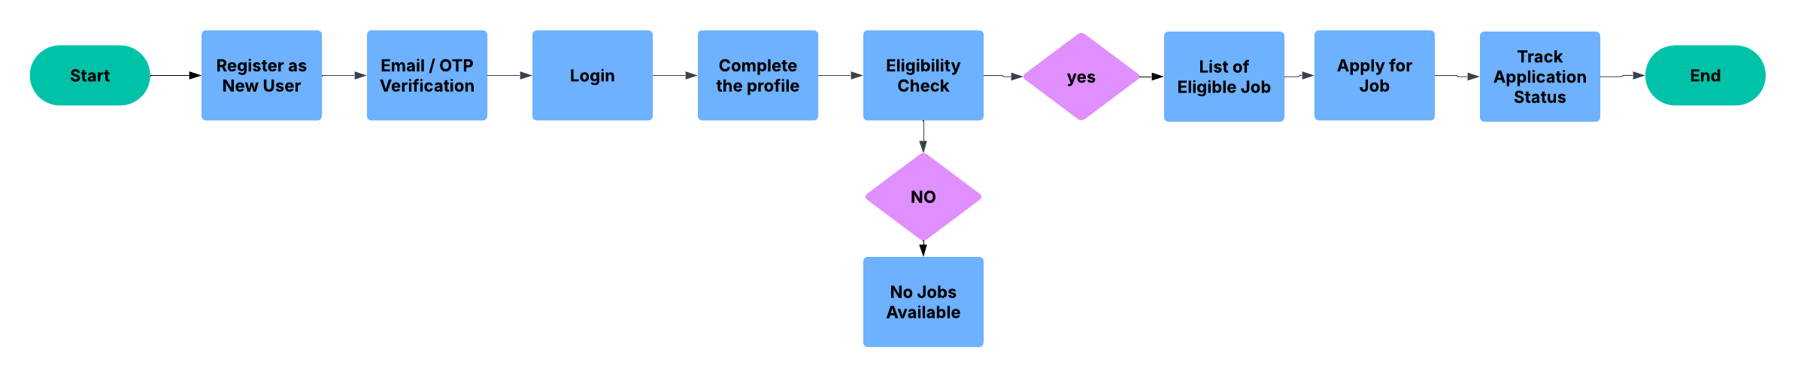

## **9.2 TPO – Job Posting & Interview Scheduling**

## **9.3 Company HR – Job Posting to Offer Upload**

**10. Wireframes**

Wireframes are visual blueprints that provide a clear picture of how the system’s user interface will look and function. They help bridge the gap between business requirements and technical implementation by illustrating key screens in a simplified, structured format. These early sketches are useful for stakeholders to validate the flow of the system before actual development begins. The following wireframes represent important pages for different user roles within the Smart Campus Hiring Automation System and are designed to ensure intuitive user experience, easy navigation, and clarity of actions.

## **10.1 Student Registration Page**

The Student Registration Page allows new users (students) to register for the platform by filling out their basic details. This is the first step for any student wishing to participate in campus placements. The form includes fields like First Name, Last Name, Email, Phone Number, Password, Gender, and Confirm Password. It ensures that every student provides complete information for verification and eligibility checking.

The form design is clean, minimal, and user-friendly, with clear labels and validation messages to assist students during registration.

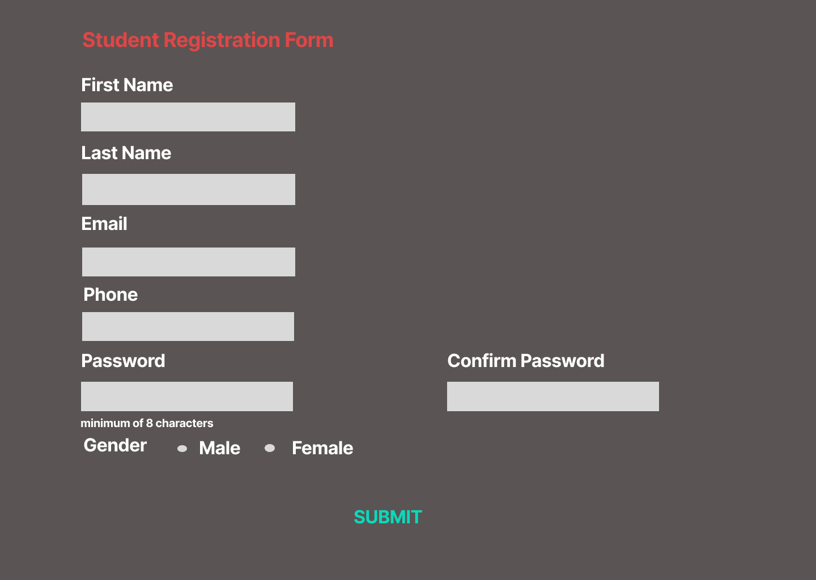

## **10.2 Training & Placement Officer Dashboard**

This wireframe shows the TPO dashboard with job posting form and job listing table. The form captures job details like title, eligibility, deadline, and package. The table helps track posted jobs with applicant count and status.

## **10.3 Company HR – Job Posting Form**

This wireframe represents a job posting form used by company HRs to submit job details. It captures essential fields such as company name, job title, location, package, and application deadline. The layout ensures a user-friendly experience for quick data entry.

# **11. Glossary of Terms**

|  |  |
| --- | --- |
| **Term** | **Definition** |
| TPO | Training and Placement Officer – responsible for managing campus placements. |
| JD (Job Description) | A document outlining job roles, responsibilities, qualifications, and package. |
| Eligibility Criteria | Conditions that students must meet to apply for a job (e.g., CGPA, Department). |
| Dashboard | A centralized screen showing navigation and data for a particular user role. |
| Applicant | A student who has applied for a job through the placement portal. |
| Placement Portal | The online system used to manage campus hiring processes. |
| CGPA | Cumulative Grade Point Average – academic performance measure. |
| Job Posting | Process of uploading a new job opportunity on the portal by TPO or HR. |
| Wireframe | A low-fidelity layout that outlines structure and elements of a screen/page. |
| User Interface (UI) | The design and layout users interact with on the placement platform. |

# **12. Approval & sign-off**

|  |  |  |  |  |  |
| --- | --- | --- | --- | --- | --- |
| **Name** | **Designation** | **Department** | |  | | --- | |  |   **Signature** | **Date** |
| Mr. R. Karthik | Company Director | Executive Office |  |  |
| Ms. Divya Sharma | Training & Placement Officer | Placement Cell |  |  |
| Mr. Ankit Roy | IT Manager | IT Department |  |  |