LAB 3

Write a program using any Object-oriented programming language to show the implementation of RSA. The input p and q should be generated by randomly (15 Marks)

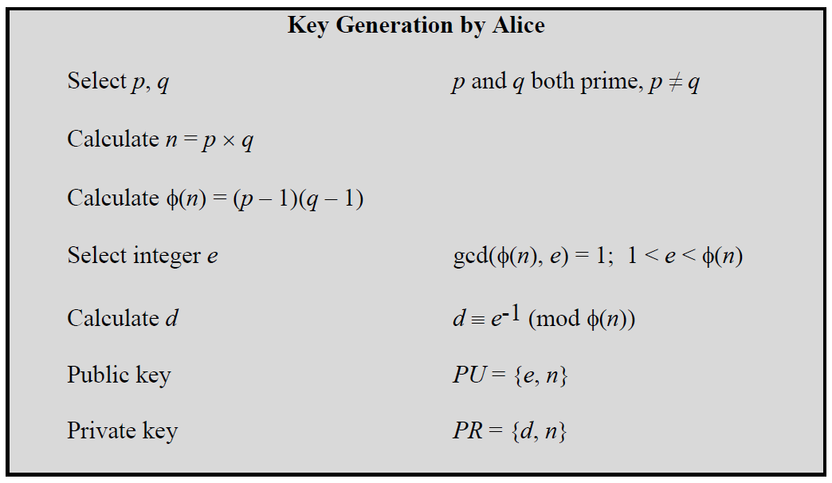

To encrypt a message, M, with the public key, create the ciphertext, C, using the equation: C = Me mod n

The receiver then decrypts the ciphertext with the private key using the equation: M = Cd mod n

**Evaluation Criteria**

1. Correctness of code
2. Random number Generation of p, q
3. Generation of multiple pairs of PU ( e,n) and PR Keys (d,n)
4. Encryption and Decryption of input message
5. A lab report showing your code , sample outputs and code explanation

**Lab Report: Implementation of RSA Encryption and Decryption in Python**

**Objective**

The objective of this lab is to implement the RSA encryption and decryption algorithm in Python. The program will generate random prime numbers, create public and private keys, and allow the user to encrypt and decrypt a message.

## Introduction

RSA (Rivest-Shamir-Adleman) is a public-key cryptosystem that is widely used for secure data transmission. In RSA, a pair of keys is generated: a public key, which is used for encryption, and a private key, which is used for decryption.

**Main Program**

**import random**

**import math**

**def is_prime(n):**

**if n < 2:**

**return False**

**for i in range(2, int(math.sqrt(n)) + 1):**

**if n % i == 0:**

**return False**

**return True**

**def generate_prime(min_val, max_val):**

**prime = random.randint(min_val, max_val)**

**while not is_prime(prime):**

**prime = random.randint(min_val, max_val)**

**return prime**

**def egcd(a, b):**

**if a == 0:**

**return (b, 0, 1)**

**else:**

**g, y, x = egcd(b % a, a)**

**return (g, x - (b // a) * y, y)**

**def mod_inverse(e, phi):**

**g, x, y = egcd(e, phi)**

**if g != 1:**

**raise Exception('Modular inverse does not exist')**

**else:**

**return x % phi**

**def generate_keypair():**

**# Generate p and q**

**p = generate_prime(10, 50)**

**q = generate_prime(10, 50)**

**while p == q:**

**q = generate_prime(10, 50)**

**n = p * q**

**phi = (p - 1) * (q - 1)**

**# Choose e**

**e = random.randint(2, phi - 1)**

**while math.gcd(e, phi) != 1:**

**e = random.randint(2, phi - 1)**

**# Compute d**

**d = mod_inverse(e, phi)**

**return ((e, n), (d, n))**

**def generate_multiple_keypairs(num_pairs):**

**keypairs = []**

**for _ in range(num_pairs):**

**keypairs.append(generate_keypair())**

**return keypairs**

**def encrypt(pk, plaintext):**

**e, n = pk**

**cipher = [(ord(char) ** e) % n for char in plaintext]**

**return cipher**

**def decrypt(pk, ciphertext):**

**d, n = pk**

**plain = [chr((char ** d) % n) for char in ciphertext]**

**return ''.join(plain)**

**# Generate multiple keypairs**

**num_pairs = 3**

**keypairs = generate_multiple_keypairs(num_pairs)**

**# Print the generated keypairs**

**for i, (public_key, private_key) in enumerate(keypairs, 1):**

**print(f"Keypair {i}:")**

**print(f"Public Key (e, n): {public_key}")**

**print(f"Private Key (d, n): {private_key}")**

**print()**

**# Get user input message for encryption and decryption**

**message = input("Enter a message to encrypt and decrypt: ")**

**print(f"Original message: {message}")**

**# Using the first key pair for encryption and decryption**

**public_key, private_key = keypairs[0]**

**encrypted_message = encrypt(public_key, message)**

**print(f"Encrypted message: {encrypted_message}")**

**decrypted_message = decrypt(private_key, encrypted_message)**

**print(f"Decrypted message: {decrypted_message}")**

**Code Explanation**

Prime Number Generation

The first step in RSA is to generate two large prime numbers. For simplicity and ease of testing, I have generate small prime numbers in the range of 10 to 50.

is_prime(n): This function checks if a number n is a prime number by testing divisibility from 2 to the square root of n.

generate_prime(min_val, max_val): This function generates a random prime number within the specified range by repeatedly generating random numbers and checking for primality.

### Extended Euclidean Algorithm

The Extended Euclidean Algorithm is used to find the modular inverse, which is crucial for calculating the private key.

egcd(a, b): This function implements the Extended Euclidean Algorithm to find the greatest common divisor (gcd) of a and b, along with the coefficients x and y such that ax + by = gcd(a, b).

### Modular Inverse

The modular inverse is used to compute the private key d from e and phi.

mod_inverse(e, phi): This function uses the Extended Euclidean Algorithm to find the modular inverse of e modulo phi. If the gcd is not 1, it raises an exception, indicating that the modular inverse does not exist.

Key Pair Generation

generate_keypair(): This function generates two distinct prime numbers p and q, computes n = p * q and phi = (p - 1) * (q - 1). It then selects a public exponent e such that 1 < e < phi and gcd(e, phi) = 1, and computes the private key d as the modular inverse of e modulo phi.

Multiple Key Pair Generation

generate_multiple_keypairs(num_pairs): This function generates the specified number of RSA key pairs and returns them in a list.

Encryption and Decryption

encrypt(pk, plaintext): This function encrypts the plaintext message using the public key pk by raising each character's ASCII value to the power of e and taking modulo n.

decrypt(pk, ciphertext): This function decrypts the ciphertext using the private key pk by raising each encrypted value to the power of d and taking modulo n, converting the resulting values back to characters.

**SAMPLE OUTPUTS**

