**Airport Management System**

# Installation

# How to Run

# Functions

# Devolopers

# Installation:

To Install you just need to install the Requiremts.txt file with command

Pip install –r Requirements.txt

it will instal the library tkcalander other packges and database is builit

# How to Run:

To run you need to go to the cd src file

And then type this command in cmd or terminal which you are using

Python main.py

1. First you will not have a User so Add User on login Page

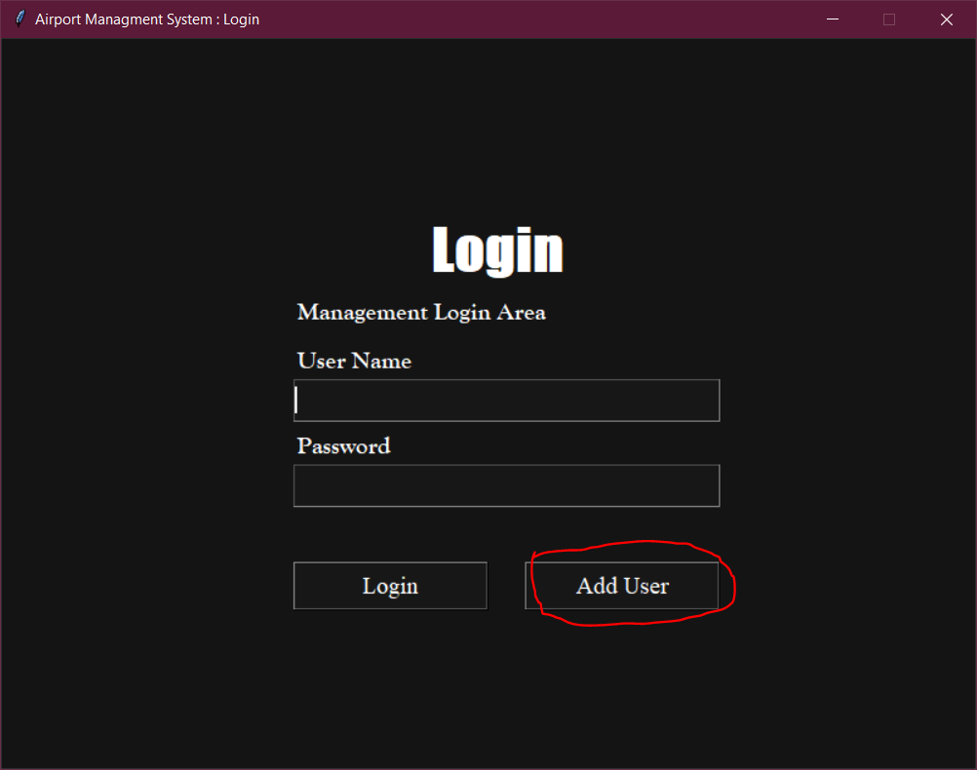

1. Window will appear enter information and submit

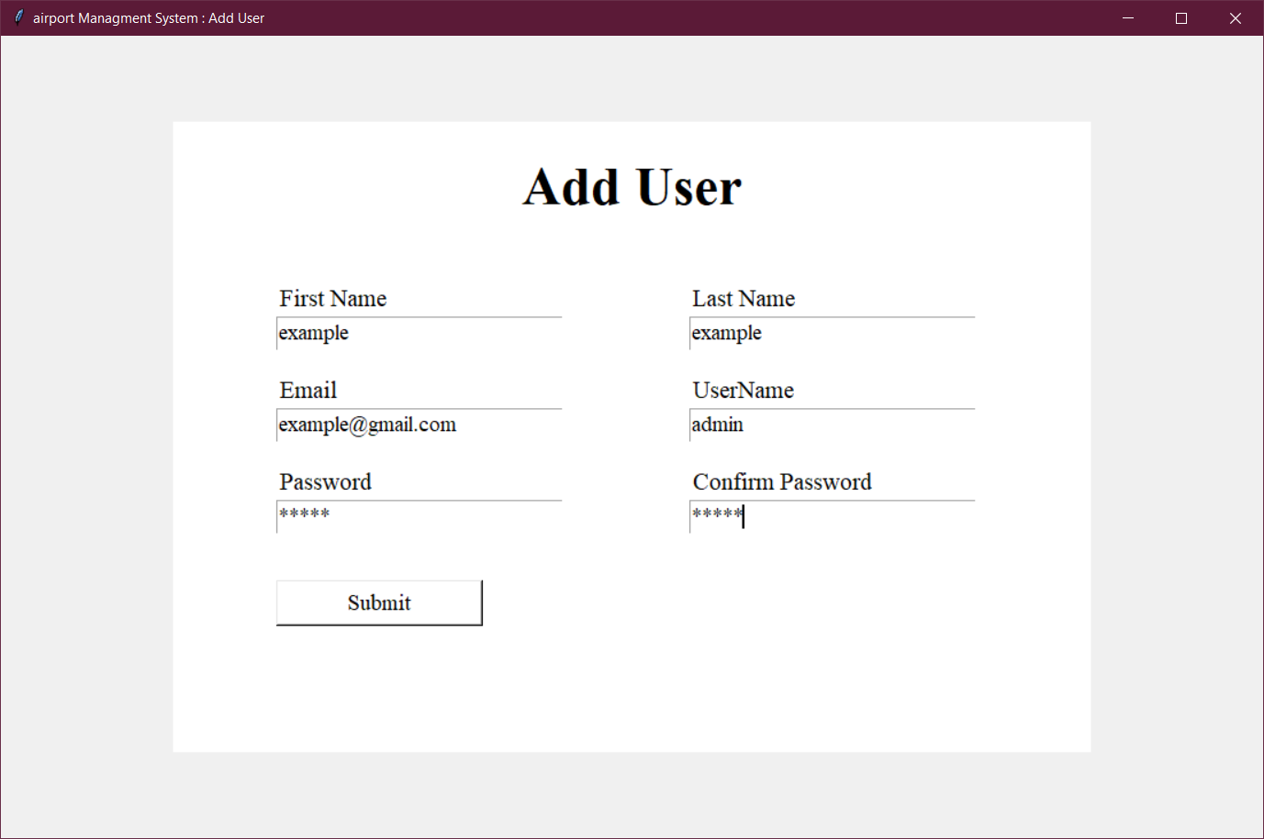

3)And it will take you to Main Home but will require a Google EMAIL and Password For Software to Send Mails to Passangers about the Reservation **You need to provide it only one time**

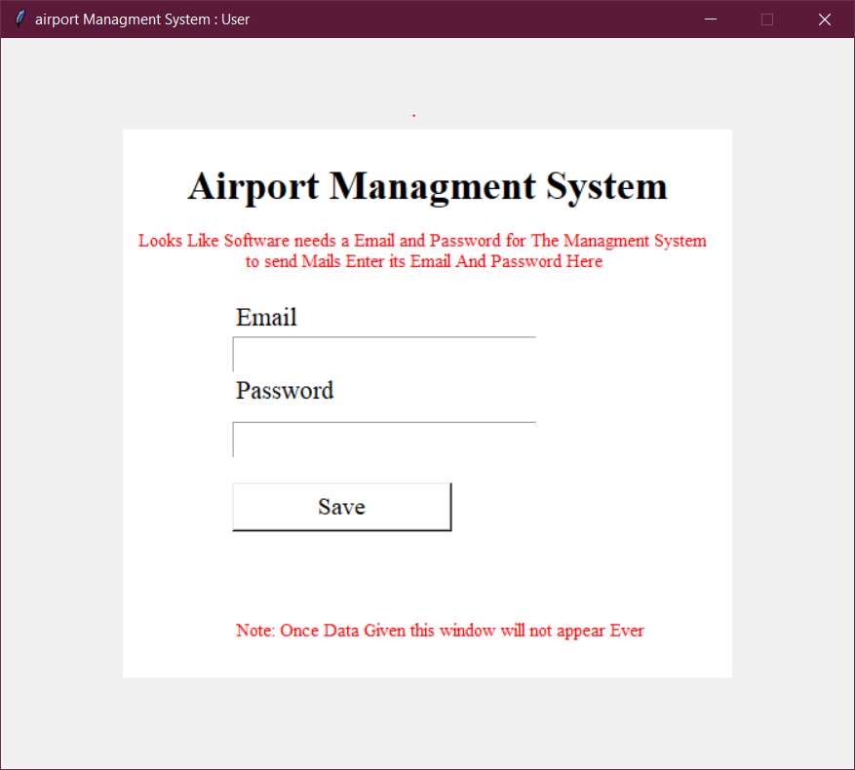

1. After that you are ready to go

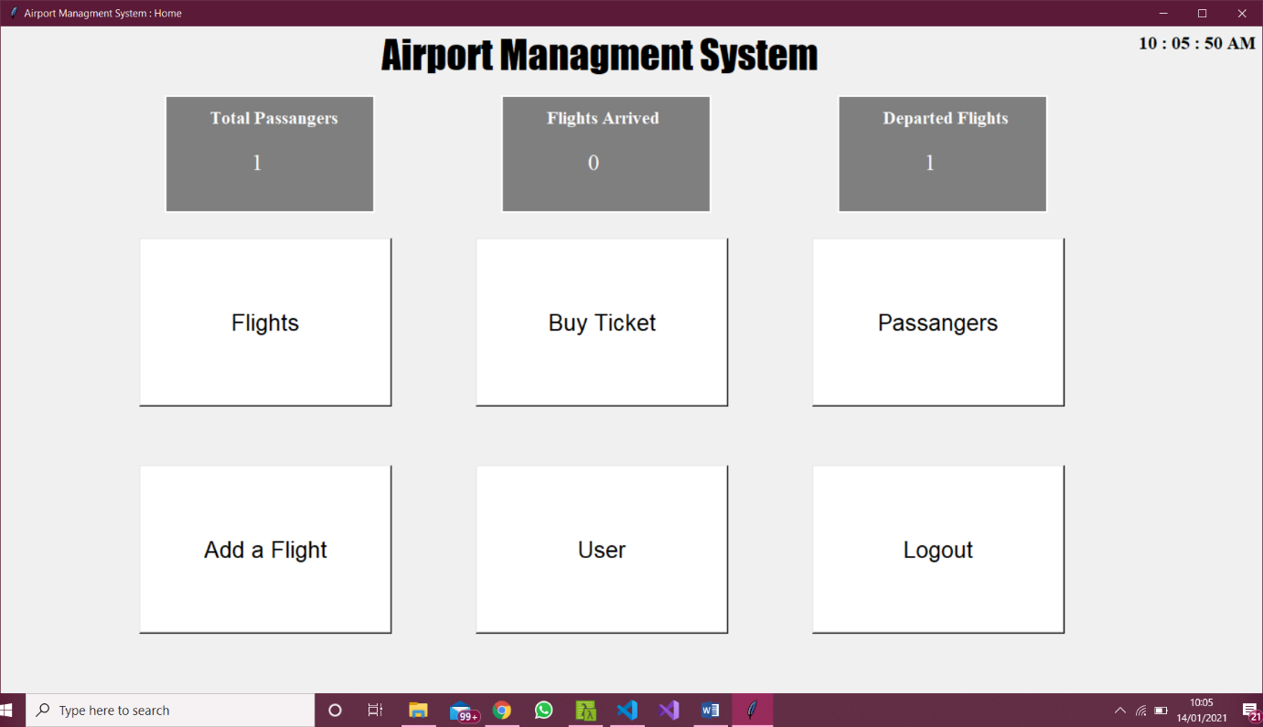

# Functions:

It will tell about all the functions you can perform with and how there code words

I will add abou them in Detail ( Hussnain ahmad)

# Devolopers:

### Backend and Database:

Hussnain Ahmad 10746

### GUI

Nasar Ali Khan 10545

Muhammad Tayab

Mubeen zia

### Github Repository to Download

https://github.com/CodeTerminator007/AirportManagmentSystemPythonSqlite3