LINKAVIE®/LINKASSOCES®/LINKABEEZ® technical specifications - CONFIDENTIAL
1 DOCUMENT PURPOSE
This document describes the functional and technical specifications for the development of the LINKAVIE®/LINKASSOCES®/LINKABEEZ® Web Service and as such is the reference document for the understanding, the pre-requisites and the features that have to be developed.
This document is attached to the Main contract as a reference.
Definitions:
• DESIGNER: The Designer is the resource responsible for the design, graphics, ergonomic, intuitivness of the website and related web applications
• DEVELOPPERS: The developpers, including project managers and code developpers are responsible for the complete site/service development, relying on the graphic deliveries coming from the Designer.

This document allows both the DESIGNER and DEVELOPPERS to have a global overview of the project and the deliveries expected each of them in their perimeter.

2 GENERAL PRESENTATION
2.1 Brands and Company
The CLIENT have 3 commercial brands to deliver its Internet services:
- LINKAVIE® for B2C market
- LINKASSOCES® for B2B organizations such as associations, sport clubs
- LINKABEEZ® for B2B Enterprise organizations

This will result in 3 different landing pages and related marketing messages, but the application itself will be the same for the 3 environments. Onlycolors and layouts will change to reflect the user connection to a personal environment, an Association environment or an Enterprise environment.
2.2 The concept
Manage and share your digital life: Write, Share and Transmit your Life story with 100% confidentiality
LINKAVIE® propose an Internet service allowing a user to store and secure multimedia and personal contents (Photos, videos, music’s, personal documents) of an entire life as well as the user numeric identities (login/passwords for different sites). Those Life contents are securely stored and organized within a numeric vault. Then, each LINKAVIE® user can create and manage his personal DIGITAL ALBUM or several thematic albums based on pictures, videos (also musics) that can be shared with full confidentiality with Friends. LINKAVIE® offers many other services such as a family tree and a shared calendar/news. A LINKAVIE® user is also able to manage his transmission to his descendants, by writing a Transmission book that will be transmitted with its other multimedia contents to the “Descendant” users he/she will have defined.
LINKAVIE® offers the capability to manage events life albums (pre-event or post events) in a very smart collaborative way, which is unique on the Market, as described in chapter 6.5. This approach will be the Marketing and Business way to get users and B2B companies into LINKAVIE and subscribe to the service with a long term approach.
LINKAVIE® includes:
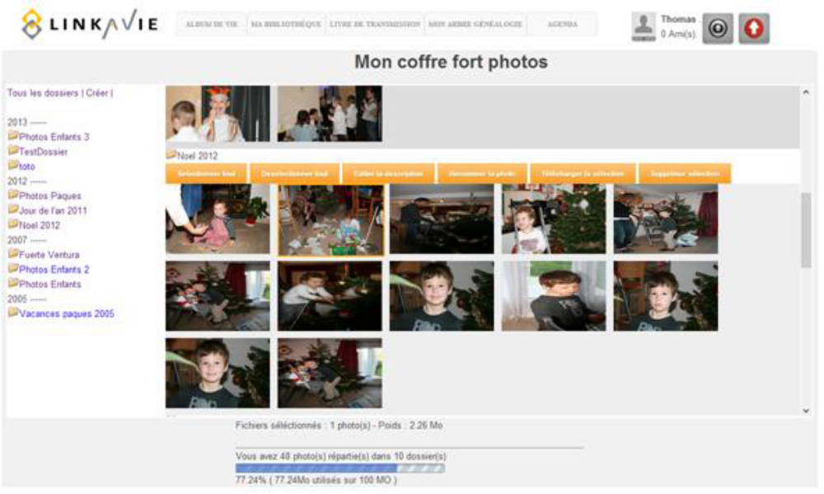
• A numeric vault of multimedia contents. The user Photos, videos, music and documents are stored, secured, organized and managed from the Site. The user interface should be simple and intuitive.
LINKAVIE®/LINKASSOCES®/LINKABEEZ® technical specifications - CONFIDENTIAL
• DIGITAL ALBUMs: Each user gets by default a personal DIGITAL ALBUM that is organized like a book with chapters and page titles, and with a summary for a rapid access to the pages. This DIGITAL ALBUM includes pages with pictures, videos, musics, text. But each user is also capable of creating different DIGITAL ALBUMs or thematic albums that can be linked or not to its personal default DIGITAL ALBUM.

Each page/chapter of an album can be shared, exchanged via Internet within a family or within a limited circle of friends, with strong confidentiality.
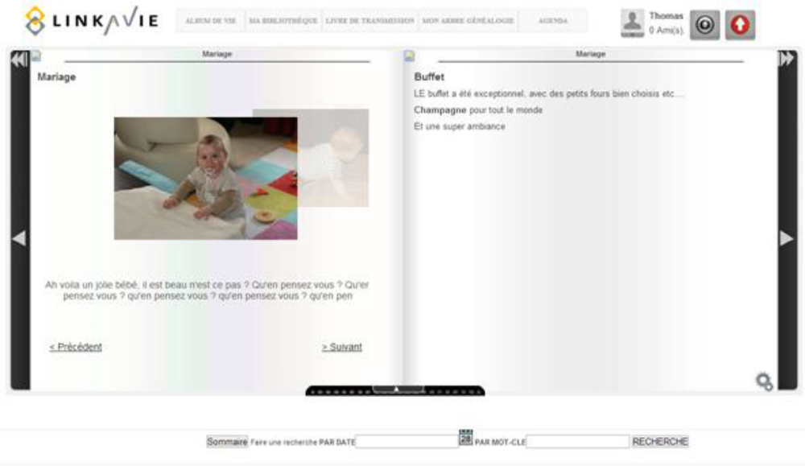
• A Library: The user Library includes its different albums. Also at any time, a user can automatically generate a printable PhotoBook in few clicks from one of his albums. Those printable Albums are stored in the personal user Library as well.
• Live content exchange can be performed in 1 click. The platform facilitates the exchange of Album pages and its multimedia contents by a simple mouse click between subscribers (people having an account and being friends), or punctually by giving access for download to vault files to subscribers or non subscribers.
• A family tree generated semi-automatically and that can be completed manually.
• An agenda to share each others agenda within a family, friends or a community with news.
• e-cards that can be sent to a friend for an event (birthday, Christmas etc...).
• A transmission book allows each subscriber to write down notes, messages, with multimedia contents and documents. All those contents remain secret to the owner, and can only be accessed by close friends, representatives or descendants once the subscriber's death is confirmed.
• Digital transmission. When a subscriber is dead, its LINKAVIE® account, with all its life contents and digital identities (mail account, facebook account etc..) can then be attached and linked to its descendants. Those can close its numeric accounts and can keep the souvenir of the parent to keep somehow his/her story alive.

Some offline mode features will be possible on mobile devices (Tablets, smart phones), providing the capability to users to store/synchronize localy on the devices some of the heavy contents (photos/videos etc..) so that an offline usage would be possible while others features would require online connection. This last capability will be described more into details in the chapter 8: Smartphone and Tablet versions, and should be available in version 1.
Any sensitive user Data such as digital identities, documents should be encrypted with strong encryption mechanisms (AES etc..). The site should be accessible in https.
The LINKAVIE® service is not ony a B2C Internet service, but is also aimed for the B2B organizations such as associations, enterprises, sport clubs etc. willing to federate a group, a community in order to share with a high level of confidentiality and respect of people all the key moments of the organization life.
2.3 Target customers:
LINKAVIE® propose a unique service to adress 2 main targets:
Business To Consumer (B2C)
Ladies and men from 30-45 years old with children willing to exchange in a secure way their electronic life within a family or a restricted circle of friends....Also retired people that have time to take the leadership of the numeric communication of the family, to share the family album, agenda and more....Those people, that are fed-up with social networks tools that don't adress their main concern: Content confidentiality and respect of personal life
Business To Business (B2B):
Organizations (Associations, enterprises) that want to federate a group around the organization life, so that Enterprise could also be seen as some fun time to spend with colleagues that may become friends etc...
It is key to note the importance of developping LINKAVIE® for both targets as the B2B is source of B2C business.
2.4 How to get those customers in:
LINKAVIE® will market its offer with the following customers at first:
B2C
LINKAVIE will target main events such as important birthdays of a life (20, 30, 40, 50, 60 birthday events) but also, wedding, birth etc…to get people interested in doing a collaborative retrospective and make such a present to their friend. This service will be for free. In such case, those active users may become a subscriber (because they use the service for a friend, why not using it for themselves) and when transferring the account to their friend as a present for the event, their friend will be urged to become customer.
B2B
By approaching B2B companies managing big events for corporations, via partnerships, LINKAVIE will bring LINKAVIE event management service into large enterprise, and each single employee may then become a customer for his own usage.
2.5 Geography
LINKAVIE®, based in France, is willing to develop its concept first in France but rapidly in other countries. The development, as such, should be designed to support natively multi-languages. The site wording should be able to be edited in separate files and should not be hard coded. The Provider should provide an English version, with all required materials so that the Client can manage translation in different languages.
2.6 Remuneration
LINKAVIE® propose a service for free as a basis, allowing a user to test the solution without any commitment, then being able to upgrade to a paid service according to different packs of services. (See details of the commercial offering below).
The offering also adress B2B organization with a pricelist adapted to each case.
Additional revenues are expected thanks to the Album Auto-Printing service.
2.7 Commercial offer
The DESIGNER and DEVELOPPERS, each in its perimeter has to develop/design the site in such way to implement the following commercial offering. All the details and features are described in this document.
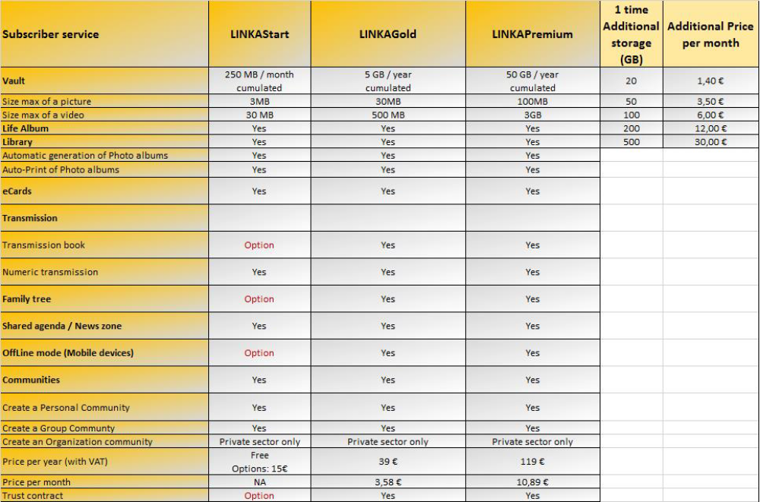
Important note: The user gets a yearly capacity of storage. If this capacity is not used during the year, the remaining capacity is not postponed for the next year (except for the unlimited offer of course).

Pricing will be reviewed on time depending of new costs structure and competition when the development will be at the final stages. In any case, pricing should be updatable from the Back-office. More details in the related section.
2.8 Marketing for viral recruitment
Viral recruitment in LINKAVIE® is quite native as a user or subscriber will share the service with friends, family etc...Each of those become potential subscribers.
Nevertheless, in order to encourage viral recruitment, some actions, linked to the features to develop, may be setup:
• Sponsorship that reward the most active subscribers
• Visibility and recruitment via Facebook
• A Blog which contents should be synchronized automatically to the LINKAVIE® Facebook fan page, twitter and News area of the site.

Sponsorship mechanisms will have to be implemented via the Back-office. Mechanisms to optimize the communication efficiency within social networks & blog will have to be implemented as well so that 1 information setup in one of those gets propagated to others.

2.9 Partner programs
To develop its activities, we will setup two kind of partner programs:
• OEM Partner programs that consist in puting a link, an ad with a product sold by the OEM, product having some consistency with the LINKAVIE® offer. OEM partners get rewarded with Back-margins. Therefore, it is important to be able to track LINKAVIE® sales with an OEM partner code. This will come as a feature at a later stage (Please refer to the Roadmap)
• Affiliates partners consist in allowing such partner to deliver the LINKAVIE® service to its customers, under its name (white label). This additional service is a way for such partner to differentiate from competition. This will come as a feature at a later stage (Please refer to the Roadmap)

3 DEFINITIONS AND ROLES
3.1 Definitions and roles descriptions
User/member: A user is a registered user using the service for free or with a subscription.
Subscriber: A Subscriber is a paid user.
Vault: The Vault is a physical storage space in the Datacenter where the customer (User or Subscriber) can store and organize his multimedia contents (Photos, videos, music, and personal documents). He is the only one that can get access to this area. A Community gets its own Vault; in this case the Vault can be shared and accessed by the community Members, depending of the community policy defined by the Community Manager.
DIGITAL ALBUM: The DIGITAL ALBUM is the core of the Site. IT is personnal to a User (Can be the default DIGITAL ALBUM or thematic albums) or common to the members of a Community. “Personal” means that the owner is the only one that can edit/update his DIGITAL ALBUM. Whereas for a Community, “Common” means that, according to the Community settings defined by the Community Manager, members of the community can view the Community DIGITAL ALBUM (or Community Album) and may be authorized to edit it. A DIGITAL ALBUM / Community Album is a numeric Album that is fed by its owner(s) with Multimedia content from the shared (for communities) or personnal Vault. The DIGITAL ALBUM can be shared with Friends.
Transmission Book: The Transmission Book is strictly personal. It contains text, multimedia contents that can only be accessed by the User as long as he/she is alive. IT becomes accessible by Close Friends, Representatives, and Descendants when the User is confirmed dead.
Representative: A Representative can be a User or not of LINKAVIE® service. This role is requested by the User that sends an email notification request to ask someone to become one of its Representatives for the LINKAVIE® service. A Representative can declare the death of the User he/she is linked to, on the Site. The Representative role is also able to confirm on the Site the User death (declared by another Representative) and then to access/View the DIGITAL ALBUM, the Library, the Transmission Book, and the Friendly Tree of the User, depending of the Access rights settings defined by the User when alive. In any case, a Representative only gets a READ ONLY access.
Close Friend: A Close Friend is a close person to the User that can be Subscriber or not of LINKAVIE®, to who the User give such « Close Friend » role. The Close Friend role is able to confirm on the Site the User death (declared by a Representative or descendnat) and then to access/View the DIGITAL ALBUM, the Library, the Transmission Book, and the Family Tree of the User, depending of the Access rights settings defined by the User when alive. In any case, a Representative only gets a READ ONLY access.
Descendant: A Descendant need to be a LINKAVIE® User (paid user or not). A Descendant gets the same role as a Representative but when the death of the User become confirmed, he/she/they are the ones to who the User account is transfered and directly linked to its personal LINKAVIE® account. The Descendant gets a READ ONLY access but is able to access all contents of the User. A Descendant has to be a LINKAVIE® User, since the beginning of the relationship setup. A Descendant will have to be a LINKAVIE® subscriber in order to maintain the dead user contents in High definition.
Friend: A Friend is a User invited by another one to share his DIGITAL ALBUM, with READ ONLY rights, as long as the relationship is maintained and according to the confidentiality settings defined by the inviting User per content. A Friend can (if allowed by the User) comment pages of the User DIGITAL ALBUM. Both Users become Friends ones to each other.
Community: A Community is a special LINKAVIE® account, created by a User, allowing a group of persons to manage and share a Group DIGITAL ALBUM corresponding to a period of time spent together. To create a Community, it is necessary to be a LINKAVIE® User.
We define 3 categories of Communities:
Pre-event Community: Free of charge, this allow a group of users to build a collaborative Digital and printable album to a offer to a friend event (birthday, wedding etc..). The related friend gets started then with LINLKAVIE and share the digital album and printable album with all the event attendees that can post comments and order a printable version as a souvenir. Then any member could use LINKAVIE for his own usage to build a family Digital album or for any community they would belong to.
Post-event Community: Free of charge, this alow a LINKAVIE user to collect pictures from an event, build his own digital and printable album and share all of it with his friends and family who attended the party. Each member can participate, comment the Digital album and order a printable version as a souvenir.
Personal Community: Free of charge, it allows a User to invite and setup a Group of (up to) 200 Users, members of the Community to share contents and albums. Each member use its personal Vault to feed the community vault (Linked storage) and then to post content in the shared DIGITAL ALBUM
Group Community: A Group Community is a paid Community Group, created by a User (Paid user or not) that can invite (up to) 100 or 200 members. A Group Community gets a dedicated Vault and storage capacity (10 or 50GB/year). In a Group Community, each member has to share the price of the service subscription. The Community Manager defines the Group Community subscription fee (minimum 5€/year/Member) so that each member share the cost and the price per User gets therefore considerably reduced. Each member can be entitled (according to the Manager Group Community settings) to post contents from the Group Vault.
Organization community: An Organization community is a paid Community, allowing inviting an unlimited number of members, with its own unlimited storage capacity Vault. The service is paid by the Organization (enterprise, association etc.). An Organization community can be ordered by a Paid or not user. Community members can be entitled (according to the Organization community Manager settings) to post contents from the Enterprise Vault ONLY. An Organization community can be Private or Public (Visible on Internet).
In a Community, there is neither Transmission Book nor Family tree.
Manager: The Manager is the owner or administrator of the Community. He is the one who defines the Community settings and rules, and gets all power on the Community contents. The Manager is able to define/invite Contributors that will share part of the responsibilities in the Community management and simple members. There is only one Manager per community.
Contributor: A Contributor helps the Manager to read/write content on the community. A contributor may have extended power, depending of the community type.
Member: A Community Member is a User of LINKAVIE® with a Community registration approved by the Manager. A Member get Read access to the community contents, can post comments to participate etc..
3.2 User rights per role
The below table defines User rights depending of its role. It is important to note that a User can cumulate several roles as follow: [Friend], [Representative], [Close Friend], [Friend and Representative], [Friend and Close Friend], [Friend and Descendant]
Permissions | User | Representative | Close Friend | Descendant | Comments
Invite someone to become Friend, Representative, Close Friend, Descendant | Yes | NA | NA | Yes
Define its own personal space settings | Yes | NA | NA | Yes
Create a new DIGITAL ALBUM page on its personal space | Yes | NA | NA | Yes
Create a new DIGITAL ALBUM page on a Friend DIGITAL ALBUM | No | NA | NA | No
Delete a page on its personal space | Yes | NA | NA | Yes
Delete a page of a Friend DIGITAL ALBUM
Add a comment to a page of its personal space | Yes | NA | NA | Yes
Add a comment to a page of a Friend space | Yes | NA | NA | Yes
Delete a comment on its personal DIGITAL ALBUM | Yes | NA | NA | Yes
Delete a comment on a Friend DIGITAL ALBUM page | No | NA | NA | No
Edit a page on its personal DIGITAL ALBUM page | Yes | NA | NA | Yes
Edit a page of a Friend | No | NA | NA | No
Generate, edit, print an Album photo from its own personal space | Yes | NA | NA | Yes
Access a Friend Vault | No | NA | NA | No
Access to a Friend DIGITAL ALBUM | Yes, according to pages confidentiality settings | NA | NA | Yes, according to pages confidentiality settings
Access to a Friend Library | Yes, according to pages confidentiality settings | NA | NA | Yes, according to pages confidentiality settings
Transparency view of a Friend agenda | Yes, according to pages confidentiality settings | No | No | Yes, according to pages confidentiality settings
Generate, edit, print an Album photo from a Friend personal space | No | NA | NA | No
Synchronize a Friend DIGITAL ALBUM page to its own LifeAlbum | Yes, according to pages confidentiality settings | NA | NA | Yes, according to pages confidentiality settings
Edit or modify confidentiality settings of a synchronized (from a Friend) page | No | NA | NA | No
Create a Community | Yes | NA | NA | Yes
Declare the Death of a User | No | Yes | No | Yes
Confirm a declared death | No | Yes | Yes | Yes
Access to the Vault of a confirmed deceased User | No | No | No | Yes
Access to the DIGITAL ALBUM of a confirmed deceased User | No | Yes, according to pages confidentiality settings | Yes, according to pages confidentiality settings | Yes
Access to the Transmission Book of a confirmed deceased User | No | Yes, according to pages confidentiality settings | Yes, according to pages confidentiality settings | Yes
Access to the Library of a confirmed deceased User | No | Yes, according to pages confidentiality settings | Yes, according to pages confidentiality settings | Yes
Access to the Family Tree of a confirmed deceased User | No | No | No | Yes
Print an Album from the library of a confirmed deceased User | No | No | No | Yes, if the account transfer has been effective. | See note 1
Edit contents of a confirmed deceased User | No | No | No | No

Note 1: Multilmedia contents are kept in high definition for 1 month after the decease is confirmed if the account transfer is not yet effective and managed by one of the decendants that need to be a Subscriber (paid user) to be able to perform this account transfer. Beyond 1 month, those contents are kept in Low definition only. If the transmission is done, contents are kept in high definition as long as one descendant maintain a paid subscription

4 TECHNICAL SPECIFICATIONS: GLOBAL OVERVIEW
The mission of the DEVELOPPERS is to develop the LINKAVIE® website and service according to the technical specifications defined in this document and all the required source code to implement the expected features and performance. The web site design, navigation, intuitivity remains the responsibility of the DESIGNER.
4.1 Site design
The DESIGNER subcontractor will bring particular attention to the quality of the design of the site/web application that should be simple, easy to use/navigate through. Each feature should seem easy and obvious to find for a non Internet knowledgeable user.
The DESIGNER will provide several proposals. One of them should be approved by THE CLIENT. THE CLIENT expect from the DESIGNER to be creative, and has no obligation to follow exactly the Web site organization and design samples described in this document, as long as all features get implemented.
The DEVELOPPERS should make their development Web Responsive so that the web site can be accessed easily from any mobile device.
4.2 Language
• The source code, paramaters, variables and all comments in the source code should be written in formal English.
• The Web service should be designed since the beginning to support several languages, seperating source code from localized text. Localization should be managed by simple files translations. A user should be able to switch easily from a language to another.

The site should support as a first version ENGLISH and French. The DEVELOPPERS will provide files with English localization, THE CLIENT being responsible to translate to FRENCH to get a French version available.
4.3 Documentation
4.3.1 General Documentation
The documentation delivered should allow a third party (new developper, production manager etc.) to understand the development architecture, technologies used, methods, files organization variables used and the different modules of the code.
A dedicated document should be delivered, written in formal English.
4.3.2 Source code Documentation
Each important function should be documented and explained directly in the Source code as comments. Those comments should be written in English.
4.3.3 Back-office Documentation
A simple user guide will explain the Back-Office features and how to use them, alerting users when an action is sensitive with for exemple an impact to the Database.
The DEVELOPPERS is responsible to deliver those documents.

Linkavie Landing page
TECHNICAL FUNCTIONAL SPECIFICATIONS : USER SERVICE
5.1 Home page organization
The Home page of the site is organized as follow (below). The DESIGNER will have to propose several alternatives in term of design, organization, and navigation. The described organization below is provided as an exemple, with the only goal to describe the different menus/features of the page.
Also note that with the same structure, we will have 3 landing pages:
- www.LINKAVIE®.fr (.com): For B2C users and related messages (for alpha version)
- www.LINKASSOCES®.fr (.com): For B2B organizations such as associations, sport clubs
- www.LINKABEEZ®.fr (.com): for B2B Enterprise and related messages

The application itself will be the same for the 3 environments, but colors and layouts will change to reflect the user connection to an Association environment or an Enterprise environment. The CLIENT will provide the graphic chart and logos to the Provider.
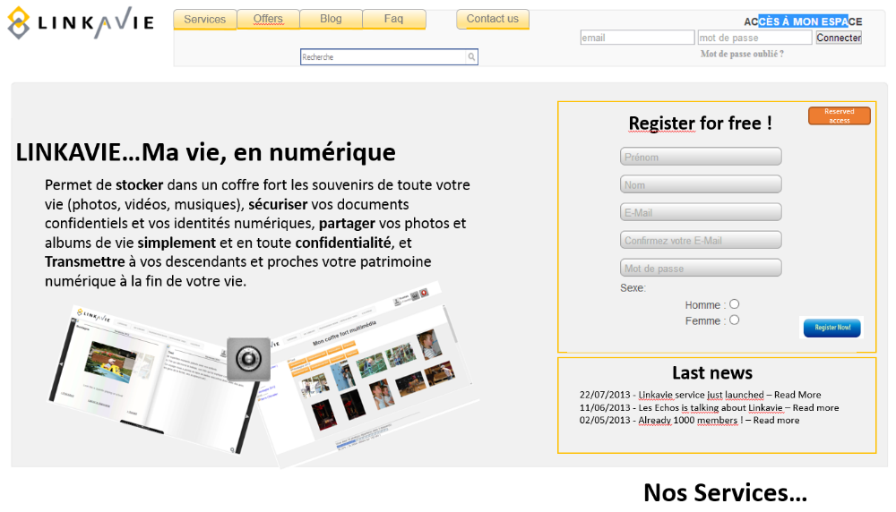
5.1.1 Header:
• Logo + Tagline

• Forgot password

The forgot password feature allow a User to generate a new password when this one has been forgotten. The User only need to write down its email address. A new initialization code is sent to th User, allowing him to follow the procedure by entering a new password (that should be confirmed / written twice).
• Login to My space

5.1.2 Tabs:
• Services

A link « Services » redirect to a web page describing LINKAVIE® services more in details with screenshots and user guides etc…
• Offers: Redirect to the page describing the LINKAVIE® services
• Blog: Redirect to LINKAVIE® Blog
• FAQ
A link « FAQ » redirect to a page with frequently asked questions and their answers.
5.1.3 Core of the page:
5.1.3.1 Registration
The main page allows a person to register for free and become a LINKAVIE® User. A paid subscription can be done only in a second step, via the User personal space, once registered. This way, the User gets a free and quick access to the service with no constraint, allowing him/her to test the service. The registration process should be quick and simple.
The LINKAVIE® service base registration is performed via the Home page of the site, requesting for a minimum of user information. The registration process should be simple and quick.
• Step 0 : Personal informations: First name, Last Name, email, LINKAVIE® password, sexe, date of birth.

• Step 1 : The user enter a visual SECURITY code to prevent automatic engines from registering fake users.. The user should check a checkbox to approve the Terms and Conditions of LINKAVIE® usage.

We will check email format and accuracy (the user is requested to type twice his email). After the registration, the User is automatically logged-in and can start using LINKAVIE® services for 5 days, without having to confirm his registration. But no invitations from the “My contacts” sections can be performed before the the user get confirmed. During the 5 days, after the user gets logged-in, on the main page, a confirmation popup appears urging the user to confirm his registration. Two days before the registration confirmation ending period, an emai is sent to the user. After 5 days, the User will be deleted from the Database automatically.
Following the registration process, a Registration Confirmation email is sent to the User (with a direct confirmation/activation URL). The User should access his emails to click on the direct confirmation link.
On the confirmation popup that appear in his main personal home page, the User can ask to resend the confirmation email and eventually change his email address.
When the user is not confirmed, he has restricted access to the site. He can’t access to « My contacts », « My communities », « my subscription », until his account get confirmed. The only thing that can be done is use his Vault and start his Life book, his family tree and use his agenda.
If the user registered entering a wrong email address, 2 ways to manage it:
- The user is logged-in (from the registration) and can change his email and resend the confirmation email as described above
- The user is not logged-in and can’t remember his email mispelling; then he has to register again. A non confirmed user is anyway deleted after 5 days from all LINKAVIE® DB.

// We will also think about integrating registration using Facebook credential, making it easier for users to register and allowing LINKAVIE® to retrieve the required data. (Next version)

5.2 Invitations, Relathionship setup and relationship validation
Each User can invite a person to become a Friend or setup a special relationship such as Representative, Close Friend or Descendant. This can be done in 2 ways:
• Via the SEARCH feature in the Header of the personal space.
• Via « My Contacts » -> « Invite Contacts »

NOTE: In case the user is not yet a confirmed user, then a error message is shown when he clicks on the “invite contacts” link asking to confirm the user account first to unlock this feature.
5.2.1 Invitation:
The procedure is as follow:
• The invitation page allow to add persons to invite whether they are LINKAVIE® Users or not ( First Name, Last Name email), define their role [Friend], [Representative], [Close Friend], [Friend and Representative], [Friend and Close Friend], [Friend and Descendant] and define if there is a family relation [None] by défault, [Father], [Mother], [Brother], [Sister], [Son], [Dauther]. This family relation will feed the User family tree. If the family relation is more complex, it will be managed from the family tree page.

o The guests (invited people) could be added manualy or importing from an Excel sheet or from contacts from Gmail, Yahoo, outlook.com.
o IT will be possible to select the language of the email invitation [French], [English] or more depending of the languages supported. The default language is the one of the current site used.
o The User will be able to add a customized message inside the standard invitation message.

An email is then sent to the invited persons. This email includes a validation URL, this URL including informations such as the User_id inviting, the role expected etc….
5.2.2 Validation of an invitation / relationship setup:
A guest, invited to become a Friend (or any other role) by a User receives a Relationship setup validation email. This email includes a URL that redirect to the Relashionship validation page. This page allows a guest to accept partially or totally the relashionship. The guest, before validating the relashionship should accept the « Responsibility Text » linked to the role that the guest is about to accept (Representative, Close Friend, Descendant).
For example, if a guest is invited to become « Close Friend and Friend » of a LINKAVIE® User, the guest can accept the role as is, or could refuse (ignore) the role, or could accept it partially by accepting to be « Close Friend » only or “Friend” only.
It is important to note that a guest that is not already a LINKAVIE® User (such information will be included in the validation URL) will be first redirected to to the registration page with a customized message explaining that to be Friend (or Descendant), they first need to be registered User before being able to accept the role or invitation. In this case, the Relatioship setup activation page will come right after the registration.
Once the relation is established, the inviting User and the guest are linked one and each other in the Database.
The inviting User is notified by email that his guest accepted totally or partially the invitation and role. The guest also receives a Relashioship setup email confirmation that give details about the accepted role and what should be the next steps. When the guest is a Representative, Close Friend, or Descendant, the guest receives also in the email a unique confidential code allowing him/her to access to the « Reserved Access » page, as described previously. "See chapter Death Management").
If the guest is non LINKAVIE® user with a role such as Representative or Close Friend that don’t require to be LINKAVIE® User, of course the Relashionship setup validation page will urge the guest to become user with a link to a free registration page.

5.3 My Personal home page
The personal LINKAVIE® home page is accessed after authentication of the User. The page is organized as follow. The DESIGNER, in its mission, will propose several alternatives in the way the links, buttons, menues will be organized, but each feature described below should be taken into account.
The header is similar as the main site one, except that the user is authenticated, and therefore can already access to his personal environment features.
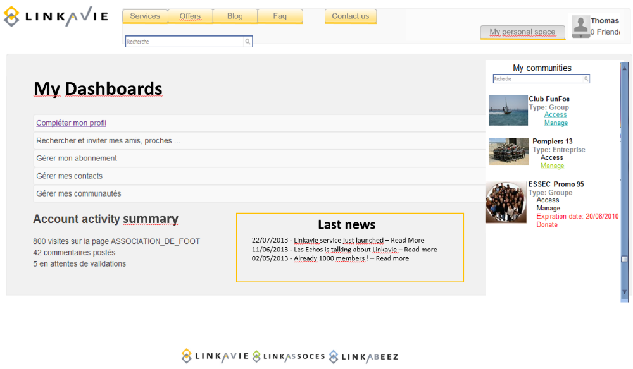
In the main page, a User can enter his login (email)/password to access his personal space. A simple welcome message will confirm that the User has been authentified and is connected to his personal space.
The User should have the choice to maintain his session opened.
5.3.2 Main page:
• Welcome message + working space:

A short text/background color should indicate clearly the working space the User is located. It could be « personal space», or the one from a « Friend » when accessing the DIGITAL ALBUM of a Friend ( In this case, the User should know which Friend he is connected to), ot it could be a “Community” space. Thanks to visual effects, the type of space will have different color aspect:
• Personal (refer to LINKAVIE® graphic chart)
• Friend (refer to LINKAVIE® graphic chart)
• Community (Refer to LINKASSOCES® and LINKABEEZ® graphic chart)

• My Dashboard: This area shows users statistics and important information dynamically.
o Quick access links such as: Complete my profile, Invite friends, Subscribe/Upgrade
o Activity account summary:
▪ General account statistics: number of Friends, storage usage versus entitled, current service pack and service expiration date etc..

▪ My News: Events or news linked to the User, its invitations, actions of Friends, news from the “Agenda & News tab” from his Friends and Communities etc..

▪ My detailed albums friends activity :
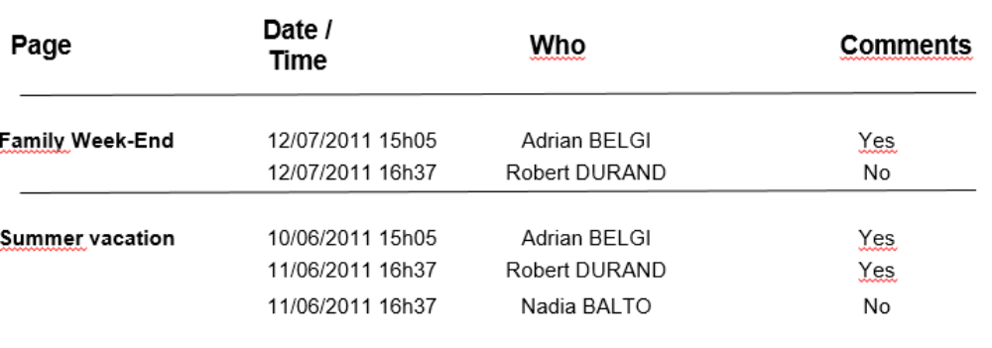
Direct links would redirect to the related page on the personal space of the user.
• LINKAVIE® Blog news

• Activate my account popup

When the user is logged-in (Non Confirmed User), a popup appears (on the upper right side) to ask him to validate his account, offering the possibility to resend the confirmation email (See details chapter "Registration and registration confirmation »). This popup don’t appear anymore when the user is confirmed.
• My communities list

It lists all users’ communities (if any) with direct access to the Community space or community management page.
• My Personal links

Based on the user Digital identities informations (Facebook login/pwd, twitter, gmail etc..), put Gmail/Yahoo/Ootlook logo + Facebook logo + Twitter logo so that when clicking on their logo, the user is redirected in a new browser tab to
his related site, pre-authenticated.

5.4 My Personal Space
This is the Javascript application that is downloaded to the desktop user and that provides the core service of the site, managing DIGITAL ALBUMs, personal vault, family tree, calendar/news, communities DIGITAL ALBUMs etc…
The user should be able to switch easily from his “Personal Home page” to his “My personal space”, as some of the features are on the site (Personal home page) and others in the Web application (Javascript “My personal space”).
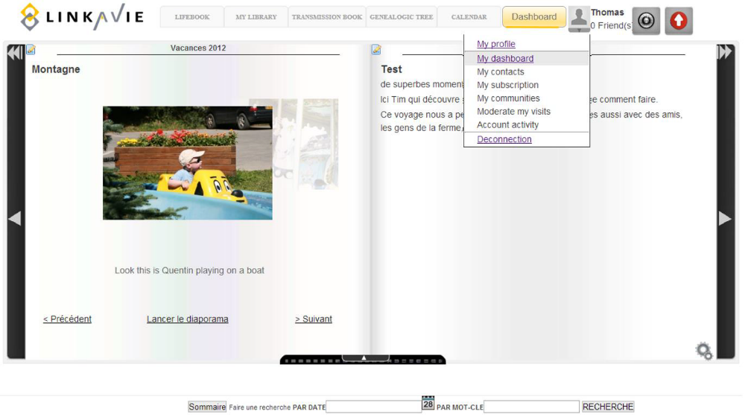
5.5.2 My Contacts and Groups
Contacts and Groups can be managed via "My contacts".
5.5.2.1 Contacts management:
This section allows to:

Add/Invite contacts (See chapter « Invitations, relation setting and validation »). From there, it will be possible to invite LINKAVIE® Users or Non LINKAVIE® Users with all different roles: [Friend], [Representative], [Close Friend], [Friend and Representative], [Friend and Close Friend], [Friend and Descendant].

5.5.4 My Dashoboards
This button redirects to the Dashboard page, as detailed in “5.3 – Main page”

5.6 The Vault
The User Vault is a storage space for storing, organizing personal multimedia contents. It is a way for the User to maintain its personal Data safely, and available to him to share part of them within its DIGITAL ALBUM or Transmission Book, or also, more instantly to let Friends to download a group of pictures, videos etc. even if those poeople are not LINKAVIE® users (Picasa-like).
The Vault for a Community allows the Community to feed its organization DIGITAL ALBUM.
For Alpha-version we distinguish only 1 main Vaults:
• Multimedia Vault: Pictures

The multimedia Vault organizes pictures all together under folders that have a name, a date or a period. The multimedia vault will propose 1 view:
• Pictures only
In next versions we provide «View all» multimedia view.
Depending of the view and selections, different actions on selected items will be possible, consistently with the type of items, as described in the “different” Vault sections below. Actions related to a selection of pictures, musics and videos will remain separated. In other words, it will not be possible to select different multimedia contents from different types (for exemple, when the user is in the “View all” view), as actions remain related to a type of multimedia.
In the footer of the page, global storage informations are dynamically updated and shown to the User.
• The total number of pictures, videos, music within the total number of folders
• The total number of documents within the total number of folders
• The total size of contents stored and the split between the different contents types (Picture, videos, music, and documents).
• The storage capacity remaining available within the curent period until the expiration date. This information appears in RED when the storage capacity reach 90% of the total capacity allowed within the current subscription.

Then, depending of each view and/or content types selected, we will show:
o The number of selected items (from a selection) / The related weight (MB)

For a better user experience, we will provide an offset scrolling feature to navigate within the vault. This means that when a user select a folder on the left side of the Vault, the right side dynamically and smoothly scroll to the right offset (position).

5.6.1 Multimedia Vault:
5.6.1.1 Pictures Vault
The Pictures Vault allow the User to import pictures (by Copy/paste if possible from the Desktop, or from Picasa/Google+ account and Flicker).
The import features should allow the following:
• Import in an existing folder (a list button will list all folders with dates/periods starting from the most recent to the oldest folder)
• Import in a new folder. The user will then define a folder name and date/period

Then, the pictures could be selected via the explorer or by doing a copy/paste from the explorer. The import window will show the weight of the selected pictures compared to the remaining user storage capacity, and will prevent the user from importing the pictures if the limit is overpassed (Import button greyed + show the overpassed capacity in red). A short message will encourage the User to upgrade and a direct link to the Upgrade page will be proposed.
Pictures format supported should be: .jpg, .jpeg, .gif, .png, Tiff
The import Window will propose the user to select one or several pictures to transfer to his Facebook/Google+ account with a post. This transfer will be performed on the fly while importing the pictures.
Also, the import wizard will let the user dynamically create a new page (with new or within an existing chapter, define a page title and position among other pages from the same chapter) within its Lifebook or other thematic albums, adding a page text description as a possibility, and generating automatically the page in the album. With that way, one single wizard allow the user to:
- Secure his pictures in his vault
- Post a Facebook message with pictures
- Build a new page of his albums.

Pictures are uploaded at the original format, but a “Fast speed upload” option allows the User to convert dynamically its pictures with a maximum size of 2 MB, more than enough to print PhotoBooks in a good quality, and allowing the User to optimize his Vault storage capacity, but avoiding to upload 5 to 10MB pictures that 90% of users don’t need. The picture convertion is performed on the fly.
We will retrieve from the picture the following informations:
• Picture name
• Picture “Taken date”, that we will call “Picture Date”
• Picture “Last Modified” Date which is the date when the file has been stored on a desktop
• Picture format

We will record on LINKAVIE® storage servers the following formats (To be discussed with the Provider):
00 = 60x60 : To give a quick view of a selection and perform an action on a selection of pictures
05 = 150x100 : Pictures Vault thumbails
10 = 270x180 : Pictues inside the Carousel
50= 600x n (n being the proportional high of the picture, used to preview pictures in an intermediate size)
100= Original picture, used for Diaporama
Features available are:
• Select one, several or all pictures within a folder/bloc. It should also be possible to select pictures from different blocs/folders.
• Unselect all pictures of a folder

From a selection, we will dynamically show the available actions:
• Preview of selected pictures (could be a Pop-up with informations such as File_Name, File_size, File_Date, Description
• Delete a selection of pictures or a folder (definitively remove the pictures and the different formats from the site)
• “Rename” 1 picture or “rename” several pictures (selected) simultaneously. This will change the file name.
• “Edit description” when 1 picture is selected. This option allows the user to define the Picture short description (Max 140 caracters)
• invitation with the direct link access to view the pictures and get a button to select and download the the pictures he likes.
• Move selected pictures from a folder to antoher one.

Share :
o Via email a Folder or a selection with people that are not LINKAVIE® Users, to allow them to view and to download such group of pictures (Picasa-Like). This will generate a link included into the email sent. The user may decided to password protect the access to this public page.
o Via Facebook, make a post with same kind of URL, password protected as an option. This way, pictures get not posted on Facebook (risky for user personal life)

When the user pass his mouse over a picture, we will show the following informations inside a small window attached to the mouse cursor:
File Name / format / Taken Date / Resolution / Description
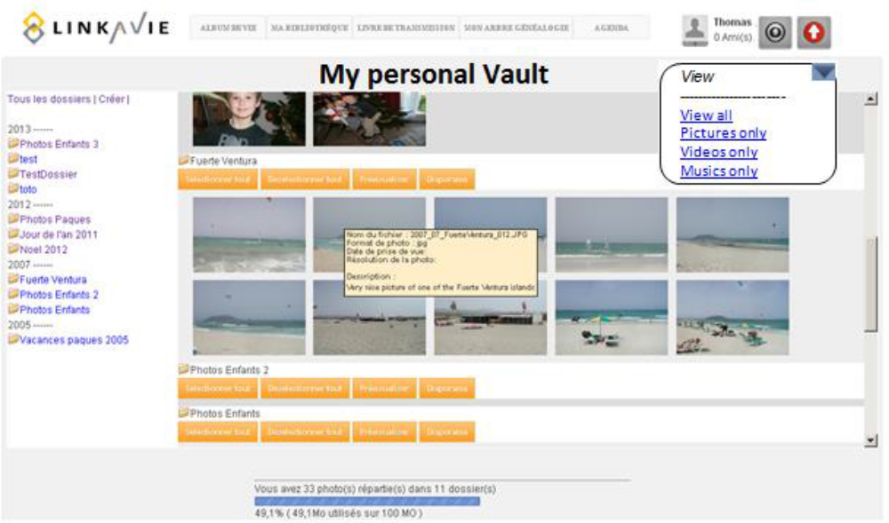
5.7 DIGITAL ALBUMs
Each user gets by default a personal DIGITAL ALBUM that is organized like a book with chapters and page titles, and with a summary for a rapid access to the pages. This DIGITAL ALBUM includes pages with pictures, videos, musics, text. But each user is also capable of creating different DIGITAL ALBUMs or thematic albums that can be linked or not to its personal default DIGITAL ALBUM. If linked, then pages of a specific thematic album will be integrated also as part of the default user Life book.
The DIGITAL ALBUM / Life book is the core of the proposed service. It allows any User to create its own numeric Album with multimedia contents (Pictures, videos, music, and text) as Souvenirs. A user will have the ability to create:
- A single global user life book (by default)
- Thematic DIGITAL ALBUMs related to his personal life and that can be merged (or not, up to the user) into the global life book
- Specific albums not related directly to his personal life (ex: a Friend album present) that will not be merged into his global DIGITAL ALBUM.
Those albums will be stored and organized inside the user Library.
Below is described the features related to a DIGITAL ALBUM:
5.7.1 Album page structure
A DIGITAL ALBUM page gets a Title, within a Chapter. By Default, the Chapter is the current year but could be changed when creating or editing a page. The DIGITAL ALBUM navigation can be performed from the DIGITAL ALBUM summary (Chapter list / Page list). The summary is generated automatically when creating pages.
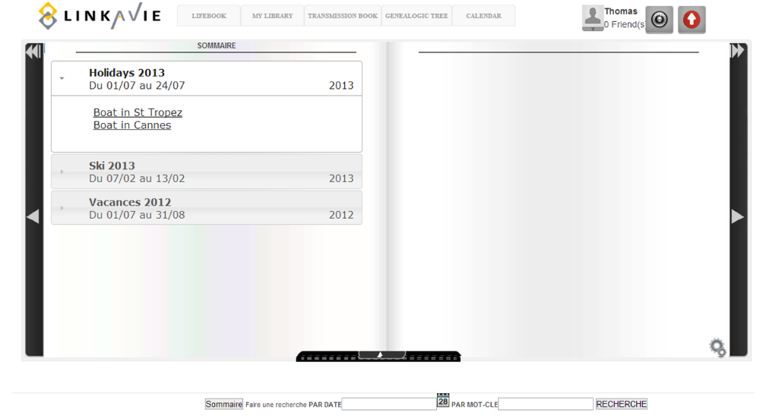
A DIGITAL ALBUM page is defined as a Text and multimedia page with blocks
• A picture (Carrousel) block
• Text blocks to describe something, vacations, and a day, whatever.

Important Note: The Provider (DESIGNER & DEVELOPPERS) may suggest a different organization. For example, a page could include both multimedia and text contents. This has to be discussed. If a different approach is selected, the Provider will adapt the related features to the new agreed design approach.

The chapter of a page will be located at the top-left of a page. We will show also the date/period of the chapter on the top-right.
The Title or section of a page is on the top left of a page, under the chapter. We could have several sections inside a page.

DIGITAL ALBUM Summary : A summary is created and updated each time a page is created. The summary contains Chapters (organized from the most recent ones to the oldest ones), and inside chapters page titles (Organized in the same order as the pages of the chapter in the DIGITAL ALBUM). A simple click on a link of the summary allows the User to access directly the beginning of a chapter or a page. The Summary will be represented as a traditional book summary.

A Picture Object within a multimedia page is represented by a carousel. We will show by default the Carousel with the format 10 = 270x180 : Pictues inside the Carousel
When clicking on the pictures, the Carousel effect is triggered, allowing the user to view pictures one by one easily. The User from there should be able to switch to a Preview mode or Full screen Diaporama mode.
The Carousel will show for eac upfront picture, the picture description, if available and as defined in the Multimedia Vault -> Edit description feature.
Don't need at alpha version A page will include Friends (approved) Comments: This object is dedicated to Friends willing to add comments to a page. This object is there only if the User allowed comments in its personal settings, and if they get approved by the user.
5.7.2 DIGITAL ALBUM Navigation
When a User accesses his DIGITAL ALBUM, the last page of the DIGITAL ALBUM is shown by default, on the left side. The same happens when reaching the LifeAlbum of a Friend; it reaches the last page he is allowed to view.
The DIGITAL ALBUM should propose 4 ways of Navigation.
• Page to page: 2 buttons « Previous page » and « Next page » allow the User to go from one page to the previous or next page of the DIGITAL ALBUM. A friendly effect (PageFlip or other) will happen as a transition.

5.7.3 Add a page
A dynamic menu allows the User to add a new page within a new or an existing chapter. The date of the day is added auomatically in the Chapter date/period field (if New chapter is selected) as default but can be changed by the user. The User needs to define a page title, and define a Chapter (default chapter name is the current year) or attach the page to an existing chapter.
If the user selects an existing chapter that already has pages, he can define where the new page gets positioned among the others (before or after a selected existing page within the chapter).
The user should be asked when adding a page if he is willing to add pictures with at first a carrousel block, so that the user don’t create a blank page.
Thenthe user can add different blocks to his page:
The Text block police style is the one predefined by the User in his profile settings, but when writing/editing a text (Editing Text Window appearing after selecting “Text page”), the user gets the possibility to have access to few editing options (Bold / Italic / Underline). The User can change his default policy settings (Text color, size, police type etc..) but the the entire DIGITAL ALBUM is then updated with the new style, for consistency reasons.

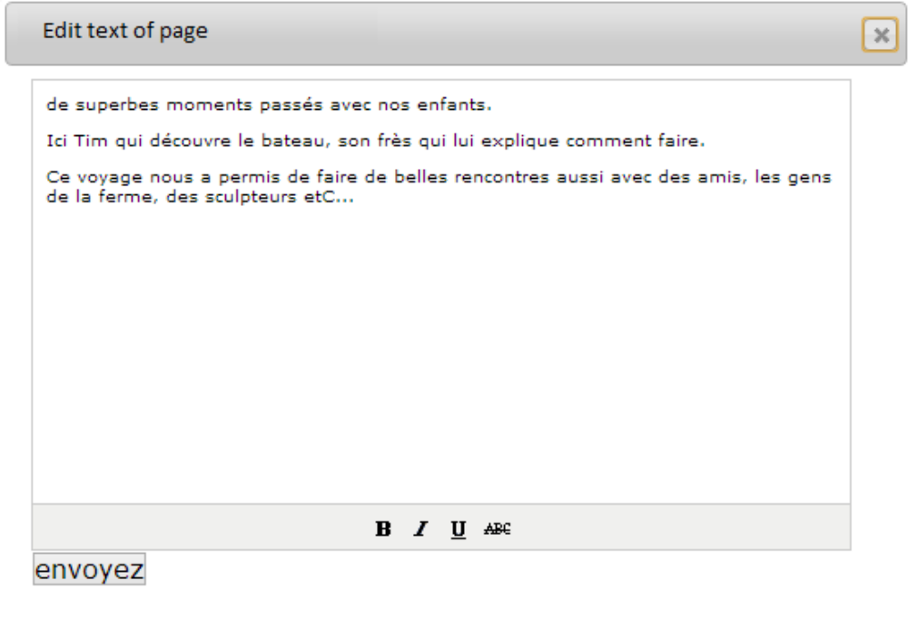

When the user selects a Multimedia block type, an Editing Window appears, giving access to the user personal multimedia vaults allowing the User to drag and drop some multimedia contents from his Vaults (pictures at alpha version).
Features of the Editing Window or Editing bar are as follow:
• Access to multimedia contents and preview (pictures/videos) or listen (music) of contents
• Drag and drop of pictures, videos, music and documents (Documents for the Transmission book only) according to page organization rules (To be defined with the Designer) and depending of the block type selected.
• Reorganize the carrousel pictures order (in the carrousel window – see example below)
• Remove some pictures from the carrousel (Drag & drop from the carrousel window to the trash)
• Cancel or validate a block.

The Design and conception of this Editing tool is important, allowing the creation or edition of a page in a very intuitive manner, keeping the user experience easy to access, to change, adapt smoothly.
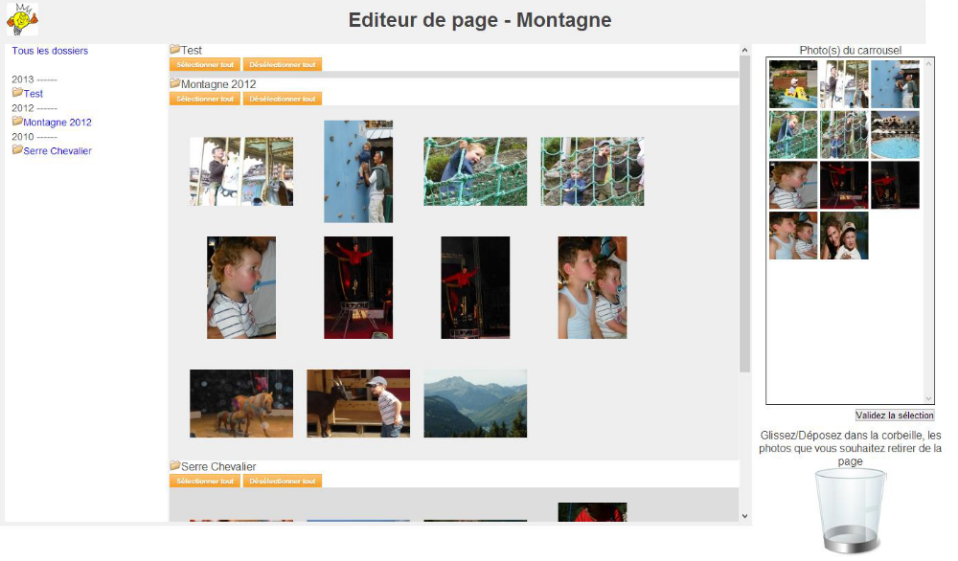
Editing a multimedia page
When adding a page, the DIGITAL ALBUM summary is automatically updated. Friends authorized to access the page are notified by email of the new new published page.
5.7.4 Page Edition
A dynamic menu allows the User to edit a page. When editing a page, the Editing window or tool bar is opened. It allows the same features as the creation of a page plus:
• Modify the date/period, title and chapter of the page
• Modify multimedia contents from the page (carrousel) per block
• Edit text of a text area
The page Edition updates automatically the Summary, if modifications are made on the title, date or chapter for instance.
The User Friends authorized to view the page are notified of a page change.
5.7.7 Share a page or chapter / confidentiality setting
Sharing a page within Linkavie
At the page level, a sharing button allow the user to share the page, the entire chapter or the all album is working at. When selecting this button, the user can define who this will be share to among his existing contacts, groups or new contacts.
This will generate an email to those contacts informing about the available share on Linkavie, with a direct access link :
- For an existing user, he will just have to log-in and then will directly access the page/chapter/album (Also accessible via the contacts view -> book icon)
- For a non linkavie user, he will have to register first (for free), and then will be redirected to the page/chapter/album

The related confidentiality setting mechanism is defined in the chapter “Confidentiality Filter management”.
Important: The Linkavie subscriber should also be able to share the page/chapter/album with non Linkavie users, so those users will be notified that they are invited to view a page on Linkavie and they will have to register first, then be able to access their friend page.
Sharing a page on Facebook
Make a Post on Facebook with a link to view a page or a chapter (The access could be password protected or not). The user selects wthere he wants to share a page or an entire chapter.
5.8 The Library and Printable Albums
The Library lists and shows all the printable albums of the User + the different user albums ( User default DIGITAL ALBUM + other personal DIGITAL ALBUMs, other albums like specific albums, Printable PhotoBooks). The global user Life book can be accessed via a seperate and dedicated tab, as shown in an exemple below, or could be the first album of his Personal DIGITAL ALBUMs. (At the alpha version the library will show only differen user albums DIGITALs albums)
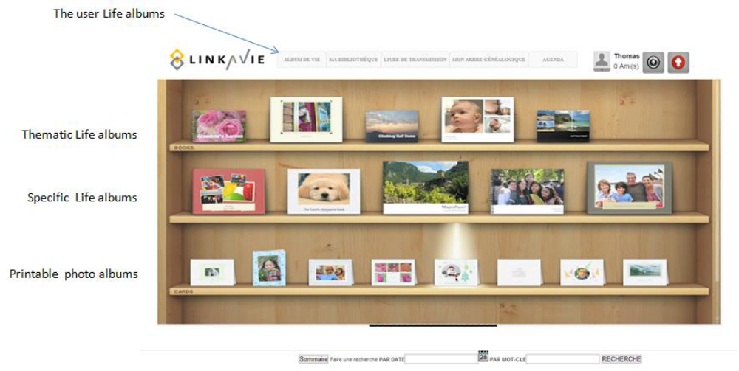
The User can easily identify an Album by its name, date, or the cover represented. The User can also do a SEARCH to identify an Album, using name or date of the album as well as string text matching a page Title for instance.
One single click on an Album opens it and allows the User to edit, print it (for Printable albums), as describe thereafter. It is also possible to select one or several albums and delete them definitively.

7 TECHNOLOGICAL SPECIFICATIONS
7.1 User help
The DEVELOPPERS have to setup some mechanisms of help, as intuitive as possible, in coordination with the DESIGNER. A first idea would be to have a mascot that would be there anytime some help would be required. The Mascot will appear on some specific pages, and/or by passing the mouse over a feature.
7.2 Multi-currency management / Intracommunautaire (CEE) VAT
We should support online payment as follow:
• Credit card payment (Visa, Mastercard and others per countries covered)
• Paypal
In the case of Group community, we should support « posptponed/delayed invoices » with the capability to cancel an order automatically in case the subscription fee is not reached by the community 1 month after the community creation.
The payment system should support monthly payments by credit card and automatic renewals (For users and Enterprise communities), without having to host users payment informations.
The CLIENT, with the support of the Provider will select the right payment system according to its features and price (PAyline, ATOS, Banks offerings etc…).
7.3 Emails management
The LINKAVIE® service requires a thin email management, avoiding to be rejected into SPAMs by the email operators (Gmail, Yahoo, Outlook.com etc..). We will have to manage LINKAVIE® service operational emails (subscription emails, notifications or alerts emails etc..) and Marketing emailings. For this last one, LINKAVIE® is thinking about using Marketing emailing tools such as Mailjet.com. We will evaluate how such (or other ones per advise) emailing solutions could be worth being integrated with LINKAVIE®.
We will then study and define how to use such tool with LINKAVIE® Database so that marketing emailing gets managed easily.
Besides, we will define Emailing templates (W3C) to ensure the best chance to get all emails delivered. This is part of Development and DESIGNERs task to work together to achieve this level of design and performance in email delivery.
Any email sent should have the following header :
"In order to receive our newsletter properly, we advise you to add newsletter@LINKAVIE®.fr to your adress book.
If you can’t read properly this page, click HERE or open your favorite browser at http://www.LINKAVIE®.fr/news/"
Any email sent should contain the following footer:
The exaxt sentence should be changed on a per country basis.
"Accordingly to the Information and Liberty law of the 6 of January 1978, you are entitled to access, change or reject any information related to your personal data. You simply need to ask for it by sending us an email at contact@LINKAVIE®.fr.
LINKAVIE® is respectfull and guaranty your confidentiality. LINKAVIE® is a trademark of TAMOLINKS group registered at the RCS of Aix en PRovence xxxx
IF you are not willing anymore to receive LINKAVIE® newsletter, click here to unsubscribe"
7.4 Performance, Scalability and High availability
The DEVELOPPERS will provide very high attention to the site navigation and user service performance:
7.4.1 Performance:
The LINKAVIE® service should support hundreds of users as well as thousands and thousands of users, without having performance decrease. As such, any development will have to be designed, per its architecture (Database architecture and requests optimization), cache memory usage, technology selection, to ensure such performance.
Besides, in order to optimize user service perception, when the user logs in into his account, part of the LINKAVIE® application should be downloaded locally and RUN into memory on the user desktop (Javascript Web application). Such piece of code downloaded should take less than 10 seconds (for an ADSL line of 512 Mbs) so that such download gets easily accepted by the users. In order to keep the user waiting, we will show graphically a download progression bar with percentage of the ongoing download.
7.4.2 Scalability:
The development architecture should be defined so that the physical infrastructure can easily be upgraded (Number of web servers, DB servers) while the number of users is growing. Also, all developments will be designed so that moving from a Datacenter hosting provider (like Amazon Web Services) to another one such as a traditional Service Provider (Like OVH Dedicated servers services) will be easy.
Besides, in order to optimize performances, the different modules/roles of the LINKAVIE® service should be able to be installed on the same pool of servers or splitted into different pools of servers, in order to dedicate tasks to specific servers if required.
7.4.3 High availability:
The LINKAVIE® service and web site should work with no problem with Load balancers, to maintain user sessions when the traffic gets loadbalanced. The support of Load balancing should help being able to increase the number of server easily so that the Production manager can adapt its capacity planning according to the increase of traffic.
Besides, the Database environment should be designed to support DB high availability. So if a DB server (physical or virtual) fails, it gets relayed by another one with no or limited service interruption.
7.4.4 Storage capacity scalability:
The storage scalability should be transparent from the application point of view. The storage technology should be discussed upstream. The storage management from the application/development point of view should be defined clearly so that storage upgrades could support thousands of Terabytes. IT should be easy to add new storage bays, servers etc…
The documentation provided by the DEVELOPPERS will provide all details explaining how to scale up the storage easily, in line with the developments.
7.5 LINKAVIE® User Interface adaptability
In order to provide the best user experience to LINKAVIE® users, the LINKAVIE® user interface should adapt automatically to the browser window size that may depend of the user screen size. It means that whatever the browser window size is, with a minimum of 800x600, the content of the window will auto adapt to fill-in 100% of the window (We can see such exemple in sites like joomeo.fr or plug-unplug.com). As an exemple, in the Picture Vault, a user could certainly be able to see a maximum of 5 columns of pictures in a 800x600 screen, while in a much bigger screen, a user could certainly be able to visualize 10 or more columns of pictures. The code of LINKAVIE® should autoadapt what should be fixed (the left side of the window) and what should be flexible according to the window size.
7.6 Supported environments
The LINKAVIE® service should support: Safari, Firefox, Opera, Internet Explorer 7+ and Chrome
LINKAVIE® should be supported on the following platforms: X86 desktop or notebooks from Windows 7 as well as MOAC OS.
We will also support mobile phones and tablets on: IOS, Android, Windows RT

9 BACK-OFFICE
The LINKAVIE® Back-Office developped by the DEVELOPPERS allows the LINKAVIE® teams to perform some operations in order to manage its activity. We have 4 levels of administration roles.
• Administrator: All permissions
• Marketing: Access to Marketing functions only
• Sales: Access to sales functions and reports only
• Finance: Access to Financial reports
Below is described all the functions that operators could do through the Back-Office
9.1.1 Operational actions:
Administrator level:
• Change/update texts and tables (exemple : Service pack descriptions) of static pages
• Pricelist update
• Promotional codes generation linked to a discount (that can reach up to 100%)
• Tracked registration links: Be able to generate different registration links (per partner for instance) and be able to track registrations and Business per specific registration links.
• Change manualy the current period storage capacity of a user or a community, change the expiration date and all parameters that define the service perimeter of the user/community.
• Change update the Service packs definitions (duration / storage capacity / price)
• Manage a manual order via Back-office ( for a user or a Community)
• Add/Delete a user or a community (properly deletes all contents, DB, links to other users and manages emails notifications).
• Edit any profile fields or settings of a user or a community.
• Escalate issues / Send feedback feature:
o In its personal space, the user has a button to escalate a problem or a feature request or idea. He has then a window to describe the problem or idea. When a problem is escalated, the administrators get notified by email.
o In Back-Office, the administrator get access to the list of escalations, is able to classify between problems, ideas, feature requests and get of each escalation: The first name and last name and email of the user, escalation type (Feature request, Bug or problem), and the description. The bacoffice allows the administrator to allocate a status (Pending, ongoing, Solved, under development, In the Roadmap, Canceled) and define priorities (1 to 5). The report can be exported in Excel
• Search any functional email linked to a user, a community, and be able to resend the email
Marketing level:
• Change/update LINKAVIE®/LINKASSOCES®/LINKABEEZ® site Marketing contents
• Add ads (for the Free users): The Back-office should provide a simple method to add ads in a predefined area within the user personal space. Ads will then show one after the others in a random way.
• Incentive tool:
o The incentive tool allows a LINKAVIE® user to sponsor non LINKAVIE® users to invite them to subscribe. The invitation email includes a sponsoring link so that we can track the sponsor user when the new user registers. Each LINKAVIE® user gets an amount of points. If the new user registers, the sponsor user get no point, but if the new user subscribe (pay user) within 3 months, the Sponsor user get 10 additional points. When a user can pretend to get a reward (as setup via the back-office), he can reach the reward page and select his reward (ex: More storage capacity for the current period, Expiration date extension or a present).
o The Back-office allows visualizing the sponsor users and seeing the list of new users they sponsored, theitr email, the service they subscribed, the registration date, subscription date (pay users) and the number of points witht he details. (Simple registration = 0 point, paid subscription = 10 points). This report can be exported in Excel.
o The Back-office allows the LINKAVIE® operator to change the number of points manualy for each line or to reset the points of a sponsor. When the sponsor users get their points reseted, it means that the points have been consumed and the sponsor rewarded.

Rewards will be managed manualy when they are a present.
9.1.2 Analysis reports:
Administrator level:
• "Storage capacity used: Total, average per user and per year (split between photos, videos, musics, documents) and per community + Filter per user profiles (Free, paid users, per service pack).
• Storage evolution with time
• Average of time of Service usage per user (per week, month, year). Split per month within a period. Filter per service pack
• Uploads tracability : We track all uploads, what, who when

Sales level:
• Number of new registrations, subscriptions per month + revenues on a defined period. Filters per criterias such as (Sexe, age...)
• Average of friends per user. Filters per criterias such as (Sexe, age...)
• Split of service subscriptions per user types (Free users, servic packs): Total amount or on a selected period
• List + email of free users using the service since more than x months (x can be defined)
• List + email of users having their birthday in month mm (mm can be defined)
• Dashboards of renewals that should come on a coming period to be defined (filter = Next month, next quarter), shows/filterautomatic and non automatic renewals. For users and Communities.

Finance level:
• Orders and payment reports per period
• CEWE Color orders tracking and status
• Activate a Community service (which Sends automatically the invoice)
• Change Organization community “Automatic renewal” value to Yes/No

All reports should be exportable to Excel with users or Manager/Contributors name and emails to be able to plan Marketing actions.

10 BETA PROGRAM
The CLIENT is willing to setup a beta program, providing a Private access to the LINKAVIE® service during the development and testing phase (before the official launch of the service). The objective of such program is to get feedback from a selected number of users, at the beginning by a very small number of users, then enlarging the scope to many more.
The Beta program is defined as follow:
• In the main landing page, have a button to “Request to be part of the Beta Program”. This will allow a user to make a pre-registration with minimum contact details (To be defined), and after approval, send him a hiden registration link where the user can subscribe to the Beta program.
• Provide a special hidden link to register to the Beta program
• Each Beta user can invite other users to the Beta program. This will go through the standard invitation process of the LINKAVIE® service.
• It will be clearly mention on the site that it is a Beta version
• The feature described in the Backoffice section of this document as “Escalate issues / Send feedback” will be implemented very soon at the beginning of the Beta Program.

The Beta program will start before the delivery of the Beta version, as soon as the following minimum features are available:
• Registration / Contacts & invitations process / Confidentiality setup
• Upload pictures to the Multimedia vault, with minimum features in managing the Vault
• Create a DIGITAL ALBUM and edit DIGITAL ALBUM content.
• The related minimum email notification process (ex: When a user create a new page, authorized friends get notified)

