- the menu is the same everywhere -
Because We Care
Submit Your Event’s Details
When:
Start Date: End Date
What:
Name of the event:  *Please provide an exact name |  |  |  |  |  | text field
Event type:  *i.e. Soccer, Gymnastics, Festival, Conference |  |  |  |  |  | text field
Specify Gender: |  | Male, Female, Mixed |  |  |  | drop down
Select an age group |  | Children, Jr. High, High School, College, Adults,  Seniors, N/A |  |  |  | Select all that apply
Event Description: |  |  |  |  |  | text field
Where:
Name of Venue: |  |  |  |  |  | text field
Address: |  |  |  |  |  | text field
City, State: |  |  |  |  |  | text field
+ If more than one Location [then we need all info for each venue]

//добавить возможность добавить такие же поля для Where если event происходит в нескольких местах одновременно
Contact Information:
Contact E-mail: |  |  |  |  |  | text field
Contact Name: |  |  |  |  |  | text field
Organization: |  |  |  |  |  | text field
Web Link: |  |  |  |  |  | text field
Contact Phone: |  |  |  |  |  | text field
Additional Notes: |  |  |  |  |  | Large text field
Review & Submit [Button]
☐ Send me a copy
Do you have time to answer a few more questions?
Or skip these questions to answer at a later time.
Дальше в extended area. I want these bottom questions to be expandable, if they
want to answer them now, ok, if not, they can still submit it.
What time will the event begin? (We will need about one hour to set up): |  |  |  |  | text field
T-shirt History (how many sold in previous years): |  |  |  |  | text field
Will there be access to electricity at each location?: |  |  |  |  | Radio Button Yes / No
How many vendors are you expecting at this event?: |  |  |  |  | text field
Will anyone else be selling or giving away T-shirts at the event?: |  |  |  |  | Radio Button Yes / No
Can you position us with the best spot at each location?: |  |  |  |  | text field
What address would you like us to mail the commission check to?: |  |  |  |  | text field
If applicable:
Number of teams: |  |  |  |  | text field
Can you provide us with rosters? (Specify ages if possible)  * It is preferred that the rosters are provided in either an Excel File or Word Document. Please, no PDF files. |  |  |  |  | text field
Number of expected participants: |  |  |  |  | text field
Percentage of participants who are male vs. female: |  |  |  |  | text field
Percentage of participants who will be traveling from out-of-state: |  |  |  |  | text field
Number of expected fans: |  |  |  |  | text field
Select the services you are interested in learning about:
☐ Brand Name Apparel  ☐ Bulk Apparel  ☐ Wholesale Apparel  ☐ Free Staff/Volunteer Apparel  ☐ Online T-shirt Sales  ☐ Promotional Products/Needs  ☐ Banners  ☐ Print Products (nation-low pricing!)  ☐ Rosters  ☐ Sublimated Patches  ☐ Shin Guards |  |  |  |  | Select all that apply (checkbox)
Would you like to save this information by registering? or SUBMIT FORM without registering and be contacted by your local representative.
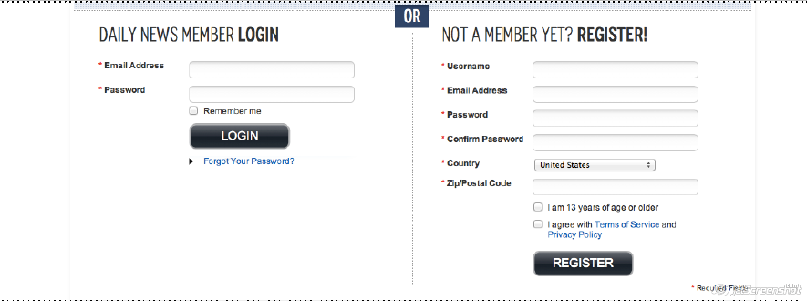 |  |  |  |  | <Example  < Please use your best judgement in this section
Review & Submit [Button]
☐ Send me a copy
Having Trouble? Find your local rep now > Contact a Representative [links to map/contact page]
http://demo.qodeinteractive.com/central/elements/
(use the call to action or pop-up)
- bottom links | - bottom links |  | - bottom links | - bottom links
- bottom -

