Could we get a quote on the following and also expected completion date since holidays are coming up? When do you guys close for xmas?

1) Change the photo results page (and similar media on photo pages) to show actual orientation of images (portrait, landscape, square etc) https://stockbo.com/v4wip/search.php?clearSearch...

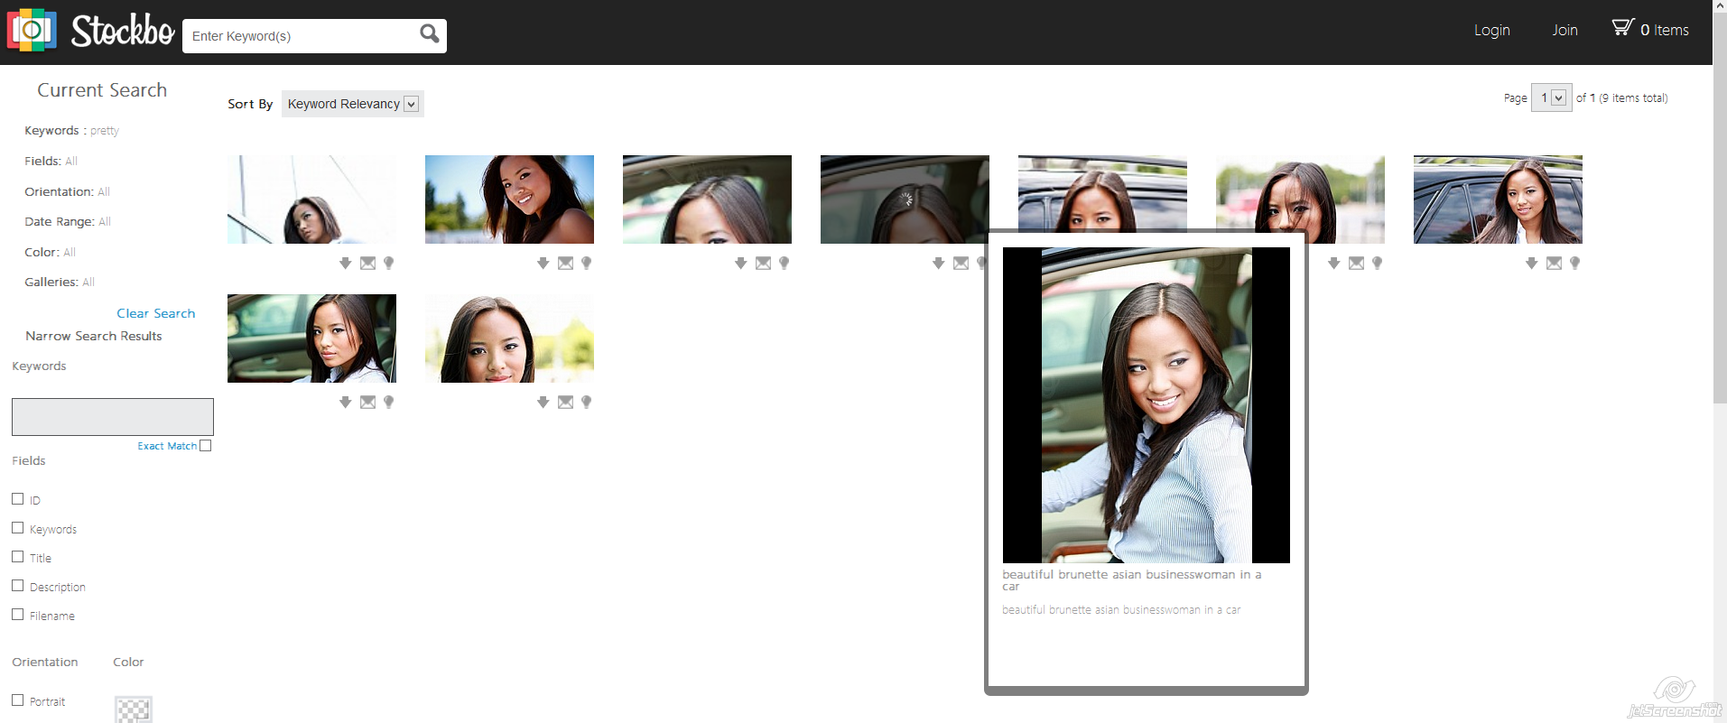

3) The photo page is still cropping some portrait images at the very bottom, could we get it to show the full image, its ok if the width has to shrink slightly in the container https://stockbo.com/v4wip/771

At preview | At the detail page
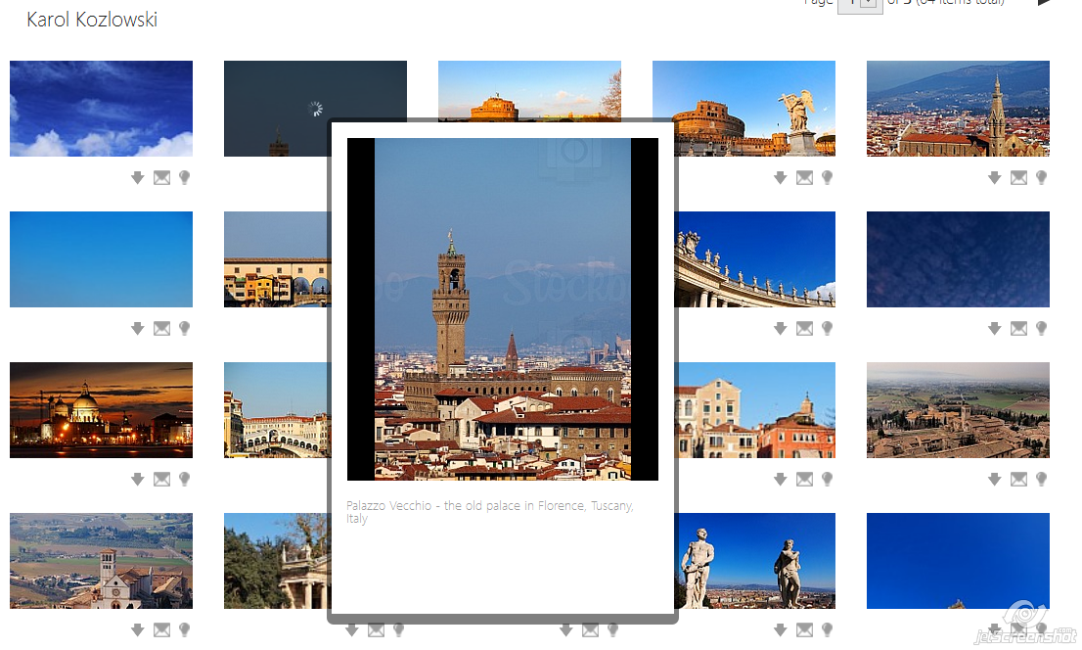 | 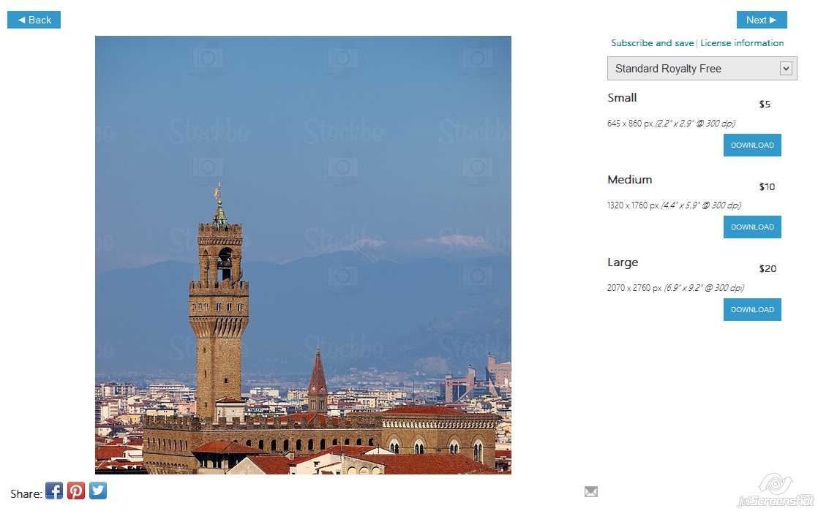

4) On the photo page the contributor information at the bottom right is using the value "Contributor Name", could we change this to the value "Contributor Display Name" ?

2) Re-design the search results page to be something like Flickr including the overlay (the above (1) is temporary is this is probably a big job) http://www.flickr.com/search/?q=car

5) We need to fix the uploading so that the store reads all the image metadata correctly like the title, description, copyright keywords (also it should recognise all separators like ","." ";" ":" at the moment it only recognises ";" and anything else does not split the keyword).

This should be for whether they upload via FTP or Java. I believe that it is the store that is reading the metadata and imports not the uploader? I think photostore uses "Uploadify" I'm not sure if this is what is reading the metadata? http://www.uploadify.com/

1), 3) and 4) the easy ones are something we'd like to get done ASAP,
2) and 5) are big jobs and is no rush

6) Is there any way you could increase the preview image in the manager? See attached image. When we are trying to approve the images are very small and hard to see and tell if the quality is good. Or maybe add a big popup preview next to the popup info box?

My team member said that if it is around double of the what it currently is (in image 1 when you click) then it should be ok
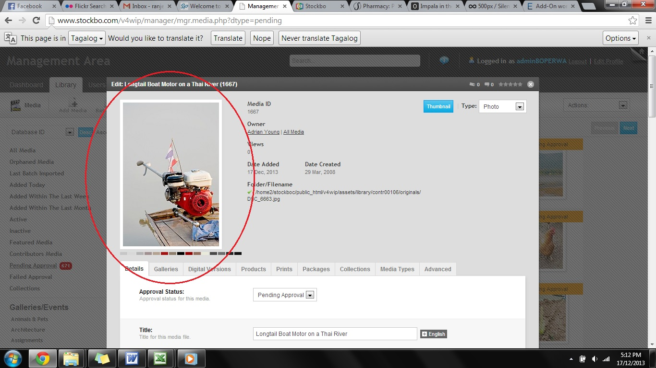
For #6 as big as you can make it will be good, so that we can see the quality

7) The quality of the home image doesn't look so good, is it being processed properly? This one at the moment should be big enough but it looks blurry and is not sharp. http://www.stockbo.com/v4wip/ (Crucial)

8) On the home page on the bottom left could we maybe make the images slightly bigger? Some of the profiles are getting cut, especially where there is a brand like Click Images and there is a bit of extra space (Crucial)

So the crucial ones are 1,3,4,6,7 if we can get those done before christmas (or most of it) will be awesome but let me know

