HealthDay TV: Overview

HealthDay TV videos are made available Monday through Saturday by 9 a.m. ET. Featuring HealthDay's Chief Medical Officer, Dr. Cindy Haines, they are designed to give viewers a daily video update on the latest medical and health topics. Each health segment will cover an important medical topic taken right out of the headlines, with Dr. Haines giving insight with short, easy-to-understand commentary.

Videos are produced in hi-resolution MP4 format. As such, they are Operating System (Windows, MAC, Linux) and browser (Internet Explorer, Firefox, Chrome) independent.

If the client wishes to download the raw MP4 videos and, optionally, a bitmap thumbnail and transcript of each, they will be made available for download via FTP. Please note that an archive of videos may comprise several gigabytes of disc space and, depending on the speed of your Internet, may require several hours' download time.

HealthDay TV: Formats

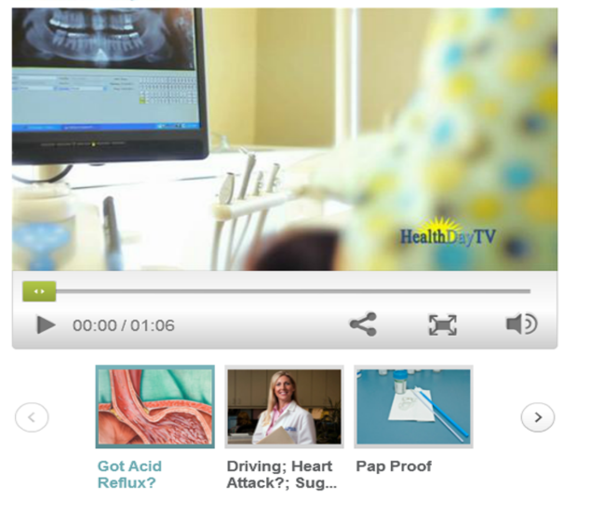
- Embedded player with archive. A few lines of javascript code can enable this resizable feature on your website. A sample screenshot is shown below:

- XML Feed -- Includes javascript embed for the player above with only a single day's video. Also includes a Headline, Blurb, and applicable HealthDay topic flags, allowing each video to be categorized according to more than 800 granular subjects. See the end of this document for a complete list of topic flags.

Here is a sample of the XML feed for HealthDay TV:

<?xml version="1.0"?>
<!DOCTYPE NEWSFEED SYSTEM "http://www.healthday.com/dtd/newsfeed.dtd">
<NEWSFEED>
<ARTICLE ID="634908" POSTING_DATE="19-Jan-2010" POSTING_TIME="08:00" ARCHIVE_DATE="12-Jan-2011">
<NEWS_TYPE>News</NEWS_TYPE>
<HEADLINE><![CDATA[Dose Dilemma]]></HEADLINE>
<BLURB><![CDATA[Not all spoons are created equal when it comes to measuring meds.]]></BLURB>
<BYLINE><![CDATA[]]></BYLINE>
<BODY><![CDATA[<script language="JavaScript" type="text/javascript" src="http://admin.brightcove.com/js/BrightcoveExperiences.js"></script>
<object id="myExperience" class="BrightcoveExperience">
<param name="bgcolor" value="#FFFFFF" />
<param name="width" value="549" />
<param name="height" value="570" />
<param name="playerID" value="1479253827001" />
<param name="playerKey" value="AQ~~,AAABTGqpZok~,8pVfAPaR1Gf_0mpxlw7JbFLwVamfvGAm" />
<param name="isVid" value="true" />
<param name="isUI" value="true" />
<param name="dynamicStreaming" value="true" />
</object>]]></BODY>
<TAGLINE><![CDATA[]]></TAGLINE>
<SOURCE><![CDATA[]]></SOURCE>
<FEATURE_BLURB><![CDATA[]]></FEATURE_BLURB>
<FEATURE_IMAGE><![CDATA[]]></FEATURE_IMAGE>
<COPYRIGHT><![CDATA[Copyright &#169; 2010 <a href="http://www.healthday.com/" target="_new">HealthDay</a>. All rights reserved.]]></COPYRIGHT>
<URL><![CDATA[id=634908]]></URL>
<TOPICS>
<TOPIC ID="DOSE"/>
<TOPIC ID="DRUG"/>
</TOPICS>
</ARTICLE>
</NEWSFEED>
- Raw Video in MP4 -- For clients who wish to use the HealthDay TV video in their own players or prepend an advertisement or preroll, the raw MP4 video can be placed on HealthDay's FTP server each day for download. At the client's option, other assets that can accompany the video include a JPG image, and the complete text of the video, which may be used to create close-captioning.

- HealthDay TV using EZ-Post -- HealthDay's proprietary EZ-Post system uses javascript to display HealthDay TV on the client's Website. This format includes a keyword search engine. Images and appearance may be customized to match host site's style sheets. A simple example is portrayed below:

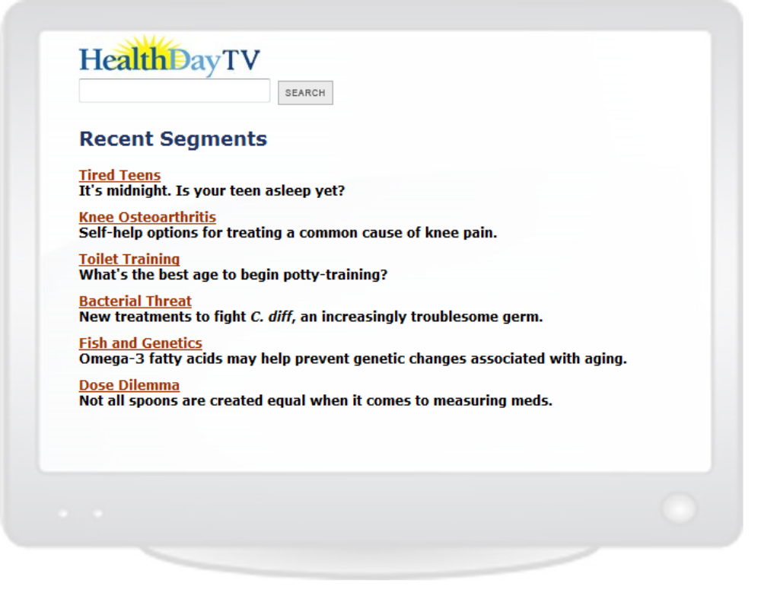

Please note: HealthDay feeds are meant to be downloaded, parsed and added to a content management system database on the client's server. XML and HTML files are NOT meant to be downloaded as an on-the-fly API by visitors to client sites.
HealthDay Technical Support

For routine contact during normal business hours, direct non-technical inquiries to your sales representative. For technical inquiries or emergencies, please contact:

Scott Roberts, Director of Technology
83 East Avenue, Suite 210
Norwalk, CT 06851
sroberts@healthday.com
(203) 855-1400 x109

Iwona Trybulska, Assistant to the Director of Technology
itrybulska@healthday.com

Appendix A: Topic Flags

=ABI - Abilify
ABOR - Abortion
=ACP - Aciphex
ACNE - Acne
=ACT - Activase
=ACL - Actonel
=ACO - Actos
PUNC - Acupuncture
=ADD - Adderall
ADCT - Addiction
ADOL - Adolescents / Teens
=ADV - Advair
AGE- - Age
AGNG - Aging: Misc.
KALC - Alcohol & Kids
ALCA - Alcohol Abuse
ALCO - Alcohol: Misc.
TTOT - Alcohol: Teetotaling
=ALM - Alimta
=ALL - Allegra
FDAL - Allergies: Food
ALLR - Allergies: Misc.
NZAL - Allergies: Nasal
ALS - ALS (Lou Gehrig's Disease)
ALTM - Alternative Medicine: Misc.
ALZH - Alzheimer's
=AMB - Ambien
AMBL - Amblyopia (Lazy Eye)
AMPU - Amputation
ANAP - Anaphylactic Shock
ANAT - Anatomy / Biology
=AND - Androgel
ANEM - Anemia
ANES - Anesthesia
ANEU - Aneurysm
ANGI - Angioplasty
ANKY - Ankylosing Spondylitis
ANOR - Anorexia
ANOZ - Anosmia (Poor Sense Of Taste Or Smell)
ATRX - Anthrax
ANTB - Antibiotics
ADEP - Antidepressants
ANTH - Antihistamines
ANTO - Antioxidants
ANXI - Anxiety
APHR - Aphrodisiacs
APPX - Appendicitis
=ARN - Aranesp
=ARI - Aricept
=ARX - Arimidex
AROM - Aromatherapy
ARTG - Arthritis: Demographics
ARTN - Arthritis: Diet
ARTD - Arthritis: Drugs
ARTM - Arthritis: Management
ARTH - Arthritis: Misc.
OSTA - Arthritis: Osteo
RHAR - Arthritis: Rheumatoid
AHIP - Artificial Hips
AKNE - Artificial Knees
=ASA - Asacol
ASPR - Aspirin
ASTH - Asthma
ATHF - Athlete's Foot
=ATP - Atripla
=ATR - Atrovent
ADHD - Attention Deficit Disorder (ADHD)
AUTI - Autism
=AVN - Avandia
=AVS - Avastin
=AVO - Avonex
=AXI - Axid
BACH - Backache
BADB - Bad Breath
BEDW - Bedwetting
BHVR - Behavior
BCAR - Beta Carotene
=BET - Betaseron
BIOF - Biofeedback
BTEC - Biotechnology
BIPO - Bipolar Affective Disorder
BFLU - Bird Flu
BORN - Birth
BIRC - Birth Control
BIRD - Birth Defects: Misc.
BDAY - Birthday
BITE - Bites & Stings
BLNF - Bladder Infections
BLND - Blindness
BLOO - Blood Disorders
BGLU - Blood Glucose Monitors
BLPR - Blood Pressure
BBLD - Body Building
BONE - Bone / Joint / Tendon Problems
=BON - Boniva
BOTX - Botox
COLS - Bowel Problems: Colostomy
GAS- - Bowel Problems: Gas
GAST - Bowel Problems: Gastritis
IBD- - Bowel Problems: Inflammatory Bowel Disease
BOWE - Bowel Problems: Misc.
BRAI - Brain
BIMP - Breast Implants
BRED - Breast Reduction
FEED - Breast-Feeding
BRON - Bronchitis
BRUI - Bruises
BULI - Bulimia
BLLY - Bullying
BUNI - Bunions
BURN - Burns
=CAD - Caduet
CAFF - Caffeine / Coffee / Tea
=CAL - Calan
-BLA - Cancer: Bladder
-BON - Cancer: Bone
-BRN - Cancer: Brain
-BRS - Cancer: Breast
-CER - Cancer: Cervical
-COL - Cancer: Colon
-ESO - Cancer: Esophageal
-KID - Cancer: Kidney
-LAR - Cancer: Laryngeal
-LEU - Cancer: Leukemia
-LUN - Cancer: Lung
-LYM - Cancer: Lymphoma
-GEN - Cancer: Misc.
-MOU - Cancer: Mouth
-OVA - Cancer: Ovarian
-PAN - Cancer: Pancreatic
-PRO - Cancer: Prostate
-REC - Cancer: Rectal
-SKI - Cancer: Skin
-STO - Cancer: Stomach
-TST - Cancer: Testicular
-THR - Cancer: Throat
-THY - Cancer: Thyroid
-UTR - Cancer: Uterine
=CAP - Capoten
=CZM - Cardizem
=CRD - Cardura
CARE - Caregiving
CARP - Carpal Tunnel Syndrome
CATS - CAT Scans
CATR - Cataracts
=CAV - Caverject
CAVI - Cavities
CBX - Celebrex
=CLB - Celebrex
=CLL - Cellcept
CELP - Cellphones
CDC- - Centers for Disease Control
PALS - Cerebral Palsy
CMCL - Chemicals
CHEM - Chemotherapy
CHPX - Chickenpox
CDEV - Child Development
CPSY - Child Psychology
CHBR - Childbirth
CHIN - Chinese Medicine
CHIR - Chiropractic
CHLA - Chlamydia
CHOD - Cholesterol: Dietary
=CIA - Cialis
=CIP - Cipro
CIRC - Circumcision
CIRR - Cirrhosis
=CLA - Claritin
CLEF - Cleft Lip / Palate
=CLI - Climara
CLIN - Clinical Trials
CLON - Cloning
CLOT - Clots
COCA - Cocaine
=COG - Cognex
COLI - Colic
COLN - Colonoscopy
CBLI - Color Blindness
=COM - Combivent
COLD - Common Cold
CPUI - Computer-Related
CMPU - Computers / Internet
AOL- - Computers / Internet: America Online
COMP - Computers / Internet: Compuserve
SCOU - Computers / Internet: HealthDay
ISP- - Computers / Internet: Internet Service Provider
MSN- - Computers / Internet: Microsoft Network
ONLN - Computers / Internet: Misc.
REMD - Computers / Internet: Remedy Online
SRCH - Computers / Internet: Search Engines
=CON - Concerta
CONC - Concussions
COND - Condoms
TWIN - Conjoined Twins
CONJ - Conjunctivitis (Pink Eye)
COOK - Cooking / Recipes
=COP - Copaxone
CSUR - Cosmetic Surgery
COSM - Cosmetics
COUG - Coughs
=COZ - Cozaar
CPR - CPR
CCAP - Cradle Cap
CRMP - Cramps
CMEN - Cramps: Menstrual
CMUS - Cramps: Muscle
=CRE - Crestor
CROH - Crohn's Disease
CUTS - Cuts & Scratches
=CYM - Cymbalta
CF-- - Cystic Fibrosis
CYST - Cysts
DAND - Dandruff
=DAY - Daypro
DEAD - Death & Dying: Misc.
DVTB - Deep Vein Thrombosis
DEFB - Defibrillators
DEMT - Dementia
DEMO - Demographics
DENT - Dental Problems: Misc.
FALS - Dentures
DEPR - Depression
=DET - Detrol
DIAG - Diabetes: Demographics
DIAN - Diabetes: Diet
DIAD - Diabetes: Drugs
DIAM - Diabetes: Management
DIAB - Diabetes: Misc.
DIA1 - Diabetes: Type I
DIA2 - Diabetes: Type II
DIAT - Diabetes: Types
DIAP - Diaper Rash
DIAR - Diarrhea
DDRU - Diet Drugs
DCAF - Dieting To Avoid Caffeine
DLAC - Dieting To Avoid Lactose Or Milk
DCHO - Dieting To Control Cholesterol
DSOD - Dieting To Control Salt
DGOM - Dieting To Gain Or Maintain Weight
DGAI - Dieting To Gain Weight
DFBR - Dieting To Increase Fiber
DLOS - Dieting To Lose Weight
DFAT - Dieting To Lower Fat Intake
DMAI - Dieting To Maintain Weight
DSUG - Dieting To Reduce Sugar
=DIF - Diflucan
DIGE - Digestion
DILC - Dilation & Curettage (D & C)
=DIO - Diovan
SPEC - Disabled / Special Needs
DISC - Discrimination
DISE - Diseases & Conditions: Misc.
DIVT - Diverticulosis Or Diverticulitis
DIVC - Divorce
DIZZ - Dizziness/Vertigo
DNA- - DNA
DOCS - Doctors
DOMV - Domestic Violence
DOSE - Dose Adjusting
DOWN - Down Syndrome
DRAB - Drug Abuse
DRUE - Drug Abuse: Effects
DRUS - Drug Abuse: Social Issues
DRUT - Drug Abuse: Treatment / Solutions
RXOK - Drug Approvals
DIMP - Drug Imports
DINT - Drug Interactions
DSAF - Drug Safety
KDRU - Drugs & Kids
IDRU - Drugs: Illicit
DRUG - Drugs: Misc.
DRDR - Drunk Driving / Riding
DYSL - Dyslexia
ECOL - E. Coli
ENTH - Ear / Nose / Throat
EARI - Ear Infections
EATD - Eating / Appetite Disorders
ECON - Economic Status
ECST - Ecstasy
ECZM - Eczema
EDUC - Education
=EFF - Effexor
ELBO - Elbow Problems
=ELO - Eloxatin
EMER - Emergencies / First Aid
EMOT - Emotional Disorders: Misc.
EMPH - Emphysema
=ENB - Enbrel
ENCP - Encephalitis
ENDC - Endocrinology
ENDO - Endometriosis
ENVR - Environment
ENVM - Environmental Medicine
EPIL - Epilepsy
=EPO - Epogen
=ERB - Erbitux
=EST - Estrace
=ESD - Estraderm
ESTR - Estrogen
ETHC - Ethics
=EVI - Evista
AERO - Exercise: Aerobics Or Calisthenics
BALL - Exercise: Baseball Or Softball
BASK - Exercise: Basketball
BOWL - Exercise: Bowling
CANU - Exercise: Canoeing Or Kayaking Or Rowing
CLIM - Exercise: Climbing
CYCL - Exercise: Cycling
DANC - Exercise: Dancing
DIVE - Exercise: Diving, Board Or Platform
DIVS - Exercise: Diving, Skin
FENC - Exercise: Fencing
FBAL - Exercise: Football
GARD - Exercise: Gardening
GOLF - Exercise: Golf
GYMX - Exercise: Gym
GYMN - Exercise: Gymnastics
HNDB - Exercise: Handball
HIKE - Exercise: Hiking Or Backpacking
FHOC - Exercise: Hockey, Field
HOCK - Exercise: Hockey, Ice
HOMX - Exercise: Home
HORS - Exercise: Horseback Riding
JRUN - Exercise: Jogging Or Running
LACR - Exercise: Lacrosse
MCHX - Exercise: Machine
MART - Exercise: Martial Arts
EXER - Exercise: Misc.
PADL - Exercise: Paddleball
PILA - Exercise: Pilates
PONG - Exercise: Ping Pong Or Table Tennis
RACQ - Exercise: Racquetball
SKIP - Exercise: Rope Skipping
SAIL - Exercise: Sailing
SHUF - Exercise: Shuffleboard
SKAT - Exercise: Skating, Ice
ROLL - Exercise: Skating, Inline Or Roller
XSKI - Exercise: Skiing, Cross-Country
DSKI - Exercise: Skiing, Downhill Or Snowboarding
WSKI - Exercise: Skiing, Water
SOCC - Exercise: Soccer
SPNG - Exercise: Spinning
SQUA - Exercise: Squash
STEP - Exercise: Stepping
SURF - Exercise: Surfing
SWIM - Exercise: Swimming
TCHI - Exercise: T'ai Chi Or Oriental
TENN - Exercise: Tennis
TRAM - Exercise: Trampolining
MILL - Exercise: Treadmill
VOLL - Exercise: Volleyball
WALK - Exercise: Walking
WTRX - Exercise: Water Exercise
LIFT - Exercise: Weight Lifting
WIND - Exercise: Windsurfing
WOOD - Exercise: Wood Chopping Or Sawing
WRES - Exercise: Wrestling
YOGA - Exercise: Yoga
EYES - Eye / Vision Problems: Misc.
EYDR - Eye Drops
FACE - Face-Lifts
FALL - Falls
FAMI - Family
FSUB - Fat Substitutes
BFAT - Fat, Body
FAT- - Fat, Dietary
FATH - Fatherhood
FATI - Fatigue
FEAR - Fears / Phobias
=FEL - Feldene
FEMP - Feminine Products
=FEN - Fentanyl
FEVR - Fever
FIBR - Fiber, Dietary
FBRD - Fibroids
FMYA - Fibromyalgia
FTEQ - Fitness Equipment
FITN - Fitness: Misc.
FLOA - Floaters (Eye)
=FLO - Flomax
=FLV - Flovent
FLU- - Flu
=FLU - Flumist
FDA- - Food & Drug Administration
FOOD - Food & Nutrition: Misc.
FADD - Food Additives
FOOE - Food Engineering
FDIR - Food Irradiation
FOOP - Food Poisoning
FOOT - Foot Problems: Misc.
=FOS - Fosamax
FRAC - Fractures
DRYM - Frequent Dry Mouth
FRND - Friendship
FROS - Frostbite
FUNR - Funerals
FUNG - Fungal Infections
GALL - Gallbladder Problems: Misc.
GSTO - Gallstones
=GAR - Gardasil
GASI - Gastrointestinal Problems
=GEM - Gemzar
GTHR - Gene Therapy
GENE - Genetic Disorders
GENF - Genetically Altered Food
GENT - Genetics
=GEO - Geodon
GLAU - Glaucoma
=GLE - Gleevec
=GLU - Glucophage
GONO - Gonorrhea
GOUT - Gout
GOVT - Government
GRAV - Grave's Disease
GRIF - Grief
H1N1 - H1N1 (Swine) Flu
HAIR - Hair And Scalp Problems: Misc.
BALD - Hair Loss
HTOE - Hammertoes
HEAD - Head Injuries
HACH - Headaches
HBIZ - Health Biz: Misc.
HCRA - Health Care Access / Disparities
CLUB - Health Clubs
COST - Health Costs
QUIZ - Health Quizzes
HAID - Hearing Aids
HEAR - Hearing Disorders: Misc.
DEAF - Hearing Loss
ANGN - Heart / Stroke-Related: Angina
CORA - Heart / Stroke-Related: Coronary-Artery Disease
HATT - Heart / Stroke-Related: Heart Attack
HIBP - Heart / Stroke-Related: High Blood Pressure
HICH - Heart / Stroke-Related: High Cholesterol
HRTS - Heart / Stroke-Related: Misc.
RHHD - Heart / Stroke-Related: Rheumatic Heart Disease
STRO - Heart / Stroke-Related: Stroke
HRTG - Heart Attack: Demographics
HRTN - Heart Attack: Diet
HRTD - Heart Attack: Drugs
HRTM - Heart Attack: Management / Prevention
HRTW - Heart Attack: Symptoms / Warning Signs / Risks
HBYP - Heart Bypass
HFAL - Heart Failure
PACE - Heart Pacemakers
GERD - Heartburn / GERD / Indigestion
HEAT - Heat- / Sunstroke
HEMO - Hemophilia
HEMR - Hemorrhoids
HEPA - Hepatitis
HERB - Herbal Medicine
=HER - Herceptin
HERN - Hernia
HERO - Heroin
HSIM - Herpes Simplex (Genital)
HZOS - Herpes Zoster (Shingles)
HICC - Hiccups
HIMI - High Mileage
=HIS - Hismanal
HIST - History of Medicine
HIVE - Hives
HOLI - Holistic Medicine
HHCR - Home Healthcare
HMEO - Homeopathy
HOMO - Homosexuality
HRT- - Hormone Replacement Therapy
FHOR - Hormones: Female
MHOR - Hormones: Male
HORM - Hormones: Misc.
THOR - Hormones: Thyroid
HSPC - Hospices
HOSP - Hospitals
=HUA - Humalog
HPVI - Human Papillomavirus (HPV)
=HUR - Humira
=HUM - Humulin
HUNT - Huntington's Disease
HYGI - Hygiene
HYPR - Hyperactivity
HYPN - Hypnosis
HYST - Hysterectomy
=HYT - Hytrin
=HYZ - Hyzaar
IMAG - Imaging Devices
=IMI - Imitrex
=IMO - Imitrex Oral
IMMN - Immune Disorders
IMMU - Immunization
IMPE - Impetigo
IMPL - Implants
IMPO - Impotence
INCO - Incontinence
BABC - Infant / Child Care
INFC - Infections: Misc.
INFR - Infertility
INFL - Inflammation
INJU - Injuries
SOMN - Insomnia
INSU - Insulin
BLUE - Insurance: Blue Cross / Blue Shield
DISA - Insurance: Disability
HMOS - Insurance: HMOs
NINS - Insurance: Lack Of
LIFI - Insurance: Life
LTRM - Insurance: Long-Term Care
MAID - Insurance: Medicaid
MEDC - Insurance: Medicare
MPRI - Insurance: Medicare + Private Insurance
INSR - Insurance: Misc.
PPOS - Insurance: PPOs
PINS - Insurance: Private
VETS - Insurance: Veterans / CHAMPUS
IRRG - Irregularity / Constipation
=JAN - Januvia
JAWP - Jaw Problems
JOCK - Jock Itch
KIDN - Kidney Problems: Misc.
KSTN - Kidney Stones
KAIL - Kids' Ailments
KIDS - Kids: Misc.
KNEE - Knee Problems
LACT - Lactose Intolerance
=LAM - Lamisil
=LAN - Lantus
LARN - Laryngitis
LASR - Lasers / Laser Surgery
LAXA - Laxatives
LERN - Learning Disabilities: Misc.
LEGL - Legal
=LES - Lescol
=LEV - Levaquin
=LVT - Levitra
=LEX - Lexapro
CRAB - Lice: Crab
LICE - Lice: Head
=LID - Lidoderm
=LIP - Lipitor
LIPO - Liposuction
-LIV - Liver
LIVR - Liver Disease: Misc.
=LOD - Lodine
LOOK - Looks: Misc.
=LTN - Lotensin
=LTR - Lotrel
=LOZ - Lovaza
LOVE - Love / Sex / Relationships: Misc.
=LOV - Lovenox
=LUC - Lucentis
=LUN - Lunesta
LUPS - Lupus
LYME - Lyme Disease
=LYR - Lyrica
MACR - Macrobiotics
MACD - Macular Degeneration
MAIL - Mail-Order Drugs
MALA - Malaria
MAMO - Mammography
MANC - Manic Depression
MARI - Marijuana
MARG - Marriage
MASS - Massage
MEAS - Measles
MEDA - Media
MYTH - Medical Myths
TECH - Medical Technology: Misc.
MEDT - Meditation
MEMO - Memory Problems
MENS - Men's Problems: Misc.
MENR - Meniere's Disease
MNNG - Meningitis
MENO - Menopause / Postmenopause
MNST - Menstruation
MENT - Mental Illness / Retardation
META - Metabolic Syndrome
METH - Methamphetamine
=MEV - Mevacor
=MIA - Miacalcin
MIGR - Migraine
MILI - Military
MIND - Mind / Body Connection
MSCG - Miscarriage
MISC - Miscellaneous
MITR - Mitral Valve Prolapse
MOBI - Mobility / Balance Problems
MONO - Mononucleosis
=MON - Monopril
PLNB - Morning-After Pill (Plan B)
MOTH - Motherhood
MSIC - Motion Sickness
MRI- - MRI Scans
MRSA - MRSA / Staph Infection
MSC- - Multiple Sclerosis
MUMP - Mumps
MUSC - Muscle Problems
MUSD - Muscular Dystrophy
MYAS - Myasthenia Gravis
MYOP - Myopia (Nearsightedness)
=NAM - Namenda
=NAS - Nasonex
NIH- - National Institues of Health
NATU - Naturopathy
NAUS - Nausea / Vomiting
NECK - Neck Problems
NERV - Nerve Disorders
=NEU - Neulasta
=NEP - Neupogen
NEUR - Neurology
=NEX - Nexium
=NIA - Niaspan
NITE - Night Blindness
NSAD - Nonsteroidal Anti-Inflammatory Drugs (NSAIDs)
NORO - Noroviruses
=NOR - Norvasc
NBLD - Nose Bleeds
NSUR - Nose Surgery
=NOV - Novolog
NURS - Nursing
NHOM - Nursing Homes / Elder Care
HNUT - Nutrition Score: High
NSUP - Nutritional Supplements
OBES - Obesity
OBCO - Obsessive-Compulsive Disorders
OCCU - Occupational Health
ORGN - Organ Donation
ORGT - Organ Transplants
ORGZ - Orgasm
=ORL - Orlistat
BRAC - Orthodontics
ORTH - Orthomolecular Medicine
OSTY - Osteopathy
PORO - Osteoporosis
OTC- - Over-The-Counter Drugs: Misc.
OVRE - Overeating
OUWT - Overweight / Underweight
KOVR - Overweight Kids
OVUL - Ovulation
=OXY - Oxycontin
PAIN - Pain
PNIC - Panic Attacks
=PAN - Pantoprazole
PAPS - Pap Smears
PARA - Paralysis
PARS - Parasites: Misc.
PRNT - Parenting
PARK - Parkinson's
=PAX - Paxil
FLOW - Peak-Flow Meters
=PEP - Pepcid
PRSP - Perspiration
PEST - Pesticides
PETS - Pets And Health
PTHR - Physical Therapy
PITU - Pituitary
PLAC - Placebos
=PLA - Plavix
PMS- - PMS
CONI - Pneumoconiosis
PNEU - Pneumonia
POIS - Poisons
POLA - Polarity Therapy
POLI - Polio
APOL - Pollution, Air
WPOL - Pollution, Water
PTSD - Post-Traumatic Stress Disorder
=AVA - Pravachol
PREG - Pregnancy
PREN - Pregnancy: Diet
PRED - Pregnancy: Drugs
PRER - Pregnancy: Risks
PRET - Pregnancy: Teens
=MAR - Premarin
PREE - Premature Birth
=EMP - Prempro
PRSB - Presbyopia
PRES - Prescription Drugs
PRSS - Press, Medical / Health Reporting
=EVA - Prevacid
=ILO - Prilosec
=PRR - Proair
=CAR - Procardia
=PRO - Procrit
=PRF - Prograf
=PUL - Propulsid
=SCR - Proscar
PROS - Prostate Problems
PRON - Prostate Problems: Diet
PROD - Prostate Problems: Drugs
PROM - Prostate Problems: Management
PRTH - Prostheses: Misc.
=PRV - Proventil
=PRG - Provigil
=ZAC - Prozac
PSOR - Psoriasis
PSYC - Psychology / Mental Health: Misc.
PUBE - Puberty
=PUM - Pulmicort
QUAC - Quackery / Hype
RABI - Rabies
RAC- - Race
RADI - Radiation
RASH - Rashes
RAYN - Raynaud's Disease
=REB - Rebif
RCLS - Recalls
REFR - Reference
=REL - Relafen
RLAX - Relaxation Therapy
=RLZ - Relenza
RELI - Religion
=REM - Remicade
RSRC - Research & Development
FLUP - Respiratory Problems: Flu Or Pneumonia
RESP - Respiratory Problems: Misc.
=RES - Restasis
RETR - Retirement Planning
=REY - Reyataz
REYE - Reye's Syndrome
RWRM - Ringworm
=RIS - Risperdal
=RIT - Ritalin
=RTX - Rituxan
ROSA - Rosacea
SAFP - Safety & Public Health
SAFE - Safety & Public Health: Misc.
CHIS - Safety: Child
FIRS - Safety: Fire
FOOS - Safety: Food
WTRS - Safety: Water
SALM - Salmonella
SALT - Salt / Sodium
SALV - Salvia (NOT Saliva)
SCAB - Scabies
SCHZ - Schizophrenia
SCIA - Sciatica
SCOL - Scoliosis
SCRN - Screening
SAD- - Seasonal Affective Disorder (SAD)
BELT - Seat Belts
SEDT - Sedatives
SEIZ - Seizures
=SEL - Seldane
SNRS - Seniors
SENS - Sensory Problems
=SEQ - Seroquel
=SER - Serzone
SARS - Severe Acute Respiratory Syndrome
SEX- - Sex
SEXA - Sex: Abuse / Rape
SEXK - Sex: Children / Teens
SEXI - Sex: Disorders
AIDS - Sexually Transmitted Diseases: AIDS/HIV
HERP - Sexually Transmitted Diseases: Herpes, Genital
STD- - Sexually Transmitted Diseases: Misc.
SHIN - Shin Splints
SHOE - Shoes
SIKL - Sickle-Cell Anemia
SIDE - Side Effects
SING - Singlehood
=SIN - Singulair
SINU - Sinus Problems
SITE - Site Reviews
SKCR - Skin Care
DRSK - Skin Disorders: Dry Skin
ITCH - Skin Disorders: Itchiness
SKIN - Skin Disorders: Misc.
WART - Skin Disorders: Warts
APNE - Sleep Problems: Apnea
SLEE - Sleep Problems: Misc.
NSMK - Smoking Cessation
SNOR - Snoring
SOCN - Social Networks
SORE - Sore Throat
SPCH - Speech Disorders
SPEE - Speeding
BIFI - Spina Bifida
SPIN - Spinal Problems
=SPR - Spiriva
SPMD - Sports Medicine
SPRN - Sprains
STAT - Statins
STEM - Stem Cells
STNT - Stents
STER - Steroids
STOM - Stomach Trouble
=STR - Strattera
STRP - Strep Infections
STRS - Stress
STUT - Stuttering
STYE - Stye
=SUB - Suboxone
SIDS - Sudden Infant Death Syndrome (SIDS)
SUGR - Sugar
SUGS - Sugar Substitutes
SUIC - Suicide
SUNB - Sunburn / Tan
SSCR - Sunscreens / Lotions
SUPP - Support Groups
SUPT - Support Groups
SURG - Surgery: Misc.
SURV - Survival
=SYN - Synagis
SYPH - Syphilis
=TAG - Tagamet
=TAM - Tamiflu
TAPE - Tapeworm
=TAX - Taxotere
TAYS - Tay-Sachs Disease
TSEX - Teen Sex / Pregnancy
TEET - Teething
TROR - Terrorism
TETN - Tetanus
THER - Therapy & Procedures: Misc.
THYD - Thyroid
=TIM - Timoptic
TINN - Tinnitus
KTOB - Tobacco & Kids
CHEW - Tobacco: Chewing Or Snuff
CGAR - Tobacco: Cigar Smoking
CIGS - Tobacco: Cigarette Smoking
TOBA - Tobacco: Misc.
PIPE - Tobacco: Pipe Smoking
TOIL - Toilet Training
TONS - Tonsillitis
TOOW - Tooth Whitening
=TOP - Topamax
TRNF - Trans Fat
TRAU - Trauma
TRMD - Travel Medicine
MSIZ - Travel Safety: Midsize Car Or Minivan
TRVS - Travel Safety: Misc.
VINJ - Travel Safety: Motor Vehicle Injury
MCYC - Travel Safety: Motorcycle
SUV- - Travel Safety: Sport/Utility Vehicle
SUBC - Travel Safety: Subcompact Or Compact
TRUK - Travel Safety: Truck Or Full-Size Van
TRAB - Travel: Abroad
TRAV - Travel: Misc.
TRUS - Travel: U.S.
=TRI - Tricor
=TRU - Truvada
TUBR - Tuberculosis
=TYS - Tysabri
ULCR - Ulcers
=ULT - Ultram
URNF - Urinary Tract Infections
URIN - Urine Problems
UTER - Uterine Problems
VACC - Vaccines
VAGI - Vaginal Problems
=VAL - Valtrex
VEIN - Varicose Veins
=VAR - Varivax
VSEC - Vasectomy
=VAS - Vasotec
VEGE - Vegetarianism
=VEN - Ventolin
VIA - Viagra
=VIB - Vibryd
VGAM - Video Games
VIOL - Violence
VIRU - Viruses
VITA - Vitamins / Minerals
=VIV - Vivelle
=VOL - Voltaren
=VYT - Vytorin
=VYV - Vyvanse
WAR- - War
WATR - Water Consumption
WTHR - Weather
GAIN - Weight Gain
LOSS - Weight Loss
WEIG - Weight: Misc.
WSTN - West Nile Virus
WIDW - Widowhood
WILL - Wills
WMEN - Women's Problems: Misc.
WHO - World Health Organization
XRAY - X-Rays
=XOL - Xolair
=YAZ - Yaz
YEAS - Yeast Infections
=ZAN - Zantac
=ZEM - Zemplar
=ZET - Zetia
=ZOC - Zocor
=ZOL - Zoloft
=ZOM - Zometa
=ZOS - Zosyn
=ZYP - Zyprexa
=ZYR - Zyrtec
=ZYV - Zyvox

