My body page

# Desktop wireframe

# 

* **The user profile info is to the left.**
  + The location part could maybe be shown with a location icon in some smart way.
  + Twins and coaches will each be shown with the nr. of connections in the front and when you click it, it will open in the same way as when clicking how many likes a person has, meaning, you can see who those connections are and there will be a quick call to action button with ’Add twin’ or ‘Add coach’ so you can connect easily – exactly like facebook has it. When clicking the person you go to the person’s profile/my body page. Please note thre needs to be a discreet scroll bar inside it. Below is how it works with facebook.

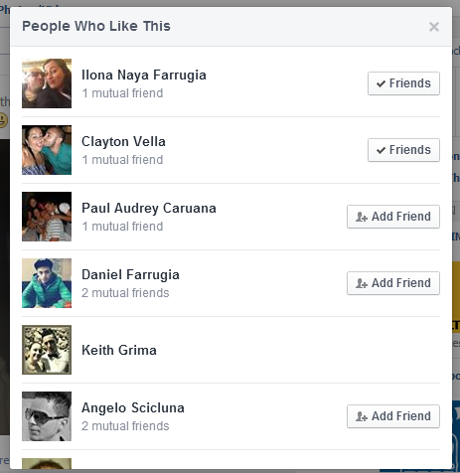

* + The groups part will also work as described in above
* **The body studio is displayed at the top in the wireframe** 
  + To the left there is the user’s body shape along with a smart way of showing the height. We need the body shape designs to be adjusted to the site for each body shape – if it’s too complicated and can’t be done in a smart/easy way, just let us know and we can use these below (they are also attached in the bodyshapes folder.
    - Women can have 4 different body shapes, they will obviously only have one displayed here.
      * 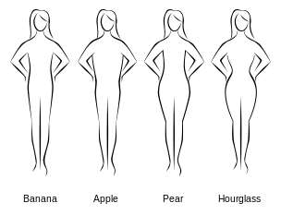
    - Men can have 5 different bodyshapes
      * Inverted triangle
        + 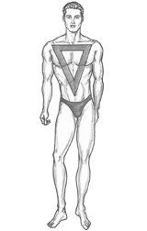
      * Trapezium
        + 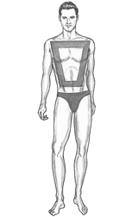
      * Rectangle
        + 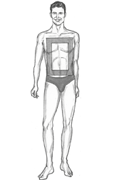
      * Oval
        + 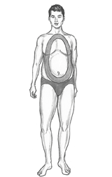
      * Triangle
        + 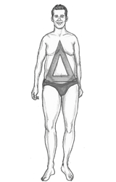
  + The users before and current picture of how their body looks will also be shown in the ’bodystudio’. This is thumbnails of their body’s that they take themselves. We would like to rename ‘Current’ to ‘During’. We are not sure if there should be aheader to these two photo’s, it needs to be clear of course that this is a before and ‘after/during’ picture of the persons body.
  + The user’s body measures are shown in a table. It displays how the body measures are today (Current) and how it was measured earlier (Start).
    - There needs to be easy access to adding an update as well as viewing and editing previous updates, so the ’current’ can be updated and the old updates can be edited. We imagine it functioning as described below.
      * When the user clicks any edit pen in the table or an ’add update’ button, it opens an iframe or new window where all the historical data is shown in a table together with the opportunity to add a new update. Below is a drafted version of it.

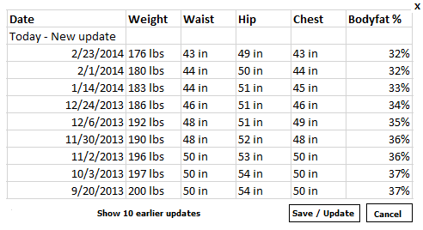

* + - * Please note, ‘waist’ should say ‘Min. waist’
      * All fields are editable by clicking a little pen to the left for each row of updates. There should also be a delete button. A new post is added in the fields at the top where the user can put in a date and measurement. By clicking at the bottom with ’show 10 earlier updates’ 10 more updates are shown and then you are able to click your way back again to the previous 10 updates.
      * We need some kind of an effect when you have the mouse/arrow over each header (min. waist, hip, chest, bodyfat) that will show a tooltip box explaining the specific header.  
        **Min. waist:** Measure your waist sucking it in as small as you can and the measure at the narrowest point between your belly button and your rib cage.  
        **Hip:** Place a tape measure at the widest part of your buttocks.  
        **Chest:** Measure the distance around your body just below the breasts/chest as you stand with upright posture.  
        **Body fat %:** The body fat percentage is the total mass of fat divided by total body mass. There are many ways to measure your body fat percentage. Your doctor, gym, personal coach and/or health clinics usually have a Bioelectrical Impedance device to measure with. Alternatively you can measure it yourself through an advanced scale or through skin fold measurements.
  + The progress bar displays the users start weight, goal weight and current weight. A very drafted version of how we imagine it is below.
    - 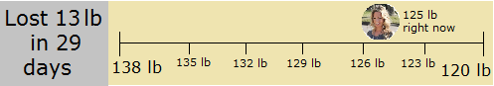
    - To the left it will state how much they have lost in either ‘lbs’ or ‘kg’, this number will be calculated based on their starting weight and goal weight. This will be followed by the number of days since they joined Twinbody.
    - To the right is where the counter is and on each side the start weight and goal weight will be placed. A minimized version of the user’s profile photo will be used to show how far he/she is progressing towards their weight goal. The weight right now will be taken from the body studio, using the last entry in the weight column.
    - If the user has gained instead of lost weight, it will to the left just say ‘Lost 0 lbs in XX days’ and to the right the profile photo will stay at the start of the line.
* To the far right there is a preview of the body studio chart. This should be a dummy picture in this phase that will show a graph of a person’s body weight progress and then it should be grey scaled and over it it should say ’Coming soon...’

**My diet journey**, is the primary content of the my body page and is a blog where users can post and edit their posts which will contain text, image and/or video alongside links.

When uploading images we are using the following plug-in, perhaps you need to keep this in mind when designing how it should look like when uploading several images: http://www.yoxigen.com/yoxview/

Below this the blog starts as pr. below. Note that the users can edit or delete their comments or blog posts of their own. This should not be a dropdown function (as it currently is on social.twinbody.com) but buttons/icons instead.

**Likes**

Note also that below each blog post there needs to be three different likes.

1. A heart
2. A flexed arm or similar (similar to the Skype version)
3. A four leaf clover

Similar to how it works on Instagram each like should be “grey” or without color if it hasn’t been clicked yet.

For each post and comment there needs to be the profile picture, username, time of posting, number of comments and number of how many likes they had of the two kinds of likes.

Below each blog update the likes are displayed in three rows we imagine in a similar fashion as to how Instagram does it:



When clicking the ’21 others’ in the above example, these 21 people (+ those 3 described before) fold out in a similar fashion as to how it would work with groups, coaches and twin connections in the user profile and how facebook does it.



The blog is in general VERY clumsy as it looks right now, we imagine the comments to be discreet and smaller like it is on Facebook for example like shown below:

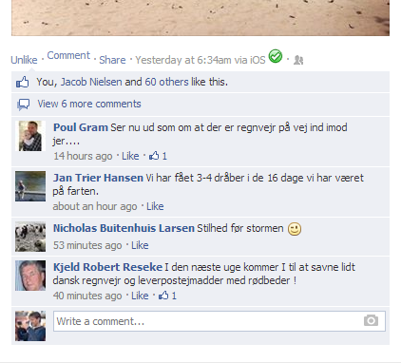

# Functions/features that won’t be available in phase 1 (This is out of scope and will not be delivered as part of this phase, it’s only FYI for later development)

* There will later be a picture progress page where users will be able to upload several pictures of their body progress as well as change/upload their before and during picture as it’s shown on their my body page. So the link to this page we were thinking could be done in a smart discreet way together with the before and during images.

# Additional comments

* We would like in the design mockups to have examples of how the diet journey would look like with different scenarios
  + Update with 1 picture
  + Update with 6 pictures and one video
  + Update with many comments and likes of different kinds
* We suggest logging in to understand the functionalities by going to social.twinbody.com and log in with username ‘Charmaine’ and password ‘fitness123’
* Please note that there needs to be 3 views of the my body page:
  + The owner of the specific page (This person should be able to edit all relevant areas, please try on social.twinbody.com)
  + The visitors to the page as twins (This person should be able to edit only his/her own posts or comments, not the rest of the areas, which belongs to the owner of the blog)
  + The visitor to a hidden profile (A person who is trying to view a hidden profile won’t be able to see everything on the page)
    - For the hidden profile version it should only display the below information:
      * Username
      * Profile photo
      * Age
      * Starting weight
      * Goal weight
      * Current weight

The rest needs to be shown in a dummy setting where you can clearly see that you need to add the user to see the rest of the profile. Up to designer to visualize this in a smart way.

* There needs to be a function to switch between American and European ways of measuring which could possibly be placed on this page if it isn’t clear/easy enough in the top menu.