Find users page

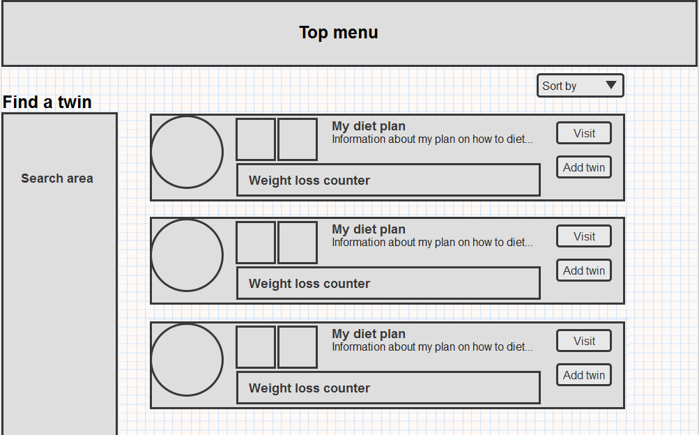

# 

* **Search area**, this will work from ticking of predefined search intervals and the profiles will be loaded as these are ticked on and off. It will work similar to how asos.com search function works. Please try and search it here: <http://www.asos.com/Search-Page-10/Cat/pgecategory.aspx?cid=18704&WT.oss=jeans&WT.oss_r=1&oss_pv=1&oss_url=1>
* **Switch between twins & coaches**, it should be possible to switch the search mode between twins and coaches. We are not sure about the best way to do this but one idea is to have two tabs at the top of the search area with ‘Twins’ and ‘Coaches’. When clicking on any of them the search area will change. So for example instead of the header ‘Find a twin’ to the left in the wireframe, it would say ‘Find users’ and then below two tabs, one with twins and one with coaches.
* **Filters**, in the search area the user should be able to find a user with the following filters available:
  + Search for a twin
    - Gender
      * Female
      * Male
    - Age
      * < 25
      * 26-35
      * 36-50
      * 51 >
    - Starting weight
      * < 60 kg
      * 61 kg – 70 kg
      * 71 kg – 80 kg
      * 81 kg – 90 kg
      * 91 kg – 100 kg
      * 101 kg – 120 kg
      * 121 kg >  
        **or**
      * < 130 lbs
      * 131 lbs – 160 lbs
      * 161 lbs – 190 lbs
      * 191 lbs – 210 lbs
      * 211 lbs – 240 lbs
      * 241 lbs – 280 lbs
      * 281 lbs >
    - Lost weight
      * < 10 kg
      * 11 kg – 20 kg
      * 21 kg – 30 kg
      * 31 kg – 40 kg
      * 41 kg >  
        **or**
      * < 20 lbs
      * 21 lbs – 40 lbs
      * 41 lbs – 60 lbs
      * 61 lbs – 80 lbs
      * 81 lbs >
    - Height
      * < 155 cm
      * 156 cm – 165 cm
      * 166 cm – 175 cm
      * 176 cm – 185 cm
      * 186 cm >  
        **or**
      * < 5’
      * 5’1’’ – 5’3’’
      * 5’4’’ – 5’6’’
      * 5’7’’ – 5’9’’
      * 5’10’’ – 5’11’’
      * 6’ >
    - Body shape (will be delivered by Johan and Jorgen)
      * 4 different images with body shapes for females
      * 5 different images with body shapes for males
  + Search for a coach
    - Coach title
      * Training
      * Nutrition
      * Psychology)
* **Measurement switch**, there should somehow be a smart way to switch between US and European measurements in the search filters.
* Search result, to the right is where twins and coaches will be displayed, this is what each of them should contain:
  + Twins
    - Profile photo
    - Username
    - Age
    - Height
    - Weight loss counter
    - Before and after picture
    - Diet plan (the diet plan will be max 200 characters long but perhaps all of that can’t be displayed on each user for the search page so in that case let us know how much can fit in there and end it with ‘…’
  + Coaches
    - Profile photo
    - Coach title
    - Presentation text (as this will probably take up most of the space in the coach search result let us know how many characters it will be able to show maximum)
* **Sort function**, at the top it should be possible to sort the search results. We are not sure how this is best displayed so we are open for suggestions. It will only be possible to sort on a twin search, and not a coach search:
  + Age
  + Height
  + Starting weight
  + Weight loss
  + Latest blog post
* **Visit or connect**, to the right there will be a link to either visit the profile page of the specific user or add the user as a connection.

# Additional comments

* Please note that there needs to be an easy access to the groups page by having a link/banner/text that does not look promotional but is an integral part of the website and easy access to searching for groups. In the same way as it’s done for the cross to search from the ’My twins’ page.