2/ On Firefox, drag&drop of folder for upload pictures is not accepted. (One of this when create folder and sfter that can’t add new files to upload)

3/ In Chrome, when I drag&drop files to upload, sometimes, they are listed on 2 columns instead of 3. See below:

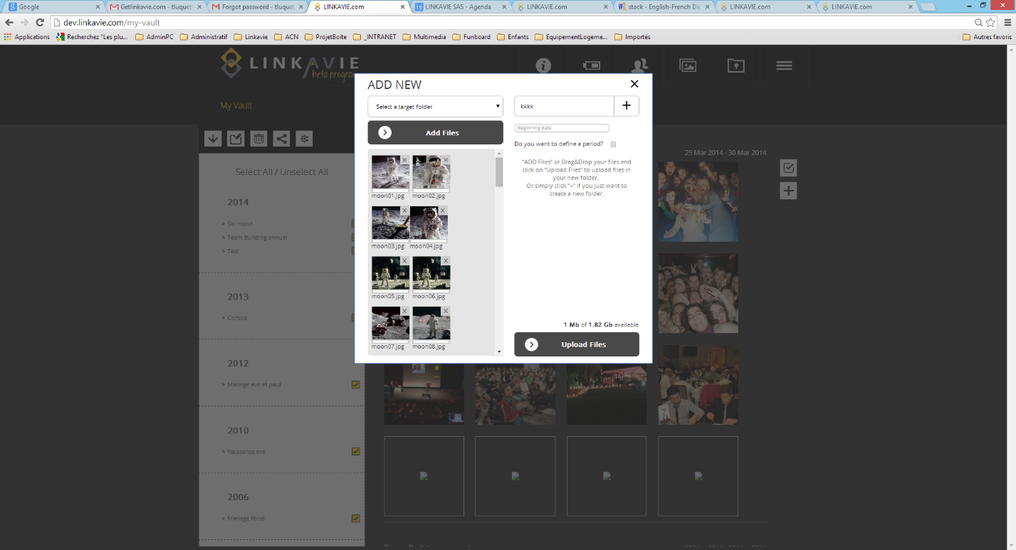

4/ Inviting someone to be friend:

User has to login with his temp login/pwd. But we should also propose to register at LINKAVIE NEwsletter on the popup. Else, we have no way to get him in the Newsletter

5/ Not sure it's a bug, but on dev, pictures with no link can't be deleted...If a picture get lost, I'd like to remove the picture icon from the vault.

6/ Sharing:  enter emails seperated by commas

-> If user enter emails with a space after comma, it says "Emails is wrong"...Difficult to understand for a user. Should say "Email is wrong or check you didn't put spaces after commas"

7/ Contacts: Should be shown in alphabetic order (As defined in specs)

8/ Translation part 2 L47 "Sorry. Server is broken. Come back later"

=> We should never have such kind of message.

To replace by "Sorry, an error has been met. Our services have been informed to resolve the issue. Please come back later"

=> I changed it in the file part 2

Not urgent:

9/ Reports: Date selection month and years are blank

10/ Reports: Avg storage - When I click on a report tab (for instance Friends links) and then I click on Avg storage tab, I get a report with big figures, which is totaly diffrent than if I do a click on "Filter button" for the same avg storage period ??? - Strange

+ indicate that it's in "GB" => Avg Storage (GB) and put 3 digits (MBs) after comma.

11/ First time library doesn’t display all albums. Should be refreshed to see

12/ add new pictures to carrousel in wooden theme there are no closed cross at this popup

13/ when delete last picture in carrousel from the vault the page is broken