Problem with SPF :

Mailjet.com reports SPF error (see below) laso in Mailjet accoutn DNS setup link.

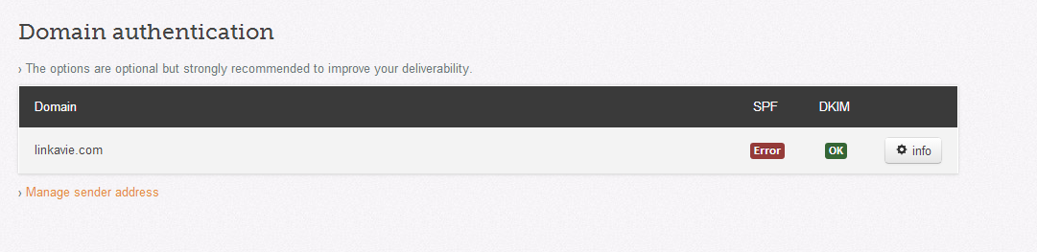

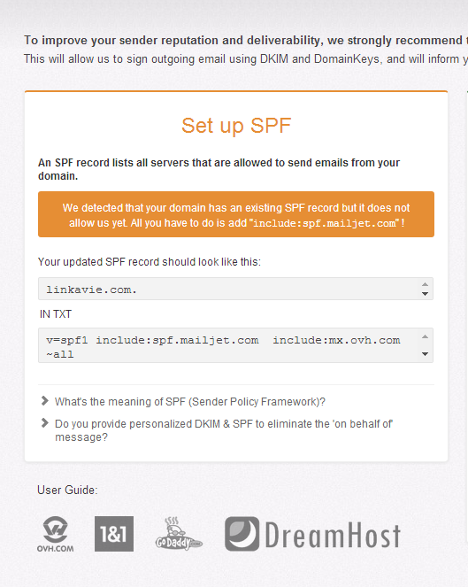

**Config at OVH :**



Today, some users received emails but with such alerts: Be careful ! This sender failed our fraud detection checks (See sample below)

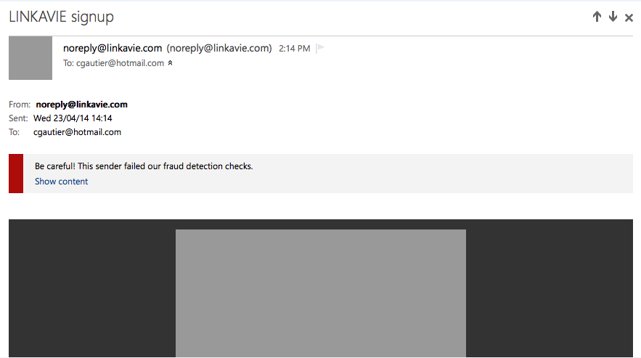

**What I found on INTERNET :**

****************************************************

Hi,

I am aware that you guys received an email from a trusted source and have been added to your safe list, but keep getting a warning message:

**Be careful! This sender failed our fraud detection checks**

To resolve this issue, the sender’s domain administrator should add the **SPF record** in the domain registrar. You may contact the sender's administrator to verify this information.

<http://answers.microsoft.com/en-us/outlook_com/forum/oemail-osend/be-careful-this-sender-failed-our-fraud-detection/c1712db2-00ab-4e61-8ede-d20aa6486f45>

IL SEMBLE QU’IL Y AI DONC BIEN UN PROBLEME DE CONFIGURATION SPF. MA CONFIG CHEZ OVH EST COMME SUIT