1. It looks like the text ’Twins’ and ’Coaches’ is not completely centered? We like the icons but had some feedback that the ribbon that goes around the neck for the whistle looked a bit weird so can you just take off the ribbon part?  
   



1. We don’t need the text next to the measurement switcher and to avoid empty space to the left we would like it to look like this with moving up the filters:  
   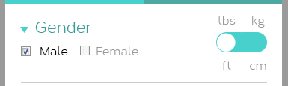
   1. Alternatively we can move the measurement switch to the top next to the tabs for ‘Twins’ and ‘coach’ search?



1. We think that the sort by text can be much smaller in height without making it look to cramped. Maybe just align it with the ‘Twins’ and ‘coaches’ tabs? Something like the below? We are also curious to see how it will work when you actually sort something, as you should be able to sort it in both ways (up & down), how it will display what you have sorted on etc.. We imagine that it is blank without a triangle to pr. default. Then when its clicked it sorts from top to bottom and show triangle one way and when its clicked again the triangle goes the other way and it sorts from bottom to top.  
   



1. When looking at the search results the first impression is that it’s not very aligned. We created an example of how we would like it to look like. The bottom example is how a search result will look like by default and when you click the foldout icon besides ‘Diet plan’ it will look like the top example. We have decided to remove the two buttons as we assume you will have the same hoover effect on the profile picture as you have when clicking the likes:  
   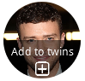  
   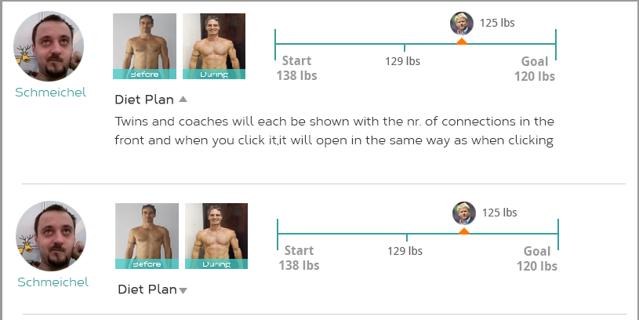



1. Regarding the selection of body shapes, it’s not really clear which body shape is being selected and we also need the same default image to show that no body shape is selected as we described in the feedback for the edit profile section in the my body page.
2. We are also curious to see how the coach search will look like, but trust you’re on top of this one. This one is described in the requirements doc for the page.
3. Remember also the dummy versions of the private profiles. The users who will only have Username and user profile picture in there and the rest will be blurred out somehow through a dummy/default version. There could be a private / personal stamp, they basically need to be connected to see the info. In the same way as comment 1. In the feedback for the my body page. Again please let us know and we can prepare some more detailed drafts/mockups of what we mean…

The user profile picture dummy looks good. These items are still remaining in nr. 7 for private profiles:

* Before picture
* During picture
* Progress bar.

1. There might be a bit too much space above and below the measurement switch at the top left.
2. The add to twins symbol at the bottom that you suggested looks good, could you add this to the top one as well, so it is just there pr. default instead of the hovering over effect of the top one. Just have it say ‘Add twin’ instead of add to twins.