visualization

April 29, 2025

[67]:

**import matplotlib.pyplot as plt import seaborn as sns**

**import numpy as np import pandas as pd**

[68]:

df= pd.read_csv('heartdisease.csv') df.head(5)

1. : age sex cp trestbps chol fbs restecg thalach exang oldpeak slope \

|  |  |  |  |  |  |  |  |  |  |
| --- | --- | --- | --- | --- | --- | --- | --- | --- | --- |
| 0 | 63 1 | 1 | 145 | 233 1 | 2 | 150 | 0 | 2.3 | 3 |
| 1 | 67 1 | 4 | 160 | 286 0 | 2 | 108 | 1 | 1.5 | 2 |
| 2 | 67 1 | 4 | 120 | 229 0 | 2 | 129 | 1 | 2.6 | 2 |
| 3 | 37 1 | 3 | 130 | 250 0 | 0 | 187 | 0 | 3.5 | 3 |
| 4 | 41 0 | 2 | 130 | 204 0 | 2 | 172 | 0 | 1.4 | 1 |

ca thal num

0 0 6 0

1 3 3 2

2 2 7 1

3 0 3 0

4 0 3 0

1. :

*#Barplot using seaborn*

sns.barplot(x='sex', y='thalach', data = df)

1. : <Axes: xlabel='sex', ylabel='thalach'>

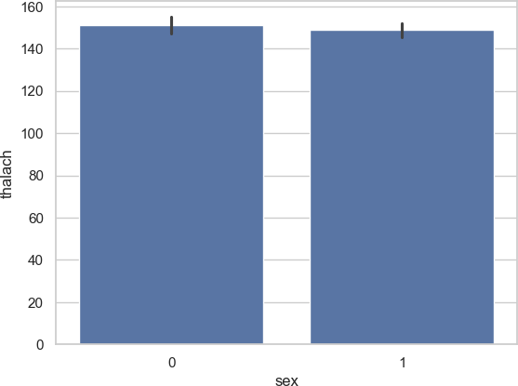

1. :

*#ScatterPlot using seaborn*

sns.scatterplot(x='age', y='thalach', data = df)

1. : <Axes: xlabel='age', ylabel='thalach'>

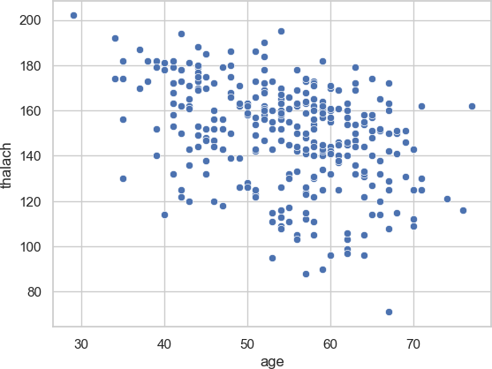

1. :

*#Lineplot using seaborn*

sns.lineplot(x='sex', y='age', data = df)

1. : <Axes: xlabel='sex', ylabel='age'>

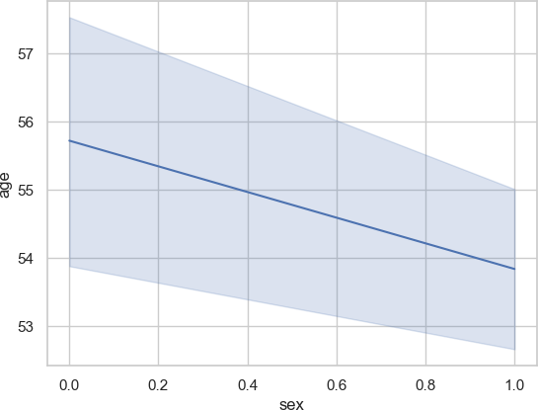

1. :

*#Pairplot using seaborn*

plt.figure(figsize=(12,12))

sns.pairplot(df, hue= 'sex' , palette = 'Blues')

1. : <seaborn.axisgrid.PairGrid at 0x2ad758de270>

<Figure size 1200x1200 with 0 Axes>

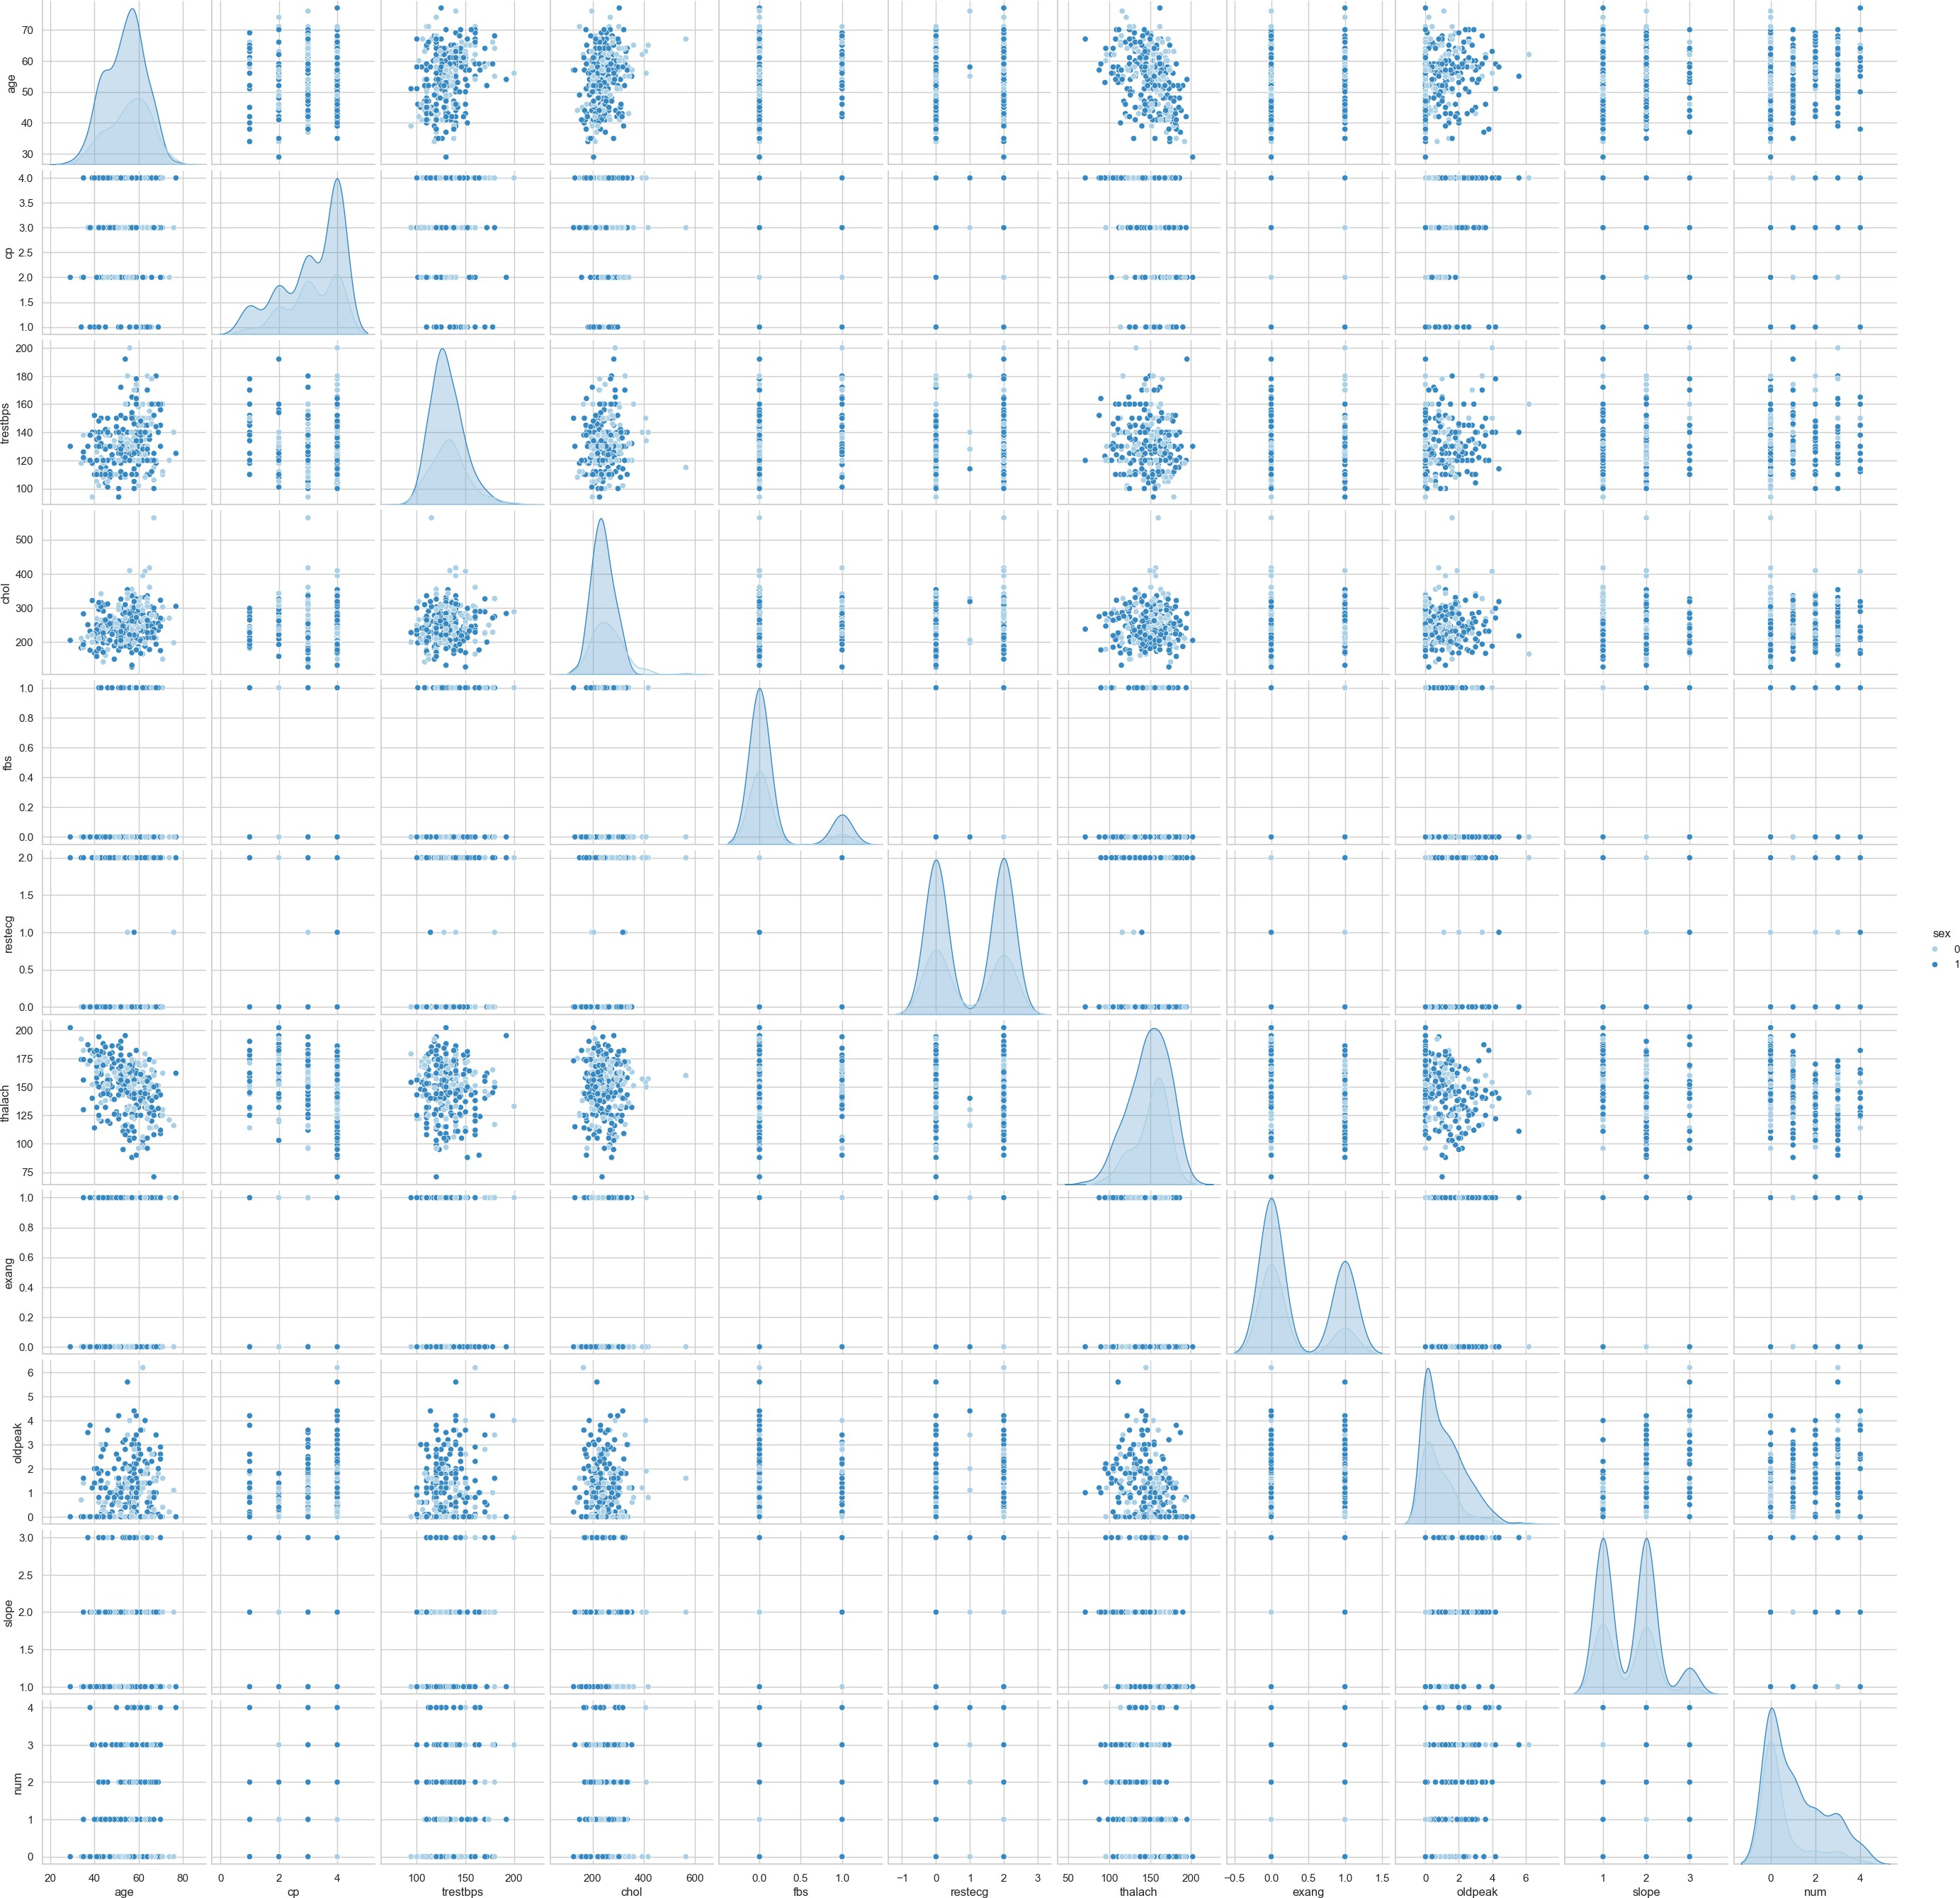

1. :

*#Displot using seaborn*

sns.displot(df['thalach'])

1. : <seaborn.axisgrid.FacetGrid at 0x2ad7d1babd0>

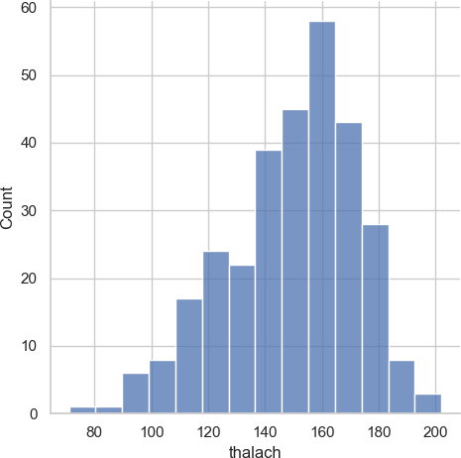

1. :

*#ScatterPlot using Matplotlib* plt.scatter(df['thalach'], df['age']) plt.show()

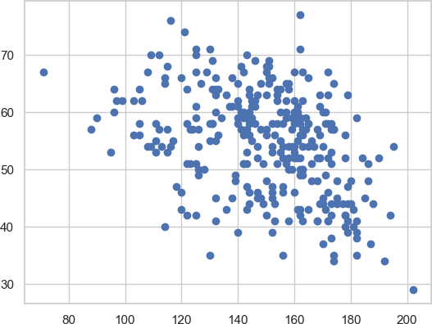

1. :

*# First, create the DataFrame correctly*

sex_df = pd.DataFrame(df['sex'].value_counts()) sex_df.columns = ['count'] *# Rename the column for clarity*

1. :

*# Now plot*

plt.pie(sex_df['count'], labels=sex_df.index, autopct='**%1.1f%%**') plt.title("Distribution by Sex - Pie Chart")

plt.show()

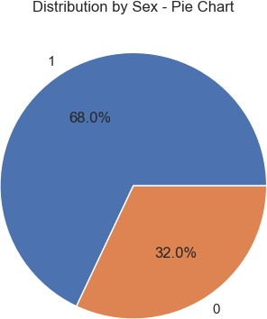

1. :

*# Bar chart*

plt.bar(sex_df.index, sex_df['count']) plt.title("Distribution by Sex - Bar Chart") plt.xlabel("Sex")

plt.ylabel("Count") plt.show()

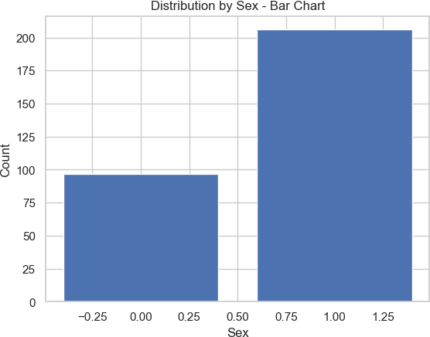

1. :

*# Step 1: Import libraries*

**import pandas as pd**

**import matplotlib.pyplot as plt import seaborn as sns**

1. :

*# Step 2: Load dataset*

df = pd.read_csv('AirQuality.csv') *# Ensure the file is in the same directory*

df['Datetime'] = pd.to_datetime(df['Date'] + ' ' + df['Time'], dayfirst=**True**)

1. :

*# Set seaborn style*

sns.set(style='whitegrid')

1. :

*#*

*# BAR PLOT: Average CO per day #*

df['Date'] = pd.to_datetime(df['Date'], dayfirst=**True**)

daily_avg_co = df.groupby(df['Date'].dt.date)['CO(GT)'].mean().head(10) *#*␣

𝗌*First 10 days for simplicity*

plt.figure(figsize=(10, 6))

sns.barplot(x=daily_avg_co.index, y=daily_avg_co.values, palette='Blues_d') plt.xticks(rotation=45)

plt.title('Average CO(GT) for First 10 Days') plt.xlabel('Date')

plt.ylabel('Average CO(GT)') plt.tight_layout() plt.show()

1. :

*#*

*# PIE PLOT: CO(GT) category proportions #*

co_levels = pd.cut(df['CO(GT)'], bins=[-1, 1, 3, 6, 10], labels=['Low',␣

𝗌'Moderate', 'High', 'Very High']) co_counts = co_levels.value_counts()

plt.figure(figsize=(6, 6))

C:\Users\amans\AppData\Local\Temp\ipykernel_14288\905959813.py:8: FutureWarning:

Passing `palette` without assigning `hue` is deprecated and will be removed in v0.14.0. Assign the `x` variable to `hue` and set `legend=False` for the same effect.

sns.barplot(x=daily_avg_co.index, y=daily_avg_co.values, palette='Blues_d')

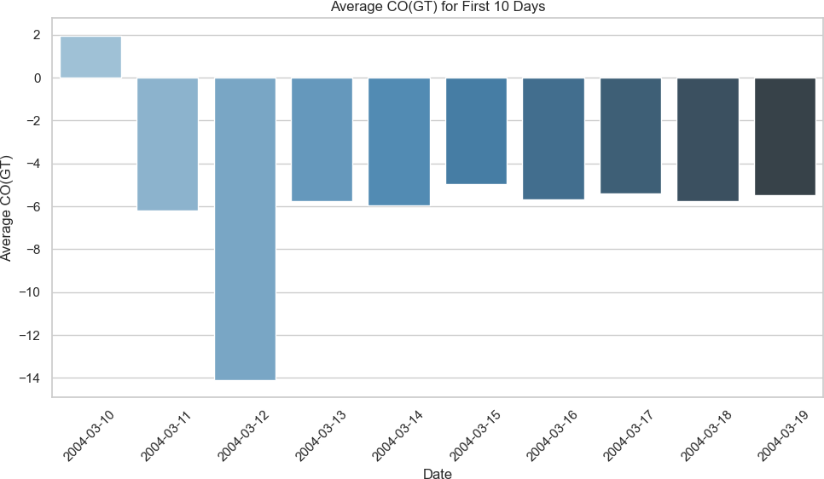

plt.pie(co_counts, labels=co_counts.index, autopct='**%1.1f%%**', startangle=90,␣

𝗌colors=sns.color_palette('pastel'))

plt.title('CO(GT) Levels Distribution') plt.show()

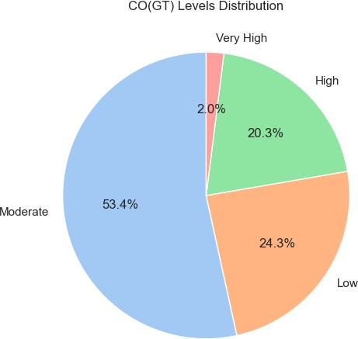

1. :

*#*

*# SCATTER PLOT: CO(GT) vs NO2(GT) #*

plt.figure(figsize=(8, 5))

sns.scatterplot(data=df, x='CO(GT)', y='NO2(GT)', color='purple') plt.title('CO(GT) vs NO2(GT)')

plt.xlabel('CO(GT)')

plt.ylabel('NO2(GT)') plt.tight_layout() plt.show()

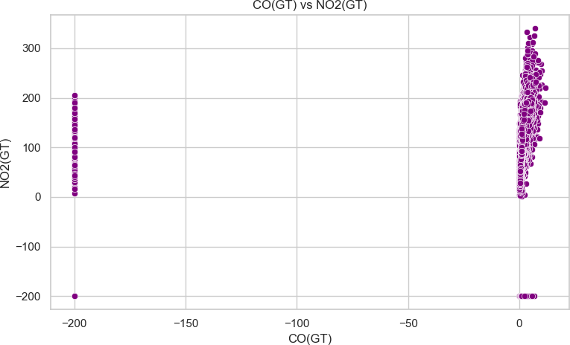

1. :

*#*

*# DISPLOT: Distribution of Temperature #*

sns.displot(df['Temp'].dropna(), bins=30, kde=**True**, color='orange', height=5,␣

𝗌aspect=1.5)

plt.title('Distribution of Temperature') plt.xlabel('Temperature (°C)') plt.show()

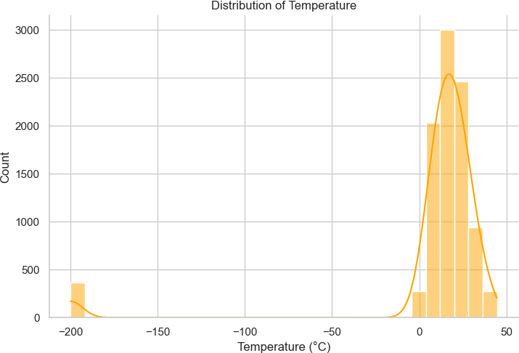

1. :

*#*

*# LINE PLOT: NO2(GT) Over Time #*

plt.figure(figsize=(14, 5))

plt.plot(df['Datetime'], df['NO2(GT)'], label='NO2(GT)', color='teal') plt.title('NO2 Concentration Over Time')

plt.xlabel('Datetime') plt.ylabel('NO2 (GT)') plt.legend() plt.tight_layout() plt.show()

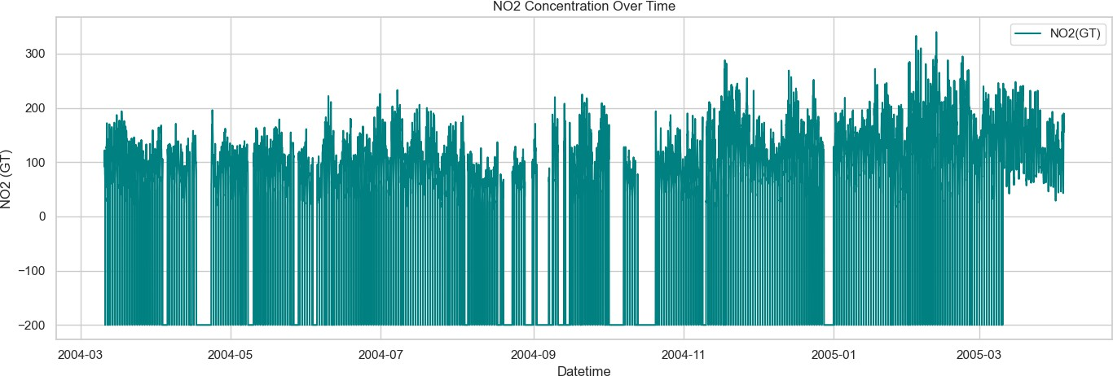

1. :

*# Step 8: Pair Plot - Selected Features*

selected_features = ['CO(GT)', 'NO2(GT)', 'Ozone', 'Temp'] sns.pairplot(df[selected_features].dropna()) plt.suptitle('Pairplot of Selected Features', y=1.02) plt.show()



 

 