**Narrowband Interference Removal from Binary FSK Signal Using Selective Median Filtering**

School of Electrical Engineering and Applied Science

University of Virginia

In Partial Fulfillment

Of the Requirements for the Degree

Bachelor of Science in Electrical Engineering

By

**Sattyik Kundu**

**July 2, 2012**

On my honor as a University student, I have neither given nor received unauthorized aid on this assignment as defined by the Honor Guidelines.

**Executive Summary**

Narrowband interference and impulse cancellation algorithms are parallel problems in the frequency domain and in the time domain, respectively. In this report, we describe a median filter based method for removing narrowband interference signal from the transmitted binary FSK (frequency shift keying) signal corrupted by both AWGN (additive white Gaussian noise) and narrowband interference. The FFT-magnitude of received FSK signal shows the narrowband interferences as impulses. Thus, the median filter can be applied to remove these impulses in the FFT-magnitude domain. Furthermore, FFT-phase values are not filtered. The filtered FFT-magnitude and the unaltered FFT-phase of the received (corrupted) FSK signal are next combined to create the filtered FFT signal. Using IFFT (inverse FFT), this filtered signal is then converted to time domain, and subsequently demodulated using non-coherent demodulation. The effectiveness of this simple filter is evaluated by(?) using improvement of BER (bit error rate) vis-à-vis no filtering scheme.

1. **Introduction**

The interference immunity of a digital communication system corrupted by narrowband interference can be significantly enhanced by excising the narrowband interference. Excision methods could be as simple as notching out, i.e., use of notch filter, the DFT coefficient(s) belonging to narrowband interference [1]. Narrowband interference and impulse cancellation algorithms are parallel problems in the frequency domain and in the time domain, respectively [2]. This work described in [2] presents iterative consecutive mean excision (CME) algorithms that can be used for these problems. However, one filter that is very effective in removing any impulse type distortion from signal is median filter [3]. For this reason, a median filter based method (Appendix-I) is chosen for removing the narrowband interference signal from a transmitted binary FSK (frequency shift keying) signal corrupted by both AWGN (additive white Gaussian noise) and narrowband interference. The FFT-magnitude (not power spectrum) of the received FSK signal shows the narrowband interferences (modeled for convenience as single frequency sinusoids) as impulses. Thus, the median filter can be applied to remove these impulses in the FFT-magnitude domain. Our experiments show that the FFT-phase spectrum should not be filtered or altered. The filtered FFT-magnitude and the unaltered FFT-phase of the received (corrupted) FSK signal are then combined to create the filtered FFT signal. Using IFFT, this filtered signal is converted to time domain, and then demodulated using non-coherent demodulation. The effectiveness of this simple filter is evaluated using improvement of BER vis-à-vis no filtering scheme.

This report is organized as follows. In section II, we describe our signal generation, noise model and the filtering scheme in detail. In section III, we describe detailed experimental results. Conclusions are described in Section IV.

1. **Proposed Filtering Scheme**

Figure 1 describes the scheme graphically. The steps are described below

1. Create FSK signal
2. Add Gaussian additive noise and narrowband sinusoidal interference noises; thus, noise model is (AWGN + Narrowband Interferences). Narrowband Interference is modeled as number of pure sinusoids with random amplitudes and random frequencies spread over the entire bandwidth.
3. Take the FTT of the noise corrupted signal.
4. Detect impulse type distortion in FFT magnitude domain using a peak detection algorithm, and then apply median filtering of FFT magnitude values only for those data points in the vicinity where peaks are detected; if no peak is detected at a particular data point, that data is not filtered or altered. In this report, this filtering scheme is referred to as *‘selective median filtering’*. On the other hand, if all data points (except two data points belonging to critical FSK frequencies

f and f as given by Eq. (3) below) in FFT magnitude domain are filtered by median filter, that filtering scheme is referred to as ‘*plain median filtering’* in this report.

1. FFT phase values are not filtered or altered.
2. Combine filtered FFT magnitude and unfiltered FFT phase, and take IFFT to create the time domain filtered signal.
3. Demodulate the filtered time domain signal using non-coherent detection.

Generate FSK Signal

Add white Gaussian noise and narrowband strong interference signal

See Figure 2

Detect peaks of FFT magnitude of corrupted signal

Replace FFT magnitude value at peak positions with a N-point median filtered value (FSK frequencies not filtered)

Do NOT alter FFT phase

Demodulation

BER Computation

Combine filtered FFT magnitude and unfiltered FFT phase

Take IFFT of combined spectrum to create time domain signal

Figure 1: Block diagram representation of filtering scheme; blocks with blue background depict the contribution of this work.

**Signal Model**

The objective is to generate binary FSK signal using continuous phase frequency shift keying (CPFSK). CPFSK is a special case of FSK where the phase is continuous [4]. A continuous phase is desirable since it is a spectrally efficient modulation scheme.

For modulation, a useful way of representing the CPFSK signal is to

express it in the conventional form of an angle-modulated signal:

 (1)

The phase of CPFSK signal increases or decreases linearly with the

time during each bit duration of  seconds:

 , (2)

here, the plus sign corresponds to sending symbol +1, and the minus sign corresponds to sending symbol -1 (or 0); the dimensionless parameter h is the deviation ratio (or modulation index). Thus, the phase shift over a bit period is +πh for symbol +1, and –πh for symbol -1 (or 0) [4].

Two FSK frequencies are then given by the following equation.

 (3)

**Noise Model**

As noted before, the noise model is made up of AWGN and Narrowband Interference. The narrowband Interference is modeled as a number of pure sinusoids with random amplitudes and random frequencies spread over the entire bandwidth. The noise model is implemented as follows.

1. Specify SINR – Signal to (Interference + Noise) in dB
2. Convert SINR to its absolute value
3. Set INR (Narrowband Interference to Noise) equal to K (typically 25).
4. SNR is equal to SINR *(1 + INR)
5. SIR = SNR/(INR + a very small number like 10^(-15))
6. Set signal power to 1 (P=1)
7. Find thermal noise and interference standard deviations from SNR and SIR (MATLAB code is shown in the Appendix)

Figure 2 shows the effect of the noise model. Here, length of the FSK signal =1024 bits; power ratio of AWGN-to-Narrowband Interference = 25; sampling frequency = 100 KHz, FSK center frequency = 25 KHz, bit period = 0.0005 sec. and h (modulation index) =1. Figure 2 shows the FFT magnitude of the noise corrupted signal normalized by the length of FFT (1024 x 50). It is clear that the narrowband interference signal (modeled as pure sinusoids) appears as a series of impulses in the frequency domain.

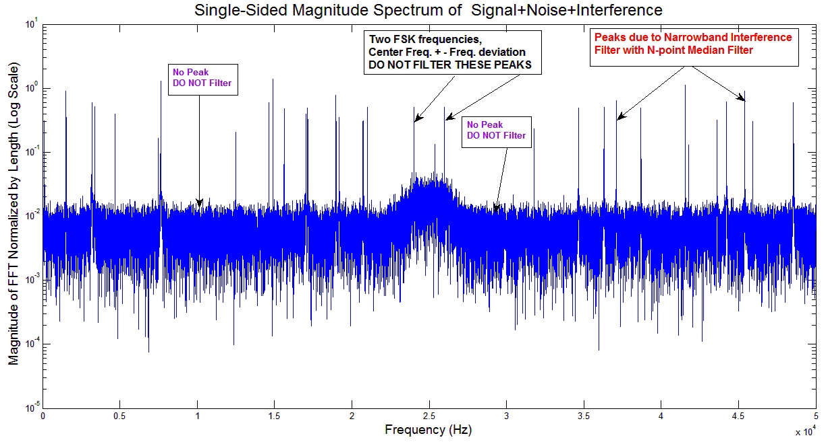Figure 2: FFT Magnitude spectrum of CPFSK + white Gaussian additive noise + narrowband interference signal, sampling frequency =100 KHz, center frequency = 25 KHz, FFT length = 1024 (no. of bits) x 50 (no. of samples/bit), h (modulation index)=1

Consider Figure 2. In this example, the sampling frequency is 100 KHz, center frequency separation is 25 KHz. In this graph, the FSK frequencies are 26 KHz and 24 KHz, and they appear as two impulses for this particular modulation index. The peak detection algorithm will very likely detect these peaks, but the data points belonging to these two frequencies should not be filtered (Figure 2). The data points belonging to other detected peaks due to narrowband interference will be filtered as shown in Figure 2. The data points that are not detected as peaks will also not filtered (Figure 2).

**Implementation Details of Filtering Scheme:**

1. Take FFT of a multi-bit window of noise corrupted FSK signal and detect position of peaksin FFT magnitude domain.
2. The peak detection algorithm evaluates every FFT magnitude data point for the possible existence of peaks. The peak detection algorithm uses both slope and magnitude information over a window of samples centered at the data point under consideration. The algorithm declares the FFT magnitude data point as a peak if its slope, computed over a window centered at the data point, exceeds slope threshold, and the FFT magnitude value exceeds peak threshold (see Figure 2 above). These thresholds are empirically determined.
3. If the detected peak is not close to any two critical FSK frequencies f and f as given by Eq. (3) below, replace the FFT magnitude value by the N-point (typically 21) median filter using FFT magnitude data around the data point under consideration; otherwise no filtering is done (see Figure 2 above). The choice of 21-point median filter is an empirical one.
4. Do not do any alteration of FFT phase values.
5. Combine filtered FFT magnitude and unfiltered FFT phase values.
6. Take the IFFT of combined modified FFT to get the time domain signal.
7. Demodulate the filtered time domain signal using conventional non-coherent detection to recover bit sequence.

As described before, Figure 2 shows which data points of FFT magnitude are filtered using the median filter. Figure 3 shows the effect of filtering by 21-point selective median filtering. In Figure 3, two-pass selective median filtered version (blue) of magnitude of FFT of noisy FSK signal (signal+ white Gaussian noise + narrowband interference signal) is superimposed on magnitude of FFT of noisy signal (red); clearly many impulses are severely reduced in value or removed while critical FSK frequencies (f and f as given by Eq. (3)) are preserved. Naturally, we would expect a much improved BER performance. A very relevant question is whether there is any need for peak detection at all. In other words, one can filter all FFT magnitude data points except those close to two FSK frequencies using the median filter (previously referred to as plain median filtering). In our experiments the results of selective median filtering based on peak detection is compared with that of plain, or non-selective, median filtering that needs no peak detection. It is found that selective median filtering indeed performs better than plain median filtering.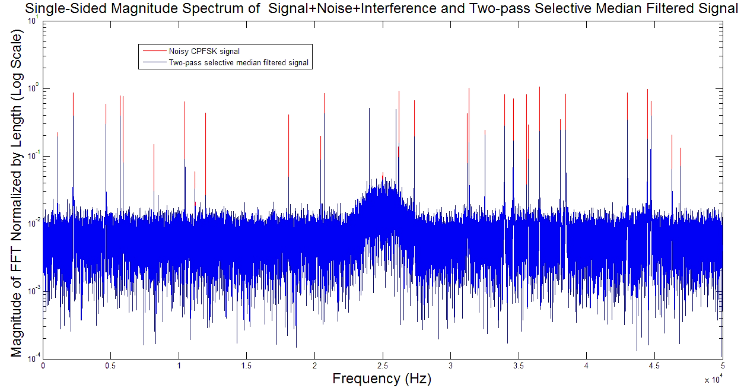Figure 3: Selective median filtered version (blue) of magnitude of FFT of noisy signal (FSK + white Gaussian noise + narrowband interference signal) superimposed on magnitude of FFT of noisy signal (red); sampling frequency =100 KHz, center frequency = 25 KHz, FFT length = 1024 (no. of bits) x 50 (no. of samples/bit), h (modulation index) =1, many impulses are severely reduced in value or removed while critical FSK frequencies are preserved.

**Detection/Demodulation Scheme**

The FSK signal demodulation is non-coherent since there is no phase recovery inside the receiver program. Because our CPFSK signal has a random signal carrier phase at the onset of a new bit, consider the binary digital communication system in which the transmitted signal is

  (4)

Where E is the energy,  is the duration of the signaling interval, and the carrier frequency  for the symbol *i* is an integral multiple of . The receiving signal, assuming an AWGN channel and a non-coherent system, may be written as

  (5)

where is the unknown carrier phase, and is the sample function of a white Gaussian noise process of zero mean and PSD .

We define

  (6)

The binary hypothesis test (i.e. the hypothesis that signal  or was transmitted), which is also our decision test for our bits, can now be used written as

 (7)

where I(.) is the modified Bessel function. Since the modified Bessel function is a monotonically increasing function, we can carry out the test in terms of also [4]:

 (8)

The test given above defines optimal quadratic non-coherent detection scheme in additive white Gaussian noise and is graphically shown below in Figure 4. Needless to say, we can also use the absolute value of the statistic instead of the squared value.

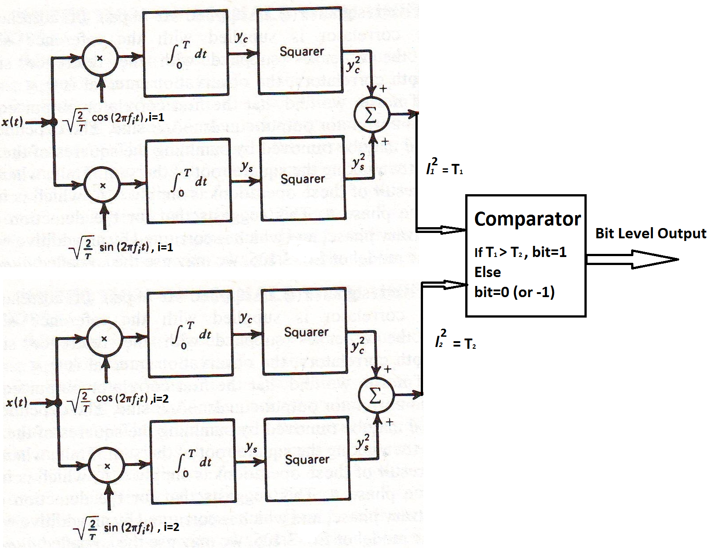

Figure 4: Simple non-coherent detection of BFSK

The decoding scheme shown in Figure 4 is used in our experiments.

1. **Experimental Results**

In this section, we describe the experimental results in details. Here, the length of the FSK signal =1024 bits; additive Noise-to-Interference Ratio = 25; and the number of samples per bit (symbol) = 50. We consider three cases: 1) sampling frequency = 100 KHz, center frequency 25 KHz, and CPFSK frequency separation = 2 KHz (bit period=0.0005 sec, h=1), 2) same as case 1 except h=2 and frequency separation of 4 KHz, and 3) same as case 1 except h=4 and frequency separation of 8 KHz. These experiments are done to show 1) the effect of different filtering schemes and 2) the effect of frequency separation on the filtering scheme.

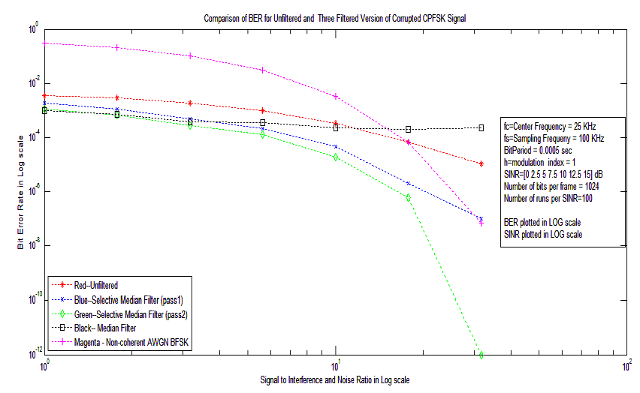

Figure 5: Comparison of BER for plain median filtered, selective median filtered (one and two pass) and unfiltered corrupted FSK signal, average of 100 simulations used to compute BER, sampling frequency = 100 KHz, FSK center frequency = 25 KHz, frequency separation = 2 KHz, theoretical value of AWGN limited non-coherent BFSK is shown for comparison

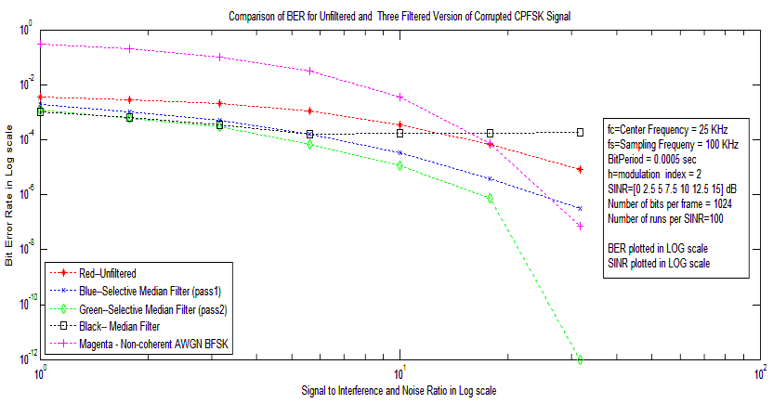

Figure 6: Comparison of BER for plain median filtered, selective median filtered (one and two pass) and unfiltered corrupted FSK signal, average of 100 simulations used to compute BER, sampling frequency = 100 KHz, FSK center frequency = 25 KHz, frequency separation = 4 KHz, theoretical value of AWGN limited non-coherent BFSK is shown for comparison

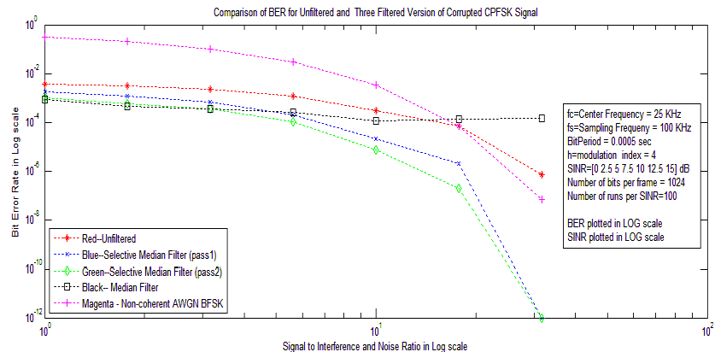

Figure 7: Comparison of BER for plain median filtered, selective median filtered (one and two pass) and unfiltered corrupted FSK signal, average of 100 simulations used to compute BER, sampling frequency = 100 KHz, FSK center frequency = 25 KHz, frequency separation = 8 KHz, theoretical value of AWGN limited non-coherent BFSK is shown for comparison

From the experiments above (Figures 5, 6 and 7), a clear trend is observed. For SINR less than 5 dB, the plain median filtering that does not use any peak detection information outperforms the single pass selective median filtering that uses peak detection information to filter only the data at the peak position. However, after SINR crosses 5 dB, the peak detection based selective median filter does better. The reason for such results is fairly obvious. At very low SINR, the amplitudes of narrow-band interference frequencies are rather strong. A plain median filter will suppress these impulses rather well though it will filter other data points not corrupted by interference as well. However, the positive gain with interference suppression far outweighs the loss of signal quality. At higher SINR, the amplitudes of narrow-band interference frequencies are rather small. Thus, the positive gain with interference suppression cannot outweigh the loss of signal quality. This explains why we get a rather flat BER performance for the plain median filter. For selective median filter, the positive gain with interference suppression always outweighs the loss of signal quality. Hence, this filtering scheme shows consistent improvement with increasing SINR. To overcome the shortcomings of one-pass selective median filtering at low values of SINR, two pass selective median filtering is used. When we do a second pass of selective median filtering, we see that this filtering scheme is uniformly better than median filtering over the entire range of chosen SINR. This trend is seen for all frequency separations. *Hence, we conclude that the selective median filtering scheme based on peak detection algorithm is a better choice that plain median filtering.*

1. **Conclusions**

This report discusses narrowband interference removal from transmitted CPFSK. Filtering clearly improves BER performance. Although the experiments are carried out using CPFSK signal, the scheme proposed here is also applicable to plain FSK signal. We make the following conclusions:

1. Two-pass selective median filter is good for the entire SINR range, while (non-selective) plain median filtering is good for SINR less than 5 dB.
2. The selective two-pass median filtering scheme based on peak detection algorithm is a better choice than plain median filtering.
3. The same trend is observed at all FSK frequency separations.
4. At higher SINR, the amplitudes of narrow-band interference frequencies are rather small. Since plain median filtering filters all the data points, it introduces signal distortion. In this case, the positive gain with interference suppression cannot outweigh the loss of signal quality. This explains why we get a rather flat BER performance for the plain median filter, and BER performance does not improve with high SINR. For selective median filter, the positive gain with interference suppression always outweighs the loss of signal quality as non-corrupted data points remain mostly unaltered.

Looking forward, further improvement may be achieved by fine tuning the peak detection algorithm (Appendix-I).

1. **References**

[1] J. G. Proakis, “Interference suppression in spread spectrum systems,” Proceedings of IEEE 4th International Symposium on Spread Spectrum Techniques and Applications, Page(s): 259 – 266, vol.1, Sep 1996.

[2] H. Saarnisaari, “Consecutive mean excision algorithms in narrowband or short time interference mitigation,” in Proceedings of the Position Location and Navigation Symposium (PLANS ’04), pp. 447–454, Monterey, CA, USA, April 2004.

[3] M. H. DeGroot, "Probability and Statistics," page(s) 167-171, Addison-Wesley Publishing Company, 1975

[4] S. Haykin, “Digital Communications,” page(s) 291-294 and 96-99, John Wiley and Sons, New York, 1988.

**Appendix-I**

**Computation of Thermal Noise and Interference Standard Deviations**

SINR_dB=5.0; %Eb/No in dB list of values

INR=25;

P=1; %signal power

%Derived parameters

SINR=10.^(SINR_dB/10);

SNR=SINR*(1+INR); %signal-to-noise ratio

SIR=SNR./(INR+eps); %signal-to-interference ratio, eps –very small num

SIRdB = 10 * log10(SIR);

num_int=30; %number of interfering sinusoids

% NSAMP=number of samples per bit

sigma_z=sqrt(NSAMP*P./SNR); %thermal noise standard deviation

sigma_i=sqrt(NSAMP*P./SIR); %interference standard deviation

**Some Details on Peak Detection Algorithm**

The program calls findpeaks_freq.m as shown below

P= findpeaks_freq (Signal, SlopeThreshold, AmpThreshold, smoothwidth, peakgroup)

Typically, P= findpeaks_freq(rs, 0.01, 200, 5,5);   
rs = signal with peaks (FFT magnitude of corrupted FSK signal)

P = peak number and position, height, and width of each peak.  
*SlopeThreshold* = 0.01 (slope threshold of the signal where peaks are detected, found by experimentation); signal slope below this will be overlooked by the peak detection algorithm.  
*AmpThreshold* = 200 (amplitude threshold of the signal where peaks are detected, found by experimentation); peak amplitude below this will be overlooked by the peak detection algorithm.

*smoothwidth=5, peakgroup=5;* these two parameters set the number of points (window of samples centered at the data point) for peak finding

AmpThreshold, and smoothwidth control sensitivity; higher values will neglect smaller features, i.e., peaks.

Reference: T. C. O'Haver, 1995. Version 2 Last revised Oct 27, 2006

**Median Filter**

For a set of data, the median is the middle-most value. The median is best

described using an odd number of data. Let X , X, …, X  , …X be the dataset

of length 2n+1. Now, let us arrange the data in the ascending order starting from the

lowest value: X , …, X, …X where X is the lowest value, and X is

the highest value. Now, Xis the middle-most value, and, hence, the median. If the

length of the dataset is even, we have two middle-most values; the average of these

two values is taken as the unique median.

**Acknowledgement:**

I sincerely express my gratitude to Prof. Stephen Wilson for all his help.

Without his help, suggestions and guidance, I could not have completed this

assignment.