CodeVerse – an AI-powered Project Knowledge Graph and Visualization Tool


Rida Fatima (BSE223046) Syeda Maryam Ali (BSE223054) Sajeeya Waseem (BSE223038)

Supervised By

Dr. Aamir Nadeem Spring 2026

Design Project-II

Department of Software Engineering
Capital University of Science & Technology, Islamabad

MEMBERS’ SIGNATURES

Supervisor’s Signature


Project Report

VERSION
V X.0
NUMBER OF MEMBERS
03

TITLE
CodeVerse – an AI-powered Project Knowledge Graph and Visualization Tool

SUPERVISOR NAME
Dr.Aamir Nadeem

MEMBER NAME | REG. NO. | EMAIL ADDRESS
Rida Fatima | BSE223046 | rida.fatima42525@gmail.com
Syeda Maryam Ali | BSE223054 | maryamali.12155@gmail.com
Sajeeya Waseem | BSE223038 | sajeeyawaseem12@gmail.com

Approval Certificate

This project, entitled as “CodeVerse – an AI-powered Project Knowledge Graph and Visualization Tool” has been approved for the award of

Bachelors of Science in Software Engineering

Committee Signatures:

Supervisor:

(Supervisor Name Dr / Mr / Ms)

Project Coordinator:

(Mr. Ibrar Arshad)

Head of Department:

(Dr. Nadeem Anjum)

Declaration

We, hereby, declare that “No portion of the work referred to, in this project has been submitted in support of an application for another degree or qualification of this or any other university/institute or other institution of learning”. It is further declared thatthis undergraduate project, neither as a whole nor as a part thereof has been copied out from any sources, wherever references have been provided.

MEMBERS’ SIGNATURES

Acknowledgements

We would like to sincerely thank Dr. Aamir Nadeem for his valuable guidance, support, and encouragement throughout this project. His advice and feedback at every stage of the work were extremely helpful and made it possible to complete the project successfully. The time and effort he dedicated to supervising and assisting in this work are greatly appreciated.

Executive Summary

In modern software development, projects often contain number of interconnected files and modules, making it challenging for new developers to understand project structures without extensive documentation. To address this issue, our project CodeVerse introduces an AI-powered code visualization and onboarding tool that simplifies how developers explore and understand complex codebases.

CodeVerse connects to GitHub repositories and automatically analyzes source code to generate an interactive visual map that displays dependencies between files and modules. It also provides AI-generated summaries of each file, explaining its functionality in simple language. Additionally, a smart chatbot is integrated to answer natural language queries like “What does this module do?” or “Which files depend on X?”, making onboarding faster and more intuitive.

CodeVerse demonstrates how AI and visualization can transform developer onboarding by reducing time, minimizing chances of mistakes, and improving productivity—offering a powerful and scalable solution for modern software teams.

Table of Contents

Chapter 1 14
- Introduction 14
  - Project Introduction 14
    - Brief Description of the Project 14
    - Introduction of the Beneficiary of the Project 15
  - Existing Examples / Solutions 15
  - Business Scope 18
  - Useful Tools and Technologies: 20
    - Programming Language 21
    - Development Environment 21
  - Project Work Break Down 23
  - Project Timeline 27
References: 28
Chapter 2 30
- Requirement Specification and Analysis 30
  - Epics 31
    - Epic E4: 31
    - Epic E1 31
    - Epic E2 31
    - Epic E3 31
    - Epic E4: 31
    - Epic E5: 31
    - Epic E6: 32
    - Epic E7: 32
    - Epic E8: 32
    - Epic E9: 33
    - Epic E10: 33
  - User Stories: 33
  - Test-cases 44
2.5. Traceability Matrix 73
Chapter 3 77
- System Design 77
  - Software Architecture 77
  - Data Modeling 78
    - Relational Databases; 79
    - Entity Relationship Diagram: 79
    - Database Schema: 80
    - NoSQL Databases: 81
  - Workflow Diagram: 83
  - Third-Party Dependencies: 84
Chapter 4 86
- Software Development 86
  - Coding Standards: 87
  - Development Environment: 89
  - Software Description 90
- Login Process 91
- Loading Data 91
- Data Processing 92
- Report Generation (Visualization & History) 92

List of Figures

Figure 1-1 Work breakdown structure 27
Figure 1-2 Sample Gant Chart 28
Figure 1-1 Work breakdown structure 27
Figure 2-1 Home Page 28
Figure 2-2 Developer MFA Login 27
Figure 2-3 Developer Account Signup 28
Figure 2-4 Developer MFA 28
Figure 2-5 Developer Authentication for Login 27
Figure 2-6 Developer Password Recovery 28
Figure 2-7 Developer Dashboard 28
Figure 2-8 Visualization Graph For Frontend 28
Figure 2-9 Visualization Graph for Backend 23
Figure 2-10 AI Chatbot 24
Figure 2-11 AI Summaries 24
Figure 2-12 Visulization Graph History 24
Figure 2-13 AI Summaries History 23
Figure 2-14 Admin MFA Login 23
Figure 2-15 Admin Account Signup 24
Figure 2-16 Admin MFA 24
Figure 2-17 Admin Authentication for Login 23
Figure 2-18Admin Password Recovery 24
Figure 2-19 Github App Integration 24
Figure 2-20 Admin Dashboard 24
Figure 2-21 User Access and Managment 24
Figure 2-22 Invite User and Access 23
Figure 2-23 Admin Audit Logs 24
Figure 2-24 Admin Settings and Security 24

List of Tables
Table 1-1 Lean Canvas 14
Table 1-2 Task Allocation 20

Chapter 1

Introduction

Software projects are becoming larger and more complicated over time. A single project can have number of files stored in different folders. When a new developer joins an ongoing project, it becomes very difficult to understand how everything is connected. If proper documentation is missing, they have to spend a lot of time reading the code manually just to know what each part does. This not only slows down their work but also increases the chances of mistakes and makes project maintenance harder.
To address this challenge, we propose CodeVerse, an AI-powered tool designed to make complex software projects easier to understand. By visualizing relationships between different parts of a project, CodeVerse helps developers quickly grasp the overall structure, even without prior experience or technical knowledge.

Project Introduction

Brief Description of the Project

The goal of this project is to help new developers easily understand complex ongoing software projects. Many codebases contain numerous files organized in different folders and modules, making it difficult to see how everything connects without proper documentation. This often results in wasted time, confusion, and a higher chance of mistakes when working on a project.

To address this problem, CodeVerse, an AI-powered visualization tool, connects to GitHub repositories and automatically analyzes the codebase. It generates a clear and interactive visual map that shows the relationships and dependencies between files and modules. In addition, CodeVerse provides AI-generated summaries of each file, highlighting its purpose and key functionalities, and includes a smart chatbot that answers questions in natural

language, helping developers quickly find information without manually searching through the code. By doing this, CodeVerse saves time, reduces chances of mistakes, and makes onboarding into new projects much smoother.

CodeVerse supports multiple technology stacks commonly used in modern development, including projects built with React, Python, Node.js, and Express frameworks. Its visualization engine is designed to scale effectively from small to mid-level repositories, ensuring smooth performance even when handling hundreds of interconnected files and modules.

Introduction of the Beneficiary of the Project

The main beneficiaries of this project are software development teams and individual developers who work on GitHub repositories.

      - For new developers, the system helps them quickly understand a project’s structure without spending weeks reading code line by line.
      - For experienced developers, it makes maintaining and updating code easier by giving them a visual overview of dependencies.
      - For organizations and companies, it reduces onboarding costs, improves productivity, and lowers the chances of mistakes when making changes.

Existing Examples / Solutions

This section surveys existing tools and systems that aim to help developers understand codebases. While these tools address certain aspects like visualization, analysis, or summarization, they fall short of providing a complete solution for onboarding and interactive code exploration.

CppDepend

      - History & Background: A static analysis tool for C/C++ codebases, providing insights into code quality, dependencies, and potential issues.
      - Working: Analyzes code to generate detailed reports on metrics, dependencies, and rule-based analysis. Includes dependency graphs and code metrics for better maintainability.

Shortcomings / Missing Features:
        - Limited to C/C++ (not suitable for modern languages like JavaScript or React).
        - No AI-generated summaries of files or modules.
        - Lacks interactive Q&A or onboarding support for new developers[1].

Sourcegraph

      - History & Background: A code search and navigation tool designed to help developers explore large codebases across multiple languages.
      - Working: Scans repositories to enable fast search, cross-references, and navigation within development environments.

Shortcomings / Missing Features:
        - No visual map of project structure or dependencies.
        - Does not provide AI-generated summaries or interactive Q&A.
        - Focused on code search rather than aiding developer onboarding[2].

CodeBERT

      - History & Background: A pre-trained language model for programming languages, designed for code understanding, summarization, and generation.
      - Working: Trained on large code datasets; can be fine-tuned to summarize functions, search code, or generate context-aware code.

Shortcomings / Missing Features:
        - No visual representation of code structure or dependencies.
        - Lacks interactive exploration and real-time guidance for developers[3].

Jarviz

      - History & Background: A visualization tool for Java codebases, providing insights into class hierarchies, method calls, and dependencies.
      - Working: Generates visual representations of code structures to help developers understand relationships and organization within a project.

Shortcomings / Missing Features:
        - No AI-generated summaries or natural language explanations.
        - Does not support interactive Q&A or onboarding for new developers[4].

CodeNetVis (Cytoscape App)

      - History & Background: A plugin for Cytoscape that visualizes complex code dependencies and relationships.
      - Working: Creates network-like graphs of code dependencies, enabling exploration of relationships within large codebases.

Shortcomings / Missing Features:
        - Focused mainly on static visualization; lacks interactive exploration.
        - No AI-driven summaries or contextual Q&A support.
        - Requires manual setup and configuration for larger projects[5].

The survey of existing tools shows that while CppDepend, Sourcegraph, CodeBERT, Jarviz, and CodeNetVis offer partial solutions—such as code analysis, search, or visualization—none fully support developer onboarding for complex projects. Most tools are limited in language support, lack AI-generated summaries, and do not provide interactive Q&A or dynamic exploration. Visualization features are often static, and contextual guidance for new developers is missing. This highlights a clear gap in the market, which CodeVerse aims to fill by integrating AI-powered summaries, interactive code exploration, and natural language assistance into a single platform, making it easier to understand large codebases efficiently.

Business Scope
From a business perspective, CodeVerse has strong potential in the rapidly growing software development industry, where efficient project understanding and onboarding are critical. Its target market includes software development companies, IT consultancies, startups, and freelance developers who frequently work on legacy codebases. By integrating AI-powered visualization, automated summary, and natural language interaction, CodeVerse reduces onboarding time, improves productivity, and minimizes development errors—factors that directly translate into cost savings and faster project delivery. The tool can be offered as a subscription-based SaaS platform or as an enterprise integration solution for organizations managing multiple repositories. With the increasing adoption of AI tools in software engineering, CodeVerse has significant potential to become a key productivity and knowledge management solution in modern development environments.

Table 1-1Lean Canvas

Problem | Solution | Unique Value Proposition | Unfair Advantage | Customer Segments
- New developers struggle to grasp complex codebases without proper documentation.  - Limited  resources and manual exploration make onboarding slow and inefficient. | - AI-  generated summaries of files helps developers quickly understand the functionality of each file.  - Interactive  dependency of files and | “CodeVerse uniquely combines AI-  powered code summaries, interactive dependency visualizations, and a smart chatbot to help developers quickly understand | Exclusive AI training datasets from multiple codebases.  Custom AI models fine-tuned specifically for code comprehension. | Software Development Teams  Individual Developers / Freelancers

3. Lack of visual maps and guidance increases mistakes and makes understanding relationships in code harder. | reduces manual searching and speeds up onboarding.  3. Implement a smart chatbot for natural language queries to provide context-aware answers. | codebases. Unlike existing tools, it accelerates onboarding, reduces mistakes, and supports integration with both public and private GitHub repositories.” | Integrated platform combining visualization, AI summaries, and chatbot in one tool.
Existing Alternatives | Key Metrics | High-Level Concept | Channels | Early Adopters
Static analysis tools: Show metrics and dependencies but lack AI summaries.  Code search tools:  Help find code but  don’t show structure or support onboarding.  Visualization tools:  Display dependencies but | Reduction in onboarding time.  Number of repositories analyzed.  User adoption (teams, individuals). Decrease in onboarding-related errors. | “CodeVerse is like a GPS for codebases, guiding developers through complex projects with visual maps, AI summaries, and an interactive assistant.” | Direct engagement through developer platforms (GitHub)  Email outreach to organizations and freelance developers to promote adoption. | New developers joining mid-to-large software teams.  Freelance developers working on open-source or collaborative projects.  Small startups with limited

miss AI explanations and interactivity. |  |  |  | resources for onboarding.
Cost Structure |  |  | Revenue Structure
AI & Development: Building and training the code analysis tool.  Hosting: Running the tool on servers or cloud.  Software Tools: Any libraries or APIs needed.  Time & Effort: Your own work hours as a student. |  |  | Subscription-based SaaS model (monthly/annual per user/team). Enterprise licensing for large companies.  Custom integration services. Premium support packages.

Useful Tools and Technologies:

This section describes the technologies that will be used during the design, development, and testing of the proposed system. Each tool and technology has been selected based on its functionality, compatibility, and contribution to the project’s overall objectives.

Programming Language Backend Language: Python
Python is a high-level, general-purpose language known for its readability and versatility.It offers a wide range of libraries and frameworks suitable for AI integration, code analysis, and backend development.Frameworks such as Flask or FastAPI will be used to develop RESTful APIs for efficient communication between the frontend and backend.

Frontend Technologies: React.js and Cytoscape.js

React.js provides a component-based architecture that supports dynamic, interactive, and reusable user interfaces.Cytoscape.js is a JavaScript library designed for interactive graph visualization, allowing users to explore the knowledge graph that represents project dependencies.

Development Environment

VS Code is a lightweight, cross-platform IDE that supports multiple programming languages, including Python and JavaScript.It offers integrated GitHub version control, terminal access, and debugging tools, simplifying the development workflow.The availability of extensions such as Python, ESLint, and Prettier helps maintain code quality and consistency.It also supports integration with Docker and GitHub Actions, making it suitable for future CI/CD pipelines.

Database

Neo4j for Knowledge Graph & Code Structure Storage

Neo4j is a graph database ideal for representing complex relationships between files, modules, and dependencies. It allows efficient storage and querying of interconnected data, making it perfect for visualizing code structures and understanding how different parts of a project interact.

MongoDB (or PostgreSQL) for Chatbot Queries & Summaries

MongoDB is a flexible, schema-less database ideal for storing AI-generated summaries, chat history, and user context. Its ability to handle JSON-like documents makes it perfect for dynamically storing varied data structures such as file summaries and conversational responses.

PostgreSQL (or Firebase) for Authentication & User Data (GitHub login):

PostgreSQL or Firebase provides a reliable and secure way to manage user authentication, sessions, and repository preferences. It ensures data integrity, supports relational queries, and securely handles sensitive information like access tokens and login sessions. These platforms also offer scalability and easy integration with third-party logins such as GitHub.

Supported Operating Systems

The proposed system will support multiple platforms including Windows, macOS, and Linux. These platforms have been selected because all the chosen tools and frameworks are cross-platform compatible, which allows the system to be developed and deployed seamlessly across any major operating system.

Network Protocol

The system uses HTTPS to ensure secure and encrypted communication between the client and server, especially when handling sensitive data like GitHub tokens and user information.A RESTful API architecture will be implemented to enable structured and efficient communication between the frontend (React.js) and backend (Python).This design allows the frontend to request repository data, summaries, and graph information dynamically.

In future versions, WebSocket technology may be introduced to support real-time updates
when new commits are pushed to a repository.

Project Work Break Down

All projects require careful planning, including an outline of who on the team is doing what and when. The project work breakdown provides a clear structure for dividing the entire system into smaller, manageable tasks and assigning them to the respective team members. It helps in scheduling, progress tracking, and ensuring that all modules are completed efficiently within the given timeline.

Our project, CodeVerse – AI-Powered Code Visualization and Developer Onboarding Tool, has been divided into well-defined phases that cover requirement analysis, design, development, AI integration, testing, and documentation. Each team member is assigned tasks based on their strengths to ensure effective project delivery.

Team Members and Roles

- Rida Fatima – Backend Developer (Server, APIs, Database Management)
- Syeda Maryam Ali – Frontend Developer (User Interface & Visualization Design)
- Sajeeya Waseem – AI Specialist (Code Analysis, Summarization Model, Chatbot Integration)

Table 1-2Task Allocation

Phase | Tasks / Activities | Assigned  Member(s) | Duration  (Weeks) | Justification
1. Requirement Analysis & Research | Identify problem, analyze existing tools (CodeBERT, Sourcegraph, etc.), gather system requirements,  finalize scope. | All Members | Weeks 1–  3 | Shared phase ensures clear understanding and alignment on objectives.
2. Literature Review & Feasibility Study | Review similar AI-powered systems, assess technical feasibility (AI, visualization, GitHub  API), and tool selection. | All Members | Weeks 4–  5 | Helps validate chosen tech stack before development  begins.
3. System Architecture Design | Design overall architecture, module interaction, and data flow diagrams. | Rida & Sajeeya | Weeks 6–  7 | Backend and AI module coordination is essential for  integration.
4. Frontend UI/UX Design | Create mockups and wireframes for visualization dashboard, chatbot panel, and  repository explorer. | Maryam | Weeks 8–  9 | Maryam’s UI/UX expertise ensures clear and interactive layout.
5. Backend Setup & Development (Phase 1) | Initialize Python backend (Flask/FastAPI), connect GitHub API, and implement repository  fetching. | Rida | Weeks 10–12 | Sets foundation for backend and data retrieval from GitHub.
6. Database Design & Implementation | Configure Neo4j (for graph),  MongoDB/PostgreSQL | Rida & Maryam | Weeks 13–14 | Collaboration  helps align frontend data flow

 | (for chatbot, summaries,  authentication). |  |  | with backend  schemas.
7. AI Model Research & Dataset Preparation | Prepare dataset for code summarization, test pretrained models like  CodeBERT/CodeT5. | Sajeeya | Weeks 15–16 | Preprocessing and testing ML models require careful  setup.
8. AI Integration & Summarization Module | Integrate trained/fine-tuned model with backend APIs. | Sajeeya & Rida | Weeks 17–19 | Combines AI logic with backend data  communication.
9. Chatbot Development | Develop NLP-based chatbot using Hugging Face/OpenAI API; connect backend with UI. | Sajeeya & Maryam | Weeks 20–22 | Collaboration ensures smooth chatbot interface and logic  integration.
10. Visualization Module (Interactive Graph) | Build Cytoscape.js/D3.js visualization for project structure with hover summaries and  dependency links. | Maryam | Weeks 23–25 | Needs creativity and interactivity aligned with AI-generated data.
11. Backend  Integration (Phase 2) | Connect AI outputs, visualization data, chatbot APIs, and authentication into  unified system. | Rida, Maryam, & Sajeeya | Weeks 26–27 | Maryam assists with frontend-backend data binding and UI  testing.
12. System Testing & Debugging | Perform functional, integration, and performance testing;  resolve errors. | All Members | Weeks 28–29 | Team effort to ensure stability and user  experience.
13. Optimization & Final Deployment | Optimize AI response  time, deploy on cloud (AWS/Render), and | Rida & Sajeeya | Week 30 | Ensures system  reliability and scalability.

finalize CI/CD
integration.
14. Documentation & User Guide | Write technical documentation, user manual, and architecture  overview. | All Members | Week 31 | Clear documentation for presentation and  usability.
15. Final Presentation & Demonstration | Prepare slides, video demo, and present final system. | All Members | Week 32 | Shared phase to demonstrate complete system  functionality.

Justification of Time Allocation

- AI Integration (5 weeks): Requires more time due to model setup, fine-tuning, and API integration handled by Sajeeya.
- Backend Development (5 weeks): Assigned to Rida, who manages data flow and system communication.
- Frontend Development (5 weeks): Allocated to Maryam for designing an interactive and user-friendly visualization interface.
- Shared Phases (Requirements, Testing, Documentation): Promote teamwork and consistency across all modules.

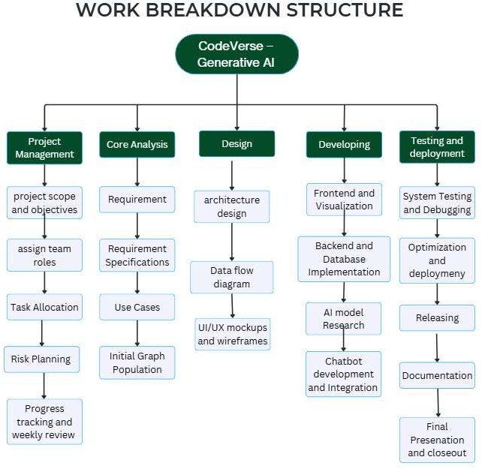

Figure 1 Work breakdown structure

Project Timeline
The project spans across two academic semesters: October 2025 – January 2026 (Semester 7) and March 2026 – June 2026 (Semester 8). The timeline is divided into research, development, integration, evaluation, and documentation phases.

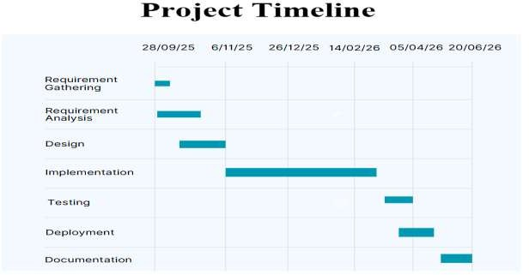

Figure 2 Gantt Chart

References:
- R. Li, P. Liang, M. Soliman, and P. Avgeriou, “Understanding Software Architecture Erosion: A Systematic Mapping Study,” Journal of Software: Evolution and Process, vol. 34, no. 3, e2423, Feb. 2022.
- J. Chen, X. Hu, Z. Li, C. Gao, X. Xia, and D. Lo, “Code Search Is All You Need? Improving Code Suggestions with Code Search,” in Proceedings of the IEEE/ACM 46th International Conference on Software Engineering (ICSE ’24), Lisbon, Portugal, Apr. 2024, pp. 1-13. doi:10.1145/3597503.3639085
- A. P. S. Venkatesh, R. Sunil, S. Sabu, A. M. Mir, S. Reis & E. Bodden, “An empirical study of large language models for type and call graph analysis in Python and JavaScript,” Empirical Software Engineering, vol. 30, article no. 167, 2025

- A. Sandur, C. Park, S. Volos, G. Agha & M. Jeon, “Jarvis: Large-scale Server Monitoring with Adaptive Near-data Processing,” Proceedings of the 38th IEEE International Conference on Data Engineering (ICDE 2022), pp. xx-yy, Feb. 2022
- M. Khosla, Jurek Leonhardt, Wolfgang Nejdl & Avishek Anand, “Node Representation Learning for Directed Graphs,” in Machine Learning and Knowledge Discovery in Databases – ECML PKDD 2019, Lecture Notes in Computer Science, vol. 11906, pp. 395-411, 2020.
- M. Khosla, Jurek Leonhardt, Wolfgang Nejdl & Avishek Anand, “Node Representation Learning for Directed Graphs,” in Machine Learning and Knowledge Discovery in Databases – ECML PKDD 2019, Lecture Notes in Computer Science, vol. 11906, pp. 395-411, 2020.
- Y. Cao, S. Zhang, X. Cai, and J. Liu, “An Efficient Deep Learning Model for Network Traffic Classification in IoT Systems,” IEEE Internet of Things Journal, vol. 10, no. 5, pp. 3174–3184, Mar. 2025. doi:10.1109/9425912.

Chapter 2

- Requirement Specification and Analysis:

The emphasis of this chapter is on identifying and documenting the requirements for the intended software system. It focuses on understanding what the system should do and how it should behave from the user’s perspective. This phase involves continuous interaction with users and stakeholders to determine specific features, resolve ambiguities, and ensure that all functional and non-functional aspects of the system are properly captured.

The purpose of this chapter is to define the scope and expectations of the proposed system CodeVerse, an AI-powered project knowledge graph and visualization platform. It provides a clear description of the system’s functionalities in the form of epics and user stories, ensuring a structured approach to system development. Each epic represents a broad system feature, while each user story refines those features into specific, actionable requirements.

Epics:

Epics define the major, high-level capabilities needed to build CodeVerse, an AI-powered project knowledge graph and visualization platform. As the system connects to GitHub repositories, extracts and analyzes code structures, generates AI-based file summaries, visualizes dependencies, and allows developers to interact through natural language queries, each epic represents a broad functional area that delivers real value to software teams. These epics collectively cover CodeVerse’s core objectives, secure repository integration, automated code comprehension, interactive graph-based visualization, AI-driven insights, strict access control, and an intuitive user experience for both administrators and developers.

Epic E1:

Title: Admin Authentication & GitHub App Integration

Description: As an admin, I want to securely create an account by verifying my email using a one-time verification code, and then connect the organization’s GitHub account to the tool via a GitHub App, so the tool can access repositories using short-lived tokens generated by the GitHub App.

Epic E2:

Title: User Management & Access Control

Description: As an admin, I want to manage user access by inviting users, assigning repository permissions, revoking access when needed, and reviewing audit logs, so that only authorized team members can interact with project data and all actions are traceable.

Epic E3:

Title: Admin Settings & Security

Description: As an admin or developer, I want to manage my account settings, including enabling or disabling Multi-Factor Authentication (MFA), changing my username, and updating my password, so that I can maintain the security and personalization of my account.

Epic E4:

Title: Developer Authentication & Secure Project Access

Description: As a developer, I want to create an account by verifying my email through a one-time verification code sent to my email address and securely log into the system, so that I can access projects with read-only permissions and safely explore project data without making any modifications to the code or project files.

Epic E5:

Title: Public GitHub Repository Analysis and Visualization

Description: As a developer, I want to analyze publicly available GitHub repositories by providing a repository URL, so that I can generate visualization graphs, dependency structures, and automated summaries to better understand the project.

Epic E6:

Title: Visualization & Interaction

Description: As a developer, I want the system to generate interactive visualization graphs for frontend and backend files, showing file-level import/export relationships, function connections, and data flow (through props) between files, so that I can easily understand how different parts of the project communicate and interact with each other.

Epic E7:

Title: Code Analysis and AI-Powered Summarization

Description: As a developer, I want the system to analyze my code and generate simple, human-readable summaries for each source file, including purpose, key functionalities and file dependencies, so that I can quickly understand the purpose of the specific code file without examining it entirely.

Epic E8:

Title: Interactive Chat-based Query System

Description: As a developer, I want to ask natural language questions about my project and receive contextual responses so that I can quickly understand codebase, and explore dependencies without manually inspecting files.

Epic E9:

Title: Historical Visualization & Summaries

Description: As a developer, I want the system to store all generated visualization graphs and AI summaries in the database so that I can view past versions and understand how the project evolved over time.

Epic E10:

Title: Real-Time Repository Updates

Description: As a developer, I want the system to detect updates in GitHub repositories and send real-time notifications when changes occur, so that I can regenerate visualization graphs using the latest data.

User Stories:

User stories define the functionalities of CodeVerse from the perspective of both developers and administrators, ensuring that every feature reflects real user needs such as secure repository access, accurate code analysis, interactive visualization, and smooth UI navigation. Each user story clearly outlines the purpose behind the requirement, keeping the development process user-centered and goal-driven. The acceptance criteria associated with each story establish measurable conditions to verify proper implementation, ensuring secure authentication, reliable system behavior, complete logging, and a responsive, intuitive user experience across the platform.

E1-US1:

Title: Admin Account Sign-Up with Email Verification

Description: As an admin, I want to create an account using my email and password and verify my email using a one-time verification code so that I can securely access the system.

Acceptance Criteria: Given the admin sign-up page, when I enter valid details and successfully verify my email using the one-time verification code, then my admin account is created and I can securely log in to the system.

E1-US2:

Title: Admin Login with MFA

Description: As an admin, I want to log in using Multi-Factor Authentication (MFA) if enabled, to securely access the tool.

Acceptance Criteria: Given the admin login page, when the admin enters valid login credentials, then the system prompts for MFA verification if enabled before granting access to the tool.

E1-US3:

Title: Admin Password Recovery

Description: As an admin, I want a "Forgot Password" option so that I can recover my account if I forget the password.
Acceptance Criteria: Given the login page, when the admin clicks "Forgot Password," then the system sends a password reset email.

E1-US4:

Title: GitHub App Integration for Repository Access

Description: As an admin, I want to connect the organization’s GitHub account to the tool through a GitHub App so that the tool can securely access the repositories.

Acceptance Criteria: Given the admin is logged in, when the admin connects the GitHub App, the system first issues short-lived tokens, then confirms the connection is active, and finally provides developers with read-only access to the repositories.

E2-US1:

Title: Email User Invitations

Description: As an admin, I want to invite users via email so that they can join the system with proper access rights.

Acceptance Criteria: Given the user management panel, when the admin sends an invitation, then the invited user receives an email to join.

E2-US2:

Title: Assign Repository Access

Description: As an admin, I want to assign repository access to users so that only authorized developers can view project data.

Acceptance Criteria: Given the user list, when the admin assigns repository permissions, then only authorized users can access assigned projects.

E2-US3:

Title: Revoke User Access

Description: As an admin, I want to revoke user access at any time, ensuring that the individual immediately loses access to the particular repository.

Acceptance Criteria: Given the user list, when the admin clicks "Revoke Access," then the user loses access immediately.

E2-US4:

Title: View Invitation Status

Description: As an admin, I want a system to show active and pending invitations so that I can track who has joined.

Acceptance Criteria: Given the user management page, when the admin opens it, then a list of pending and active users is displayed.

E2-US5:

Title: View Audit Log

Description: As an admin, I want to view audit log so that I can track user actions and security changes.

Acceptance Criteria: Given the audit log, when the admin views it, then all actions are displayed with actor, action, and timestamp.

E3-US1:

Title: Enable or Disable MFA for User Accounts

Description: As an admin or developer, I want to enable or disable Multi-Factor Authentication (MFA) so that I can manage account security settings effectively.

Acceptance Criteria: Given MFA option is available in Account Settings, when the admin enables or disables MFA and saves the changes, then the system updates the MFA configuration successfully for the account and applies it to subsequent login attempts.

E3-US2:

Title: Change Username

Description: As an admin or developer, I want to change my username so that I can personalize and maintain my account information.

Acceptance Criteria: Given the username update option is available in Account Settings, when a valid new username is entered and the changes are saved, then the username is updated successfully and reflected in the account profile

E3-US3:

Title: Update Account Password

Description: As an admin or developer, I want to update my account password so that I can maintain the security of my account.

Acceptance Criteria: Given the password update option is available in Account Settings, when the current password along with a valid new password is entered and the changes are confirmed, then the password is updated successfully and a confirmation message is displayed.

E4-US1:

Title: Developer Account Sign-Up with Email Verification

Description: As a developer, I want to create an account using my email and password and verify my email using a one-time verification code so that I can securely access the system.

Acceptance Criteria: Given the developer sign-up page, when I enter valid details and successfully verify my email using the one-time verification code, then my admin account is created and I can securely log in to the system.

E4-US2:

Title: Developer Login with MFA

Description: As a developer, I want to log in using Multi-Factor Authentication (MFA) if enabled, to securely access the tool.

Acceptance Criteria: Given the developer login page, when the developer enters valid login credentials, then the system prompts for MFA verification if enabled before granting access to the tool.

E4-US3:

Title: Developer Password Recovery

Description: As an developer, I want a "Forgot Password" option so that I can recover my account if I forget the password.
Acceptance Criteria: Given the login page, when the developer clicks "Forgot Password," then the system sends a password reset email.

E4-US4:

Title: Assigned Projects in Read-Only Mode

Description: As a developer, I want to access only assigned projects so that I can explore project data without modifying code.

Acceptance Criteria: Given the project list, when the developer opens a project, then it opens in read-only mode.

E4-US5:

Title: Project Searching

Description: As a developer, I want a search bar that allows me to quickly find my assigned projects so that I can easily explore and visualize project repositories in read only mode.

Acceptance Criteria: Given the project list, when the developer enters text in the search bar, then matching assigned projects are displayed and presents it for visualization in read-only mode.
.

E5-US1:

Title: Generate Repository Visualization Graph

Description: As a developer, I want to paste a public GitHub repository URL and run the analysis so that I can generate an interactive visualization graph of the repository and understand its dependency structure.

Acceptance Criteria: Given a valid public GitHub repository URL is provided, when the developer starts the analysis, then the system generates and displays an interactive visualization graph of the repository.

E5-US2:

Title: Generate Automated File Summaries

Description: As a developer, I want to view automated summaries for repository files so that I can better understand the functionality and purpose of different parts of the project.

Acceptance Criteria: Given the repository analysis is completed, when the developer selects a file from the visualization graph, then the system displays an automated summary for the selected file.

E6-US1:

Title: File-Level Dependency Graphs

Description: As a developer, I want the system to generate interactive graphs showing file-level import and export dependencies so that I can understand file relationships.

Acceptance Criteria: Given a connected repository, when I request a visualization, then the system displays all file-level dependencies as an interactive graph.

E6-US2:

Title: Function, Props Connections and Internal File Dependencies

Description: As a developer, I want to view internal file dependencies, including function or method calls, props connections, and relationships between components, so that I can explore how different parts of the code interact with each other.

Acceptance Criteria: Given a file node in the visualization graph, when the developer opens or selects the file, then the system displays internal dependencies such as function/method calls, props connections, and component relationships.

E6-US3:

Title: Interactive Visualization Features

Description: As a developer, I want to interact with the visualization using zooming, panning, node selection, so that I can navigate large codebases efficiently.

Acceptance Criteria: Given a repository graph, when I use interactive controls, then the graph responds smoothly and highlights selected nodes or dependencies.

E7-US1:

Title: Generate AI Summaries

Description: As a developer, I want the system to analyze each file and generate AI-based human-readable summaries so that I can quickly understand the purpose and functionality of files.

Acceptance Criteria: Given a repository, when I run the analysis, then the system produces summaries including purpose, key functionalities and file dependencies.

E7-US2:

Title: Regenerate Summary on Re-Analyze

Description: As a developer, I want to regenerate an AI summary when I re-analyze the response so that I can get a more accurate explanation.

Acceptance Criteria: Given a file summary, when the developer clicks the "Re-analyze Summary" button, then a new AI-generated summary is produced and displayed.

E8-US1:

Title: Ask Natural Language Questions

Description: As a developer, I want to ask natural language questions about my project so that I can quickly retrieve insights without manually examining the code.

Acceptance Criteria:Given a repository, when I type a question in the chatbot, then the system returns a relevant contextual answer.

E8-US2:

Title: Start a New Conversation

Description: As a developer, I want to click a “New Chat” button so that I can start a fresh conversation without the previous context.

Acceptance Criteria: Given the chat interface, when the developer clicks the “New Chat” button, then a new empty chat window opens and previous messages are cleared from the view.

E8-US3:

Title: View Chat History

Description: As a developer, I want to view the history of my chat sessions so that I can revisit past questions and answers for repositories I have access to.

Acceptance Criteria: Given the developer dashboard, when a chat session occurs, then it is saved in the database and the developer can view it if they currently have access.

    - E8-US4:
Title: Repository Switching in Chat-based Query System
Description:
As a developer, I want the ability to switch the chatbot context to a different repository using a “Switch Repository” option so that I can ask questions and receive responses related to the selected repository without leaving the chat interface.
Acceptance Criteria:
Given the chat-based query system, when the developer selects the “Switch Repository” option and chooses another accessible repository, then the chatbot updates its context to the selected repository and provides responses based only on that repository’s codebase and data.

E9-US1:

Title: Developer Access to Summary History

Description: As a developer, I want to view the history of AI-generated summaries for repositories I have access to so that I can revisit past insights.

Acceptance Criteria: Given the developer dashboard, when a summary is generated, then then the system stores and maintains the history of generated summaries, and the developer can view the history if they currently have access.

E9-US2:

Title: Developer Access to Dependency Graph History

Description: As a developer, I want to view the history of generated dependency graphs for repositories I have access to so that I can review older visualizations.

Acceptance Criteria: Given the developer dashboard, when a dependency graph is generated, then it is saved in the database and the developer can view it if they currently have access.

E10-US1:

Title: Receive Real-Time Repository Update Notifications

Description: As a developer, I want to receive real-time notifications when updates occur in connected GitHub repositories so that I can stay informed about new commits and repository changes.

Acceptance Criteria: Given a connected GitHub repository, when a commit or update occurs, then the system sends a real-time notification to developers who have access to the repository.

E10-US2:

Title: Regenerate Repository Visualizations After Updates

Description: As a developer, I want to regenerate visualization graph after repository updates have been made in the connected GitHub repository, so that I can view the latest changes.

Acceptance Criteria: Given a connected GitHub repository, when the developer triggers regeneration, then the system generates updated visualization graphs using the latest repository data.

Test-cases
Test cases represent structured scenarios that specify the inputs, execution steps, and expected outcomes required to verify that each feature of CodeVerse functions correctly. They ensure that all system requirements, such as secure authentication, accurate code analysis, reliable visualization, and proper AI responses, are thoroughly validated. By systematically executing these test cases, the team can identify defects, confirm expected behavior, and ensure the overall reliability and quality of the CodeVerse platform.

Table 2-1: Successful AdminAccount Creation with Email Verification
Test ID: E1-US1-TC1 | US ID: E1-US1
Test Case Description | Verify that an admin account is successfully created when valid signup details and correct verification code are entered.
Inputs | Admin entered valid email address, strong password, and correct verification code sent to the email.
Expected Result | The system successfully creates the admin account and allows the admin to log in.

Table 2-2 Account Creation Failure with Invalid Verification Code
Test ID: E1-US1-TC2 | US ID: E1-US1
Test Case Description | Verify that email verification fails when an incorrect verification code is entered.
Inputs | Admin entered valid username and password and an invalid or incorrect verification code.
Expected Result | System shows “Invalid verification code” and denies account creation.

Table 2-3 Successful Admin Login with Valid Details and MFA
Test ID: E1-US1-TC3 | US ID: E1-US1
Test Case Description | Verify that the admin can successfully log in with valid credentials and the correct MFA code after MFA has been enabled for the account.
Inputs | Admin enters a valid email, correct password, and valid MFA verification code.
Expected Result | The system authenticates the admin successfully and grants access to the tool.

Table 2-4 Email Already Registered

Test ID: E2-US1-TC4 | US ID: E2-US1
Test Case Description | Verify that signup fails when the entered email already exists in the  system.
Inputs | The admin enters an email address that is already associated with an  existing account.
Expected Result | The system shows an error message stating that the email is already  registered and blocks the signup attempt.

Table 2-5 Request Password Reset

Test ID: E1-US2-TC1 | US ID: E1-US2
Test Case Description | Verify admin can request a password reset using “Forgot Password.”
Inputs | Admin clicks “Forgot Password” and enters valid registered email.
Expected Result | System sends a password-reset email.

Table 2-6 Error on Invalid Email

Test ID: E1-US2-TC2 | US ID: E1-US2
Test Case Description | Verify system does not send reset email to unregistered email.
Inputs | Admin enters an unregistered email address.
Expected Result | System displays “Email not found.”

Table 2-7 Successful GitHub App Connection

Test ID: E1-US3-TC1 | US ID: E1-US3
Test Case Description | Verify admin can connect GitHub App to allow repository access.
Inputs | Admin clicks “Connect GitHub App” and completes authorization.
Expected Result | System issues tokens, verifies connection, and enables repo access.

Table 2-8 Send Invitation Email

Test ID: E2-US1-TC2 | US ID: E2-US1
Test Case Description | Verify that an admin can successfully invite a new user by providing a  valid email address.
Inputs | Admin enters a valid email and clicks “Send Invitation.”
Expected Result | System sends an invitation email to the user and displays a success  confirmation.

Table 2-9 Assign Repository Access

Test ID: E2-US2-TC1 | US ID: E2-US2
Test Case Description | Verify that an admin can successfully assign a repository to a specific  user so the user gains the correct access permissions.
Inputs | Admin selects a user from the user list, chooses a repository, and  clicks “Assign Access.”
Expected Result | System assigns the repository to the user, granting them read-only  access, and displays a confirmation message.

Table 2-10 Prevent Duplicate Repository Assignment to User

Test ID: E2-US2-TC2 | US ID: E2-US2
Test Case Description | Verify that the system prevents an admin from assigning a repository to a user if that user already has access to it.
Inputs | Admin selects a user who already has access to the repository and  attempts to assign the same repository again.
Expected Result | System displays an error message such as “Access already granted.”

Table 2-11 Revoke Access Successfully

Test ID: E2-US3-TC1 | US ID: E2-US3
Test Case Description | Verify that the system correctly handles an attempt to revoke access for a user whose access has already been revoked
Inputs | Admin clicks “Revoke Access” for selected user.
Expected Result | User immediately loses repository access.

Table 2-12 Revoke Already Revoked Access

Test ID: E2-US3-TC2 | US ID: E2-US3
Test Case Description | Verifies that the system correctly handles a situation where an admin  attempts to revoke access for a user whose access has already been revoked.
Inputs | Admin clicks “Revoke Access” again.
Expected Result | System displays “No active access to revoke.”

Table 2-13 Display Invitation request status

Test ID: E2-US4-TC1 | US ID: E2-US4
Test Case Description | Verify that the system correctly displays all user invitations with their  current status.
Inputs | Admin opens User Management page.
Expected Result | System lists pending, active, and inactive status

Table 2-14 Successful Activation of MFA in Account Settings

Test ID: E3-US1-TC1 | US ID: E3-US1
Test Case Description | Verify that an admin or developer can successfully enable MFA from Account Settings.
Inputs | Admin or developer navigates to Account Settings, enables MFA toggle, and clicks Save.
Expected Result | MFA is enabled successfully and applied to future login attempts.

Table 2-15 Automatic Logout After Inactivity

Test ID: E3-US2-TC1 | US ID: E3-US2

Test Case Description | Verify that system logs out the user after the configured period of  inactivity.
Inputs | User remains inactive for the configured timeout (e.g., 15 minutes).
Expected Result | System ends the user’s session and redirects to login.

Table 2-16 Audit Logs Display

Test ID: E3-US3-TC1 | US ID: E3-US3
Test Case Description | Verify that the admin can view all audit log entries, ensuring visibility into all  user actions for monitoring and compliance purposes.
Inputs | Admin opens audit logs page.
Expected Result | Logs display with action, and timestamp.

Table 2-17 Empty Logs Display Message

Test ID: E3-US3-TC2 | US ID: E3-US3
Test Case Description | Verify that system shows a friendly message when no logs exist.
Inputs | Admin opens audit logs page.
Expected Result | System shows “No audit records found.”

Table 2-18 Save All Settings Successfully

Test ID: E3-US4-TC1 | US ID: E3-US4
Test Case Description | Verify that all modified settings are saved together.
Inputs | Admin updates multiple settings and clicks “Save All Changes.”
Expected Result | All settings are persisted and success message appears.

Table 2-19 No save on no changes

Test ID: E3-US4-TC2 | US ID: E3-US4
Test Case Description | Verify that clicking save without changes does not alter configuration.
Inputs | Admin clicks save without modifying any settings.
Expected Result | System keeps existing settings; still shows confirmation.

Table 2-20 Successful Developer Account Creation with Email Verification
Test ID: E4-US1-TC1 | US ID: E4-US1
Test Case Description | Verify that a developer account is successfully created when valid signup details and correct verification code are entered.
Inputs | Developer entered valid email address, strong password, and correct verification code sent to the email.
Expected Result | The system successfully creates the developer account and allows the admin to log in.

Table 2-21 Developer Account Creation Failure with Incorrect Verification Code
Test ID: E4-US1-TC2 | US ID: E4-US1
Test Case Description | Verify that email verification fails when an incorrect verification code is entered.
Inputs | Developer entered valid username and password and an invalid or incorrect verification code.
Expected Result | System shows “Invalid verification code” and denies account creation.

Table 2-22 Successful Developer Login with Valid Details and MFA

Test ID: E4-US1-TC3 | US ID: E4-US1
Test Case Description | Verify that the developer can successfully log in with valid credentials and the correct MFA code after MFA has been enabled for the account.
Inputs | Developer enters a valid email, correct password, and valid MFA verification code.
Expected Result | The system authenticates the developer successfully and grants access to the tool.

Table 2-23 Email already exists

Test ID: E2-US1-TC4 | US ID: E2-US1
Test Case Description | Verify that signup fails when the entered email already exists in the  system.
Inputs | The user enters an email address that is already associated with an  existing account.
Expected Result | The system shows an error message stating that the email is already  registered and blocks the signup attempt.

Table 2-24 Open Assigned Project Read-Only

Test ID: E4-US2-TC1 | US ID: E4-US2
Test Case Description | Verify that assigned projects open in read-only mode.
Inputs | Developer selects a project assigned to them.
Expected Result | System displays all files as read-only without edit options.

Table 2-25 Prevent Edit Attempt

Test ID: E4-US2-TC2 | US ID: E4-US2
Test Case Description | Verify that developer cannot edit code in read-only mode.
Inputs | Developer attempts to modify a file.
Expected Result | System blocks edits and shows read-only message.

Table 2-26 Search Displays Matching Projects

Test ID: E4-US3-TC1 | US ID: E4-US3
Test Case Description | Verify that when a developer types a keyword, the system filters and  displays only the assigned projects that match the query.
Inputs | Developer enters search query into search bar.
Expected Result | Only projects matching the query are displayed.

Table2-27 No Results Message

Test ID: E4-US3-TC2 | US ID: E4-US3
Test Case Description | Verify system displays a message when no project matches the search  term.
Inputs | Developer enters a keyword that matches no projects.
Expected Result | “No matching projects found” message appears.

Table 2-28 Successful Generation of Interactive Repository Visualization Graph
Test ID: E5-US1-TC1 | US ID: E5-US1
Test Case Description | Verify that a developer can successfully generate a repository visualization graph using a valid public GitHub repository URL.
Inputs | Developer enters a valid public GitHub repository URL and clicks on the button “Start Analysis”.
Expected Result | System analyzes the repository and displays an interactive visualization graph successfully.

Table 2-29 Validation Error for Invalid GitHub Repository URLs
Test ID: E5-US1-TC2 | US ID: E5-US1
Test Case Description | Verify that the system rejects invalid GitHub repository URLs.
Inputs | Developer enters an incorrectly formatted or invalid repository URL and clicks on the button “Start Analysis”.
Expected Result | System displays a validation error message and analysis does not start.

Table 2-30 2-30 Automated File Summary Generation from Visualization Graph

Test ID: E5-US2-TC1 | US ID: E5-US2

Test Case Description | Verify that the system generates and displays an automated summary when a developer selects a file from the visualization graph.
Inputs | Developer completes repository analysis and selects a file node from the graph.
Expected Result | System displays an automated summary for the selected file successfully.

Table 2-31 Prevention of Summary Generation Without File Selection

Test ID: E5-US2-TC2 | US ID: E5-US2
Test Case Description | Verify that summaries are not generated until the developer selects a file from the visualization graph.
Inputs | Repository analysis is completed and the visualization graph is displayed, but the developer has not selected any file from the graph.
Expected Result | System prevents summary generation.

Table 2-32 Generate File-Level Dependency Graph

Test ID: E6-US1-TC1 | US ID: E6-US1
Test Case Description | Verify that system generates interactive graph showing import/export dependencies.
Inputs | Developer requests dependency graph generation.
Expected Result | System displays graph with all file-level relationships.

Table 2-33 Verification of Component Prop Connections in Interactive Graph

Test ID: E6-US2-TC1 | US ID: E6-US2
Test Case Description | Verify that system generates interactive graph showing props connections between components correctly.
Inputs | Developer requests graph generation for a component file containing props passed between components.

Expected Result | System displays graph with all props relationships and component connections accurately.

Table 2-34 Visualization of Method and Function Call Dependencies

Test ID: E6-US3-TC1 | US ID: E6-US3
Test Case Description | Verify that system displays method and function call relationships within the file.
Inputs | Developer selects the Function Graph option to generate and view function-level relationships
Expected Result | System shows all internal method and function dependency elements

Table 2-35 Reset View Button

Test ID: E6-US3-TC2 | US ID: E6-US3
Test Case Description | Verify reset view returns to default zoom/position.
Inputs | Developer clicks “Reset View.”
Expected Result | Graph returns to initial default layout.

Table 2-36 Generate Summary for Repository

Test ID: E7-US1-TC1 | US ID: E7-US1
Test Case Description | Verify that the system generates a readable AI summary for each file.
Inputs | Developer runs analysis on a connected repository.
Expected Result | Summaries  produced. | with purpose, | key functions, | and | dependencies | are

Table 2-37 Missing File Content Handling

Test ID: E7-US1-TC2 | US ID: E7-US1
Test Case Description | Verify the system handles unreadable or broken files gracefully.
Inputs | Repository contains unreadable/broken files.
Expected Result | Summary marks file as "Unable to analyze" without failing analysis.

Table 2-38 Re-analyze Generates New Summary

Test ID: E7-US2-TC1 | US ID: E7-US2
Test Case Description | Verify new summary is generated when developer clicks "Re-analyze  Summary."
Inputs | Developer clicks re-analyze on a file summary.
Expected Result | Fresh summary replaces old one.

Table 2-39 Answer Developer Question

Test ID: E8-US1-TC1 | US ID: E8-US1
Test Case Description | Verify that when a developer asks a natural language question about a repository, the chatbot returns a relevant answer containing accurate  contextual details from the repository.
Inputs | Developer types or speaks a question regarding the repository contents.
Expected Result | Chatbot responds with information that is accurate, relevant, and  derived from the repository context

Table 2-40 Handle Unknown Questions

Test ID: E8-US1-TC2 | US ID: E8-US1

Test Case Description | Verify that when a developer asks a question unrelated to the repository, the chatbot responds appropriately with a fallback or  informative message.
Inputs | Developer types a question that is not related to the repository contents (e.g., “What’s the weather today?”).
Expected Result | Chatbot provides a fallback response indicating it cannot answer the  query, or suggests asking repository-related questions.

Table 2-41 New Chat Clears Existing Messages

Test ID: E8-US2-TC1 | US ID: E8-US2
Test Case Description | Verify that when a developer clicks the “New Chat” button, the  system opens a fresh conversation window.
Inputs | Developer clicks New Chat button.
Expected Result | Conversation resets and no previous chat are visible.

Table 2-42 Developer Can View Chat History

Test ID: E8-US2-TC2 | US ID: E8-US2
Test Case Description | Verify that a developer can access previous chat sessions by navigating  to chat history
Inputs | Developer navigates to chat history.
Expected Result | System displays previous chat logs with all messages intact, allowing  the developer to review

Table 2-43 Summary History Saved

Test ID: E9-US1-TC1 | US ID: E9-US1
Test Case Description | Verify each generated summary is saved to history.

Inputs | Developer runs summary generation.
Expected Result | Summary stored with timestamp.

Table 2-44 Developer Views Summary History

Test ID: E9-US1-TC2 | US ID: E9-US1
Test Case Description | Verify that a developer can view the history of AI-generated summaries by opening the Summary History section.
Inputs | Developer opens Summary History section.
Expected Result | System displays a list of past AI-generated summaries with relevant  details.

Table 2-45 Restricted Access

Test ID: E9-US1-TC3 | US ID: E9-US1
Test Case Description | Verify developer cannot view summaries for repos they lost access to.
Inputs | Developer attempts to access history after removal.
Expected Result | System displays a message “Access denied.”

Table 2-46 Graph History Saved

Test ID: E9-US2-TC1 | US ID: E9-US2
Test Case Description | Verify each generated dependency graph is saved.
Inputs | Developer generates dependency graph.
Expected Result | Graph stored in history.

Table 2-47 Developer Views Graph History

Test ID: E9-US2-TC2 | US ID: E9-US2
Test Case Description | Verify that a developer can open historical dependency graphs by  accessing the graph history.
Inputs | Developer navigates to the Graph History section
Expected Result | System loads and displays the selected historical dependency graph  with all nodes and connections.

Table 2-48 Access Blocked After Revocation

Test ID: E9-US2-TC3 | US ID: E9-US2
Test Case Description | Verify developer loses access to graph history after repo access removed.
Inputs | Developer attempts to open history after removal.
Expected Result | Access denied.

Table 2-49 Real-Time GitHub Commit and Update Notifications

Test ID: E10-US1-TC1 | US ID: E10-US1
Test Case Description | Verify that developers receive real-time notifications when updates occur in a connected GitHub repository.
Inputs | A new commit or repository update occurs in a connected GitHub repository.
Expected Result | System sends a real-time notification to authorized developers successfully.

Table 2-50 Successful Regeneration of Visualization Graph After Updates

Test ID: E10-US2-TC1 | US ID: E10-US2
Test Case Description | Verify that a developer can successfully regenerate the repository visualization graph after repository updates.

Inputs | Developer clicks the Regenerate Visualization option for a connected repository with recent updates.
Expected Result | System regenerates and displays the updated visualization graph using the latest repository data.

User Interface Design:

The UI is designed to be clean, simple, and consistent across all views, ensuring users can easily navigate between features without confusion. Buttons, menus, and forms follow the same layout style, colors, and spacing to provide a smooth and predictable experience. Every screen prioritizes clarity, readability, and quick access to core actions.

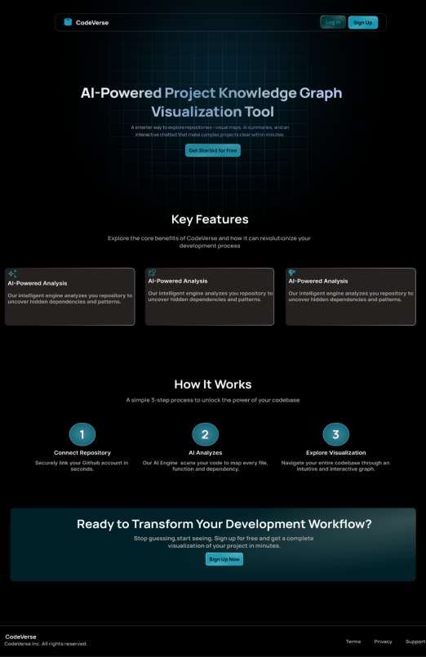

Figure 2-1 Home Page

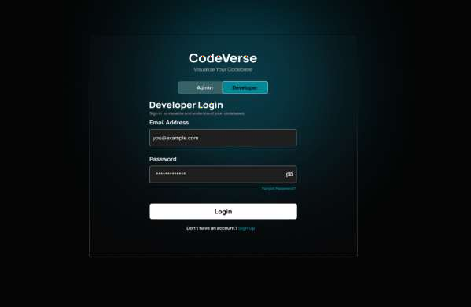

Figure 2-2 Developer MFA Login
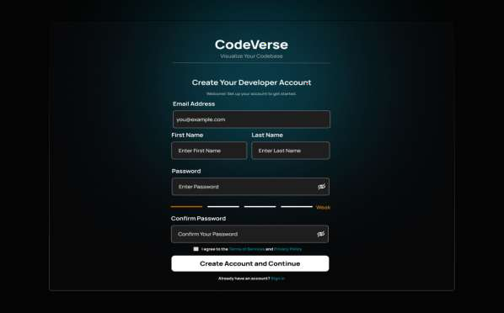

Figure 2-3 Developer Account Sign up

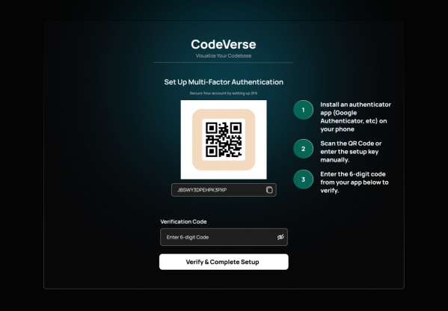

Figure 2-4 Developer MFA

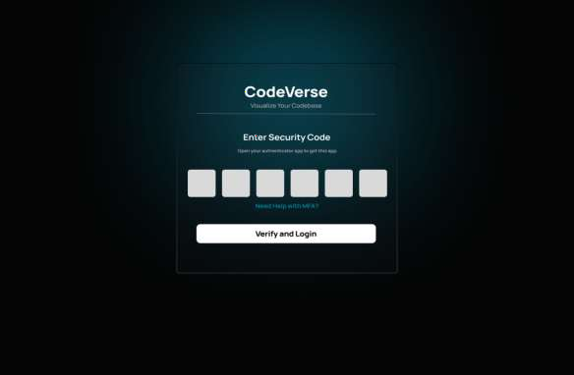

Figure 2-5 Developer Authentiation for Login
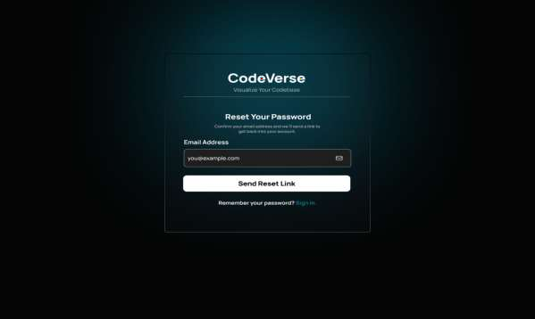

Figure 2-6 Developer Password Recovery

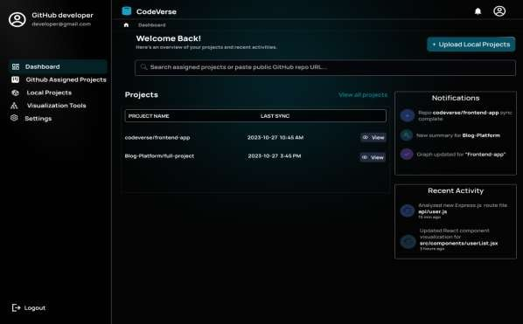

Figure 2-7 Developer Dashobard
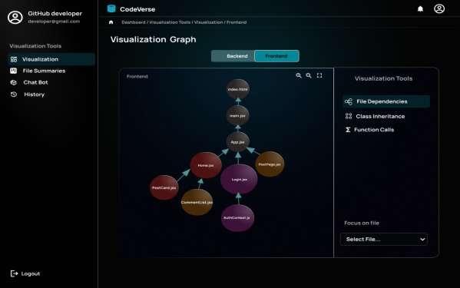

Figure 2-8 Visulization Graph for frontend

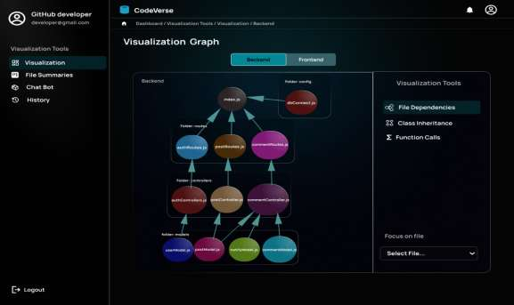

Figure 2-8 Visulization Graph for backend
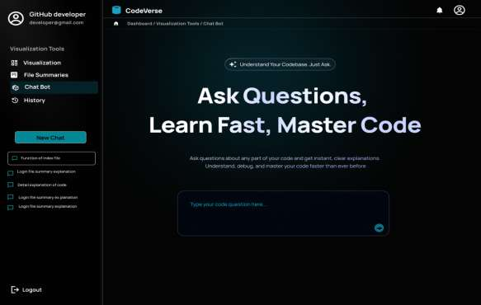

Figure 2-10 AI Chatbot

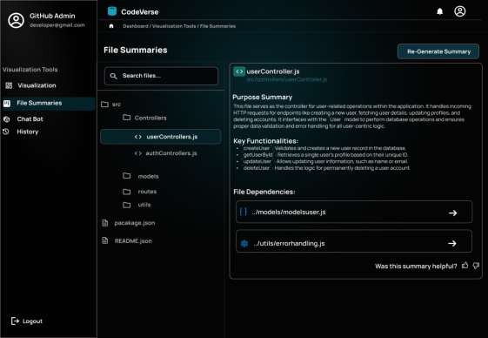

Figure 2-11 AI Summaries
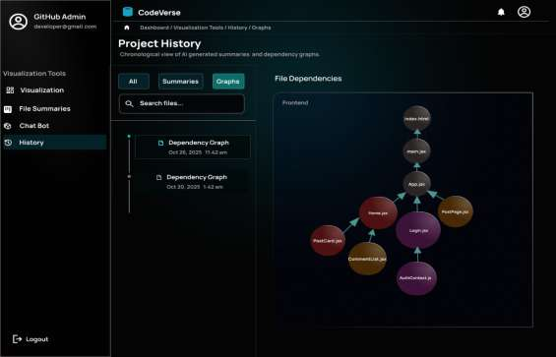

Figure 2-12 Visualization Graph History

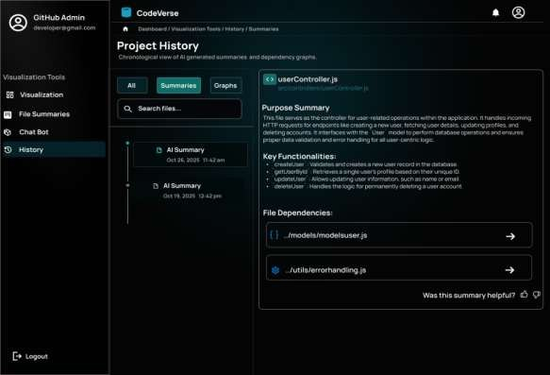

Figure 2-13 AI Summaries History
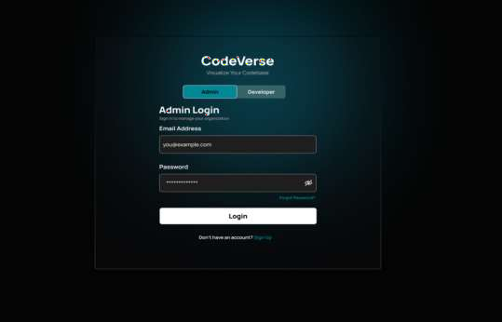

Figure 2-14 Admin MFA Login

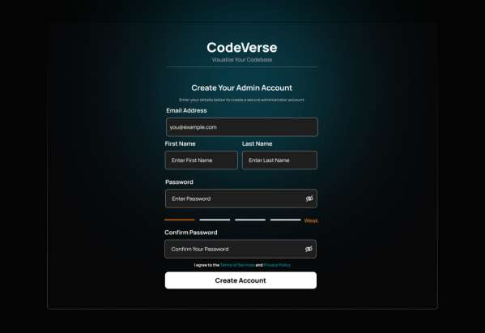

Figure 2-15 Admin Account Signup



Figure 2-16 Admin MFA
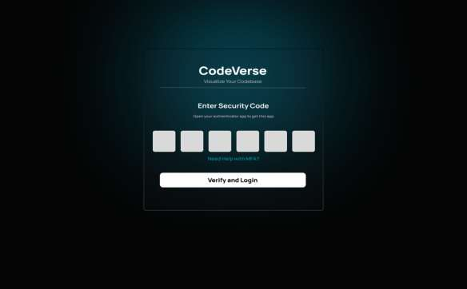

Figure 2-17 Admin Auythentication for Login

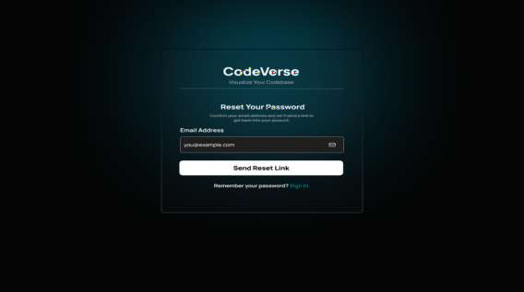

Figure 2-18 Admin Password Recovery
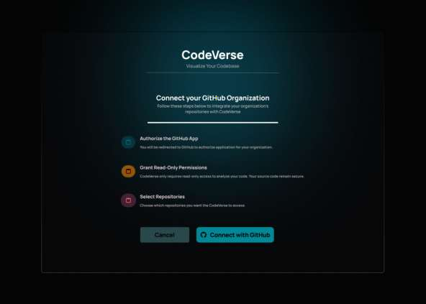

Figure 2-19 Github App Integration

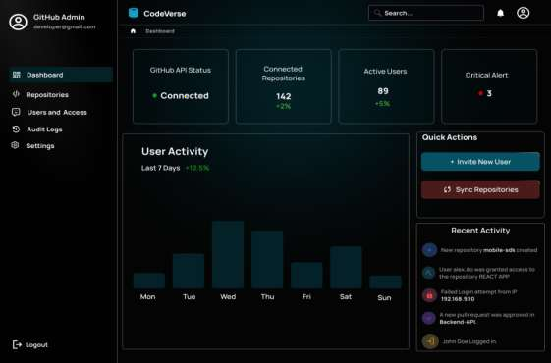

Figure 2-20 Admin Dashobaord
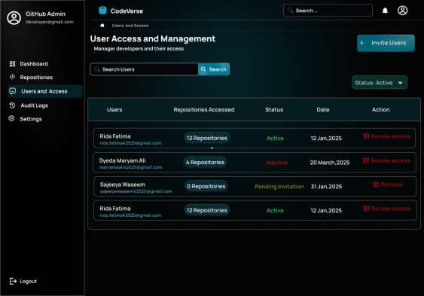

Figure 2-21 User Access and Managment

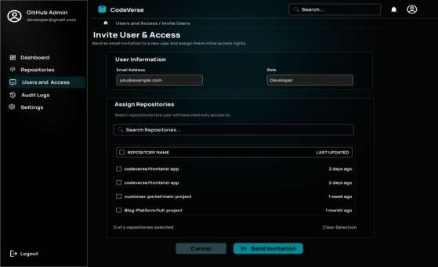

Figure 2-22 Inivite user and Access
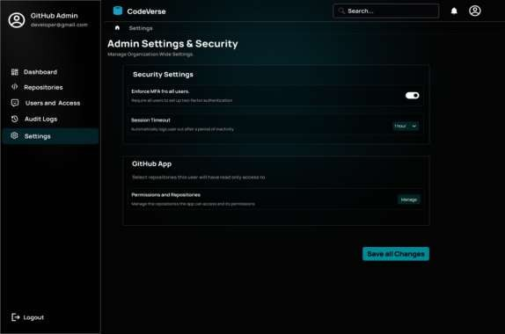

Figure 2-23 Admin Settings anf Security

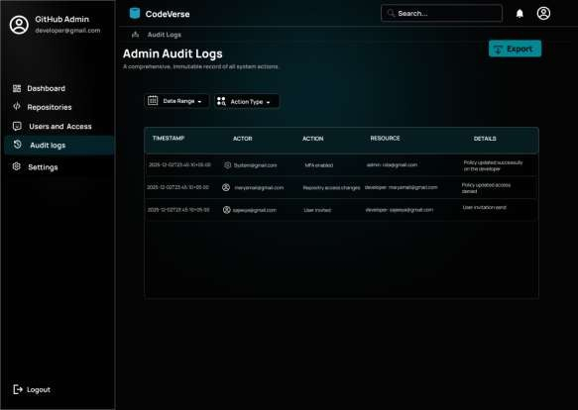

Figure 2-24 Admin Audit Logs

Traceability Matrix:
The Traceability Matrix provides a structured mapping between the epics, user stories, test cases, and corresponding UI references within CodeVerse. This matrix ensures that every system requirement from secure authentication and repository integration to AI-powered summarization, visualization, and chatbot functionality is properly validated through targeted test cases and supported within the user interface. By maintaining this one-to-one linkage, the traceability matrix confirms that all functionalities are fully implemented, tested, and aligned with the project objectives, helping the development team monitor coverage, identify gaps, and maintain consistency throughout the system lifecycle.

Epic | User Story (US) | Test Case (TC) | UI Reference (UI)
E1 | E1-US1 | E1-US1-TC1 | E1-US1-UI1

E1 | E1-US1 | E1-US1-TC2 | E1-US1-UI2
E1 | E1-US2 | E1-US2-TC1 | E1-US2-UI1
E1 | E1-US2 | E1-US2-TC2 | E1-US2-UI2
E1 | E1-US3 | E1-US3-TC1 | E1-US3-UI1
E2 | E2-US1 | E2-US1-TC2 | E2-US1-UI1
E2 | E2-US2 | E2-US2-TC1 | E2-US2-UI1
E2 | E2-US2 | E2-US2-TC2 | E2-US2-UI2
E2 | E2-US3 | E2-US3-TC1 | E2-US3-UI1
E2 | E2-US3 | E2-US3-TC2 | E2-US3-UI2
E2 | E2-US4 | E2-US4-TC1 | E2-US4-UI1
E3 | E3-US1 | E3-US1-TC1 | E3-US1-UI1
E3 | E3-US2 | E3-US2-TC1 | E3-US2-UI1
E3 | E3-US3 | E3-US3-TC1 | E3-US3-UI1
E3 | E3-US3 | E3-US3-TC2 | E3-US3-UI2
E3 | E3-US4 | E3-US4-TC1 | E3-US4-UI1
E3 | E3-US4 | E3-US4-TC2 | E3-US4-UI2
E4 | E4-US1 | E4-US1-TC1 | E4-US1-UI1
E4 | E4-US1 | E4-US1-TC2 | E4-US1-UI2
E4 | E4-US2 | E4-US2-TC1 | E4-US2-UI1
E4 | E4-US2 | E4-US2-TC2 | E4-US2-UI2
E4 | E4-US3 | E4-US3-TC1 | E4-US3-UI1
E4 | E4-US3 | E4-US3-TC2 | E4-US3-UI2
E5 | E5-US1 | E5-US1-TC1 | E5-US1-UI1
E5 | E5-US1 | E5-US1-TC2 | E5-US1-UI2
E5 | E5-US2 | E5-US2-TC1 | E5-US2-UI1
E5 | E5-US2 | E5-US2-TC2 | E5-US2-UI2
E6 | E6-US1 | E6-US1-TC1 | E6-US1-UI1
E6 | E6-US2 | E6-US2-TC1 | E6-US2-UI1
E6 | E6-US3 | E6-US3-TC1 | E6-US3-UI1
E6 | E6-US3 | E6-US3-TC2 | E6-US3-UI2
E7 | E7-US1 | E7-US1-TC1 | E7-US1-UI1
E7 | E7-US1 | E7-US1-TC2 | E7-US1-UI2

E7 | E7-US2 | E7-US2-TC1 | E7-US2-UI1
E8 | E8-US1 | E8-US1-TC1 | E8-US1-UI1
E8 | E8-US1 | E8-US1-TC2 | E8-US1-UI2
E8 | E8-US2 | E8-US2-TC1 | E8-US2-UI1
E8 | E8-US2 | E8-US2-TC2 | E8-US2-UI2
E9 | E9-US1 | E9-US1-TC1 | E9-US1-UI1
E9 | E9-US1 | E9-US1-TC2 | E9-US1-UI2
E9 | E9-US1 | E9-US1-TC3 | E9-US1-UI3
E9 | E9-US2 | E9-US2-TC1 | E9-US2-UI1
E9 | E9-US2 | E9-US2-TC2 | E9-US2-UI2
E9 | E9-US2 | E9-US2-TC3 | E9-US2-UI3
E10 | E10-US1 | E10-US1-TC1 | E10-US1-UI1
E10 | E10-US2 | E10-US2-TC1 | E10-US2-UI1
E10 | E10-US2 | E10-US2-TC2 | E10-US2-UI2
E10 | E10-US3 | E10-US3-TC1 | E10-US3-UI1

  - Use Case Diagram:

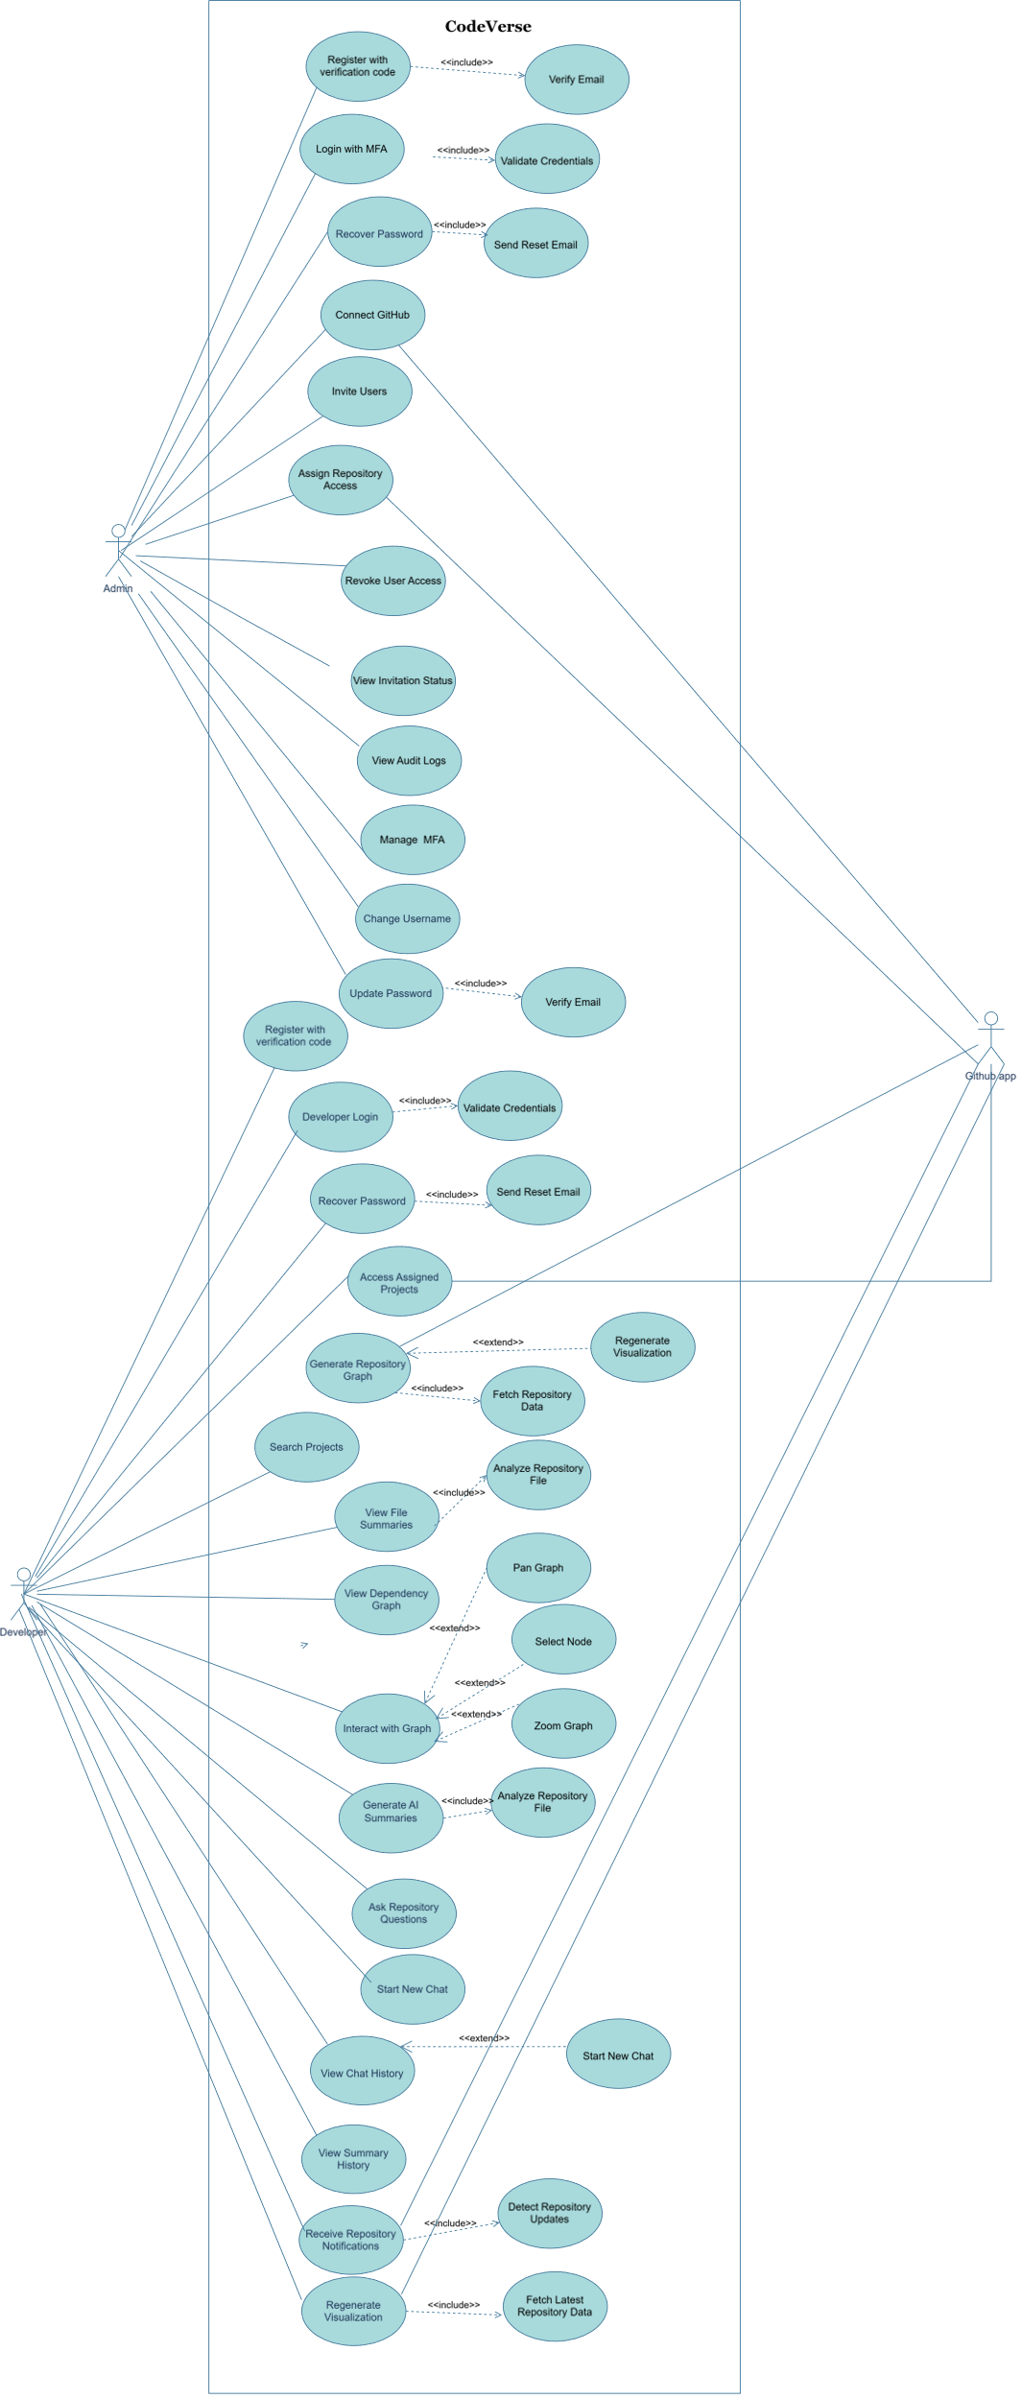

Chapter 3

System Design

This chapter provides the architectural blueprint of the proposed system, CodeVerse – an AI-Powered Project Knowledge Graph and Visualization Tool, and bridges the gap between system requirements and implementation. It explains how the different components of CodeVerse are organized, how they interact with one another, and how they collectively support the required functionality. The primary objective of this chapter is to present a clear and well-structured design that ensures all user requirements are properly addressed and can be efficiently translated into the development phase.

Software Architecture:

Describes the high-level architecture of CodeVerse, which is based on client–server and cloud-based architecture. It highlights the interaction between the frontend interface, backend services, AI processing modules, databases, and external services such as GitHub and authentication providers.

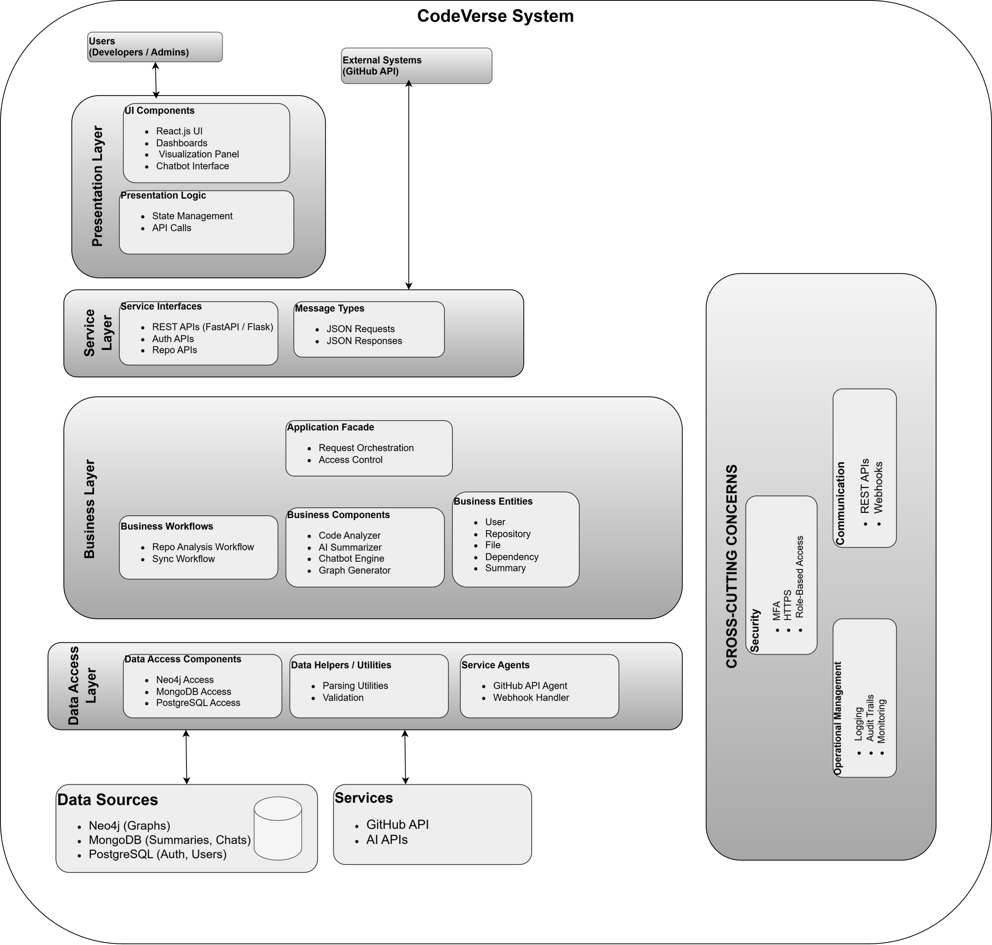

Figure 3.1

Data Modeling:

Data modeling defines how data will be structured, organized, and managed within the CodeVerse system. It ensures that the database design aligns with the system requirements and supports efficient storage, retrieval, and consistency of information. Since CodeVerse manages structured project data such as users, repositories, files, dependencies, and summaries, a well-defined data model is essential to maintain relationships between different system components. The data model provides a clear blueprint for how information flows within the system and supports scalability as the number of repositories and users grows.

Depending on the system requirements, CodeVerse utilizes a combination of relational and graph-based data modeling approaches. Relational databases are used to manage structured and transactional data such as user accounts, authentication details, and repository metadata, while graph-based storage is employed to represent complex relationships among files, modules, and dependencies.

Relational Databases:

Relational databases organize data into structured tables consisting of rows (records) and columns (attributes). In CodeVerse, each table represents a core entity such as User, Repository, File, Summary, and Session. Relationships between these entities are established, ensuring referential integrity and consistency across the system.
The relational database model is particularly suitable for handling authentication, authorization, and user-specific data, where strong consistency and structured querying are required. Using SQL, the system can efficiently perform operations such as user login validation, repository management, and retrieval of file summaries linked to specific users and projects.

Entity Relationship Diagram:

The Entity Relationship Diagram (ERD) provides a conceptual representation of the data model for the CodeVerse system. It illustrates the main entities involved in the system and the relationships between them, helping developers understand how data is logically organized before implementation.
In the CodeVerse ERD, entities such as User, Repository, File, Module, Dependency, Summary, Chatbot, and KnowledgeGraph are represented along with their relationships. For example, a User can connect to multiple Repositories, a Repository contains multiple Files, and each File may have an associated Summary and multiple Dependencies. The KnowledgeGraph stores and manages these dependencies, enabling efficient retrieval and visualization, while the Chatbot interacts with users by querying the stored graph data.

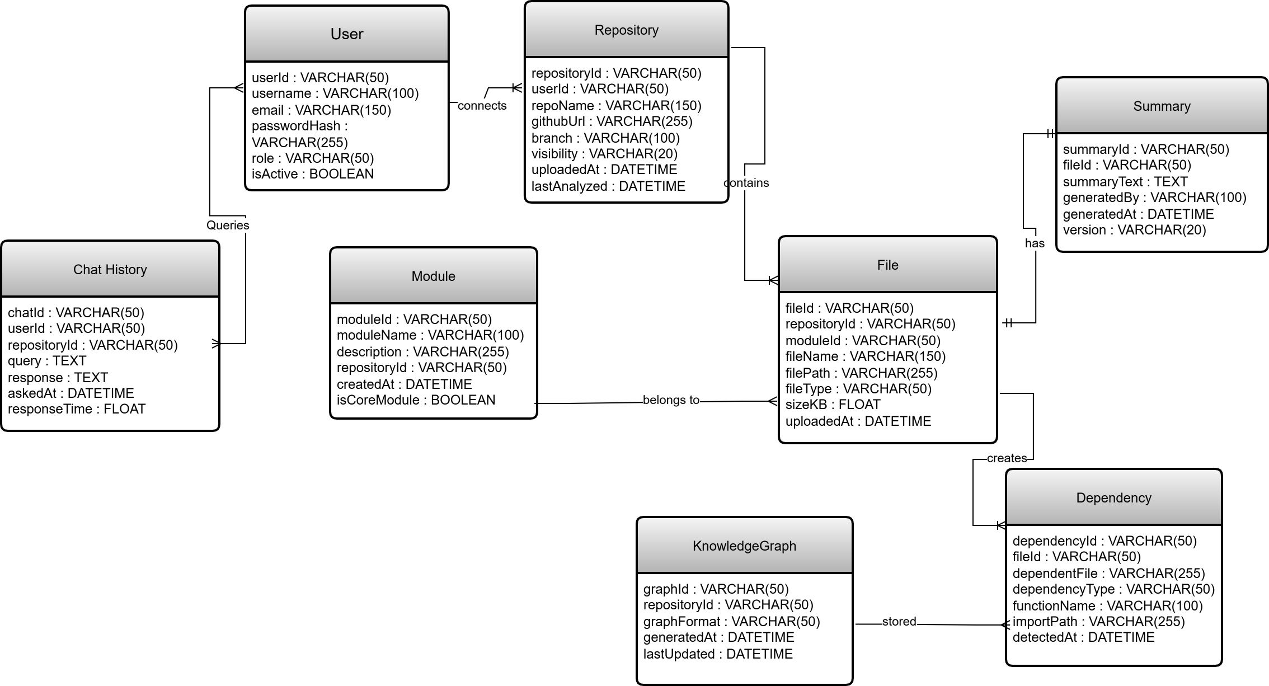

Figure 3.4 Entity Relationship diagram

Database Schema:
n CodeVerse, the database schema outlines the interaction between core entities such as users, repositories, files, dependencies, AI-generated summaries, and chatbot queries. These entities are connected using primary and foreign keys, which enforce referential integrity across the system. The schema also incorporates normalization principles to reduce redundancy and improve data consistency, while indexing is applied to frequently accessed fields to enhance query performance.
The database schema for CodeVerse has been designed using a visual modeling tool and is presented as a single unified diagram to clearly illustrate the relationships among system components. This design enables efficient storage, retrieval, and management of project data while supporting the functional requirements. The schema serves as a foundation for implementing backend logic, visualization features, and AI-driven services within the platform.

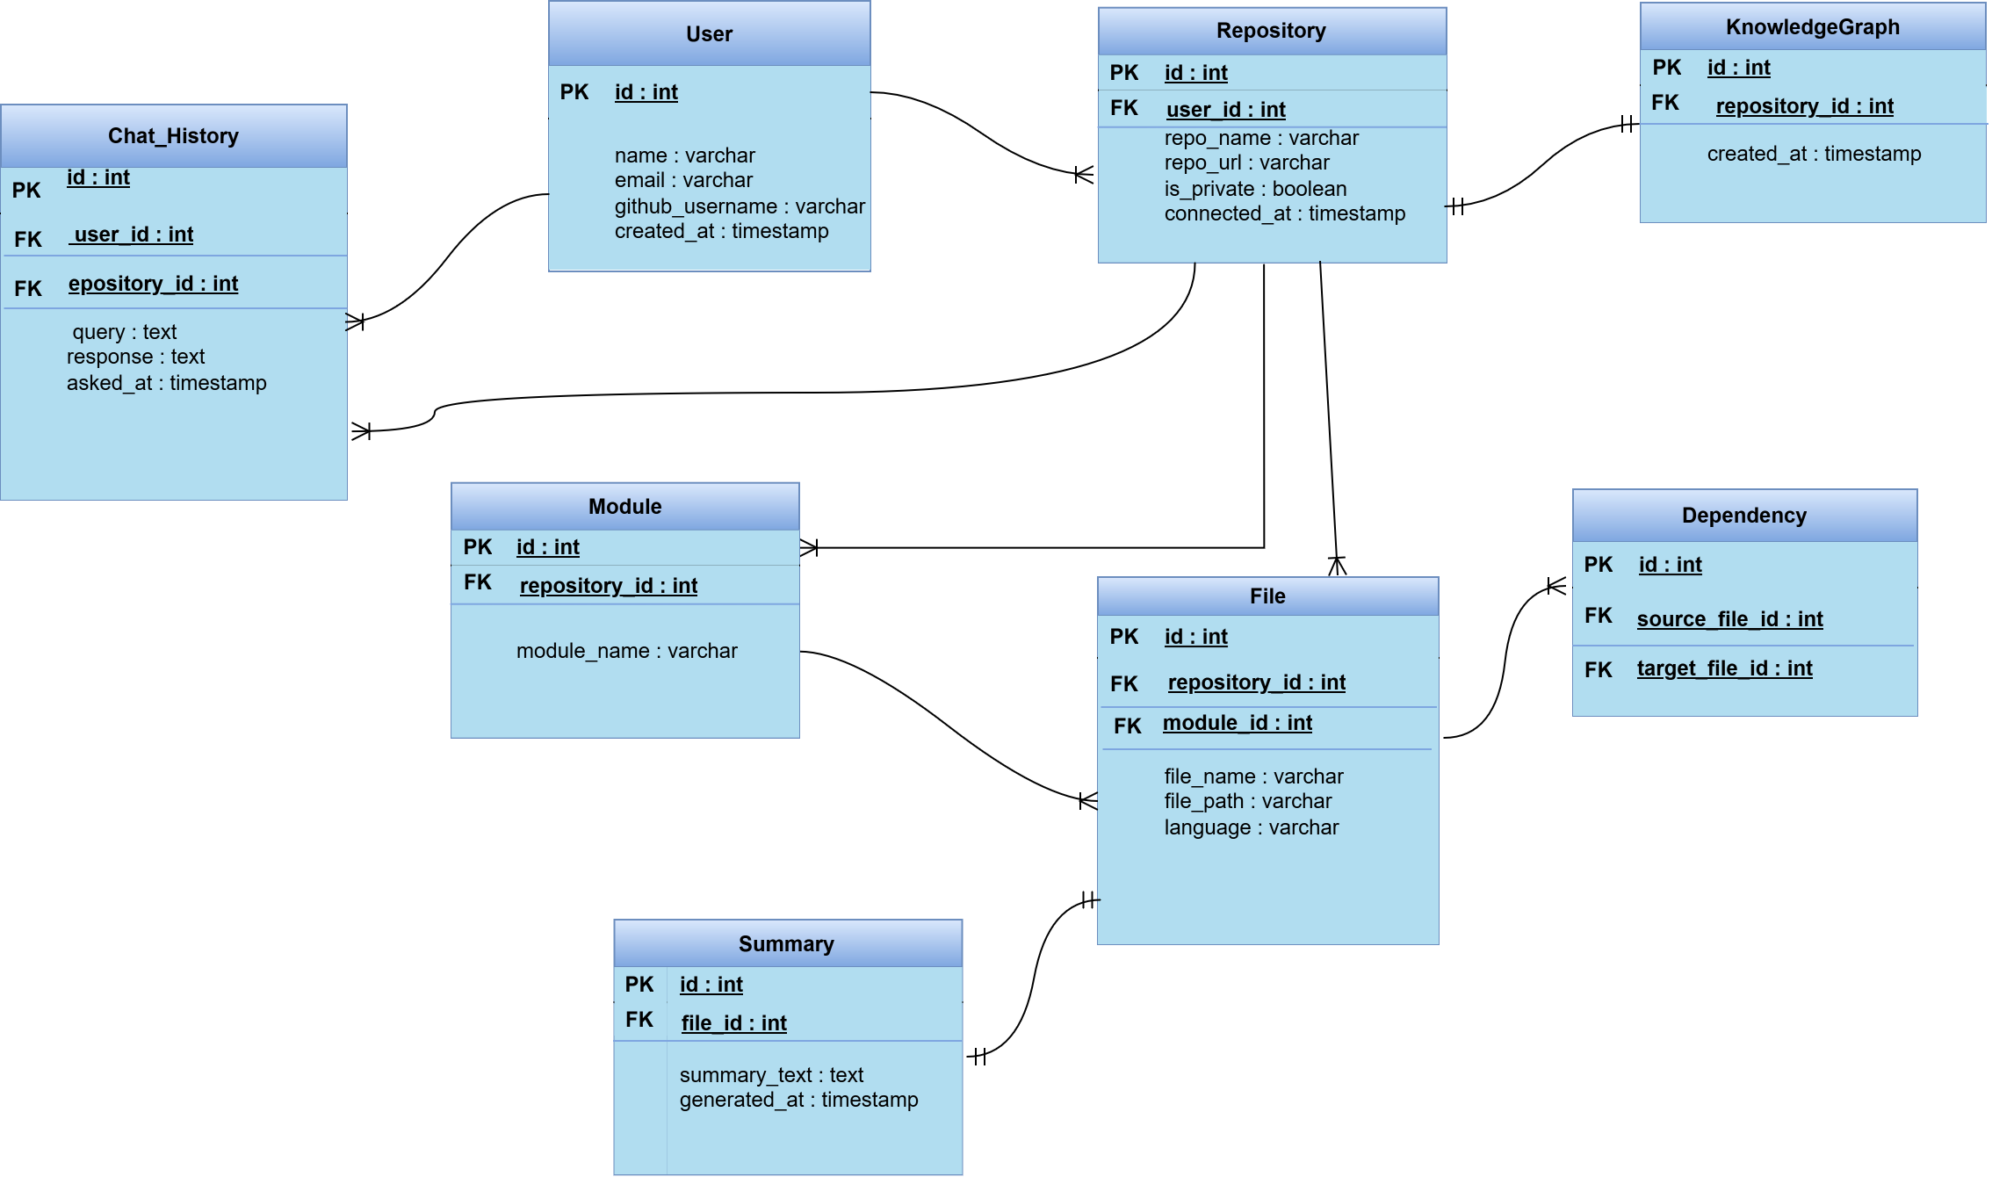

Figure 3.5 Database Scheme

NoSQL Databases:

In addition to the relational database, CodeVerse utilizes a NoSQL database to manage dynamic and unstructured data generated by AI components. NoSQL databases represent data using document-based node structures such as JSON or BSON, making them highly suitable for systems that require flexibility, scalability, and schema-less data storage.
This approach is particularly beneficial for CodeVerse, as AI-generated summaries and chatbot interactions may vary in structure and size. By using a NoSQL database, the system can efficiently store nested and hierarchical data without enforcing rigid table structures. This design allows CodeVerse to adapt easily as new features or AI enhancements are introduced.
{

"user_id": "U2026",

"username": "developer_maryam", "repository": {

"repo_id": "R101",

"repo_name": "CodeVerse-Backend", "files": [
{

"file_path": "src/auth/login.py", "language": "Python",
"summary": "This file handles user authentication and token validation."

},

{

"file_path": "src/utils/helpers.py", "language": "Python",
"summary": "Provides utility functions used across the project."

}

]

},

"chat_history": [

{

"question": "Which files depend on login.py?",

"answer": "helpers.py and middleware.py depend on login.py", "timestamp": "2026-01-15"
}

]

}

Workflow Diagram:

Workflow represents the sequence of activities, actions, or steps carried out to complete a specific process within the CodeVerse system. It illustrates how tasks are initiated, the order in which they are executed, and how decisions or conditions influence the overall flow of operations. Workflow diagrams, such as activity diagrams or flowcharts, are used to visually represent these processes, making it easier to understand system behavior, user interactions, and backend processing logic.
In CodeVerse, the workflow begins when a user logs into the system using secure authentication and connects a GitHub repository. Once the repository is successfully connected, the system fetches the project files and initiates automated code analysis. During this phase, the backend analyzes file structures and dependencies, generates AI-based summaries, and stores the extracted relationships in the knowledge graph. After processing is complete, the system displays an interactive visualization graph that allows users to explore files, modules, and dependencies. Additionally, users can interact with the chatbot to query project information using natural language. A detailed workflow diagram illustrating this process is shown in Figure 3.6, highlighting the sequential flow and decision points involved in repository analysis and visualization.

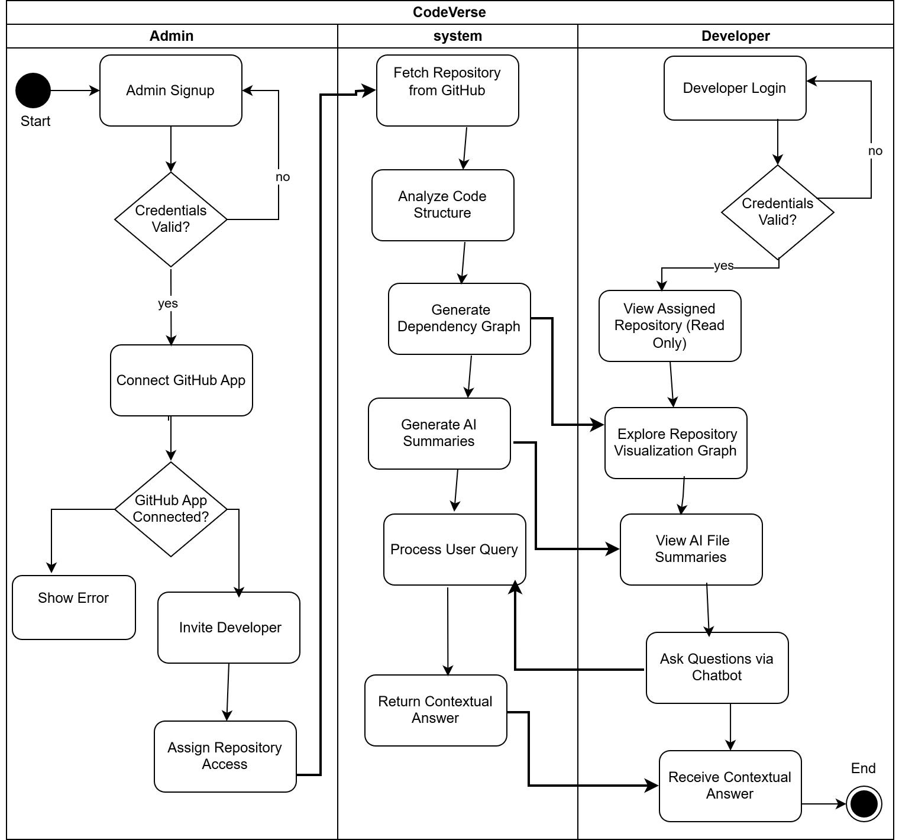

Figure 3.6 Workflow Diagram

Third-Party Dependencies:

Third-Party Dependencies:

Third-Party Dependencies refer to external libraries, frameworks, APIs, or tools that are integrated into the CodeVerse system to enhance functionality and simplify development. Instead of implementing all features from scratch, these dependencies provide reliable and well-tested solutions for common tasks such as authentication, data visualization, artificial intelligence processing, and external service communication. Proper documentation of third-party dependencies ensures system maintainability, scalability, and transparency in design.

CodeVerse relies on several third-party dependencies to support its core features, including repository integration, visualization, and AI-powered analysis. These dependencies enable efficient development while ensuring system reliability and performance.
• PostgreSQL Database: for storing structured project data, user information, metadata, and application-related records efficiently.
• Neo4j Database: for storing and managing the knowledge graph representing file dependencies, relationships, and project architecture.
• Chroma Database: for vector storage and semantic search of embeddings generated from source code and documentation.
• Groq API: for high-speed AI inference, code summarization, and intelligent chatbot response generation.
• Google Gemini API: for advanced AI-powered code understanding, natural language querying, and contextual analysis of repositories.
• GitHub API: for secure access to public and private repositories, retrieval of source code files, and repository integration.

Chapter 4

Software Development

The implementation section is like the specification and design section in that it describes the system, down to the code level. This section focuses on the realization of concepts. It explains how the proposed system design was transformed into a working software solution and highlights the practical aspects of system development. This chapter also discusses the challenges faced during implementation and the strategies used to resolve them.
The architecture, module interactions, and workflows defined during the design phase were consistently followed during development to maintain alignment between design and implementation, which is essential for achieving the project objectives.
During the implementation of CodeVerse, several unforeseen challenges were encountered. These difficulties are discussed below:

Its complexity:

Implementing role-based access control introduced significant complexity, particularly for administrative features such as revoking user access from the database. Ensuring that access to revocation was immediately reflected across repositories and visualization of data required careful handling of permissions, database relationships, and session management. This functionality requires multiple development iterations to ensure correctness and security.

Lack of documentation:

Limited and sometimes unclear documentation for third-party authentication and security mechanisms created challenges during development. Integrating secure features such as email verification, multi-factor authentication, and GitHub App authorization required additional experimentation and testing to fully understand token handling, permission scopes, and authentication flows.

Lack of suitable supporting software:

Implementing secure email verification and notification services was challenging due to the absence of a fully integrated solution that fits the system’s security requirements. Connecting email services with authentication logic, handling verification failures, and ensuring reliable delivery of emails requires additional backend logic and validation mechanisms.

Overambitious project aims:

Initially, the project aimed to implement several advanced features simultaneously, including secure authentication and real-time repository updates. Managing all these features within a limited academic timeline proved challenging. To overcome this, priorities were adjusted, and core functionalities such as access control and visualization were emphasized, ensuring a stable and functional system.

Coding Standards:

To ensure code readability, consistency, maintainability, and ease of collaboration, standard coding practices were followed throughout the development of the CodeVerse system. Consistent coding standards helped reduce errors, improved code understanding among team members, and made future enhancements easier.

Indentation Standards:

Proper indentation was strictly maintained to improve code clarity and structure. In the backend, Python’s standard indentation of four spaces was used consistently to define code blocks. In the frontend, JavaScript and React components followed uniform indentation to clearly represent component hierarchy and logic flow. Consistent indentation ensured better readability and minimized logical errors.

Declaration Standards:

All variables, functions, classes, and components were declared clearly and explicitly before use. Meaningful default values were assigned where required, and unnecessary global variables were avoided to reduce dependency issues. Backend functions were organized into separate

modules based on functionality, while frontend components were structured logically to maintain separation of concerns.

Naming Conventions:

Descriptive and meaningful names were used for variables, functions, classes, and files to clearly convey their purpose.
  - Backend (Python): snake_case was used for variable and function names, while class names followed PascalCase.
  - Frontend (React.js): Component names followed PascalCase, and variables and functions followed camelCase.
  - Database: Collection and table names were kept meaningful and consistent to reflect their stored data.
This naming approach improved code readability and reduced confusion during development and debugging.

Statement Standards:

Code statements were written in a clear and structured manner, avoiding overly complex logic within a single block. Conditional statements, loops, and exception handling were properly formatted and commented where necessary. Error handling was implemented to manage unexpected system behavior gracefully, especially in authentication, repository access, and AI processing modules. Redundant code was avoided, and reusable logic was placed in common utility functions to improve maintainability.
By following these coding standards, the CodeVerse project maintained a clean and organized codebase, enabling effective teamwork, easier debugging, and smooth integration between system components.

Development Environment:

This section describes the tools, technologies, and development setup used during the implementation of the CodeVerse system, along with the rationale behind their selection. Each tool was chosen based on its compatibility, efficiency, and suitability for building an AI-powered, secure, and scalable software solution.

Development Environment and Deployment Setup:

Visual Studio Code (VS Code) was used as the primary development environment for both frontend and backend development. VS Code provides strong support for Python and JavaScript, integrated GitHub version control, debugging tools, and a rich ecosystem of extensions. The development environment was deployed locally on developer machines using a modular setup, where the backend, frontend, and database services were configured and tested independently before integration.

Backend Technologies and Packages:

The backend was developed using Python due to its strong support for AI, data processing, and API development. Frameworks such as FastAPI were used to build RESTful APIs that enable communication between the frontend and backend. Additional Python packages were used for authentication handling, GitHub API integration, and data processing. Virtual environments were used to manage dependencies and ensure consistency across development machines.

Frontend Technologies and Libraries:

The frontend was developed using React.js, which provides a component-based architecture suitable for building dynamic and interactive user interfaces.

Databases and Supporting Software:

PostgreSQL was used as the primary database management system for the CodeVerse project due to its reliability, security, and strong support for relational data. It was utilized to store user accounts, authentication credentials, and access control information. PostgreSQL was selected because it ensures data integrity through constraints and relationships, making it well-suited for managing structured data such as user roles, permissions, and repository access mappings. In addition to PostgreSQL, supporting software tools were used to enhance system functionality. Email services were integrated for account verification, password recovery, and system notifications. GitHub APIs were used to securely fetch repository data using short-lived access tokens, ensuring controlled and read-only access to codebases. These supporting tools worked together with PostgreSQL to provide a secure, scalable, and reliable data management foundation for the CodeVerse system.

Third-Party Libraries and Services:

Several third-party libraries and APIs were integrated, including GitHub APIs for repository access, email services for verification, and notifications. These external tools significantly reduced development effort while improving system reliability and feature richness.

Software Description

This section describes the major software modules implemented in the CodeVerse system. Each module represents a critical functional component and collectively ensures secure access and accurate code analysis.

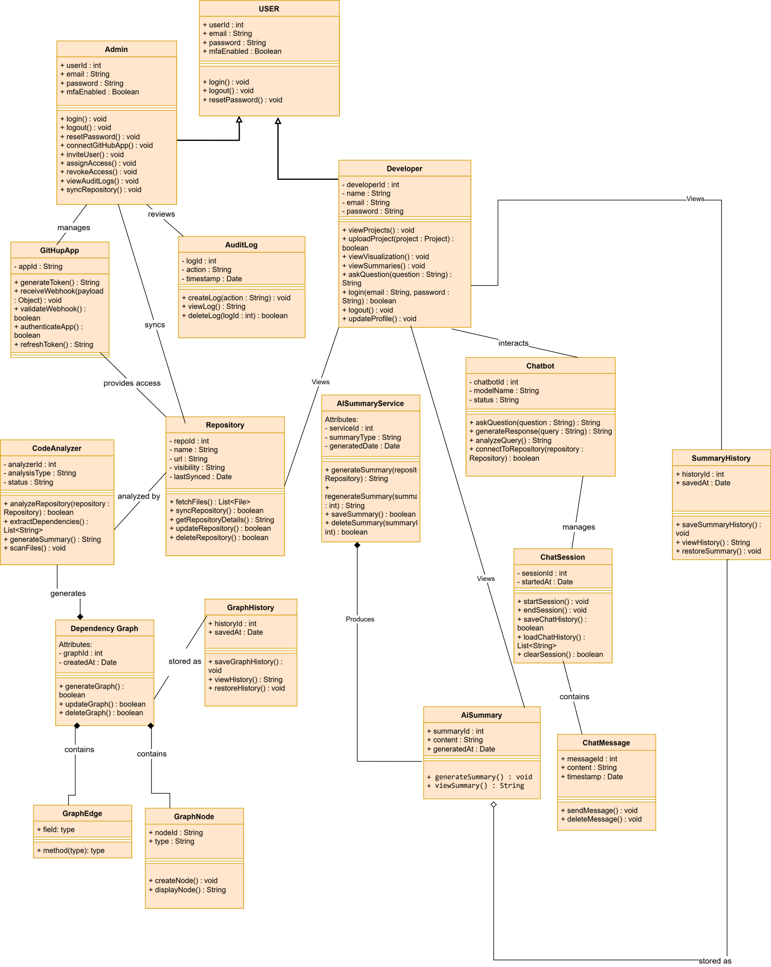

Login Process

The login module handles secure authentication for both administrators and developers. It supports account registration, login, password recovery, and multi-factor authentication (MFA). The logic ensures that only authorized users can access the system, and that developers are restricted to read-only permissions.

Loading Data

The data load graph database. ing module is responsible for fetching repositories from GitHub or accepting local project uploads. It validates repository structure, scans files for safety, and prepares the data for analysis.

Data Processing

In the current implementation of CodeVerse, the data processing module focuses on handling basic parsing of simple project structures to extract file-level dependencies. The system identifies relationships, such as which files import or reference other files. It parses source files, identifies imports, classes, and function calls, and stores relationships in the Neo4j
The extracted dependency information is then prepared for visualization, allowing developers to understand how files are connected at a basic level. This approach ensures that the implemented functionality remains stable, demonstrable, and aligned with the project timeline while still validating the overall system concept.

Report Generation (Visualization & History)

The module is responsible for presenting processed data to the user in a clear and interactive visual format. In the current implementation, the system generates a simple dependency graph for projects, illustrating file-to-file relationships such as imports and usage dependencies. This allows developers to visually explore how different files are connected within a project structure.
Additionally, the system maintains a basic history of generated dependency graphs, enabling users to view previously created visualizations. This historical view helps demonstrate how project structure analysis can be tracked over time. The visualization module focuses on clarity and usability, supporting simple navigation actions such as node selection and visual inspection of dependencies.

E1-US1: Admin Account Sign-Up with Email Verification:
@router.post("/login")
def login(data: LoginRequest): conn = None
cur = None try:
conn = get_db()

cur = conn.cursor()

cur.execute("""
SELECT id, password_hash, role, is_email_verified, mfa_enabled, mfa_secret
FROM users
WHERE email=%s AND role=%s
""", (data.email.lower(), data.role.lower()))

user = cur.fetchone() if not user:
raise HTTPException(status_code=400, detail="Invalid credentials")

user_id, password_hash, role, email_verified, mfa_enabled, mfa_secret
= user

if not verify_password(data.password, password_hash): raise HTTPException(status_code=400, detail="Invalid
credentials")

if not email_verified: raise HTTPException(
status_code=403,
detail="Please verify your email before login"
)

access_token = create_access_token({ "sub": str(user_id),
"role": role
})

return {
"mfa_required": False, "user_id": user_id, "access_token": access_token, "token_type": "bearer"
}

finally:
if cur: cur.close() if conn: conn.close()
def mfa_setup(data: MFASetupRequest): conn = None

cur = None try:
conn = get_db()
cur = conn.cursor()

# Generate secret
secret = pyotp.random_base32() totp = pyotp.TOTP(secret)
otpauth_url = totp.provisioning_uri( name=f"CodeVerse:{data.user_id}", issuer_name="CodeVerse"
)

# Save secret to DB
cur.execute("UPDATE users SET mfa_secret=%s, mfa_enabled=FALSE WHERE id=%s", (secret, data.user_id))
conn.commit()

return {"otpauth_url": otpauth_url, "secret": secret} # return secret for debugging

finally:
if cur: cur.close() if conn: conn.close()

- Description: This code implements admin login with MFA support. It first verifies the user’s credentials and email verification status, then generates an access token for successful login. The mfa_setup function generates a secret key for Time-based One-Time Password (TOTP) MFA, saves it to the database, and returns a provisioning URL for the authenticator app.

Test Case (Successful Admin Signup with Valid Details and email verification):

Table 4-1: Successful Admin Signup with Valid Details and verification code

Test ID: E1-US1-TC1 | US ID: E1-US1
Test Case Description | Verify that an admin account is successfully created when valid signup details and correct verification code are entered.

Inputs | Email:rida.maryam1215@gmail.com first name:rida, last name:Fatima  password:Hello123
Expected Result | The system successfully creates the admin account and allows the admin to log in.
Actual Result | Admin successfully created the account.

E1-US2: Admin Login with MFA:
@router.post("/signup-initiate")
def signup_initiate(data: SignupRequest): conn = None
cur = None try:
conn = get_db()
cur = conn.cursor()
otp = str(random.randint(100000, 999999))
expires_at = datetime.utcnow() + timedelta(minutes=10)

cur.execute("""
INSERT INTO users (
email, first_name, last_name, password_hash, role, is_email_verified, email_otp, email_otp_expires, mfa_enabled, mfa_secret
)
VALUES (%s,%s,%s,%s,%s,FALSE,%s,%s,FALSE,NULL)
RETURNING id """, (
data.email.lower(), data.first_name, data.last_name, hash_password(data.password), data.role.lower(),
otp, expires_at
))

user_id = cur.fetchone()[0] conn.commit()

# SEND EMAIL OTP
send_otp_email(data.email, otp)

return {
"message": "Verification code sent to email", "user_id": user_id,
"email": data.email
}
except psycopg2.errors.UniqueViolation: if conn:
conn.rollback()
raise HTTPException(status_code=400, detail="Email already exists") finally:
if cur: cur.close()
if conn: conn.close()

- Description: This function handles admin account sign-up by creating a new user in the database with a hashed password and generating a one-time email verification code (OTP). It sends the OTP to the admin’s email and returns the user ID and email for verification. The function also ensures duplicate emails are not allowed.

Test Case (Successful Login with Correct Credentials and MFA):

Table 4-2: Successful Login with Correct Credentials and MFA

Test ID: E1-US1-TC1 | US ID: E1-US1
Test Case Description | Verify that the admin can successfully log in with valid credentials and the correct MFA code after MFA has been enabled for the account.
Inputs | Username:rida.fatima425252@gmail.com Password:Hello123
Expected Result | The system authenticates the admin successfully and grants access to the tool.
Actual Result: | Admin successfully created account.

E1-US3: Admin Password Recovery:

def forgot_password():
email = request.json.get("email")

if email not in admins:
return jsonify({"message": "Admin not found"}), 404

token = str(uuid.uuid4()) admins[email]["reset_token"] = token

# In real system → send email print("Password reset token:", token)

return jsonify({"message": "Reset token generated"})

# 2. Reset password
@app.route("/admin/reset-password", methods=["POST"]) def reset_password():
email = request.json.get("email") token = request.json.get("token")
new_password = request.json.get("new_password") admin = admins.get(email)
if not admin or admin["reset_token"] != token: return jsonify({"message": "Invalid token"}), 400

admin["password"] = hashlib.sha256(new_password.encode()).hexdigest() admin["reset_token"] = None

return jsonify({"message": "Password updated successfully"})

if name == " main ": app.run(debug=True)
- Description: This code provides admin password recovery functionality. The forgot_password function generates a unique reset token for the admin and simulates sending it via email, while the reset_password function verifies the token and updates the admin’s password securely using hashing.

Test Case (Request Password Reset):

Table 4-3: Request Password Reset

Test ID: E1-US2-TC1 | US ID: E1-US2
Test Case Description | Verify admin can request a password reset using “Forgot Password.”
Inputs | Admin clicks “Forgot Password” and enters  email:rida.maryam1215@gmail.com
Expected Result | System sends a password-reset email.
Actual Result | Password updated successfully

E1-US4: GitHub App Integration for Repository Access:
async def get_installation_token(installation_id: int): jwt_token = generate_app_jwt()

headers = {
"Authorization": f"Bearer {jwt_token}", "Accept": "application/vnd.github+json"
}

url = f"https://api.github.com/app/installations/{installation_id}/access_tokens"

async with httpx.AsyncClient() as client:
r = await client.post(url, headers=headers) r.raise_for_status()
return r.json()["token"]
def get_installation_access_token(installation_id: int): jwt_token = get_github_jwt()
headers = {"Authorization": f"Bearer {jwt_token}", "Accept": "application/vnd.github+json"}
url = f"https://api.github.com/app/installations/{installation_id}/access_tokens"
resp = requests.post(url, headers=headers) if resp.status_code != 201:
raise HTTPException(status_code=500, detail="Failed to get installation access token")
return resp.json().get("token")

- Description: This code handles GitHub App integration by generating a JWT for the app and using it to request an installation access token from GitHub. The token allows the app to access repositories of a specific installation securely.

Test Case (Successful GitHub App Connection):

Table 4-4: Successful GitHub App Connection

Test ID: E1-US3-TC1 | US ID: E1-US3
Test Case Description | Verify admin can connect GitHub App to allow repository access.
Inputs | Admin clicks “Connect GitHub App” and completes authorization.
Expected Result | System issues tokens, verifies connection, and enables repo access.
Actual Result | Repositries are showing to admin

E2-US1: Email User Invitations:
def send_invitation_email(to_email: str, invite_link: str): msg = EmailMessage()
msg["Subject"] = "CodeVerse Repository Invitation" msg["From"] = SENDER_EMAIL
msg["To"] = to_email

msg.set_content(f""" Hello,

You have been invited to CodeVerse.

Click the link below to accept your invitation and access assigned repositories:

🔗 {invite_link}

If you did not expect this invitation, please ignore this email.

— CodeVerse Team """)

try:
with smtplib.SMTP(SMTP_SERVER, SMTP_PORT) as server: server.starttls()
server.login(SENDER_EMAIL, SENDER_PASSWORD) server.send_message(msg)
print(f"✅ Invitation email sent to {to_email}")
except Exception as e:
print("❌ Invitation email send failed:", e) raise

- Description: This function sends email invitations to users for accessing CodeVerse repositories. It constructs an email with a personalized invitation link and uses SMTP to deliver it securely. Errors during sending are caught and reported for debugging.

Test Case (Send Invitation Email):

Table 4.5: Send Invitation Email

Test ID: E2-US1-TC2 | US ID: E2-US1
Test Case Description | Verify that an admin can successfully invite a new user by providing a  valid email address.
Inputs | Admin enters a valid email:rida.maryam1215@gmail.com and clicks  “Send Invitation.”
Expected Result | System sends an invitation email to the user and displays a success  confirmation.
Actual Result | Developer receive an email invitation.

E2-US2: Assign Repository Access:
def get_admin_repos(user_id: int = Depends(get_current_user_id)): """Admin: fetch all repos from their GitHub App installation""" conn = get_db()
cur = conn.cursor()
cur.execute("SELECT installation_id FROM github_installations WHERE admin_user_id=%s", (user_id,))
row = cur.fetchone()

cur.close() conn.close() if not row:
return {"repositories": []}

installation_id = row[0]
token = get_installation_access_token(installation_id) headers = {"Authorization": f"token {token}"}
resp = requests.get("https://api.github.com/installation/repositories", headers=headers)
if resp.status_code != 200: return {"repositories": []}

return {"repositories": resp.json().get("repositories", [])}

- Description: This function generates a GitHub App JWT and uses it to request an installation access token for a specific app installation. The token allows read-only access to the repositories assigned to that installation.

Test Case (Assign Repository Access in Read-Only Mode):

Table 4-6. Assign Repository Access in Read-Only Mode

Test ID: E2-US2-TC1 | US ID: E2-US2
Test Case Description | Verify that an admin can successfully assign a repository to a specific  user so the user gains the correct access permissions.
Inputs | Admin selects a user from the user list, chooses a repository, and  clicks “Assign Access.”
Expected Result | System assigns the repository to the user, granting them read-only  access, and displays a confirmation message.
Actual Result | System assigns the repository to the user, granting them read-only  access, and displays a confirmation message

E2-US3: Revoke User Access:
def revoke_access(id: int, is_invite: bool = Query(...), db: Session = Depends(get_db)):

try:
if is_invite:
# Case 1: Remove a pending invitation db.query(Invitation).filter(Invitation.id == id).delete()
else:
# Case 2: Remove repository access for an active developer # If you want the user to disappear from the "Users" list,
# you must either delete the user or ensure the GET query filters
them out.
db.query(UserRepository).filter(UserRepository.user_id == id).delete()

# Optional: Delete the user entirely if "Revoke" means "Delete
User"
# db.query(User).filter(User.id == id).delete()

db.commit()
return {"message": "Access revoked and user removed from view"} except Exception as e:
db.rollback()
raise HTTPException(status_code=500, detail=str(e))

- Description: This function revokes a user’s access by deleting either a pending invitation or an active repository association from the database. It commits the changes if successful, and rolls back in case of any errors, returning a message confirming the access revocation.

Test Case (Revoke Access Successfully):

Table 4-7: Revoke Access Successfully

Test ID: E2-US3-TC1 | US ID: E2-US3
Test Case Description | Verify that the system correctly handles an attempt to revoke access for a user whose access has already been revoked
Inputs | Admin clicks “Revoke Access” for selected user.
Expected Result | User immediately loses repository access.
Actual Result | Developer cannot view the respositries.

E2-US4: View Invitation Status:

def accept_invite(token: str, payload: AcceptPayload, db: Session = Depends(get_db)):
invite = db.query(Invitation).filter(Invitation.token == token).first() if not invite:
raise HTTPException(status_code=404, detail="Invitation not found") if invite.accepted:
return {"message": "Already accepted"}

# Validate user exists
user = db.query(User).filter(User.id == payload.user_id).first() if not user:
raise HTTPException(status_code=404, detail="User not found")

try:
# Link repositories
for rid in invite.repo_ids:
exists = db.query(UserRepository).filter_by(user_id=user.id, repo_id=rid).first()
if not exists:
db.add(UserRepository(user_id=user.id, repo_id=rid))

# Mark invite accepted invite.accepted = True db.commit()
except Exception as e: db.rollback()
raise HTTPException(status_code=500, detail=f"Failed to accept invite: {e}")

return {"message": "Invite accepted and repositories linked"}

- Description: This function allows a user to accept an invitation by validating the invitation token and ensuring the user exists. It links the user to the repositories included in the invitation, marks the invitation as accepted, and commits the changes to the database

Test Case (Display Invitation Request Status):

Table 4-8 Display Invitation request status

Test ID: E2-US4-TC1 | US ID: E2-US4

Test Case Description | Verify that the system correctly displays all user invitations with their  current status.
Inputs | Admin opens User Management page.
Expected Result | System lists pending, active, and inactive status
Actual Result | Displays the status of the invitation

    - E3-US1-Enable or Disable MFA for User Accounts

def setup_mfa(data: MFASetupRequest):
conn = get_db()
cur = conn.cursor()

secret = pyotp.random_base32()
totp = pyotp.TOTP(secret)

otpauth_url = totp.provisioning_uri(
name=f"CodeVerse:{data.user_id}",
issuer_name="CodeVerse"
)

cur.execute("""
UPDATE users
SET mfa_secret=%s, mfa_enabled=FALSE
WHERE id=%s
""", (secret, data.user_id))
conn.commit()

cur.close()
conn.close()

return { "otpauth_url": otpauth_url }

- Description: This setup_mfa() function is used to set up Multi-Factor Authentication (MFA) for a user.It first creates a database connection and generates a unique secret key using the pyotp library.
Then, it creates a TOTP authentication URL (otpauth_url) that can be scanned using apps like Google Authenticator. The generated secret is stored in the users table with MFA initially disabled (mfa_enabled = FALSE).
- Test Case (Successful Activation of MFA in Account Settings)

Table 2-14 Successful Activation of MFA in Account Settings

Test ID: E3-US1-TC1 | US ID: E3-US1
Test Case Description | Verify that an admin or developer can successfully enable MFA from Account Settings.
Inputs | Admin or developer navigates to Account Settings, enables MFA toggle, and clicks Save.
Expected Result | MFA is enabled successfully and applied to future login attempts.
Actual Result | MFA is enabled successfully and applied to future login attempts.

    - E3-US2 Change Username

def update_user_name(data: NameUpdate, token: str = Depends(oauth2_scheme)):
payload = decode_access_token(token)
user_id = payload.get("sub")

if not user_id:
raise HTTPException(status_code=status.HTTP_401_UNAUTHORIZED, detail="Session expired")

conn = None
cur = None
try:
conn = get_db()
cur = conn.cursor()

# Execute update using your existing database column names
cur.execute("""
UPDATE users
SET first_name = %s, last_name = %s
WHERE id = %s
""", (data.firstName, data.lastName, user_id))

if cur.rowcount == 0:
raise HTTPException(status_code=404, detail="User record not found")

conn.commit()
return {"status": "success", "message": "Identity records updated in database"}

except Exception as e:
if conn: conn.rollback()
raise HTTPException(status_code=500, detail=f"Database Error: {str(e)}")
finally:
if cur: cur.close()
if conn: conn.close()

- Description: This update_user_name() function is used to update a user’s first and last name in the database. It first verifies the user by decoding the access token and extracting the user_id.
After establishing a database connection, it updates the first_name and last_name fields in the users table. If no matching user is found, it returns a 404 error, while database issues are handled using exception handling and rollback.
- Test Case (Change Username in Settings)

Table 2-16 Change Username in Account Settings

Test ID: E3-US2-TC1 | US ID: E3-US2
Test Case Description | Update user name with valid token and correct data
Inputs | Valid JWT token, firstName="Rida", lastName="Fatima"
Expected Result | User record updated successfully and success message returned
Actual Result | User name updated successfully

    - E3-US3 (Update Account Password):
def change_password(data: PasswordUpdate, token: str = Depends(oauth2_scheme)):
payload = decode_access_token(token)
user_id = payload.get("sub")

conn = None
cur = None
try:
conn = get_db()
cur = conn.cursor()

# 1. Fetch current hashed password from DB
cur.execute("SELECT password_hash FROM users WHERE id = %s", (user_id,))
result = cur.fetchone()

if not result:
raise HTTPException(status_code=404, detail="User not found")

db_password_hash = result[0]

# 2. VERIFY: Compare entered current password with DB hash
if not verify_password(data.currentPassword, db_password_hash):
# This triggers the "Wrong Password" alert on your frontend
raise HTTPException(
status_code=status.HTTP_400_BAD_REQUEST,
detail="The current password you entered is incorrect."
)

# 3. PREVENT: Check if new password is same as old
if data.currentPassword == data.newPassword:
raise HTTPException(
status_code=400,
detail="New password cannot be the same as the old password."
)

# 4. UPDATE: Hash new password and save
hashed_new_password = hash_password(data.newPassword)
cur.execute("""
UPDATE users
SET password_hash = %s
WHERE id = %s
""", (hashed_new_password, user_id))

conn.commit()
return {"status": "success", "message": "Security credentials updated"}

except HTTPException as he:
# Re-raise HTTP exceptions so FastAPI handles them
raise he
except Exception as e:
if conn: conn.rollback()
raise HTTPException(status_code=500, detail=f"Internal Server Error: {str(e)}")
finally:
if cur: cur.close()
if conn: conn.close()

- Descrption: This change_password() function is used to securely update a user’s account password. It first verifies the user through the access token and retrieves the current hashed password from the database. The function checks whether the entered current password is correct and ensures the new password is different from the old one. After validation, the new password is hashed and updated in the users table for security purposes.
- Test Case (Update Account Password):

Table 2-16 Change Password in Account Settings

Test ID: E3-US3-TC1 | US ID: E3-US3
Test Case Description | Change password with correct current password and valid new password
Inputs | Valid token, correct current password=Hello123@, new password=Hello1234@ different from old
Expected Result | Password updated successfully with success message
Actual Result | Password changed successfully

E4-US1: Developer Account Sign-Up with Email Verification
def login(data: LoginRequest): conn = None
cur = None try:
conn = get_db()
cur = conn.cursor()

cur.execute("""
SELECT id, password_hash, role, is_email_verified, mfa_enabled, mfa_secret
FROM users
WHERE email=%s AND role=%s
""", (data.email.lower(), data.role.lower()))

user = cur.fetchone() if not user:
raise HTTPException(status_code=400, detail="Invalid credentials")

user_id, password_hash, role, email_verified, mfa_enabled, mfa_secret
= user

if not verify_password(data.password, password_hash): raise HTTPException(status_code=400, detail="Invalid
credentials")

if not email_verified: raise HTTPException(
status_code=403,
detail="Please verify your email before login"
)

# =============================

# MFA REQUIRED FOR DEVELOPERS # =============================
if role.lower() == "developer":
if not mfa_enabled or not mfa_secret: mfa_secret = pyotp.random_base32() cur.execute("""
UPDATE users
SET mfa_secret=%s, mfa_enabled=TRUE WHERE id=%s
""", (mfa_secret, user_id)) conn.commit()

return {
"mfa_required": True, "user_id": user_id
}

# ============================= # ADMIN LOGIN (NO MFA)
# =============================
access_token = create_access_token({ "sub": str(user_id),
"role": role
})

return {
"mfa_required": False, "user_id": user_id, "access_token": access_token, "token_type": "bearer"
}

finally:
if cur: cur.close() if conn: conn.close()

def mfa_setup(data: MFASetupRequest): conn = None
cur = None try:
conn = get_db()

cur = conn.cursor()

# Generate secret
secret = pyotp.random_base32() totp = pyotp.TOTP(secret)
otpauth_url = totp.provisioning_uri( name=f"CodeVerse:{data.user_id}", issuer_name="CodeVerse"
)

# Save secret to DB
cur.execute("UPDATE users SET mfa_secret=%s, mfa_enabled=FALSE WHERE id=%s", (secret, data.user_id))
conn.commit()

return {"otpauth_url": otpauth_url, "secret": secret} # return secret for debugging

finally:
if cur: cur.close() if conn: conn.close()

- Description: This code implements admin login with MFA support. It first verifies the user’s credentials and email verification status, then generates an access token for successful login. The mfa_setup function generates a secret key for Time-based One-Time Password (TOTP) MFA, saves it to the database, and returns a provisioning URL for the authenticator app.

Test Case (Successful Developer Signup with email verification):

Table 4-9 Successful Developer Signup with verification code

Test ID: E4-US1-TC1 | US ID: E4-US1
Test Case Description | Verify that a developer account is successfully created when valid signup details and correct verification code are entered.
Inputs | Developer enters username:rida.maryam1215@gmail.com  password:Hello123
Expected Result | The system successfully creates the developer account and allows the admin to log in.
Actual Result | System authenticates and grants access to developer dashboard.

E4-US2: Developer Login with MFA:
def signup_initiate(data: SignupRequest): conn = None
cur = None try:
conn = get_db()
cur = conn.cursor()

otp = str(random.randint(100000, 999999))
expires_at = datetime.utcnow() + timedelta(minutes=10)

cur.execute("""
INSERT INTO users (
email, first_name, last_name, password_hash, role, is_email_verified, email_otp, email_otp_expires, mfa_enabled, mfa_secret
)
VALUES (%s,%s,%s,%s,%s,FALSE,%s,%s,FALSE,NULL)
RETURNING id """, (
data.email.lower(), data.first_name, data.last_name, hash_password(data.password), data.role.lower(),
otp, expires_at
))

user_id = cur.fetchone()[0] conn.commit()

# SEND EMAIL OTP
send_otp_email(data.email, otp)

return {
"message": "Verification code sent to email", "user_id": user_id,
"email": data.email
}

except psycopg2.errors.UniqueViolation:

if conn:
conn.rollback()
raise HTTPException(status_code=400, detail="Email already exists") finally:
if cur: cur.close()
if conn: conn.close()

- Description: This function handles developer account sign-up by creating a new user in the database with a hashed password and generating a one-time email verification code (OTP). It sends the OTP to the admin’s email and returns the user ID and email for verification. The function also ensures duplicate emails are not allowed.

Test Case (Successful Developer Login with Valid Details and MFA): Table 4-10 Successful Developer Login with credentials and MFA
Test ID: E2-US1-TC3 | US ID: E2-US1
Test Case Description | Verify that the developer can successfully log in with valid credentials and the correct MFA code after MFA has been enabled for the account.
Inputs | The developer enters a valid email, first name, last name, password,  matching confirm password, scans the MFA QR code, enters the verification code sent on their email and then submits.
Expected Result | The system authenticates the developer successfully and grants access to the tool.

E4-US3: Developer Password Recovery:
@app.route("/admin/forgot-password", methods=["POST"]) def forgot_password():
email = request.json.get("email")

if email not in admins:
return jsonify({"message": "Admin not found"}), 404

token = str(uuid.uuid4()) admins[email]["reset_token"] = token

# In real system → send email print("Password reset token:", token)

return jsonify({"message": "Reset token generated"})

# 2. Reset password
@app.route("/admin/reset-password", methods=["POST"]) def reset_password():
email = request.json.get("email") token = request.json.get("token")
new_password = request.json.get("new_password") admin = admins.get(email)
if not admin or admin["reset_token"] != token: return jsonify({"message": "Invalid token"}), 400

admin["password"] = hashlib.sha256(new_password.encode()).hexdigest() admin["reset_token"] = None

return jsonify({"message": "Password updated successfully"})

- Description: This code provides developer password recovery functionality. The forgot_password function generates a unique reset token for the admin and simulates sending it via email, while the reset_password function verifies the token and updates the admin’s password securely using hashing.

Test Case (Request Password Reset)

Table 4-11: Request Password Reset

Test ID: E4-US3-TC1 | US ID: E4-US3
Test Case Description | Verify developer can request a password reset using “Forgot  Password.”
Inputs | Developer clicks “Forgot Password” and enters  email:rida.maryam1215@gmail.com
Expected Result | System sends a password-reset email.

Actual Result | Password updated successfully

E4-US4: Assigned Projects in Read-Only Mode:
async def get_installation_token(installation_id: int): jwt_token = generate_app_jwt()

headers = {
"Authorization": f"Bearer {jwt_token}", "Accept": "application/vnd.github+json"
}

url = f"https://api.github.com/app/installations/{installation_id}/access_tokens"

async with httpx.AsyncClient() as client:
r = await client.post(url, headers=headers) r.raise_for_status()
return r.json()["token"]

- Description: This function generates a GitHub App JWT and uses it to request an installation access token for a specific app installation. The token allows read-only access to the repositories assigned to that installation.

Test Case (Assign Repository Access in read-only mode):

Table 4-12 Assign Repository Access in Read-Only Mode

Test ID: E4-US4-TC1 | US ID: E4-US4
Test Case Description | Verify that an admin can successfully assign a repository to a specific  user so the user gains the correct access permissions.
Inputs | Admin selects a user from the user list, chooses a repository, and  clicks “Assign Access.”
Expected Result | System assigns the repository to the user, granting them read-only  access, and displays a confirmation message.

Actual Result | System assigns the repository to the user, granting them read-only  access, and displays a confirmation message

E4-US5: Project Searching:
const searchUsers = (users, searchText) => { return users.filter(user =>
user.name.toLowerCase().includes(searchText.toLowerCase()) || user.email.toLowerCase().includes(searchText.toLowerCase())
);
};

- Description: This function allows searching through a list of users by matching the search text with their name or email, ignoring case. It filters and returns only the users that contain the search string, enabling quick project or user lookup

Test Case (Search Displays Matching Projects):

Table 4-13: Search Displays Matching Projects

Test ID: E4-US5-TC1 | US ID: E4-US5
Test Case Description | Verify that when a developer types a keyword, the system filters and  displays only the assigned projects that match the query.
Inputs | Developer enters search query into search bar.
Expected Result | Only projects matching the query are displayed.
Actual Result | Shows a specific user if exist.

    - E5-US1 Generate Repository Visualization Graph

async def generate_graph(
request: Request,
full_repo: str = Query(...),
installation_id: int | None = Query(None),
user_data: dict = Depends(get_current_user)
):
# Determine token: Use installation token if available, otherwise fallback to public/env token
if installation_id and installation_id != 0:
if installation_id:
token = get_installation_access_token(installation_id)
else:
token = os.getenv("GITHUB_TOKEN") # for public repos
else:
# Fallback to a personal access token or skip for strictly public repos
token = os.getenv("GITHUB_TOKEN")

user_id = user_data.get("id")
headers = {"Accept": "application/vnd.github+json"}
if token:
headers["Authorization"] = f"token {token}"

async with httpx.AsyncClient(timeout=120.0) as client:
tree_url = f"https://api.github.com/repos/{full_repo}/git/trees/HEAD?recursive=1"
resp = await client.get(tree_url, headers=headers)

if resp.status_code != 200:
# If public repo fails, it might need a token or the repo name is wrong
raise HTTPException(status_code=resp.status_code, detail=f"GitHub Error: {resp.text}")

items = resp.json().get("tree", [])
# ... rest of your existing parsing logic ...
file_paths = [i["path"] for i in items if not any(d in i["path"].split("/") for d in IGNORE_DIRS)
and any(i["path"].endswith(ext) for ext in SUPPORTED_EXTENSIONS)]

nodes, edges = [], []
for path in file_paths:
content_url = f"https://api.github.com/repos/{full_repo}/contents/{path}"
c_resp = await client.get(content_url, headers=headers)
if c_resp.status_code == 200:
raw_code = base64.b64decode(c_resp.json()["content"]).decode("utf-8", errors="ignore")
nodes.append({"id": path, "data": {"label": path.split("/")[-1], "content": raw_code}})
for dep in extract_dependencies(raw_code):
resolved = resolve_github_path(path, dep, file_paths)
if resolved: edges.append({"source": path, "target_full": resolved})

sync_to_neo4j(request.app.state.neo4j_driver, full_repo, nodes, edges, user_id)
return {"nodes": nodes, "dependencies": edges}

- Description: This generate_graph() function creates a dependency graph of a GitHub repository. It first determines the correct authentication token (installation token or fallback GitHub token) and then uses the GitHub API to fetch the repository file structure. It filters relevant source files based on supported extensions and ignores unwanted directories. Next, it fetches each file’s content, decodes it, and extracts dependencies to build graph nodes and edges.
- Test Case (Generate Repository Visualization Graph)

5-15: Generate Repository Visualization Graph

Test ID: E5-US1-TC1 | US ID: E5-US1
Test Case Description | Generate dependency graph for a valid GitHub repository using authentication and async processing
Inputs | full_repo="octocat/Hello-World", installation_id=12345 (or None), valid GITHUB_TOKEN in environment, authenticated user from get_current_user, HTTP request with valid headers
Expected Result | Nodes and dependencies graph returned successfully
Actual Result | Graph generated successfully

    - E5-US2 (Generate AI Summaries)

async def process_summary(request: SummaryRequest, current_user: any = Depends(get_current_user)):
# Safely extract user_id
user_id_val = None
if isinstance(current_user, (list, tuple)) and len(current_user) > 0:
user_id_val = current_user[0]
elif isinstance(current_user, dict):
user_id_val = current_user.get("id")
else:
user_id_val = getattr(current_user, "id", None)

if user_id_val is None:
raise HTTPException(status_code=401, detail="User identification failed.")

user_id = str(user_id_val)

# 1. Cache Check
if not request.regenerate:
try:
cached = get_file_summary_db(request.file_path, user_id)
if cached:
return {"summary": cached, "cached": True}
except Exception as e:
print(f"🔍 Cache Lookup Error: {e}")

# 2. AI Generation
new_summary = generate_file_summary(request.file_content)

# Handle specific status flags from the utility
new_summary = generate_file_summary(request.file_content)

if new_summary == "SERVICE_UNAVAILABLE_RETRY_LATER":
raise HTTPException(
status_code=503,
detail="The AI is currently under heavy load. Please try again in a moment."
)

if new_summary == "Could not generate a simple summary.":
# Changed to 422 or 500 depending on preference;
# 500 is what happened before, but now we catch it gracefully.
raise HTTPException(
status_code=500,
detail="The AI failed to analyze this file. Please ensure it contains valid code."
)

# 3. Save to Neo4j
try:
saved = save_file_summary_db(request.file_path, new_summary, user_id)
if not saved:
print(f"⚠️ DB Save Warning: No node found for {request.file_path}")
except Exception as e:
print(f"💾 Database Save Error: {e}")

return {"summary": new_summary, "cached": False}

- Description: This process_summary() function generates or retrieves a file summary for an authenticated user. It first extracts and validates the user ID from the token. If caching is allowed, it checks the database and returns a stored summary if available. Otherwise, it generates a new AI-based summary and handles errors like service overload or invalid content. Finally, it saves the summary in Neo4j and returns it with a cached status flag.
- Test Case (Automated File Summary Generation from Visualization Graph)

Table Automated File Summary Generation from Visualization Graph

Test ID: E5-US2-TC1 | US ID: E5-US2

Test Case Description | Verify that the system generates and displays an automated summary when a developer selects a file from the visualization graph.
Inputs | Developer completes repository analysis and selects a file node app.jsx from the graph.
Expected Result | System displays an automated summary for the selected file successfully.
Actual Result | System displays an automated summary for the selected file successfully.

E6-US1: File-Level Dependency Graphs:
def get_file_dependencies(directory): """
Scan all Python files in the directory and find which files import which.
Returns a dictionary where keys are filenames and values are list of dependent files.

"""
files = [f for f in os.listdir(directory) if f.endswith(".py")] dependencies = {f: [] for f in files}

# Map module names to file names
module_to_file = {os.path.splitext(f)[0]: f for f in files}

for file in files:
file_path = os.path.join(directory, file) with open(file_path, "r") as f:
tree = ast.parse(f.read(), filename=file) for node in ast.walk(tree):
if isinstance(node, ast.Import): for alias in node.names:
if alias.name in module_to_file: dependencies[file].append(module_to_file[alias.na
me])
elif isinstance(node, ast.ImportFrom):
if node.module and node.module in module_to_file: dependencies[file].append(module_to_file[node.module]
)

return dependencies

@app.route("/dependencies", methods=["GET"]) def dependencies_api():
directory = request.args.get("dir", ".") # default current folder deps = get_file_dependencies(directory)
return jsonify(deps)

if name == " main ": app.run(debug=True)

- Description: This function scans all Python files in a directory to determine which files import which others, returning a dependency map. The API exposes this as JSON so it can be consumed for visualization or analysis.

Test Case (Generate File-Level Dependency Graph):

Table 4-14: Generate File-Level Dependency Graph

Test ID: E6-US1-TC1 | US ID: E6-US1
Test Case Description | Verify that system generates interactive graph showing import/export dependencies.
Inputs | Developer requests dependency graph generation.
Expected Result | System displays graph with all file-level relationships.
Actual Result | System displays graph with all file-level relationships.

    - E6-US2 Function, Props Connections and Internal File Dependencies

@router.post("/generate-function-graph")
async def generate_function_graph(
request: Request,
full_repo: str = Query(...),
installation_id: int | None = Query(None),
user_data: dict = Depends(get_current_user)
):
# 1. Token Handling
if installation_id and installation_id != 0:
token = get_installation_access_token(installation_id)
else:
token = os.getenv("GITHUB_TOKEN")

headers = {"Accept": "application/vnd.github+json"}
if token:
headers["Authorization"] = f"token {token}"

user_id = user_data.get("id")

async with httpx.AsyncClient(timeout=150.0) as client:
# 2. Fetch File Tree
tree_url = f"https://api.github.com/repos/{full_repo}/git/trees/HEAD?recursive=1"
resp = await client.get(tree_url, headers=headers)

if resp.status_code != 200:
raise HTTPException(status_code=resp.status_code, detail="Failed to fetch repo tree")

items = resp.json().get("tree", [])
# Focus on logic-heavy files
file_paths = [
i["path"] for i in items
if any(i["path"].endswith(ext) for ext in SUPPORTED_EXTENSIONS)
and not any(d in i["path"].split("/") for d in IGNORE_DIRS)
]

all_functions_data = []

# 3. Process each file for functions
for path in file_paths:
content_url = f"https://api.github.com/repos/{full_repo}/contents/{path}"
c_resp = await client.get(content_url, headers=headers)

if c_resp.status_code == 200:
raw_code = base64.b64decode(c_resp.json()["content"]).decode("utf-8", errors="ignore")

# Use your imported function parser
functions = extract_function_dependencies(raw_code, path)
all_functions_data.extend(functions)

# 4. Build the Function Graph (Nodes & Edges)
# Assuming build_function_graph returns {"nodes": [...], "edges": [...]}
graph = build_function_graph(all_functions_data)

# 5. Sync to Neo4j
sync_functions_to_neo4j(
request.app.state.neo4j_driver,
full_repo,
graph,
user_id
)

return graph

async def generate_state_graph(
request: Request,
full_repo: str = Query(...),
user_data: dict = Depends(get_current_user)
):
print(f"🔥 STATE GRAPH API CALLED FOR: {full_repo}")
token = os.getenv("GITHUB_TOKEN")
headers = {"Accept": "application/vnd.github+json"}
if token:
headers["Authorization"] = f"token {token}"

async with httpx.AsyncClient(timeout=120.0) as client:
# 1. Fetch File Tree
tree_url = f"https://api.github.com/repos/{full_repo}/git/trees/HEAD?recursive=1"
resp = await client.get(tree_url, headers=headers)

if resp.status_code != 200:
raise HTTPException(status_code=resp.status_code, detail="GitHub Error")

items = resp.json().get("tree", [])
# Filter for React/JS files
file_paths = [
i["path"] for i in items
if i["path"].endswith((".js", ".jsx", ".ts", ".tsx"))
and not any(x in i["path"] for x in ["node_modules", "dist", "build"])
]

files_data = []
for path in file_paths:
content_url = f"https://api.github.com/repos/{full_repo}/contents/{path}"
c_resp = await client.get(content_url, headers=headers)

if c_resp.status_code == 200:
raw_code = base64.b64decode(c_resp.json()["content"]).decode("utf-8", errors="ignore")
# Extract state (Redux, Props, Context)
state_deps = extract_state_dependencies(raw_code)
if state_deps: # Only include files that actually use state/props
files_data.append({
"path": path,
"state_dependencies": state_deps
})

# 2. Build the Graph
graph = build_state_graph(files_data)
return graph
- Description: This module provides two GitHub-based graph generation APIs.
generate_function_graph extracts function-level dependencies from a repository, builds a function graph, and stores it in Neo4j.generate_state_graph analyzes frontend files (React/JS/TS) to extract state, props, and context dependencies and builds a state dependency graph. Both endpoints fetch repository files using GitHub API, filter relevant code files, and process them asynchronously.
- Test Case (Function, Props Connections and Internal File Dependencies)
Table 4-15: (Function, Props Connections and Internal File Dependencies)

Test ID: E6-US2-TC1 | US ID: E6-US2
Test Case Description | Generate function graph for a valid GitHub repository with authentication
Inputs | full_repo="octocat/Hello-World", valid GITHUB_TOKEN, supported extensions present, authenticated user via get_current_user
Expected Result | API should successfully fetch repository tree from GitHub, filter supported files, extract function dependencies using extract_function_dependencies, build graph using build_function_graph
Actual Result | System displays graph with all function-level relationships.

E6-US3: Interactive Visualization Features:
// Interaction logic for D3 nodes
function addNodeInteractions(nodeSelection, simulation) {
// Enable drag behavior
const dragBehavior = d3.drag()
.on("start", (event, d) => {
if (!event.active) simulation.alphaTarget(0.3).restart(); // activate simulation
d.fx = d.x; // fix x position d.fy = d.y; // fix y position
})
.on("drag", (event, d) => {
d.fx = event.x; // update fixed x d.fy = event.y; // update fixed y
})
.on("end", (event, d) => {
if (!event.active) simulation.alphaTarget(0); // cool down
simulation
d.fx = null; // release fixed x d.fy = null; // release fixed y
});

nodeSelection.call(dragBehavior);
}
- Description: This function adds drag-and-drop interaction to nodes in a D3.js force-directed graph. It allows nodes representing files or modules to be moved interactively while the graph layout dynamically adjusts, enhancing exploration of file-level dependencies.

Test Case (Visualization of Method and Function Call Dependencies):

Table 4-15 Visualization of Method and Function Call Dependencies

Test ID: E6-US3-TC1 | US ID: E6-US3
Test Case Description | Verify that system displays method and function call relationships within the file.
Inputs | Developer selects the Function Graph option to generate and view function-level relationships
Expected Result | System shows all internal method and function dependency elements
Actual Result | Graph responds to all zoom and pan interactions without lag,  distortion, or errors, maintaining accurate display of nodes and connections.

    - E7-US1 Generate AI Summaries

def generate_file_summary(file_content: str, max_retries=3):
if not file_content or len(file_content.strip()) < 10:
return "File is empty or contains no code."

model_id = "gemini-3.1-flash-lite-preview"

prompt = f"""
Analyze this code and explain it simply.
IMPORTANT: Use exactly two newlines between every section and every bullet point.

**Main Purpose:**
(One simple sentence)

**How it works:**

* (Step one)

* (Step two)

* (Step three)

**Important Notes:**

* (Key detail)

CODE:
{file_content}
"""

for attempt in range(max_retries):
try:
response = client.models.generate_content(
model=model_id,
contents=prompt
)

if response and response.text:
return response.text.strip()

return "Could not generate a simple summary."

except Exception as e:
error_msg = str(e).lower()
print(f"⚠️ Attempt {attempt + 1} failed: {e}")

# If it's a 503 (Overloaded) or 429 (Rate Limit), wait and retry
if any(err in error_msg for err in ["503", "unavailable", "429", "quota"]):
if attempt < max_retries - 1:
wait_time = (attempt + 1) * 2 # Wait 2s, then 4s
print(f"Retrying in {wait_time} seconds...")
time.sleep(wait_time)
continue
else:
return "SERVICE_UNAVAILABLE_RETRY_LATER"

# For other errors (like 404 or Auth), don't retry
return "Could not generate a simple summary."

- Description:
This function takes a piece of code as input and generates a simple human-readable summary using an AI model. It first checks whether the input is empty or too small and returns a message if there is nothing meaningful to analyze. Then it builds a structured prompt that instructs the model to explain the code in sections like purpose, working steps, and important notes. Finally, it calls the model with retry logic to handle temporary errors like rate limits or service unavailability and returns the generated explanation.

Test Case (Table 2-36 Generate Summary for Repository)

Test ID: E7-US1-TC1 | US ID: E7-US1
Test Case Description | Verify that the system generates a readable AI summary for each file.
Inputs | Developer clicks on node app.jsx to generate summary
Expected Result | Summaries  Produced. | with purpose, | key functions, | and | dependencies | are
Actual Result | Summaries  Produced. | with purpose, | key functions, | and | dependencies | are

    - E7-US2 Regenerate Summary on Re-Analyze

useEffect(() => {
if (activeNode) {
setSummary("");
setError(null);
fetchSummary(false);
}
}, [activeNode?.id]);

const fetchSummary = async (isRegenerate = false) => {
if (!activeNode) return;

setLoading(true);
setError(null);

try {
const token = localStorage.getItem("token");

if (!token) {
setError("Please log in to view AI summaries.");
setLoading(false);
return;
}

// 🔥 FIX: SAFE CONTENT PICK (NO UI CHANGE)
const fileContent =
activeNode?.data?.content ||
activeNode?.data?.codeSnippet ||
activeNode?.data?.code ||
"// Source code not available";

const response = await axios.post(
"http://localhost:8000/api/summaries/process",
{
file_path: activeNode.id,
file_content: fileContent,
regenerate: isRegenerate
},
{
headers: { Authorization: `Bearer ${token}` }
}
);

- Description: The regenerate function (isRegenerate) is used when the user explicitly wants a new AI explanation for the same file. If it is false, the system may use cached or previously generated summary. If it is true, it forces the backend to ignore cached results and generate a fresh summary again using the AI model.

- Test Case (Re-analyze Generates New Summary)

Table 2-38 Re-analyze Generates New Summary

Test ID: E7-US2-TC1 | US ID: E7-US2
Test Case Description | Verify new summary is generated when developer clicks "Re-analyze  Summary."
Inputs | Developer clicks re-analyze button on a file summary.
Expected Result | Fresh summary replaces old one.
Actual Result | Fresh summary replaces old one.

E8-US1: Ask Natural Language Questions
async def chat_with_repository(request: ChatRequest):
try:
# 1. Get AI Answer
answer = await process_chat_message(
request.repository,
request.message,
request.history
)

# 2. Store both User Message and AI Answer in Neo4j
await save_chat_message(
user_id=request.user_id,
repo_name=request.repository,
session_id=request.session_id,
user_msg=request.message,
ai_msg=answer
)

return {"role": "assistant", "content": answer}

except Exception as e:
print(f"❌ Chat Router Error: {e}")
raise HTTPException(status_code=500, detail=str(e))

a) Description: When a request comes in, it first calls process_chat_message() which sends the user’s message, repository name, and chat history to an AI system to generate a response. This returned value is stored in answer. Next, it saves the full conversation into a database (Neo4j) using save_chat_message(), storing both the user’s message and the AI’s response along with metadata like user ID, repository name, and session ID.

b) Test Case (Answer Developer Question)

Table 2-39 Answer Developer Question

Test ID: E8-US1-TC1 | US ID: E8-US1
Test Case Description | Verify that when a developer asks a natural language question about a repository, the chatbot returns a relevant answer containing accurate  contextual details from the repository.
Inputs | Developer types or speaks a question regarding the repository contents.
Expected Result | Chatbot responds with information that is accurate, relevant, and  derived from the repository context
Actual Result | Chatbot responds with information that is accurate, relevant, and  derived from the repository context

E8-US2 Start a New Conversation
const createNewChat = () => {
const newId = `sess_${Date.now()}_${Math.floor(Math.random() * 1000)}`;
const newChat = {
id: newId,
title: "New Analysis",
messages: [],
};
setChats((prev) => [newChat, ...prev]);
setActiveChatId(newId);
setSessionId(newId);
};

Description: This function is responsible for creating a new chat session in the application. It first generates a unique session ID using the current timestamp combined with a random number to ensure that every chat is distinct. After that, it creates a new chat object with this ID, a default title called “New Analysis,” and an empty messages array since no conversation has started yet. The function then updates the chat state by adding this new chat to the beginning of the existing chat list so it appears as the most recent one.

Test Case (New Chat Clears Existing Messages)

Table 2-41 New Chat Clears Existing Messages

Test ID: E8-US2-TC1 | US ID: E8-US2
Test Case Description | Verify that when a developer clicks the “New Chat” button, the  system opens a fresh conversation window.
Inputs | Developer clicks New Chat button.
Expected Result | Conversation resets and no previous chat are visible.

E8-US3 View Chat History
async def fetch_history(user_id: str, repo_name: str):
print(f"🔍 Fetching history for {user_id} in {repo_name}")

sessions = await get_user_repo_history(user_id, repo_name)

if not sessions:
return {"sessions": []}

return {"sessions": sessions}

Description: This async function is used to fetch chat history for a specific user and repository. It first logs a debug message showing which user and repository history is being requested. Then it calls get_user_repo_history() to retrieve all stored chat sessions from the database for that user and repo. If no sessions are found, it returns an empty list inside a "sessions" object.

Test Case (Developer Can View Chat History)

Table 2-42 Developer Can View Chat History

Test ID: E8-US2-TC2 | US ID: E8-US2
Test Case Description | Verify that a developer can access previous chat sessions by navigating  to chat history
Inputs | Developer navigates to chat history.
Expected Result | System displays previous chat logs with all messages intact, allowing  the developer to review
Actual Result | System displays previous chat logs with all messages intact, allowing  the developer to review

E9-US1 Developer Access to Summary History
async def get_summary_history(user_data: dict = Depends(get_current_user)):
# Ensure user_id is a string as expected by Neo4j
user_id = str(user_data.get("id"))

try:
# 1. Fetch data from DB
history_list = get_all_user_summaries(user_id)

# 2. Return the list directly.
# Your latest HistoryPage.jsx is designed to handle this flat list.
return history_list

except Exception as e:
# This print will show up in your terminal to tell you exactly what failed
print(f"❌ ERROR in /summary-history: {str(e)}")
raise HTTPException(
status_code=500,
detail=f"Internal Server Error: {str(e)}"
)

Description: This async function is a FastAPI endpoint that retrieves a user’s summary history from the database. It first extracts the authenticated user information using get_current_user and converts the user ID into a string to ensure compatibility with Neo4j. Then it calls get_all_user_summaries(user_id) to fetch all saved summaries for that user from the database. The function directly returns this list because the frontend (HistoryPage.jsx) is already designed to handle a flat list structure.

Test Case (Developer Views Summary History)

Table 2-44 Developer Views Summary History

Test ID: E9-US1-TC2 | US ID: E9-US1
Test Case Description | Verify that a developer can view the history of AI-generated summaries by opening the Summary History section.
Inputs | Developer opens Summary History section.
Expected Result | System displays a list of past AI-generated summaries with relevant  details.

4.3.29. E10-US1 Receive Real-Time Repository Update Notifications
async def github_webhook(request: Request, db: Session = Depends(get_db)):

print("🔥 WEBHOOK RECEIVED")

try:
raw_body = await request.body()

if not raw_body:
return {"status": "empty body"}

payload = json.loads(raw_body)

event = request.headers.get("X-GitHub-Event")
if event != "push":
return {"status": "ignored"}

# -------------------
# EXTRACT DATA
# -------------------
repo = payload.get("repository", {})
repo_id = repo.get("id")
repo_name = repo.get("name")
pusher = payload.get("pusher", {}).get("name")

print("📁 Repo:", repo_name, repo_id)

if not repo_id:
return {"status": "missing repo id"}

# -------------------
# GET USERS LINKED TO REPO
# -------------------
links = db.query(UserRepository).filter(
UserRepository.repo_id == repo_id
).all()

print("👥 USERS FOUND:", len(links))

if not links:
return {"status": "no linked users"}

# -------------------
# CREATE NOTIFICATIONS
# -------------------
notifications = []

for link in links:

# validate user exists
user = db.query(User).filter(User.id == link.user_id).first()
if not user:
print(f"❌ USER NOT FOUND: {link.user_id}")
continue

notifications.append(
Notification(
user_id=link.user_id,
repo_id=repo_id,
title="Repository Updated",
message=f"{pusher} pushed code to {repo_name}",
event_type="push",
is_read=False
)
)

db.add_all(notifications)
db.commit()

print("✅ Notifications saved")

# -------------------
# SOCKET EMIT
# -------------------
await sio.emit(
"repo_updated",
{
"repoId": repo_id,
"repoName": repo_name,
"pusher": pusher,
"message": f"{pusher} pushed changes"
},
room=f"repo_{repo_id}"
)

print(f"📡 Emitted to repo_{repo_id}")

return {"status": "success"}

except Exception as e:
print("❌ WEBHOOK ERROR:", str(e))
return {"status": "error", "message": str(e)}
- Description: This function is a GitHub webhook handler that listens for repository events (specifically push events) and then creates notifications and real-time updates for users linked to that repository.
When a webhook request is received, it first logs that the webhook has arrived and reads the raw request body. If the body is empty, it returns early. It then parses the JSON payload and checks the GitHub event type from the headers, only continuing if the event is a push.

Test Case (Real-Time GitHub Commit and Update Notifications)

Table 2-49 Real-Time GitHub Commit and Update Notifications

Test ID: E10-US1-TC1 | US ID: E10-US1
Test Case Description | Verify that developers receive real-time notifications when updates occur in a connected GitHub repository.
Inputs | A new commit or repository update occurs in a connected GitHub repository.
Expected Result | System sends a real-time notification to authorized developers successfully.
Actual Result | System sends a real-time notification to authorized developers successfully.

