# **Name:** Vinayak Kumar Singh **Subject:** Python Lab

# **Register No**: 23MCA1030 **Date**:05-09-2023

# **Exercise:Digital Assignment - 1**

Q1. Design a webpage for an online Pizza Delivery system using HTML5

**HTML Code**

<!DOCTYPE html>

<html lang="en">

<head>

    <meta charset="UTF-8">

    <meta name="viewport" content="width=device-width, initial-scale=1.0">

    <title>Pizza Delivery</title>

    <link rel="stylesheet" href="pizzadeliverystlyes.css">

</head>

<body>

    <header>

        <h1>Vinayak Online Pizza Delivery</h1>

    </header>

    <nav>

        <ul>

            <li><a href="#menu">Menu</a></li>

            <li><a href="#offer">Offer</a></li>

            <li><a href="#order">Order</a></li>

            <li><a href="#contact">Contact</a></li>

        </ul>

    </nav>

    <img src="banner.jpg" alt="Girl in a jacket" width="865px" height="auto">

    <section id="menu">

        <h2>Menu</h2>

        <p>Choose your Pizza:</p>

        <br>

        <ul>

            <li>

                <img src="pizza.jpg" alt="Pizza 1">

                <h3>Pizza Margherita</h3>

                <p>₹699</p>

                <p>Classic tomato, mozzarella, and basil pizza.</p><br>

                <button>Add to Cart</button>

            </li>

            <li>

                <img src="pizza2.jpg" alt="Pizza 2">

                <h3>Pizza Marinara</h3>

                <p>₹799</p>

                <p>Classic Marinara, mozzarella, and basil pizza.</p><br>

                <button>Add to Cart</button>

            </li>

            <li>

                <img src="pizza3.jpg" alt="Pizza 3">

                <h3>Pizza Pepperoni </h3>

                <p>₹899</p>

                <p>Delicious pepperoni, tomato, and mozzarella pizza.</p><br>

                <button>Add to Cart</button>

            </li>

        </ul>

    </section>

<section id="offer">

    <form id="pizza_large_menu">

        <h3>Special Discount offer</h3>

      <div id="pizzaaaa">

          <strong>Available Pizza Type:</strong><br>

          <input type="radio" id="pizza1" name="pizza" value="Pizza Margherita" required>

          <label for="pizza1">Pizza Margherita - ₹699</label><br>

          <input type="radio" id="pizza2" name="pizza" value="Pepperoni Pizza" required>

          <label for="pizza2">Pepperoni Pizza - ₹799</label><br>

          <input type="radio" id="pizza3" name="pizza" value="Hawaiian Pizza" required>

          <label for="pizza3">Hawaiian Pizza - ₹749</label><br>

          <input type="radio" id="pizza4" name="pizza" value="Veggie Supreme Pizza" required>

          <label for="pizza4">Veggie Supreme Pizza - ₹849</label><br>

          <input type="radio" id="pizza5" name="pizza" value="BBQ Chicken Pizza" required>

          <label for="pizza5">BBQ Chicken Pizza - ₹899</label><br>

          <input type="radio" id="pizza6" name="pizza" value="Mushroom Truffle Pizza" required>

          <label for="pizza6">Mushroom Truffle Pizza - ₹949</label><br>

          <input type="radio" id="pizza7" name="pizza" value="Margherita Stuffed Crust" required>

          <label for="pizza7">Margherita Stuffed Crust - ₹999</label><br>

          <input type="radio" id="pizza8" name="pizza" value="Supreme Meat Lovers" required>

          <label for="pizza8">Supreme Meat Lovers - ₹1049</label><br>

          <input type="radio" id="pizza9" name="pizza" value="Vegan Delight Pizza" required>

          <label for="pizza9">Vegan Delight Pizza - ₹899</label><br>

          <input type="radio" id="pizza10" name="pizza" value="Seafood Sensation Pizza" required>

          <label for="pizza10">Seafood Sensation Pizza - ₹1099</label><br>

        </div>

        <input type="submit" value="Add to Cart" style="color: white; background: #ff6600;">

      </form>

    </section>

    <section id="order">

        <h2>Order</h2>

        <h3>Your Cart</h3>

        <ul id="cart">

        </ul>

        <p>Total: <span id="total">₹0.00</span></p>

        <button>Chekout</button>

    </section>

    <section id="contact">

        <h2>Contact Us</h2>

        <p>If you have any questions please contact us:</p>

        <address>

            Email: <a href="mailto:pizzadelivery@pizza.com">pizzadelivery@pizza.com</a><br>

            Phone: <a href="tel:+91 1234567890">+91 1234567890</a>

        </address>

    </section>

    <footer>

        <p>&copy; 2023 Vinayak Online Pizza Delivery</p>

    </footer>

</body>

</html>

**CSS CODE**

body, h1, h2, h3, p, ul, li {

    margin: 0;

    padding: 0;

}

body {

    background-color: #f2f2f2;

    color: #333;

    font-family: Arial, sans-serif;

}

header {

    background-color: #ff6600;

    color: #fff;

    text-align: center;

    padding: 10px 0;

}

nav ul {

    list-style-type: none;

    text-align: center;

    background-color: #333;

    padding: 10px 0;

}

nav ul li {

    display: inline;

    margin-right: 20px;

}

nav ul li a {

    text-decoration: none;

    color: #fff;

}

#menu {

    padding: 20px;

    background-color: #fff;

}

#menu h2 {

    font-size: 24px;

    margin-bottom: 10px;

}

#menu ul {

    list-style-type: none;

    display: flex;

    justify-content: space-between;

}

#menu li {

    flex: 0 0 calc(30% - 20px);

    background-color: #f9f9f9;

    border: 1px solid #ddd;

    padding: 10px;

    text-align: center;

    margin-bottom: 20px;

}

#menu img {

    max-width: 100%;

    height: 200px;

}

#menu button {

    background-color: #ff6600;

    color: #fff;

    border: none;

    padding: 5px 10px;

    cursor: pointer;

}

#order {

    padding: 20px;

    background-color: #fff;

}

#order h2 {

    font-size: 24px;

    margin-bottom: 10px;

}

#order h3 {

    font-size: 18px;

    margin-bottom: 10px;

}

#cart {

    list-style-type: none;

    padding: 0;

}

#cart li {

    margin-bottom: 10px;

}

#total {

    font-weight: bold;

    color: #ff6600;

}

#order button {

    background-color: #ff6600;

    color: #fff;

    border: none;

    padding: 10px 20px;

    cursor: pointer;

}

#contact {

    padding: 20px;

    background-color: #fff;

}

#contact h2 {

    font-size: 24px;

    margin-bottom: 10px;

}

address {

    margin-top: 10px;

    font-style: normal;

}

footer {

    text-align: center;

    background-color: #333;

    color: #fff;

    padding: 10px 0;

}

#pizza_large_menu{

    margin: 50px;

    margin-top: 10px;

    margin-bottom: 10px;

}

#pizzaaaa {

    border: 2px solid #333;

    padding: 10px;

    margin-top: 10px;

    margin-bottom:10px

}

**Output:**

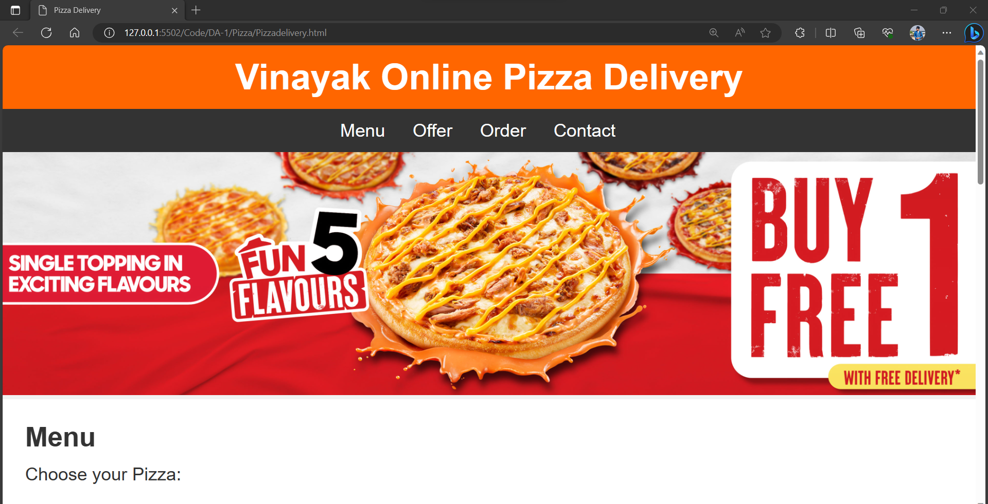

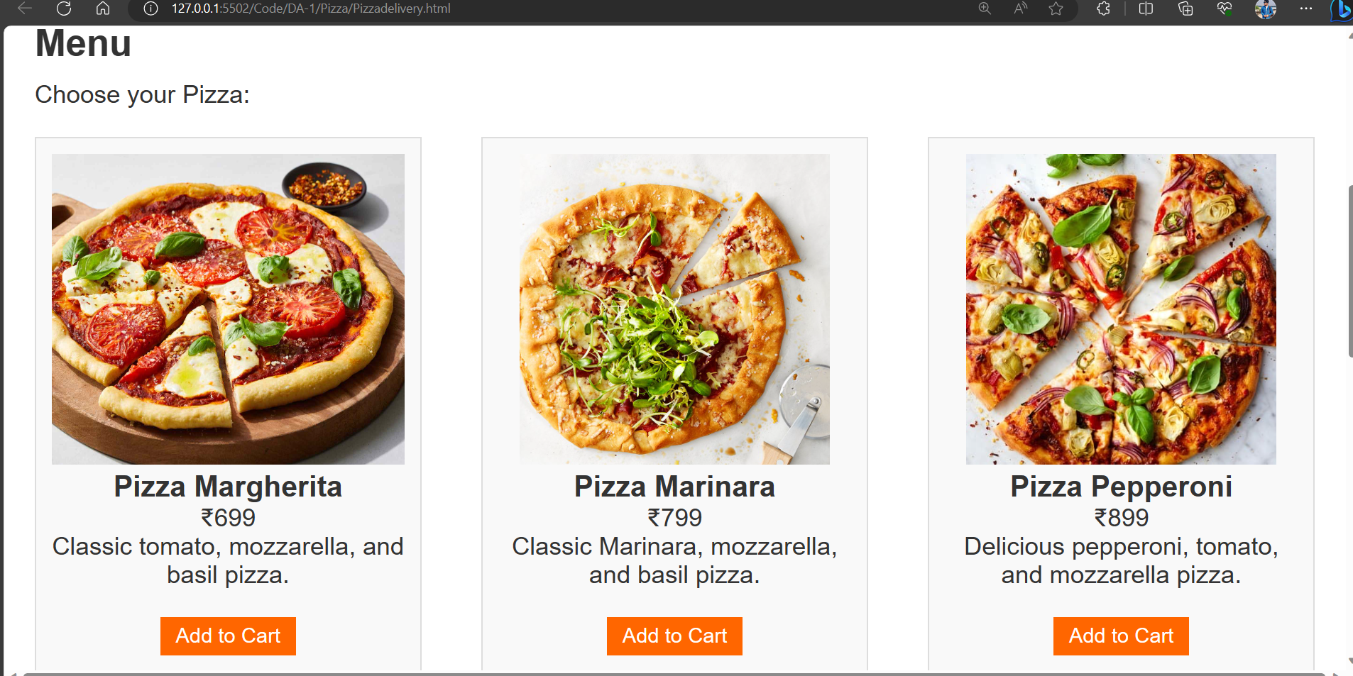

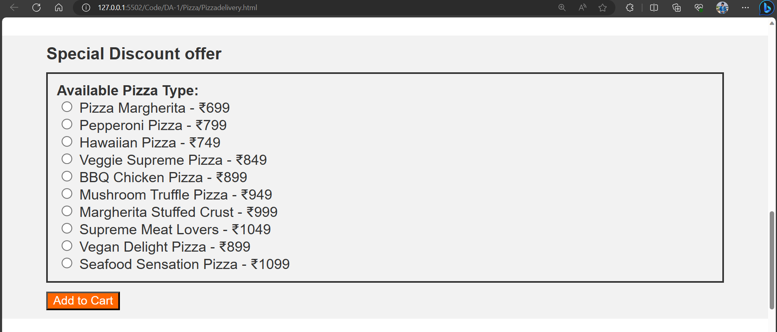

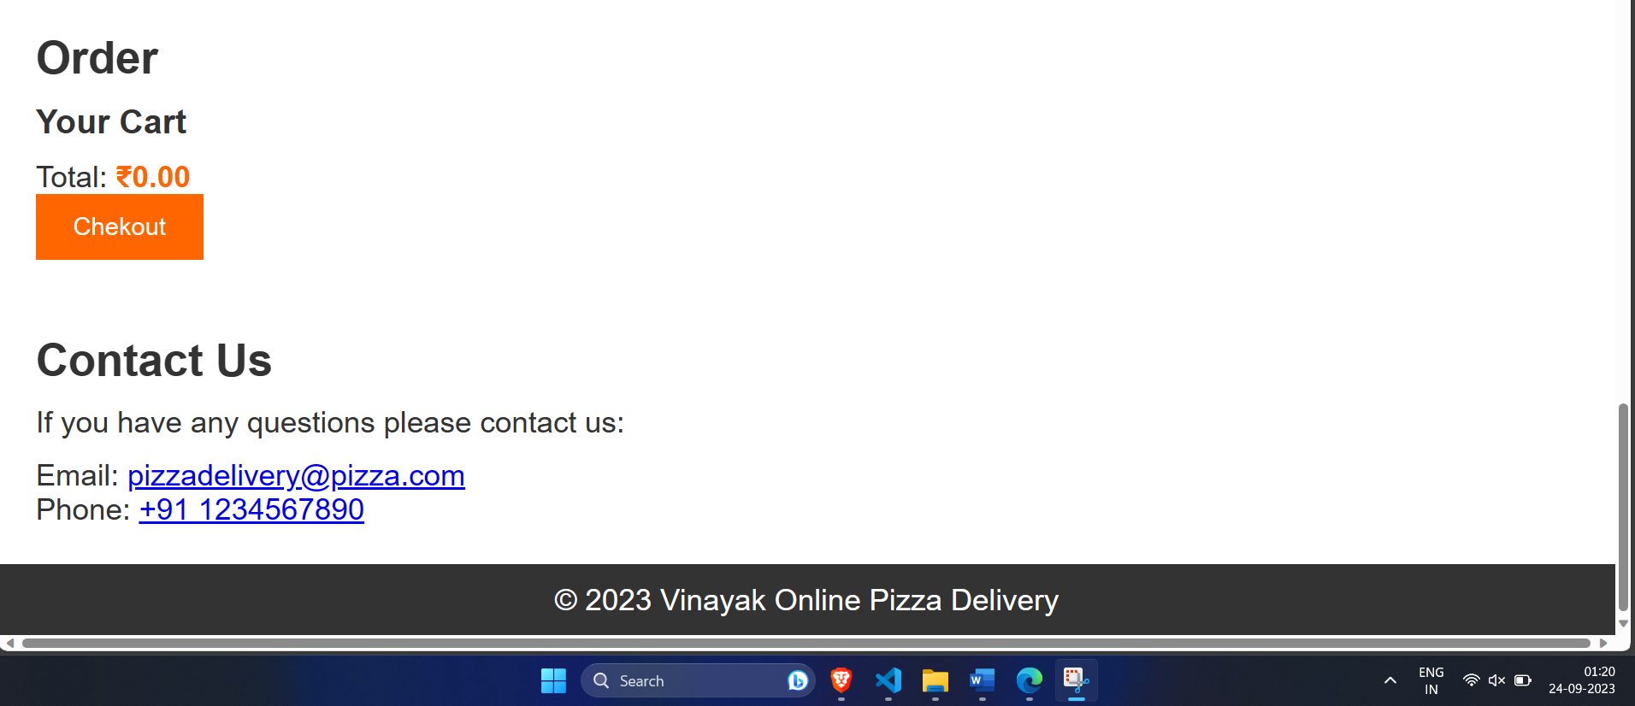

Q2. Develop an online COVID-19 tracker using HTML and JavaScript. Design the web page with three textboxes to fetch the number of newly infected cases on a particular day corresponding to three states. Create a button to add the count to the existing cases of the three states. Use DOM property event handling to update the count when the button is clicked and alert which state has maximum cases for every submission of the button. The total number of cases could be the same for any two or all the three states. In such case it should alert the name of all the states with similar count. Both name and count must be displayed.

**Code:**

<!DOCTYPE html>

<html>

<head>

    <title>COVID-19 Tracker</title>

</head>

<body>

    <h1>COVID-19 Tracker</h1>

    <div id="container" >

        <b>State1 : </b><input type="text" id="state1" placeholder="State 1"><br><br>

        <b>State2 : </b><input type="text" id="state2" placeholder="State 2"><br><br>

        <b>State3 : </b><input type="text" id="state3" placeholder="State 3"><br><br>

        <button id="submit">Submit</button>

    </div>

    <script>

        let state1 = document.getElementById("state1");

        let state2 = document.getElementById("state2");

        let state3 = document.getElementById("state3");

        let submitButton = document.getElementById("submit");

        let maxCases = 0;

        submitButton.addEventListener("click", function () {

            let newCases1 = parseInt(state1.value);

            let newCases2 = parseInt(state2.value);

            let newCases3 = parseInt(state3.value);

            let totalCases1 = newCases1;

            let totalCases2 = newCases2;

            let totalCases3 = newCases3;

            if ((totalCases1 > totalCases2) &&  (totalCases1 > totalCases3)){

                maxCases = totalCases1;

                maxCasesState = alert("The state with maximum cases is State 1"  + " with " + maxCases + " cases");

            }

            else if ((totalCases2 > totalCases1) &&  (totalCases2 > totalCases3)){

                maxCases = totalCases2;

                maxCasesState = alert("The state with maximum cases is State 2"+ " with " + maxCases + " cases");

            }

            else if ((totalCases3 > totalCases1) &&  (totalCases3 > totalCases2)){

                maxCases = totalCases3;

                maxCasesState = alert("The state with maximum cases is State 3"+ " with " + maxCases + " cases");

            }

            else if((totalCases1==totalCases2)&&(totalCases2!=totalCases3))

            {

                maxCases=totalCases1;

                maxCasesState=alert("The state with maximum cases is state 1 and state 2"+" with "+maxCases+" cases each");

            }

            else if((totalCases2==totalCases3)&&(totalCases1!=totalCases2))

            {

                maxCases=totalCases2;

                maxCasesState=alert("The state with maximum cases is state 2 and state 3"+" with "+maxCases+" cases each");

            }

            else if((totalCases1==totalCases3)&&(totalCases1!=totalCases2))

            {

                maxCases=totalCases1;

                maxCasesState=alert("The state with maximum cases is state 1 and state 3"+" with "+maxCases+" cases each");

            }

            else if((totalCases1===totalCases2)&&(totalCases2===totalCases3)){

                maxCases=totalCases1;

                maxCasesState=alert("The state with maximum cases is state 1, state 2 and state 3"+ " with " + maxCases + " cases each")

            }

        });

    </script>

</body>

</html>

**Output:**

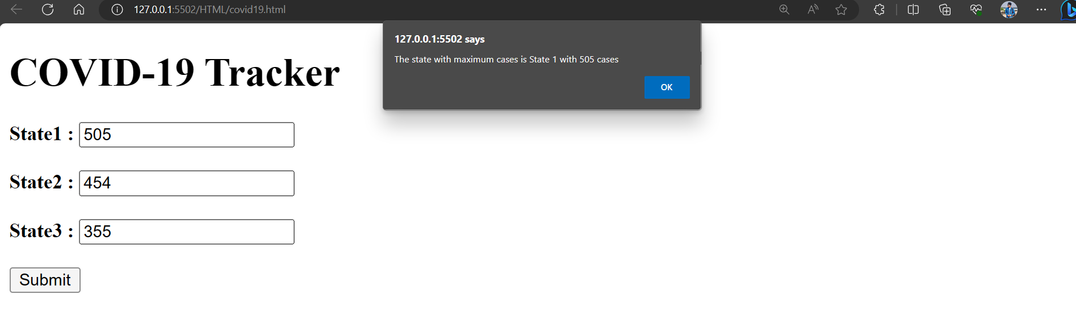

Q3. Develop an online application for Indian Premier League – 2021 Auction Process using HTML, JavaScript and DOM. The application is an editor for IPL auction result for Chennai Super Kings. The webpage has a heading section with heading “IPL Auction 2021”. Create a button “EditDate” that appends current date to the heading using TextNode method. The webpage also has three <div> sections for player list, newly added batsmen and dropped bowler. Fetch the current set of players from a textbox and add it to the first <div> as a child element using <p> tag when “Add Player” button is clicked. Assume in second <div> there is an unordered list of two batsmen who are to be replaced. Fetch the names of the two new batsmen from two textboxes and on clicking “Replace batsmen” button, replace the previous two batsmen from the unordered list. Assume that the third <div> has an unordered list of 3 bowlers in descending order of performance. Create a button “DropBowler” that deletes the last bowler in the list.

Code:

<!DOCTYPE html>

<html>

<head>

    <title>IPL Auction 2021</title>

</head>

<body>

    <h1 id="auctionHeading">IPL Auction 2021</h1>

    <button id="editDate">Edit Date</button>

    <div id="playerList">

        <h2>Player List</h2>

        <input type="text" id="newPlayer" placeholder="New Player Name">

        <button id="addPlayer">Add Player</button>

    </div>

    <div id="newBatsmen">

        <h2>Newly Added Batsmen</h2>

        <ul>

            <li>Virat</li>

            <li>Dhoni</li>

            <li>Rohit</li>

            <li>Sachin</li>

        </ul>

        <input type="text" id="batsman1" placeholder="Batsman 1">

        <input type="text" id="batsman2" placeholder="Batsman 2">

        <button id="replaceBatsmen">Replace Batsmen</button>

    </div>

    <div id="droppedBowler">

        <h2>Dropped Bowler</h2>

        <ul>

            <li>Sunil</li>

            <li>Ashwin</li>

            <li>Bumrah</li>

            <li>Malinga</li>

        </ul>

        <button id="dropBowler">Drop Bowler</button>

    </div>

    <script>

        function editDate() {

            let heading = document.getElementById("auctionHeading");

            let currentDate = new Date().toLocaleDateString();

            heading.innerText = "IPL Auction 2021 - " + currentDate;

        }

        function addPlayer() {

            let playerList = document.getElementById("playerList");

            let newPlayerName = document.getElementById("newPlayer").value;

            if (newPlayerName.trim() !== "") {

                let newPlayerElement = document.createElement("p");

                newPlayerElement.textContent = newPlayerName;

                playerList.appendChild(newPlayerElement);

                document.getElementById("newPlayer").value = "";

            }

        }

        function replaceBatsmen() {

            let batsman1Name = document.getElementById("batsman1").value;

            let batsman2Name = document.getElementById("batsman2").value;

            let batsmenList = document.getElementById("newBatsmen").querySelector("ul");

            let existingBatsmen = batsmenList.querySelectorAll("li");

            for (let i = 0; i < existingBatsmen.length; i++) {

                if (existingBatsmen[i].textContent === batsman1Name) {

                    existingBatsmen[i].textContent = batsman2Name;

                    break;

                }

            }

            document.getElementById("batsman1").value = "";

            document.getElementById("batsman2").value = "";

        }

        function dropBowler() {

            let droppedBowler = document.getElementById("droppedBowler");

            let bowlersList = droppedBowler.querySelector("ul");

            let bowlers = bowlersList.querySelectorAll("li");

            if (bowlers.length > 0) {

                bowlersList.removeChild(bowlers[bowlers.length - 1]);

            }

        }

        document.getElementById("editDate").addEventListener("click", editDate);

        document.getElementById("addPlayer").addEventListener("click", addPlayer);

        document.getElementById("replaceBatsmen").addEventListener("click", replaceBatsmen);

        document.getElementById("dropBowler").addEventListener("click", dropBowler);

    </script>

</body>

</html>

**Output:**

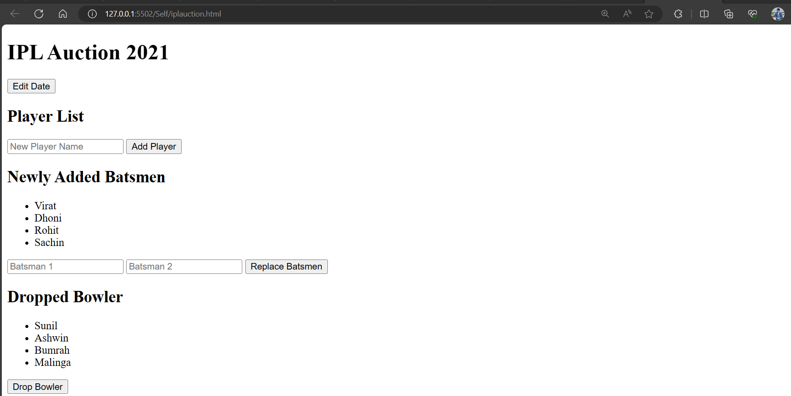

*Edit Date and Add Player*

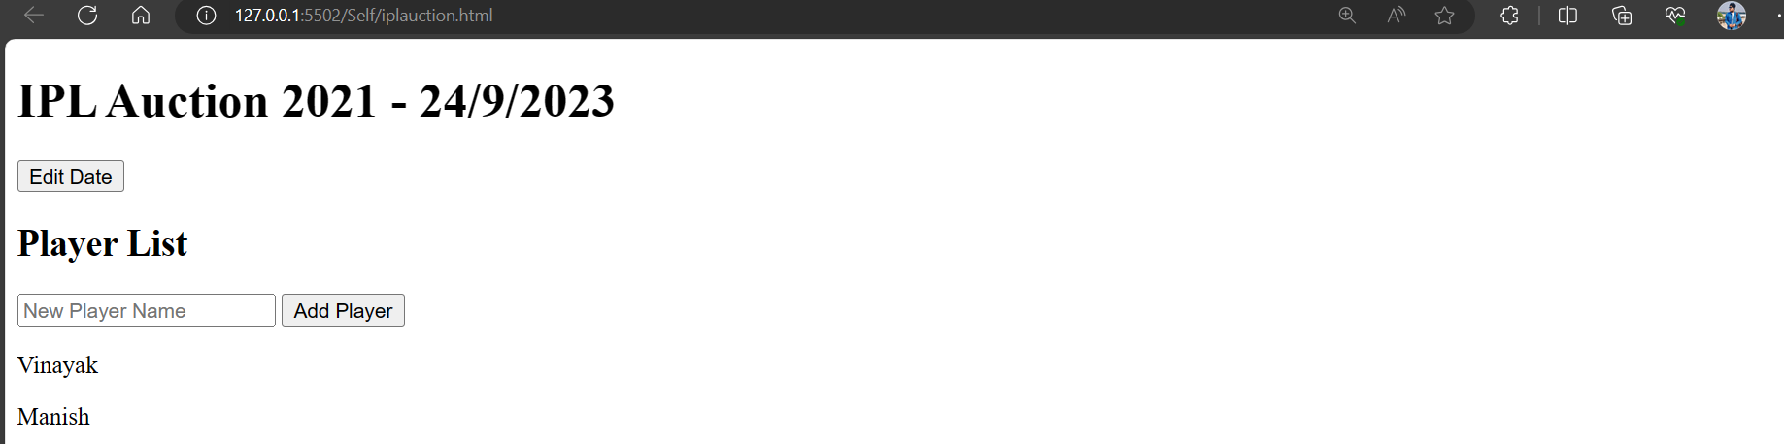

*Replacing Player* 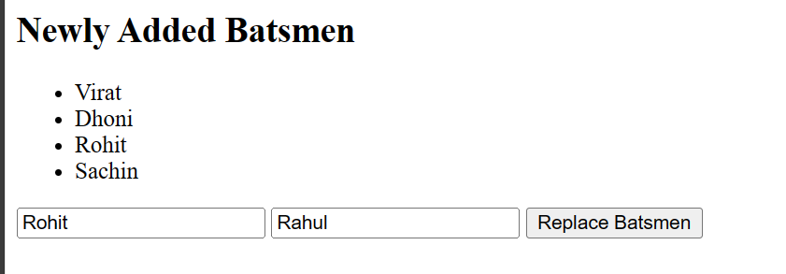

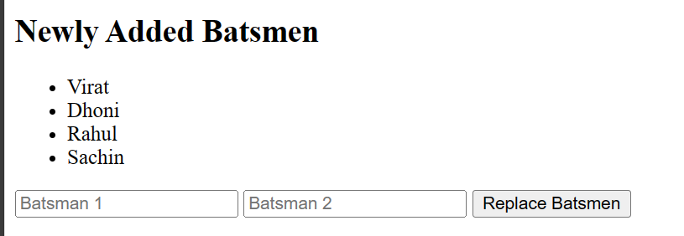

*Bowler Starting State* **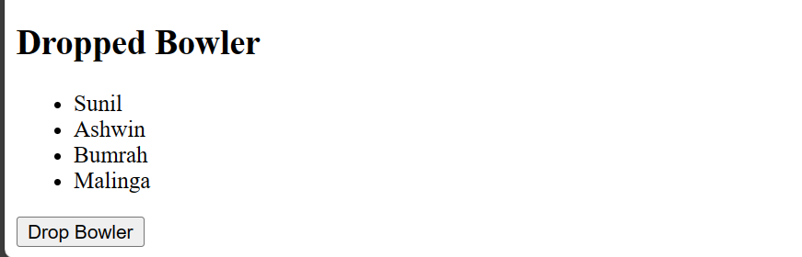***Dropping 2 Bowler after performing all commands***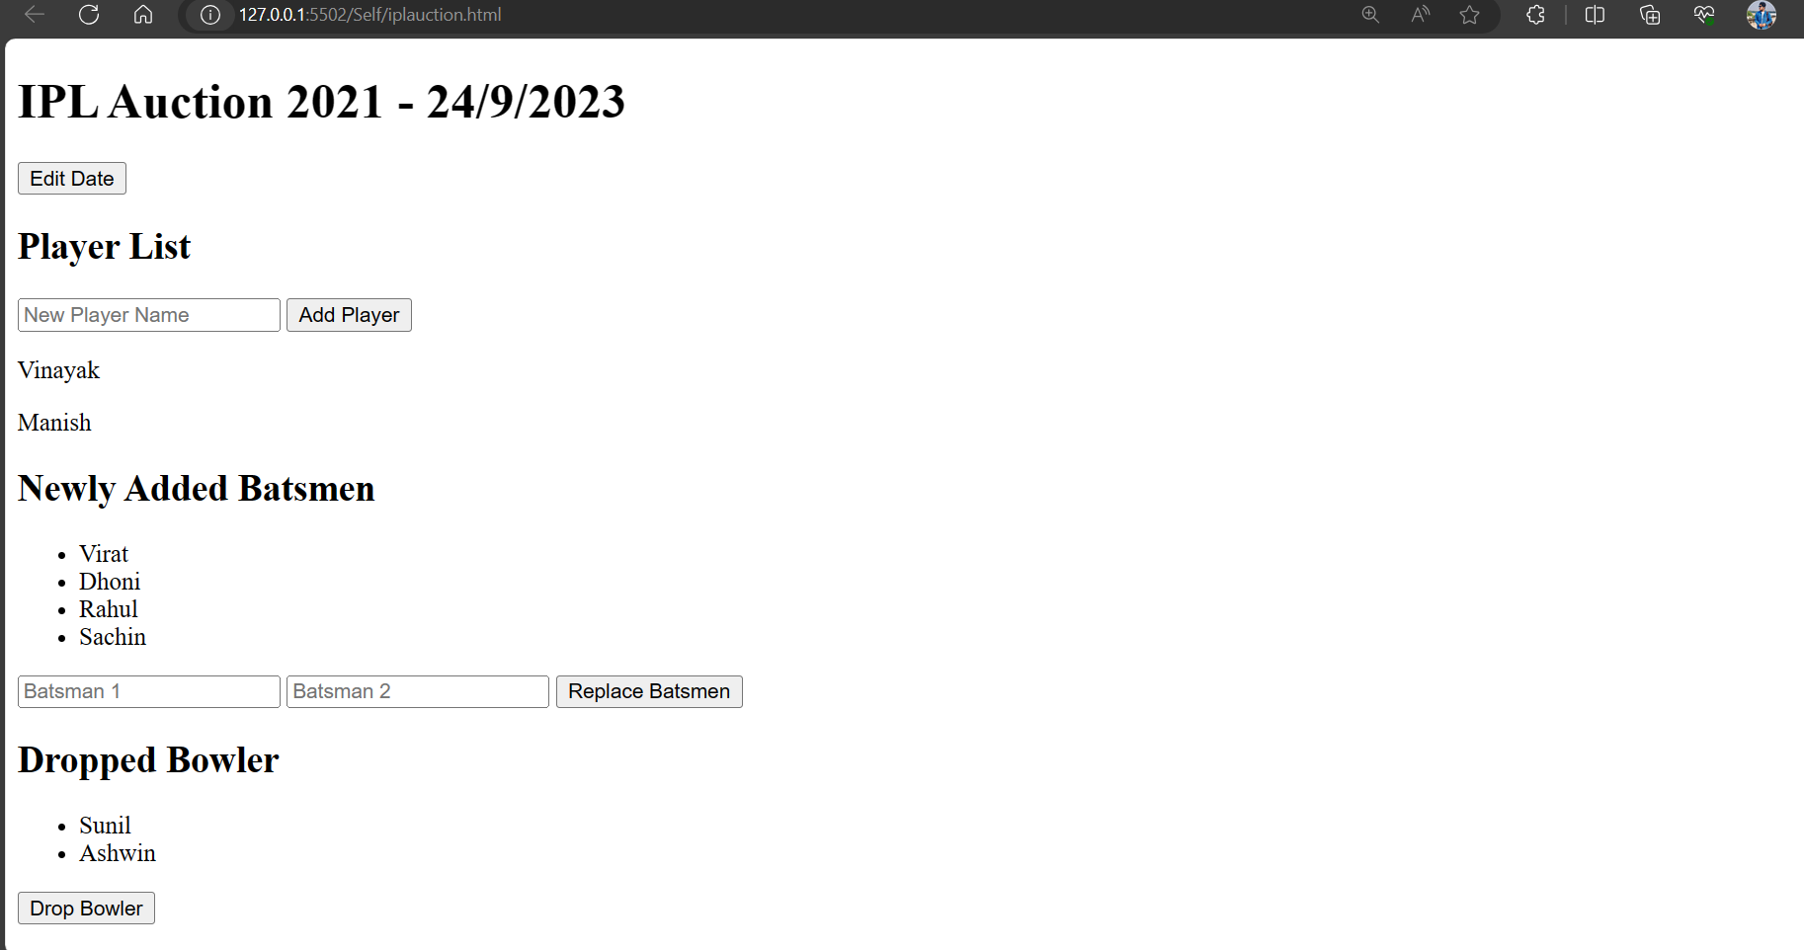**

Q4. CMF Hospital wants you to develop an online application to analyze the cognitive ability of geriatric patients using HTML and JavaScript. To analyze the cognitive ability a simple online test is done to determine memory and basic problem solving skills. Design the web from of the analyzer and implement validations as follows:

* Design a form with 8 textboxes, 8 div (for displaying error messages) and a button. The patient has to enter details in the form.
* The entries in the textbox is as follows:
* Textbox 1 = name
* Textbox 2 = number of brothers of patient + 2
* Textbox 3 = Textbox 2 value X 2
* Textbox 4 = Textbox 3 value + 1
* Textbox 5 = Textbox 4 value X 5
* Textbox 6 = Textbox 5 value + number of sisters the patient has
* Textbox 7 = Number of brothers the patient has
* Textbox 8 = Number of sister the patient has Textboxes from 3 to 5 must hold the correct numeric value corresponding to the operation specified. Incase case of error an error message must be displayed in the corresponding <div>. As long as valid entry is given in any textbox the focus must remain in the textbox.
* To check the ability of the patient deduct 25 from the value in the sixth textbox. If the difference is a two digit number then the first digit is the number of brothers and second digit is the number of sisters. If the difference is one digit non-zero value then the number of sisters is the one digit difference value and the number of brothers is zero. If the difference is zero then the patient has no brothers and sisters.
* Validate the derived count of brothers and sisters from previous step with the values entered 7th and 8th textboxes. If it is a match set the div next to 8th textbox as “Good memory and problem solving skills” else “Retardation is memory and problem solving skills”.

For example:

If I have 1 brother and 0 sister then

* Textbox 2 = 1 + 2 = 3
* Textbox 3 = 3 X 2 = 6 (Validate that correct product is entered here)
* Textbox 4 = 6 + 1 = 7 (Validate that correct sum is entered here)
* Textbox 5 = 7 X 5 = 35 (Validate that correct product is entered here)
* Textbox 6 = 35 + 0 = 35 (35-25=10) So no of brothers (first digit) - 1 and no of sisters (second digit) - 0
* Textbox 7 = Number of brothers the patient has
* Textbox 8 = Number of sister the patient has

If 7th textbox has 1 and 8th textbox is 0 then the div text is “Good memory and problem-solving skills” else “Retardation is memory and problem-solving skills”.

Note: Assume maximum number of brothers is 5 and maximum number of sisters is 5.

Code:

<!DOCTYPE html>

<html lang="en">

<head>

    <meta charset="UTF-8">

    <meta name="viewport" content="width=device-width, initial-scale=1.0">

    <title>CMF Hospital </title>

    <style>

        body {

            font-family: Arial, sans-serif;

            background-color: #f0f0f0;

            margin: 0;

            padding: 0;

        }

        h1 {

            text-align: center;

            color: #333;

            margin: 5px 0;

        }

        #cognitiveForm {

            max-width: 800px;

            margin: 0 auto;

            padding-top: 5px;

            padding-bottom: 5px;

            padding-left: 5px;

            padding-right: 5px;

            background-color: #fff;

            box-shadow: 0px 0px 10px rgba(0, 0, 0, 0.1);

            border-radius: 10px;

        }

        label {

            display: block;

            margin-bottom: 10px;

            font-weight: bold;

        }

        input[type="text"],

        input[type="number"] {

            width: 100%;

            padding: 4px;

            margin-bottom: 4px;

            border: 1px solid #ccc;

            border-radius: 3px;

            box-sizing: border-box;

        }

        button[type="button"] {

            width: 100%;

            background-color: tomato;

            color: #fff;

            border: none;

            padding: 10px;

            cursor: pointer;

            border-radius: 4px;

        }

        .error {

            color: red;

            font-weight: bold;

            margin-top: 2px;

            text-align: center;

        }

    </style>

</head>

<body>

    <h1>CMF Hospital - Cognitive Ability Analyzer</h1>

    <form id="cognitiveForm">

        <label for="name">Patient's Name:</label>

        <input type="text" id="name" name="name" required><br>

        <label for="brothers">Number of Brothers:</label>

        <input type="number" id="brothers" name="brothers" required><br>

        <label for="sisters">Number of Sisters:</label>

        <input type="number" id="sisters" name="sisters" required><br>

        <label for="result2">Textbox 2:</label>

        <input type="number" id="result2" name="result2" readonly><br>

        <label for="result3">Textbox 3:</label>

        <input type="number" id="result3" name="result3" readonly><br>

        <label for="result4">Textbox 4:</label>

        <input type="number" id="result4" name="result4" readonly><br>

        <label for="result5">Textbox 5:</label>

        <input type="number" id="result5" name="result5" readonly><br>

        <label for="result6">Textbox 6:</label>

        <input type="number" id="result6" name="result6" readonly><br>

        <label for="patientBrothers">Number of Brothers (Textbox 7):</label>

        <input type="number" id="patientBrothers" name="patientBrothers" required><br>

        <label for="patientSisters">Number of Sisters (Textbox 8):</label>

        <input type="number" id="patientSisters" name="patientSisters" required><br>

        <button type="button" onclick="calculateCognitiveAbility()">Calculate</button>

        <div id="cognitiveResult" class="error"></div>

    </form>

    <script>

        function calculateCognitiveAbility() {

            const brothers = parseInt(document.getElementById('brothers').value);

            const sisters = parseInt(document.getElementById('sisters').value);

            const patientBrothers = parseInt(document.getElementById('patientBrothers').value);

            const patientSisters = parseInt(document.getElementById('patientSisters').value);

            const result2 = brothers + 2;

            const result3 = result2 * 2;

            const result4 = result3 + 1;

            const result5 = result4 * 5;

            const result6 = result5 + sisters;

            document.getElementById('result2').value = result2;

            document.getElementById('result3').value = result3;

            document.getElementById('result4').value = result4;

            document.getElementById('result5').value = result5;

            document.getElementById('result6').value = result6;

            const cognitiveAbility = result6 - 25;

            const cognitiveResult = document.getElementById('cognitiveResult');

            if (cognitiveAbility >= 10) {

                const firstDigit = Math.floor(cognitiveAbility / 10);

                const secondDigit = cognitiveAbility % 10;

                if (firstDigit === patientBrothers && secondDigit === patientSisters) {

                    cognitiveResult.innerText = 'Good memory and problem-solving skills.';

                } else {

                    cognitiveResult.innerText = 'Retardation in memory and problem-solving skills.';

                }

            } else if (cognitiveAbility === 0) {

                if (patientBrothers === 0 && patientSisters === 0) {

                    cognitiveResult.innerText = 'Good memory and problem-solving skills.';

                } else {

                    cognitiveResult.innerText = 'Retardation in memory and problem-solving skills.';

                }

            } else {

                if (patientBrothers === 0 && cognitiveAbility === patientSisters) {

                    cognitiveResult.innerText = 'Good memory and problem-solving skills.';

                } else {

                    cognitiveResult.innerText = 'Retardation in memory and problem-solving skills.';

                }

            }

        }

    </script>

</body>

</html>

**Output:**

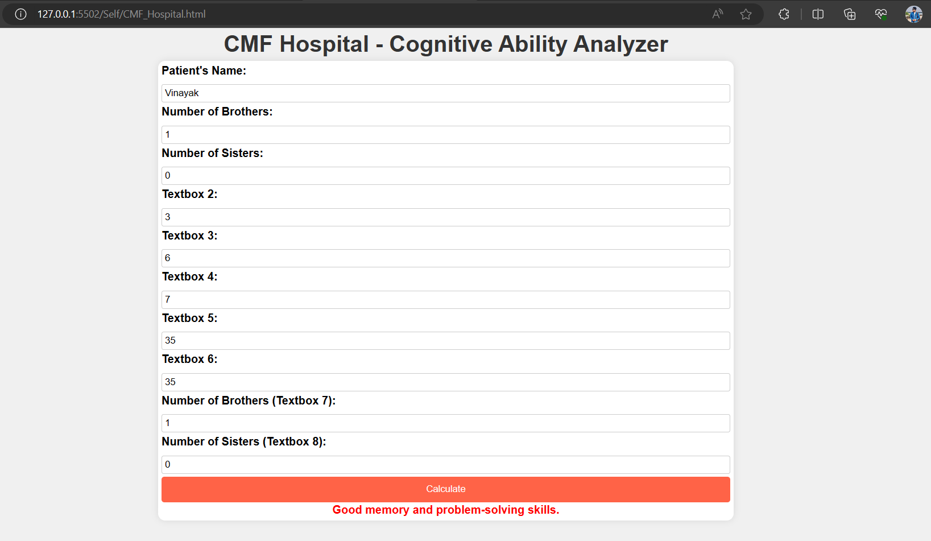

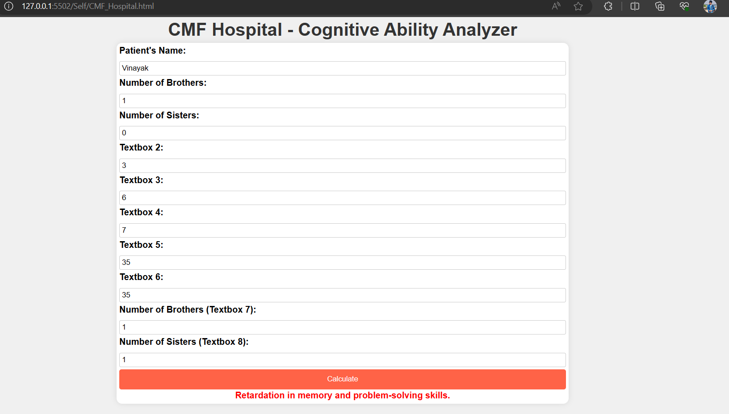

# END