==============================================================
Sprint 1
aws sts get-caller-identity
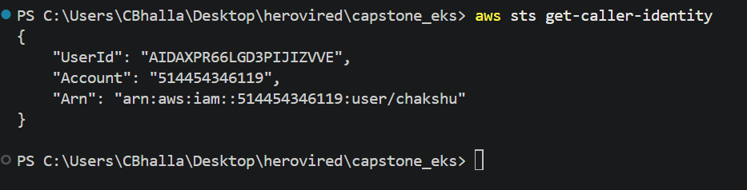
Version update(helm and kubectl)
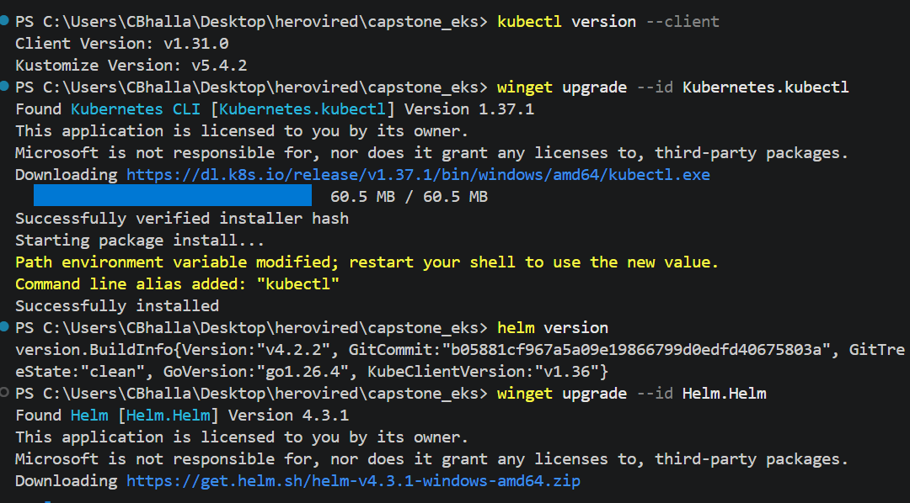

Verified all software updates and run the provision script to create a eks cluster on aws end .

Bash ./k8s-health-checker/scripts/01-provision-eks.sh
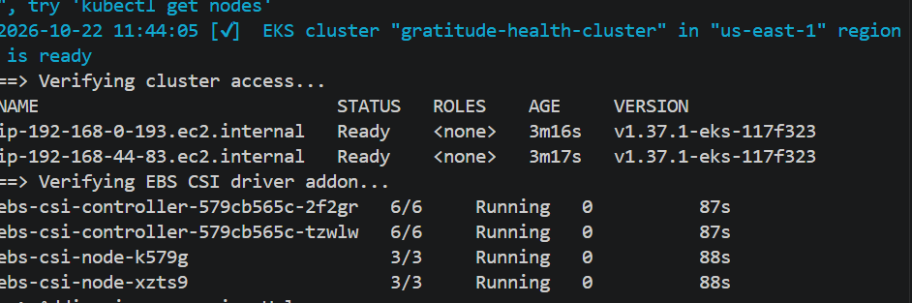
kubectl config current-context
kubectl cluster-info
kubectl get nodes
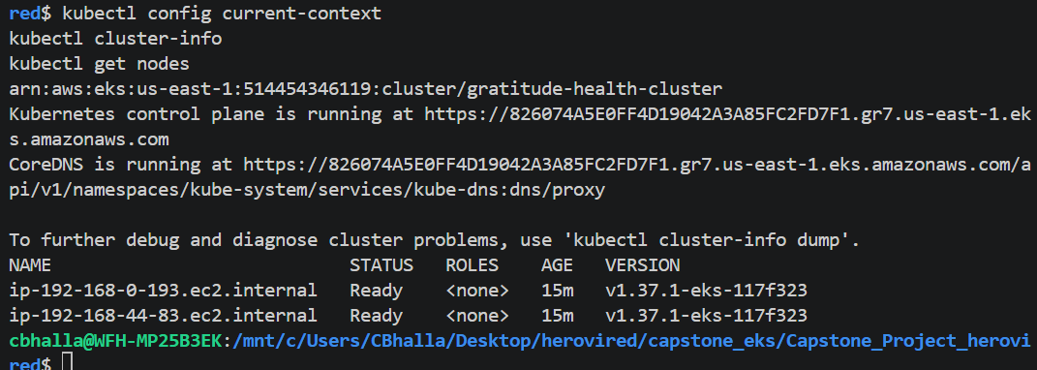
kubectl get pods -n ingress-nginx
kubectl get svc -n ingress-nginx
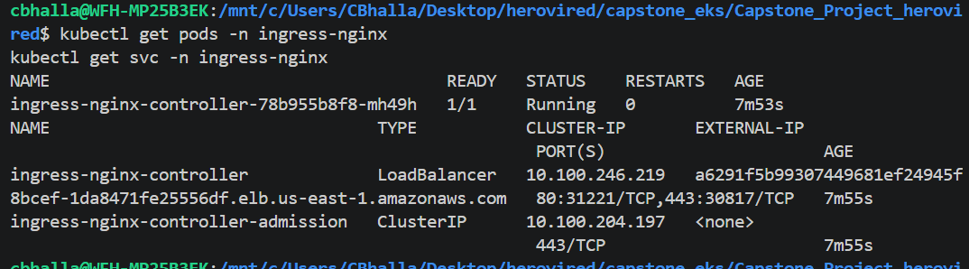
helm version
helm repo add ingress-nginx https://kubernetes.github.io/ingress-nginx
helm repo update
helm upgrade --install ingress-nginx ingress-nginx/ingress-nginx \
--namespace ingress-nginx --create-namespace \
--set controller.service.type=LoadBalancer \
--set controller.service.annotations."service\.beta\.kubernetes\.io/aws-load-balancer-type"=nlb \
--set controller.resources.requests.cpu=100m \
--set controller.resources.requests.memory=128Mi

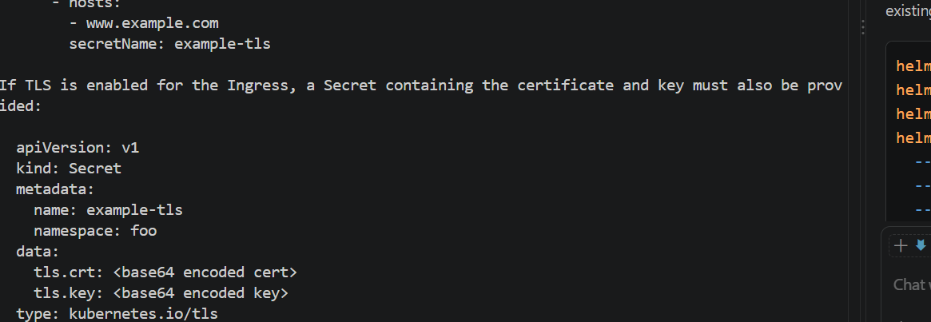
kubectl get pods -n kube-system | grep ebs-csi
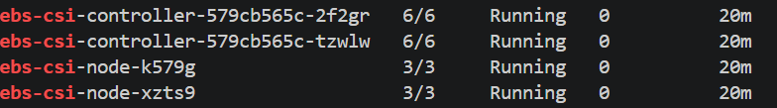
kubectl get nodes -o wide
Bash ./k8s-health-checker/scripts/02-deploy-gratitudeapp.sh
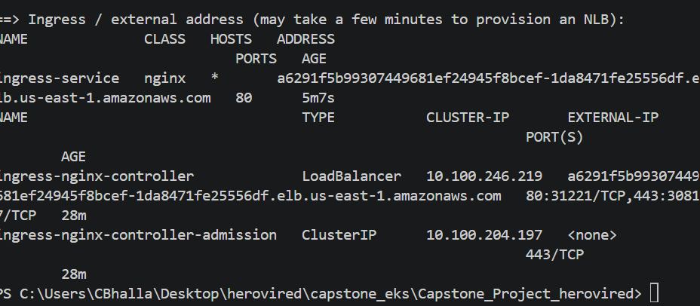

kubectl config current-context
kubectl get pods -n default

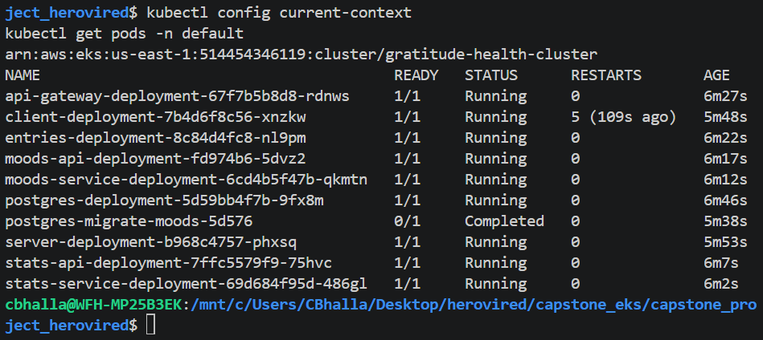

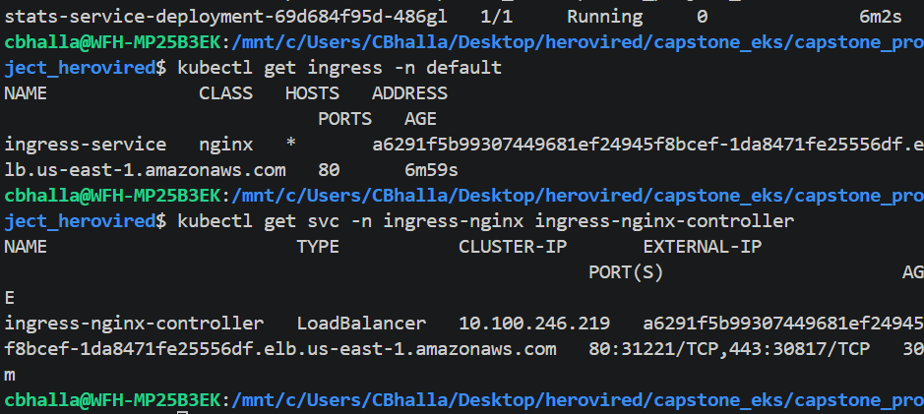
curl -I http:// a6291f5b99307449681ef24945f8bcef-1da8471fe25556df.elb.us-east-1.amazonaws.com
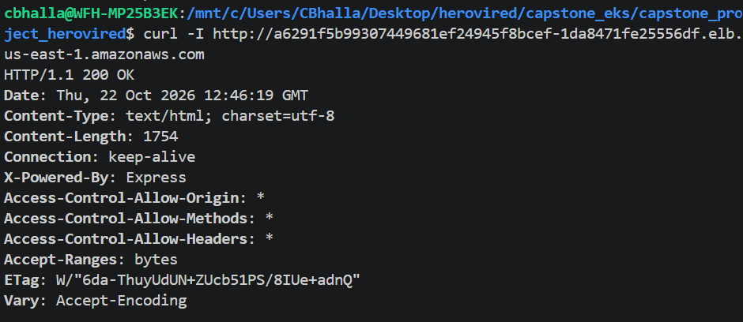
Pushed to repository (health checker )
Done. Image pushed to:
514454346119.dkr.ecr.us-east-1.amazonaws.com/gratitude-health-checker:latest
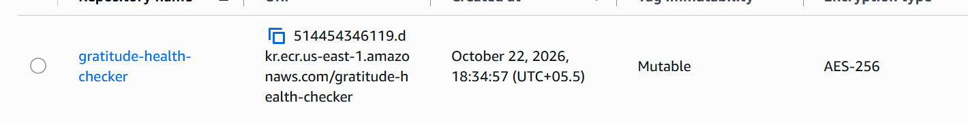

Bash ./k8s-health-checker/scripts/03-deploy-monitoring.sh
kubectl get pods -n default
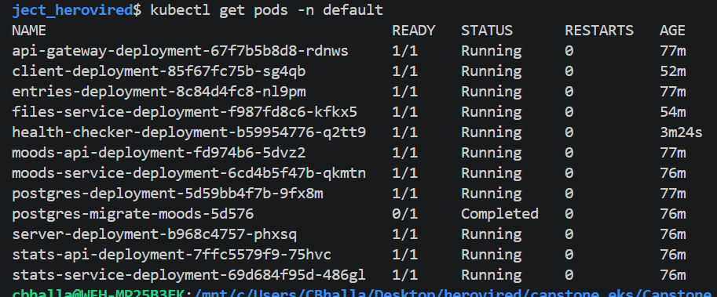

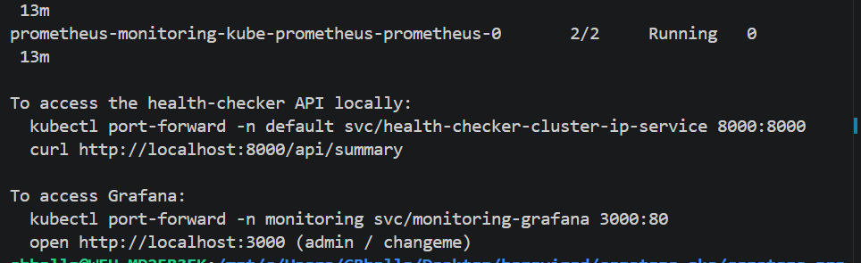
To access the health-checker API locally:
kubectl port-forward -n default svc/health-checker-cluster-ip-service 8000:8000
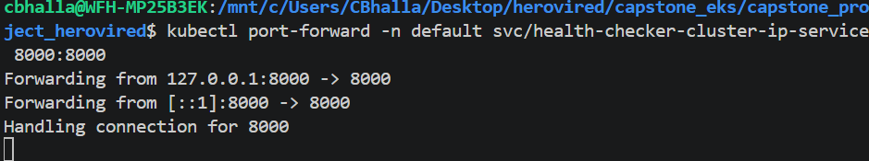
curl http://localhost:8000/healthz

curl http://localhost:8000/api/nodes | python3 -m json.tool
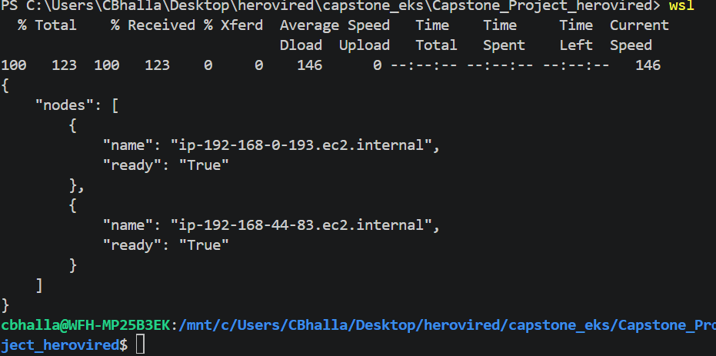
# Raw Prometheus metrics
http://localhost:8000/metrics
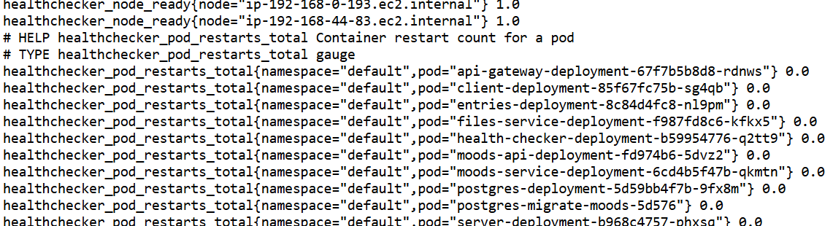

To access Grafana:
kubectl port-forward -n monitoring svc/monitoring-grafana 3000:80
open http://localhost:3000
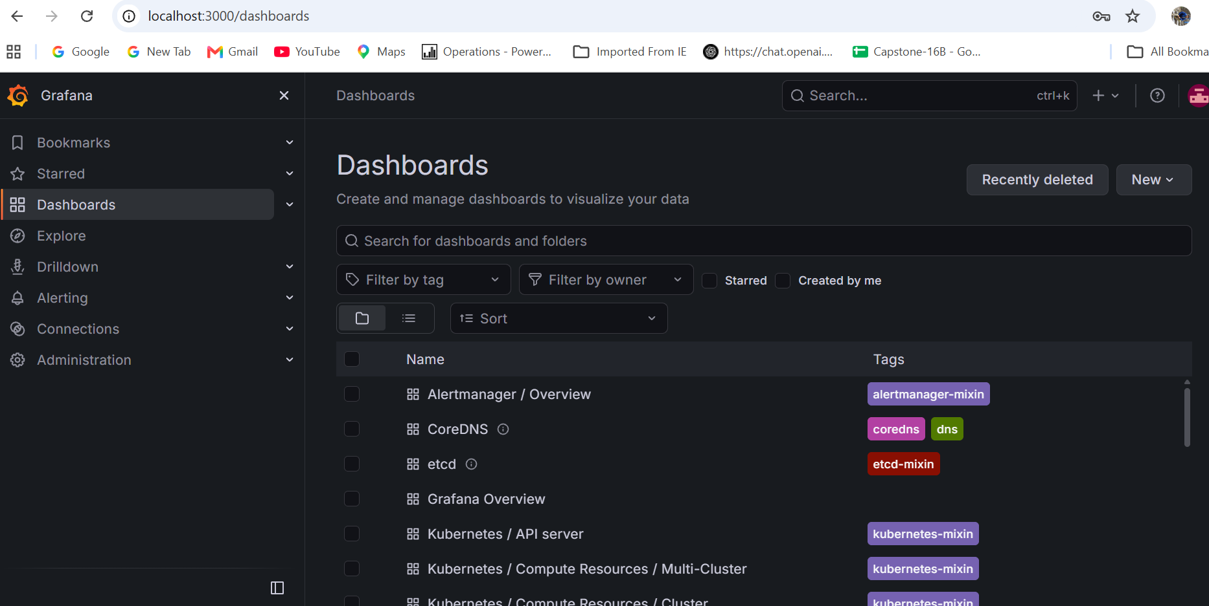
kubectl port-forward -n monitoring svc/monitoring-kube-prometheus-prometheus 9090:9090
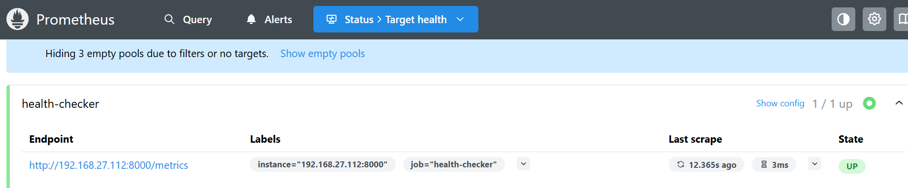

NLB=$(kubectl get svc -n ingress-nginx ingress-nginx-controller \
-o jsonpath='{.status.loadBalancer.ingress[0].hostname}')
echo "App URL: http://$NLB"

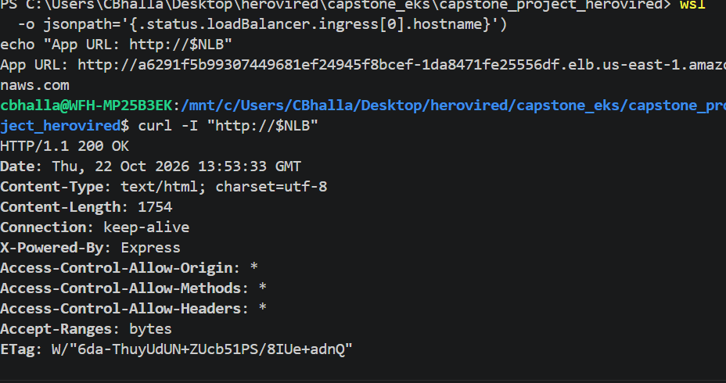
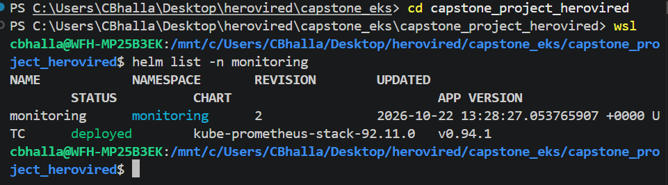
==========================================================================
Sprint 2
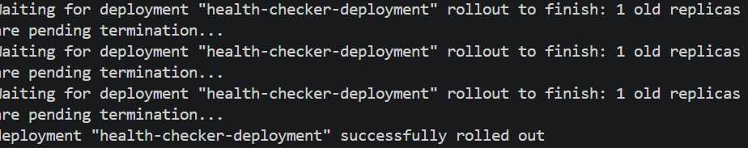
kubectl apply -f k8s-health-checker/deploy/grafana/node-pod-health-dashboard.yaml
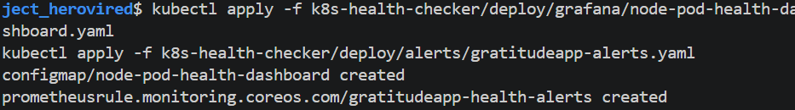
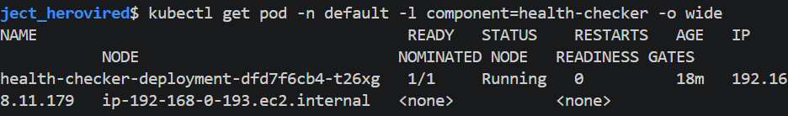
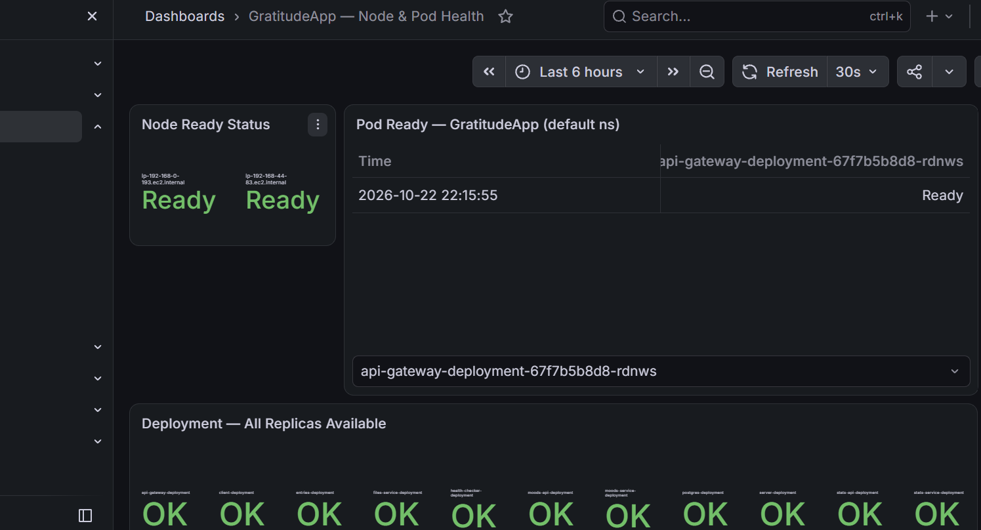
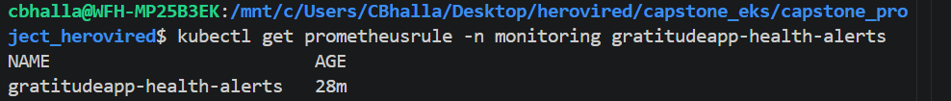
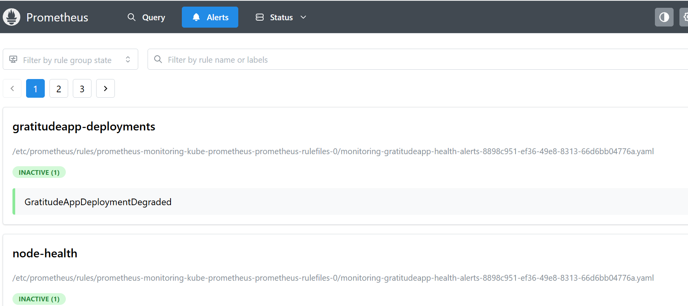
curl -s http://localhost:8000/metrics | grep healthchecker_pod_ready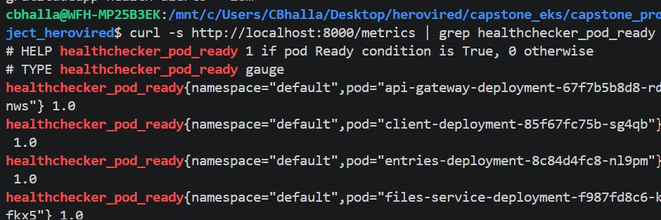
curl -s http://localhost:8000/metrics | grep healthchecker_deployment_all_replicas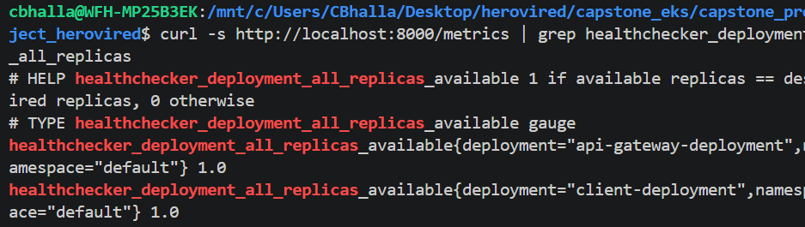
curl -s http://localhost:8000/api/pods | python3 -m json.tool | head -40
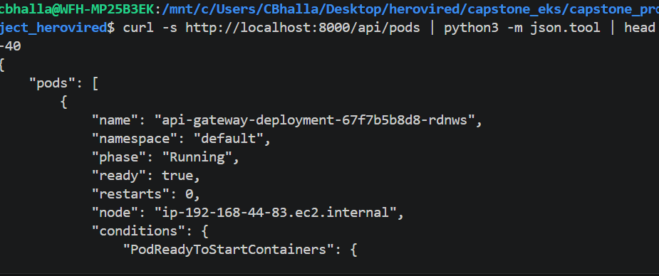

kubectl scale deployment client-deployment --replicas=0 -n default

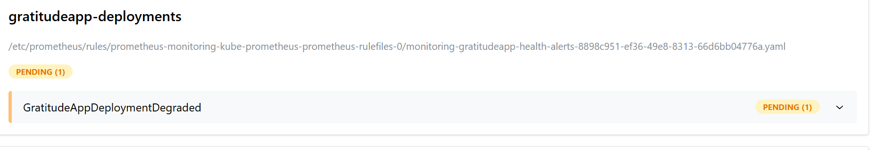
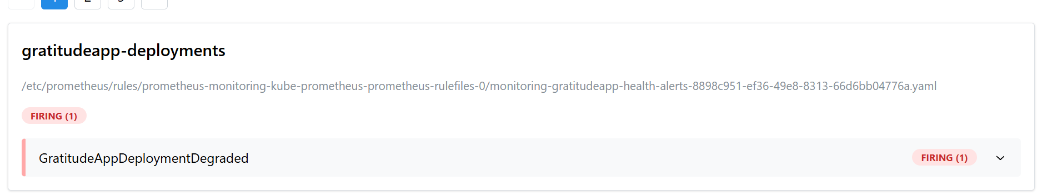

===================================================================
Sprint 3
all old pods running fine …
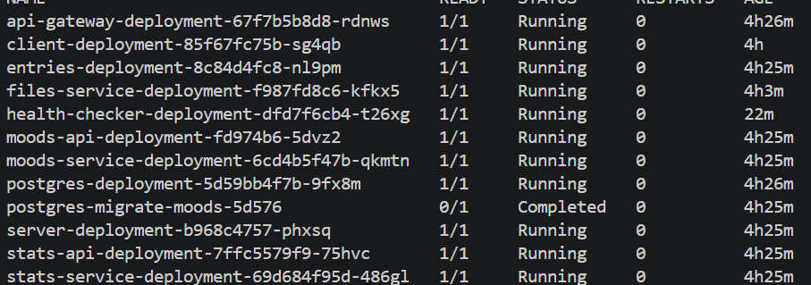
Upgrading health checker
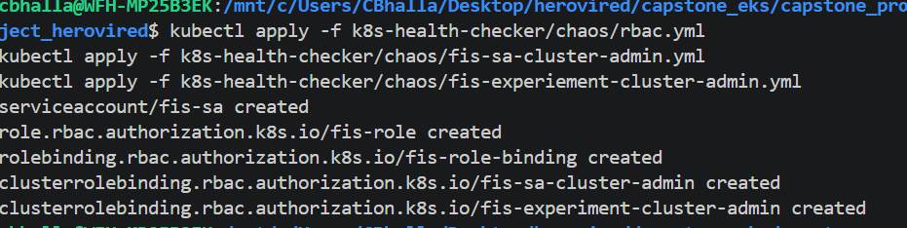
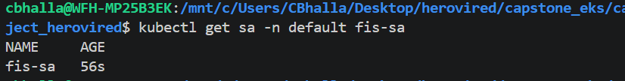
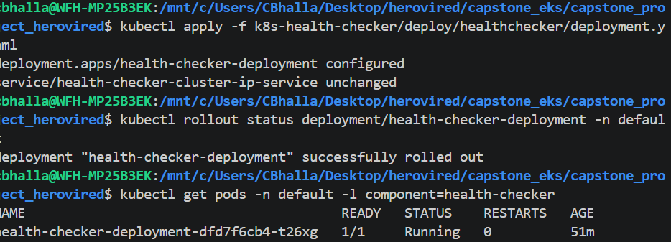

kubectl logs -n default -l component=health-checker --tail=25
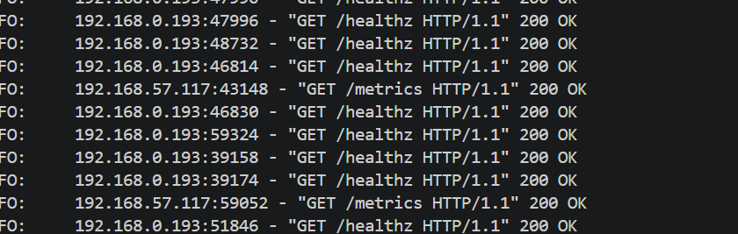
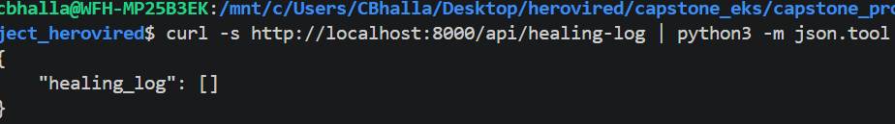

curl -s http://localhost:8000/metrics | grep "healthchecker_healing_actions"
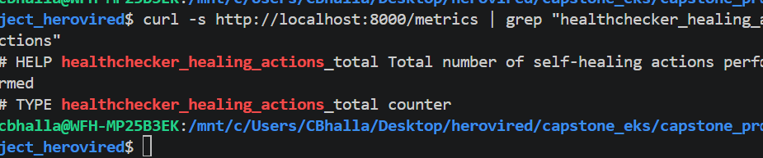
kubectl get pods -n default -l app=chaos-crashloop-test -w

curl -s http://localhost:8000/api/healing-log
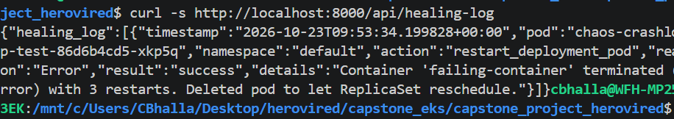
kubectl delete deployment chaos-crashloop-test -n default
Create and change the role under file fis-template.json for testing
arn:aws:iam::514454346119:role/awsfis_demo
kubectl get pods -n default -l component=health-checker
kubectl logs -n default deployment/health-checker-deployment --tail=100
kubectl get endpoints -n default health-checker-cluster-ip-service

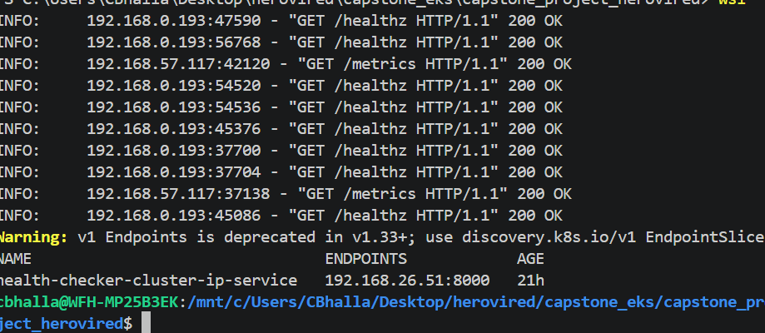

Did the experiment failure and stop the test experiment for fis
aws fis stop-experiment --id EXTumtVeZVi9xBr --region us-east-1
kubectl auth can-i delete pods \
--as=system:serviceaccount:default:health-checker -n default
kubectl get clusterrolebinding health-checker-binding

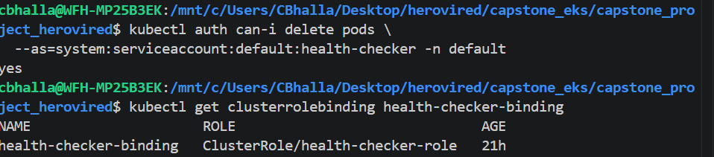
================================================================
Sprint 4

kubectl top nodes
kubectl top pods -n default
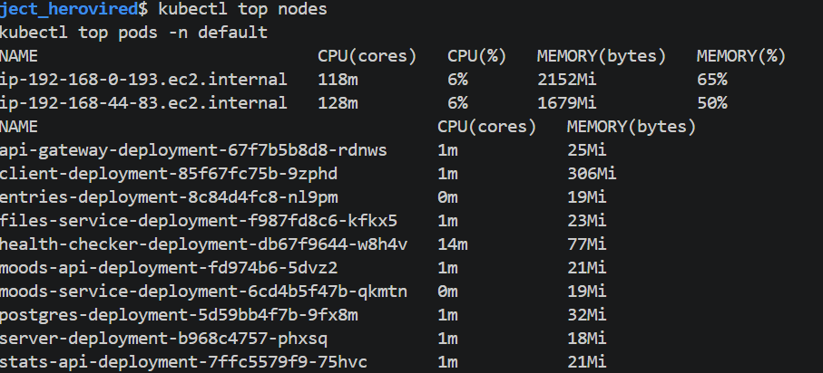
kubectl apply -f k8s-health-checker/gratitude-k8s/api-gateway-deployment.yml
kubectl apply -f k8s-health-checker/gratitude-k8s/client-deployment.yml
kubectl apply -f k8s-health-checker/gratitude-k8s/server-deployment.yml
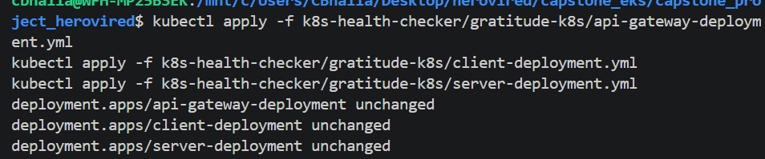
kubectl rollout status deployment/api-gateway-deployment -n default
kubectl rollout status deployment/client-deployment -n default
kubectl rollout status deployment/server-deployment -n default
kubectl get pods -n default
kubectl top pods -n default

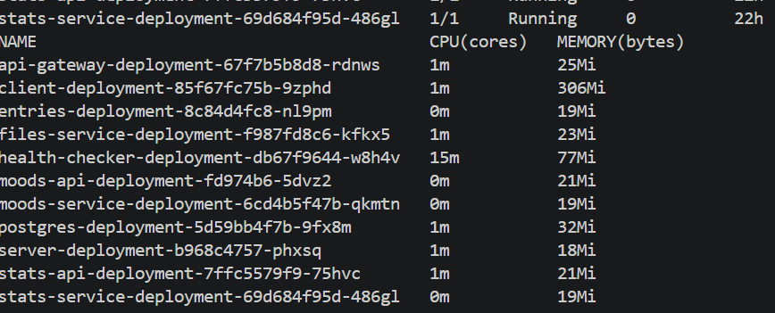
- `api-gateway-deployment`: 1–5 replicas
- `client-deployment`: 1–5 replicas
- `server-deployment`: 1–4 replicas

kubectl apply -f k8s-health-checker/deploy/autoscaling/hpa-gratitudeapp.yaml
kubectl get hpa -n default
kubectl describe hpa -n default
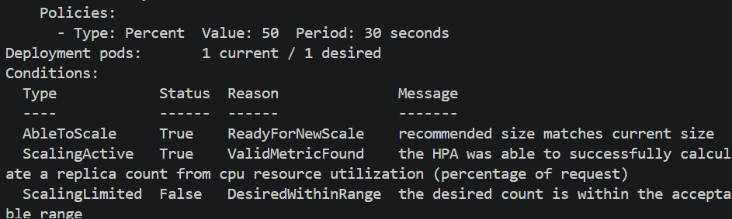
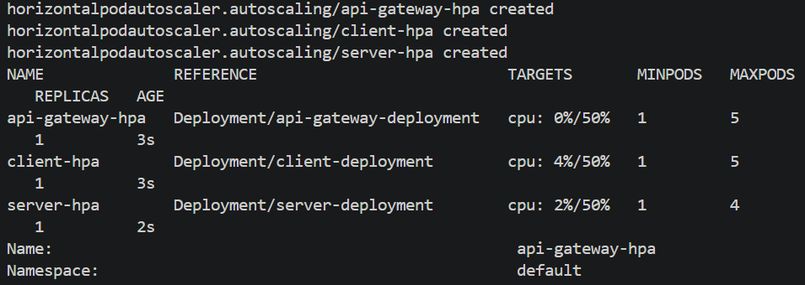
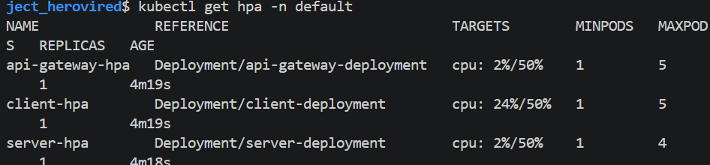

curl -s http://localhost:8000/api/node-balancing | python3 -m json.tool
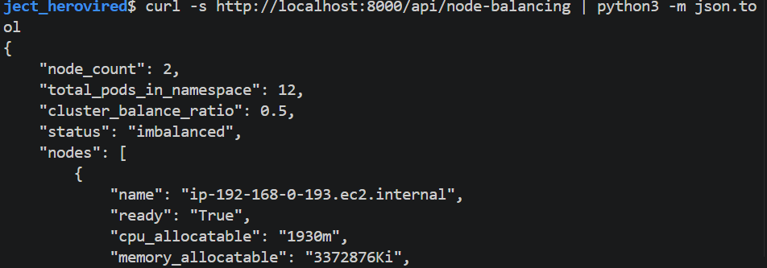
curl -s http://localhost:8000/metrics \
| grep -E 'healthchecker_node_pod_count|healthchecker_node_cpu_capacity_cores|healthchecker_cluster_balance_ratio'
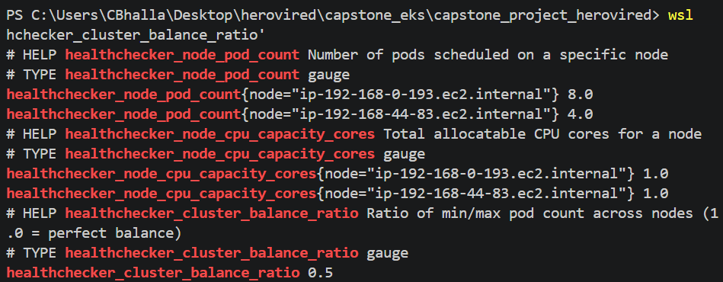

New terminal
kubectl apply -f k8s-health-checker/deploy/autoscaling/load-generator.yaml
kubectl rollout status deployment/load-generator -n default --timeout=120s
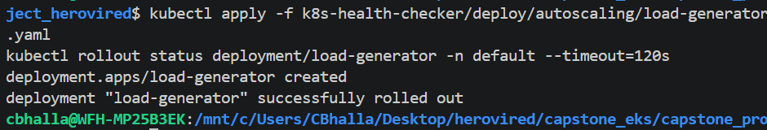

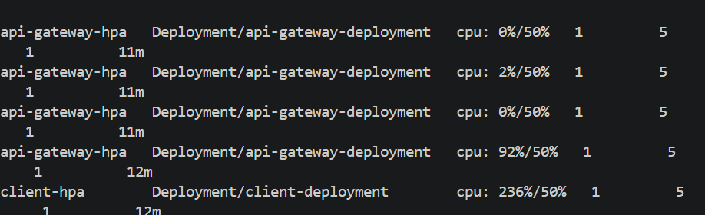

kubectl get hpa -n default
kubectl get deployments api-gateway-deployment client-deployment

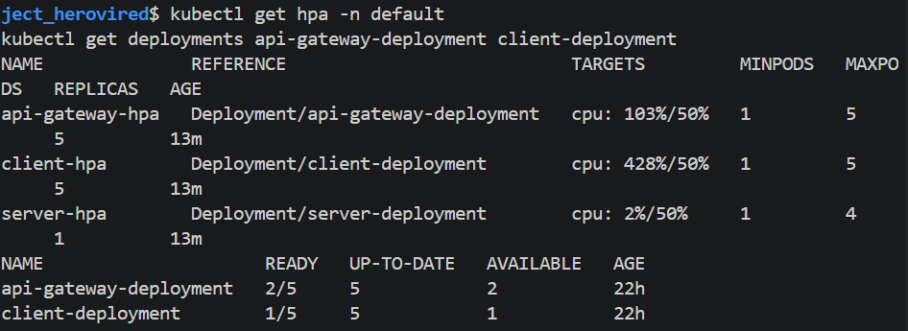
kubectl delete -f k8s-health-checker/deploy/autoscaling/load-generator.yaml --ignore-not-found
Reverted back the hpa and client deployment to max 1
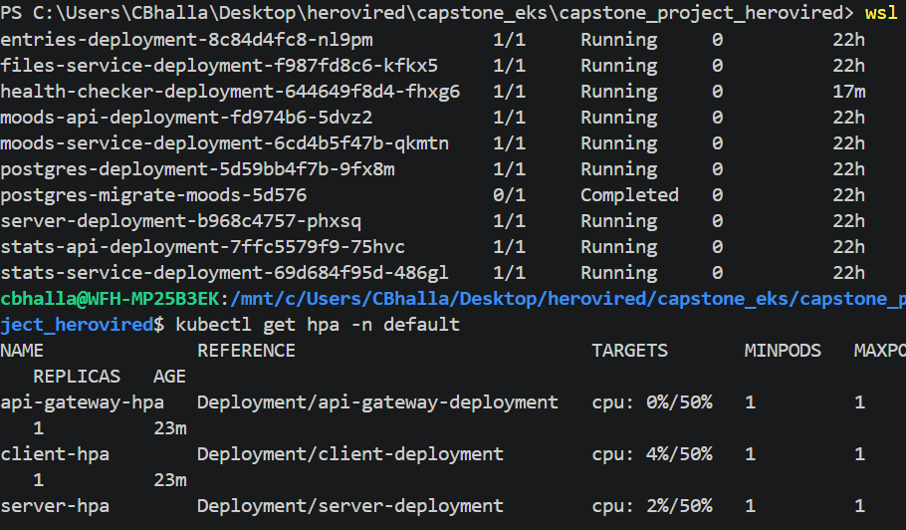
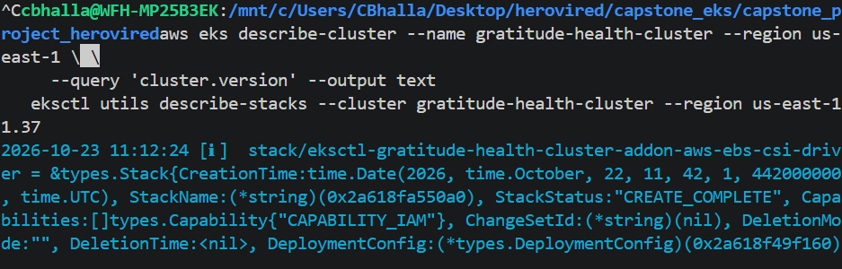
aws eks describe-nodegroup \
--cluster-name gratitude-health-cluster \
--nodegroup-name default-ng \
--region us-east-1 \
--query 'nodegroup.resources.autoScalingGroups[].name' \
--output text
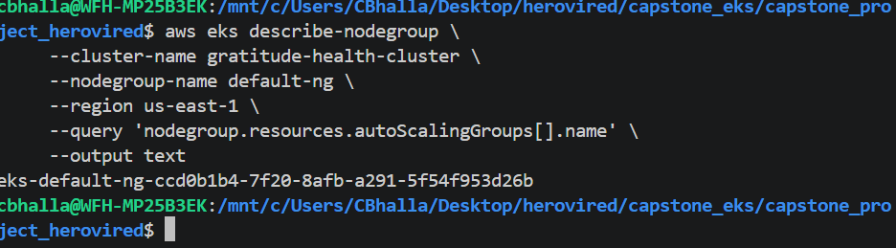
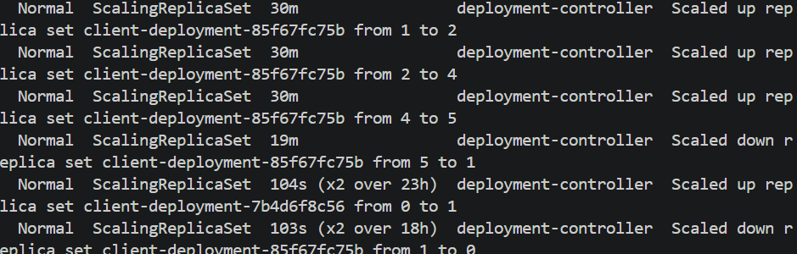
============================================================================
Sprint 5 Problem statement
kubectl get svc -n monitoring
kubectl get alertmanager -n monitoring
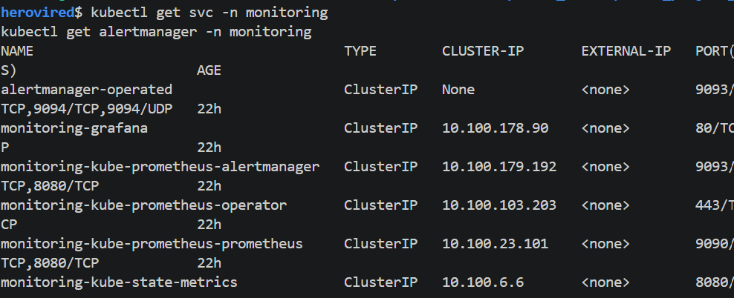
kubectl apply -f k8s-health-checker/deploy/healthchecker/deployment.yaml
kubectl rollout restart deployment/health-checker-deployment -n default
kubectl rollout status deployment/health-checker-deployment -n default --timeout=180s
kubectl get pods -n default -l component=health-checker
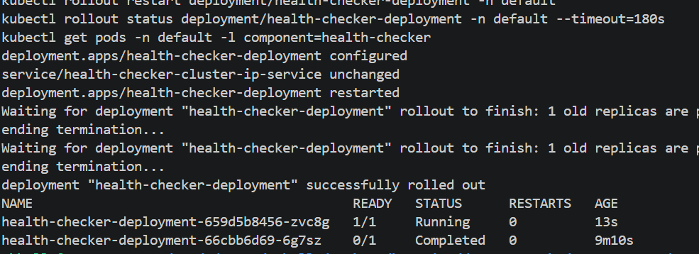
umask 077
cp k8s-health-checker/deploy/alerts/alertmanager-config.yaml /tmp/alertmanager-config.yaml
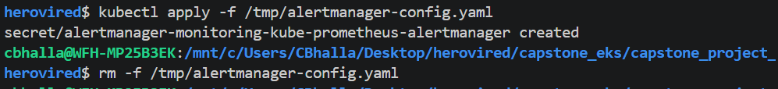
kubectl logs -n monitoring alertmanager-monitoring-kube-prometheus-alertmanager-0 \
-c alertmanager --tail=50
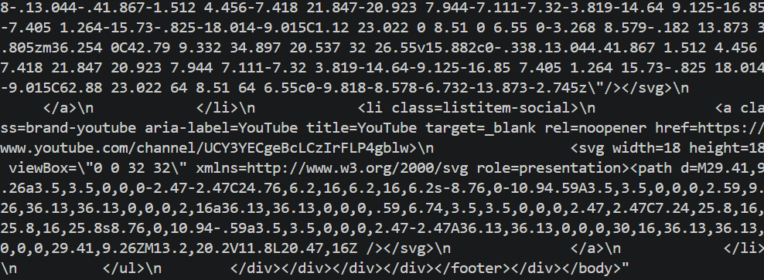

curl -s -X POST http://localhost:8000/api/notify/slack \
-H 'Content-Type: application/json' \
-d '{
"title": "EKS Sprint 5 test",
"message": "Checking notification integration.",
"severity": "warning",
"fields": {
"Environment": "EKS test",
"Cluster": "gratitude-health-cluster"
}
}' | python3 -m json.tool
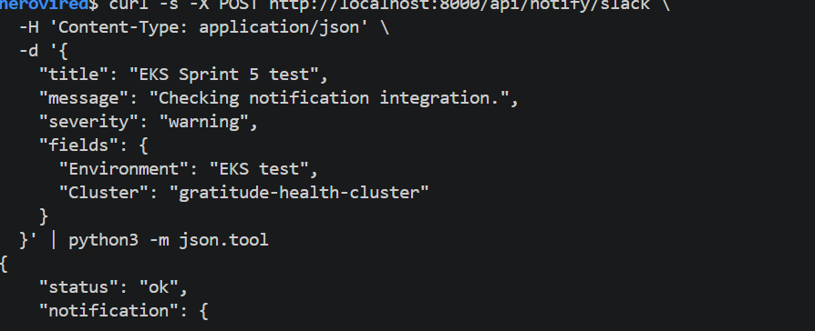
curl -s http://localhost:8000/api/notifications | python3 -m json.tool
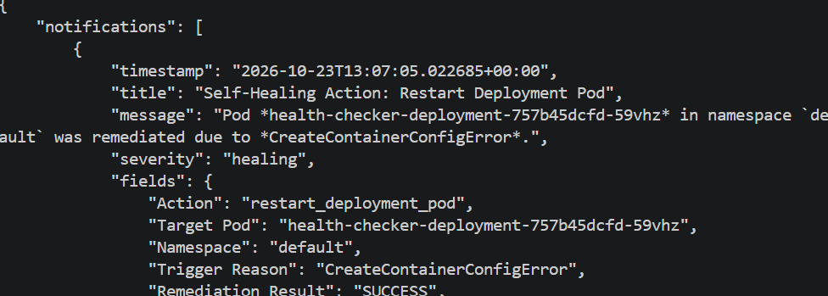
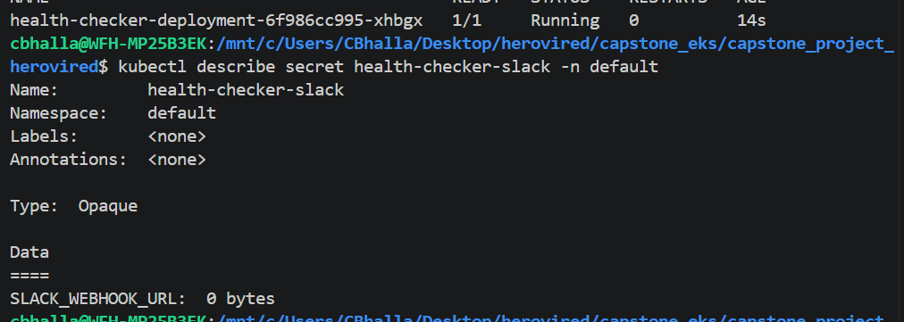
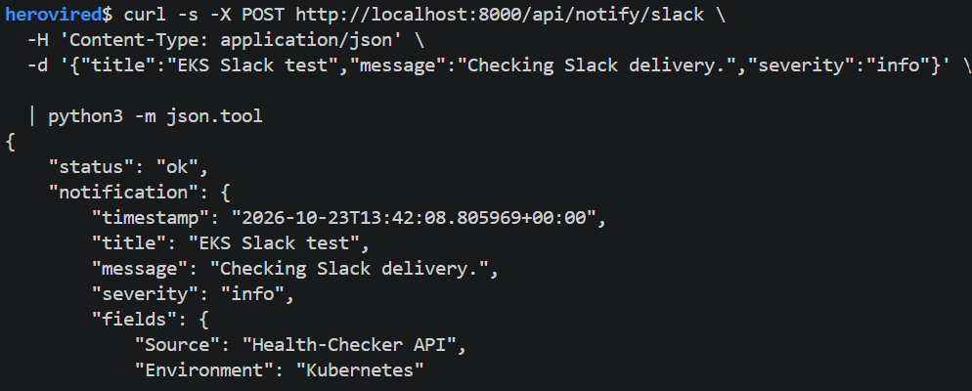
kubectl logs -n default deployment/health-checker-deployment --tail=50
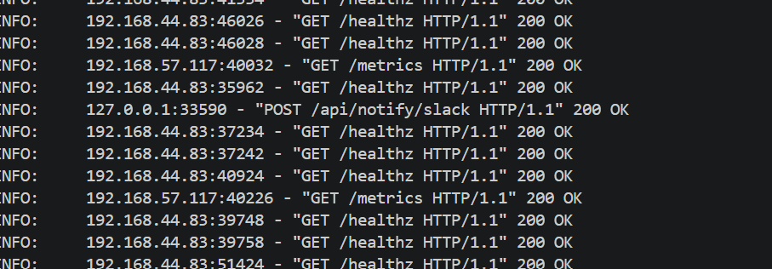
ORIGINAL_REPLICAS=$(kubectl get deployment entries-deployment -n default \
-o jsonpath='{.spec.replicas}')
echo "Recorded replicas: $ORIGINAL_REPLICAS"
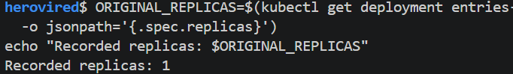
kubectl scale deployment entries-deployment --replicas=0 -n default
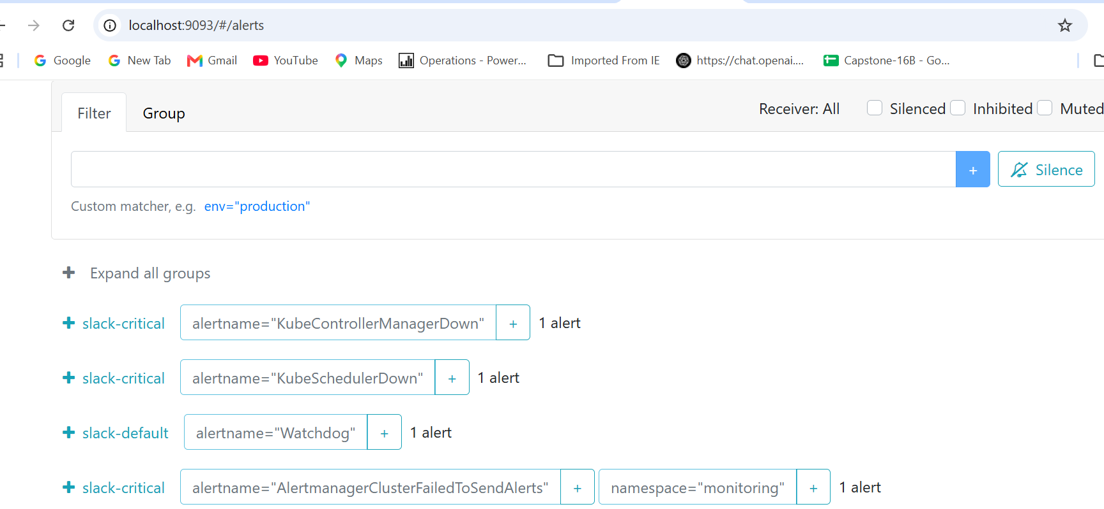
kubectl describe deployment health-checker-deployment -n default
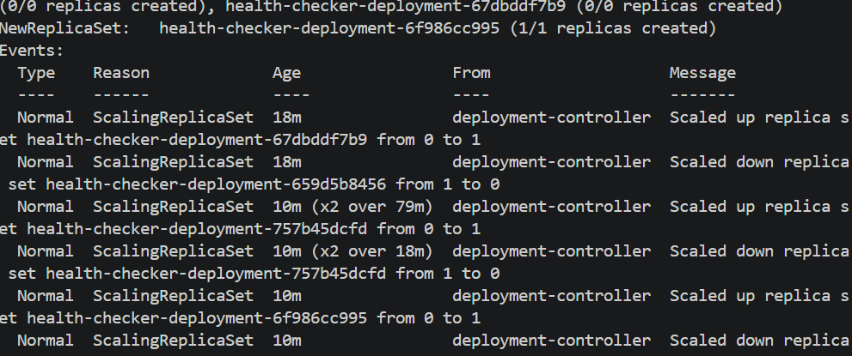

Sprint 6
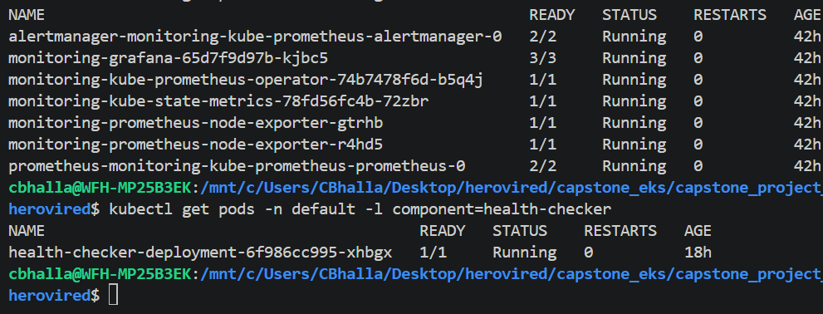
kubectl apply -f k8s-health-checker/deploy/grafana/sprint6-full-dashboard.yaml
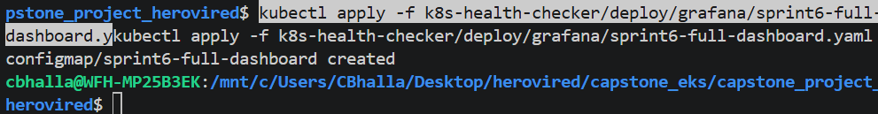
kubectl get configmap sprint6-full-dashboard -n monitoring

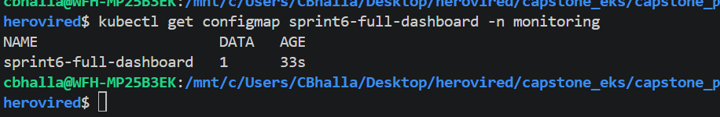
curl -s http://localhost:8000/metrics | grep healthchecker_ | head -5
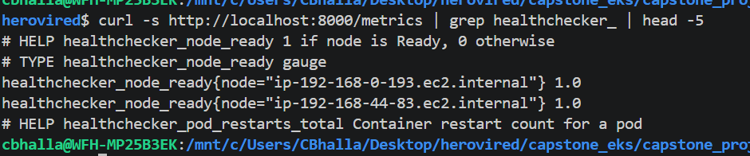
kubectl get configmap -n monitoring | grep dashboard
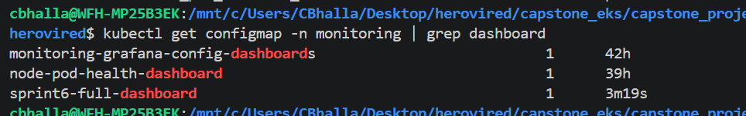
pkill -f "port-forward.*3000" 2>/dev/null || true
kubectl port-forward svc/monitoring-grafana -n monitoring 3000:80
