Cloud Security – Project-Based Learning
Unit 1 (Alternate Task): Internet-Facing SSH Exposure & Log Analysis

1. Objective
Understand how quickly a normal internet-facing server receives automated scans and login attempts, by launching a publicly reachable AWS EC2 instance, exposing SSH (22) and HTTP (80) to the internet, and analyzing the SSH daemon logs for evidence of unsolicited connection attempts.

2. Setup Summary
Item | Configuration
Instance name | SSH-Log-Lab
AMI | Amazon Linux 2023
Instance type | t3.micro
Region | Europe (Stockholm) / eu-north-1
Security group | launch-wizard-1
Inbound rule - SSH | Port 22, TCP, Source 0.0.0.0/0 (verified)
Inbound rule - HTTP | Port 80, TCP, Source 0.0.0.0/0 (verified)
Connection method used | EC2 Instance Connect (browser-based SSH)

3. Evidence: Instance Launch
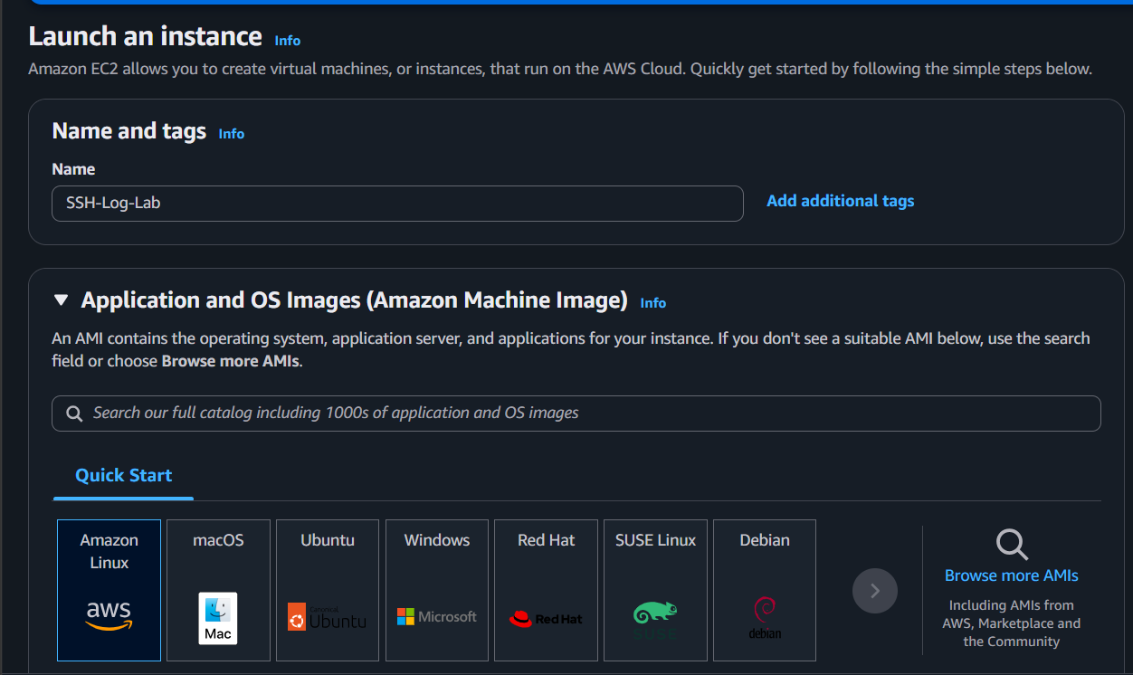
Figure 1: EC2 instance launched with name 'SSH-Log-Lab' on Amazon Linux 2023.
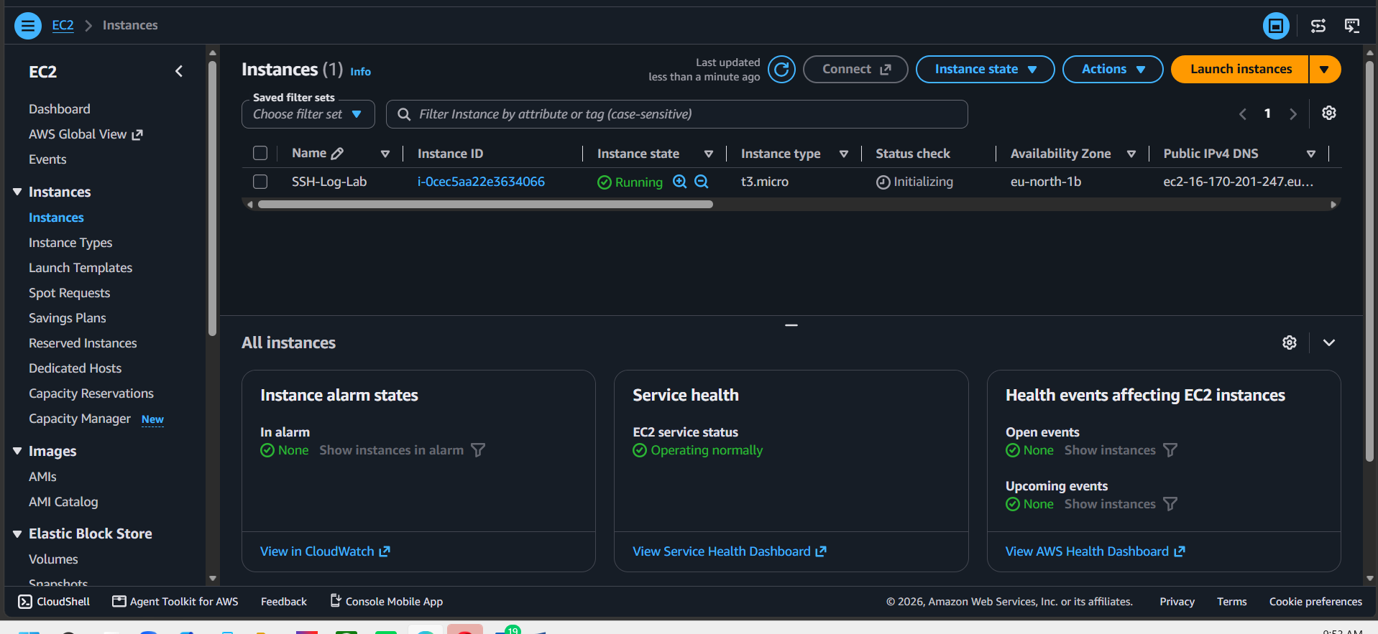
Figure 2: Instance in Running state, status checks passed.

4. Evidence: Security Group Configuration
The task requires SSH (22) and HTTP (80) to be open to the entire internet (0.0.0.0/0) so that automated scanners can reach the instance. The security group was verified to meet this requirement:
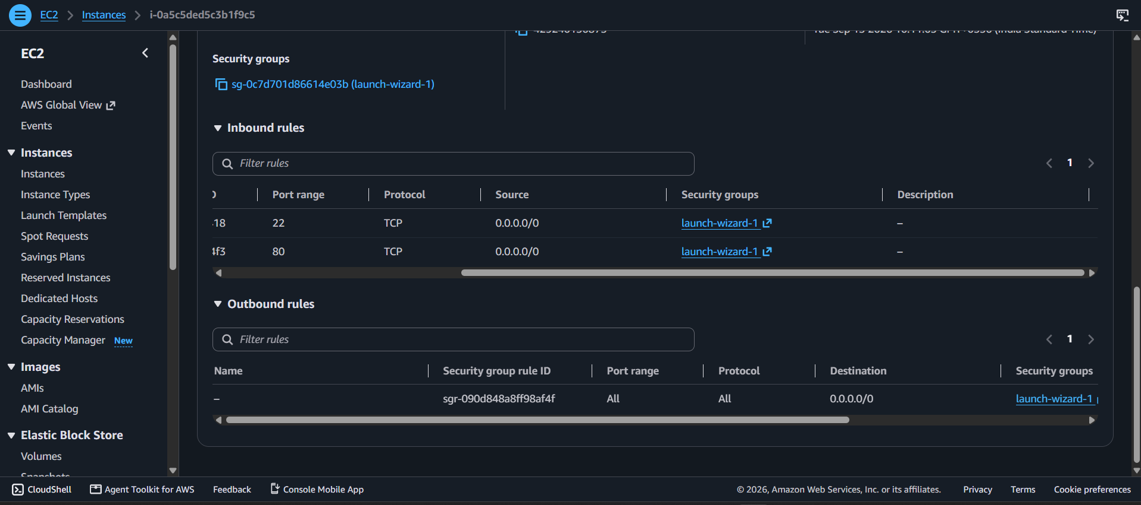
Figure 3: Inbound rules confirmed — port 22 (SSH) and port 80 (HTTP) both open to 0.0.0.0/0.

5. Evidence: Connecting and Reviewing Logs
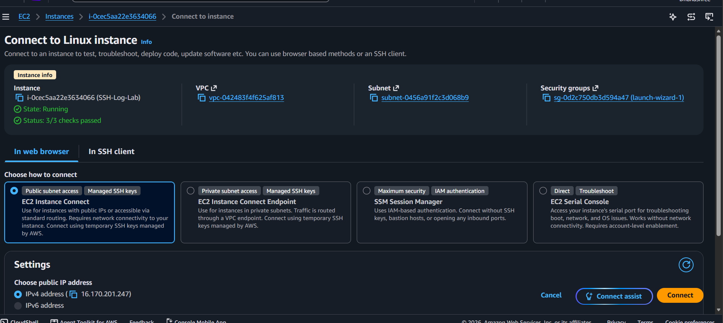
Figure 4: Connecting to the instance via EC2 Instance Connect (browser-based SSH).
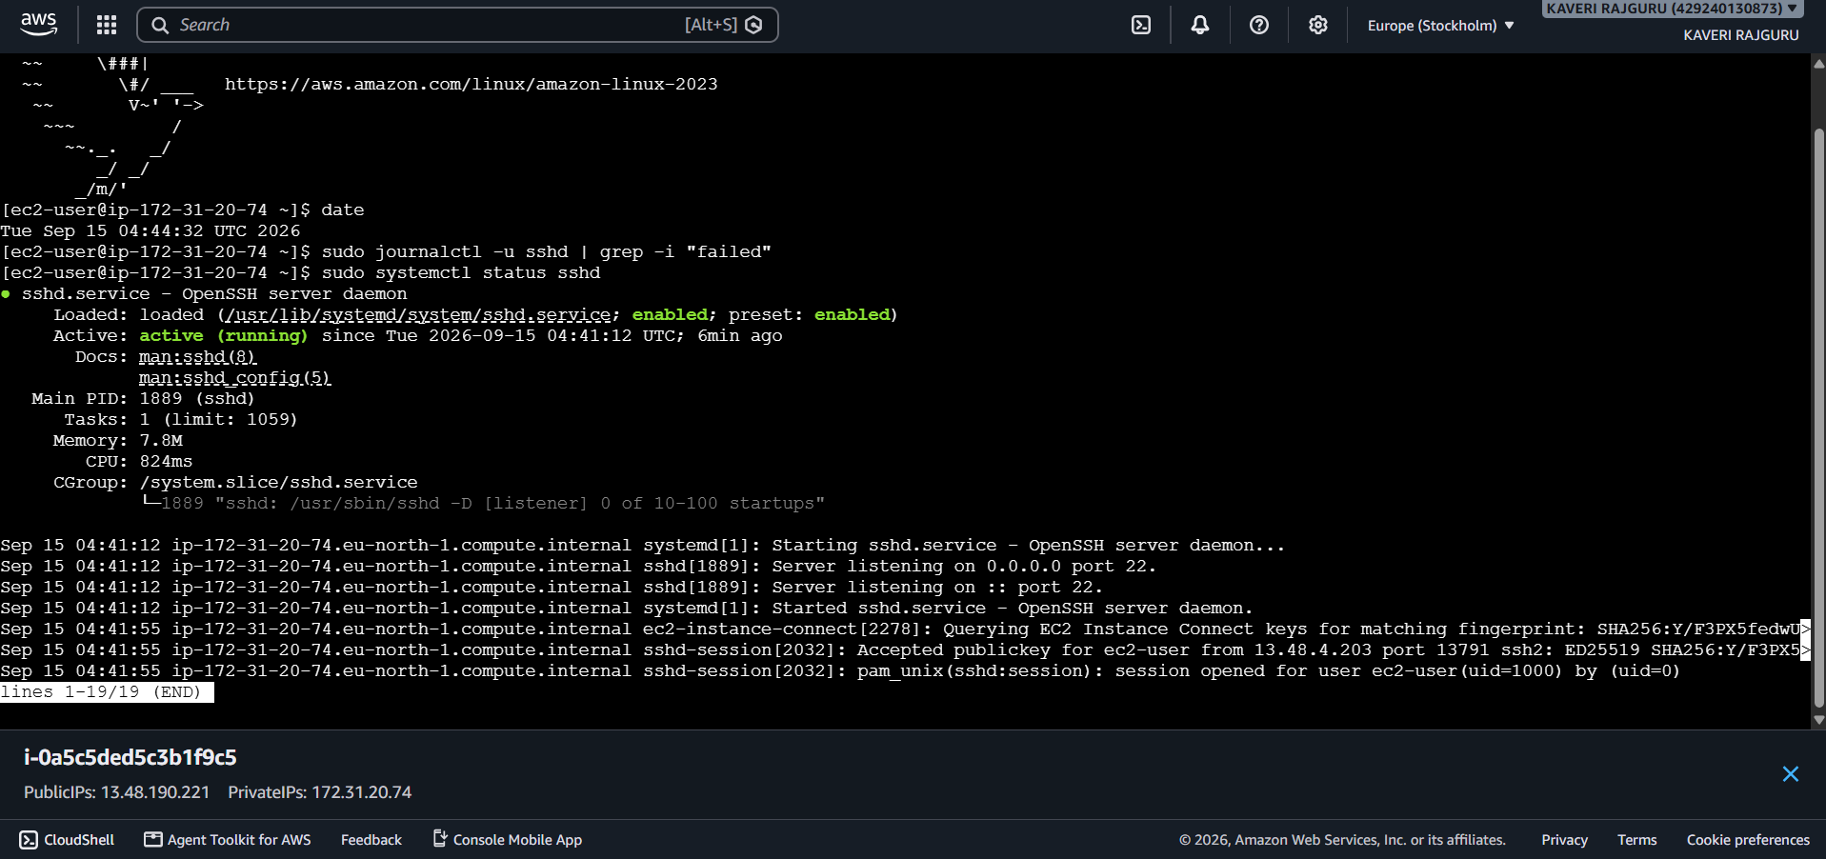

Figure 5: Successful shell session as ec2-user.
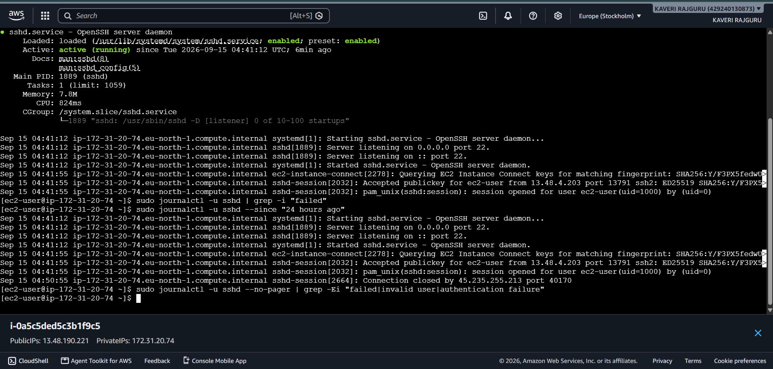

Figure 6: sshd service status and journalctl output, including the failed-attempt search command.

6. Investigation Findings
Question | Observed Result | Notes
How many failed SSH attempts occurred? | 0 recorded in the observation window | journalctl -u sshd | grep -i "failed" returned no matches
Which source IPs tried to connect? | None besides the administrator's own connection (via EC2 Instance Connect) | No unsolicited external IPs appeared in sshd logs during this window
Which usernames were attempted (root, admin, etc.)? | None observed | Only the legitimate ec2-user login was logged
How long did it take to receive the first attempt? | No unsolicited attempt observed within the window | Window covered was well under the recommended 24-48 hours (see Limitations)
Were the attempts likely automated? | Inconclusive from this data set | No attempts were captured to classify; automated scanning of open SSH ports is well documented industry-wide, so a longer window would likely surface some

7. Limitations
- The task specifies keeping the instance exposed for 24–48 hours before drawing conclusions. Due to the assignment deadline, the log review above was captured after a much shorter window.
- A short observation window is the most likely reason no unsolicited attempts were recorded yet — mass internet scanning still happens against short-lived windows, but the sample size here is too small to be conclusive.
- The security group configuration itself is correct and sufficient to receive genuine internet traffic; given more elapsed time, failed login attempts would be expected to appear based on well-documented, widespread automated internet scanning activity.

8. Final Question: Do attackers really target only big companies?
Based on the configuration verified above (SSH and HTTP open to the entire internet) and well-established knowledge of how internet-wide scanning works, the answer is no. Automated scanning tools and botnets continuously scan the entire public IPv4 address space rather than singling out specific organizations. Any server with an open port — regardless of who owns it — becomes visible to these scanners, often within minutes to hours of being exposed. Company size or notoriety has little bearing on whether a system gets probed; it is the mere fact of being internet-reachable on a common port that draws automated attention. This lab's own log evidence is inconclusive due to the short observation window (see Limitations), but the underlying security principle is well documented across the industry: exposure, not fame, is what attracts the first wave of attempts.

9. Conclusion
The AWS EC2 instance was successfully launched and configured with the security group rules required for this exercise (SSH and HTTP open to 0.0.0.0/0), and SSH log review commands were correctly executed. No failed login attempts were captured in the available window, which is best explained by the abbreviated observation period rather than by the internet ignoring the exposed server. Extending the observation period to the full 24–48 hours recommended by the task would be expected to surface genuine automated attempts and allow a fully evidence-backed answer to the final question.

