This the website that i have use a preference like in this i have to use make almost same section with same effect sound and animation the site is Aziz Khaldi | Software Engineer Portfolio
Okh now i give u the second site in that the hero section i want to use the site OGAKI | The Social-First Beauty Agency

And the screen shot is ➖

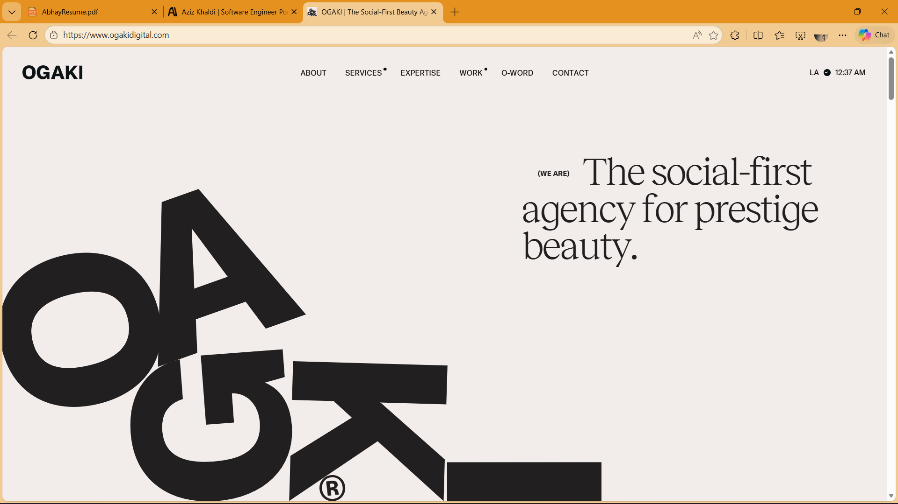

Okh now u have to make this hero section page as it is with the same text animation so u can tack reference from this website OGAKI | The Social-First Beauty Agency
Now the most important part is i am ging u the series of the pages that u have to created with reference of the website:-

First section is 

Second section is :- 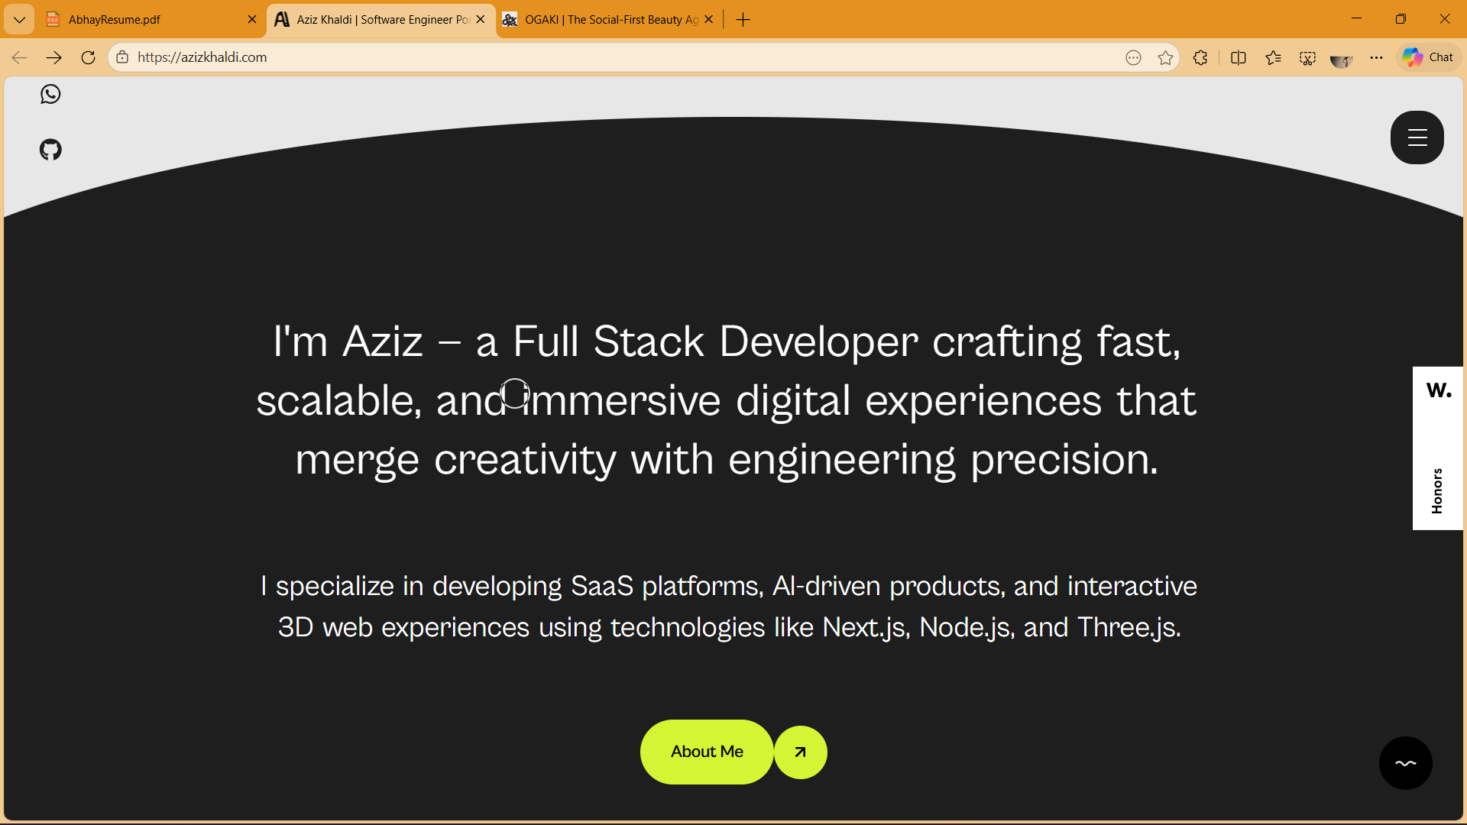

Third section is :- 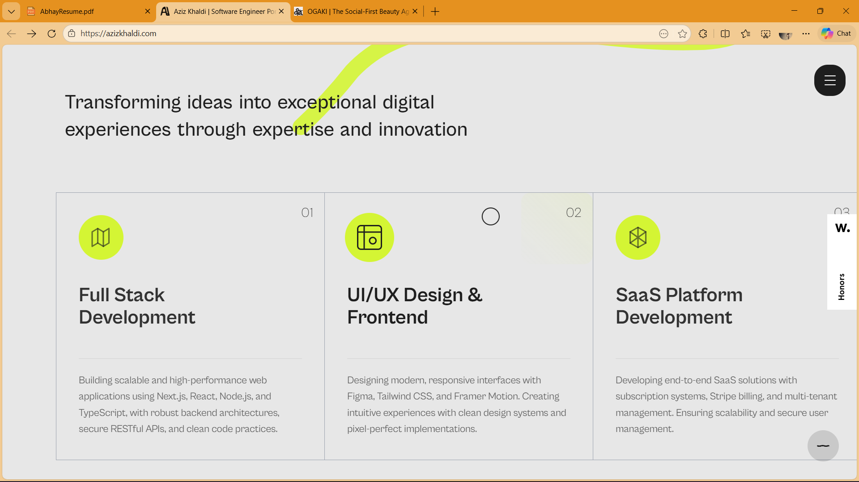

Fourth section is :- 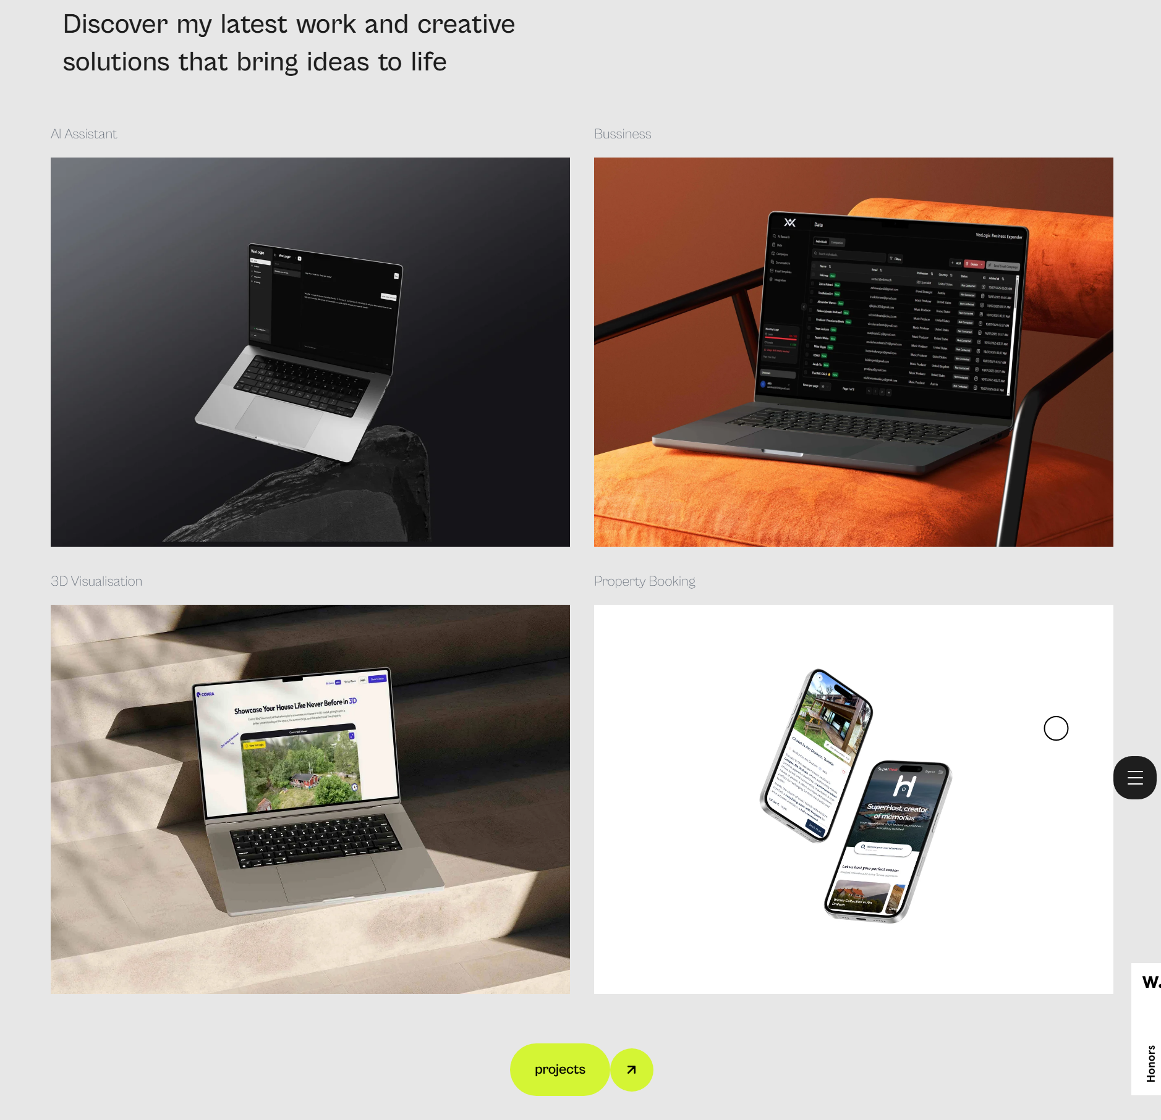

Then fiveth section:-
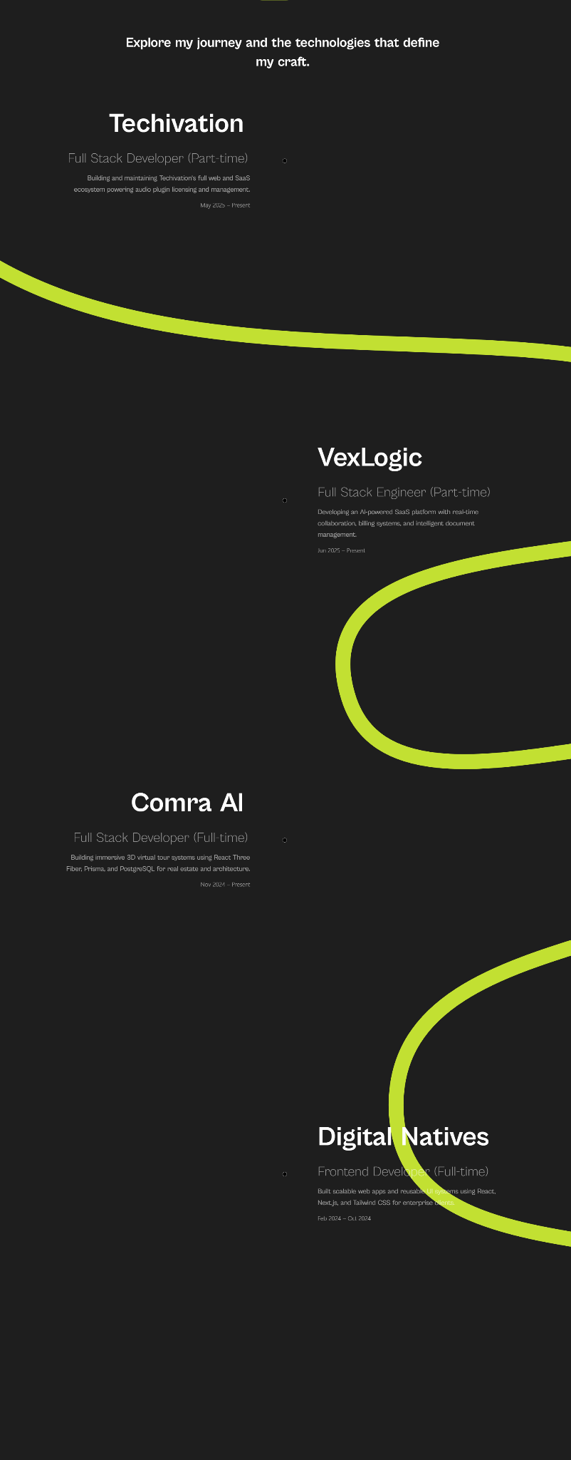
The six one is ➖
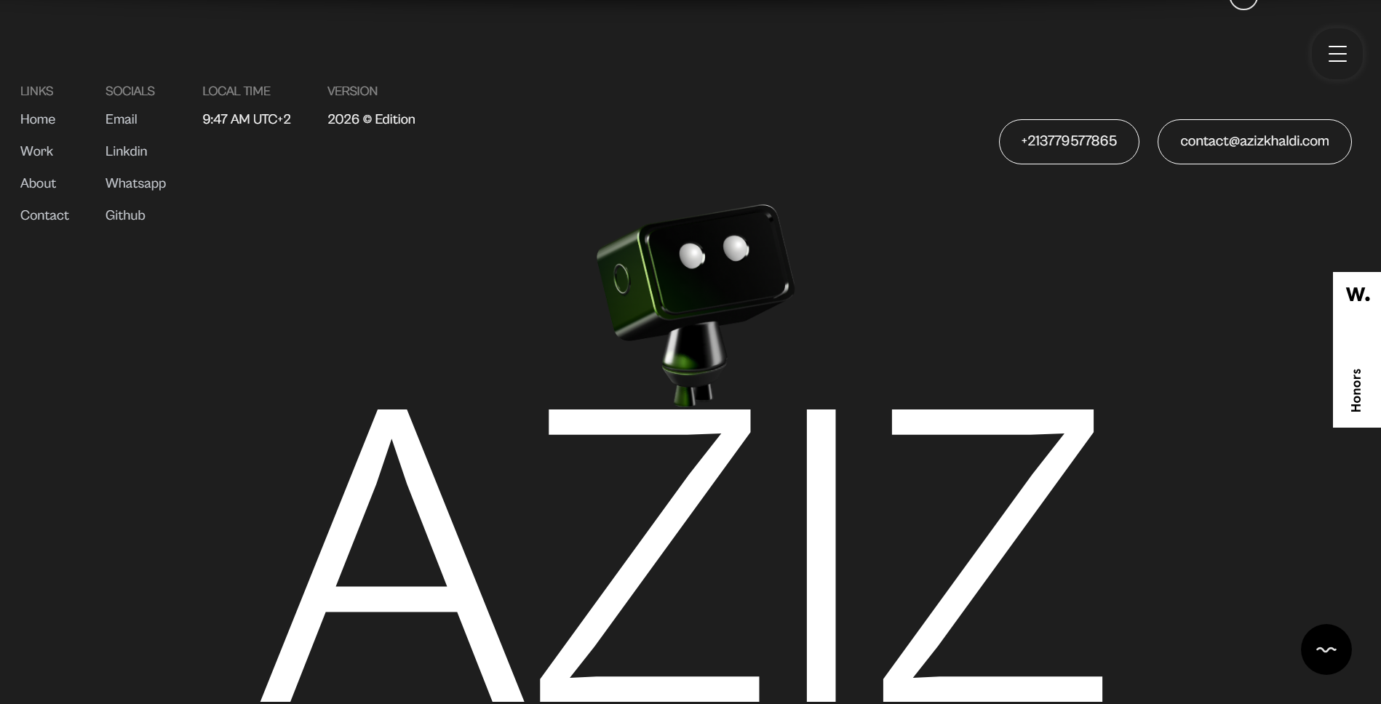

Okh now keep in mind that i just only give u this screen shot as a refeance that wht u have to make it. You have to make it exact from the reference site only because in that this screen shot is working functionly with the effect and animations. Also u ave to make sure that do not change any thing because i want the animation . it is mandatory that u give me the exact code that i want from u with the full functional animation adn effect.

