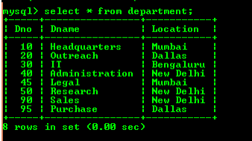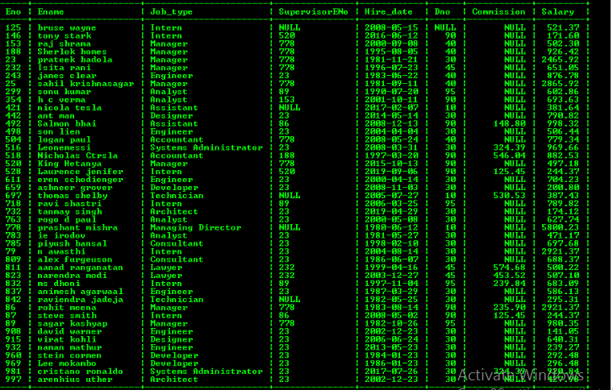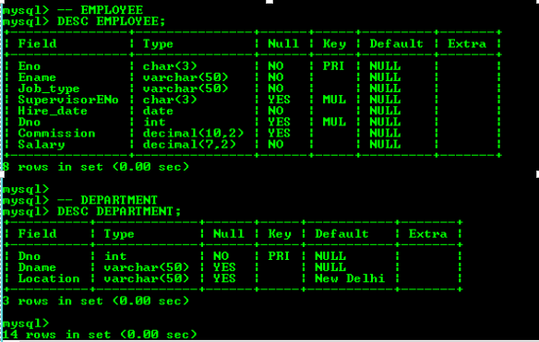

Q1)

SELECT Eno,ename,job_type,hire_date from employee;

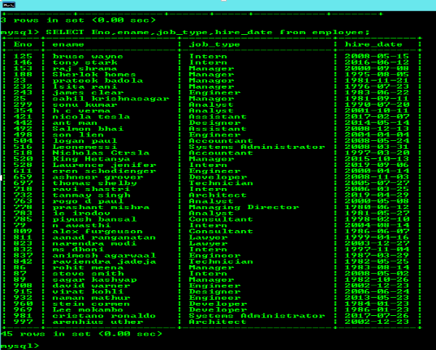

Q2)

SELECT DISTINCT Job_type from employee;

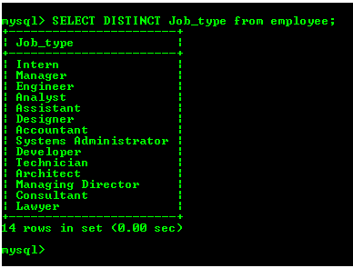

Q3)

SELECT CONCAT(Ename, ',',Job_type) AS Employee_Job FROM EMPLOYEE;

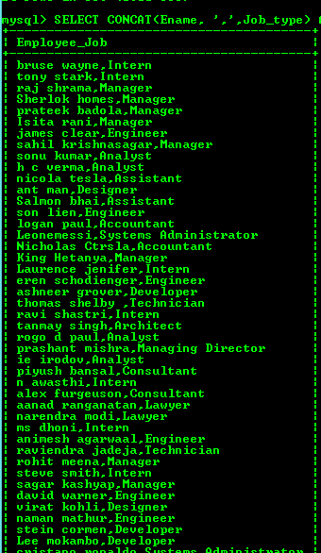

Q4)

SELECT CONCAT(Eno, ',',Ename, ',',Job_type, ',',IFNULL(SupervisorENo, ''), ',',Hire_date, ',',IFNULL(Dno, ''), ',',IFNULL(Commission, ''), ',', Salary) AS THE_OUTPUT FROM EMPLOYEE;

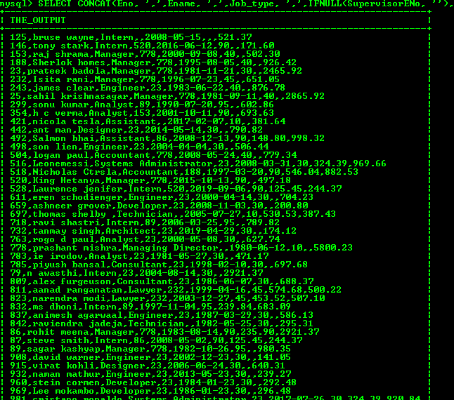

Q5)

SELECT Ename,Salary FROM EMPLOYEE WHERE Salary > 2850;

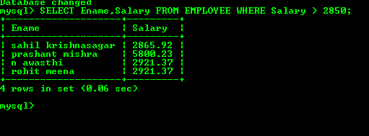

Q6)

SELECT Ename,Dno FROM EMPLOYEE WHERE Eno = '79';

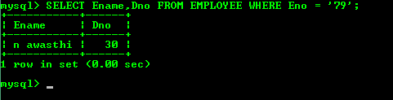

Q7)

SELECT Ename,Salary FROM EMPLOYEE WHERE Salary NOT BETWEEN 1500 AND 2850;

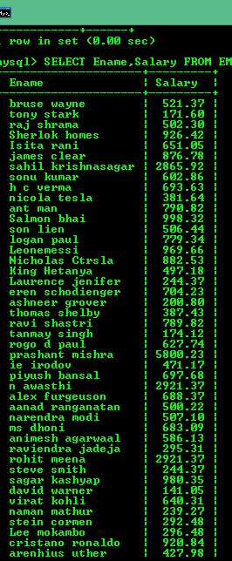

Q8)

SELECT Ename,Dno FROM (EMPLOYEE NATURAL JOIN DEPARTMENT) WHERE Dno IN (10, 30) ORDER BY

Ename;

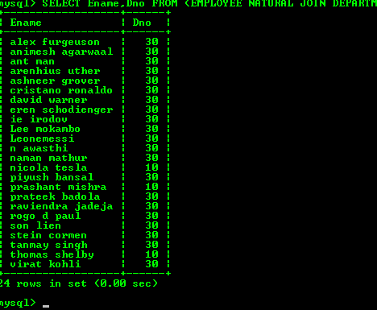

Q9)

SELECT Ename, Hire_date FROM EMPLOYEE WHERE Hire_date LIKE '1981______';

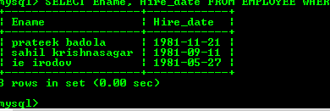

Q10)

SELECT Ename, Job_type FROM EMPLOYEE WHERE SupervisorENo IS NULL;

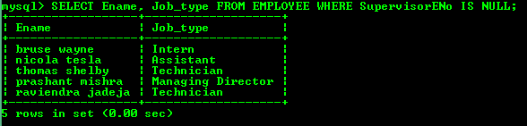

Q11)

SELECT Ename,Salary,Commission FROM EMPLOYEE WHERE Commission IS NOT NULL;

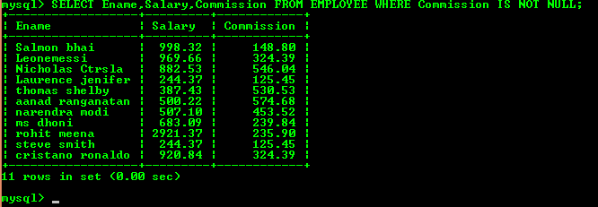

Q12)

SELECT * FROM EMPLOYEE ORDER BY Salary DESC, Commission DESC;

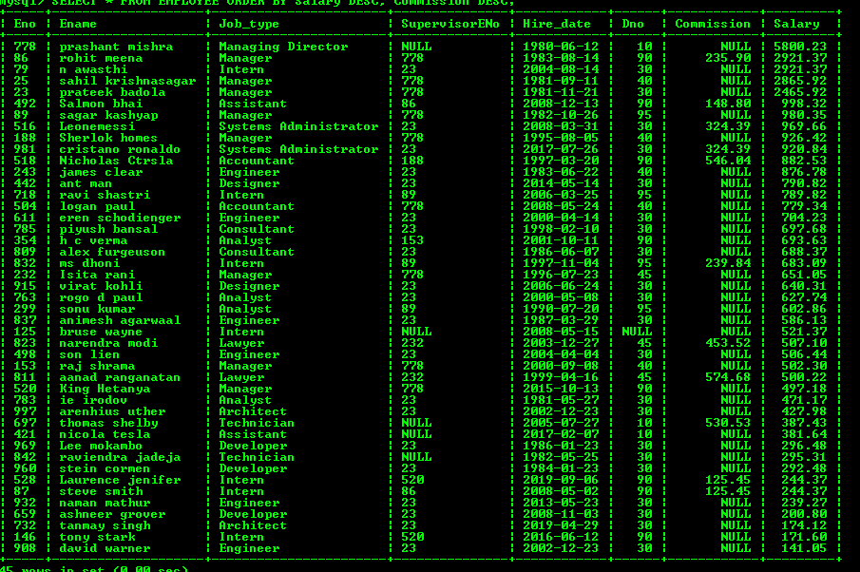

Q13)

SELECT Ename FROM EMPLOYEE WHERE Ename LIKE '__A%';

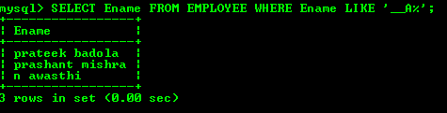

Q14)

SELECT Ename FROM EMPLOYEE  WHERE Ename LIKE '%R%R%' OR Ename LIKE '%A%A%' OR Dno = 30

OR SupervisorENo = '778';

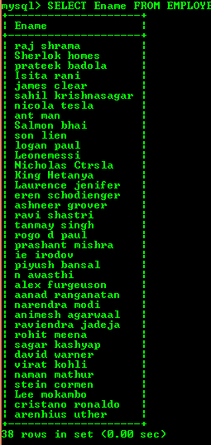

Q15)

SELECT Ename,Salary,Commission FROM EMPLOYEE WHERE Commission > 1.05 * Salary;

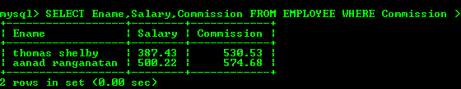

Q16)

SELECT DATE(NOW()),DAYNAME(NOW());

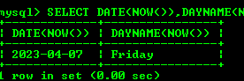

Q17)

SELECT Ename,Hire_date,date_add(date_add(Hire_date,INTERVAL 6 MONTH),INTERVAL (7-WEEKDAY(date_add(Hire_date,INTERVAL 6 MONTH))) DAY) AS REVIEW_DATE FROM employee;

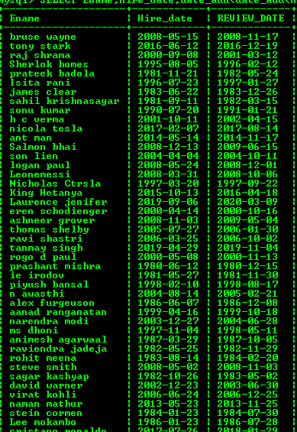

Q18)

SELECT Ename, TIMESTAMPDIFF(MONTH, Hire_date, NOW())FROM (EMPLOYEE NATURAL JOIN

DEPARTMENT) WHERE Dname = 'Purchase';

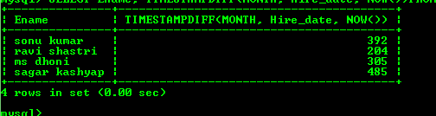

Q19)

SELECT CONCAT(Ename, ' earns $',Salary, ' monthly ','but wants $', 3 * Salary )AS  "Dream Salary" FROM

EMPLOYEE;

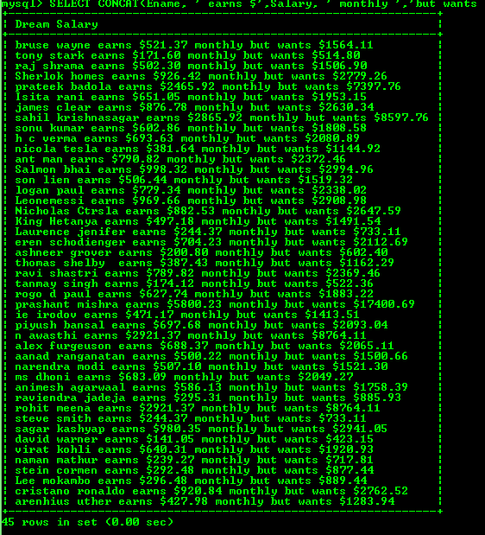

Q20)

SELECT CONCAT( UPPER(SUBSTR(Ename, 1, 1)),LOWER(SUBSTR(Ename, 2)))AS "Name",LENGTH(Ename) FROM EMPLOYEE WHERE Ename LIKE 'J%' OR Ename LIKE 'A%' OR Ename LIKE 'M%';

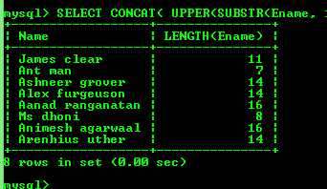

Q21)

SELECT Ename,Hire_date,DAYNAME(Hire_date) FROM EMPLOYEE;

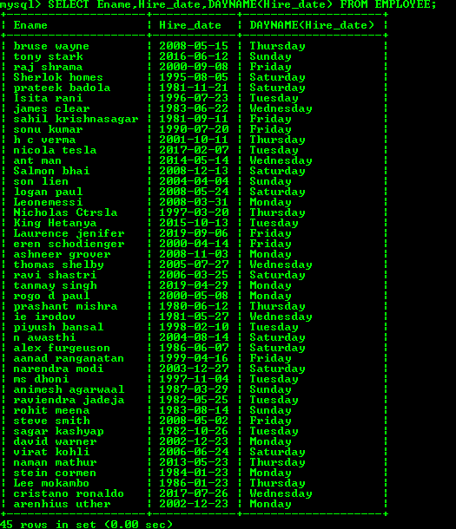

Q22)

SELECT Ename,Dname,Dno FROM (EMPLOYEE NATURAL JOIN DEPARTMENT);

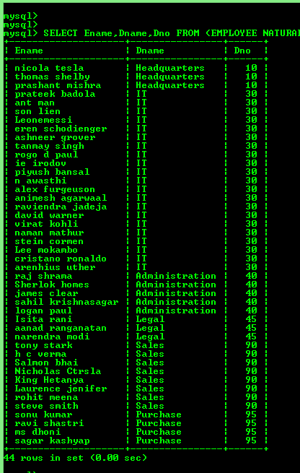

Q23)

SELECT DISTINCT Job_type FROM EMPLOYEE WHERE Dno = 30;

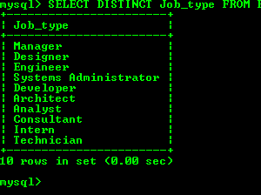

Q24)

SELECT Ename,Dname FROM (EMPLOYEE NATURAL JOIN DEPARTMENT) WHERE Ename LIKE '%A%';

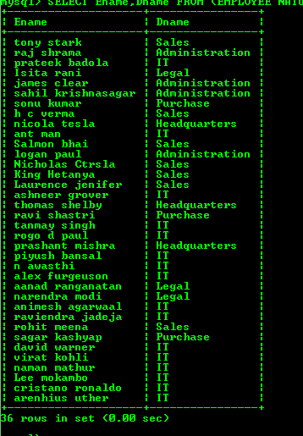

Q25)

SELECT Ename,Job_type,Dno,Dname FROM (EMPLOYEE NATURAL JOIN DEPARTMENT) WHERE Location = 'Dallas';

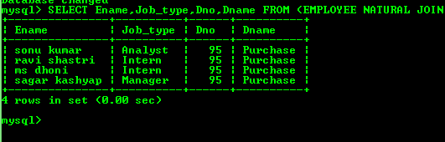

Q26)

SELECT E.Ename,E.Eno,S.Ename AS SupervisorName, S.Eno   AS SupervisorEno FROM EMPLOYEE AS E LEFT OUTER JOIN EMPLOYEE AS S oN E.SupervisorENo = S.Eno;

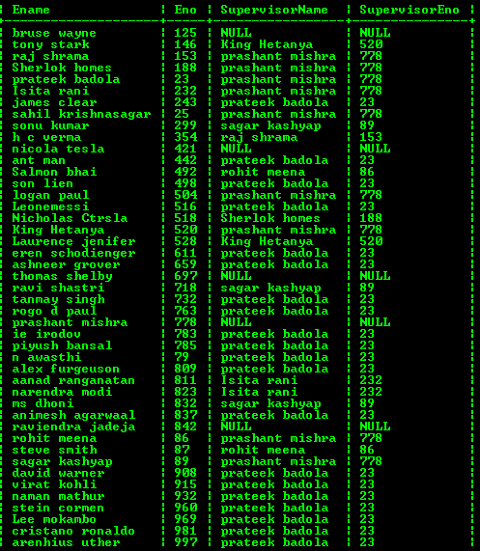

Q27)

SELECT L.Ename,L.Dno,L.Salary FROM EMPLOYEE AS L, EMPLOYEE AS R WHERE L.Dno = R.Dno AND L.Salary = R.Salary AND L.Eno <> R.Eno AND R.Commission IS NOT NULL;

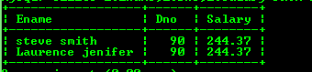

Q28)

SELECT Ename, RPAD('*', Salary / 100, '*') AS Salary_Star FROM EMPLOYEE;

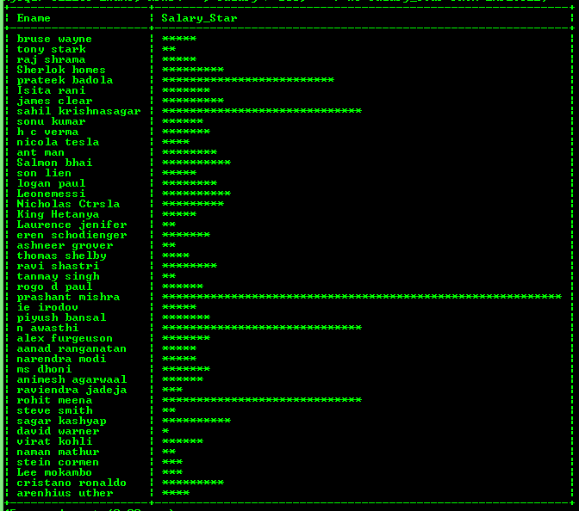

Q29)

SELECT MAX(Salary),MIN(Salary),SUM(Salary),AVG(Salary) FROM EMPLOYEE;

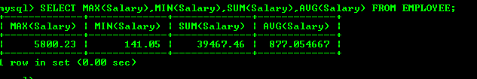

Q30)

SELECT Job_type,COUNT(DISTINCT Eno)FROM EMPLOYEE GROUP BY Job_type;

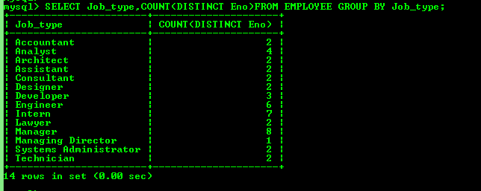

Q31)

SELECT COUNT(DISTINCT SupervisorENo)FROM EMPLOYEE;

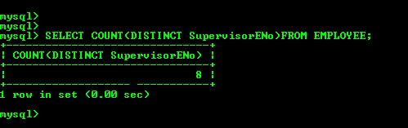

Q32)

SELECT Dname,Location,COUNT(*)AS NumberOfEmployees,ROUND(AVG(Salary), 2) AS AvgSalary FROM EMPLOYEE NATURAL JOIN DEPARTMENT GROUP BY EMPLOYEE.Dno;

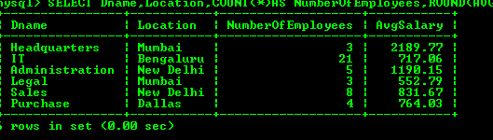

Q33)

SELECT Ename,Hire_date FROM EMPLOYEE WHERE Dno IN (  SELECT Dno FROM EMPLOYEE WHERE Ename LIKE 'Blake%');

Screenshot (400).png

Q34)

SELECT Eno,Ename FROM EMPLOYEE WHERE Salary > ( SELECT AVG(Salary) fROM EMPLOYEE );

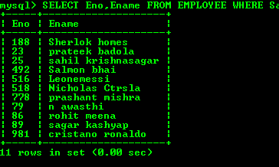

Q35)

SELECT Eno, Ename FROM EMPLOYEE WHERE Dno IN(SELECT Dno FROM EMPLOYEE  WHERE Ename LIKE '%T%');

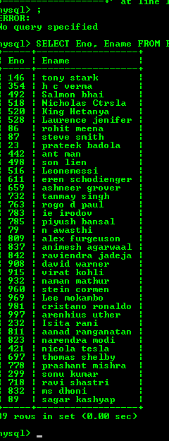

Q36)

SELECT Ename,Salary FROM EMPLOYEE  WHERE SupervisorENo IN (SELECT Eno FROM EMPLOYEE WHERE Ename LIKE 'King%');

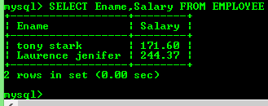

Q37)

SELECT Dno,Ename,Job_type FROM (EMPLOYEE NATURAL JOIN DEPARTMENT) WHERE Dname = 'Sales';

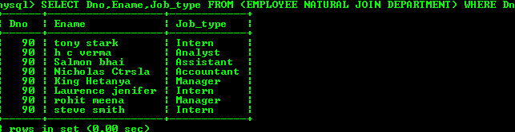

Q38)

SELECT Ename,Dname FROM (EMPLOYEE NATURAL JOIN DEPARTMENT) WHERE TIMESTAMPDIFF (YEAR,Hire_date,NOW()) > 20;

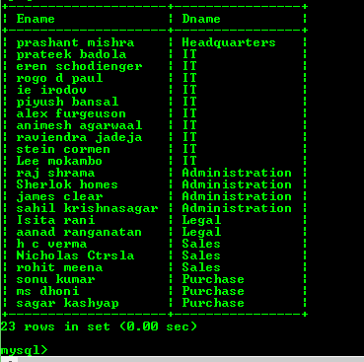

Q39)

SELECT Location,COUNT(*) FROM DEPARTMENT GROUP BY Location;

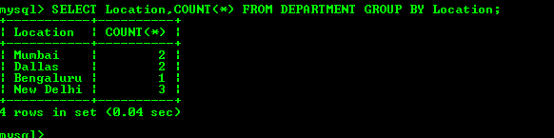

Q40)

SELECT Dname FROM (EMPLOYEE NATURAL JOIN DEPARTMENT) GROUP BY Dno HAVING COUNT(*) > 20;

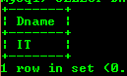

Q41)

(SELECT Ename FROM EMPLOYEE WHERE Eno NOT IN ( SELECT DISTINCT SupervisorENo FROM EMPLOYEE WHERE SupervisorENo IS NOT NULL)) UNION(SELECT Ename FROM EMPLOYEE WHERE Eno IN ( SELECT SupervisorENo FROM EMPLOYEE WHERE SupervisorENo IS NOT NULL GROUP BY SupervisorENo HAVING COUNT(*) > 5 ) );

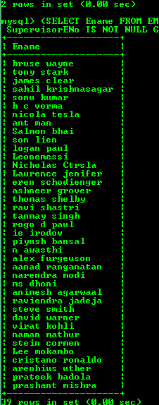

Q42)

WITH JOBCOUNT AS ( SELECT COUNT(*) AS ECount FROM EMPLOYEE GROUP BY Job_type)SELECT Job_type, COUNT(*) FROM EMPLOYEE GROUP BY Job_type HAVING COUNT(*) IN ((SELECT MAX(ECount) FROM JOBCOUNT)UNION(SELECT MIN(ECount)FROM JOBCOUNT));

