Database Systems Lab
(CL1002)
Date: 2nd-December-2024
Course Instructor(s)
Ms. Fatima Gado

Lab Mid Exam (A)
Total Time: 120 minutes
Total Wtg: 50
Total Questions: 04
Semester: Fall-2024
Campus: Karachi
Department(s): CS

Submission Instructions:
- Return the question paper mention your student ID on it.
- Read each question completely before answering it. There are 3 questions on 3 pages.
- Attempt all the given questions. All questions are carrying different points.
- Cheating in any case will lead to F-GRADE as per university rule.
- In case of any ambiguity, you may make assumption. But your assumption should not contradict any statement inthe question paper.

Student Name Roll No Section Student Signature

Question # 01: SQL Queries (LLO #: 3) [5 Weightage]

- Write a query to find the following output:
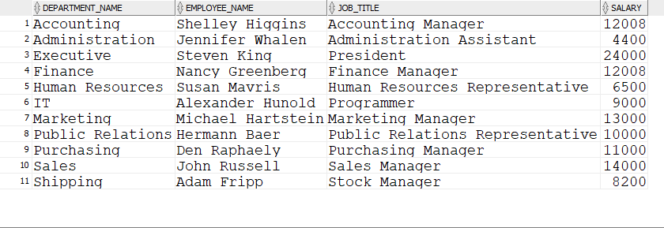
- Find departments where the difference between the highest-paid and lowest-paid employee is greater than $4000. Display the department name, maximum salary, minimum salary, and the salary difference.
- Identify the year and department that hired the most employees. Show the department name, year, and the number of hires.
- Find employees whose salary has not changed since they were hired. Display the employee name, hire date, current salary, and the department they work in.
- Write a query to find the employees who earn more than their direct manager. Display the employee name, manager’s name, and their salary.

Note : Submission will be (Query + output screenshot).

Question # 02: Triggers & Transaction (LLO #: 4) [20 Weightage]

- TRIGGER 15wtg
Product Table
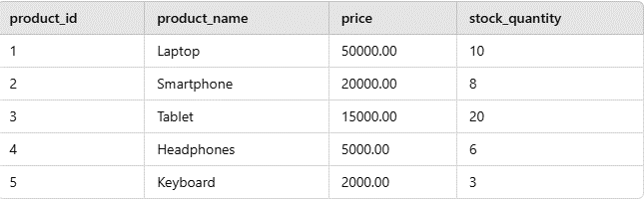
Using the provided data of Product Table, create a trigger named stock_threshold_check that fires BEFORE UPDATE on the Products table. The trigger should monitor the stock_quantity column during updates. If the new stock quantity (NEW.stock_quantity) is below the threshold value of 5, log a warning message in the Stock_Alert table.
Stock_Alert Table(alert_id | , product_id, | current_stock, | alert_message & | alert_date).

- TRANSACTIONS 5wtg
Create a hotel guest reservation system. First, create the following tables: guests (guest_id, name, email), rooms (room_id, room_type, price), reservations (reservation_id, guest_id, room_id, check_in, check_out), payments (payment_id, reservation_id, amount), and reservation_log (log_id, reservation_id, action). Insert a new guest, select a room, make a reservation, process the payment, and log the action. Ensure that the transaction is committed only if all steps succeed; otherwise, roll back the changes.

Question # 03: PL/SQL (LLO #: 4) [15 Weightage]

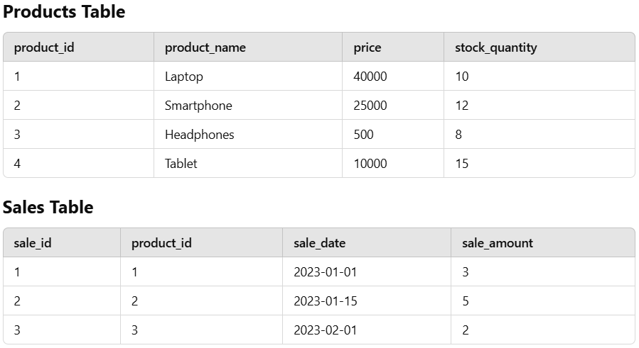

- A retail company maintains two tables: Products (columns: product_id, product_name, price, stock_quantity) and Sales (columns: sale_id, product_id, sale_date, sale_amount). Write a stored procedure named RecordSale that takes two input parameters (p_product_id and p_sale_amount). The procedure should: Check if the product exists in the Products table. If not, display a message: "Product not found." If the product is found, check if the sale amount is greater than the stock quantity. If yes, display a message: "Insufficient stock for the sale." If the sale is possible, update the stock quantity in the Products table and insert a record in the Sales table.
- Write a stored function named GetTotalSalesAmount that takes a product_id as an input parameter and returns the total sales amount for that product by summing the sale amounts from the Sales table. solution

Question # 04: MongoDB (LLO #: 3) [10 Weightage]

- Insert the following entries in mongoDB.
[
{ "book_id": "B001", "title": "Data Science Fundamentals", "author": "John Smith", "category": "Technology", "price": 29.99, "in_stock": true },
{ "book_id": "B002", "title": "Learning MongoDB", "author": "Jane Doe", "category": "Technology", "price": 35.99, "in_stock": false },
{ "book_id": "B003", "title": "Web Development with JavaScript", "author": "Mark Lee", "category": "Programming", "price": 24.99, "in_stock": true },
{ "book_id": "B004", "title": "Introduction to Python", "author": "Alice Brown", "category": "Programming", "price": 19.99, "in_stock": true },
{ "book_id": "B005", "title": "Advanced SQL Queries", "author": "Michael White", "category": "Database", "price": 45.99, "in_stock": true },
{ "book_id": "B006", "title": "C++ Basics", "author": "John Smith", "category": "Programming", "price": 29.99, "in_stock": true },
{ "book_id": "B007", "title": "Machine Learning with Python", "author": "Sara Green", "category": "Technology", "price": 39.99, "in_stock": true },
{ "book_id": "B008", "title": "Deep Learning Essentials", "author": "David Grey", "category": "Technology", "price": 59.99, "in_stock": false },
{ "book_id": "B009", "title": "Data Structures in Java", "author": "Lucas Blue", "category": "Programming", "price": 49.99, "in_stock": true },
{ "book_id": "B010", "title": "Artificial Intelligence", "author": "Sophia Grey", "category": "Technology", "price": 69.99, "in_stock": true }
]

- Update the price of all books in the "Technology" category that have a price less than $40, and set the in_stock value to false.
- Delete a book where the book_id is "B008" and it is out of stock (in_stock: false).
- Update the price of books by "John Smith" in the "Technology" category to $35, but only if the price is greater than $20 and the book is in stock.
- Find all books from the "Programming" category with a price greater than $25, and where the in_stock value is true. Sort them by price in descending order.
- Delete all books that are either in the "Programming" category and out of stock (in_stock: false), or have a price greater than $50.
- Update the price of books with book_id "B005" and "B006" to $40, and set their in_stock value to true.
- Find all books where the author is "Jane Doe" or the category is "Database", and the price is between $30 and $60.
- Update the price of all books in the "Programming" category to $50, only if their current price is less than $50 and they are currently in stock.
- Delete all books where the price is less than $30 and the category is "Technology", and their in_stock value is false.
- Update the title of the book with book_id "B010" to "AI Revolution", and reduce its price by 10%.
Note : Submission will be (Query + output screenshot).

BEST OF LUCK☺

