DBS Project Report

DATABASE SYSTEMS
Project Submission

Title: FoodExpress — Online Food Ordering System

FAST National University of Computer & Emerging Sciences
Karachi Campus

Group Members
Bazil Uddin Khan — 24K-0559
Daanial Tejani — 24K-0671
Abdul Manan — 23K-0829

Abstract
The FoodExpress Online Food Ordering System is a web-based application that digitises the process of browsing restaurant menus, placing orders, processing payments, and tracking deliveries. The system replaces traditional phone-based or in-person ordering with a unified platform that serves three categories of users — customers, restaurant administrators, and platform admins — each with role-appropriate access. Customers can register securely, browse restaurants and menus grouped by category, manage a shopping cart, and complete checkout with their preferred payment method. Administrators manage the entire system: monitoring orders, updating order status, controlling menu availability, and viewing real-time business analytics.
The application ensures data integrity through proper database normalisation (3NF), foreign-key referential integrity with cascade rules, secure password hashing using Werkzeug's scrypt algorithm, parameterised queries that prevent SQL injection, and explicit MySQL transactions that guarantee atomic order placement across the orders, order_details, and payments tables. The schema includes nine relational tables, three triggers that automatically maintain derived data (order totals, restaurant ratings), and three database views that abstract complex aggregations for reporting purposes. Customers can also leave star-rated reviews for restaurants, with an ‘AFTER INSERT’ trigger that automatically recomputes each restaurant's average rating without any application-side code.

Introduction

Background
The food-delivery sector has seen rapid growth in Pakistan over the past decade, with services such as Foodpanda, Cheetay, and EatMubarak becoming household names. Customers now expect to browse menus, place orders, and track deliveries from their phones rather than calling individual restaurants. From the restaurant's side, an integrated digital order pipeline reduces phone-handling overhead, eliminates handwritten order errors, and produces an audit trail of every transaction.

Motivation
Manual order-taking is slow, error-prone, and difficult to audit. Customers wait on hold while restaurants juggle phone, walk-in, and delivery orders simultaneously. This project addresses these challenges by providing a centralised platform where customers self-serve their orders, restaurants receive structured order data with automatic totals, and administrators have single-pane visibility over every order in the system.

Objectives
- Develop a centralised, normalised relational database for food-ordering operations
- Implement secure user authentication with role-based access for customers and admins
- Provide an intuitive interface for browsing restaurants and menus grouped by category
- Manage shopping carts and complete checkout with multiple payment methods
- Demonstrate ACID transactions through atomic order placement spanning multiple tables
- Implement database triggers that maintain derived data (order totals, restaurant ratings) automatically
- Provide an admin dashboard with real-time aggregate analytics
- Allow customers to leave star-rated reviews for restaurants, with average ratings auto-maintained by a database trigger
- Allow customers to browse menu items by food category across all restaurants
- Ensure data integrity through foreign-key constraints, indexes, and 3NF normalisation
- Prevent common security risks such as SQL injection (via parameterised queries) and password disclosure (via cryptographic hashing)

Scope
The system covers:
- User registration and authentication (customers and admins)
- Restaurant directory with category grouping
- Menu management with availability toggling
- Shopping cart (session-based) and checkout (database-persistent)
- Order placement with explicit MySQL transactions
- Customer order history and live status tracking
- Admin dashboard with aggregate KPIs (customers, orders, revenue, pending orders)
- Admin order-status management
- Search across menu items by name and description
- Database views and advanced SQL reports for business intelligence
- Customer-facing review system (one review per customer per restaurant)
- Category-based browsing of menu items across all restaurants

Limitations
- No real-time GPS delivery tracking — order status is updated manually by admins
- No integration with external payment gateways — payment is simulated as 'Cash on Delivery' or 'Online'
- Web-only interface; no native mobile application
- Single-tenant deployment — does not support multiple platform operators
- Email/SMS notifications are not implemented

System Requirements & Analysis

Functional Requirements
- User registration with email uniqueness validation
- Secure login using cryptographic password hashing (scrypt)
- Role-based access control: customer routes vs admin routes
- Browse restaurants and menu items, grouped by category
- Search menu items by name or description (LIKE pattern)
- Add items to cart, modify quantities, remove items
- Atomic checkout — orders, order_details, and payments inserted within a single transaction
- View personal order history with line-item detail
- Track order status across six states (Pending, Confirmed, Preparing, Out for Delivery, Delivered, Cancelled)
- Admin dashboard with aggregate counts and recent orders feed
- Admin order-status updates with automatic payment status synchronisation
- Admin menu-item availability toggling
- Admin views for customers, restaurants, and menu items
- Customers can submit a star rating (1–5) and optional comment per restaurant
- One-review-per-customer-per-restaurant rule enforced at both UI and route level
- Browse all available menu items in a single category across all restaurants

Non-Functional Requirements
- Responsive Bootstrap 5 user interface that adapts to mobile and desktop
- Cryptographic password hashing using Werkzeug's scrypt algorithm
- SQL injection prevention through parameterised queries (mysql-connector %s placeholders)
- Server-side session management for authenticated users and admins
- Atomic order placement using MySQL START TRANSACTION / COMMIT / ROLLBACK
- Foreign-key referential integrity with appropriate ON DELETE rules (CASCADE / RESTRICT)
- Indexed columns for frequently queried fields (customer_id, restaurant_id, status)
- Generated columns for derived values (order_details.subtotal)
- Triggers that auto-maintain order totals and restaurant ratings
- Error handling with user-facing flash messages

User Roles

Customer
- Register and log in with email + password
- Browse restaurants and view menus
- Search for specific food items
- Manage shopping cart
- Place orders with payment-method selection
- View personal order history
- Track live status of in-progress orders
- Submit a star-rated review and comment per restaurant

Admin
- Log in with username + password (separate credential space from customers)
- View dashboard with system-wide aggregate KPIs
- View all orders across the system
- Update order status (Pending → Confirmed → Preparing → Out for Delivery → Delivered)
- View customer accounts
- View registered restaurants
- View and toggle availability of menu items

Data Dictionary

categories
Field | Type | Description
category_id (PK) | INT AUTO_INCREMENT | Unique category identifier
name | VARCHAR(100) UNIQUE NOT NULL | Category name (e.g., Burgers)
description | TEXT | Free-text description
created_at | TIMESTAMP | Auto-set on insert

restaurants
Field | Type | Description
restaurant_id (PK) | INT AUTO_INCREMENT | Unique restaurant ID
name | VARCHAR(150) NOT NULL | Restaurant name
address | VARCHAR(255) NOT NULL | Physical address
phone | VARCHAR(20) | Contact phone
email | VARCHAR(100) UNIQUE | Contact email
rating | DECIMAL(2,1) | Avg rating (auto-updated by trigger)
is_active | BOOLEAN | Soft-delete flag
created_at | TIMESTAMP | Auto-set on insert

customers
Field | Type | Description
customer_id (PK) | INT AUTO_INCREMENT | Unique customer ID
first_name | VARCHAR(50) NOT NULL | Given name
last_name | VARCHAR(50) NOT NULL | Family name
email | VARCHAR(100) UNIQUE NOT NULL | Login identifier
password_hash | VARCHAR(255) NOT NULL | Werkzeug scrypt hash
phone | VARCHAR(20) | Contact phone
address | VARCHAR(255) | Default delivery address
created_at | TIMESTAMP | Account-creation date

admins
Field | Type | Description
admin_id (PK) | INT AUTO_INCREMENT | Unique admin ID
username | VARCHAR(50) UNIQUE NOT NULL | Admin login name
email | VARCHAR(100) UNIQUE NOT NULL | Contact email
password_hash | VARCHAR(255) NOT NULL | Werkzeug scrypt hash
created_at | TIMESTAMP | Account-creation date

menu_items
Field | Type | Description
item_id (PK) | INT AUTO_INCREMENT | Unique menu-item ID
restaurant_id (FK) | INT NOT NULL | → restaurants.restaurant_id
category_id (FK) | INT NOT NULL | → categories.category_id
name | VARCHAR(150) NOT NULL | Item name
description | TEXT | Item description
price | DECIMAL(10,2) NOT NULL | Unit price (Rs.)
image_url | VARCHAR(255) | Image filename or URL
is_available | BOOLEAN | Availability toggle
created_at | TIMESTAMP | Auto-set on insert

orders
Field | Type | Description
order_id (PK) | INT AUTO_INCREMENT | Unique order ID
customer_id (FK) | INT NOT NULL | → customers.customer_id
restaurant_id (FK) | INT NOT NULL | → restaurants.restaurant_id
order_date | TIMESTAMP | Auto-set on insert
status | ENUM(...) | Pending / Confirmed / Preparing / Out for Delivery / Delivered / Cancelled
total_amount | DECIMAL(10,2) | Auto-maintained by trigger
delivery_address | VARCHAR(255) | Delivery destination

order_details
Field | Type | Description
detail_id (PK) | INT AUTO_INCREMENT | Unique detail row
order_id (FK) | INT NOT NULL | → orders.order_id
item_id (FK) | INT NOT NULL | → menu_items.item_id
quantity | INT NOT NULL | Number of units
unit_price | DECIMAL(10,2) NOT NULL | Price snapshot at order time
subtotal | DECIMAL GENERATED | = quantity × unit_price (computed column)

payments
Field | Type | Description
payment_id (PK) | INT AUTO_INCREMENT | Unique payment ID
order_id (FK UNIQUE) | INT NOT NULL | → orders.order_id (1-to-1)
payment_date | TIMESTAMP | Auto-set on insert
amount | DECIMAL(10,2) NOT NULL | Amount paid
method | ENUM | Cash on Delivery / Online
status | ENUM | Pending / Completed / Failed / Refunded

reviews
Field | Type | Description
review_id (PK) | INT AUTO_INCREMENT | Unique review ID
customer_id (FK) | INT NOT NULL | → customers.customer_id
restaurant_id (FK) | INT NOT NULL | → restaurants.restaurant_id
rating | INT CHECK (1-5) | Star rating
comment | TEXT | Free-text review
review_date | TIMESTAMP | Auto-set on insert

Normalisation (3NF)
The schema satisfies the requirements of First, Second, and Third Normal Forms:
- 1NF — every column holds an atomic value; no repeating groups (e.g., line items live in order_details, not as a comma-separated string in orders)
- 2NF — every non-key attribute depends on the entire primary key (order_details uses a surrogate detail_id; quantity and unit_price depend on it fully)
- 3NF — no transitive dependencies; for example, customer name is stored only in customers, not duplicated in orders
- All many-to-many relationships are resolved via associative tables (orders + order_details represents the many-to-many between customers and menu_items)
- Generated columns (order_details.subtotal) and triggers (orders.total_amount) handle derived data without violating 3NF, because the source columns remain canonical

Conceptual & Logical Design

Use-Case Diagram
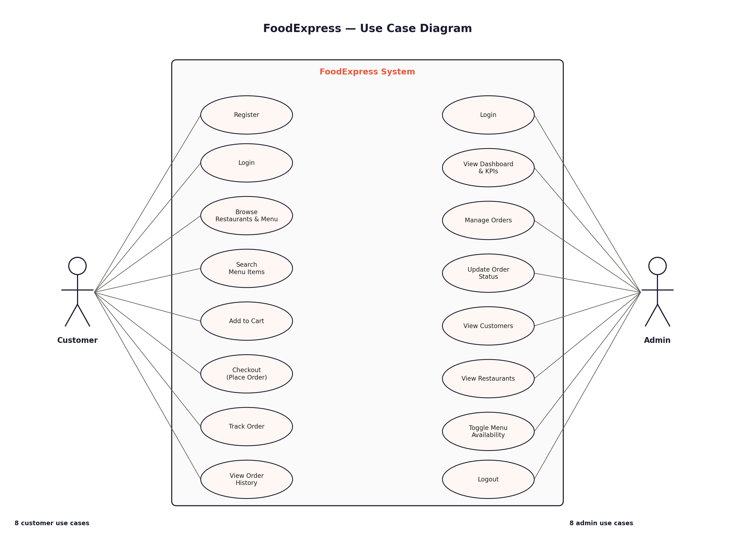

ERD (Entity Relationship Diagram)

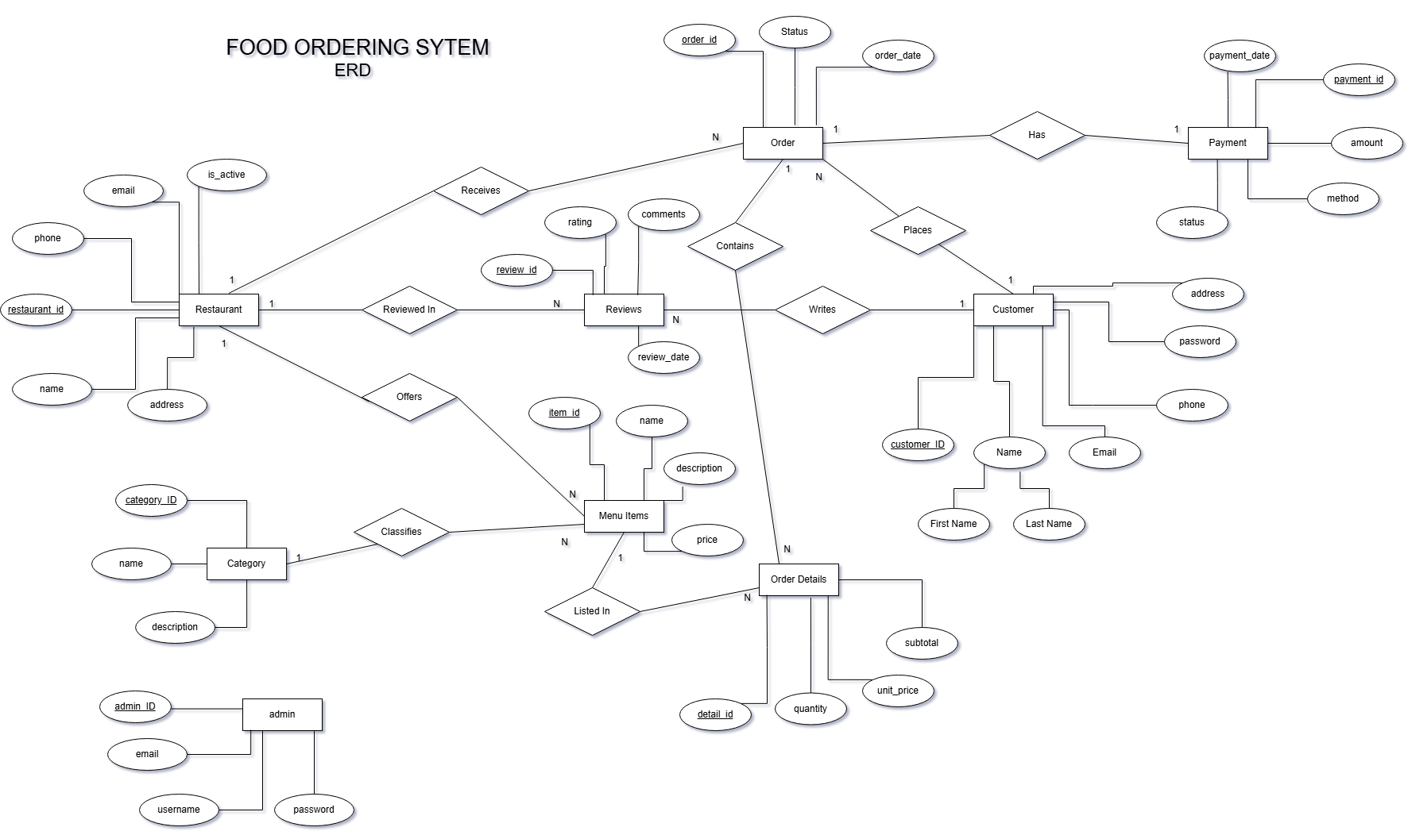

Relational Schema (3NF)
All tables are normalised to 3NF with:
- No repeating groups
- All non-key attributes fully dependent on the primary key
- No transitive dependencies
- Foreign-key referential integrity with explicit ON DELETE / ON UPDATE rules
- Indexes on every foreign key column to keep JOIN performance acceptable

Database Implementation

SQL Table Creation Scripts
Selected CREATE TABLE statements (full schema in sql/schema.sql):
-- Customers
CREATE TABLE customers (
customer_id INT AUTO_INCREMENT PRIMARY KEY,
first_name VARCHAR(50) NOT NULL,
last_name VARCHAR(50) NOT NULL,
email VARCHAR(100) NOT NULL UNIQUE,
password_hash VARCHAR(255) NOT NULL,
phone VARCHAR(20),
address VARCHAR(255),
created_at TIMESTAMP DEFAULT CURRENT_TIMESTAMP
) ENGINE=InnoDB;
-- Orders (parent of order_details)
CREATE TABLE orders (
order_id INT AUTO_INCREMENT PRIMARY KEY,
customer_id INT NOT NULL,
restaurant_id INT NOT NULL,
order_date TIMESTAMP DEFAULT CURRENT_TIMESTAMP,
status ENUM('Pending','Confirmed','Preparing',
'Out for Delivery','Delivered','Cancelled')
DEFAULT 'Pending',
total_amount DECIMAL(10,2) NOT NULL DEFAULT 0.00,
delivery_address VARCHAR(255),
FOREIGN KEY (customer_id) REFERENCES customers(customer_id)
ON DELETE CASCADE ON UPDATE CASCADE,
FOREIGN KEY (restaurant_id) REFERENCES restaurants(restaurant_id)
ON DELETE CASCADE ON UPDATE CASCADE,
INDEX idx_customer (customer_id),
INDEX idx_restaurant (restaurant_id),
INDEX idx_status (status)
) ENGINE=InnoDB;
-- Order details with computed subtotal
CREATE TABLE order_details (
detail_id INT AUTO_INCREMENT PRIMARY KEY,
order_id INT NOT NULL,
item_id INT NOT NULL,
quantity INT NOT NULL DEFAULT 1,
unit_price DECIMAL(10,2) NOT NULL,
subtotal DECIMAL(10,2) GENERATED ALWAYS AS
(quantity * unit_price) STORED,
FOREIGN KEY (order_id) REFERENCES orders(order_id)
ON DELETE CASCADE,
FOREIGN KEY (item_id) REFERENCES menu_items(item_id)
ON DELETE RESTRICT,
INDEX idx_order (order_id)
) ENGINE=InnoDB;

Triggers
Three triggers automatically maintain derived data:
-- Auto-update orders.total_amount when order_details are INSERTED
DELIMITER //
CREATE TRIGGER trg_update_order_total_insert
AFTER INSERT ON order_details
FOR EACH ROW
BEGIN
UPDATE orders
SET total_amount = (
SELECT COALESCE(SUM(subtotal), 0)
FROM order_details
WHERE order_id = NEW.order_id
)
WHERE order_id = NEW.order_id;
END //
-- Auto-update restaurant rating when a review is added
CREATE TRIGGER trg_update_restaurant_rating
AFTER INSERT ON reviews
FOR EACH ROW
BEGIN
UPDATE restaurants
SET rating = (
SELECT ROUND(AVG(rating), 1)
FROM reviews
WHERE restaurant_id = NEW.restaurant_id
)
WHERE restaurant_id = NEW.restaurant_id;
END //
DELIMITER ;
The trg_update_restaurant_rating trigger is fired live by the customer review form — every time a customer submits a review through the UI, the average rating in restaurants.rating is recomputed without any application-side code.

Views
Three views encapsulate complex aggregations for the reporting layer:
-- View 1: Customer order summary with payment info
CREATE VIEW vw_customer_orders AS
SELECT o.order_id,
CONCAT(c.first_name, ' ', c.last_name) AS customer_name,
c.email AS customer_email,
r.name AS restaurant_name,
o.order_date,
o.status,
o.total_amount,
p.method AS payment_method,
p.status AS payment_status
FROM orders o
JOIN customers c ON o.customer_id = c.customer_id
JOIN restaurants r ON o.restaurant_id = r.restaurant_id
LEFT JOIN payments p ON o.order_id = p.order_id;
-- View 2: Restaurant revenue (Delivered orders only)
CREATE VIEW vw_restaurant_revenue AS
SELECT r.restaurant_id,
r.name AS restaurant_name,
COUNT(DISTINCT o.order_id) AS total_orders,
COALESCE(SUM(o.total_amount), 0) AS total_revenue,
r.rating
FROM restaurants r
LEFT JOIN orders o ON r.restaurant_id = o.restaurant_id
AND o.status = 'Delivered'
GROUP BY r.restaurant_id, r.name, r.rating;
-- View 3: Most-ordered menu items
CREATE VIEW vw_popular_items AS
SELECT mi.item_id,
mi.name AS item_name,
r.name AS restaurant_name,
mi.price,
COUNT(od.detail_id) AS times_ordered,
SUM(od.quantity) AS total_qty_sold
FROM menu_items mi
JOIN order_details od ON mi.item_id = od.item_id
JOIN restaurants r ON mi.restaurant_id = r.restaurant_id
GROUP BY mi.item_id, mi.name, r.name, mi.price
ORDER BY times_ordered DESC;

Sample Data
INSERT INTO categories (name, description) VALUES
('Burgers', 'Beef, chicken, and veggie burgers'),
('Pizza', 'Classic and gourmet pizzas'),
('Biryani', 'Authentic desi rice dishes'),
('Chinese', 'Noodles, rice, and stir-fry'),
('Desserts', 'Sweets and ice cream'),
('Beverages', 'Drinks and refreshments');
INSERT INTO restaurants (name, address, phone, email) VALUES
('Burger Lab', 'Shahrah-e-Faisal, Karachi', '0321-1234567', 'info@burgerlab.pk'),
('Pizza Point', 'Tariq Road, Karachi', '0333-7654321', 'hello@pizzapoint.pk'),
('Student Biryani', 'Bahadurabad, Karachi', '0300-1112233', 'order@studentbiryani.pk'),
('Ginsoy', 'Clifton, Karachi', '0312-9998877', 'eat@ginsoy.pk');
The catalog was later expanded to 9 restaurants and 35 menu items (adding restaurants such as Howdy, The Juice Box, Cinnabon, Karachi Broast, and OPTP, with a stronger focus on the Beverages category).

Key Queries
Selected advanced queries used by the application and reporting layer:
-- Q1: Total revenue per restaurant (delivered orders only)
SELECT * FROM vw_restaurant_revenue ORDER BY total_revenue DESC;
-- Q2: Top 3 most-ordered items
SELECT * FROM vw_popular_items LIMIT 3;
-- Q3: Customers who have spent more than Rs. 1500 in total
SELECT CONCAT(c.first_name, ' ', c.last_name) AS customer,
SUM(o.total_amount) AS total_spent
FROM customers c
JOIN orders o ON c.customer_id = o.customer_id
WHERE o.status = 'Delivered'
GROUP BY c.customer_id
HAVING total_spent > 1500;
-- Q4: Average order value per restaurant
SELECT r.name, ROUND(AVG(o.total_amount), 2) AS avg_order_value
FROM restaurants r
JOIN orders o ON r.restaurant_id = o.restaurant_id
GROUP BY r.restaurant_id;
-- Q5: Monthly order trend
SELECT DATE_FORMAT(order_date, '%Y-%m') AS month,
COUNT(*) AS order_count,
SUM(total_amount) AS revenue
FROM orders
GROUP BY month
ORDER BY month;

Atomic Checkout — Transaction Implementation
The checkout route in app.py wraps three multi-row inserts into a single MySQL transaction so that a partial failure cannot leave the database in an inconsistent state. If any INSERT fails, the entire checkout is rolled back and no rows are persisted.
conn = get_db()
cur = conn.cursor()
try:
if conn.in_transaction: # close any implicit txn from prior SELECTs
conn.commit()
conn.start_transaction() # ---- BEGIN ----
for rid, items in by_restaurant.items():
cur.execute('''INSERT INTO orders
(customer_id, restaurant_id, status, total_amount, delivery_address)
VALUES (%s, %s, 'Pending', %s, %s)''',
(user_id, rid, total, address))
new_order_id = cur.lastrowid
cur.executemany('''INSERT INTO order_details
(order_id, item_id, quantity, unit_price)
VALUES (%s, %s, %s, %s)''',
[(new_order_id, i['item_id'], i['quantity'], i['price']) for i in items])
cur.execute('''INSERT INTO payments
(order_id, amount, method, status)
VALUES (%s, %s, %s, 'Pending')''',
(new_order_id, total, payment_method))
conn.commit() # ---- COMMIT ----
except Exception as exc:
conn.rollback() # ---- ROLLBACK on failure ----
flash(f'Checkout failed: {exc}', 'danger')

Application

Technology Stack
Layer | Technology
Frontend | HTML5, CSS3, Bootstrap 5, Bootstrap Icons, custom CSS
Backend | Python 3 + Flask 3.x
Database driver | mysql-connector-python (pure Python)
Database | MySQL 8.x (InnoDB)
Auth / hashing | Werkzeug scrypt
Templating | Jinja2
Fonts | DM Sans, Playfair Display (Google Fonts)

Key User Interfaces

Homepage
- Hero section with brand introduction
- Category chips for quick filtering
- Restaurant cards rendered from the live restaurants table
- Search bar that posts to /search
- Cart counter in the navbar driven by session state

Restaurant Menu
- Menu items grouped by category (live JOIN with categories)
- Per-item Add to Cart button with quantity
- Availability filter — items with is_available = FALSE are hidden
- Customer reviews section with submit form (one review per customer per restaurant)

Restaurant Reviews
- Existing reviews displayed at the bottom of each restaurant page (customer name, star rating, comment, date)
- Logged-in customers see a "Leave a review" form with star-radio picker and comment field
- Customers who have already reviewed see a "You have already reviewed this restaurant" notice instead of the form
- Logged-out visitors see a "Log in to leave a review" prompt
- On submit, the trg_update_restaurant_rating trigger fires automatically and updates restaurants.rating

Category Browse
- Clicking any category pill on the homepage opens a page listing all available items in that category
- Page joins menu_items × restaurants so the originating restaurant is shown for each item
- Items can be added to card directly from the category page.

Cart
- Lists items the user has added during the current session
- Per-item subtotal and overall total
- Remove and quantity controls
- Proceed-to-Checkout button

Checkout
- Confirms delivery address (defaults to user's saved address)
- Payment-method selection (Cash on Delivery / Online)
- On submit: starts a MySQL transaction, inserts order + line items + payment, commits

My Orders
- Lists all orders for the logged-in customer (most recent first)
- Each order card shows status badge, line items, total, payment method/status
- In-progress orders show a Track button that opens the live tracker

Order Tracking
- Five-step progress indicator (Pending → Confirmed → Preparing → Out for Delivery → Delivered)
- Reflects the current order.status value from the database

Admin Dashboard
- Total customers, restaurants, orders, revenue (delivered), pending orders — single subquery-aggregated SELECT
- Recent-orders table joining orders × customers × restaurants
- Sticky admin nav with Dashboard, Orders, Customers, Restaurants, Menu Items, Logout

Admin Order Management
- All orders sortable / scannable by status
- Status dropdown per row → POST to /admin/order/<id>/update
- Setting status = Delivered also updates the linked payment to Completed

Admin Menu Management
- Lists all menu items joined with restaurant and category
- One-click toggle for is_available

Testing & Results
The system was tested end-to-end against the full set of functional requirements. Each test below was executed against the live MySQL database and verified by querying the affected tables in MySQL Workbench.

Functional Tests
# | Test Case | Expected Result | Outcome
1 | Register new customer with unique email | Row inserted; redirect to login | PASS
2 | Register with duplicate email | Flash error; no row inserted | PASS
3 | Login with correct credentials | Session set; redirect to homepage | PASS
4 | Login with wrong password | Flash error; no session | PASS
5 | Add item to cart while logged out | Redirected to login first | PASS
6 | Add item to cart while logged in | Cart count increments; session updated | PASS
7 | Checkout with cart items | orders + order_details + payments inserted in one transaction | PASS
8 | Trigger fires on order_details INSERT | orders.total_amount = SUM(order_details.subtotal) | PASS
9 | Track in-progress order | Live status reflects orders.status | PASS
10 | Admin updates order to Delivered | orders.status + payments.status both updated | PASS
11 | Admin toggles menu item to unavailable | Item disappears from customer menu | PASS
12 | Search by item name | LIKE pattern returns matching rows | PASS
13 | Search by description | LIKE pattern matches description text | PASS
14 | SQL injection attempt in login email | Treated as literal string (parameterised) | PASS
15 | Foreign-key violation (delete category in use) | RESTRICT prevents the delete | PASS
16 | Submit a review while logged in | Row inserted; restaurant rating recomputed by trigger | PASS
17 | Submit a second review for the same restaurant | Rejected with 'already reviewed' message; no INSERT | PASS
18 | View reviews on a restaurant page | All reviews shown with customer names (JOIN query) | PASS
19 | Click a category pill on the homepage | Page loads showing all items in that category across restaurants | PASS

Non-Functional Tests
- Responsive design verified at 360 px, 768 px, 1280 px, and 1920 px viewports
- Login passwords are stored as scrypt hashes (~150-character strings beginning with 'scrypt:32768:8:1$')
- All SQL uses %s parameter placeholders — no string concatenation of user input
- Failed checkout simulation (invalid item_id) correctly rolls back the entire transaction
- Admin session is independent of customer session — confirmed by simultaneous logins in two browsers

Screenshots

Customer Side UI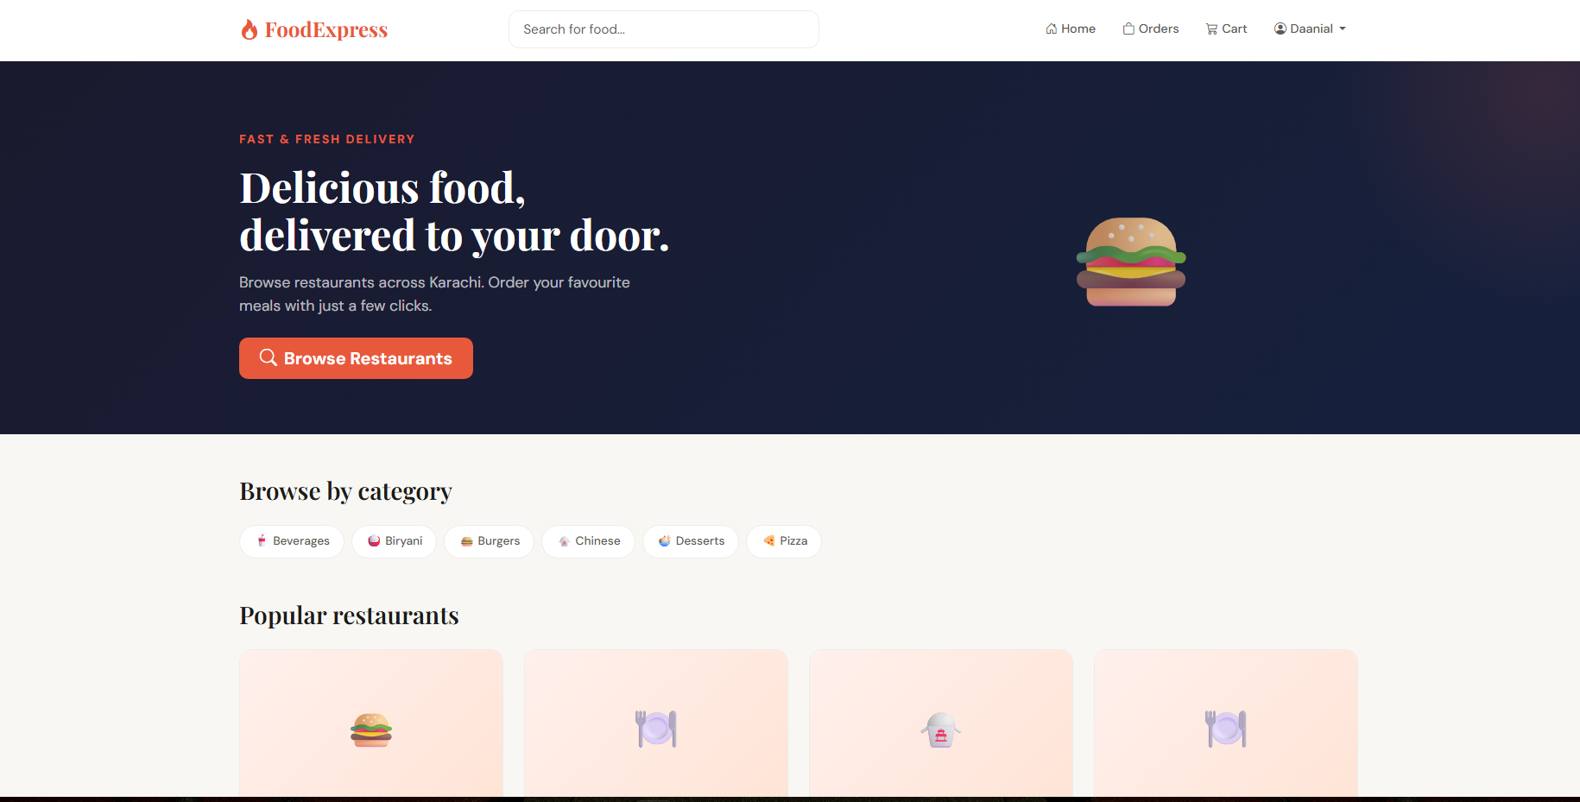
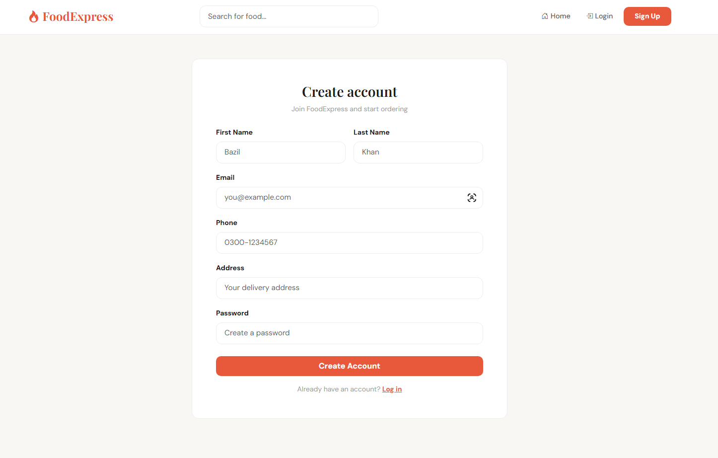
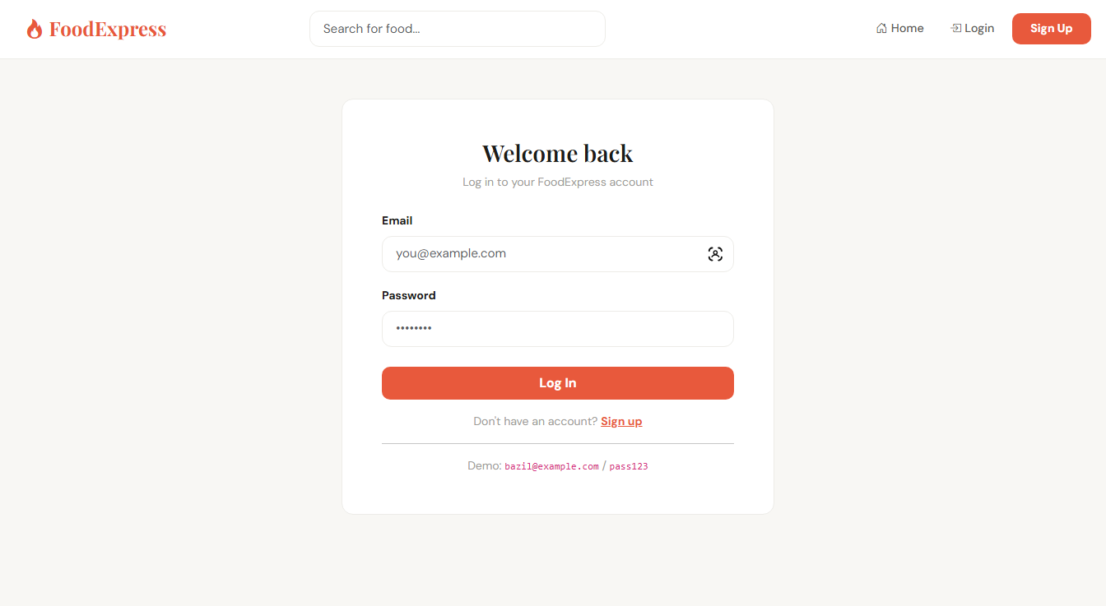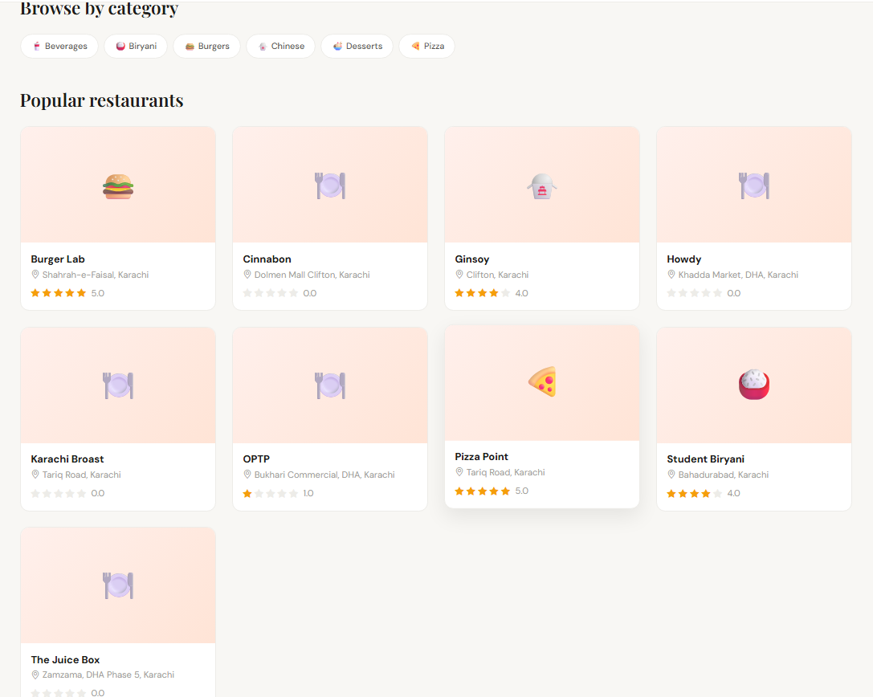
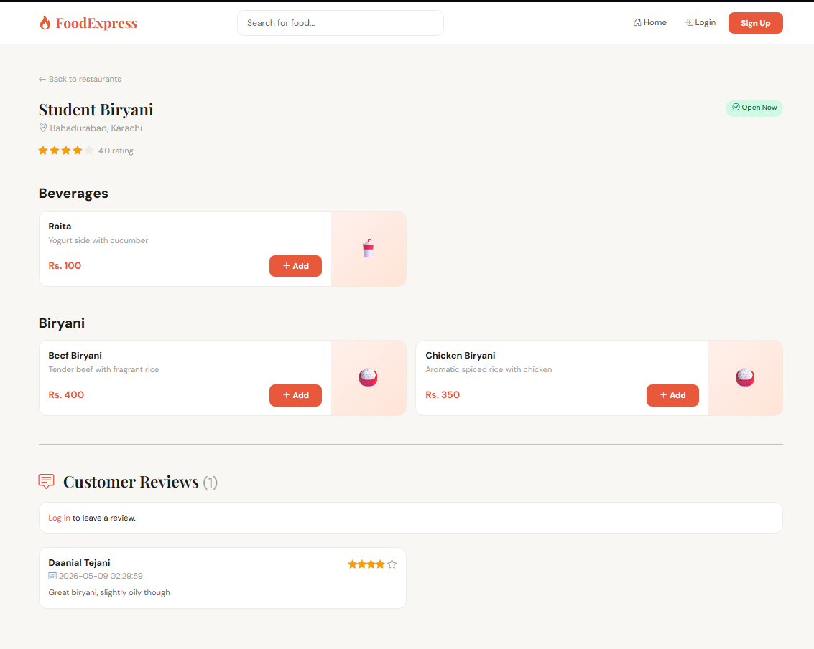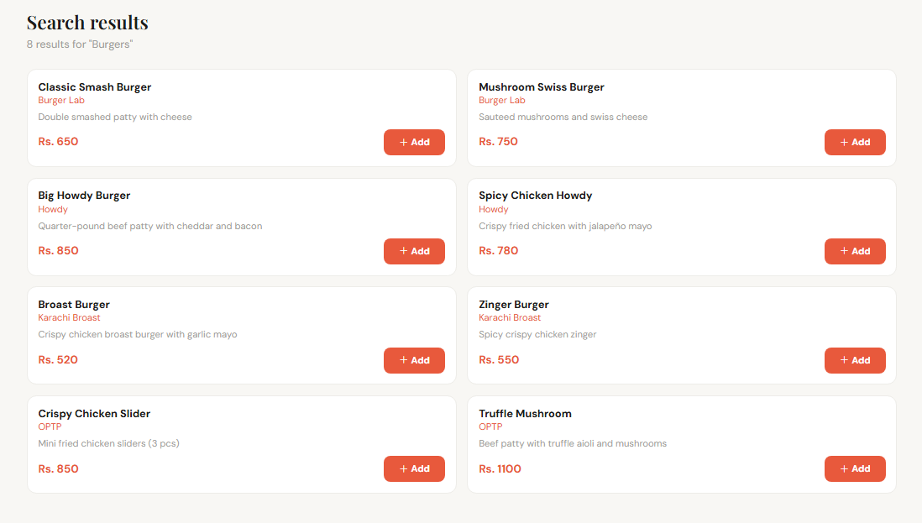
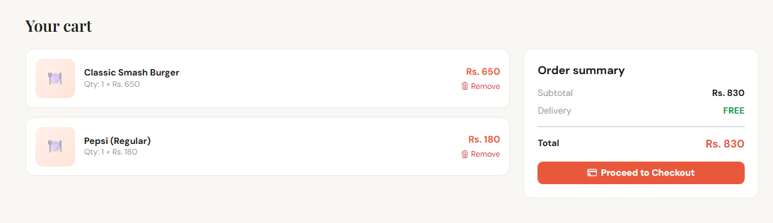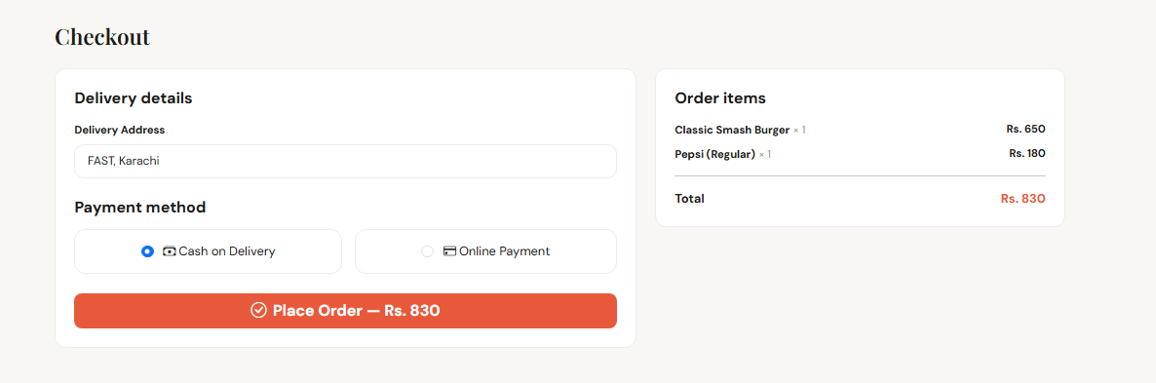
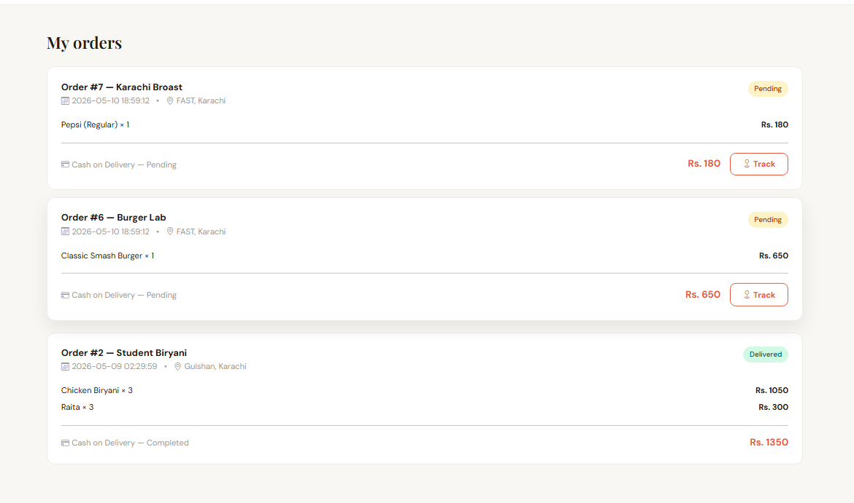

Admin UI
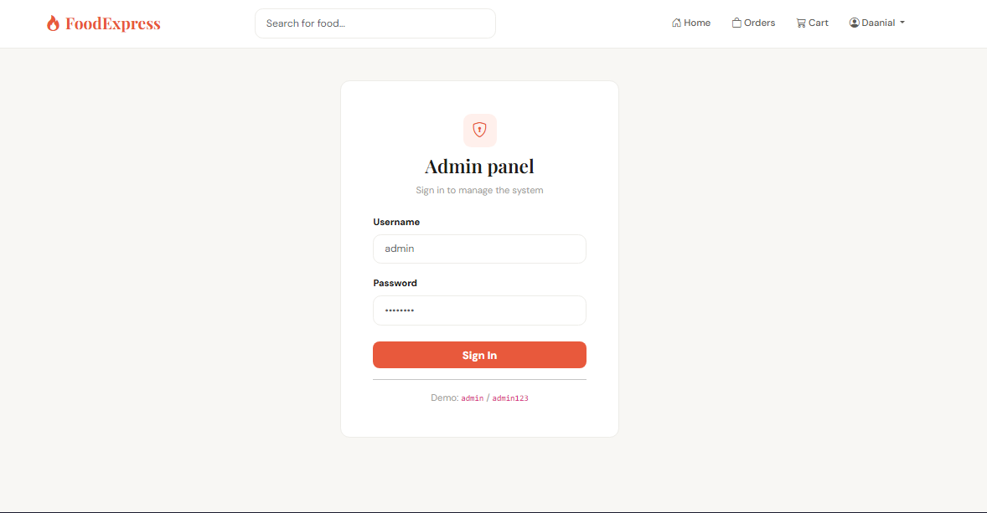
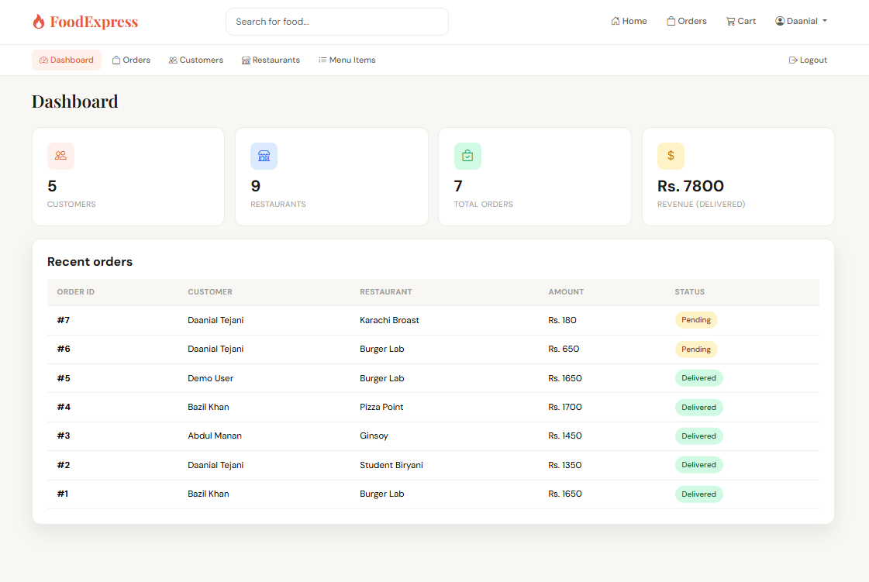
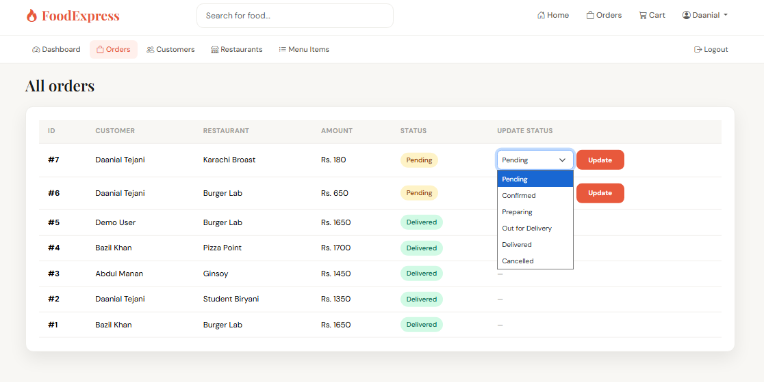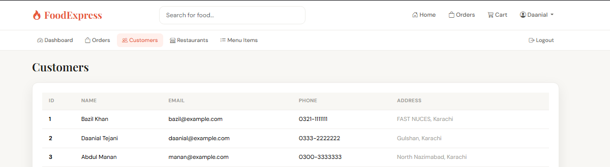
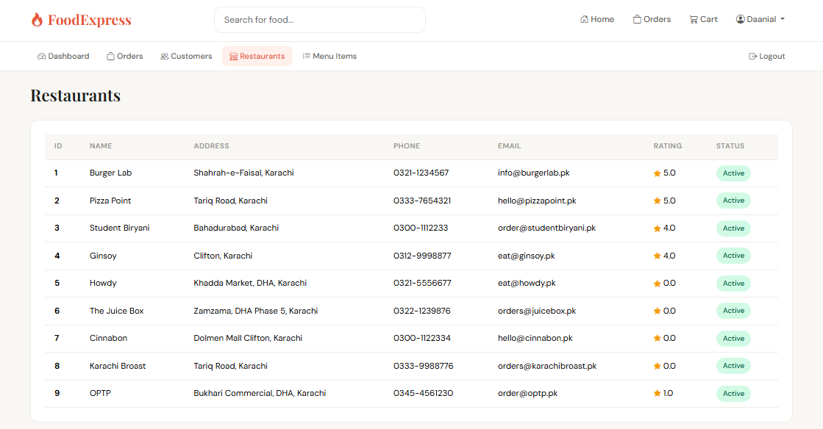
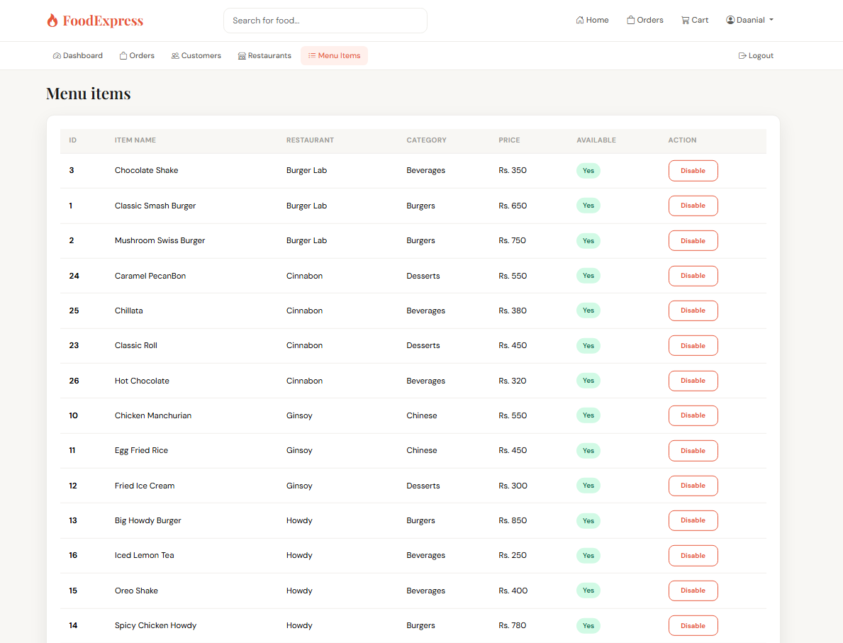

Database
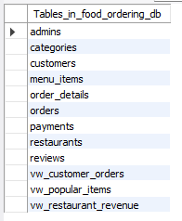
Customer
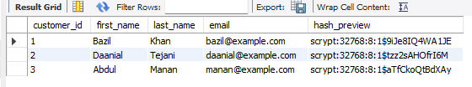
Order Details:
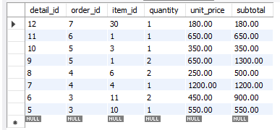
Restaurants:
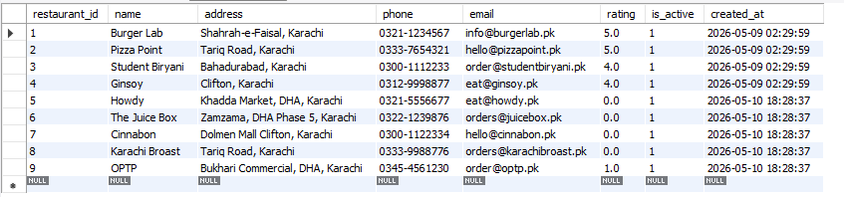

Triggers:
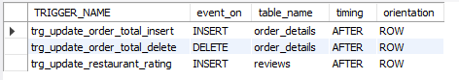
Views:
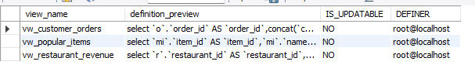

Results & Discussion

Achievements
- Delivered a fully working web application backed by a real MySQL database (no in-memory mocking)
- Implemented all functional requirements from the project proposal
- Demonstrated proper 3NF normalisation across nine related tables
- Implemented three database triggers that fire correctly under live conditions
- Implemented three database views that simplify reporting queries
- Implemented atomic, ACID-compliant checkout using explicit MySQL transactions
- Built a polished, responsive UI with Bootstrap 5 and custom typography
- Demonstrated secure password handling with Werkzeug's scrypt algorithm
- Demonstrated SQL injection prevention through universal use of parameterised queries
- Implemented a customer review system that demonstrates the AFTER INSERT trigger live — submitting a review through the UI automatically recomputes the affected restaurant's average rating in the database
- Implemented category-based browsing of menu items via a JOIN query across menu_items and restaurants

Issues Encountered
- MySQL Connector raised 'Transaction already in progress' on checkout — root cause: with autocommit=False, prior SELECTs in the same request had already started an implicit transaction. Fix: commit any in-flight transaction before calling start_transaction()
- Seed data in schema.sql shipped with placeholder password strings ('hashed_pw_1', etc.) that Werkzeug rejected — solved by writing init_passwords.py to overwrite them with real hashes after schema load
- Decimal × float arithmetic in some templates required explicit float() casts when storing prices in the session cart
- Shared connection lifecycle had to be carefully tied to Flask's request context — implemented using flask.g and a teardown_appcontext handler

Observations
- Triggers significantly simplify application code — the developer never has to remember to recompute order totals
- Generated columns (order_details.subtotal) eliminate one source of bugs by removing manual recomputation entirely
- Database views give the reporting layer a stable contract that survives schema refactors
- Wrapping multi-row inserts in a transaction is the cheapest way to guarantee data consistency
- Even for a small project, indexing every foreign key produced visibly faster JOIN performance during testing

Conclusion
The FoodExpress Online Food Ordering System successfully addresses the core requirements of digitising the restaurant-ordering workflow through a well-designed relational database and a clean web interface. Customers can self-serve their orders end-to-end, restaurants receive structured order data, and administrators have real-time visibility into every transaction in the system.
The application proves particularly useful in:
- Centralising order management across multiple restaurants
- Eliminating manual phone-based order errors
- Producing a complete audit trail of every order, payment, and status change
- Providing real-time business intelligence through pre-built database views
- Demonstrating modern database engineering practices in a teaching context
From an educational standpoint, the project demonstrates the practical value of the database concepts taught in the Database Systems course — normalisation, referential integrity, transactions, triggers, views, indexes, and parameterised queries — all working together to deliver a real-world application.
Limitations of the current implementation:
- Single-deployment instance with no multi-tenant or multi-location support
- Online payments are simulated; no integration with actual payment processors
- Restaurants cannot self-manage their menus — admin owns all menu CRUD
- No email or SMS notifications when order status changes

Future Enhancements

Restaurant Staff Role
- Dedicated restaurant_staff table with FK to restaurants
- Self-service login that scopes views to the staff member's restaurant only
- Restaurant-side dashboard for incoming orders and menu CRUD

Stored Procedures
- sp_place_order() — encapsulate the multi-table checkout in a single procedure call
- sp_get_revenue_by_date(start, end) — parameterised reporting stored procedure
- Reduces network round-trips and centralises business rules in the database

Advanced Analytics
- Window functions (ROW_NUMBER, RANK) for ranked reports (e.g., top-N restaurants per month)
- Materialised reports with scheduled refresh for heavy aggregations
- Time-series charts using Chart.js fed by the views

Notifications
- Email confirmation on order placement
- SMS / push notifications when status changes
- Customer-facing order-cancellation flow

Payment Gateway Integration
- Integration with Stripe / JazzCash / EasyPaisa for real online payments
- PCI-compliant tokenisation; payment processor handles card data

Mobile Application
- Native iOS and Android apps consuming a JSON API exposed by Flask
- Push notifications for status changes and promotions

Work Distribution
Work was divided so that each member owns an end-to-end vertical slice of the system that they can demonstrate and defend independently in viva.

Bazil Uddin Khan (24K-0559) — Database Architect
- Entity-Relationship Diagram (ERD)
- Normalisation analysis (1NF → 2NF → 3NF)
- Complete schema design — all 9 tables, foreign keys, indexes, ENUMs, generated columns (sql/schema.sql)
- All 3 triggers (trg_update_order_total_insert, trg_update_order_total_delete, trg_update_restaurant_rating)
- All 3 views (vw_customer_orders, vw_restaurant_revenue, vw_popular_items)
- Five advanced SQL reporting queries
- Sample seed data design

Daanial Tejani (24K-0671) — Backend & Database Integration
- Flask application architecture (app.py)
- MySQL connection layer (db.py, config.py)
- Authentication system — register, login, logout, decorators, scrypt hashing
- Customer features — browse, restaurant menu, cart, search
- Atomic checkout implementation with explicit START TRANSACTION / COMMIT / ROLLBACK
- Order history and live tracking
- init_passwords.py setup script
- Universal use of parameterised queries to prevent SQL injection

Abdul Manan (23K-0829) — Frontend & Admin Module
- All 18 HTML templates with Bootstrap 5
- Custom CSS — colour system, typography (DM Sans + Playfair Display), badges, cards
- Responsive layout for mobile and desktop
- Bootstrap Icons throughout
- Jinja2 template logic — loops, filters, status badges, conditional rendering
- Admin module end-to-end — login, dashboard, order management, customer/restaurant/menu views, availability toggling
- Flash-message system for user feedback

