

Teacher Signature:

Student Registration No:

Lab Manual for Software Construction

Lab No. 9
Software Testing

BAHRIA UNIVERSITY KARACHI
(Department of Software Engineering)

SOFTWARE CONSTRUCTION

LAB EXPERIMENT # 9

Software Testing
Introduction
Testing is the process of executing a program with the intent of finding errors. A good test case is one with a high probability of finding an as-yet undiscovered error. A successful test is one that discovers an as-yet-undiscovered error.
The causes of the software defects are: specification may be wrong; specification may be a physical impossibility; faulty program design; or the program may be incorrect.

Basic Definitions
- A failure is an unacceptable behavior exhibited by a system.
- A defect is a flaw in any aspect of the system that contributes, or may potentially contribute, to the occurrence of one or more failures. It might take several defects to cause a particular failure.
- An error is a slip-up or inappropriate decision by a software developer that leads to the introduction of a defect.

Error → causes → Fault in code → becomes → Defect when found by testers

Software Testing
Error
It is a human mistake/action error during development or design
Example: A programmer writes the code to implement addition but mistakenly uses the subtraction operator:
- Cause: Carelessness or oversight while coding.
- Impact: The addition function does not work as intended.
- Detected By: Developer during development

Error is further splited into, Fault/Bug or Defect and Q/A Team is responsible for capturing them.

Fault/Bug
A fault or bug is an issue in the code, caused by an error, that makes the application behave incorrectly. Mistake in code, code maybe missing, extra or incorrect.
Example
The calculator incorrectly calculates percentages. For example, 50% of 200 gives 50 instead of 100.
- Issue: Incorrect calculation logic for percentages.
- Cause: Developer implemented the wrong formula.
- Detected By: QA during testing.

Defect
Defect (working code with Missing requirements, Exception are not handled correctly like divide by 0). A defect refers to the actual problem in the code or design that causes incorrect functionality.
Example
The formula for percentage calculation in the calculator is implemented incorrectly in the source code. i.e. The calculator application was expected to handle large calculations but restrict the output to a maximum of 8 digits.
- Issue: The format used for percentage calculation does not follow correct calculation principles.
- Cause: Developer implemented an incorrect format.
- Detected By: QA during testing.

Failure
Failure (End user identified any problem within working application is called failure). A failure is the manifestation of a fault in the system during its execution. It occurs when the system behaves incorrectly as a result of a fault.
Example
When the calculator is used, the output for 50% of 200 is shown as 50 instead of 100, leading to incorrect results for the user.
- Issue: The system produces incorrect output during execution (incorrect calculation results).
- Cause: The fault (wrong formula for percentage calculation) caused the application to fail during actual use.
- Detected By: End user while using the application.
Good Test Attributes
A good test has a high probability of finding an error, not redundant, and should not
be too simple or too complex.
Types of Testing
Black box testing
Focuses on the software's external behavior, without access to the source code. This method evaluates the software from the user's perspective, emphasizing functionality based on requirements and specifications.

White box testing
Involves a thorough inspection of the software's internal workings, including its code, architecture, and configuration. This method can expose issues like security vulnerabilities, broken paths, or data flow issues.

Integration testing
Ensures that all components work well together and individually. This is a common functional testing type that is often automated.

Performance testing
Checks how a system behaves under heavy load. This type of testing helps confirm the stability, reliability, and availability of the product.

Regression testing
Confirms that changes to code don't negatively impact software features. This is an essential type of testing because applications and software are developed almost daily.

Unit Testing
Unit testing is testing each unit separately. In unit testing interfaces tested for proper information flow and local data are examined to ensure that integrity is maintained. Boundary conditions and all error handling paths should also be tested. It Verifies the correctness of individual components or units of code within a software. These units are the smallest functional or logical pieces of the software, such as functions, methods, or classes.

Unit Testing and the Arrange, Act and Assert (AAA) Pattern

Arrange/Assign: This is the first step of a unit test application. Here we will arrange the test, in other words we will do the necessary setup of the test. For example, to perform the test we need to create an object of the targeted class, if necessary, then we need to other variable initialization, etc.

Act: This is the middle step of a unit step application. In this step we will execute the test. In other words we will do the actual unit testing and the result will be obtained from the test application. Basically we will call the targeted function in this step using the object that we created in the previous step.

Assert: This is the last step of a unit test application. In this step we will check and verify the returned result with expected results.

Example 1: Testing Add function
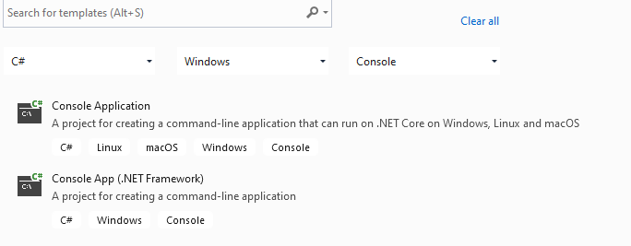
Step 1: Choose a Console App(.NET Freamework)

Step 2: Create a class that contain methods to be tested.
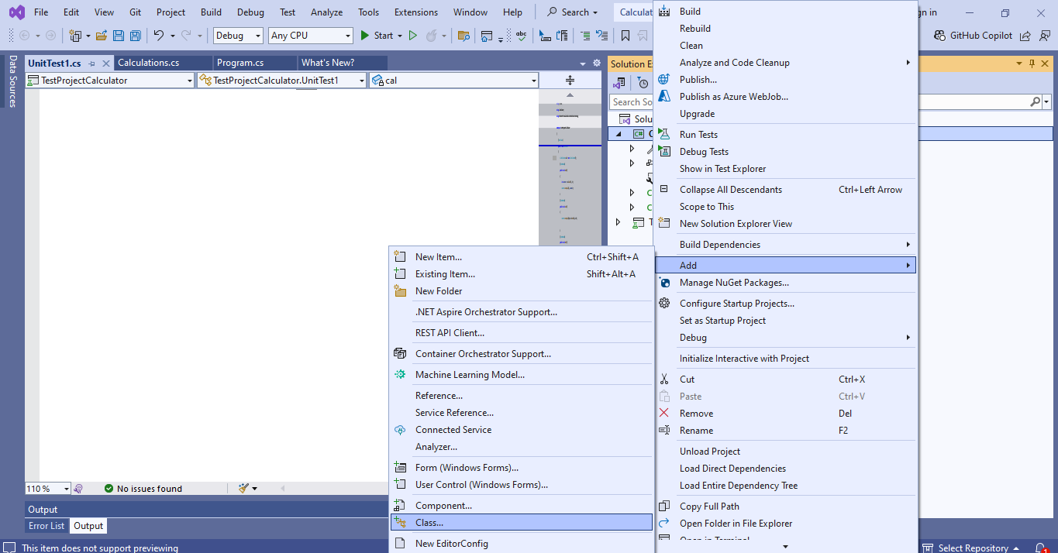

Step 3: Add necessary code
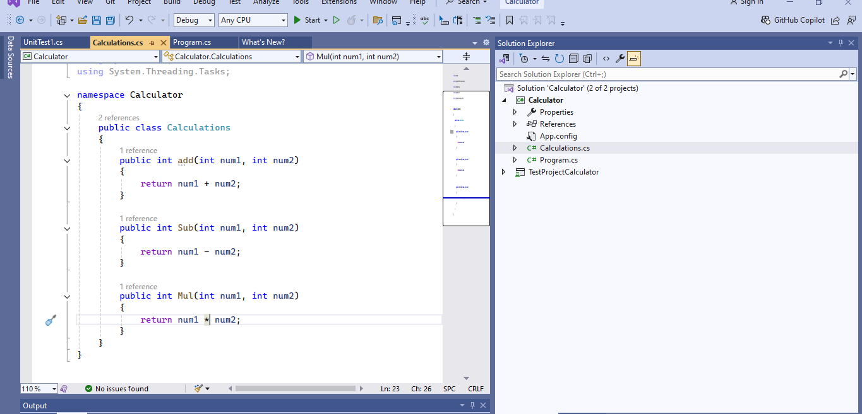

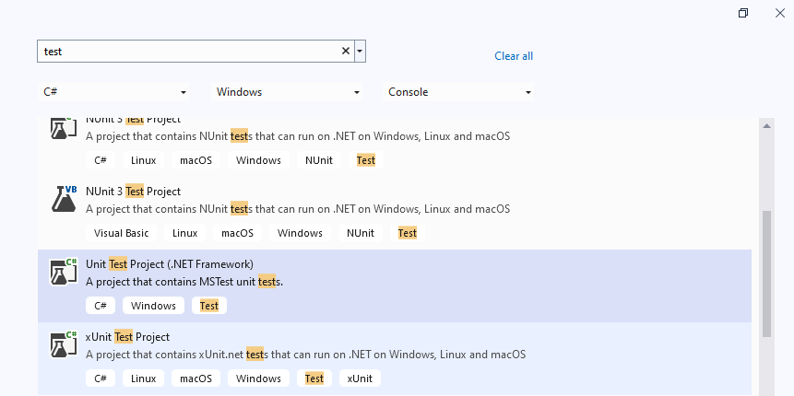
Step 4: Add new project for testing each functionality.

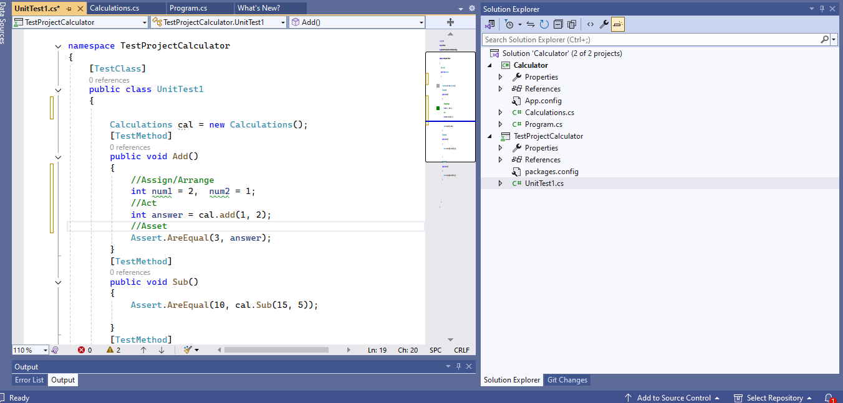
Step 5: Follow (AAA) Pattern to write test cases:

Testing Results:

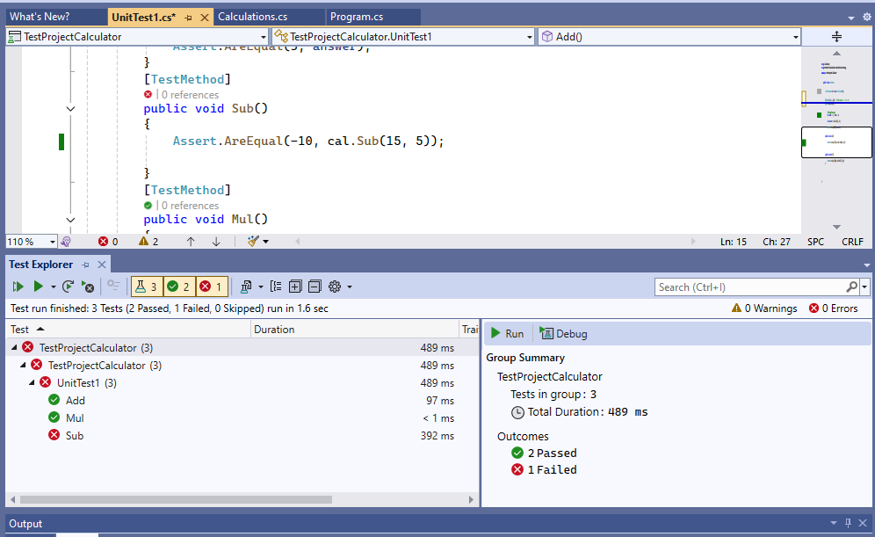

Additional Knowledge:
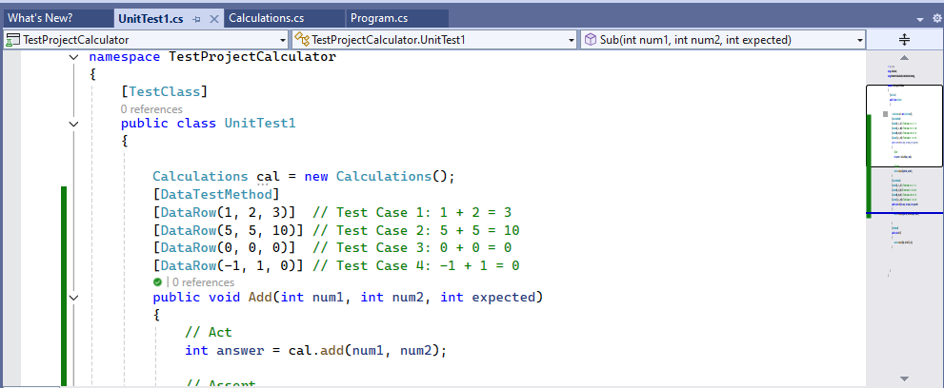
If you want to test multiple data points without duplicating code, you can use DataRow with MSTest.
Related Content:
- https://www.perfecto.io/resources/types-of-testing
- https://brightsec.com/blog/unit-testing/
- https://learn.microsoft.com/en-us/visualstudio/test/walkthrough-creating-and-running-unit-tests-for-managed-code?view=vs-2022

Tasks
- Make at-least 5 test cases for your project. Use the following template.
Example:
TEST CASE # 01
System : E-Voting System | Subsystem : Help Menu.
Designed By : Wajiha Arif | Design Date :
Executed By : Wajiha Arif | Execution Date:
Short Description : To check Help Menu.

Pre Conditions : Voter must have Username and Password.

Steps | Action | Expected System Response | Pass/fail
1 | Start E-voting system on a PC. Open the web browser and type in the web address below to be able to connect to the test server running e-voting system. | The link above opens the login page for the E-voting system. | Pass
2 | 3- Try to login to the online E-voting system.  Username : Wajiha Arif  Password : 123456 | - Username field shouldn’t accept characters more than 15.  - Password field shouldn’t accept characters more than 15. | Pass
3 | Click the button labeled “Help Menu”. | - Html help menu should open on another window. | Pass
4 | Close the Online E-voting system. | Online E-voting prototype application will be closed. | Pass

Post Condition : That must be true after successful execution of test case

- Create a login module on windows form and perform unit testing on each possibility of login functionality. [Hint: use multiple data points]
- Both fields are null
- Both fields are filled incorrectly
- One of the fields is empty
- Both fields are filled correctly
- One of the fields is filled correctly

- Scenario:
A coffee shop system processes customer orders, manages the menu (coffee and sandwiches), and handles payments. The system needs to handle the following:
- Customers place orders, choosing whether they want coffee and/or a sandwich.
- The system calculates the total cost of the order based on the selected items.
- The system processes the payment once the total is calculated.
- The system allows the menu prices (for coffee and sandwiches) to be updated.
Consider your refactored code (done in previous lab) and perform Unit testing on “Amount Calculation” Functionality of application.

Note: Don’t use any AI tool, zero will be marked in such case!

TIME BOXING:

Activity Name | Activity Time | Total Time
Instruments Allocation + Setting up Lab | 10 mints | 10 mints
Walk through Theory & Tasks (Lecture) | 60 mints | 60 mints
Implementation & Practice time | 90 mints | 80 mints
Evaluation Time | 20 mints | 20 mints
 | Total Duration | 180 mints
Teacher Signature:

Student Registration No:

