CHAPTER FOUR (CONTINUED)
POVERTY STATUS OF YAM FARMERS
4.10 Determination of the Relative Poverty Line
Table 4.6: Determination of the Relative Poverty Line among Yam-Farming Households
Measure | Value
Total number of households | 60
Total monthly household expenditure (₦) | 6,950,250.00
Mean per-capita monthly household expenditure (₦/person/month) | 20,289.03
2/3 of mean per-capita monthly expenditure — Poverty Line (₦/person/month) | 13,526.02

Table 4.6 presents the determination of the relative poverty line for the sampled yam-farming households in Akpabuyo LGA (N = 60). The total monthly expenditure across all sampled households amounted to ₦6,950,250.00. Dividing total household expenditure by household size yields a mean per-capita monthly household expenditure (PCHE) of ₦20,289.03 per person per month.
The relative poverty line was estimated at two-thirds (2/3) of the mean per-capita monthly household expenditure. Based on the mean per-capita monthly household expenditure of ₦20,289.03, the resulting poverty line was ₦13,526.02 per person per month. This relative poverty line represents the minimum monthly per-capita expenditure threshold for classifying households within the sampled farming community.
4.11 Poverty Status Distribution of Yam Farmers
Table 4.7: Poverty Status of Yam-Farming Households in Akpabuyo LGA
Poverty status | Frequency (n) | Percentage (%)
Poor | 13 | 21.67
Non-poor | 47 | 78.33
Total | 60 | 100.00

Table 4.7 presents the distribution of yam-farming households according to their poverty status based on the calculated relative poverty line of ₦13,526.02 per person per month. Households with per-capita monthly expenditure strictly below the poverty line (PCHE < ₦13,526.02) were classified as poor, while households with per-capita monthly expenditure at or above the threshold (PCHE ≥ ₦13,526.02) were classified as non-poor.
The empirical results indicate that out of the 60 sampled yam-farming households, 13 households are classified as poor, representing a poverty incidence of 21.67%. Conversely, 47 households are classified as non-poor, constituting 78.33% of the sampled population. These findings demonstrate that approximately one-fifth of the yam-farming households in Akpabuyo LGA live below the community relative poverty threshold, while the remaining four-fifths maintain monthly per-capita expenditure above the relative poverty line.
4.12 Foster–Greer–Thorbecke (FGT) Poverty Indices
Table 4.8: Foster–Greer–Thorbecke Poverty Indices among Yam-Farming Households
Poverty measure | FGT parameter (α) | Index | Percentage (%)
Poverty incidence/headcount (P0) | 0 | 0.2167 | 21.67
Poverty depth/gap (P1) | 1 | 0.0232 | 2.32
Poverty severity (P2) | 2 | 0.0034 | 0.34

Table 4.8 presents the Foster–Greer–Thorbecke (FGT) poverty indices computed across the sampled yam-farming households in Akpabuyo LGA. The FGT class of poverty measures provides quantitative estimates of poverty incidence (P0), poverty depth (P1), and poverty severity (P2).
The poverty incidence or headcount ratio (P0, α = 0) is 0.2167 (21.67%), confirming that 21.67% of the sampled households fall below the relative poverty line of ₦13,526.02.
The poverty depth or gap index (P1, α = 1) is 0.0232 (2.32%). The poverty gap index measures the average shortfall of per-capita expenditure from the poverty line expressed as a proportion of the poverty line across the entire sample. A P1 index of 0.0232 indicates that, on average, a financial transfer equivalent to 2.32% of the poverty line (or approximately ₦313.42 per person per month) across all sampled households would be required to bring all poor households exactly up to the poverty threshold, under perfect targeting.
Among poor households specifically, the mean normalized poverty gap is 0.1069 (10.69%). This supplementary descriptive measure reveals that households classified as poor incur an average expenditure shortfall of 10.69% relative to the poverty line threshold.
The poverty severity index (P2, α = 2) is 0.0034 (0.34%). By squaring the normalized poverty gaps, the P2 index places greater weight on households that experience severe expenditure shortfalls below the poverty line. A P2 index of 0.0034 reflects a relatively low level of extreme inequality among the poor population in the study area.
4.13 Graphical Representation of Poverty Status
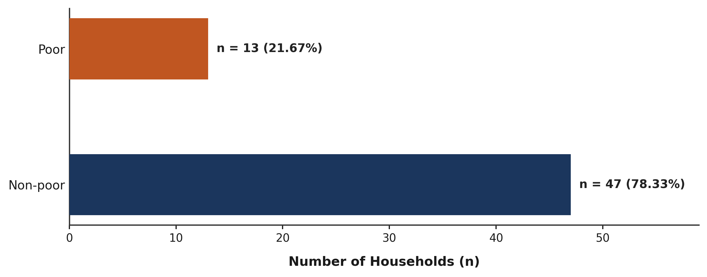
Figure 4.3: Poverty Status of Yam-Farming Households in Akpabuyo LGA
Figure 4.3 visually presents the distribution of sampled yam-farming households between the non-poor and poor status categories. The horizontal bar chart highlights the structural distribution within Akpabuyo LGA, showing that non-poor households constitute the majority (n = 47, 78.33%), while poor households account for the minority portion (n = 13, 21.67%).

