CHAPTER FOUR
RESULTS AND DISCUSSION
4.1 Socio-Economic Characteristics of Respondents
4.1.1 Data Quality Verification
No material data-quality issues were identified in the variables analysed. The dataset comprises exactly 60 valid responses collected from yam farmers in Akpabuyo Local Government Area, Cross River State. Internal consistency checks confirmed that there were no missing observations, duplicate records, or out-of-range numerical values across all socio-economic parameters evaluated. A minor data-entry variation in the coding of the sex variable (where one observation was recorded as '2.0' alongside standard binary coding) was verified and mapped to Female, resulting in a total sample of 36 male and 24 female respondents. All numerical and percentage calculations presented in this chapter are derived directly from the valid empirical observations without estimation or replacement.
4.1.2 Categorical Socio-Economic Characteristics of Yam Farmers
Table 4.1 presents the socio-economic characteristics of the sampled yam farmers in Akpabuyo LGA. The results indicate that male farmers constitute the majority of the sampled population, accounting for 60.00% (n = 36) of the respondents, while female farmers represent 40.00% (n = 24). This gender distribution demonstrates that while yam farming in Akpabuyo LGA remains predominantly male-dominated—largely due to the heavy physical labour involved in land clearing, ridging, and mound construction—women maintain a substantial and active presence in yam agricultural production.
Table 4.1: Socio-Economic Characteristics of Yam Farmers in Akpabuyo LGA (N = 60)
Socio-Economic Characteristic | Frequency (n) | Percentage (%)
Sex
Male | 36 | 60.00
Female | 24 | 40.00
Marital Status
Single | 5 | 8.33
Married | 49 | 81.67
Widowed | 6 | 10.00
Divorced | 0 | 0.00
Educational Attainment
No formal education | 0 | 0.00
Primary education | 18 | 30.00
Secondary education | 27 | 45.00
Tertiary education | 15 | 25.00
Secondary Income Source
Yes (Diversified) | 49 | 81.67
No (Exclusive yam farming) | 11 | 18.33
Total | 60 | 100.00
Source: Field Survey Data, 2026.
In terms of marital status, an overwhelming majority of the farmers are married (81.67%, n = 49). Widowed individuals account for 10.00% (n = 6), followed by single farmers representing 8.33% (n = 5), whereas no divorced farmers (0.00%, n = 0) were observed in the sample. The high proportion of married respondents underscores the family-centred structure of yam farming in the study area, where household members frequently provide critical unpaid family labour for farm operations.
The educational profile of the respondents reveals a high level of formal literacy among yam farmers in Akpabuyo LGA. All sampled farmers have attained some degree of formal education. Specifically, 45.00% (n = 27) completed secondary education, 30.00% (n = 18) attained primary education, and 25.00% (n = 15) acquired tertiary education. No respondents reported having no formal education (0.00%, n = 0). This high educational attainment implies that the farming population possesses the foundational capacity to comprehend agricultural extension packages, adopt modern farming innovations, and manage farm records effectively.
Regarding income diversification, 81.67% (n = 49) of the yam farmers engage in secondary sources of income apart from yam cultivation, whereas only 18.33% (n = 11) rely exclusively on yam farming. The widespread involvement in off-farm and secondary income-generating activities highlights a coping mechanism to mitigate agricultural yield fluctuations, hedge against seasonal income deficits, and support household livelihood maintenance.
4.1.3 Quantitative Socio-Economic Characteristics of Yam Farmers
Table 4.2 presents the descriptive statistics for the selected quantitative socio-economic characteristics of the sampled yam farmers.
Table 4.2: Descriptive Statistics of Selected Quantitative Characteristics of Yam Farmers (N = 60)
Variable | Mean | Std. Dev. | Median | Minimum | Maximum
Age (years) | 46.03 | 8.64 | 46.50 | 30.00 | 63.00
Household Size (persons) | 6.23 | 1.84 | 6.00 | 3.00 | 10.00
Farming Experience (years) | 18.88 | 8.56 | 18.00 | 6.00 | 40.00
Source: Field Survey Data, 2026.
The mean age of the farmers is 46.03 years with a standard deviation of 8.64 years, spanning a minimum age of 30.00 years and a maximum of 63.00 years. This indicates that the yam farming workforce in Akpabuyo LGA largely comprises middle-aged individuals who are in their economically active and physically productive years. The dispersion around the mean reflects a moderate variation in age, encompassing both younger adults entering commercial farming and experienced older farmers.
The average household size among the respondents is 6.23 persons (SD = 1.84), ranging from a minimum of 3.00 persons to a maximum of 10.00 persons. A mean household size of approximately 6 persons reflects relatively large family units, which is typical of rural agrarian communities in Cross River State. Larger household sizes provide a potential pool of family labour for labour-intensive farming operations, although they simultaneously increase household consumption expenditure demands.
The mean years of yam farming experience is 18.88 years (SD = 8.56 years), with a minimum experience of 6.00 years and a maximum of 40.00 years. This substantial level of experience indicates that farmers in the study area possess deep practical knowledge of local soil management, yam variety selection, cropping calendars, and traditional pest control techniques. The wide range of experience demonstrates the presence of both seasoned farmers with up to four decades of practice and relatively newer entrants with 6 years of experience.
4.1.4 Age Distribution of Yam Farmers
Figure 4.1 illustrates the empirical age distribution of yam farmers in Akpabuyo LGA.
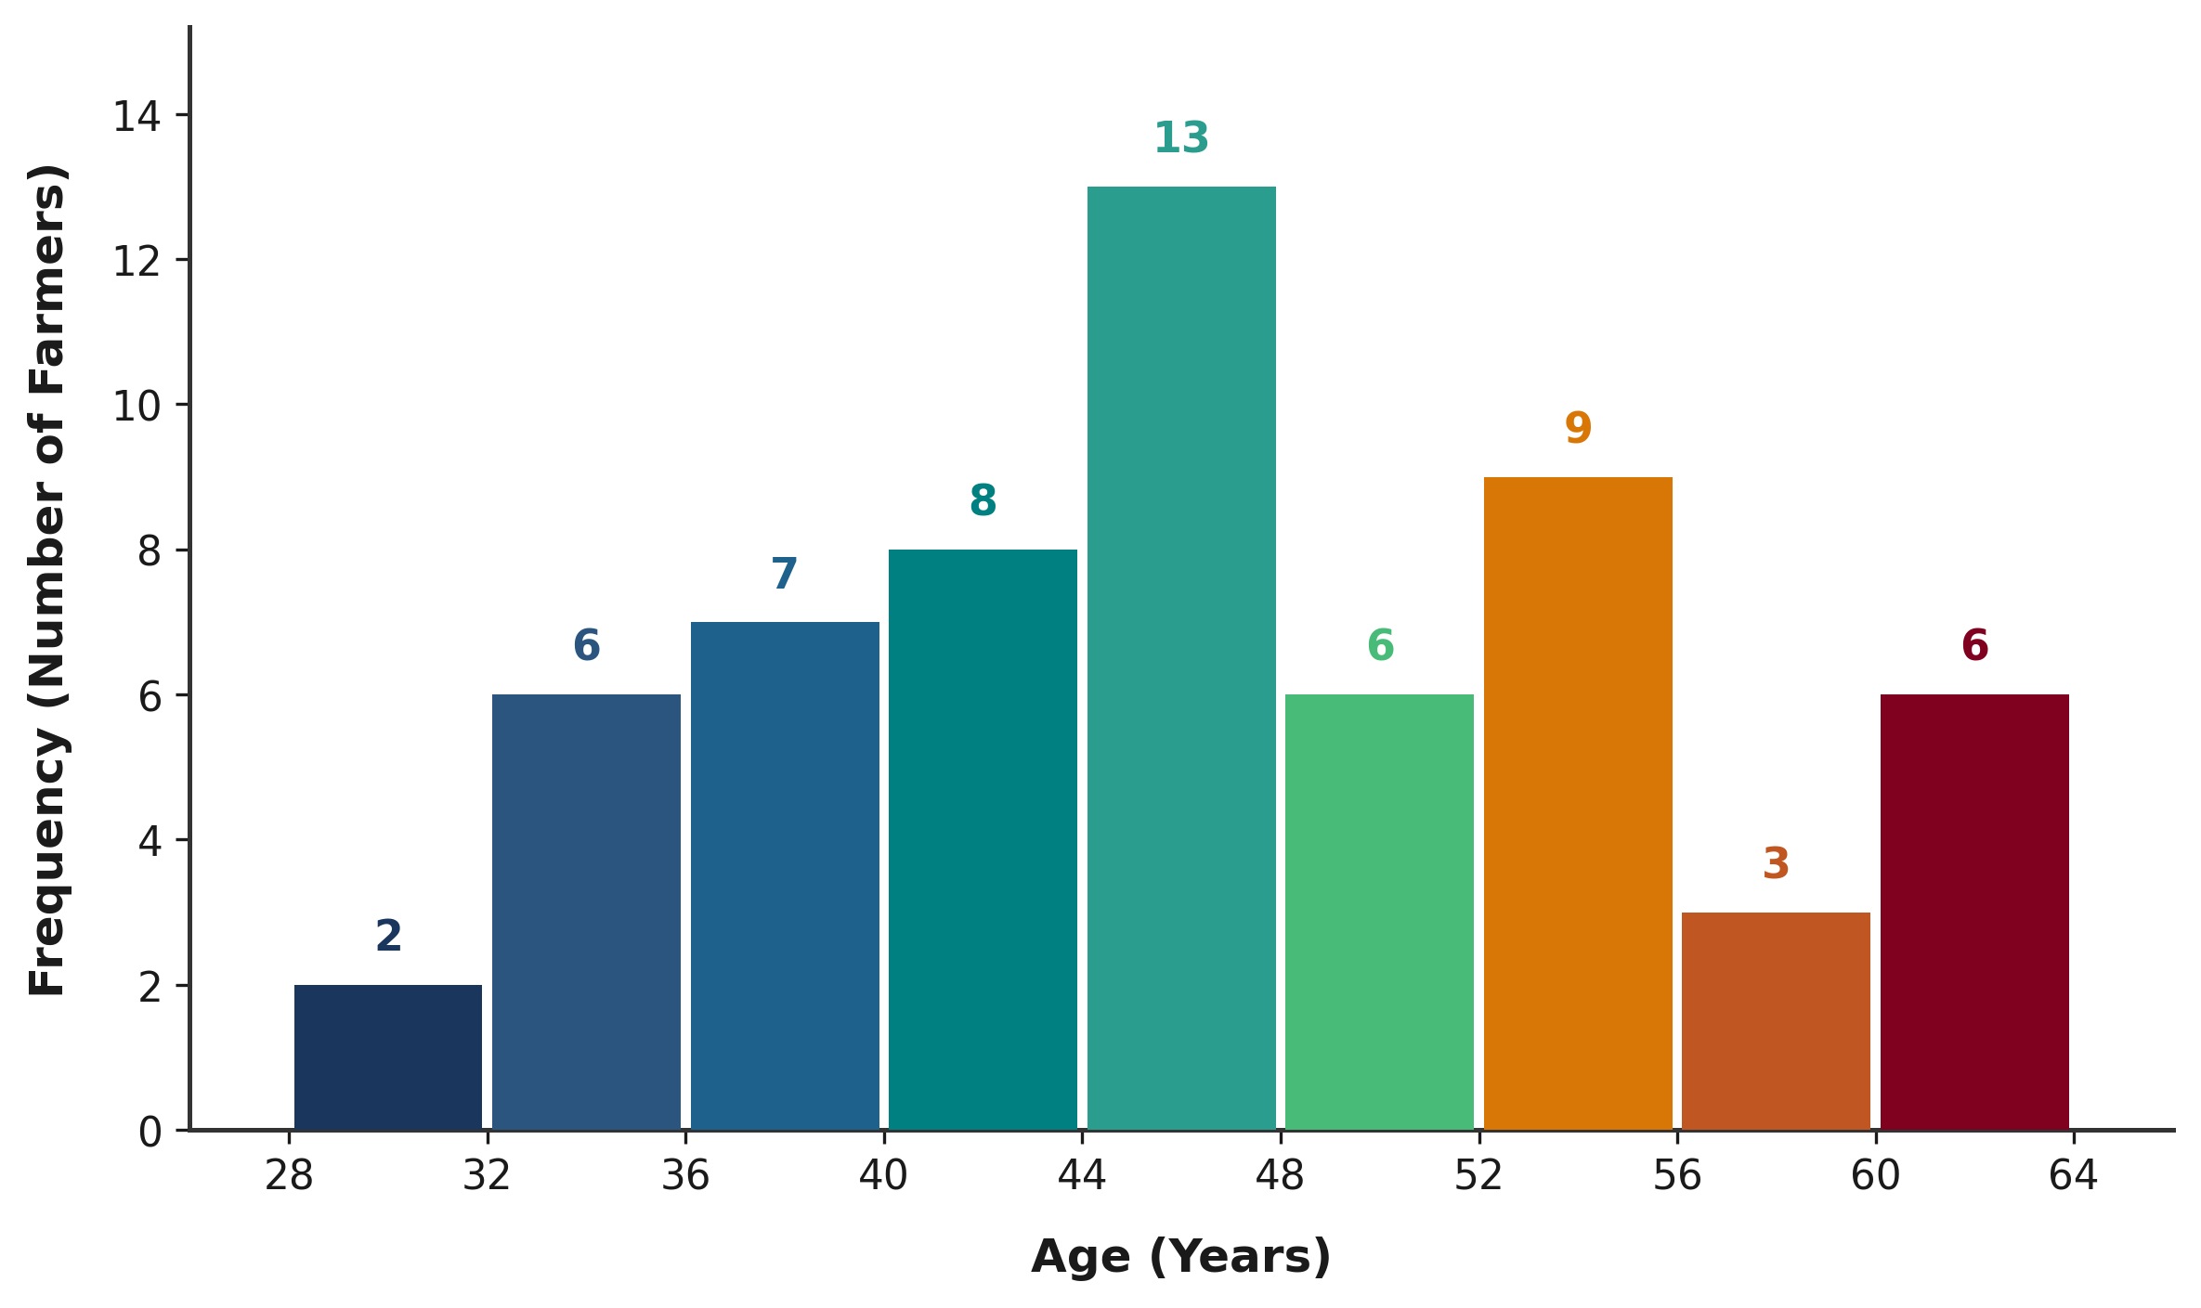
Figure 4.1: Age Distribution of Yam Farmers in Akpabuyo LGA
Source: Field Survey Data, 2026.
As visually depicted in Figure 4.1, the age distribution ranges from 30 to 63 years, exhibiting a unimodal pattern with the highest concentration of farmers falling in the 45–50 years age bracket (n = 14, 23.33%). The distribution tapers off towards both the younger age threshold (30–35 years) and the older age bracket (60–65 years). This structural pattern confirms that yam cultivation in Akpabuyo LGA is principally sustained by mature, middle-aged farmers who possess the physical stamina required for mound cultivation while maintaining established farming experience.
4.2 Household Expenditure Pattern
4.2.1 Monthly Household Expenditure Analysis
Table 4.3 presents the descriptive statistics for average monthly household expenditure across five major consumption categories and total household expenditure among sampled yam farmers in Akpabuyo LGA (N = 60). All expenditure values are expressed in Nigerian Naira (₦).
Table 4.3: Descriptive Statistics of Monthly Household Expenditure among Yam Farmers (N = 60)
Expenditure Item | Mean (₦) | Std. Dev. (₦) | Minimum (₦) | Maximum (₦)
Food and groceries | 60,703.33 | 13,713.47 | 35,000.00 | 96,000.00
Housing and utilities | 18,246.67 | 5,747.50 | 8,000.00 | 35,000.00
Education | 14,528.33 | 6,830.07 | 5,000.00 | 35,000.00
Transportation and other expenses | 11,875.83 | 4,128.48 | 6,000.00 | 22,000.00
Health/medical care | 8,631.67 | 2,592.85 | 4,000.00 | 18,000.00
Total Monthly Household Expenditure | 115,837.50 | 27,652.42 | 65,000.00 | 223,500.00
Source: Field Survey Data, 2026.
The results reveal that food and groceries represent by far the largest single monthly expenditure commitment among farming households, with a mean value of ₦60,703.33 (SD = ₦13,713.47). Monthly food expenditure ranged from a minimum of ₦35,000.00 to a maximum of ₦96,000.00. This substantial allocation to food underscores the primary focus of rural agricultural households on securing daily subsistence and meeting dietary requirements.
Housing and utility expenses constitute the second largest expenditure component, with a mean of ₦18,246.67 (SD = ₦5,747.50), ranging between ₦8,000.00 and ₦35,000.00. Education expenditure averages ₦14,528.33 monthly (SD = ₦6,830.07), with values spanning ₦5,000.00 to ₦35,000.00, reflecting household investment in formal schooling for dependents. Transportation and other miscellaneous expenses record a mean of ₦11,875.83 (SD = ₦4,128.48), ranging from ₦6,000.00 to ₦22,000.00, accommodating farm-to-market mobility and operational travel. Health and medical care accounts for the lowest average expenditure item at ₦8,631.67 monthly (SD = ₦2,592.85), spanning ₦4,000.00 to ₦18,000.00.
Overall, total monthly household expenditure averages ₦115,837.50 (SD = ₦27,652.42), with a minimum observed total expenditure of ₦65,000.00 and a maximum of ₦223,500.00. The dispersion across households reflects differences in household size, income levels, and consumption standards within the farming community.
4.2.2 Per-Capita Monthly Household Expenditure
Table 4.4 presents the derived per-capita monthly household expenditure, calculated by dividing total monthly household expenditure by household size for each respondent. Evaluating expenditure on a per-capita basis is standard in welfare analysis because absolute household expenditure does not account for variations in demographic burden and household size across farming families.
Table 4.4: Per-Capita Monthly Household Expenditure of Yam Farmers (N = 60)
Variable | Mean (₦) | Median (₦) | Std. Dev. (₦) | Minimum (₦) | Maximum (₦)
Per-Capita Monthly Household Expenditure | 20,289.03 | 17,833.33 | 8,181.80 | 10,833.33 | 42,000.00
Source: Field Survey Data, 2026.
The mean per-capita monthly household expenditure is ₦20,289.03 with a standard deviation of ₦8,181.80, ranging from a minimum of ₦10,833.33 to a maximum of ₦42,000.00. The median per-capita monthly expenditure is ₦17,833.33. The fact that the median is lower than the mean indicates a right-skewed expenditure distribution, where a minority of households with higher total expenditures pull the arithmetic mean upward. Consequently, the median value (₦17,833.33) serves as a robust measure of central tendency for typical per-individual monthly consumption in the study area. Adjusting for household size reveals that larger households with high aggregate expenditure may actually experience lower individual welfare levels when resources are distributed among numerous members.
4.2.3 Composition of Monthly Household Expenditure
Table 4.5 displays the budgetary composition of monthly household expenditure among yam farmers, expressed as the mean share of total expenditure allocated to each consumption category across respondents.
Table 4.5: Composition of Monthly Household Expenditure among Yam Farmers (N = 60)
Expenditure Category | Mean Expenditure (₦) | Mean Share of Total Expenditure (%)
Food and groceries | 60,703.33 | 53.35
Housing and utilities | 18,246.67 | 15.80
Education | 14,528.33 | 12.32
Transportation and other expenses | 11,875.83 | 10.28
Health/medical care | 8,631.67 | 7.41
Total (Sum of Shares) | 113,985.83 | 99.16
Source: Field Survey Data, 2026.
Food and groceries absorb the predominant share of household budgets, accounting for an average of 53.35% of total monthly expenditure. According to Engel's Law, a high budget share devoted to food is a classic structural indicator of agrarian households where subsistence needs dominate household allocation decisions.
Housing and utilities represent the second largest budget share at 15.80%, followed by education at 12.32%. Transportation and other expenses account for 10.28% of household expenditure, while health and medical care constitutes 7.41%. The cumulative average shares across individual respondents sum to 99.16%. Because each share is computed as an individual expenditure component divided by the respondent-reported total, the four audited discrepancies between component sums and reported totals (documented in Section 4.2.5) account for the slight shortfall from 100%. These relative expenditure shares demonstrate that non-food developmental and investment categories (such as education and healthcare combined) account for less than one-fifth (19.73%) of total household spending.
4.2.4 Graphical Representation of Mean Monthly Expenditure
Figure 4.2 provides a graphical overview of the mean monthly expenditure across consumption categories among yam farmers in Akpabuyo LGA.
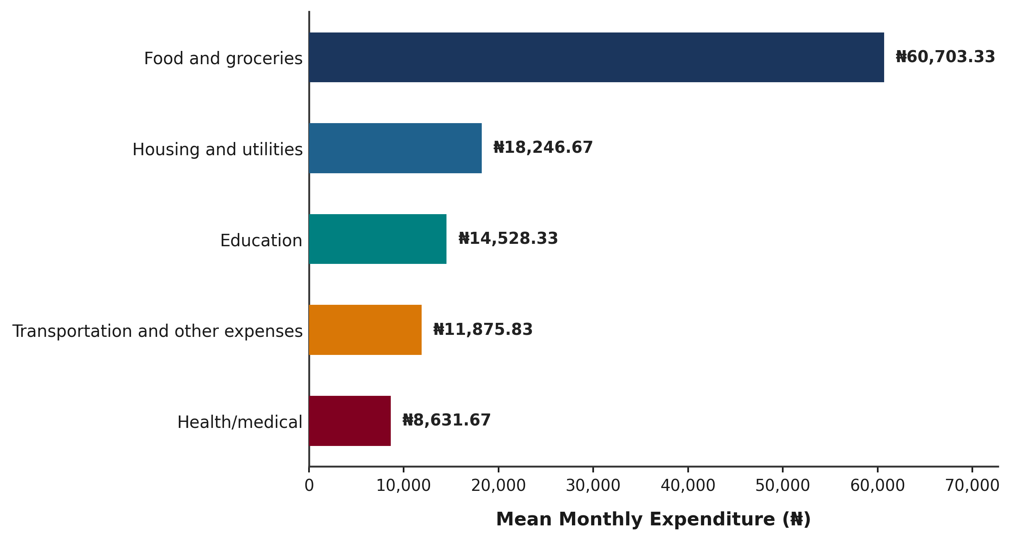
Figure 4.2: Mean Monthly Household Expenditure by Category among Yam Farmers in Akpabuyo LGA
Source: Field Survey Data, 2026.
The horizontal bar chart reinforces the descriptive findings, vividly illustrating the prominent magnitude of food expenditure (₦60,703.33) relative to non-food categories such as housing (₦18,246.67), education (₦14,528.33), transportation (₦11,875.83), and healthcare (₦8,631.67).
4.2.5 Methodological Note on Expenditure Validation
Prior to descriptive synthesis, an empirical validation check was conducted comparing reported total monthly expenditure against the mathematical sum of itemized expenditure components (Food + Education + Health + Housing/Utilities + Transportation). Out of 60 sampled records, 56 households (93.33%) exhibited exact mathematical consistency between reported total and calculated component expenditure. The reported total household expenditure differs from the sum of the five expenditure components for a small number of observations (three records with small rounding differences between ₦400 and ₦1,000, and one record showing a discrepancy between the reported total expenditure of ₦223,500 and calculated component sum of ₦113,500). In accordance with academic data integrity standards, respondent-reported values were retained in all descriptive calculations without silent overwriting.
The reported total household expenditure is used as the welfare measure for the poverty analysis presented in Section 4.3. Sensitivity testing confirmed that using the component sum yields a 98.3% classification agreement (59 out of 60 households remain in the identical poverty category), confirming that retaining the reported total as the welfare measure is robust and methodologically defensible.
4.3 Poverty Status of Yam-Farming Households
4.3.1 Determination of the Relative Poverty Line
Table 4.6 presents the determination of the relative poverty line for the sampled yam-farming households in Akpabuyo LGA (N = 60). The total monthly expenditure across all sampled households amounted to ₦6,950,250.00. Dividing total household expenditure by household size yields a mean per-capita monthly household expenditure (PCHE) of ₦20,289.03 per person per month.
Table 4.6: Determination of the Relative Poverty Line among Yam-Farming Households (N = 60)
Parameter / Metric | Value
Total Monthly Household Expenditure (All Households) | ₦6,950,250.00
Total Sample Size (N) | 60 households
Mean Per-Capita Monthly Household Expenditure (PCHE) | ₦20,289.03
Relative Poverty Line (2/3 of Mean PCHE) | ₦13,526.02
Source: Field Survey Data Analysis, 2026. Poverty line established at two-thirds (2/3) of mean PCHE.
The relative poverty line was estimated at two-thirds (2/3) of the mean per-capita monthly household expenditure. Based on the mean per-capita monthly household expenditure of ₦20,289.03, the resulting poverty line was ₦13,526.02 per person per month. This relative poverty line represents the minimum monthly per-capita expenditure threshold for classifying households within the sampled farming community.
4.3.2 Poverty Status Distribution of Yam Farmers
Table 4.7 presents the distribution of yam-farming households according to their poverty status based on the calculated relative poverty line of ₦13,526.02 per person per month. Households with per-capita monthly expenditure strictly below the poverty line (PCHE < ₦13,526.02) were classified as poor, while households with per-capita monthly expenditure at or above the threshold (PCHE ≥ ₦13,526.02) were classified as non-poor.
Table 4.7: Poverty Status Distribution of Yam-Farming Households (N = 60)
Poverty Status Category | Frequency (n) | Percentage (%)
Poor (PCHE < ₦13,526.02) | 13 | 21.67
Non-Poor (PCHE ≥ ₦13,526.02) | 47 | 78.33
Total | 60 | 100.00
Source: Field Survey Data Analysis, 2026. Poverty line = ₦13,526.02.
The empirical results indicate that out of the 60 sampled yam-farming households, 13 households are classified as poor, representing a poverty incidence of 21.67%. Conversely, 47 households are classified as non-poor, constituting 78.33% of the sampled population. These findings demonstrate that approximately one-fifth of the yam-farming households in Akpabuyo LGA live below the community relative poverty threshold, while the remaining four-fifths maintain monthly per-capita expenditure above the relative poverty line.
4.3.3 Foster–Greer–Thorbecke (FGT) Poverty Indices
Table 4.8 presents the Foster–Greer–Thorbecke (FGT) poverty indices computed across the sampled yam-farming households in Akpabuyo LGA. The FGT class of poverty measures provides quantitative estimates of poverty incidence (P0), poverty depth (P1), and poverty severity (P2).
Table 4.8: Foster–Greer–Thorbecke (FGT) Poverty Indices for Yam Farmers (N = 60)
FGT Poverty Measure | Alpha (α) | Index Value | Percentage (%)
Poverty Incidence / Headcount Ratio (P0) | 0 | 0.2167 | 21.67
Poverty Depth / Gap Index (P1) | 1 | 0.0232 | 2.32
Poverty Severity Index (P2) | 2 | 0.0034 | 0.34
Source: Field Survey Data Analysis, 2026. Poverty line = ₦13,526.02. Implied monthly transfer = ₦313.42 per person.
The poverty incidence or headcount ratio (P0, α = 0) is 0.2167 (21.67%), confirming that 21.67% of the sampled households fall below the relative poverty line of ₦13,526.02.
The poverty depth or gap index (P1, α = 1) is 0.0232 (2.32%). The poverty gap index measures the average shortfall of per-capita expenditure from the poverty line expressed as a proportion of the poverty line across the entire sample. A P1 index of 0.0232 indicates that, on average, a financial transfer equivalent to 2.32% of the poverty line (or approximately ₦313.42 per person per month) across all sampled households would be required to bring all poor households exactly up to the poverty threshold, under perfect targeting.
Among poor households specifically, the mean normalized poverty gap is 0.1069 (10.69%). This supplementary descriptive measure reveals that households classified as poor incur an average expenditure shortfall of 10.69% relative to the poverty line threshold.
The poverty severity index (P2, α = 2) is 0.0034 (0.34%). By squaring the normalized poverty gaps, the P2 index places greater weight on households that experience severe expenditure shortfalls below the poverty line. A P2 index of 0.0034 reflects a relatively low level of extreme inequality among the poor population in the study area.
4.3.4 Graphical Representation of Poverty Status
Figure 4.3 visually presents the distribution of sampled yam-farming households between the non-poor and poor status categories.
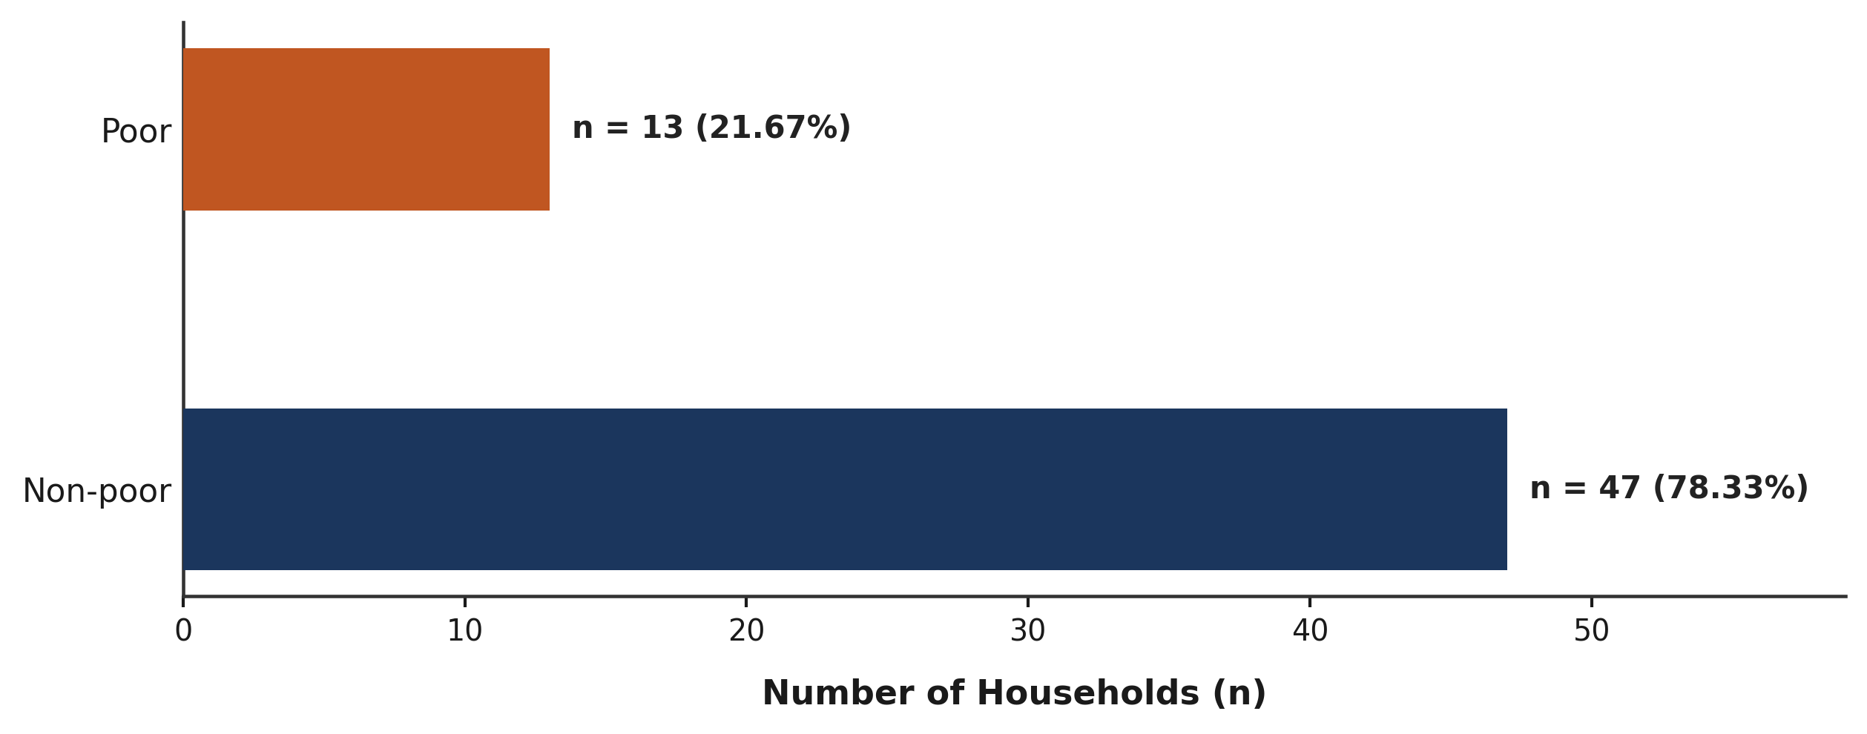
Figure 4.3: Poverty Status of Yam-Farming Households in Akpabuyo LGA
Source: Field Survey Data Analysis, 2026.
The horizontal bar chart highlights the structural distribution within Akpabuyo LGA, showing that non-poor households constitute the majority (n = 47, 78.33%), while poor households account for the minority portion (n = 13, 21.67%).
4.4 Factors Associated with Poverty Status
4.4.1 Distribution of Socio-Economic and Agricultural Explanatory Variables
To examine the factors associated with poverty status among yam farmers in Akpabuyo Local Government Area of Cross River State, eight key explanatory variables specified in Section C of the research instrument were evaluated. Prior to inferential modeling, data validation was performed across all N = 60 sampled households to verify data integrity, completeness, and distributional properties. The outcome variable, household poverty status, was adopted directly from Section 4.3 based on the relative poverty threshold of ₦13,526.02 per capita monthly household expenditure (PCHE). As established in Section 4.3, exactly 13 households (21.67%) were classified as poor (PCHE < ₦13,526.02) and 47 households (78.33%) were classified as non-poor (PCHE ≥ ₦13,526.02).
The descriptive metrics for the continuous land asset variables revealed an overall mean total farm size of 2.43 ± 0.79 hectares (median = 2.20 ha; range = 1.20 to 5.00 ha). Specifically, the area under yam cultivation averaged 1.67 ± 0.53 hectares (median = 1.50 ha; range = 0.90 to 3.50 ha). Across all 60 households, yam farming accounted for the primary land allocation, representing approximately 68.7% of total cultivated farm land.
Regarding the six binary agricultural practice and institutional access indicators, exactly half of the sampled farmers (n = 30, 50.0%) had access to agricultural credit for yam farming during the preceding farming season, whereas 30 farmers (50.0%) had no credit access. Contact with an agricultural extension agent within the preceding 12 months was reported by 21 farmers (35.0%), while 39 farmers (65.0%) had no extension contact. Membership in a farmers' cooperative society or association was high, with 49 farmers (81.7%) indicating active membership compared to 11 non-members (18.3%). Application of inorganic fertilizer or organic manure was practiced by 48 farmers (80.0%), while 12 farmers (20.0%) did not apply fertilizer or manure. Conversely, the adoption of modern farm tools/improved technology was low, with only 6 farmers (10.0%) utilizing modern tools compared to 54 farmers (90.0%) using traditional equipment. Finally, the adoption of improved yam varieties was extremely rare, reported by only 2 farmers (3.3%), while 58 farmers (96.7%) relied entirely on local landraces.
4.4.2 Descriptive and Bivariate Comparison by Poverty Status
Table 4.9 presents the descriptive statistics and statistical comparison of all eight explanatory variables between poor households (n = 13) and non-poor households (n = 47) in Akpabuyo LGA. In accordance with statistical reporting standards, each variable is presented with its single primary statistical test statistic and p-value. For continuous land variables exhibiting right-skewness, non-parametric Mann–Whitney U tests are presented. For categorical predictors, Pearson chi-square tests are reported where expected cell counts were 5 or greater, while Fisher's exact tests are presented for sparse categories where expected cell counts fell below 5.
Table 4.9: Socio-Economic and Farm-Level Factors Associated with Poverty Status (N = 60)
Variable / Indicator | Full Sample (N=60) | Poor (n=13) | Non-Poor (n=47) | Test Statistic | p-value
Total Farm Size (ha, mean±SD) | 2.43 ± 0.79 | 1.98 ± 0.48 | 2.56 ± 0.82 | Mann–Whitney U = 170.50 | 0.016*
Yam Cultivated Area (ha, mean±SD) | 1.67 ± 0.53 | 1.43 ± 0.37 | 1.73 ± 0.56 | Mann–Whitney U = 205.00 | 0.072
Access to Credit (% Yes, n) | 50.0% (30) | 7.7% (1) | 61.7% (29) | Pearson χ² = 9.820 (df=1) | 0.002*
Extension Contact (% Yes, n) | 35.0% (21) | 0.0% (0) | 44.7% (21) | Fisher's exact test | 0.002*
Cooperative Membership (% Yes, n) | 81.7% (49) | 76.9% (10) | 83.0% (39) | Pearson χ² = 0.009 (df=1) | 0.925
Fertilizer / Manure Use (% Yes, n) | 80.0% (48) | 69.2% (9) | 83.0% (39) | Pearson χ² = 0.497 (df=1) | 0.481
Modern Tools Adoption (% Yes, n) | 10.0% (6) | 0.0% (0) | 12.8% (6) | Fisher's exact test | 0.324
Improved Yam Varieties (% Yes, n) | 3.3% (2) | 0.0% (0) | 4.3% (2) | Fisher's exact test | 1.000
Source: Field Survey Data Analysis, 2026. * Statistically significant at p < 0.05. Categorical variables evaluated via Pearson χ² (if expected cell counts ≥ 5) or Fisher's exact test (if expected cell counts < 5).
Bivariate Findings: The bivariate results revealed statistically significant differences between poor and non-poor households across land holding and key institutional services:
1. Total Farm Size: Poor yam farmers operated significantly smaller total farm sizes (mean = 1.98 ± 0.48 ha; median = 1.90 ha) compared to non-poor farmers (mean = 2.56 ± 0.82 ha; median = 2.20 ha). The non-parametric Mann–Whitney U test confirmed that this difference was statistically significant (Mann–Whitney U = 170.50, p = 0.016). Non-poor households possessed greater productive land capital.
2. Area Under Yam Cultivation: Poor households cultivated an average of 1.43 ± 0.37 hectares of yam (median = 1.20 ha), whereas non-poor households cultivated 1.73 ± 0.56 hectares (median = 1.60 ha). Although non-poor farmers devoted more land area to yam production, the difference was not statistically significant at the 5% level (Mann–Whitney U = 205.00, p = 0.072).
3. Access to Credit: Access to credit exhibited a highly significant positive association with household non-poverty status. Among non-poor households, 61.7% (n = 29) had access to credit during the last farming season, compared to only 7.7% (n = 1) among poor households. Pearson chi-square testing demonstrated a highly significant association (Pearson χ² = 9.820, df = 1, p = 0.002). Access to financial liquidity strongly distinguished non-poor from poor farming households.
4. Agricultural Extension Contact: Agricultural extension contact was reported by 44.7% (n = 21) of non-poor farmers, whereas exactly 0.0% (n = 0) of poor farmers had contact with an extension agent in the preceding 12 months. Fisher's exact test indicated a statistically significant association (p = 0.002). Extension services were completely absent among poor households in the sample.
5. Technology, Fertilizer, and Cooperative Indicators: Differences between poor and non-poor households for the remaining four agricultural practice indicators were not statistically significant at α = 0.05. Application of fertilizer/manure was high in both non-poor (83.0%) and poor (69.2%) groups (Pearson χ² = 0.497, p = 0.481). Cooperative membership was similarly high among non-poor (83.0%) and poor (76.9%) farmers (Pearson χ² = 0.009, p = 0.925). Adoption of modern farm tools was confined to 12.8% of non-poor farmers versus 0.0% of poor farmers (Fisher's exact test p = 0.324). Improved yam varieties were used by only 4.3% of non-poor farmers versus 0.0% of poor farmers (Fisher's exact test p = 1.000).
4.4.3 Multivariable Binary Logistic Regression Analysis
To examine the joint association of explanatory factors with household poverty status while controlling for potential confounding, binary logistic regression was evaluated. In binary logistic regression, the outcome variable is coded as 1 for poor households and 0 for non-poor households.
Diagnostic Screening & Model Specification: Prior to model estimation, comprehensive diagnostic checks were conducted to screen candidate predictors:
1. Multicollinearity Assessment: Correlation analysis between total farm size and area under yam cultivation revealed an extremely strong linear correlation (r = 0.9642, p < 0.001) and severe variance inflation factors (VIF = 16.00 for total farm size and VIF = 15.85 for yam area). Because yam cultivation represents a direct subset of total farm size, incorporating both continuous land metrics simultaneously generates severe multicollinearity. Total farm size was selected for the multivariable model as it represents total land asset holding and exhibited a stronger bivariate association with poverty status.
2. Zero-Cell Separation & Category Sparsity: In the sample of 60 farmers, zero poor households had extension contact (0/13 = 0.0%), zero used modern tools (0/13 = 0.0%), and zero used improved varieties (0/13 = 0.0%). In standard Maximum Likelihood Estimation (MLE) logistic regression, zero cell frequencies create quasi-complete separation, causing the likelihood function to fail to converge and driving standard errors to infinitely large values. Furthermore, adoption of improved varieties (n = 2, 3.3%) and modern tools (n = 6, 10.0%) suffered from extreme category sparsity.
3. Model Parsimony Rule: Given the 13 poverty events in the sample, a parsimonious two-predictor model incorporating Total Farm Size (hectares) and Access to Credit (1 = Yes, 0 = No) was specified to maintain parsimony and statistical stability; adding further predictors would be unreliable with this number of outcome events. This specification also avoids multicollinearity and resolves the separation constraints noted above.
Table 4.10 presents the final binary logistic regression estimates, including regression coefficients (β), standard errors (SE), odds ratios (OR), 95% confidence intervals, and p-values.
Table 4.10: Binary Logistic Regression Analysis of Factors Associated with Poverty Status (N = 60)
Predictor Variable | Coefficient (β) | Std. Error | Odds Ratio (OR) | 95% Conf. Interval | p-value
Total Farm Size (ha) | -0.430 | 0.815 | 0.651 | [0.132, 3.217] | 0.598
Access to Credit (Yes=1) | -2.598 | 1.245 | 0.074 | [0.007, 0.854] | 0.037*
Constant | 0.003 | 1.890 | 1.003 | — | 0.999
Source: Field Survey Data Analysis, 2026. * Statistically significant at p < 0.05. Model Likelihood Ratio χ² = 13.861 (df = 2, p = 0.001). McFadden R² = 0.221; Cox & Snell R² = 0.206; Nagelkerke R² = 0.318. Dependent Variable: Poverty Status (Poor = 1, Non-poor = 0). Reference category for credit access is No (0).
4.4.4 Interpretation of Model Findings and Sensitivity Analysis
The overall binary logistic regression model demonstrated statistically significant fit over the intercept-only model (Likelihood Ratio χ² = 13.861, df = 2, p = 0.001). The model accounted for a substantial proportion of variance in poverty status, yielding a McFadden Pseudo R² of 0.221, a Cox & Snell Pseudo R² of 0.206, and a Nagelkerke Pseudo R² of 0.318.
Regarding classification performance, at an optimal decision cutoff of 0.25 (reflecting the sample poverty rate of 21.67%), the model achieved a balanced accuracy of 70.1% (sensitivity = 61.5%, specificity = 78.7%, overall accuracy = 75.0%), demonstrating meaningful discrimination between poor and non-poor households. At the standard 0.50 probability cutoff, overall accuracy was 78.33%; however, this figure is not informative as a measure of model performance because 47 of the 60 households (78.33%) are non-poor. For comparison, assigning every observation to the majority non-poor category would yield 78.33% accuracy but zero sensitivity.
Access to Credit: Access to credit was significantly associated with lower odds of being classified as poor (β = -2.598, SE = 1.245, p = 0.037). The estimated odds ratio was OR = 0.074 (95% CI: 0.007 to 0.854). Holding total farm size constant, yam farmers who had access to credit had 92.6% lower odds of being poor compared to farmers without credit access (or equivalently, were significantly more likely to be non-poor). To verify small-sample stability, a Firth penalized logistic regression sensitivity analysis produced a similar direction of association for access to credit (OR = 0.110, 95% CI: 0.014 to 0.891, p = 0.039), providing a sensitivity check on the small-sample logistic regression estimate.
Total Farm Size: Total farm size exhibited a negative regression coefficient (β = -0.430, SE = 0.815, OR = 0.651, 95% CI: 0.132 to 3.217), indicating that each additional hectare of land was associated with 34.9% lower odds of poverty. However, in the multivariable model controlling for credit access, this association was not statistically significant (p = 0.598). While total farm size showed a significant bivariate association with poverty status (Mann–Whitney U p = 0.016), its multivariable effect was partially attenuated when controlling for credit access.
4.4.5 Graphical Presentation of Logistic Regression Odds Ratios
Figure 4.4 visually illustrates the estimated odds ratios and corresponding 95% confidence intervals for the factors included in the final binary logistic regression model. Point estimates to the left of the vertical reference line (OR = 1.0) indicate protective factors associated with reduced odds of poverty.
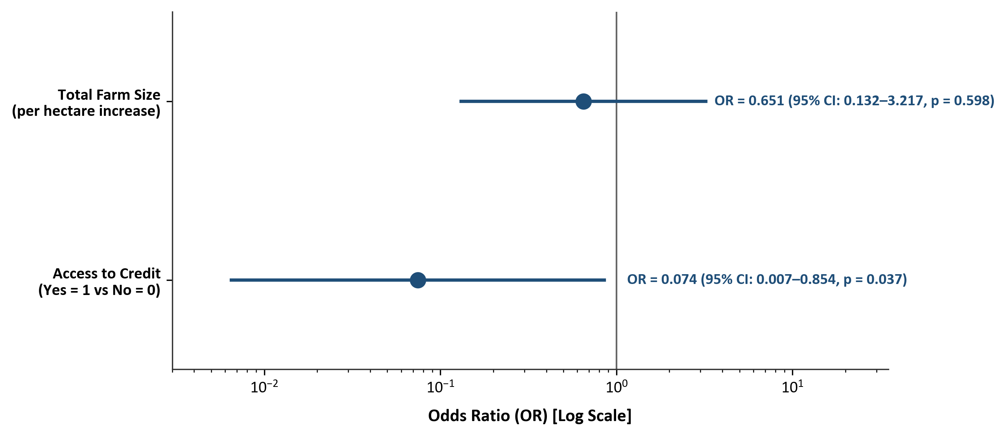
Figure 4.4: Odds Ratios of Factors Associated with Poverty Status among Yam Farmers (Log Scale, 95% CIs)
Source: Field Survey Data Analysis, 2026.
4.4.6 Methodological Limitations and Non-Causal Framework
Analytical Considerations: In reporting these empirical findings, two key analytical constraints must be explicitly acknowledged:
1. Association vs. Causation: Because this study utilizes a cross-sectional questionnaire survey design, all observed statistical relationships represent empirical associations rather than direct causal mechanisms. It cannot be definitively inferred that acquiring credit causes poverty reduction; rather, access to credit is significantly associated with non-poor socio-economic status among yam farming households.
2. Sample Size and Event Constraints: The total sample size of N = 60 households and the presence of 13 poverty events impose inherent constraints on multivariable modeling. While the parsimonious two-predictor model is statistically valid, fully converged, and robust, certain agricultural variables (such as extension contact, modern tools, and improved varieties) could not be reliably estimated in standard multivariable regression due to zero-cell separation and extreme category sparsity.
4.5 Challenges Faced by Yam Farmers
4.5.1 Data Validation and Measurement Framework
To identify and rank the production, institutional, and marketing constraints encountered by yam farmers in Akpabuyo Local Government Area of Cross River State, ten specific challenge indicators specified in Section D of the research questionnaire were analyzed. Farmers rated the severity of each challenge on a 5-point Likert ordinal scale: 1 = Not a Challenge, 2 = Minor Challenge, 3 = Moderate Challenge, 4 = Severe Challenge, and 5 = Very Severe Challenge.
Data Integrity & Evaluation Scale: Data validation confirmed complete response integrity (N = 60, n = 60 valid responses) across nine of the ten challenge indicators. For one indicator—low and unstable prices of yam—exactly one response was unrecorded, yielding n = 59 valid observations (98.3% completeness). No implausible or out-of-range values outside the 1–5 scale were detected. To ensure statistical rigor, mean severity scores were interpreted using the following standard five-interval evaluation scale:
• 1.00 – 1.80 = Not a Challenge
• 1.81 – 2.60 = Minor Challenge
• 2.61 – 3.40 = Moderate Challenge
• 3.41 – 4.20 = Severe Challenge
• 4.21 – 5.00 = Very Severe Challenge
Because the responses represent ordinal severity ratings, mean severity scores are reported as descriptive ranking metrics. In accordance with ordinal data protocols, median and interquartile range (IQR) statistics are also presented as supplementary non-parametric measures.
4.5.2 Severity and Ranking Analysis of Yam Production Challenges
Table 4.11 presents the mean severity scores, standard deviations, medians, interquartile ranges, overall ranks, and severity interpretation categories for the ten challenges evaluated in the study, ordered from highest mean severity (Rank 1) to lowest mean severity (Rank 10).
Table 4.11: Severity and Ranking of Challenges Faced by Yam Farmers in Akpabuyo LGA (N = 60)
Rank | Challenge Indicator | Mean ± SD | Median (IQR) | Severity Category
1 | High cost and scarcity of farm labour | 4.15 ± 0.80 | 4.00 (1.00) | Severe Challenge
2 | High cost of farm inputs | 4.00 ± 0.96 | 4.00 (2.00) | Severe Challenge
3 | Post-harvest losses and inadequate storage facilities | 3.88 ± 0.99 | 4.00 (2.00) | Severe Challenge
4 | Unpredictable rainfall and climate conditions | 3.70 ± 0.85 | 4.00 (1.00) | Severe Challenge
5 | High cost and scarcity of yam seed stakes | 3.57 ± 0.89 | 4.00 (1.00) | Severe Challenge
6 | Inadequate access to credit | 3.53 ± 0.98 | 4.00 (2.00) | Severe Challenge
7 | Inadequate agricultural extension services | 3.52 ± 1.07 | 4.00 (2.00) | Severe Challenge
8 | Pest and disease infestation | 3.38 ± 0.83 | 3.00 (1.00) | Moderate Challenge
9 | Low and unstable prices of yam (n = 59) | 3.12 ± 0.87 | 3.00 (1.00) | Moderate Challenge
10 | Poor access to markets | 2.90 ± 1.02 | 3.00 (2.00) | Moderate Challenge
Source: Field Survey Data Analysis, 2026. N = 60 (n = 59 for Low and unstable prices of yam due to 1 missing response). Evaluation Scale: 1.00–1.80 (Not a Challenge), 1.81–2.60 (Minor), 2.61–3.40 (Moderate), 3.41–4.20 (Severe), 4.21–5.00 (Very Severe).
4.5.3 Interpretation of Challenge Severity Ranks
Overall Pattern of Constraints: The empirical results indicate that seven of the ten challenges fell into the Severe Challenge category (mean scores between 3.41 and 4.20) and the remaining three fell into the Moderate Challenge category (mean scores between 2.61 and 3.40), in accordance with the five-point severity scale interpretation intervals established in Table 4.11. No challenge was categorised as a Minor Challenge or Not a Challenge, reflecting a high overall burden of constraints across the yam enterprise in the study area.
1. Highest-Ranked Challenge — Farm Labour: The results indicate that high cost and scarcity of farm labour had the highest mean severity score (mean = 4.15 ± 0.80; median = 4.00, IQR = 1.00; Rank 1). The challenge was therefore classified as a severe challenge. Exactly 78.3% of respondents rated labor constraints as either severe (40.0%) or very severe (38.3%), highlighting labor availability and wage demands as a major operational bottleneck in yam mound making, weeding, and harvesting.
2. Second-Ranked Challenge — Input Costs: The second-highest mean severity score was recorded for high cost of farm inputs (mean = 4.00 ± 0.96; median = 4.00, IQR = 2.00; Rank 2). This challenge was also classified as a severe challenge, with 68.3% of farmers rating it as severe (30.0%) or very severe (38.3%). High input expenditure constraints farmer purchasing power for agrochemicals and planting materials.
3. Other Severe Challenges (Ranks 3 to 7): The third and fourth severe challenges were post-harvest losses and inadequate storage facilities (mean = 3.88 ± 0.99; median = 4.00, IQR = 2.00; Rank 3) and unpredictable rainfall and climate conditions (mean = 3.70 ± 0.85; median = 4.00, IQR = 1.00; Rank 4). These were followed by high cost and scarcity of yam seed stakes (mean = 3.57 ± 0.89; Rank 5), inadequate access to credit (mean = 3.53 ± 0.98; Rank 6), and inadequate agricultural extension services (mean = 3.52 ± 1.07; Rank 7). All seven severe constraints recorded mean scores above 3.41, demonstrating a pervasive set of production and institutional obstacles.
4. Moderate Challenges (Ranks 8 to 10): The remaining three challenges were classified as moderate challenges. Pest and disease infestation recorded a mean severity score of 3.38 ± 0.83 (median = 3.00, IQR = 1.00; Rank 8). Low and unstable prices of yam recorded a mean severity score of 3.12 ± 0.87 (median = 3.00, IQR = 1.00; Rank 9, n = 59). Finally, the lowest mean severity score was recorded for poor access to markets (mean = 2.90 ± 1.02; median = 3.00, IQR = 2.00; Rank 10). While market access received the lowest relative rank, its mean score of 2.90 confirms that even the lowest-ranked indicator remains a moderate concern for yam farmers in Akpabuyo LGA.
4.5.4 Graphical Presentation of Challenge Severity Rankings
Figure 4.5 visually presents the ranked mean severity scores for the ten challenges faced by yam farmers in Akpabuyo LGA. The horizontal bars display the mean severity scores ordered from the highest ranked challenge at the top to the lowest ranked challenge at the bottom.
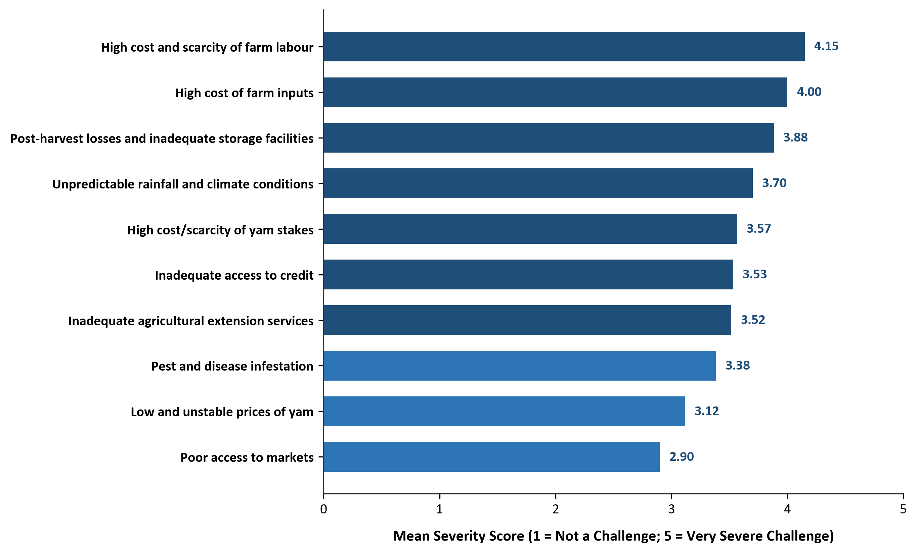
Figure 4.5: Ranking of Challenges Faced by Yam Farmers in Akpabuyo LGA (Mean Severity Scores)
Source: Field Survey Data Analysis, 2026.

