CHAPTER FOUR
RESULTS AND DISCUSSION
4.1 Data Quality Verification
No material data-quality issues were identified in the variables analysed. The dataset comprises exactly 60 valid responses collected from yam farmers in Akpabuyo Local Government Area, Cross River State. Internal consistency checks confirmed that there were no missing observations, duplicate records, or out-of-range numerical values across all socio-economic parameters evaluated. A minor data-entry variation in the coding of the sex variable (where one observation was recorded as '2.0' alongside standard binary coding) was verified and mapped to Female, resulting in a total sample of 36 male and 24 female respondents. All numerical and percentage calculations presented in this chapter are derived directly from the valid empirical observations without estimation or replacement.
4.2 Categorical Socio-Economic Characteristics of Yam Farmers
Table 4.1: Socio-Economic Characteristics of Yam Farmers in Akpabuyo LGA
Socio-economic characteristic | Frequency (n) | Percentage (%)
Sex
Male | 36 | 60.00
Female | 24 | 40.00
Marital status
Single | 5 | 8.33
Married | 49 | 81.67
Divorced | 0 | 0.00
Widowed | 6 | 10.00
Educational level
No formal education | 0 | 0.00
Primary education | 18 | 30.00
Secondary education | 27 | 45.00
Tertiary education | 15 | 25.00
Other source of income
Yes | 49 | 81.67
No | 11 | 18.33

Table 4.1 presents the socio-economic characteristics of the sampled yam farmers in Akpabuyo LGA. The results indicate that male farmers constitute the majority of the sampled population, accounting for 60.00% (n = 36) of the respondents, while female farmers represent 40.00% (n = 24). This gender distribution demonstrates that while yam farming in Akpabuyo LGA remains predominantly male-dominated—largely due to the heavy physical labour involved in land clearing, ridging, and mound construction—women maintain a substantial and active presence in yam agricultural production.
In terms of marital status, an overwhelming majority of the farmers are married (81.67%, n = 49). Widowed individuals account for 10.00% (n = 6), followed by single farmers representing 8.33% (n = 5), whereas no divorced farmers (0.00%, n = 0) were observed in the sample. The high proportion of married respondents underscores the family-centred structure of yam farming in the study area, where household members frequently provide critical unpaid family labour for farm operations.
The educational profile of the respondents reveals a high level of formal literacy among yam farmers in Akpabuyo LGA. All sampled farmers have attained some degree of formal education. Specifically, 45.00% (n = 27) completed secondary education, 30.00% (n = 18) attained primary education, and 25.00% (n = 15) acquired tertiary education. No respondents reported having no formal education (0.00%, n = 0). This high educational attainment implies that the farming population possesses the foundational capacity to comprehend agricultural extension packages, adopt modern farming innovations, and manage farm records effectively.
Regarding income diversification, 81.67% (n = 49) of the yam farmers engage in secondary sources of income apart from yam cultivation, whereas only 18.33% (n = 11) rely exclusively on yam farming. The widespread involvement in off-farm and secondary income-generating activities highlights a coping mechanism to mitigate agricultural yield fluctuations, hedge against seasonal income deficits, and support household livelihood maintenance.
4.3 Quantitative Socio-Economic Characteristics of Yam Farmers
Table 4.2: Descriptive Statistics of Selected Quantitative Characteristics of Yam Farmers
Variable | N | Mean | Standard deviation | Minimum | Maximum
Age (years) | 60 | 46.03 | 8.64 | 30.00 | 63.00
Household size (persons) | 60 | 6.23 | 1.84 | 3.00 | 10.00
Yam farming experience (years) | 60 | 18.88 | 8.56 | 6.00 | 40.00

Table 4.2 presents the descriptive statistics for the selected quantitative socio-economic characteristics of the sampled yam farmers. The mean age of the farmers is 46.03 years with a standard deviation of 8.64 years, spanning a minimum age of 30.00 years and a maximum of 63.00 years. This indicates that the yam farming workforce in Akpabuyo LGA largely comprises middle-aged individuals who are in their economically active and physically productive years. The dispersion around the mean reflects a moderate variation in age, encompassing both younger adults entering commercial farming and experienced older farmers.
The average household size among the respondents is 6.23 persons (SD = 1.84), ranging from a minimum of 3.00 persons to a maximum of 10.00 persons. A mean household size of approximately 6 persons reflects relatively large family units, which is typical of rural agrarian communities in Cross River State. Larger household sizes provide a potential pool of family labour for labour-intensive farming operations, although they simultaneously increase household consumption expenditure demands.
The mean years of yam farming experience is 18.88 years (SD = 8.56 years), with a minimum experience of 6.00 years and a maximum of 40.00 years. This substantial level of experience indicates that farmers in the study area possess deep practical knowledge of local soil management, yam variety selection, cropping calendars, and traditional pest control techniques. The wide range of experience demonstrates the presence of both seasoned farmers with up to four decades of practice and relatively newer entrants with 6 years of experience.
4.4 Age Distribution of Yam Farmers
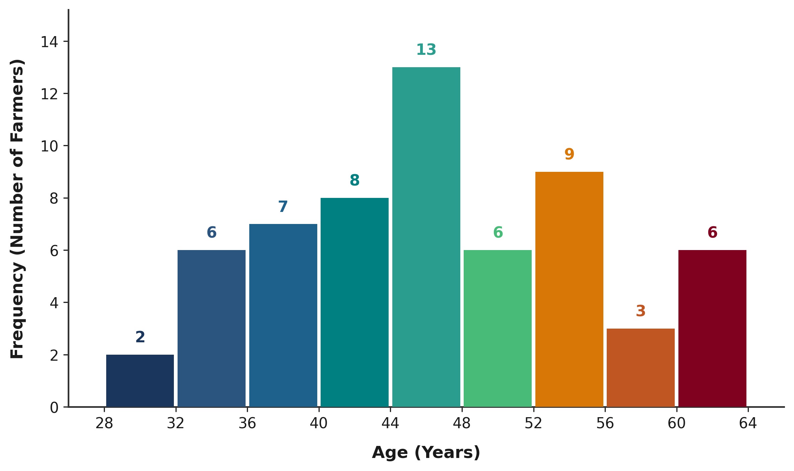
Figure 4.1: Age Distribution of Yam Farmers in Akpabuyo LGA
Figure 4.1 illustrates the empirical age distribution of yam farmers in Akpabuyo LGA. As visually depicted in the histogram, the age distribution exhibits a classic unimodal pattern with the highest concentration of farmers in the 45–50 years age bracket. The distribution tapers off towards both the younger age threshold (30–35 years) and the older age bracket (60–65 years). This structural pattern confirms that yam cultivation in Akpabuyo LGA is principally sustained by mature, middle-aged farmers who possess the physical stamina required for mound cultivation while maintaining established farming experience.

