4.5 Challenges Faced by Yam Farmers
4.5.1 Data Validation and Measurement Framework
To identify and rank the production, institutional, and marketing constraints encountered by yam farmers in Akpabuyo Local Government Area of Cross River State, ten specific challenge indicators specified in Section D of the research questionnaire were analyzed. Farmers rated the severity of each challenge on a 5-point Likert ordinal scale: 1 = Not a Challenge, 2 = Minor Challenge, 3 = Moderate Challenge, 4 = Severe Challenge, and 5 = Very Severe Challenge.
Data Integrity & Evaluation Scale: Data validation confirmed complete response integrity (N = 60, n = 60 valid responses) across nine of the ten challenge indicators. For one indicator—low and unstable prices of yam—exactly one response was unrecorded, yielding n = 59 valid observations (98.3% completeness). No implausible or out-of-range values outside the 1–5 scale were detected. To ensure statistical rigor, mean severity scores were interpreted using the following standard five-interval evaluation scale:
• 1.00 – 1.80 = Not a Challenge
• 1.81 – 2.60 = Minor Challenge
• 2.61 – 3.40 = Moderate Challenge
• 3.41 – 4.20 = Severe Challenge
• 4.21 – 5.00 = Very Severe Challenge
Because the responses represent ordinal severity ratings, mean severity scores are reported as descriptive ranking metrics. In accordance with ordinal data protocols, median and interquartile range (IQR) statistics are also presented as supplementary non-parametric measures.
4.5.2 Severity and Ranking Analysis of Yam Production Challenges
Table 4.11 presents the mean severity scores, standard deviations, medians, interquartile ranges, overall ranks, and severity interpretation categories for the ten challenges evaluated in the study, ordered from highest mean severity (Rank 1) to lowest mean severity (Rank 10).
Rank | Challenge Variable | Mean Score | SD | Interpretation Category
1 | High cost and scarcity of farm labour | 4.15 | 0.80 | Severe Challenge
2 | High cost of farm inputs | 4.00 | 0.96 | Severe Challenge
3 | Post-harvest losses and inadequate storage facilities | 3.88 | 0.99 | Severe Challenge
4 | Unpredictable rainfall and climate conditions | 3.70 | 0.85 | Severe Challenge
5 | High cost/scarcity of yam stakes | 3.57 | 0.89 | Severe Challenge
6 | Inadequate access to credit | 3.53 | 0.98 | Severe Challenge
7 | Inadequate agricultural extension services | 3.52 | 1.07 | Severe Challenge
8 | Pest and disease infestation | 3.38 | 0.83 | Moderate Challenge
9 | Low and unstable prices of yam | 3.12 | 0.87 | Moderate Challenge
10 | Poor access to markets | 2.90 | 1.02 | Moderate Challenge

Source: Field Survey Data Analysis, 2026. N = 60 (n = 59 for Low and unstable prices of yam due to 1 missing response). SD = Standard Deviation. Evaluation Scale: 1.00–1.80 (Not a Challenge), 1.81–2.60 (Minor), 2.61–3.40 (Moderate), 3.41–4.20 (Severe), 4.21–5.00 (Very Severe).
4.5.3 Interpretation of Challenge Severity Ranks
Overall Pattern of Constraints: The empirical results indicate that seven of the ten challenges fell into the 'Severe Challenge' category (mean scores between 3.41 and 4.20), while the remaining three challenges were classified as 'Moderate Challenges' (mean scores between 2.61 and 3.40). No challenge was categorized as a minor challenge or not a challenge, reflecting a high overall burden of constraints across the yam enterprise in the study area.
1. Highest-Ranked Challenge — Farm Labour: The results indicate that high cost and scarcity of farm labour had the highest mean severity score (mean = 4.15 ± 0.80; median = 4.00, IQR = 1.00; Rank 1). The challenge was therefore classified as a severe challenge. Exactly 78.3% of respondents rated labor constraints as either severe (40.0%) or very severe (38.3%), highlighting labor availability and wage demands as a major operational bottleneck in yam mound making, weeding, and harvesting.
2. Second-Ranked Challenge — Input Costs: The second-highest mean severity score was recorded for high cost of farm inputs (mean = 4.00 ± 0.96; median = 4.00, IQR = 2.00; Rank 2). This challenge was also classified as a severe challenge, with 68.3% of farmers rating it as severe (30.0%) or very severe (38.3%). High input expenditure constraints farmer purchasing power for agrochemicals and planting materials.
3. Other Severe Challenges (Ranks 3 to 7): The third and fourth severe challenges were post-harvest losses and inadequate storage facilities (mean = 3.88 ± 0.99; median = 4.00, IQR = 2.00; Rank 3) and unpredictable rainfall and climate conditions (mean = 3.70 ± 0.85; median = 4.00, IQR = 1.00; Rank 4). These were followed by high cost and scarcity of yam seed stakes (mean = 3.57 ± 0.89; Rank 5), inadequate access to credit (mean = 3.53 ± 0.98; Rank 6), and inadequate agricultural extension services (mean = 3.52 ± 1.07; Rank 7). All seven of these constraints recorded mean scores above 3.50, demonstrating a pervasive set of production and institutional obstacles.
4. Moderate Challenges (Ranks 8 to 10): The remaining three challenges were classified as moderate challenges. Pest and disease infestation recorded a mean severity score of 3.38 ± 0.83 (median = 3.00, IQR = 1.00; Rank 8). Low and unstable prices of yam recorded a mean severity score of 3.12 ± 0.87 (median = 3.00, IQR = 1.00; Rank 9, n = 59). Finally, the lowest mean severity score was recorded for poor access to markets (mean = 2.90 ± 1.02; median = 3.00, IQR = 2.00; Rank 10). While market access received the lowest relative rank, its mean score of 2.90 confirms that even the lowest-ranked indicator remains a moderate concern for yam farmers in Akpabuyo LGA.
4.5.4 Graphical Presentation of Challenge Severity Rankings
Figure 4.5 visually presents the ranked mean severity scores for the ten challenges faced by yam farmers in Akpabuyo LGA. The horizontal bars display the mean severity scores ordered from the highest ranked challenge at the top to the lowest ranked challenge at the bottom.
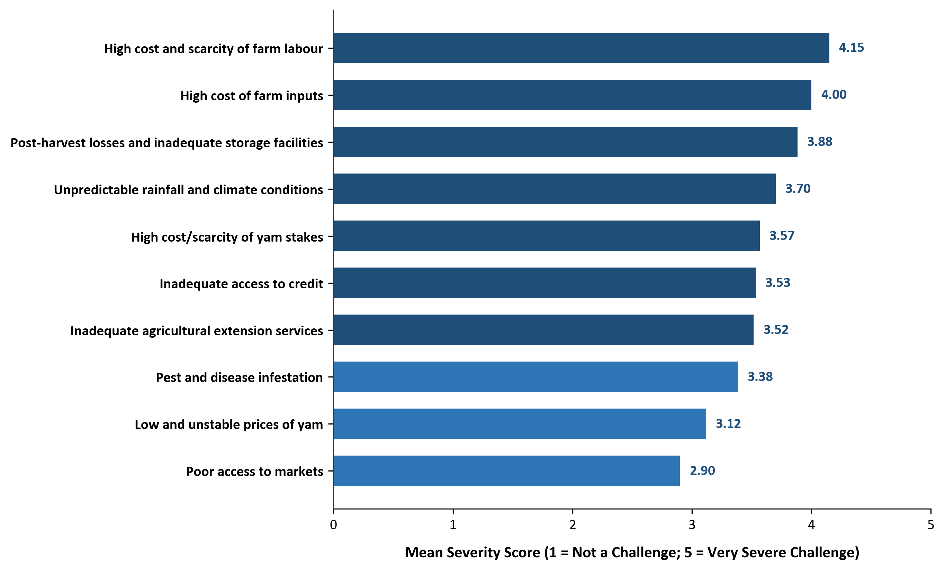
Figure 4.5: Ranking of Challenges Faced by Yam Farmers in Akpabuyo LGA (Mean Severity Scores)

