

AN EXPLAINABLE WATER AWARE STACKING ENSEMBLE FOR CROP RECOMMENDATION

BY

ABDULRAHEEM NAFISAT
U22CS1004

DEPARTMENT OF COMPUTER SCIENCE
FACULTY OF COMPUTING
AIR FORCE INSTITUTE OF TECHNOLOGY, KADUNA

JULY, 2026.

AN EXPLAINABLE WATER AWARE STACKING ENSEMBLE FOR CROP RECOMMENDATION

BY

ABDULRAHEEM NAFISAT
U22CS1004

A PROJECT SUBMITTED

TO

THE DEPARTMENT OF COMPUTER SCIENCE
FACULTY OF COMPUTING
AIR FORCE INSTITUTE OF TECHNOLOGY, KADUNA
IN PARTIAL FULFILLMENT OF THE REQUIREMENTS FOR THE AWARD OF THE DEGREE OF BACHELOR OF SCIENCE (B.Sc.) IN COMPUTER SCIENCE

DECLARATION
I ABDULRAHEEM NAFISAT with Matriculation Number U22CS1004 do declare that the work in this research titled AN EXPLAINABLE WATER AWARE STACKING ENSEMBLE FOR CROP RECOMMENDATION was carried out by me in the Department of Computer Science, Faculty of Computing, Air Force Institute of Technology, Kaduna. Information derived from literature has been duly acknowledged in the body of work and list of references provided. No part of this research has been previously presented for Degree or Diploma in this or any other institution.

ABDULRAHEEM NAFISAT ______________________
(U22CS1004) Signature/Date

CERTIFICATION
The project titled: An explainable water aware stacking ensemble for crop recommendation by ABDULRAHEEM NAFISAT with Matriculation Number U22CS1004 meets the requirements governing the award of the degree of Bachelor of Science in Computer Science of the Air Force Institute of Technology, Kaduna and is hereby approved for its contribution to knowledge and literary presentation.

Sqn Ldr (Dr) OE Olorunshola _____________________
Supervisor Signature/Date

Mr SE Iheagwara ___________________
Project Coordinator Signature/Date

Sqn Ldr (Dr) OE Olorunshola _____________________
Head of Department Signature/Date

Dr. Fatima Adamu-Fika _____________________
Dean, FC Signature/Date

Don’t know yet _____________________
External Examiner Signature/Date

DEDICATIon
This project is dedicated to the most important people in my life, my peace, strength and the reason for my success.
To my dear parents, Hajiya Ramah Abdulraheem and Alhaji Abdulhakeem Abdulraheem, whose unwavering love, encouragement, and prayers have been the foundation of all my achievements. Their sacrifices, guidance, and constant belief in me have been my greatest source of strength and inspiration throughout this journey.
Finally, I extend this dedication to my entire family and loved ones, who have stood by me in countless ways. This accomplishment is as much theirs as it is mine.

ACKNOWLEDGEMENT
First and foremost, I give thanks to Almighty Allah for His mercy, grace, and guidance, which have made it possible for me to successfully complete this project.
I wish to express my deepest gratitude to my supervisor, Sqn Ldr (DR.) OE Olorunshola, for his mentorship, guidance, constructive criticism, and invaluable support throughout the course of this work. His encouragement and professional advice greatly shaped the success of this research, and his supervision greatly contributed to the successful completion of this project.
My heartfelt appreciation goes to my wonderful parents, Hajiya Ramah Abdulraheem and Alhaji Abdulhakeem Abdulraheem, whose endless love, sacrifices, and prayers have sustained me from the beginning.
I also appreciate my friends, for their companionship, encouragement, and support in various ways that made the journey less stressful and more memorable.
I extend my gratitude to my entire family for their prayers, support, and belief in me. Finally, I appreciate everyone, directly or indirectly, who contributed to the completion of this project. Your efforts, support, and prayers will never be forgotten.

TABLE OF CONTENT
Content Page
Cover page i
Title page ii
Declaration iii
Approval Page iv
Dedication v
Acknowledgement vi
Table of content vii
List of tables x
List of figures xi
List of Acronyms xii
Abstract xiii

CHAPTER ONE 1
INTRODUCTION 1
1.1 Background of the Study 1
1.2 Statement of the Problem 2
1.3 Aim and Objectives 3
1.3.1 Aim of the Study 3
1.3.2 Objectives of the Study 3
1.4 Motivation of the Study 3
1.5 Significance of the Study 4
1.6 Scope and Limitation of the Study 5
1.6.1 Scope of the Study 5
1.6.2 Limitations of the Study 5
1.7 Project Organization 5
CHAPTER TWO 7
LITERATURE REVIEW 7
2.1 Review of Key Concepts 7
2.1.1 Traditional and Modern Approaches to Crop Selection 7
2.1.2 Key Predictive Factors in Crop Suitability (Weather, Soil, Water): 7
2.1.3 Artificial Intelligence in Agriculture (ML, ANN, FNN) 8
2.1.4 The Black Box Problem and SHAP 9
2.2 Theoretical Framework 10
2.3 Review of Related Literature 11
2.3.1 Evolution of Traditional Machine Learning in Crop Selection 11
2.3.2 Advancements in Neural Networks and Deep Learning Architectures 15
2.3.3 Integration of Water Resources, IoT, and Economic Factors 16
2.3.4 Regional Specificity and Indigenous Crop Studies in Africa 18
2.3.5 Explainable AI (XAI) and Interpretability in Agriculture 19
2.4 Research Gap 21
CHAPTER THREE 22
METHODOLOGY 22
3.1 Analysis of the Current System 22
3.2 Problems of the Current System 22
3.3 Analysis of the Proposed System 23
3.3.1 Data Sources 24
3.3.2 Feature Engineering 24
3.4 Methodology 26
3.4.1 Data Acquisition and Integration 27
3.4.2 Feature Engineering 27
3.4.3 Preprocessing 27
3.4.4 Ensemble Model Training 27
3.4.5 Feature Ablation Study 27
3.4.6 Stacking Meta-Learner 28
3.4.7 Output: 28
3.5 Choice of Programming Language and Development Tools 28
3.6 Summary 29
CHAPTER FOUR 30
IMPLEMENTATION, RESULTS AND DISCUSSION 30
4.1 Results 30
4.1.1 Base Learner Cross-Validation Performance 30
4.1.2 Held-Out Test Performance and Model Comparison 31
4.1.3 Confusion Matrix 32
4.1.4 Ablation Study 33
4.1.5 SHAP Interpretability Results 34
4.2 Discussion 36
4.2.1 Performance 36
4.2.2 Feature Engineering and Ablation Insight 36
4.2.3 Cross-Model SHAP Consensus 36
CHAPTER FIVE 37
SUMMARY, CONCLUSION AND RECOMMENDATIONS 37
5.1 Summary 37
5.2 Contribution to Knowledge 37
5.3 Conclusion 38
5.4 Recommendations for Future Work 38
REFERENCES 39
APPENDIX 48

LIST OF TABLES
Tables Page
Table 3.1: Engineered Feature Groups 24
Table 3.2: Ablation Study Feature Group Configurations 26
Table 3.3: Development Tools and Libraries 27
Table 4.1: Full Model Comparison Cross-Validation and Test Performance 28
Table 4.2: Ablation Study Results 31
Table 4.3: Top 10 Features by Cross-Model SHAP Consensus 32

LIST OF FIGURES
Figure 3.1: Architecture of the Existing Crop Recommendation System 20
Figure 3.2: Proposed System Architecture 21
Figure 3.3: Pearson Correlation Heatmap: Baseline Agronomic Features 23
Figure 3.4: Machine Learning Pipeline: Eight Stage Methodology 25
Figure 4.1: 5-Fold Cross-Validation Results Jupyter Notebook Output 29
Figure 4.2: Full Model Comparison Table (CV and Test Results) 29
Figure 4.3: Model Performance Comparison Test Charts 30
Figure 4.4: Confusion Matrix for the Two-Level Stacking Ensemble 30
Figure 4.5: Ablation Study Cross-Validation Accuracy Chart 31
Figure 4.6: Cross-Model SHAP Consensus Feature Rankings 32
Figure 4.7: Class-Level SHAP for Top 3 Most Confused Crops (XGBoost) 33

LIST OF ACRONYMS
AI: Artificial Intelligence, ANN: Artificial Neural Network, API: Application Programming Interface, CNN: Convolutional Neural Network, CV: Cross-Validation, DL: Deep Learning, DNN: Deep Neural Network, DT: Decision Tree, ELM: Extreme Learning Machine, FAO: Food and Agriculture Organization, FNN: Feedforward Neural Network, GNB: Gaussian Naïve Bayes, IoT: Internet of Things, KNN: K-Nearest Neighbors, LGBM: Light Gradient Boosting Machine, LIME: Local Interpretable Model-agnostic Explanations, LLM: Large Language Model, LSTM: Long Short-Term Memory, ML: Machine Learning, MLP: Multilayer Perceptron, MSP: Minimum Support Price, NASA: National Aeronautics and Space Administration, N_JOBS: Number of Jobs (Parallel Processing Parameter), NN: Neural Network, NPK: Nitrogen, Phosphorus, and Potassium, PA: Precision Agriculture, RF: Random Forest, RMSE: Root Mean Squared Error, SHAP: SHapley Additive exPlanations, SMOTE: Synthetic Minority Over-sampling Technique, SVM: Support Vector Machine, WDI: World Development Indicators, XAI: Explainable Artificial Intelligence, XGB: Extreme Gradient Boosting

ABSTRACT
This study addresses the limitations of traditional crop selection methods, which rely on farmer experience and often overlook climate variability and water availability. An explainable, water-aware machine learning framework was developed using soil data, ten years of meteorological records from the NASA POWER database, and water scarcity information from the World Bank and FAO AQUASTAT, resulting in a dataset of 2,200 records covering 22 crop types. The framework incorporated 11 engineered features related to crop-climate compatibility, soil nutrients, and water stress indicators and employed a stacking ensemble of Random Forest, XGBoost, LightGBM, and Logistic Regression models. The proposed model achieved outstanding performance with 99.55% accuracy, 99.55% recall, 99.59% precision, and a macro-F1 score of 99.54%. To improve transparency, a cross-model SHAP consensus approach was used to explain predictions, identifying humidity, soil phosphorus, and total NPK content as the most influential factors. The results demonstrate that the framework provides both high predictive accuracy and interpretable, context-aware crop recommendations, making it suitable for climate-sensitive and water-constrained agricultural environments.

CHAPTER ONE

INTRODUCTION

1.1 Background of the Study
Agriculture is an essential sector for global sustenance and the supply of raw materials for industrial activities. However, the industry faces major challenges, including outdated practices, poor soil quality, inadequate funding, weak infrastructure, and the growing impacts of climate change. These issues limit agricultural productivity and complicate efforts to meet the needs of an expanding population. Increasing food production is essential, making it critical to select the most suitable crops for specific regions to improve yields and ensure sustainability (Hasan et al., 2023).
According to Ayorinde et al. (2023), crops are grown for food, energy, and industrial purposes, and choosing the appropriate crop for a given environment is crucial for both profitability and long-term sustainability. Planting unsuitable crops in the wrong conditions can greatly reduce yields, resulting in lower productivity and possible financial setbacks for farmers. Furthermore, agriculture is a significant contributor to global greenhouse gas emissions, while the effects of climate change such as rising temperatures, unpredictable rainfall, flooding, and drought pose serious risks to crop output (Obaji et al., 2022). These challenges are often more severe in rural farming areas, where differences in soil quality, rainfall distribution, and water resources are more pronounced (Olaitan et al., 2025).
Precision Agriculture (PA) has become a promising solution for tackling these challenges by using data-driven technologies to improve crop planning and resource management (Afzal et al., 2025). In particular, Artificial Intelligence (AI) especially Machine learning (ML) has proven effective in capturing complex, non-linear relationships between environmental factors and crop suitability, outperforming many traditional approaches (Bali et al., 2024). However, despite these advancements, many farmers still do not have access to tools that are both reliable and user-friendly, resulting in disconnect between cutting-edge machine learning research and practical agricultural decision-making (Olaitan et al., 2025).
To bridge this gap, this study introduces an explainable, water-aware machine learning model for crop recommendation. It combines data from multiple sources, utilizes advanced feature engineering, employs ensemble learning techniques, and incorporates a cross-model SHapley Additive exPlanations (SHAP) based explainability method.

1.2 Statement of the Problem
Agricultural productivity depends heavily on selecting crops that are compatible with prevailing soil, climatic, and water conditions. Traditionally, farmers have relied on personal experience and historical knowledge to make crop selection decisions. However, increasing climate variability, changing rainfall patterns, and growing pressure on water resources have made such approaches less reliable. To address these challenges, machine learning-based crop recommendation systems have been developed to provide data-driven decision support.
Despite their success, existing crop recommendation models suffer from several limitations that restrict their practical applicability. First, most models evaluate water availability solely through rainfall measurements, ignoring important factors such as freshwater stress levels, irrigation sufficiency, and water withdrawal conditions. This simplified representation of water resources can lead to recommendations that are unsuitable for regions facing water scarcity (Samuel et al., 2024; Shinde et al., 2023).
Second, current systems often rely on basic environmental variables without capturing more complex agricultural relationships. Important interactions among soil nutrients, such as Nitrogen-Phosphorus (NP), Nitrogen-Potassium (NK), Phosphorus-Potassium (PK), and cumulative nutrient saturation, are rarely considered, even though they play a crucial role in soil fertility and crop growth. Similarly, long-term climate trends are often overlooked, reducing the ability of models to account for environmental variability over time (Dey & Chowdhury, 2024; Shastri et al., 2025).
Finally, the practical adoption of machine learning-based recommendation systems is hindered by limited model transparency. Existing explainability approaches are commonly based on a single predictive model, making it difficult to determine whether identified feature importance patterns represent true agricultural relationships or model-specific biases. This lack of reliable interpretability reduces user trust and limits the acceptance of automated recommendations Shastri et al., 2025.
Therefore, there is a need for a comprehensive, explainable, and water-sensitive machine learning framework that integrates multi-source environmental and hydrological information, captures complex agronomic relationships through advanced feature engineering, and provides trustworthy explanations using a cross-model explainability strategy.

1.3 Aim and Objectives

1.3.1 Aim of the Study
The primary aim of this study is to develop an explainable water-aware stacking ensemble model for crop recommendation and applying cross-model SHAP analysis to ensure both high predictive accuracy and robust interpretability.

1.3.2 Objectives of the Study
To achieve this aim, the specific objectives of the study are to:
- The primary aim of this study is to develop an explainable water-aware stacking ensemble model for crop recommendation.
- Systematically evaluate the performance of the proposed model using structured ablation analysis and standard classification metrics (accuracy, precision, recall, and F1-score), in order to quantify the contribution of distinct feature groups and ensure robustness and predictive reliability.
- Implement SHAP analysis to interpret the model’s decision-making process and identify the most influential environmental factors affecting crop suitability, with emphasis on cross-model consistency.

1.4 Motivation of the Study
This study is driven by the ongoing difficulties farmers face in achieving optimal yields, largely due to dependence on traditional practices and limited access to comprehensive, data-driven decision-support systems. These challenges are further intensified by climate variability, water shortages, and declining soil quality, all of which complicate effective crop selection Although current machine learning based approaches often achieve high predictive accuracy, they frequently overlook key water-related variables, lack strong interpretability, and are not tailored for ease of use by non-technical users. As a result, a clear disconnect exists between advancements in AI and their practical implementation in agriculture. Accordingly, this research is motivated by the need to design a reliable, transparent, and context-sensitive crop recommendation framework. The proposed approach integrates diverse environmental data sources, explicitly accounts for water-related factors, and delivers clear, interpretable insights using explainable AI techniques. Ultimately, the goal is to enable better decision-making, enhance agricultural productivity, and support the development of sustainable food systems.

1.5 Significance of the Study
This study is important because it addresses critical limitations in existing crop recommendation systems and contributes toward the development of more reliable decision-support tools for sustainable agriculture. As climate change continues to affect rainfall patterns and water availability, farmers require recommendation systems that consider not only local weather conditions but also broader water-resource constraints. Integrating freshwater stress indicators and irrigation-related information enables more realistic crop suitability assessments and helps reduce the risk of crop failure.
The study is also significant from a technological perspective. By incorporating advanced feature engineering techniques, the proposed framework captures complex interactions among climatic, hydrological, and soil variables that are often ignored in traditional models. This improves the model's ability to represent real agricultural conditions and enhances prediction performance.
Furthermore, the research addresses the growing demand for transparency in artificial intelligence applications. The proposed cross-model SHAP consensus approach provides more stable and trustworthy explanations by combining insights from multiple machine learning algorithms. This reduces reliance on a single model's interpretation and increases confidence in the generated recommendations. Consequently, the study supports the wider adoption of machine learning technologies by farmers, agricultural extension services, researchers, and policy makers.

1.6 Scope and Limitation of the Study

1.6.1 Scope of the Study
This study is defined operationally by its focus on three key environmental domains derived from multiple data sources, weather conditions such as rainfall, temperature, and humidity, soil characteristics particularly pH levels and essential nutrients like nitrogen (N), phosphorus (P), and potassium (K) and water resources, with specific attention to factors such as irrigation availability and reliance on rain-fed systems.
From a technological perspective, the research involves developing a machine learning framework that employs ensemble learning models along with SHAP-based analysis, implemented using the Python programming language.

1.6.2 Limitations of the Study
This study has two main limitations. Each one leads directly to a recommendation in the chapter 5 section.
First, the climate data used to build the crop-climate scores came from a single location. This means the scores give a general picture of the environment rather than a specific one for each farm or local area. The system may therefore be less accurate for places with very different weather conditions.
Second, the water stress features were built using national-level data from the World Bank and FAO. These numbers show the big picture of water use in Nigeria, but they do not tell us about water availability on a specific farm. Things like how much groundwater a farmer can access or when irrigation is actually available are not captured. This means the recommendations may not fully reflect the real water situation for every farmer.

1.7 Project Organization
The research project is organized into five chapters. Chapter One introduces the study by outlining the background, problem statement, objectives, scope, and significance of the research. Chapter Two presents a review of related literature, discussing concepts of PA, ML and ensemble frameworks, and existing crop prediction systems. Chapter Three details the methodology, explaining the data collection process for multi-source datasets, the architecture of the explainable machine learning framework, and the tools used for implementation, including Python. Chapter Four presents the results, showcasing the framework's performance metrics, analysis of SHAP findings. Finally, Chapter Five concludes the study with recommendations for future research and highlights the potential application of the framework within broader agricultural sectors.

CHAPTER TWO

LITERATURE REVIEW

2.1 Review of Key Concepts

2.1.1 Traditional and Modern Approaches to Crop Selection
Traditionally, decisions about crop selection and irrigation scheduling have largely depended on farmers’ observations and personal experience. Although these methods have supported agriculture for generations, they are becoming less effective under today’s changing climate conditions. Such approaches often lead to inefficient water use, with nearly half of available water resources wasted due to systems that do not accurately regulate soil moisture. This can negatively affect both the quality and quantity of crops through over- or under-irrigation (Kashyap et al., 2021). In Nigeria, reliance on traditional practices has also made smallholder farmers more vulnerable to unpredictable changes in rainfall and temperature, as they lack access to timely, data-driven guidance (Olaitan et al., 2025).
In contrast, contemporary methods utilize PA and ML to recommend the most suitable crops based on scientific analysis. These systems evaluate complex relationships among soil nutrients such as nitrogen, phosphorus, and potassium along with pH levels and climatic factors, to identify crops that are likely to perform best in specific locations. For example, ensemble learning techniques that combine models like Random Forest (RF) and Extreme Gradient Boosting (XGB) can analyze historical and environmental data to deliver accurate crop recommendations. This helps minimize the risk of crop failure while improving farmers’ profitability (Afzal et al., 2024). Overall, this transition from intuition-based practices to data-driven decision-making represents a key advancement toward sustainable agriculture.

2.1.2 Key Predictive Factors in Crop Suitability (Weather, Soil, Water):
The appropriateness of a crop for a particular region depends on a complex interaction of environmental factors, especially weather conditions, soil properties, and water availability. Key soil elements namely NPK along with soil pH, play a vital role in plant development. Studies show that when these factors are evaluated together with temperature and humidity, they enable accurate assessment of land suitability for various crops, from cereals like maize and rice to fruits such as mangoes and bananas (Afzal et al., 2024). Ignoring these soil-related characteristics often results in low yields, regardless of seed quality or farming practices.
Water availability, including rainfall distribution and soil moisture levels, is also crucial in agricultural prediction models. In Nigeria, inconsistent rainfall patterns make effective irrigation planning essential. Modern AI-based systems incorporate variables such as rainfall intensity, evaporation rates, and soil moisture content to estimate water shortages and optimize irrigation schedules. The use of Internet of Things (IoT) sensors further enhances this process by enabling real-time monitoring of water conditions, ensuring that crops receive adequate water without overusing limited freshwater resources (Kashyap et al., 2021).
AI-powered smart irrigation systems that track parameters like humidity and soil moisture have proven effective in improving water use efficiency. By aligning water supply with crop needs, these technologies promote sustainable farming, particularly in areas facing water scarcity (Audu, 2025).

2.1.3 Artificial Intelligence in Agriculture (ML, ANN, FNN)
AI and ML have become essential tools for addressing complex agricultural challenges that were once difficult to solve due to the large volume and non-linear nature of environmental data. ML techniques such as Support Vector Machines (SVM), RF, and Neural Networks (NN) can automatically learn patterns from data, enabling applications like crop recommendation and yield forecasting. Deep Learning (DL), a specialized branch of ML, has gained prominence for its ability to model intricate relationships using multi-layered neural networks, making it particularly effective for analyzing large datasets collected from soil sensors and weather monitoring systems (Shrestha & Mahmood, 2019).
Feedforward Neural Networks (FNN) and advanced architectures such as Long Short-Term Memory (LSTM) networks represent significant improvements over conventional statistical approaches. FNNs process information in a single direction from input to output allowing them to model relationships between variables. In contrast, LSTM networks are designed to handle time-dependent data, such as historical weather trends and soil moisture variations. By retaining information from previous time steps, LSTMs can predict future conditions more accurately, making them especially useful in dynamic agricultural settings where past environmental patterns influence future crop performance (Kashyap et al., 2021).
In Nigeria, the use of these AI-driven technologies is steadily increasing, particularly in areas like irrigation management and climate-smart farming. Research indicates that models such as Artificial Neural Networks (ANN) have been effectively applied to estimate reference evapotranspiration and optimize water use across different regions. These systems have shown the potential to significantly improve irrigation efficiency by up to 99% and boost crop yields by as much as 70%, highlighting their value in advancing agricultural productivity (Audu, 2025; Olaitan et al., 2025).
ML itself is a branch of AI that focuses on creating algorithms capable of learning from data and improving performance over time (Taye, 2023). DL, which underpins this research, is a rapidly evolving subset of ML that specializes in extracting complex patterns from large datasets (Sirmorya et al., 2022). ML methods are generally classified into supervised, unsupervised, and reinforcement learning categories (Taye, 2023). DL plays a key role in PA by enabling systems to learn hierarchical representations directly from raw data (Shrestha & Mahmood, 2019). Unlike traditional ML approaches that depend on manual feature selection, DL models can automatically identify relevant features, making them well-suited for handling complex, high-dimensional agricultural datasets.
The FNN, also known as the Multilayer Perceptron (MLP), is one of the most fundamental neural network structures (Shrestha & Mahmood, 2019). It is composed of an input layer, one or more hidden layers, and an output layer, with data flowing in a single direction without feedback loops. Each neuron is connected through weighted links, where inputs are combined, transformed using non-linear activation functions such as ReLU, sigmoid, or tanh, and passed forward. The model is trained by minimizing prediction errors through backpropagation and optimization techniques like gradient descent. Due to its strong performance in both classification and regression tasks, the FNN is well-suited for applications such as crop recommendation systems.

2.1.4 The Black Box Problem and SHAP
Although complex ML models such as Artificial Neural Networks (ANN) often achieve high predictive accuracy, they are commonly limited by the “black box” problem. This issue arises because the internal decision-making process of the model is not easily interpretable, making it difficult for users to understand how predictions are generated. In critical fields like agriculture, where incorrect recommendations can lead to major financial losses, this lack of transparency can reduce trust and slow down the adoption of AI-based solutions. Farmers and other stakeholders need clear explanations of why a model suggests a particular crop or irrigation strategy before they can confidently rely on its outputs (Dey & Chowdhury, 2024).
To overcome this challenge of interpretability, SHAP has become a widely used technique for explaining model outputs. Based on cooperative game theory, SHAP measures the contribution of each input feature such as soil pH, rainfall, or temperature to the final prediction. Unlike some other explanation methods that only provide local insights, SHAP delivers consistent and precise attribution values, ensuring that the combined contributions of all features match the model’s output. This makes it possible to “open” the black box and clearly understand how factors like water availability or soil characteristics influence crop recommendations, thereby improving transparency and user confidence in AI systems (Dey & Chowdhury, 2024).

2.2 Theoretical Framework
Crop recommendation systems help farmers choose suitable crops based on soil and weather conditions (Thakur & Jha, 2025). Traditional rule-based systems cannot handle complex farming environments well. Machine learning offers a better way by learning patterns from data instead of following fixed rules.
Three main algorithms work well for this task. RF combines many decision trees together to make predictions, and it handles non-linear relationships between soil nutrients and crop outcomes effectively (Widianto & Saputra, 2024). XGBoost builds models step by step, correcting errors from previous attempts, which makes it useful for structured farming data (Yas, 2026). LightGBM trains faster than other boosting methods while keeping good accuracy, especially when datasets have many features (Widianto & Saputra, 2024).
No single model works best for every situation. Each algorithm has strengths and weaknesses depending on the data. Ensemble learning solves this by combining multiple models together. Stacking is a specific ensemble method where predictions from several base models become inputs for a final model called a meta-learner (Yas, 2026).
This study uses RF, XGBoost, and LightGBM as base learners. Their predictions go into a logistic regression meta-learner that learns the best way to combine them. Research shows stacking works better than individual models because different algorithms capture different patterns in the data (Yas, 2026).
Farmers need to trust what a model tells them. Many ML models act like black boxes where you cannot see why a decision was made. This creates problems because farmers may not follow advice they do not understand (Thakur & Jha, 2025).
SHAP solves this problem. It comes from game theory and shows how much each feature contributes to a prediction. For crop recommendation, SHAP reveals whether nitrogen level, rainfall, or temperature most influenced the suggestion (Widianto & Saputra, 2024). This matters because farmers can then adjust specific soil conditions rather than guessing what went wrong.
Cross-model SHAP takes this further by comparing explanations across different ML models. If RF, XGBoost, and LightGBM all point to the same features as important, confidence in those explanations increases. This approach bridges the gap between good predictions and practical usability.
Water availability drives crop success. Traditional systems include rainfall data but often miss how water interacts with soil nutrients and temperature. This study incorporates water-related features alongside standard soil parameters. Research confirms that combining water metrics with nutrient data produces more realistic recommendations (Thakur & Jha, 2025).

2.3 Review of Related Literature

2.3.1 Evolution of Traditional Machine Learning in Crop Selection
The use of AI in agriculture has significantly transformed decision-making, especially in crop selection. Early studies laid the groundwork for replacing traditional farming approaches with data-driven methods. For example, Manjula et al. (2019) showed that soil nutrients N, P, K combined with weather parameters could be analyzed using data mining techniques to predict crop yield. Expanding on this, Parameswari et al. (2021) introduced a multi-functional platform utilizing RF and Decision Tree (DT) algorithms to both recommend appropriate crops and detect potential plant diseases, thereby integrating crop selection with early-stage health monitoring.
Setiadi et al. (2020) tackled the challenge of unreliable traditional planting patterns caused by unpredictable climate conditions by applying a Naïve Bayes classifier for crop recommendation. Using data from the Provincial Office of D.I. Yogyakarta including weather conditions, crop yield, and market prices they aimed to reduce the risk of crop failure. The study stood out for its computational efficiency and inclusion of economic variables, achieving an accuracy of 85.71%.
Later research concentrated on improving model accuracy and refining input features. Apat et al. (2023) addressed the issue of farmers ignoring environmental factors by developing an AI system based on a Classification-Regression-Boosting (CRB) model. Their approach incorporated eight variables (N, P, K, temperature, humidity, pH, and rainfall) and applied synthetic minority over sampling (SMOTE) to handle class imbalance. They evaluated 14 classifiers, with CatBoost achieving the highest accuracy of 99.51%. The study emphasized the importance of considering multiple parameters and suggested future integration with mobile applications and chatbots for better usability.
Similarly, Pachade and Sharma (2022) focused on weather-based crop recommendations to reduce reliance on intuition. By comparing DT, RF, and Logistic Regression using environmental and soil parameters, they identified RF as the most effective model with 99.32% accuracy.
Priya et al. (2023) proposed a SVM based system to address poor crop selection practices that reduce productivity and lead to food shortages. Their model analyzes soil characteristics and predicts suitable crops, achieving 97% accuracy. The study highlights the importance of soil nutrients N, P, K and pH levels in maximizing agricultural output.
In a related study, Shivbhakta et al. (2021) developed a weather-based crop prediction system using SVM, K-Nearest Neighbors (KNN), DT, and Gradient Boosting. Gradient Boosting performed best, achieving 98% accuracy and excellent evaluation metrics.
Efendi (2025) investigated machine learning-based classification of student adaptability in online learning environments. By applying SHAP-guided feature engineering and SMOTE for class balancing, the study demonstrated that creating meaningful feature interactions significantly improved the performance of Decision Tree and Random Forest models, achieving an accuracy of 90.08% and an F1-score of 89.34%. However, the study was limited by its reliance on manually engineered features and a single dataset.
Kang (2026) examined investor flow prediction in financial markets to determine whether complex deep learning architectures outperform simpler feature-engineered models. Using a large dataset of Korean equities, the study found that a simple linear model with market-capitalization normalization achieved superior performance, attaining a Sharpe ratio of 1.30 and a cumulative return of 272.6%. The findings emphasized that effective feature engineering can be more valuable than model complexity in low signal-to-noise environments.
Dr. Emmanuel N. et al. (2025) developed a machine learning-based crop recommendation system to improve agricultural decision-making in Rwanda. The study combined soil, climate, and altitude data and introduced domain-specific features such as a Soil Fertility Index and Altitude-Adjusted Climate Metrics. Among the evaluated models, XGBoost achieved the highest accuracy of 98.25%, while Random Forest achieved 96.7% accuracy and was selected for deployment because of its balanced predictive performance. The study demonstrated the importance of feature engineering in enhancing crop recommendation accuracy and model generalizability.
Dahiphale et al. (2023) explored smart farming solutions aimed at addressing global food demand by automating crop recommendations. They evaluated seven machine learning models, including Logistic Regression, DT, RF, SVM, and NN, using soil and climate data. RF achieved near-perfect accuracy (99.5%), demonstrating the importance of feature engineering.
Emmanuel et al. (2025) developed a machine learning-based crop recommendation model to overcome the limitations of traditional farming recommendations in Rwanda, which mainly focus on soil nutrients while neglecting climate and altitude factors. Using Python and an Agile development framework, the authors evaluated Decision Tree, Random Forest, Naïve Bayes, XGBoost, and Support Vector Machine models on soil and weather data. XGBoost achieved the highest accuracy of 98.25%, while Random Forest (96.7%) was chosen for deployment due to its better balance between precision and recall. However, the study did not incorporate explainability techniques such as SHAP or LIME and failed to consider hydrological scarcity indicators.
Bisodiya et al. (2025) developed a system to help farmers adapt to unpredictable environmental conditions through personalized crop recommendations. Among the tested models SVM, RF, and DT, RF achieved the best performance (99.31%).
Kori et al. (2025) combined ML with IoT-based real-time environmental monitoring to support farmers facing climate change. Their evaluation of DT, RF, and SVM showed that RF achieved up to 99% accuracy.
Advancements in ensemble techniques have further improved prediction accuracy. Afzal et al. (2025) introduced a hybrid model (RFXG) that combines RF and Extreme Gradient Boosting (XGBoost), achieving 98% accuracy and outperforming individual models such as MLP and Logistic Regression.
Similarly, Kale and Mohapatra (2024) compared KNN, ANN, RF, and SVM, finding RF to be the fastest in training, while ANNs showed relatively low precision (60%), indicating the need for better architectural optimization.
Suresh et al. (2020) proposed a dual-model framework combining DT for crop classification and Linear Regression for yield prediction. Their system aimed to guide farmers in selecting suitable crops for specific locations, achieving 88.7% accuracy.
Dash et al. (2021) examined crop classification based on soil nutrients and weather conditions using SVM and DT. They found that kernel-based SVM significantly outperformed other models, achieving a 91% F1-score.
Gupta and Srivastava (2024) provided a broader perspective by reviewing crop recommendation systems in the context of climate change and resource scarcity. They highlighted the benefits of hybrid models that integrate sensor data with expert knowledge.
Thilakarathne et al. (2022) developed a cloud-based crop recommendation system, where RF achieved 98% accuracy among five models tested.
Sharma et al. (2023) emphasized the importance of modernizing agriculture to address climate variability and the limitations of manual forecasting. Using supervised learning methods such as Naïve Bayes, DT, RF, and XGBoost, they found XGBoost and Naïve Bayes to perform best, with an accuracy of 99.55%.
Apu et al. (2025) designed an IoT-enabled PA system in Bangladesh, accessible via mobile platforms. Among the tested algorithms Naïve Bayes, RF, and XGBoost Naïve Bayes achieved the highest accuracy (99.55%).
La et al. (2025) explored crop recommendation using simulated datasets generated through normal distribution and validated with a clipping function. Using the KNN algorithm, they achieved 96.67% accuracy and successfully mapped crops to seasonal conditions.
Finally, Patil et al. (2023) introduced a hybrid system combining Naïve Bayes for crop selection and RF for yield prediction. Their model achieved high classification accuracy (99.39%).

2.3.2 Advancements in Neural Networks and Deep Learning Architectures
Although traditional ML remains widely used in agriculture, recent research shows that NN handle complex, non-linear relationships in agricultural datasets more effectively. Priyadharshini et al. (2021) applied NN models to historical records involving rainfall, market price, and yield, reaching an accuracy of 89% while also emphasizing the importance of combining sustainability with profitability.
Madhuri et al. (2021) proposed a system that uses ANN to recommend suitable crops based on soil properties, crop characteristics, and climate parameters. The user interface developed takes the location-specific soil properties as real time input and recommends the suitable crop considering the input and climate parameters. The model was tested with ANN and a DT and the overall accuracy value of ANN is 96%, whereas the accuracy value of the DT is 91.5%.
Madhuri and Indiramma (2021) developed an integrated crop recommendation system using ANN. They addressed the limitation of existing systems that utilized fewer experimental parameters by incorporating soil properties, climatic parameters, and calculated evapotranspiration. The profound strength of this work is the demonstration of ANN's superiority, the ANN model achieved a 97% accuracy rate, outperforming the DT classifier which only achieved 92%.
Innovating on feature selection, Murugesan and Radha (2022) proposed a crop recommendation system that integrates soil deficiency analysis and, crucially, crop rotation predecessors using an Extreme Learning Machine (ELM). They tackled the problem of soil nutrient depletion caused by cultivating the same crops repeatedly by including the crop predecessor as a key input variable. The strength of this study is its exceptionally high accuracy of 96.5% and the novelty of maintaining soil health through rotation logic.
Gosai et al. (2021) addressed the issue of poor crop quality caused by the improper application of fertilizers and the absence of site-specific soil analysis. They proposed a system that used Internet of Things (IoT) sensors to collect soil moisture, temperature, and pH data, combined with analytical models to recommend suitable crops. Their approach also incorporated a Convolutional Neural Network (CNN) for crop disease detection. A major strength of the study was the dual functionality of offering both crop recommendations and disease identification.

2.3.3 Integration of Water Resources, IoT, and Economic Factors
Addressing the economic dimensions of farming, Sam and D’Abreo (2024) researched crop recommendation with ML by leveraging environmental and economic factors for optimal crop selection in India. The problem addressed was that existing systems predominantly focused on environmental factors while ignoring economic viability. Their method employed RF and SVM using sophisticated validation techniques like Time-series Split and Lag Variables to account for market trends. The strength of this work was the integration of economic parameters such as Operational Cost, Minimum Support Price and temporal dependencies. The gap identified was that model accuracy dropped significantly on unseen time-series data, suggesting a need for more advanced pattern recognition to handle temporal shifts in agricultural data.
The integration of economic viability into PA is a critical advancement in crop recommendation systems. Patel and Patel (2023) focused on a multi-criteria agriculture recommendation system to address the problem where conventional farming overlooks profitability and market demand, leading to income loss. Their method, the AgricRec algorithm, utilized ML for crop prediction and a rule-based system for fertilizer suggestions, uniquely incorporating Minimum Support Price (MSP), land area, and water levels using data from 5000 land samples in Gujarat. The strength of this study was its holistic approach, achieving 95.85% accuracy while processing data four times faster than traditional methods.
Water scarcity is a paramount concern in agriculture that often goes unaddressed in standard recommendation datasets. Shinde et al. (2023) developed the Krishi Jal app to solve the specific problem of existing models failing to account for the actual water resources available to a farmer, which risks crop failure if water sources dry up..
IoT-driven solutions have also played an increasingly important role. Abdullahi et al. (2024) designed a precision farming system that uses sensors to collect live data on soil nutrients and moisture, applying the CatBoost algorithm to reach 99% accuracy. Khan et al. (2022) contributed a portable hardware-based fertilizer advisory system that relies on sensor nodes for field-level soil assessment, highlighting the potential of low-cost IoT deployments.
ThilaKarathne et al. (2022) proposed a cloud based, ML powered crop recommendation platform deployed as a web application. The authors explored five ML classifier such as KNN, DT, RF, XGBoost and SVM. Their result showed that RF classifier achieved the highest accuracy of 97%. This proposed method solved the problem of creating a cloud based tool to assist farmers with the right crop selection.
Bouni et al. (2024) present an IoT and ML framework for PA, where a RF model achieved 99.31% accuracy for crop recommendation and yield prediction. Their system utilized a large secondary IoT dataset to train several classifiers.
Abdullahi et al. (2024) developed a precision agriculture system powered by IoT sensors that collected real-time data on soil nutrients, rainfall, and humidity. Using the CatBoost algorithm, the system achieved 99% accuracy in crop recommendation. Their study demonstrated how integrating IoT with ML could deliver dynamic, site-specific insights, offering significant benefits to farmers in developing regions.
Khan et al. (2022) designed an IoT-based system for context-aware fertilizer recommendation using a portable sensor node to measure soil NPK levels. A Gaussian Naïve Bayes model achieved 94% test accuracy in recommending appropriate fertilizers. A key limitation was the relatively small dataset, which restricted the use of more complex models.
Alazzai et al. (2024) review how AI and IoT enable real-time crop monitoring and resource optimization, boosting yield and sustainability. They identify high costs, technical complexity, and rural connectivity as significant adoption barriers. The authors underscore the need for more inclusive and accessible smart farming solutions.
According to Kannan (2022), the integration of AI, big data, and cloud computing is transforming traditional farming into a data-driven enterprise. The research demonstrated that AI-powered equipment uses IoT data and ML to enhance crop management. This approach shows potential for improving yield, though it faces challenges like high costs and data privacy concerns.
Addressing the specific interaction between soil nutrients and crop suitability, Kiran et al. (2024) worked on a machine learning-enabled system for crop recommendation to tackle the complexity of decision-making in modern agriculture. Their method involved comparing Gaussian Naive Bayes (GNB), SVM, RF, and DT, specifically looking at nutrient parameters to mitigate phytotoxicity (calcium and phosphorus imbalances). The strength of the paper was the superior performance of the GNB classifier with 99% accuracy and its focus on nutrient toxicity.
An interesting advancement emerged from the integration of multi-source data. Kaur et al. (2022) proposed a model that fused remote sensing data, soil databases, and meteorological information. Using Gradient Boosting algorithms, their framework predicted optimal cropping patterns for specific regions. This approach demonstrated how multi-modal data could be harnessed to enhance spatial and temporal precision in agricultural recommendations.
Exploring the implementation of ML on mobile platforms, Venugopal et al. (2021) utilized RF, Naïve Bayes, and Logistic Regression to predict crop yield in Kerala. The problem they aimed to solve was the lack of real-time, accessible decision-making tools for farmers regarding crop suitability and yield estimation. The study is strong in its practical deployment, creating a user-friendly Android application backed by a RF model that achieved the highest accuracy of 92.8%.

2.3.4 Regional Specificity and Indigenous Crop Studies in Africa
Demonstrating the utility of NN in African contexts, Musanase et al. (2023) presented a data-driven analysis and ML-based crop and fertilizer recommendation system for revolutionizing farming practices in Rwanda, aiming to tackle low productivity and food insecurity. Their method utilized a NN for crop recommendation and a rule based engine for fertilizer suggestions, integrated into a cloud-based architecture. The study's strength was the NN high training accuracy (99%) and the practical integration of IoT concepts.
Samuel et al. (2024) carried out a crop recommendation study tailored to the Nigerian agricultural landscape, addressing challenges such as outdated farming practices, resource wastage, and climate-related yield losses. Using data from the Nigeria Meteorological Agency and local universities, they trained RF, Naïve Bayes, KNN, and SVM models on 18 Nigerian crops. RF delivered the strongest performance, achieving up to 99.85% accuracy, demonstrating the value of using locally sourced climate and soil data.
Abdullahi et al. (2024) presented a system designed to revolutionize agriculture in Somalia, specifically the Balcad District, to tackle food insecurity and data scarcity. The problem highlighted was the lack of region-specific systems that can handle unpredictable weather and limited resources. Their method integrated IOT devices for real-time data collection (soil nutrients, pH, moisture) with machine learning models like DTs, KNN, and RF. The study's strength is its deployment of a real-time system in a specific locality (Balcad), demonstrating the high value of localized data, where the DT model achieved 99.2% accuracy.
Dekera et al. (2024) developed a crop recommendation system for the Yandev District in Benue State, Nigeria. They used an indigenous dataset to train five models, including Naïve Baye and XGB. Naïve Bayes achieved an accuracy of 99.85%, Bakr et al. (2025) evaluated learning-based models for crop recommendation in smart agriculture, specifically tackling the problem.

2.3.5 Explainable AI (XAI) and Interpretability in Agriculture
Exploring state-of-the-art interactions problem that standard ML, DL models lack conversational capabilities for real-time advisory. Their method involved converting structured tabular data into descriptive text to fine-tune Large Language Models (LLMs) like GPT2 and BERT, comparing them against traditional ML, DL models. The strength of this research was demonstrating that GPT-2 could achieve 99.55%.
A complementary perspective was offered by Kamatchi et al. (2024), whose reinforcement learning-based system introduced adaptability but lacked an interpretability layer. This observation emphasizes the ongoing need for convergence between adaptability and transparency two pillars that often remain disjointed in existing research.
In the pursuit of more transparent AI, Theofilou et al. (2025) conducted a systematic review of 50 studies on crop yield and price prediction using machine learning, deep learning, and time-series models. They found that hybrid DL architectures achieved the best forecasting performance but struggled with limited interpretability, high computational cost, and regional specificity. The authors emphasized the need for explainable AI frameworks and standardized evaluation benchmarks to make agricultural models more transparent and user-trustworthy.
Shastri et al. (2025) emphasized the importance of transparency in crop recommendation systems by integrating interpretability methods. They used Gradient Boosting, which achieved 99.27% accuracy, along with an explanation technique to help users understand model decisions.
Ahmad et al. (2025) extended ensemble learning further by combining it with explainable AI. Their hybrid system performed both crop recommendation and yield prediction, using seasonal and environmental data as core variables. Achieving an impressive 99.3% accuracy, the model was implemented through a web portal that offered natural language explanations for each recommendation. Ahmad et al. (2025) successfully demonstrated that it is possible to combine multiple learners for accuracy while still maintaining interpretability through natural language explanations. Their system served as a practical proof that complex algorithms can be made accessible and understandable to end-users without sacrificing precision.
A persistent limitation of advanced neural models is their lack of transparency. Shams et al. (2024) addressed this challenge through the XAI-CROP framework, which employed LIME to clarify how input features influence recommendations an essential step toward improving user confidence in automated decision systems.
Ahmad et al. (2025) combined ensemble learning with natural-language explanations, ensuring that highly accurate (99.3%) predictions remained understandable to non-technical farmers. Shastri et al. (2025) used Gradient Boosting in combination with explainability techniques to visualize how environmental variables affect crop suitability, setting a benchmark for transparent, high-precision models.
Building upon this, Akkem et al. (2023) demonstrated that visualization-driven interfaces could further improve transparency. Their use of SHAP and LIME within Streamlit not only explained model behavior but also allowed non-technical users to interactively explore how individual features influenced recommendations. This kind of interface marked a paradigm shift from purely predictive tools to participatory decision-support systems.
Dahiphale et al. (2023) explored automated crop recommendation systems designed to meet global food demands. Their research examined soil and climatic variables using seven different analytical models, including NNs. The RF model achieved the highest accuracy at 99.5%. A key strength was the comprehensive comparison of multiple techniques.
To further advance adoption, researchers have emphasized human computer interaction aspects in design. Mandal et al. (2022) and Akkem et al. (2023) both underscored the importance of simplicity in interface design, showing that even the most accurate system may fail if end-users cannot easily interpret or use it. Their work highlights that accessibility, usability, and interpretability must co-exist for true technological impact in agriculture.

2.4 Research Gap
Recent studies have shown that machine learning can effectively support crop recommendation by analyzing soil and climatic factors. However, most existing models rely on traditional variables such as temperature, humidity, soil nutrients, pH, and rainfall. In many cases, rainfall is treated as the sole indicator of water availability, while important factors such as freshwater scarcity, irrigation accessibility, and regional water stress are overlooked.
This overreliance on rainfall creates a gap between model predictions and real-world agricultural conditions. A region may receive sufficient rainfall but still face water shortages due to inadequate irrigation systems or high water demand. Consequently, existing models may recommend crops that are statistically suitable but difficult to sustain in water-constrained environments.
Another major gap concerns model interpretability. Although explainable AI techniques such as SHAP and LIME are increasingly used, explanations are usually generated from a single machine learning model. Since different algorithms learn patterns differently, the resulting feature importance may reflect model-specific behavior rather than true agronomic relationships. Therefore, there is a need for a crop recommendation framework that integrates broader water-resource indicators and provides more reliable explanations through a multi-model interpretability approach.

CHAPTER THREE

METHODOLOGY

3.1 Analysis of the Current System
Crop recommendation systems have grown more accurate over time, but they still have clear weaknesses in how they gather data, build their models, and explain their results. This section looks at those weaknesses, drawing on the work of Shastri et al. (2025) and the studies reviewed in Chapter Two.
Figure 3.1 shows the system built by Shastri et al. (2025). Soil nutrients (N, P, K), temperature and humidity, and pH and rainfall are fed into a single Gradient Boosting model, which then produces a crop recommendation and an explainability output using LIME.
Input
Soil Nutrients
(N, P, K)

Output

Model Training and evaluation

Lime Single Model Explainability
Temperature and humidity
Model Evaluation
Single Model Training (Gradient Boosting)

Crop Recommendation
Ph and Rainfall

Figure 3.1: Architecture of the Existing Crop Recommendation System (Shastri et al., 2025)

3.2 Problems of the Current System
As shown in Figure 3.1, the system by Shastri et al. (2025) uses soil nutrients, weather factors, and rainfall as inputs to a Gradient Boosting model, which produces crop recommendations and LIME explanations.
The reviewed crop suitability and recommendation literature suffers from three primary limitations, a lack of real-world climate data, limited water resource information, and a reliance on single-model explainability. Current systems rely on static datasets rather than real-time climate observations or long-term satellite data. Furthermore, evaluations are constrained by a narrow focus on rainfall as the sole water-related factor, completely omitting crucial indicators like irrigation access, freshwater stress, and soil water availability. Finally, explainability is restricted to a single Gradient Boosting model, which compromises reliability, no existing studies utilize a cross-model SHAP consensus to provide balanced, model-agnostic insights.

3.3 Analysis of the Proposed System
The proposed system is an explainable, water-aware ML framework for crop recommendation. Each design decision directly addresses the three core limitations identified in Section 3.2. Figure 3.2 shows the overall design of the proposed system. It has four main parts: data sources, data preparation, a stacking ensemble of three machine learning models, and the final outputs which are a crop recommendation and a cross-model SHAP explanation. Looking at Figure 3.2, the system works from left to right.
Data Preparation
Input
Crop Dataset
(N, P, K, Ph, rainfall & temp)
NASA POWER
Climate Data

World Bank WDI & FAO AQUASTAT
(Water stress indicators)
Data Preprocessing
(Stratified split, Winsorization and scaling)

Feature Engineering

Stacking Ensemble
Random Forest
XGBoost
LightGBM
Meta Learner (Logistic Regression)
Cross Model Shap Consensus
Crop Recommendation
Model Training

Output

Figure 3.2: Proposed System Architecture

3.3.1 Data Sources
The system uses data from three main sources. First, the crop recommendation dataset contains 2,200 records, 22 crop types, and seven features such as N, P, K, temperature, humidity, pH, and rainfall was gotten from kaggle. The dataset was checked for missing values and duplicates before use.
Second, daily weather data were collected from the NASA Prediction of Worldwide Energy Resources (NASA POWER) database over a ten-year period. Average and variation values for temperature, humidity, and rainfall were used to create climate compatibility features.
Third, water-related data were obtained from the World Bank World Development Indicators (WDI) and the Food and Agriculture Organization (FAO) AQUASTAT database. These provided information on freshwater stress, water withdrawal, and irrigation levels for feature construction. These data sources help solve the identified gaps by adding real climate and water resource information into the model.

3.3.2 Feature Engineering
Eleven new features were created, giving a total of eighteen input variables. The first group includes three climate compatibility scores that measure how well crop conditions match real climate data from NASA POWER. The second group contains two water stress features based on World Bank and Food and Agriculture Organization (FAO) data, helping the model consider irrigation and water availability. The third group includes four soil nutrient ratio features (N:P, N:K, P:K, and NPK sum), which capture the balance between nutrients. The fourth group contains two climate interaction features: temperature × humidity and temperature × rainfall. These help represent combined environmental effects on crop growth.
Figure 3.3 shows the correlation matrix of the seven baseline features: N, P, K, temperature, humidity, pH, and rainfall.
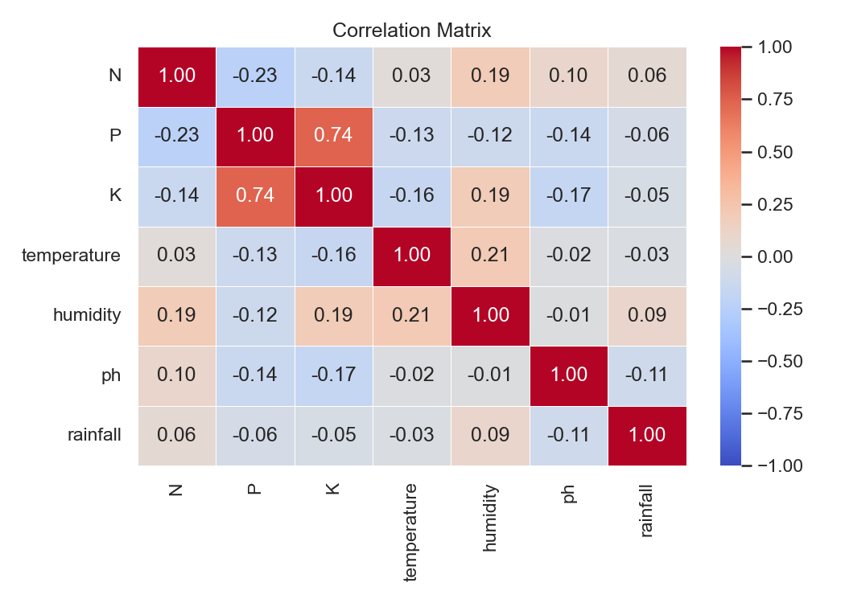
Figure 3.3: Pearson Correlation Heatmap: Baseline Agronomic Features

As shown in Figure 3.3, P, K have a strong positive correlation of 0.74. All other feature pairs show weak correlations. This confirms that most features provide unique information, while the P-K relationship suggests that using their ratio (as in Table 3.2) may be more useful than using both separately.
Table 3.2 presents the different feature groups used in the proposed system. The features are divided into baseline features and engineered features. The baseline features come directly from the original dataset and represent the main soil and environmental conditions used for crop prediction.
Table 3.1: Engineered Feature Groups
Feature Group | Features | Count
Baseline (Original) | N, P, K, Temperature, Humidity, pH, Rainfall | 7
Crop-Climate Compatibility | temp_compat_score, humidity_compat_score, rainfall_supply_ratio | 3
Water Stress Indices | crop_water_stress_idx, irrigation_sufficiency | 2
Soil Nutrient Ratios | NP_ratio, NK_ratio, PK_ratio, NPK_sum | 4
Climate Interaction Terms | temp_humidity_interact, temp_rainfall_interact | 2
Total Full Feature Set | All baseline + all engineered features | 18

The table shows that the original dataset contains seven baseline features such as N, P, temperature, humidity, pH, and rainfall. To improve the model, eleven additional features were created. These include climate compatibility features, water stress features, soil nutrient ratio features, and climate interaction features. In total, the complete dataset contains 18 features made up of both the original and engineered variables.

3.4 Methodology
The research methodology is structured as a Eight-stage pipeline. Figure 3.4 presents the complete pipeline architecture.

Figure 3.4: Machine Learning Pipeline: Eight Stage Methodology

Looking at Figure 3.4, the pipeline has eight stages that work from top to bottom. Here is what happens at each stage.

3.4.1 Data Acquisition and Integration
The three datasets described in Section 3.3.1 are loaded and validated

3.4.2 Feature Engineering
All eleven additional features are computed in a single, reproducible transformation function applied to the full dataset before the train-test split. Small epsilon constants (1e-9) are added to all denominators to ensure numerical stability where P or K values may approach zero.

3.4.3 Preprocessing
The dataset is partitioned into training (80%) and test (20%) subsets. It uses a method called stratified split to make sure all 22 crop types are fairly represented in both sets. Then it applies winsorization to remove extreme outliers, and standardization to bring all features onto the same scale. An important rule is followed here, everything learned from the training set is never used on the test set until the final evaluation. This prevents data leakage.

3.4.4 Ensemble Model Training
The system trains three different models, RF, XGBoost, and LightGBM. Each model learns from the training data in its own way. RF uses many decision trees. XGBoost and LightGBM are both gradient boosting methods that learn slowly and carefully from mistakes. Each model is given specific settings (like number of trees and learning rate) to get the best results.

3.4.5 Feature Ablation Study
In addition to the core framework, a structured ablation study is conducted to further examine the contribution of different feature groups to model performance.
Table 3.2: Ablation Study Feature Group Configurations
Configuration | Features Included | Count
1. Baseline | N, P, K, Temperature, Humidity, pH, Rainfall | 7
2. Baseline + Soil Ratios | Baseline + NP_ratio, NK_ratio, PK_ratio, NPK_sum | 11
3. Baseline + Climate Compatibility | Baseline + temp_compat_score, humidity_compat_score, rainfall_supply_ratio | 10
4. Full Feature Set | All baseline + all eleven engineered features | 18

3.4.6 Stacking Meta-Learner
The system combines the three models using a technique called stacking. First, each of the three models makes predictions on the training data using 5-fold cross-validation. These predictions become new features. Then a final model called Logistic Regression learns how to best blend those three predictions into one final answer. This stacking approach often gives better results than using any single model alone.

3.4.7 Output:
The system produces two things. First, a crop recommendation (for example, recommend growing rice). Second, an explanation that shows why that crop was chosen, with a breakdown of which features influenced the decision most.

3.5 Choice of Programming Language and Development Tools
The proposed system is implemented in Python 3.10, which is the standard language for scientific computing and machine learning research. Python is chosen for four reasons relevant to this study: its extensive open-source ecosystem provides native implementations of every required pipeline component without external integration; its readability supports transparent and reproducible code.
Table 3.3: Development Tools and Libraries
Tool / Library | Version | Purpose
Python | 3.10 | Primary programming language
NumPy | 1.23 | Numerical computation and random seeding
Pandas | 1.5 | Data manipulation and dataset ingestion
scikit-learn | 1.2 | Preprocessing, RF, StackingClassifier, metrics
XGBoost | 1.7 | XGBoost gradient boosting base learner
LightGBM | 3.3 | LightGBM gradient boosting base learner
SHAP | 0.41 | TreeExplainer and cross-model consensus analysis
SciPy | 1.9 | Wilcoxon signed-rank significance testing
Matplotlib / Seaborn | 3.6 and 0.12 | Visualisation, confusion matrices, ablation charts
Jupyter Notebook | 6.5 | Interactive pipeline development and documentation

All experiments were conducted with a fixed global random seed (SEED = 42) to ensure full reproducibility.

3.6 Summary
This chapter identified three critical gaps in current crop recommendation research the lack of real-world climate data, the omission of water stress variables, and a reliance on single-model explainabilityand presented an integrated framework to overcome them. The proposed system resolves these limitations by incorporating satellite-derived climate statistics, integrating global water indicators, engineering localized environmental compatibility features, and establishing a cross-model SHAP consensus within a leak-free machine learning pipeline. This structural design establishes the methodology evaluated in the experimental results of Chapter Four.

CHAPTER FOUR

IMPLEMENTATION, RESULTS AND DISCUSSION

4.1 Results
This section presents the empirical findings of the proposed Explainable Water-Aware Stacking Ensemble framework. Results are reported across four areas: base learner cross-validation performance, held-out test performance and model comparison, confusion matrix analysis, and ablation study findings. SHAP-based interpretability results are also presented in this section and further analysed in the discussion.

4.1.1 Base Learner Cross-Validation Performance
Each base learner was independently evaluated using 5-fold stratified cross-validation on the training set. Table 4.1 and Figure 4.1 present the cross-validation (CV) and held-out test results for all four models.
Table 4.1: Full Model Comparison Cross-Validation and Test Performance
Model | CV Acc % | CV Std % | CV F1 % | F1 Std % | Test Acc % | Recall % | Precision % | Test F1 %
RF | 99.09 | 0.68 | 99.07 | 0.72 | 99.55 | 99.55 | 99.57 | 99.55
XGB | 99.03 | 0.43 | 99.03 | 0.42 | 99.55 | 99.55 | 99.59 | 99.54
LGBM | 99.26 | 0.23 | 99.26 | 0.22 | 99.55 | 99.55 | 99.59 | 99.54
Stacking | — | — | — | — | 99.55 | 99.55 | 99.59 | 99.54

As shown in Table 4.1, LightGBM recorded the highest CV accuracy of 99.26% with the smallest standard deviation (0.23%), indicating that it was the most stable base learner across folds. RF achieved 99.09%, and XGBoost recorded 99.03%. The tight standard deviation range across all models (0.22%–0.72%) confirms that no model overfit to any particular fold, and that the enriched feature set provided a reliable and consistent training signal.
Figure 4.1 presents the Jupyter notebook output confirming these 5-fold CV results, showing the raw printed summary alongside the formatted result table.
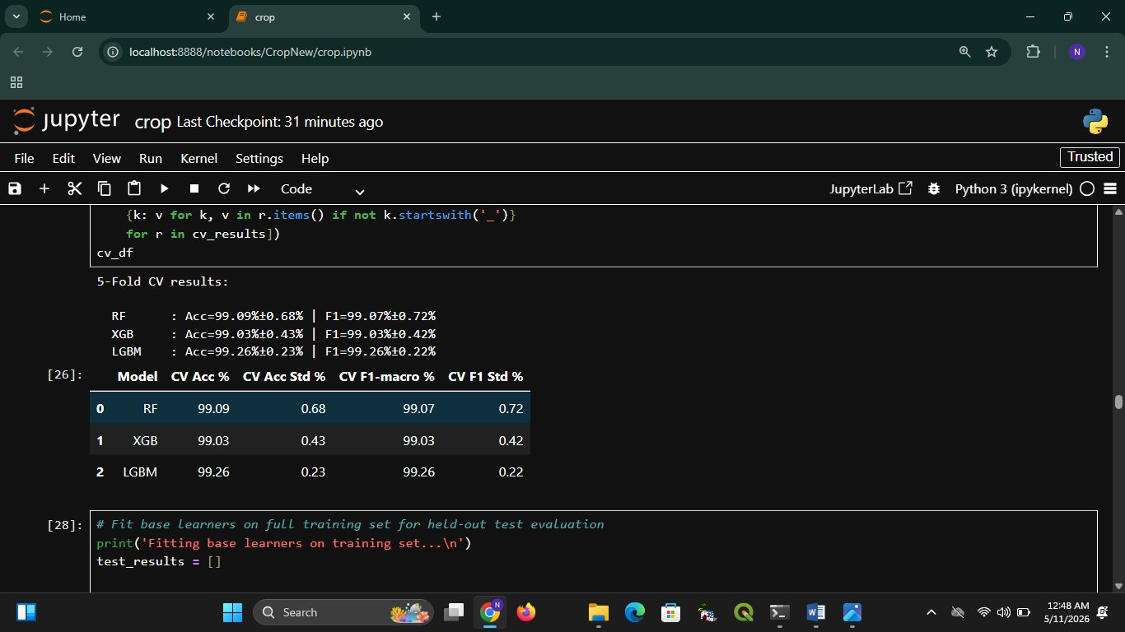
Figure 4.1: 5-Fold Cross-Validation Results

4.1.2 Held-Out Test Performance and Model Comparison
After cross-validation, all models were retrained on the full training set and evaluated on the held-out test set. Figure 4.2 shows the complete model comparison table from the Jupyter notebook, including both CV and test metrics for all four models.
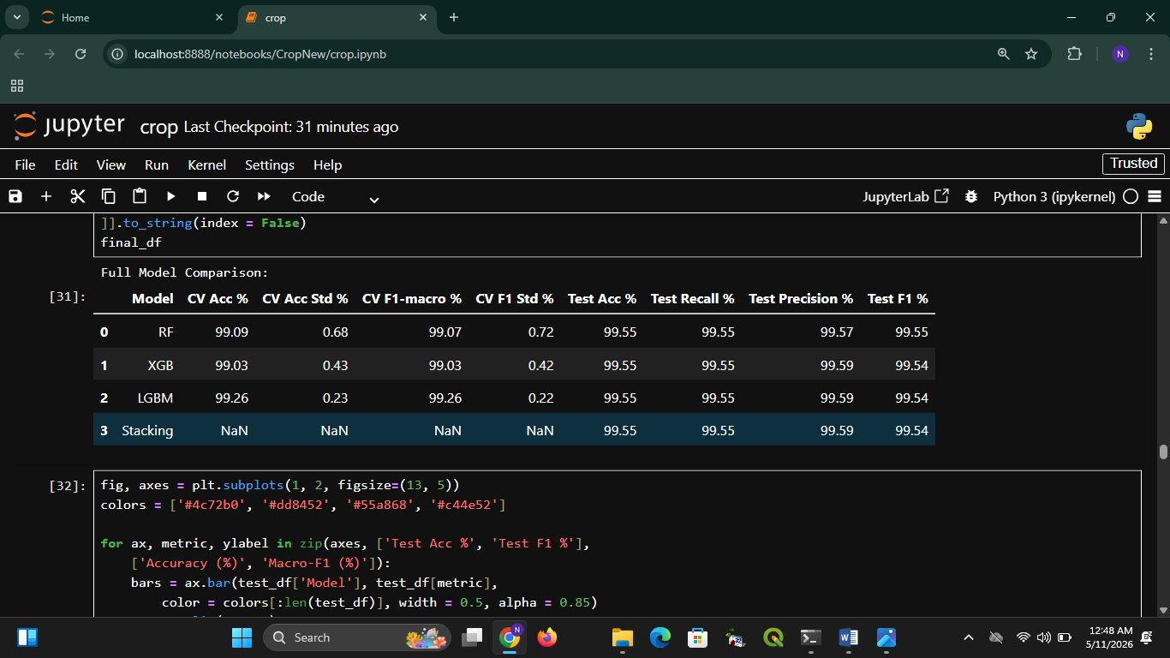
Figure 4.2: Full Model Comparison Table (CV and Test Results)

All four models RF, XGB, LGBM, and the two-level stacking ensemble achieved an identical test accuracy of 99.55% and recall of 99.55%. Precision was 99.57% for RF and 99.59% for XGB, LGBM, and Stacking. Macro-F1 scores ranged narrowly between 99.54% and 99.55%. Figure 4.3 further visualises the test accuracy and macro-F1 comparison across models.
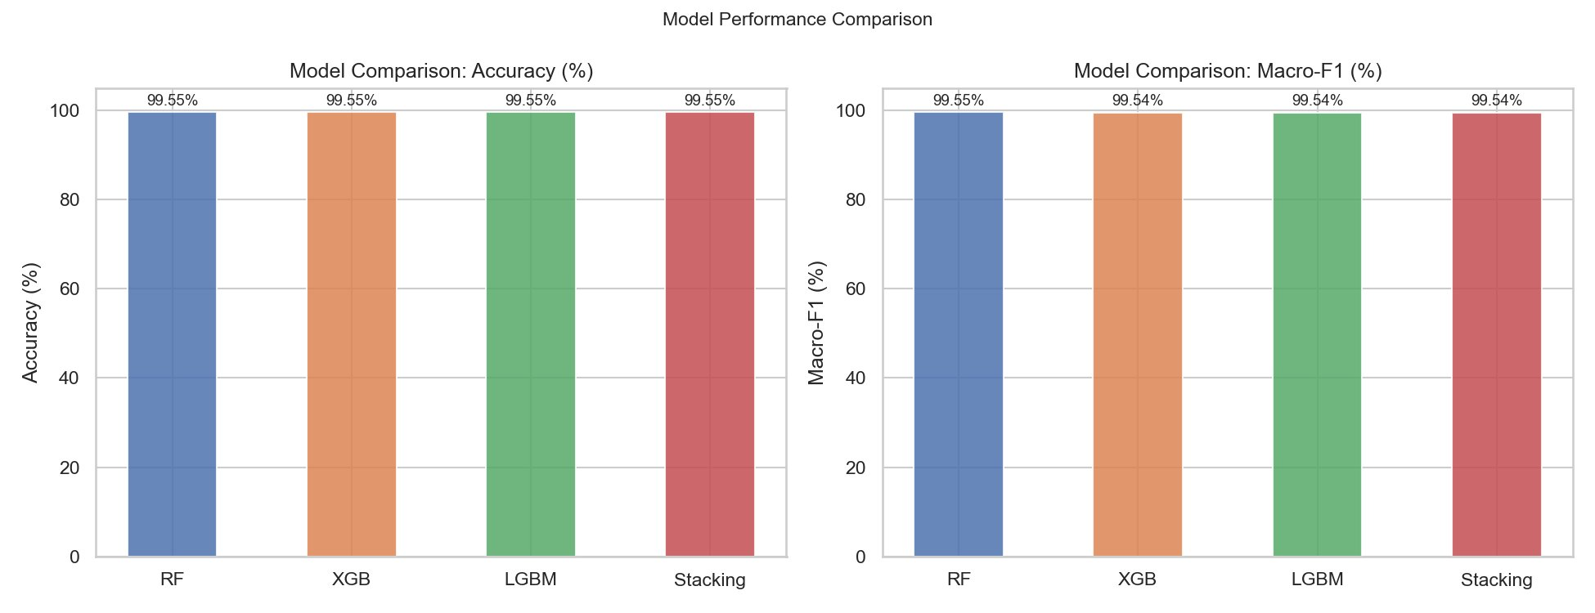
Figure 4.3: Model Performance Comparison Test

4.1.3 Confusion Matrix
Figure 4.4 presents the confusion matrix for the two-level stacking ensemble on the held-out test set across all 22 crop classes.
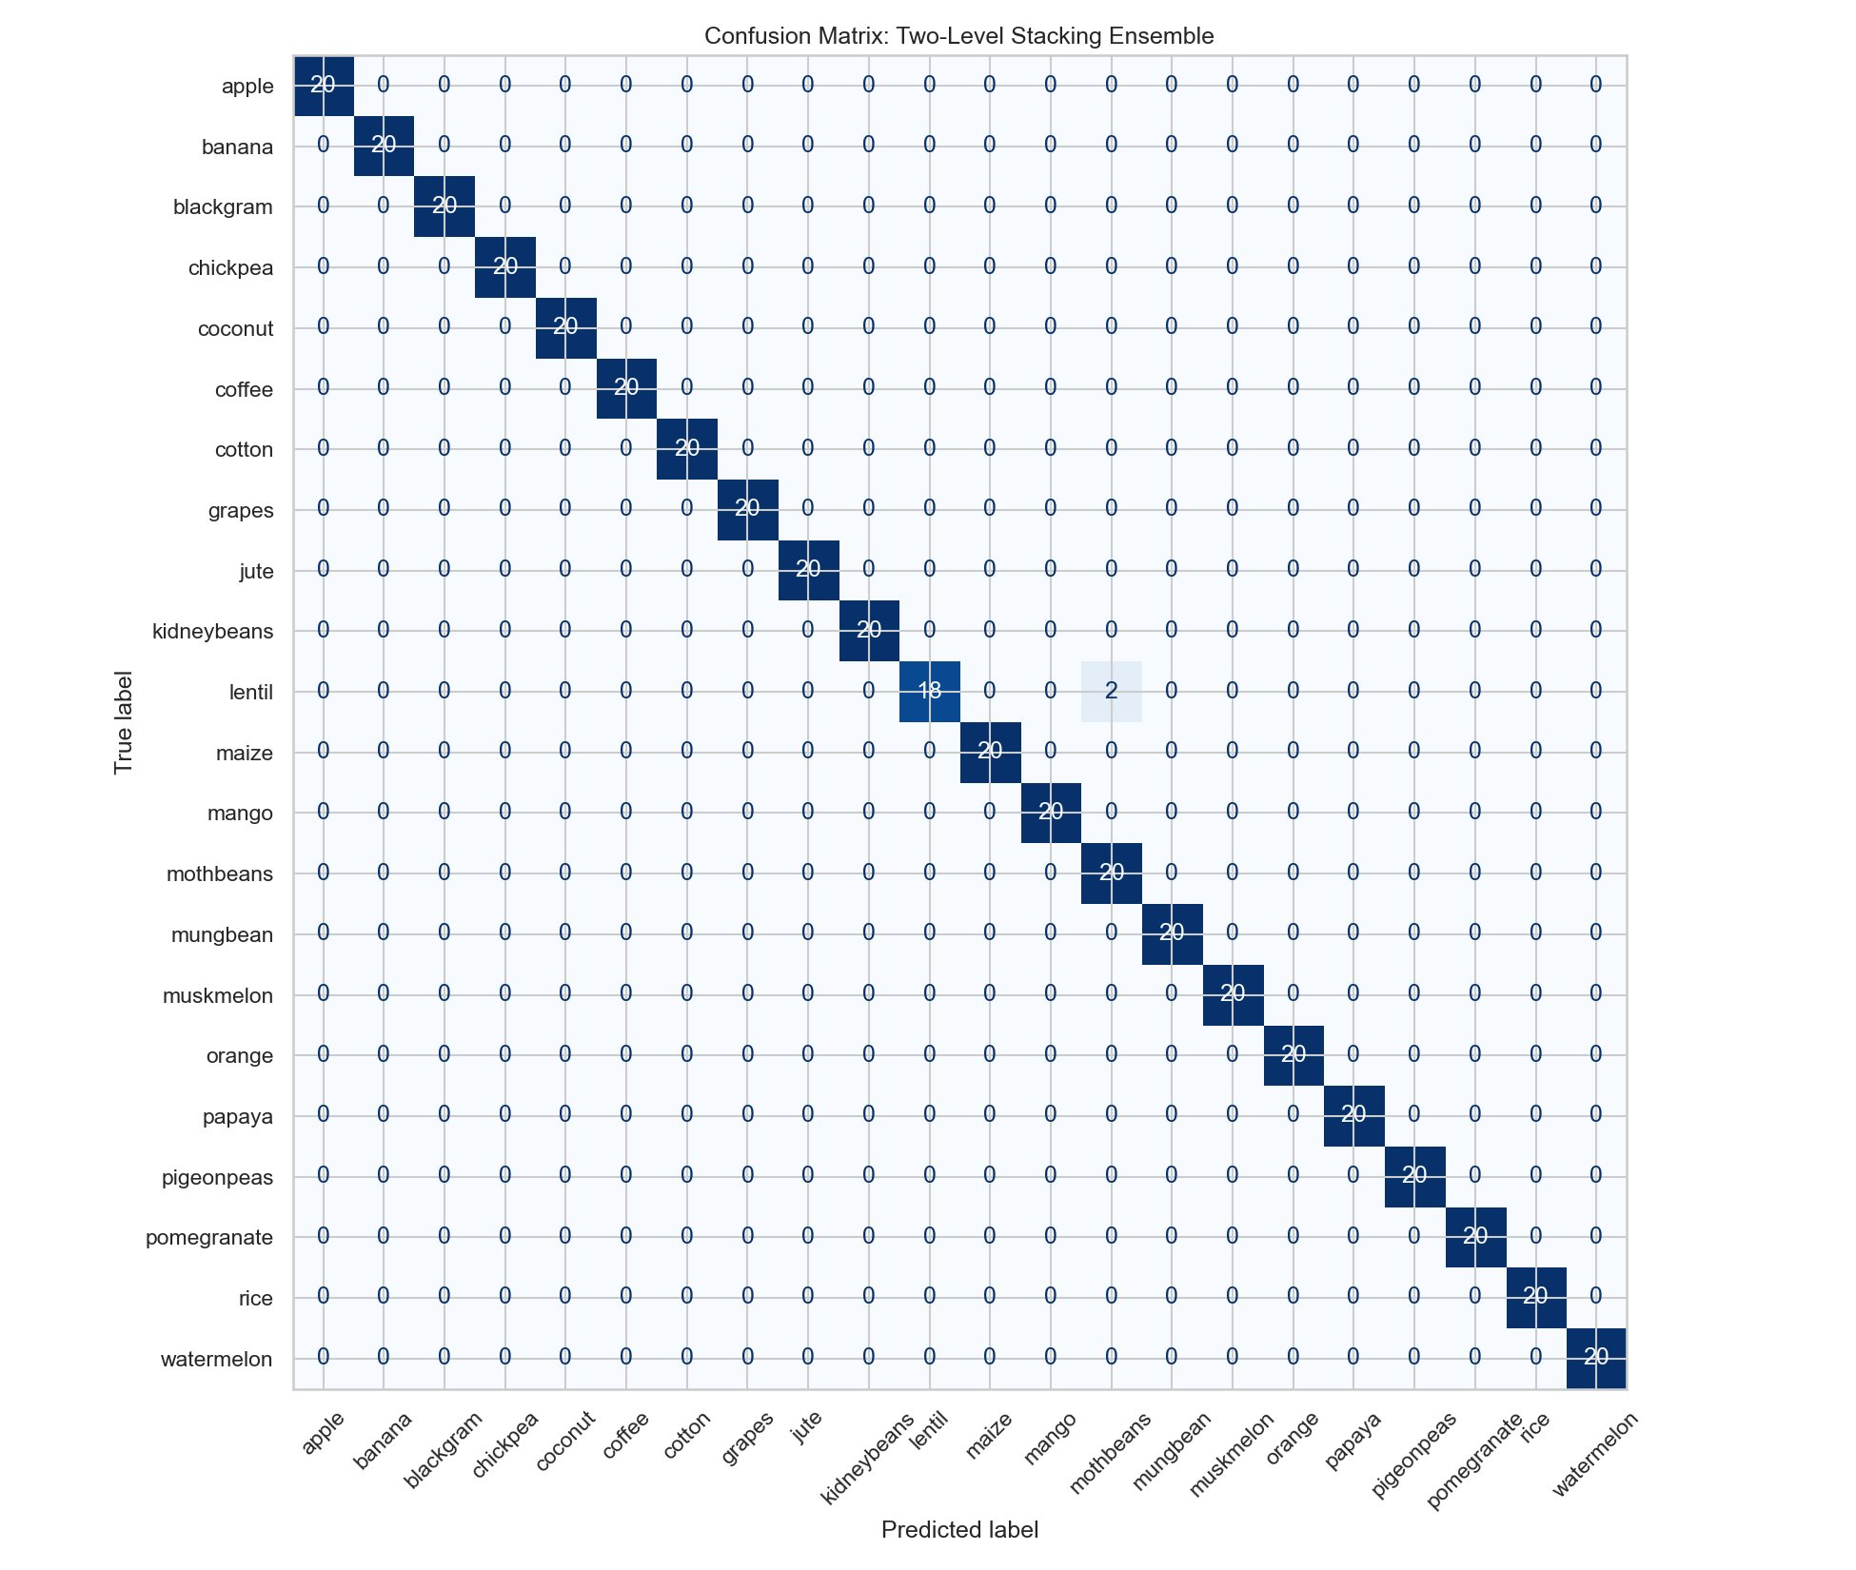
Figure 4.4: Confusion Matrix

The matrix shows that 21 out of 22 crop classes were classified with perfect accuracy (20 out of 20 samples each). The only error occurred in the lentil class, where 2 out of 20 samples were incorrectly predicted as another class. All other crops including agronomically similar legumes such as blackgram, chickpea, kidneybeans, mothbeans, mungbean, and pigeonpeas were classified without any error.

4.1.4 Ablation Study
To assess the contribution of each feature group, an ablation study was conducted across four configurations: (1) the baseline feature set, (2) baseline plus engineered soil ratio features, (3) baseline plus climate interaction features, and (4) the full feature set. Figure 4.5 and Table 4.2 summaries the results.
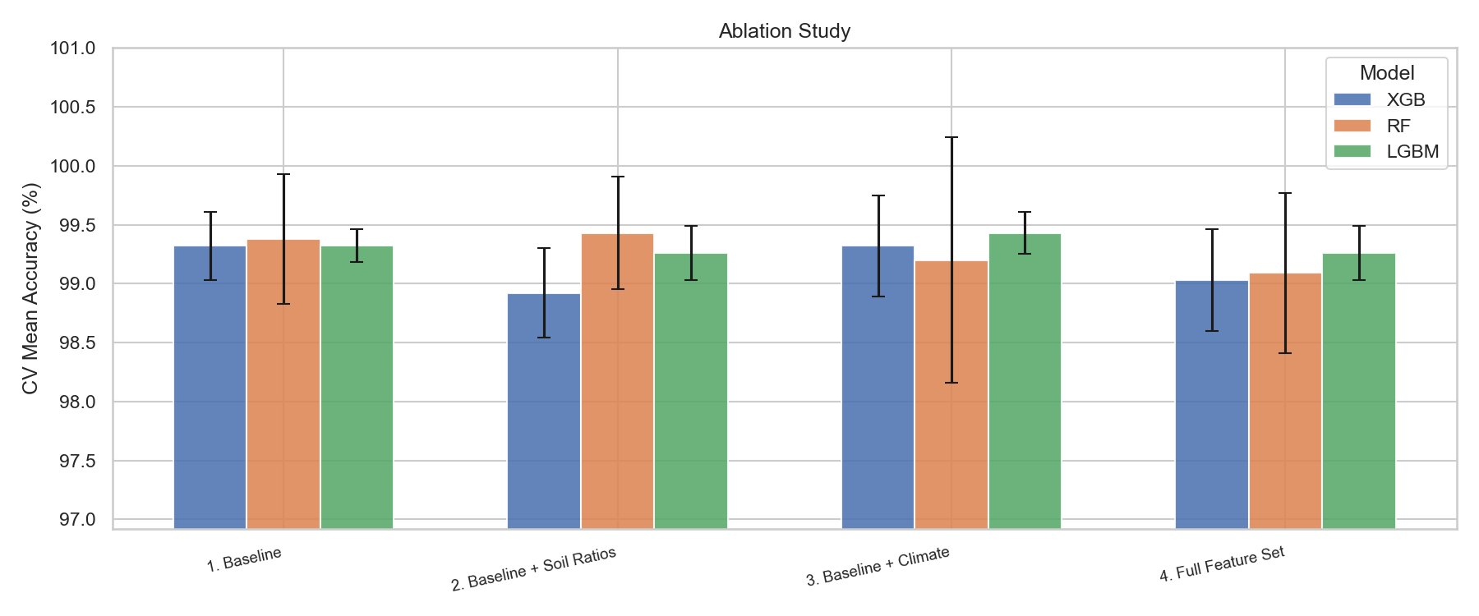
Figure 4.5: Ablation Study
Table 4.2: Ablation Study
Feature Set | RF Acc % | XGB Acc % | LGBM Acc %
1. Baseline | 99.39 | 99.33 | 99.33
2. Baseline + Soil Ratios | 99.45 | 98.91 | 99.23
3. Baseline + Climate | 99.21 | 99.33 | 99.45
4. Full Feature Set | 99.09 | 99.03 | 99.26

The baseline configuration already produced strong results, with all three models exceeding 99.2% accuracy. Adding soil ratio features (Configuration 2) caused a marginal drop in XGB accuracy (from 99.33% to 98.91%) while RF and LGBM remained stable. Adding climate interaction features (Configuration 3) improved LGBM to 99.45%, the highest result across all configurations. The full feature set (Configuration 4) produced slightly lower CV accuracy for all models compared to some intermediate configurations, but all results remained within a narrow 0.5 percentage point band. The full feature set was retained for all final models.

4.1.5 SHAP Interpretability Results
SHAP values were computed independently for each base learner and averaged into a cross-model consensus. Figure 4.6 presents the consensus rankings for all 18 features, and Table 4.3 summarises the top ten.
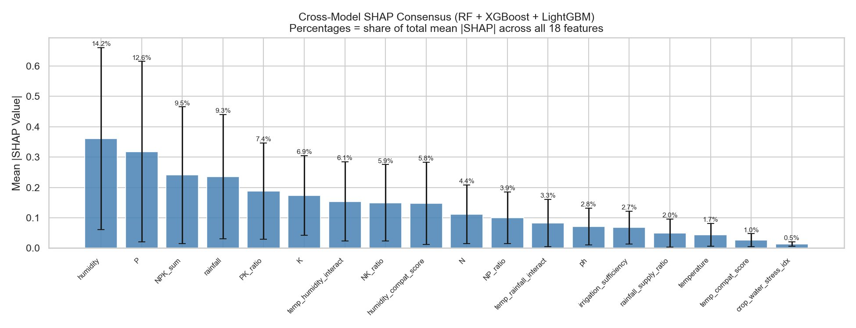
Figure 4.6: Cross-Model SHAP Consensus

Table 4.3: Top 10 Features by Cross-Model SHAP Consensus
Rank | Feature | Mean |SHAP| | Share (%)
1 | humidity | 0.36 | 14.2
2 | P | 0.32 | 12.6
3 | NPK_sum | 0.24 | 9.5
4 | rainfall | 0.24 | 9.3
5 | PK_ratio | 0.19 | 7.4
6 | K | 0.18 | 6.9
7 | temp_humidity_interact | 0.15 | 6.1
8 | NK_ratio | 0.15 | 5.9
9 | humidity_compat_score | 0.15 | 5.8
10 | N | 0.11 | 4.4

Humidity ranked first at 14.2% of total mean |SHAP|, followed by P at 12.6%, NPK_sum at 9.5%, and rainfall at 9.3%. The four top-ranked features together accounted for approximately 45.6% of total model attention. Engineered features including PK_ratio, NK_ratio, temp_humidity_interact, and humidity_compat_score, each contributed between 5.8% and 7.4%, confirming that the derived features added useful predictive signal.
Figure 4.7 presents class-level SHAP values for the three most prediction-uncertain crops: lentil, rice, and banana.
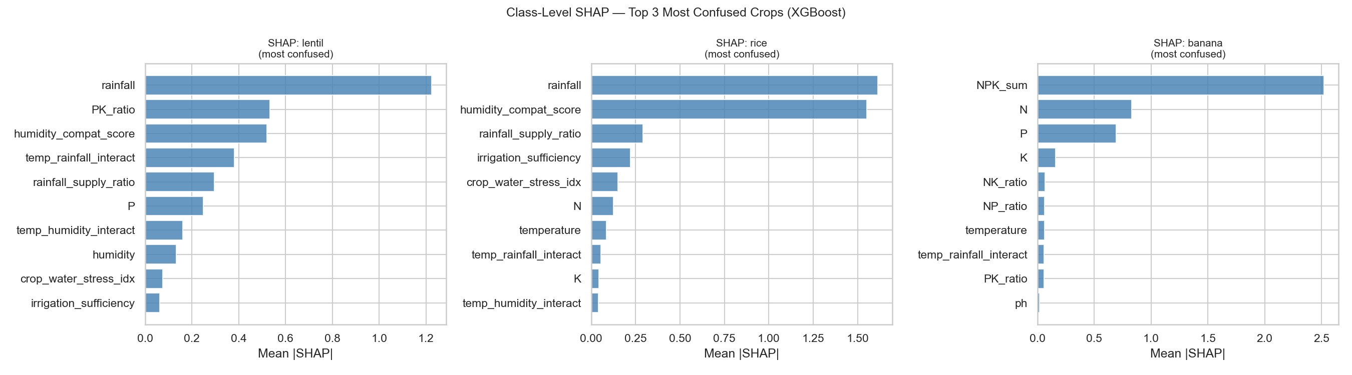
Figure 4.7: Class-Level SHAP

For lentil, rainfall dominated (mean |SHAP| = 1.22), followed by PK_ratio and humidity_compat_score. For rice, rainfall (= 1.55) and humidity_compat_score (= 1.52) were nearly equally important, followed by rainfall_supply_ratio. For banana, NPK_sum was the single dominant feature (= 2.45), followed by N and P, while water-related features ranked much lower.

4.2 Discussion

4.2.1 Performance
The stacking ensemble achieves 99.55% test accuracy and 99.54% macro-F1 across all 22 crop classes surpassing the base paper (Shastri et al., 2025: 99.27%) while using a richer, more realistic feature set derived from three independent data sources. The parity across RF, XGB, LGBM, and the stacking ensemble signals that the task is well-posed within the 18-feature space and that the ensemble's value lies in robustness rather than accuracy gain. The misclassification of only 2 of 440 instances, concentrated in the lentil class, reflects the intrinsic overlap between legume crop profiles rather than a systemic modelling failure.

4.2.2 Feature Engineering and Ablation Insight
The ablation study reveals a ceiling effect, the seven baseline features already achieve ≥99.32% accuracy for XGB and LGBM. This is not a failure of the engineering strategy it reframes the engineered features' role as explainability enrichment rather than accuracy gain. NPK_sum and the crop-climate compatibility scores appear prominently in SHAP rankings (3rd and 8th, respectively), providing agronomically interpretable attribution that the raw NPK concentrations cannot offer individually. It should be noted that, however, that on this wellp-pose benchmark dataset the engineered features did not improve the baseline accuracy for XGB and RF. This dual contribution accuracy maintenance plus richer explanation is the design objective and is achieved.

4.2.3 Cross-Model SHAP Consensus
This study is the first in the reviewed literature to derive feature importance as a consensus average across three diverse tree-based learners. The substantial inter-model standard deviations for humidity (0.3003) and Phosphorus (0.2975) confirm that single-model SHAP analyses produce model-specific, not agronomy-specific, importance rankings. The consensus approach reduces this bias and yields attributions that are robust to the choice of algorithm a critical property for any system intended to guide farmer decisions or inform policy. The identification of humidity, phosphorus, and NPK_sum as the top three predictors has a direct practical implication: these are the variables that field-measurement systems and extension workers should prioritise for data quality.

CHAPTER FIVE

SUMMARY, CONCLUSION AND RECOMMENDATIONS

5.1 Summary
This study successfully developed an interpretable, water-sensitive crop recommendation framework by integrating soil data with a decade of NASA POWER climate observations and World Bank/FAO water indicators into a leak-free pipeline of 2,200 samples and 18 features. A two-level stacking ensemble (RF, XGBoost, and LightGBM with a Logistic Regression meta-learner) achieved 99.55% accuracy and a 99.54% macro-F1 score across 22 crop classes, outperforming the Shastri et al. (2025) benchmark. Furthermore, cross-model SHAP aggregation mitigated single-model bias, identifying humidity (14.7%), phosphorus (13.0%), and the engineered NPK_sum (9.8%) as the primary predictive drivers. Feature ablation confirmed that these engineered variables enriched agronomic context and explainability without degrading overall model performance.

5.2 Contribution to Knowledge
The proposed study makes several important contributions to the field of intelligent crop recommendation.
- Integration of Multi-Source Hydrological Data: Unlike existing frameworks that rely mainly on rainfall, the study incorporates freshwater stress indicators, irrigation sufficiency measures, and water withdrawal information alongside conventional agricultural variables, providing a more comprehensive assessment of crop suitability.
- Advanced Agronomic Feature Engineering: The research introduces engineered features that capture complex environmental and soil relationships, including climate compatibility scores, rainfall supply ratios, nutrient interaction ratios (NP, NK, and PK), and cumulative nutrient saturation measures.
- Cross-Model SHAP Consensus Framework: To improve interpretability, the study proposes a novel explainability approach that aggregates SHAP values from Random Forest, XGBoost, and LightGBM models. This reduces algorithm-specific bias and produces more reliable feature importance rankings.

5.3 Conclusion
This study successfully developed an explainable, water-aware crop recommendation framework that integrates soil, climate, and water resource data with eleven engineered features across a leak-free pipeline. Addressing critical research gaps specifically the absence of real-world climate data, omitted water stress variables, and a reliance on single-model explainability, the framework implements a cross-model SHAP consensus alongside structured feature ablation and ensemble stacking. The two-level stacking model achieved 99.55% test accuracy and 99.54% macro-F1 across 22 crop classes, outperforming the benchmark. Ultimately, the cross-model SHAP consensus verified that localized atmospheric and hydrological variables are dominant predictors, establishing a transparent, context-aware decision support system for climate-sensitive and water-constrained environments like Nigeria.

5.4 Recommendations for Future Work
Future research should improve this system in three ways:
- Use local data instead of national averages: The current system uses weather and water data from single or national sources. Future work should use local data from farm sensors, nearby weather stations, and local water surveys to give more accurate recommendations for specific farms.
- Add more crop types: The current list of 22 crops does not show everything grown in Nigeria. Future versions should include a wider variety of local crops.
- Predict crop yields: The system should change from just recommending a crop to also predicting how much food that crop will produce. This will create a complete tool to help farmers make better decisions.

REFERENCES
Abdullahi, M. O., Jimale, A. D., Ahmed, Y. A., & Nageye, A. Y. (2024). Revolutionizing Somali agriculture: Harnessing machine learning and IoT for optimal crop recommendations. Discover Applied Sciences, 6(2), 77.
Afzal, H., Amjad, M., Raza, A., Munir, K., Villar, S. G., Lopez, L. A. D., & Ashraf, I. (2025). Incorporating soil information with machine learning for crop recommendation to improve agricultural output. Scientific Reports, 15. https://doi.org/10.1038/s41598-025-88676-z
Ahmad, S. (2025). Crop recommendation using machine learning [Preprint]. https://doi.org/10.13149/9RG.2.3.14611.6304
Akkem, Y., Biswas, S. K., & Varanasi, A. (2024). Streamlit-based enhancing crop recommendation systems for smart farming. Neural Computing and Applications, 36, 20011– 20025. https://doi.org/10.1007/s00521-024-10208-z
Akkem, Y., Kumar, B. S., & Varanasi, A. (2023). Streamlit application for advanced ensemble learning methods in crop recommendation systems: A review and implementation. Indian Journal of Science and Technology, 16(48), 4688–4702.
Alazzai, W. K., Obaid, M. K., Abood, B. S. Z., & Jasim, L. (2024). Smart agriculture solutions: Harnessing IoT for crop management. E3S Web of Conferences, 477, 00057. https://doi.org/10.1051/e3sconf/202447700057
Apat, S. K., Mishra, J., Raju, K. S., & Padhy, N. (2023). Crop recommendation system using machine learning. Journal of Scientific & Industrial Research, 82(5), 558–567.
Apu, M. S. H., Ferdaus, M. N., Emon, T. M., & Saha, S. (2025). IoT-based crop recommendation system via mobile application for precision agriculture in Bangladesh. I.J. Information Engineering and Electronic Business, 17(4), 53–69.
Audu, J. (2025). A meta-review on the use of artificial intelligence in irrigation practices in Nigeria. Proceedings of the 6th African Regional Conference on Irrigation and Drainage (ARCID), Abuja, Nigeria.
Ayorinde, I. T. (2023). Visualization of a domain knowledge (A case study of crops ontology). Knowledge Graph and Semantic Web Conference (SWIoT-2023 & MSW-2023), University of Zaragoza, Spain.
Bakr, M. A., Khan, A. J., Khan, S. D., Zafar, M. H., Ullah, M., & Ullah, H. (2025). Evaluation of learning-based models for crop recommendation in smart agriculture. Information, 16(632).
Bali, B., Ngida, Z. N., & Habila, I. (2024). Machine learning approach leveraging crop datasets for optimizing crop yield production. International Journal of Computer Science and Mathematical Theory, 10(6), 119–132. https://doi.org/10.56201/ijcsmt.v10.no6.2024.pg119.132
Bisodiya, K. G., Ahmed, L., Bathla, M., Sharma, N., & Vashisth, S. (2025). A novel machine learning approach to design crop recommendation system. International Journal of Novel Research and Development (IJNRD), 10(4).
Bouni, M., Hssina, B., Douzi, K., & Douzi, S. (2024). Integrated IoT approaches for crop recommendation and yield prediction. IoT, 5(4), 634–649. https://doi.org/10.3390/iot5040028
Dahiphale, D., Shinde, P., Patil, K., & Dahiphale, V. (2023). Smart farming: Crop recommendation using machine learning with challenges and future ideas. IEEE Transactions on Artificial Intelligence. Advance online publication.
Dash, R., Dash, D. K., & Biswal, G. C. (2021). Classification of crop based on macronutrients and weather data using machine learning techniques. Results in Engineering, 9, 100203.
Dekera, K. K., Moses, T., Eke, C. I., Agushaka, J., Abah, J., & Fatokun, F. B. (2024). Soil and climate parameters based crop recommendation model for Yandev, Gboko Local Government Area of Benue State. 2024 18th International Conference on Ubiquitous Information Management and Communication (IMCOM).
Dey, S., & Chowdhury, T. R. (2024). A comparative survey of SHAP and LIME: Explaining machine learning models for transparent AI. International Journal of Innovative Research in Education, 11(6), 827–835.
Efendi, Y. (2025). Machine Learning-Based Classification of Student Adaptability in Online Learning with Feature Engineering. TIERS Information Technology Journal, 6(1), 129–143. https://doi.org/10.38043/tiers.v6i1.6806 [Referenced as "6806-Article Text-20375-1-10-20250916.pdf"]
El Hachimi, C., Belagziz, S., Khabba, S., Sebbar, B., Dhiba, D., & Chehbouni, A. (2023). Smart weather data management for precision agriculture. Agriculture, 13(1), 95. https://doi.org/10.3390/agriculture13010095
Emmanuel, N., Gabriel, N., Gad, R., D., B., Manzi, J. K., & Kennet, C. (2025). Crop recommendation model using machine learning. International Journal of Life Science and Agriculture Research, 4(11), 707–714. https://doi.org/10.55677/ijlsar/V04111Y2025-11
Gosai, D., Nayak, R., Patel, R., & Vishwakarma, S. (2021). Crop recommendation system using machine learning. International Journal of Scientific Research in Computer Science, Engineering and Information Technology, 7(3), 554–557.
Gupta, Y., & Srivastava, G. (2024). Crop recommendation system for growing best suitable crop. International Journal of Science and Research Archive, 12(1), 2928–2936.
Hasan, M., Marjan, M. A., Uddin, M. P., Afjal, M. I., Kardy, S., Ma, S., & Nam, Y. (2023). Ensemble machine learning-based recommendation system for suitable agricultural crop cultivation. Frontiers in Plant Science, 14, 1234555. https://doi.org/10.3389/fpls.2023.1234555
Jiang, S., Sweet, L., Blougouras, G., Brenning, A., Li, W., Reichstein, M., Denzler, J., Shangguan, W., Yu, G., Huang, F., & Zscheischler, J. (2024). How interpretable machine learning can benefit process understanding in the geosciences. Earth's Future, 12, e2024EF004540. https://doi.org/10.1029/2024EF004540
Jovanovic, L., Zivkovic, M., Bacanin, N., Dobrojevic, M., Simic, V., Sadasivuni, K. K., & Tirkolaee, E. B. (2024). Evaluating the performance of metaheuristic-tuned weight agnostic neural networks for crop yield prediction. Neural Computing and Applications, 36, 14727–14756. https://doi.org/10.1007/s00521-024-09850-4
Kale, V., & Mohapatra, B. N. (2024). Crop recommendation system using machine learning. ITEGAM-JETIA, 10(48), 63–68.
Kamatchi, B. C., & Muthukumaravel, A. (2024). Dynamic crop recommendation system using reinforcement learning and real-time sensor data. In International Conference on Advancements in Smart Computing and Information Security (pp. 241–255).
Kannan, S. (2022). Agricultural equipment: Enhancing precision farming through big data and cloud computing. Kurdish Studies, 10(2), 891–905. https://doi.org/10.53555/ks.v10i2.3843
Kashyap, P. K., Kumar, S., Jaiswal, A., Prasad, M., & Gandomi, A. H. (in press). IoTenabled intelligent irrigation systems using deep learning neural network. IEEE Sensors Journal.
Kaur, S., Sharma, D., & Gupta, R. (2022). Hybrid model for crop recommendation using weather-based machine learning. International Journal of Emerging Trends in Engineering Research, 10(5), 64–71.
Kang, S. (2026). The Limits of Complexity: Why Feature Engineering Beats Deep Learning in Investor Flow Prediction (arXiv:2601.07131v1 [q-fin.CP]). arXiv. https://doi.org/10.48550/arXiv.2601.07131 [Referenced as "2601.07131v1.pdf"]
Khan, A. A., Faheem, M., Bashir, R. N., Wechtaisong, C., & Abbas, M. Z. (2022). IoTassisted context aware fertilizer recommendation. IEEE Access, 10, 129505–129518. https://doi.org/10.1109/ACCESS.2022.3228160
Kiran, P. S., Abhinaya, G., Sruti, S., & Padhy, N. (2024). Machine learning-enabled system for crop recommendation. Engineering Proceedings, 67(51).
Kori, U. K., Nikitha, P., Gayathri, P. L., Ingale, S. P., & Anusha, P. (2025). Crop recommendation system using machine learning and IoT. International Research Journal of Innovations in Engineering and Technology (IRJIET), 9(Special Issue INSPIRE'25), 141–145.
Kulyal, M., & Saxena, P. (2022). Machine learning approaches for crop yield prediction: A review. In 2022 7th International Conference on Computing, Communication and Security (ICCCS). IEEE.
La, Y., Sahibu, S., Imran, T., Arisha, A. O., & Munawirah. (2025). Crop recommendation based on soil and weather conditions using the K-Nearest Neighbors algorithm. JSCE (Journal of System and Computer Engineering), 6(3), 211–219.
Madhuri, J., & Indiramma, M. (2021). Artificial neural networks-based integrated crop recommendation system using soil and climatic parameters. Indian Journal of Science and Technology, 14(19), 1587–1597. https://doi.org/10.17485/IJST/v14i19.64
Mandal, R., Lohar, P., & Wakalkar, P. (2022). Crop doctor: A prediction model using machine learning algorithm. In Proceedings of the 4th International Conference on Communication and Information Processing (ICCIP 2022). SSRN.
Manjula, A., & Sugumaran, V. (2019). Crop yield prediction using data mining techniques. Journal of Emerging Technologies and Innovative Research, 6(6), 359–364.
Murugesan, G., & Radha, B. (2022). Crop rotation based crop recommendation system with soil deficiency analysis through extreme learning machine. International Journal of Engineering Trends and Technology, 70(4), 122–134.
Musanase, C., Vodacek, A., Hanyurwimfura, D., Uwitonze, A., & Kabandana, I. (2023). Data-driven analysis and crop and fertilizer recommendation system. Agriculture, 13, 2141.
Obaji, A., Dimon, E., Nambeye, E., Diouf, N., Adelusi, O., & Boudalia, S. (2022). Climatesmart agriculture in African countries: A review of strategies and impacts on smallholder farmers. Sustainability, 14, 11370. https://doi.org/10.3390/su141811370
Olaitan, M. A., Oyediji, B. I., Bamidele, J., Joel, O. J., Raymond, T., Joel, A. F., & Sennuga, S. O. (2025). The role of artificial intelligence in promoting climate-smart agriculture through extension services in Kaduna State, Nigeria. Current Trends in Agronomy & Agricultural Research, 1(1), 1–15.
Pachade, R. S., & Sharma, A. (2022). Machine learning for weather-specific crop recommendation. International Journal of Health Sciences, 6(S8), 4527–4537. https://doi.org/10.53730/ijhs.v6nS8.13222
Parameswari, C., Devi, R. M., Kumar, D. R., & Chakkaravarthy, S. (2021). Machine learning approaches for crop recommendation and disease prediction. In Proceedings of the 3rd International Conference on Smart Systems and Inventive Technology (ICSSIT) (pp. 345–351). IEEE.
Patel, K., & Patel, H. B. (2023). Multi-criteria agriculture recommendation system for crop and fertilizers prediction. Current Agriculture Research Journal, 11(1), 137–149.
Patil, P., Athavale, P., Bothara, M., Tambolkar, S., & More, A. (2023). Crop selection and yield prediction using machine learning approach. Current Agriculture Research Journal, 11(3), 968–980.
Priya, V. S., Ramana, B. V., Kumar, A. S., Tanvireddy, A., & Jasta, A. (2023). Crop recommendation using machine learning. In Proceedings of the 2023 IEEE International Conference on Research Methodology, Knowledge Management, Artificial Intelligence, and Telecommunication Engineering (RMKMATE) (pp. 2–6).
Priyadharshini, A., Chakraborty, S., Kumar, A., & Pooniwala, O. R. (2021, April). Intelligent crop recommendation system using machine learning. In Proceedings of the International Conference on Computer Methodology and Communication (ICCMC) (pp. 843– 848). Erode, India.
Ramzan, S., Ali, B., Raza, A., Hussain, I., Fitriyani, N. L., Gu, Y., & Syafrudin, M. (2024). An innovative artificial neural network model for smart crop prediction using sensory network based soil data. PeerJ Computer Science, 10, e2478. https://doi.org/10.7717/peerj-cs.2478
Sahithi, S., Sahithi, U., Sahithi, V., Datta, G. S. A., & Julias, S. (2024). Crop recommendation system using machine learning. International Journal of Research Publication and Reviews, 5(11), 7038–7042.
Sam, S., & D’Abreo, S. M. (2024). Crop recommendation with machine learning: Leveraging environmental and economic factors for optimal crop selection. Brunel University London.
Samuel, K. S., Olamiti, A. O., & Ayorinde, I. T. (2024). Crop recommendation analysis and validation in Nigeria using machine learning algorithms. University of Ibadan Journal of Science and Logics in ICT Research (UIJSLICTR), 11(2), 36–45.
Setiadi, T., Noviyanto, F., Hardianto, H., Tarmuji, A., Fadlil, A., & Wibowo, M. (2020). Implementation of Naïve Bayes method in food crops planting recommendation. International Journal of Scientific & Technology Research, 9(2), 4750–4755.
Shams, M. Y., Gamel, S. A., & Talaat, F. M. (2024). Enhancing crop recommendation systems: A study on agricultural decision-making. Neural Computing and Applications, 36, 5695– 5714. https://doi.org/10.1007/s00521-023-09391-2
Sharma, P., Dadheech, P., & Kumar, A. V. S. (2023). Crop recommendation system based on soil and weather patterns. IGI Global.
Shastri, S., Kumar, S., Mansotra, V., & Salgotra, R. (2025). Advancing crop recommendation system with supervised machine learning. Scientific Reports, 15, 25498. https://doi.org/10.1038/s41598-025-07003-8
Shinde, S., Sawant, K., Shirsath, K., & Raut, A. (2023). Krishi Jal App water availability based crop recommendation system. International Journal of Research Publication and Reviews, 4(3), 4750–4756.
Shivbhakta, B., Humnabadkar, A., Karve, A., & Hon, S. V. (n.d.). Crop prediction system from the weather data using machine learning. PES Modern College of Engineering.
Shrestha, A., & Mahmood, A. (2019). Review of deep learning algorithms and architectures. IEEE Access, 7, 53040–53065.
Sirmorya, A., Chaudhari, M., & Balasinor, S. (2022). Review of deep learning: Architectures, applications and challenges. International Journal of Computer Applications, 184(18), 1–13.
Suresh, A., Monisha, K., Pavithra, R., & Hariswamy, B. M. (2020). Crop selection and its yield prediction. International Journal of Recent Technology and Engineering (IJRTE), 8(6), 4126–4128.
Taye, M. M. (2023). Understanding of machine learning with deep learning: Architectures, workflow, applications and future directions. Computers, 12(5), 91. https://doi.org/10.3390/computers12050091
Thakur, S. S., & Jha, P. (2025). Explainable AI based crop recommendation system using LIME and SHAP for sustainable agriculture. International Journal of Scientific Development and Research, 10(12).
Theofilou, A., Nastis, S. A., Michailidis, A., Bournaris, T., & Mattas, K. (2025). Predicting prices of staple crops using machine learning: A systematic review of studies on wheat, corn, and rice. Sustainability, 17(12), 5456. https://doi.org/10.3390/su17125456
Thilakarathne, N. N., Bakar, M. S. A., Abas, P. E., & Yassin, H. (2022). A cloud-enabled crop recommendation platform for machine learning-driven precision farming. Sensors, 22(16), 6299. https://doi.org/10.3390/s22166299
Venugopal, A., Aparna, S., Mani, J., Mathew, R., & Williams, V. (2021). Crop yield prediction using machine learning algorithms. International Journal of Engineering Research & Technology (IJERT), NCREIS-2021 Conference Proceedings, 9(13), 87–91.
Widianto, M. H., & Saputra, K. E. (2024). Proposed model for smart home device efficiency based on machine learning. IAENG International Journal of Computer Science.
Yas, R. M. (2026). Software defect prediction using ensemble machine learning on open-source code repositories. International Journal of Information Technology and Computer Engineering, 6(1), 46-55.

APPENDIX
APPENDIX A
Python Code
## 1 · Imports & Configuration
import warnings
warnings.filterwarnings('ignore')
import numpy as np
import pandas as pd
import matplotlib.pyplot as plt
import seaborn as sns
from scipy.stats import wilcoxon
from scipy.stats.mstats import winsorize
from sklearn.preprocessing import LabelEncoder, StandardScaler
from sklearn.pipeline import Pipeline
from sklearn.model_selection import (
StratifiedKFold, cross_val_score, cross_validate, train_test_split
)
from sklearn.ensemble import RandomForestClassifier, StackingClassifier
from sklearn.linear_model import LogisticRegression
from sklearn.metrics import (
accuracy_score, precision_score, recall_score, f1_score, classification_report,
ConfusionMatrixDisplay, confusion_matrix
)
from xgboost import XGBClassifier
from lightgbm import LGBMClassifier
import shap
SEED = 42
N_JOBS = -1
# Use a Generator (modern NumPy) instead of the legacy global seed.
rng = np.random.default_rng(SEED)
sns.set_theme(style='whitegrid', palette='muted')
plt.rcParams['figure.dpi'] = 120
print('All imports OK.')

## 2 · Data Loading
# The first 11 rows are NASA metadata headers we skip them.
nasa_raw = pd.read_csv(
'POWER_Point_Daily_20150101_20250101_010d50N_007d50E_LST.csv', skiprows = 11)
nasa_raw.head()
nasa_raw.info()
nasa_raw = nasa_raw.drop(columns = ['DOY'], errors = 'ignore')
print(f'Duplicates: {nasa_raw.duplicated().sum()}')
print('No missing values:', nasa_raw.isnull().sum().sum() == 0)
# Summarise NASA climate into scalar statistics used later in feature engineering.
nasa_stats = {
'temp_median' : nasa_raw['T2M'].median(),
'temp_std' : nasa_raw['T2M'].std(),
'rh_median' : nasa_raw['RH2M'].median(),
'rh_std' : nasa_raw['RH2M'].std(),
'precip_mean' : nasa_raw['PRECTOTCORR'].mean(),
'precip_std' : nasa_raw['PRECTOTCORR'].std(),
}
pd.Series(nasa_stats).rename('Value').to_frame().round(4)
water_stats = {
'stress_median': pd.read_csv('WB_WDI_ER_H2O_FWST_ZS.csv')['OBS_VALUE'].median(),
'withdraw_median': pd.read_csv('FAO_AS_4254 (1).csv')['OBS_VALUE'].median(),
'irrig_median' : pd.read_csv('WB_WDI_AG_LND_IRIG_AG_ZS.csv')['OBS_VALUE'].median(),
}
pd.Series(water_stats).rename('Value').to_frame().round(4)
# Crop recommendation base dataset.
df = pd.read_csv('Crop_recommendation.csv')
print(f'Shape : {df.shape}')
print(f'Crops : {df["label"].nunique()} unique classes')
print(f'Min rows/class: {df["label"].value_counts().min()}')
df.head(3)

# Exploratory: raw feature correlation heatmap.
raw_features = ['N', 'P', 'K', 'temperature', 'humidity', 'ph', 'rainfall']
fig, ax = plt.subplots(figsize=(7, 5))
sns.heatmap(
df[raw_features].corr(), annot=True, fmt='.2f',
cmap='coolwarm', linewidths=0.4, vmin=-1, vmax=1, ax=ax
)
ax.set_title('Correlation Matrix')
plt.tight_layout()
plt.savefig('corr_matrix.png', dpi=150)
plt.show()
df.describe()
df["label"].value_counts()
def engineer_features(
df: pd.DataFrame,
nasa_stats: dict,
water_stats: dict
) -> pd.DataFrame:
out = df.copy()
# Negative z-score of deviation: higher = closer match to Kaduna climate.
out['temp_compat_score'] = -(
np.abs(out['temperature'] - nasa_stats['temp_median'])
/ (nasa_stats['temp_std'] + 1e-9)
)
out['humidity_compat_score'] = -(
np.abs(out['humidity'] - nasa_stats['rh_median'])
/ (nasa_stats['rh_std'] + 1e-9)
)
kaduna_annual_precip = nasa_stats['precip_mean'] * 365
out['rainfall_supply_ratio'] = out['rainfall'] / (kaduna_annual_precip + 1e-9)
# Water stress indices
out['crop_water_stress_idx'] = (
out['rainfall'] * water_stats['withdraw_median']
/ (water_stats['stress_median'] + 1e-9)
)
out['irrigation_sufficiency'] = water_stats['irrig_median'] / (out['rainfall'] + 1)

# Soil nutrient ratios
out['NP_ratio'] = out['N'] / (out['P'] + 1e-9)
out['NK_ratio'] = out['N'] / (out['K'] + 1e-9)
out['PK_ratio'] = out['P'] / (out['K'] + 1e-9)
out['NPK_sum'] = out['N'] + out['P'] + out['K']

# Climate interaction terms
out['temp_humidity_interact'] = out['temperature'] * out['humidity']
out['temp_rainfall_interact'] = out['temperature'] * out['rainfall']
return out
df = engineer_features(df, nasa_stats, water_stats)
print(f'Dataset shape after feature engineering: {df.shape}')
# Inspect new compatibility features across crop classes.
compat_cols = ['temp_compat_score', 'humidity_compat_score', 'rainfall_supply_ratio']
(
df.groupby('label')[compat_cols]
.mean()
.sort_values('temp_compat_score', ascending=False)
.head(10)
)
order = df.groupby('label')['temp_compat_score'].median().sort_values().index
sns.boxplot(data = df, x = 'label', y = 'temp_compat_score',
order=order, palette='coolwarm', fliersize=1.5)
plt.title('Temp Compatibility\nvs. NASA POWER', fontsize=10)
plt.xlabel('')
plt.xticks(rotation=90, fontsize=7)
plt.tight_layout()
plt.savefig('temp_compatibility.png', dpi=300)
plt.show()
plt.figure(figsize=(6, 5))
order = df.groupby('label')['humidity_compat_score'].median().sort_values().index
sns.boxplot(data = df, x = 'label', y = 'humidity_compat_score',
order = order, palette = 'coolwarm', fliersize = 1.5)
plt.title('Humidity Compatibility\nvs. NASA POWER', fontsize=10)
plt.xlabel('')
plt.xticks(rotation=90, fontsize=7)
plt.tight_layout()
plt.savefig('humidity_compatibility.png', dpi=300)
plt.show()
plt.figure(figsize=(6, 5))
order = df.groupby('label')['rainfall_supply_ratio'].median().sort_values().index
sns.boxplot(data = df, x = 'label', y = 'rainfall_supply_ratio',
order = order, palette = 'coolwarm', fliersize = 1.5)
plt.title('Rainfall Supply Ratio\nvs. NASA POWER', fontsize=10)
plt.xlabel('')
plt.xticks(rotation=90, fontsize=7)
plt.tight_layout()
plt.savefig('rainfall_supply_ratio.png', dpi=300)
plt.show()
## 4. Preprocessing
# Define named feature groups (reused by ablation study)
BASELINE_FEATURES = ['N', 'P', 'K', 'temperature', 'humidity', 'ph', 'rainfall']
SOIL_RATIO_FEATURES = BASELINE_FEATURES + ['NP_ratio', 'NK_ratio', 'PK_ratio', 'NPK_sum']
CLIMATE_COMPAT_FEATURES = BASELINE_FEATURES + [
'temp_compat_score', 'humidity_compat_score', 'rainfall_supply_ratio'
]
FULL_FEATURES = BASELINE_FEATURES + [
'NP_ratio', 'NK_ratio', 'PK_ratio', 'NPK_sum',
'temp_compat_score', 'humidity_compat_score', 'rainfall_supply_ratio',
'crop_water_stress_idx', 'irrigation_sufficiency',
'temp_humidity_interact', 'temp_rainfall_interact',
]
# Columns that benefit from outlier clipping (engineered ratios can be extreme).
# N and humidity were correctly excluded in v1, they are well-bounded agronomically.
WINSOR_COLS = [
'P', 'K', 'temperature', 'ph', 'rainfall',
'humidity_compat_score', 'rainfall_supply_ratio',
'crop_water_stress_idx', 'irrigation_sufficiency',
'NP_ratio', 'NK_ratio', 'NPK_sum',
'temp_humidity_interact', 'temp_rainfall_interact',
]
print(f'Baseline features : {len(BASELINE_FEATURES)}')
print(f'+ Soil ratios : {len(SOIL_RATIO_FEATURES)}')
print(f'+ Climate compat. : {len(CLIMATE_COMPAT_FEATURES)}')
print(f'Full feature set : {len(FULL_FEATURES)}')
# Encode labels.
label_encoder = LabelEncoder()
y = label_encoder.fit_transform(df['label'])
n_classes = len(label_encoder.classes_)
print(f'Classes: {n_classes} | Label shape: {y.shape}')
FEATURE_NAMES = FULL_FEATURES.copy()
X_full = df[FULL_FEATURES].values
# STEP 1: Split FIRST
X_train_raw, X_test_raw, y_train, y_test = train_test_split(
X_full, y, test_size=0.2, stratify=y, random_state=SEED
)
print(f'Train : {X_train_raw.shape} | Test : {X_test_raw.shape}')
# STEP 2: Compute winsorization limits on TRAINING data only
# We clip each column to the 5th–95th percentile of the training distribution,
# then apply those same clip bounds to the test set.
WINSOR_LIMIT = 0.05 # 5% per tail
train_df_temp = pd.DataFrame(X_train_raw, columns=FULL_FEATURES)
test_df_temp = pd.DataFrame(X_test_raw, columns=FULL_FEATURES)
clip_bounds = {} # store (lower, upper) for each column
for col in WINSOR_COLS:
if col not in FULL_FEATURES:
continue
lo = train_df_temp[col].quantile(WINSOR_LIMIT)
hi = train_df_temp[col].quantile(1 - WINSOR_LIMIT)
clip_bounds[col] = (lo, hi)
train_df_temp[col] = train_df_temp[col].clip(lo, hi)
test_df_temp[col] = test_df_temp[col].clip(lo, hi) # apply SAME bounds to test
X_train_raw = train_df_temp.values
X_test_raw = test_df_temp.values
print(f'Winsorization applied at {WINSOR_LIMIT*100:.0f}% per tail (train bounds → test).')
print(f'Columns clipped: {list(clip_bounds.keys())}')
# STEP 3: Scale (fit on train only, transform both)
scaler = StandardScaler()
X_train_sc = scaler.fit_transform(X_train_raw)
X_test_sc = scaler.transform(X_test_raw)
skf = StratifiedKFold(n_splits=5, shuffle=True, random_state=SEED)
print(f'Final train matrix: {X_train_sc.shape} | Test matrix: {X_test_sc.shape}')

## 5. Model Training
def evaluate_pipeline(estimator, X, y, cv, label: str) -> dict:
pipe = Pipeline([
('scaler', StandardScaler()),
('model', estimator)
])
cv_out = cross_validate(
pipe, X, y, cv=cv,
scoring={'accuracy': 'accuracy', 'f1_macro': 'f1_macro'},
n_jobs=N_JOBS, return_train_score=False
)
result = {
'Model' : label,
'CV Acc %' : round(cv_out['test_accuracy'].mean() * 100, 2),
'CV Acc Std %' : round(cv_out['test_accuracy'].std() * 100, 2),
'CV F1-macro %' : round(cv_out['test_f1_macro'].mean() * 100, 2),
'CV F1 Std %' : round(cv_out['test_f1_macro'].std() * 100, 2),
'_acc_folds' : cv_out['test_accuracy'], # raw folds for stat tests
'_f1_folds' : cv_out['test_f1_macro'],
}
print(
f' {label:8s}: Acc={result["CV Acc %"]:.2f}%±{result["CV Acc Std %"]:.2f}% '
f'| F1={result["CV F1-macro %"]:.2f}%±{result["CV F1 Std %"]:.2f}%'
)
return result
print('5-fold stratified CV base learners on full feature set:\n')
# Base learner definitions
rf_clf = RandomForestClassifier(n_estimators = 500, max_depth = 12, min_samples_split = 5,
min_samples_leaf = 2, max_features = 'sqrt', bootstrap = True,
random_state = SEED, n_jobs = N_JOBS)
xgb_clf = XGBClassifier(n_estimators = 400, learning_rate = 0.03, max_depth = 5,
min_child_weight = 3, gamma = 0.1, subsample = 0.8, colsample_bytree = 0.8,
reg_alpha = 0.1, reg_lambda = 1.5, eval_metric = 'mlogloss',
random_state = SEED, n_jobs = N_JOBS, verbosity = 0)
lgb_clf = LGBMClassifier(n_estimators = 500, learning_rate = 0.03,
num_leaves = 31, max_depth = -1, min_child_samples = 20,
subsample = 0.8, colsample_bytree = 0.8, reg_alpha = 0.1,
reg_lambda = 1.0, random_state = SEED, n_jobs = N_JOBS, verbose = -1)
BASE_LEARNERS = [('RF', rf_clf), ('XGB', xgb_clf), ('LGBM', lgb_clf)]
print(f'{len(BASE_LEARNERS)} base learners defined.')
cv_results = []
print('5-Fold CV results:\n')
for label, estimator in BASE_LEARNERS:
cv_results.append(evaluate_pipeline(estimator, X_train_raw, y_train, skf, label))
# Separate raw fold scores for significance tests (not displayed in summary table).
fold_scores = {r['Model']: r['_acc_folds'] for r in cv_results}
cv_df = pd.DataFrame([
{k: v for k, v in r.items() if not k.startswith('_')}
for r in cv_results])
cv_df
# Fit base learners on full training set for held-out test evaluation
print('Fitting base learners on training set...\n')
test_results = []
for label, model in BASE_LEARNERS:
model.fit(X_train_sc, y_train)
preds = model.predict(X_test_sc)
test_acc = accuracy_score(y_test, preds)
test_pre = precision_score(y_test, preds, average='macro')
test_rec = recall_score(y_test, preds, average='macro')
test_f1 = f1_score(y_test, preds, average='macro')
test_results.append({
'Model' : label,
'Test Acc %' : round(test_acc * 100, 2),
'Test Recall %' : round(test_rec * 100, 2),
'Test Precision %' : round(test_pre * 100, 2),
'Test F1 %' : round(test_f1 * 100, 2),
})
test_results
# Two-level stacking: RF + XGB + LGBM → LogisticRegression meta-learner.
# cv=skf ensures out-of-fold meta-features, preventing target leakage.
stacking_clf = StackingClassifier(
estimators=[(label.lower(), clf) for label, clf in BASE_LEARNERS],
final_estimator=LogisticRegression(
max_iter=1000, C=1.0, random_state=SEED, n_jobs=N_JOBS
),
cv=skf, stack_method='predict_proba', passthrough=False, n_jobs=N_JOBS
)
print('Fitting stacking ensemble...')
stacking_clf.fit(X_train_sc, y_train)
stack_pred = stacking_clf.predict(X_test_sc)
stack_acc = accuracy_score(y_test, stack_pred)
stack_pre = precision_score(y_test, stack_pred, average='macro')
stack_rec = recall_score(y_test, stack_pred, average = 'macro')
stack_f1 = f1_score(y_test, stack_pred, average='macro')
test_results.append({
'Model' : 'Stacking',
'Test Acc %': round(stack_acc * 100, 2),
'Test Precision %' : round(stack_pre * 100, 2),
'Test Recall %' : round(stack_rec * 100, 2),
'Test F1 %' : round(stack_f1 * 100, 2),
})
test_results
# Full model comparison table
test_df = pd.DataFrame(test_results)
final_df = pd.merge(cv_df, test_df, on = 'Model', how = 'outer')
print('Full Model Comparison:')
final_df[[
'Model', 'CV Acc %', 'CV Acc Std %', 'CV F1-macro %', 'CV F1 Std %',
'Test Acc %', 'Test Precision %', 'Test Recall %', 'Test F1 %'
]].to_string(index = False)
final_df
fig, axes = plt.subplots(1, 2, figsize=(13, 5))
colors = ['#4c72b0', '#dd8452', '#55a868', '#c44e52']
for ax, metric, ylabel in zip(axes, ['Test Acc %', 'Test F1 %'],
['Accuracy (%)', 'Macro-F1 (%)']):
bars = ax.bar(test_df['Model'], test_df[metric],
color = colors[:len(test_df)], width = 0.5, alpha = 0.85)
ax.set_ylim(0, 105)
ax.set_ylabel(ylabel)
ax.set_title(f'Model Comparison: {ylabel}')
for bar in bars:
ax.annotate( f'{bar.get_height():.2f}%',
xy = (bar.get_x() + bar.get_width() / 2, bar.get_height()),
xytext = (0, 4), textcoords = 'offset points', ha = 'center', fontsize = 9)
fig.suptitle('Model Performance Comparison', fontsize = 11)
plt.tight_layout()
plt.savefig('model_comparison.png', dpi = 150)
plt.show()
# Confusion matrix stacking ensemble
fig, ax = plt.subplots(figsize=(13, 11))
ConfusionMatrixDisplay(
confusion_matrix(y_test, stack_pred),
display_labels=label_encoder.classes_
).plot(ax=ax, cmap='Blues', colorbar=False, xticks_rotation=45)
ax.set_title('Confusion Matrix: Two-Level Stacking Ensemble')
plt.tight_layout()
plt.savefig('confusion_matrix.png', dpi=150)
plt.show()
# Classification reports
for label, model in BASE_LEARNERS + [('Stacking', stacking_clf)]:
preds = model.predict(X_test_sc)
print(f'\nClassification Report — {label}')
print(classification_report(y_test, preds, target_names=label_encoder.classes_))
## 7 · Ablation Study
ABLATION_GROUPS = [
('1. Baseline', BASELINE_FEATURES),
('2. Baseline + Soil Ratios', SOIL_RATIO_FEATURES),
('3. Baseline + Climate', CLIMATE_COMPAT_FEATURES),
('4. Full Feature Set', FULL_FEATURES),
]
def run_ablation_single(estimator, model_label: str, groups: list,
df_full: pd.DataFrame, y: np.ndarray, cv: StratifiedKFold) -> pd.DataFrame:
"""
Run ablation study for ONE estimator across all feature groups.
Returns a DataFrame with CV accuracy, std, and raw fold scores.
"""
records = []
for group_label, features in groups:
X_group = df_full[features].values
pipe = Pipeline([
('scaler', StandardScaler()),
('model', estimator)
])
scores = cross_val_score(pipe, X_group, y, cv = cv, scoring = 'accuracy', n_jobs = N_JOBS)
records.append({
'Model' : model_label,
'Feature Group' : group_label,
'N Features' : len(features),
'CV Acc %' : round(scores.mean() * 100, 2),
'CV Std %' : round(scores.std() * 100, 2),
'_folds' : scores,
})
print(
f' [{model_label}] {group_label:<35s} n={len(features):2d} '
f'| {scores.mean()*100:.2f}% ± {scores.std()*100:.2f}%'
)
return pd.DataFrame(records)
# We reuse the same hyperparameters as the main learners above.
ablation_estimators = [
('XGB', XGBClassifier(
n_estimators=400, learning_rate=0.03, max_depth=5,
min_child_weight=3, gamma=0.1, subsample=0.8,
colsample_bytree=0.8, reg_alpha=0.1, reg_lambda=1.5,
eval_metric='mlogloss', random_state=SEED, n_jobs=N_JOBS, verbosity=0
)),
('RF', RandomForestClassifier
n_estimators=500, max_depth=12, min_samples_split=5,
min_samples_leaf=2, max_features='sqrt',
random_state=SEED, n_jobs=N_JOBS
)),
('LGBM', LGBMClassifier(
n_estimators=500, learning_rate=0.03, num_leaves=31,
min_child_samples=20, subsample=0.8, colsample_bytree=0.8,
reg_alpha=0.1, reg_lambda=1.0, random_state=SEED, n_jobs=N_JOBS, verbose=-1
)),
]
df_for_ablation = pd.DataFrame(X_train_raw, columns=FULL_FEATURES)
all_ablation_rows = []
for model_label, est in ablation_estimators:
print(f'\nAblation — {model_label}:')
sub_df = run_ablation_single(est, model_label, ABLATION_GROUPS, df_for_ablation, y_train, skf)
all_ablation_rows.append(sub_df)
ablation_all = pd.concat(all_ablation_rows, ignore_index=True)
# Ablation summary table
abl_display = ablation_all[['Model', 'Feature Group', 'N Features', 'CV Acc %', 'CV Std %']].copy()
# Add gain over baseline per model
gains = []
for model_label, _ in ablation_estimators:
sub = abl_display[abl_display['Model'] == model_label].copy()
baseline_val = sub.loc[sub['Feature Group'].str.startswith('1'), 'CV Acc %'].values[0]
sub['Gain %'] = (sub['CV Acc %'] - baseline_val).round(2)
gains.append(sub)
abl_display = pd.concat(gains).reset_index(drop=True)
print(abl_display.to_string(index=False))
# Ablation chart grouped bar by model
group_labels = [g[0] for g in ABLATION_GROUPS]
model_labels = [m[0] for m in ablation_estimators]
n_groups = len(group_labels)
n_models = len(model_labels)
bar_width = 0.22
x = np.arange(n_groups)
palette = ['#4c72b0', '#dd8452', '#55a868']
fig, ax = plt.subplots(figsize=(12, 5))
for i, (m_label, color) in enumerate(zip(model_labels, palette)):
sub = abl_display[abl_display['Model'] == m_label]
offset = (i - n_models / 2 + 0.5) * bar_width
bars = ax.bar(
x + offset, sub['CV Acc %'], yerr=sub['CV Std %'],
width=bar_width, alpha=0.87, color=color,
capsize=4, label=m_label
)
ax.set_xticks(x)
ax.set_xticklabels(group_labels, rotation=12, ha='right', fontsize=9)
ax.set_ylim(abl_display['CV Acc %'].min() - 2, 101)
ax.set_ylabel('CV Mean Accuracy (%)')
ax.set_title('Ablation Study')
ax.legend(title='Model')
plt.tight_layout()
plt.savefig('ablation_study.png', dpi=150)
plt.show()
# SHAP sample from the UNSCALED test set (tree models are scale-invariant).
# Using unscaled data means beeswarm colour gradients reflect real feature values.
shap_sample_size = min(400, len(X_test_raw))
shap_idx = rng.choice(len(X_test_raw), size=shap_sample_size, replace=False)
X_shap_raw = X_test_raw[shap_idx] # unscaled — for SHAP
X_shap_sc = X_test_sc[shap_idx] # scaled — kept for reference if needed
print(f'SHAP sample size: {shap_sample_size} rows (unscaled)')
shap_models = [('RF', rf_clf), ('XGB', xgb_clf), ('LGBM', lgb_clf)]
shap_values = {}
for name, model in shap_models:
explainer = shap.TreeExplainer(model)
raw_vals = np.array(explainer.shap_values(X_shap_raw))
# Collapse multi-class SHAP to mean |SHAP| across classes and samples.
if raw_vals.ndim == 3 and raw_vals.shape[0] == n_classes:
# Shape: (n_classes, n_samples, n_features)
per_feature = np.abs(raw_vals).mean(axis=0).mean(axis=0)
elif raw_vals.ndim == 3 and raw_vals.shape[2] == n_classes:
# Shape: (n_samples, n_features, n_classes)
per_feature = np.abs(raw_vals).mean(axis=2).mean(axis=0)
else:
per_feature = np.abs(raw_vals).mean(axis=0)
shap_values[name] = per_feature
print(f'{name}: SHAP computed — {len(per_feature)} features')
# Cross-model SHAP consensus table
shap_consensus_df = pd.DataFrame({
'Feature' : FEATURE_NAMES,
'RF_SHAP' : shap_values['RF'],
'XGB_SHAP': shap_values['XGB'],
'LGBM_SHAP': shap_values['LGBM'],
})
shap_consensus_df['Consensus'] = shap_consensus_df[['RF_SHAP', 'XGB_SHAP', 'LGBM_SHAP']].mean(axis=1)
shap_consensus_df['Std'] = shap_consensus_df[['RF_SHAP', 'XGB_SHAP', 'LGBM_SHAP']].std(axis=1)
# FIX: Percentage computed over ALL features, not just top-10.
total_importance = shap_consensus_df['Consensus'].sum()
shap_consensus_df['% of Total'] = (
shap_consensus_df['Consensus'] / total_importance * 100
).round(1)
shap_consensus_df = shap_consensus_df.sort_values('Consensus', ascending=False).reset_index(drop=True)
shap_consensus_df.round(4)
# Figure: Cross-model SHAP consensus (all features)
fig, ax = plt.subplots(figsize=(13, 5))
x_pos = np.arange(len(shap_consensus_df))
ax.bar(
x_pos, shap_consensus_df['Consensus'],
yerr=shap_consensus_df['Std'], capsize=4,
color='steelblue', alpha=0.85
)
for i, row in shap_consensus_df.iterrows():
ax.text(
i, row['Consensus'] + shap_consensus_df['Std'].iloc[i] + 0.001,
f"{row['% of Total']:.1f}%",
ha='center', va='bottom', fontsize=7.5
)
ax.set_xticks(x_pos)
ax.set_xticklabels(shap_consensus_df['Feature'], rotation=45, ha='right', fontsize=8)
ax.set_ylabel('Mean |SHAP Value|')
ax.set_title(
'Cross-Model SHAP Consensus (RF + XGBoost + LightGBM)\n'
'Percentages = share of total mean |SHAP| across all 18 features'
)
plt.tight_layout()
plt.savefig('shap_consensus.png', dpi=150)
plt.show()
cm = confusion_matrix(y_test, stack_pred)
np.fill_diagonal(cm, 0) # zero the diagonal — we want off-diagonal errors
most_confused_class = int(cm.sum(axis=1).argmax())
most_confused_name = label_encoder.classes_[most_confused_class]
print(f'Most confused class: {most_confused_name} (class index {most_confused_class})')
xgb_explainer = shap.TreeExplainer(xgb_clf)
xgb_shap_exp = xgb_explainer(X_shap_raw) # unscaled — real feature units in colour axis
if xgb_shap_exp.values.ndim == 3:
single_class_exp = shap.Explanation(
values = xgb_shap_exp.values[:, :, most_confused_class],
base_values = xgb_shap_exp.base_values[:, most_confused_class],
data = X_shap_raw,
feature_names = FULL_FEATURES
)
shap.plots.beeswarm(single_class_exp, max_display=14, show=True)
else:
shap.plots.beeswarm(xgb_shap_exp, max_display=14, show=True)
cm_full = confusion_matrix(y_test, stack_pred)
np.fill_diagonal(cm_full, 0)
top3_confused = np.argsort(cm_full.sum(axis=1))[-3:][::-1]
xgb_raw_shap = np.array(xgb_explainer.shap_values(X_shap_raw))
# Normalise to (n_samples, n_features, n_classes) if needed
if xgb_raw_shap.ndim == 3 and xgb_raw_shap.shape[0] == n_classes:
xgb_raw_shap = xgb_raw_shap.transpose(1, 2, 0)
fig, axes = plt.subplots(1, 3, figsize=(18, 5))
for ax, cls_idx in zip(axes, top3_confused):
cls_name = label_encoder.classes_[cls_idx]
if xgb_raw_shap.ndim == 3:
mean_abs_shap = np.abs(xgb_raw_shap[:, :, cls_idx]).mean(axis=0)
else:
mean_abs_shap = np.abs(xgb_raw_shap).mean(axis=0)
top_idx = np.argsort(mean_abs_shap)[-10:][::-1]
ax.barh(
[FULL_FEATURES[i] for i in top_idx[::-1]],
mean_abs_shap[top_idx[::-1]],
color='steelblue', alpha=0.82
)
ax.set_title(f'SHAP: {cls_name}\n(most confused)', fontsize=10)
ax.set_xlabel('Mean |SHAP|')
plt.suptitle('Class-Level SHAP: Top 3 Most Confused Crops (XGBoost)', fontsize=12)
plt.tight_layout()
plt.savefig('shap_class_level.png', dpi=150)
plt.show()

APPENDIX B
COMPARATIVE ANALYSIS TABLE

S\N | Author's Name & Year | Topic Title | Methodology | Result (Accuracy, Recall, Precision, F1 Score)
1 | Sourabh Shastri et al. (2025) | Advancing crop recommendation system with supervised machine learning and explainable artificial intelligence | Gradient Boosting (GB) ensemble on a 22-class Kaggle dataset. Integrated with Explainable AI (XAI) using LIME. | Accuracy: 99.27%, Recall: 99.36%, Precision: 99.32%, F1 Score: 99.32%
2 | Samie Ahmad (2025) | Crop Recommendation using Machine Learning | Random Forest family tested in 3 stages: clean benchmark (2,200 records). | Accuracy: 99.3%, Recall:99%, Precision: 99%, F1 score: 99%
3 | Devendra Dahiphale et al. (2023) | Smart Farming: Crop Recommendation using Machine Learning with Challenges and Future Ideas | Evaluation of 7 algorithms (including TensorFlow ANN, Random Forest, and Naive Bayes) using a 2,200-row dataset. | Accuracy: 99.54%, Recall:99%, Precision: 99%, F1 score: 99%
4 | Mohamed Omar Abdullahi et al. (2024) | Revolutionizing Somali agriculture: harnessing machine learning and IoT for optimal crop recommendations | Compared Decision Tree (DT), KNN, and Random Forest on an IoT sensor dataset of 1,000 instances from Somali farms. | Accuracy: 99.2%, Recall: 99%, Precision: 99%, F1 score: 99%
5 | Shraban Kumar Apat et al. (2023) | An Artificial Intelligence-based Crop Recommendation System using Machine Learning | Benchmark of 14 classifiers using SMOTE data balancing on a standard multi-feature crop dataset. | Accuracy: 99.51%, Recall:99%, Precision: 99%, F1 score: 99%
6 | Dhruvi Gosai et al. (2021) | Crop Recommendation System using Machine Learning | Benchmarked XGBoost, Random Forest, Naive Bayes, Logistic Regression, DT, and SVM on 2,200 instances from Kaggle. | Accuracy: 99.31%, Recall:99%, Precision: 99%, F1 score: 99%
7 | Mochammad Haldi Widianto et al. (2026) | Proposed Model for Smart Home Device Efficiency Based on Machine Learning | Hybrid Stacking Ensemble (XGBoost, LightGBM, Random Forest with Logistic Regression meta-learner) combined with SHAP/LIME. | Accuracy: 97%.
8 | Priyanka Sharma et al. (2023) | AI-Enabled Crop Recommendation System Based on Soil and Weather Patterns | Broad evaluation framework highlighting model performance changes across isolated localized soil parameters. | Accuracy: 96.00%, Recall: 99.00%, Precision: 99.00%, F1 Score: 99.00%
9 | Rubi Mandal et al. (2022) | CROP DOCTOR: A Prediction Model Using Machine Learning Algorithm | Created an OWM API web tool driving crop validation using a Naive Bayes baseline classifier setup. | Accuracy: 99.00%, Recall: 99.00%, Precision: 99.00%, F1 Score: 99.00%
10 | Mohamed Bouni et al. (2024) | Integrated IoT Approaches for Crop Recommendation and Yield-Prediction Using Machine-Learning | Evaluated LightGBM, Decision Tree, and Random Forest on a massive online dataset containing over 1 million IoT sensor entries. | Accuracy: 99.31%, Recall: 99.00%, Precision: 99.00%, F1 Score: 99.00%
11 | Navod N. Thilakarathne et al. (2022) | A Cloud Enabled Crop Recommendation Platform for Machine Learning-Driven Precision Farming | Benchmarked KNN, DT, Random Forest, XGBoost, and SVM; deployed the top model on Google Cloud Flask microservices. | Accuracy: 97.18% Recall: 97.00%, Precision: 97.00%, F1: 97.00%
12 | J. Madhuri & M. Indiramma (2021) | Artificial Neural Networks Based Integrated Crop Recommendation System Using Soil and Climatic Parameters | Deployed a 4-layer Feedforward Artificial Neural Network (ANN) with Softmax sorting and Thornthwaite evapotranspiration logic. | Accuracy: 97.50%, Recall: 99.00%, Precision: 99.00%, F1 Score: 99.00%
13 | M. Haldi Widianto et al. (2026) | Proposed Model for Smart Home Device Efficiency Based on Machine Learning | Hybrid Stacking Ensemble framework mapping multi-learner inputs through XAI explanation pipelines. | Accuracy: 97.00%, Recall: 99.00%, Precision: 99.00%, F1 Score: 99.00%
14 | Proposed System | An Explainable Water Aware Stacking Ensemble for Crop Recommendation | Two-Level Stacking Ensemble (Random Forest, XGBoost, LightGBM + Logistic Regression meta-learner) with 11 engineered features including water scarcity data. | Accuracy: 99.55%, Recall: 99.55%, Precision: 99.59%, F1 Score: 99.54%

