A PROJECT REPORT ON
ForeverWale
A Matrimonial / Matchmaking Web Application
Submitted in partial fulfilment of the requirements for the award of the degree of
Bachelor of Technology / Engineering in Computer Science & Engineering
Submitted by
Chaitanya Bansal, Krishna, Richit Tyagi
Roll No. / Student ID: 2510992870,2510992866,2510992816
Under the Guidance of
[AMITABH Sir]
Department of Computer Science & Engineering
[Chitkara University,CSE-AIML,3G3]
Academic Year 2025–2026

Declaration
We,Chaitanya bansal,krishna,richit tyagi, hereby declare that the project report entitled “ForeverWale – A Matrimonial / Matchmaking Web Application” submitted to [Chitkara university] in partial fulfilment of the requirements for the degree of Bachelor of Technology in Computer Science & Engineering with AIML, is an original record of work carried out by me under the guidance of [AMITABH sir].
I further declare that this report, or any part of it, has not been submitted by me or any other person for the award of any other degree, diploma, or similar title in this or any other institution, and that all sources of information used in this report have been duly acknowledged.

Student Name: Chaitanya bansal Signature: chaitanya
Roll No.: [2510992870] Date: [22-08-2026]

Acknowledgement
I would like to express my sincere gratitude to my project guide, [Guide / Faculty Name], for the valuable guidance, continuous encouragement, and constructive feedback provided throughout the development of the ForeverWale project. Their insight into web-development practices was instrumental in shaping both the technical direction and the presentation of this work.
I am also thankful to the Head of the Department, [HOD Name], and to all the faculty members of the Department of Computer Science & Engineering, [College / University Name], for providing the infrastructure, resources, and learning environment necessary to complete this project.
Finally, I extend my appreciation to my teammates and peers for their support, discussions, and feedback during the design and testing phases of the ForeverWale website, and to my family for their constant encouragement.

Abstract
ForeverWale is a browser-based matrimonial and matchmaking web application designed to help individuals and families search for a prospective life partner in a private, structured, and visually approachable environment. The current implementation is a static front-end system built entirely with HTML5, CSS3, and a small amount of vanilla JavaScript, and it does not depend on any server-side framework, database engine, or external API to render its pages.
The application is organised as a set of linked HTML documents — a landing/home page, an About Us page, a Find Matches page that lists sample partner profiles with filtering controls, a Post Your Details page for entering personal and partner-preference information, dedicated Sign In and Sign Up pages, a Contact Us page, and a lightweight Loading page. All pages share a common navigation header, a consistent colour system driven by CSS custom properties, and a light/dark theme toggle implemented in assets/app.js using the localStorage Web Storage API.
The target users of ForeverWale are adults seeking a matrimonial partner, and the family members who often participate in the search process on the Indian subcontinent, where matrimonial platforms are a well-established category of consumer web application. The interface therefore favours a calm, warm colour palette, generous white space, serif display type for headings, and card-based layouts for browsing profiles.
From a technical standpoint, the project demonstrates semantic HTML structuring, CSS Grid and Flexbox based responsive layout, CSS custom properties for theming, checkbox-driven interaction patterns that avoid JavaScript for simple UI state (such as the mobile navigation drawer and the “interest sent” button state), and a minimal, well-scoped JavaScript module for persisting the user's theme preference across page loads.
This report documents the objectives, requirement analysis, technology stack, system design, user-interface design, and page-by-page implementation of ForeverWale, together with an honest assessment of its current limitations — principally the absence of a persistent backend and database — and the future enhancements that would be required to evolve it into a production matchmaking platform.

Table of Contents
Declaration 1
Acknowledgement 1
Abstract 1
Table of Contents 1
Chapter 1: Introduction 1
1.1 Introduction 1
1.2 Background 1
1.3 Problem Statement 1
1.4 Objectives 1
1.5 Scope 1
1.6 Target Users 1
1.7 Significance of the Project 1
Chapter 2: Existing System and Proposed System 1
2.1 Existing System 1
2.2 Limitations of Existing Systems 1
2.3 Proposed System 1
2.4 Advantages of Proposed System 1
Chapter 3: Requirement Analysis 1
3.1 Functional Requirements 1
3.2 Non-Functional Requirements 1
3.3 Hardware Requirements 1
3.4 Software Requirements 1
3.5 Development Environment 1
Chapter 4: Technology Stack 1
4.1 HTML5 1
4.2 CSS3 1
4.3 JavaScript 1
4.4 Google Fonts / External Resources 1
Chapter 5: System Design 1
5.1 System Architecture 1
5.2 Website Navigation Structure 1
5.3 Page Flow 1
Chapter 6: User Interface Design 1
Chapter 7: HTML Implementation 1
7.1 Header and Navigation (shared across all pages) 1
7.2 Hero Section (index.html) 1
7.3 Profile / Match Card (find-matches.html) 1
7.4 Sign-Up Form (signup.html) 1
Chapter 8: CSS Implementation 1
8.1 CSS Variables (Theme System) 1
8.2 Global / Reset Styling 1
8.3 Navigation Styling 1
8.4 Buttons 1
8.5 Profile Cards 1
8.6 Forms 1
8.7 Dark Mode Rule Example 1
8.8 Transitions and Micro-interactions 1
8.9 Flexbox and Grid Usage 1
Chapter 9: Responsive Web Design 1
9.1 Navigation Responsiveness (≤ 880px) 1
9.2 Responsive Forms (≤ 880px) 1
9.3 Responsive Profile Grid (≤ 980px and ≤ 620px) 1
9.4 Responsive About-Us and Contact Layouts (≤ 880px) 1
9.5 Observations and Limitations 1
Chapter 10: JavaScript Implementation 1
10.1 Line-by-Line Explanation 1
10.2 Where It Is Used and Its Effect on the UI 1
Chapter 11: Page-by-Page Implementation 1
11.1 Home Page (index.html) 1
11.2 About Us Page (about-us.html) 1
11.3 Find Matches Page (find-matches.html) 1
11.4 Post Your Details Page (post-your-details.html) 1
11.5 Sign In Page (signin.html) 1
11.6 Sign Up Page (signup.html) 1
11.7 Contact Us Page (contact-us.html) 1
11.8 Loading Page (loading.html) 1
Chapter 12: Database / Backend Considerations 1
12.1 Proposed Backend Architecture (Future Work) 1
Chapter 13: Security Considerations 1
Chapter 14: Responsiveness and Cross-Browser Testing 1
14.1 Viewport Testing 1
14.2 Browser Compatibility 1
Chapter 15: Future Enhancements 1
Chapter 16: Conclusion 1
References 1

Chapter 1: Introduction

1.1 Introduction
ForeverWale is a front-end matrimonial web application developed as an academic web-development project. The name combines “forever”, reflecting the long-term nature of a matrimonial relationship, with “Wale”, a colloquial Hindi/Urdu suffix commonly used in Indian branding to denote “the one associated with”. The project was undertaken to apply and demonstrate practical HTML, CSS and JavaScript skills in the context of a realistic, content-rich consumer web application rather than a trivial demo page.
The website consists of eight HTML pages — index.html, about-us.html, find-matches.html, post-your-details.html, signin.html, signup.html, contact-us.html and loading.html — supported by a shared stylesheet (assets/style.css, approximately 1,090 lines) and a compact JavaScript file (assets/app.js) that implements the light/dark theme toggle.

1.2 Background
Online matrimonial and matchmaking platforms have become an established category of consumer web application, particularly across South Asia, where they extend the traditional, family-mediated process of partner search into a searchable, browsable digital format. Well-known commercial platforms in this space typically combine a public marketing site with an authenticated member area, profile browsing with filters, messaging, and paid subscription tiers.
As a learning project, replicating the full backend complexity of such a platform is not the primary goal; instead, ForeverWale focuses on faithfully reproducing the front-end experience — navigation, browsing, registration and enquiry flows — that a real matrimonial platform would present to a first-time visitor, while leaving persistent data storage as an area for future backend integration.

1.3 Problem Statement
- Individuals and families often find it difficult to discover suitable matches through informal or offline channels alone.
- Existing matrimonial websites frequently present cluttered interfaces with excessive advertising and information density.
- Registration and profile-creation flows on many existing platforms are lengthy and difficult to complete on mobile devices.
- Many legacy matrimonial sites are not fully responsive and render poorly on small screens.
- Users are rarely offered a simple, distraction-free way to state “who they are looking for” and immediately see representative results.
ForeverWale addresses these problems only at the interface level, since it is a static front-end project without a live backend; the report is careful throughout to distinguish what is implemented from what would need to be added in a production system.

1.4 Objectives
- To design and implement a clean, warm, and modern matrimonial website front-end using HTML5, CSS3 and JavaScript.
- To build a consistent multi-page navigation structure covering Home, Find Matches, Post Your Details, About Us, Contact Us, Sign In and Sign Up.
- To implement a card-based profile browsing interface with basic client-side filters on the Find Matches page.
- To implement a light/dark theme toggle that persists the user's preference using the localStorage API.
- To ensure the layout adapts correctly to desktop, tablet and mobile screen widths through CSS media queries.
- To identify and document the backend, database and security work that would be required for a production deployment.

1.5 Scope
The current version of ForeverWale covers the complete front-end experience of a matrimonial website: the marketing home page, informational pages, a sample profile browsing page with static demo data, and form-based pages for registration, sign-in, detail submission and contact enquiries. It does not currently cover server-side processing, persistent storage of user-submitted data, authentication enforcement, real matchmaking logic, or payment/subscription handling; these are documented as future scope in Chapter 18.

1.6 Target Users
- Unmarried adults who are personally searching for a life partner.
- Parents and family members who traditionally participate in matrimonial search on behalf of a relative.
- Prospective users evaluating the platform's browsing experience before registering.

1.7 Significance of the Project
As an academic web-development exercise, ForeverWale is significant because it goes beyond a single demonstration page and instead requires the coordinated design of a multi-page site with shared navigation, a reusable design system expressed through CSS custom properties, accessible form markup, and responsive behaviour across several distinct page templates — skills directly transferable to real-world front-end development roles.

Chapter 2: Existing System and Proposed System

2.1 Existing System
Conventional matrimonial websites generally operate as full-stack applications with member registration, profile verification, paid membership tiers, internal messaging, and recommendation engines driven by user preferences and behaviour. Their front ends are usually dense with information — advertisements, multiple call-to-action banners, and long registration forms collecting extensive demographic, educational and horoscope-related data.

2.2 Limitations of Existing Systems
- Cluttered user interfaces with competing calls to action reduce clarity for first-time visitors.
- Long, multi-step registration forms increase drop-off, especially on mobile devices.
- Inconsistent responsive behaviour on some legacy platforms leads to a degraded mobile experience.
- Limited personalization of the browsing experience for a first-time, unauthenticated visitor.
- Overloaded profile cards that are difficult to scan quickly.

2.3 Proposed System
ForeverWale proposes a simplified, visually calmer alternative focused on the core browsing and enquiry journey. The home page leads directly with a partner-search field (Looking for / basic criteria), the Find Matches page presents profiles as scannable cards with a compact filter panel, and the Post Your Details page collects information through a clearly grouped form. A single persistent light/dark theme toggle, implemented with a small JavaScript module, allows the interface to be used comfortably at any time of day.

2.4 Advantages of Proposed System
Aspect | Typical Existing Platform | ForeverWale (Current Build)
Landing experience | Dense, ad-heavy, multiple offers | Single clear hero with immediate search field
Registration form | Long, multi-step, often unresponsive | Single-page grouped form with required-field validation
Profile browsing | Table/list heavy, small thumbnails | Card grid with photo placeholder, key facts, bio and CTA
Theming | Rarely offers dark mode | Built-in light/dark toggle persisted via localStorage
Responsiveness | Inconsistent across platforms | CSS Grid/Flexbox layout with defined breakpoints
Table 2.1: Comparison between a typical existing matrimonial platform and the ForeverWale front-end.

Chapter 3: Requirement Analysis

3.1 Functional Requirements
- The system shall present a home page with a hero section and a basic partner-search field (Looking for: Bride/Groom).
- The system shall allow navigation to Home, Find Matches, Post Your Details, About Us, Contact Us and Sign In/Sign Up pages from a persistent header.
- The system shall display a grid of sample partner profiles on the Find Matches page, each showing name, age, height, occupation, location and a short bio.
- The system shall provide filter controls on the Find Matches page for narrowing the displayed profiles.
- The system shall allow a visitor to express interest in a profile via an “Interest” button that updates its own label on click.
- The system shall provide a Sign Up form collecting name, email, mobile number and password with confirmation.
- The system shall provide a Sign In form collecting email/username and password.
- The system shall provide a Post Your Details form for entering personal and partner-preference information.
- The system shall provide a Contact Us form for visitor enquiries.
- The system shall allow the visitor to toggle between light and dark themes from any page, with the preference remembered on return visits.
- The system shall collapse the navigation menu into a toggleable mobile drawer on narrow screens.

3.2 Non-Functional Requirements
Requirement | Description
Usability | Consistent navigation and visual language across all eight pages; clear form labels.
Performance | Pages are static HTML/CSS with a single small JS file, so first-paint and interaction latency are minimal.
Responsiveness | Layouts adapt at defined breakpoints (980px, 880px, 620px) using CSS Grid/Flexbox.
Maintainability | A shared stylesheet and consistent class-naming conventions ease future changes.
Accessibility | Semantic elements, associated <label> elements and aria-label attributes are used on interactive controls.
Browser Compatibility | Uses standard CSS3 and ES6 JavaScript features supported by all modern evergreen browsers.
Security | As a static front end, no sensitive data is currently transmitted or stored server-side; this is discussed further in Chapter 13.
Table 3.1: Non-functional requirements of ForeverWale.

3.3 Hardware Requirements
- Processor: Any modern dual-core processor or higher (development/testing machine)
- RAM: 4 GB minimum, 8 GB recommended
- Storage: Under 50 MB for the project source; negligible for the static site itself
- Display: Any screen from mobile (320px width) to desktop (1920px width) for testing responsive layouts

3.4 Software Requirements
- HTML5 for page markup
- CSS3 (custom properties, Flexbox, Grid, media queries, transitions) for styling
- Vanilla JavaScript (ES6) for the theme-toggle behaviour
- 'Jost' and 'Cormorant Garamond' Google Fonts for body and heading typography
- Git for version control (the uploaded project includes a .git repository)
- Any modern web browser (Chrome, Firefox, Edge) for viewing and testing

3.5 Development Environment
The project can be developed and tested using any standard code editor together with a modern web browser; no build tools, package managers, or transpilation steps are required to run the site, since it uses plain HTML, CSS and JavaScript files that can be opened directly or served through any static file server. The presence of a .git directory in the project indicates the use of Git for version control during development.

Chapter 4: Technology Stack

4.1 HTML5
Each page uses semantic sectioning elements such as <header>, <nav>, <section>, <article> and <footer> to structure content meaningfully rather than relying purely on generic <div> elements. For example, the Find Matches page wraps each profile in an <article class="profile-card"> element, which is an appropriate semantic choice for a self-contained, repeatable content block.

4.2 CSS3
The visual system is built almost entirely in CSS3. index.html embeds its own <style> block defining the shared CSS custom properties and homepage-specific styling, while assets/style.css (approximately 1,090 lines) provides the shared design system — navigation, buttons, cards, forms, auth screens, footer and responsive rules — used by the inner pages (About Us, Find Matches, Post Your Details, Sign In/Up, Contact Us, Loading).

4.3 JavaScript
assets/app.js is a small, 16-line vanilla-JavaScript module. It is solely responsible for the light/dark theme toggle: it reads a stored preference from localStorage, applies it to the document via the data-theme attribute, and updates the toggle button's icon. No other page logic (such as form submission handling, client-side validation beyond native HTML constraints, or dynamic profile filtering) is implemented in JavaScript; interactive states such as the mobile navigation drawer and the profile-card “Interest” button are instead implemented using the CSS “checkbox hack” (a hidden checkbox controlled by a <label>, styled with CSS sibling selectors).

4.4 Google Fonts / External Resources
The typography system uses 'Jost' (a geometric sans-serif) for body text and UI elements, and 'Cormorant Garamond' (a display serif) for headings, both loaded as Google Fonts references. No other third-party libraries, frameworks (such as Bootstrap or Tailwind) or JavaScript packages are used; the project is deliberately dependency-free.

Chapter 5: System Design

5.1 System Architecture
ForeverWale is currently a purely client-side, frontend-only application. There is no application server, API layer, or database in the present build; every page is a static HTML document styled with CSS and lightly enhanced with JavaScript that runs entirely in the visitor's browser.
User
|
v
Web Browser (Chrome / Firefox / Edge)
|
v
Static HTML Document (index.html, about-us.html, ...)
|
v
CSS Styling Layer (embedded <style> + assets/style.css)
|
v
JavaScript Enhancement Layer (assets/app.js - theme toggle only)
|
v
Rendered, Interactive UI in the Browser
Figure 5.1: High-level client-side architecture of ForeverWale (no backend currently implemented).

5.2 Website Navigation Structure
Home (index.html)
|-- Find Matches (find-matches.html)
|-- Post Your Details (post-your-details.html)
|-- About Us (about-us.html)
|-- Contact Us (contact-us.html)
|-- Sign In (signin.html)
| `-- (link) Sign Up (signup.html)
|-- Sign Up (signup.html)
| `-- (link) Sign In (signin.html)
`-- Loading (loading.html) [transitional/interstitial page]
Figure 5.2: Navigation graph derived from the <nav class="navbar"> links present on each page.

5.3 Page Flow
A typical visitor journey begins at the home page, where the hero search card invites the user to specify whether they are looking for a bride or groom. From there the visitor can proceed to Find Matches to browse sample profiles and express interest, to Post Your Details to submit their own information, or directly to Sign Up to create an account. Returning visitors use Sign In. The About Us and Contact Us pages are reachable from the header on every page and provide supporting information rather than being part of the core conversion path.

Chapter 6: User Interface Design
This chapter presents the visual layout of each major ForeverWale page, captured directly from the running application across both desktop and mobile viewports, and in both the light and dark theme states.
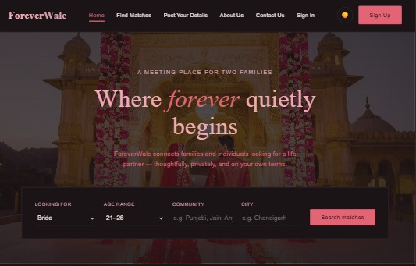
Figure 6.1: ForeverWale Home Page (desktop) — hero section with search card
Figure 6.2: Header / Navigation bar with logo, links, theme toggle and Sign Up button
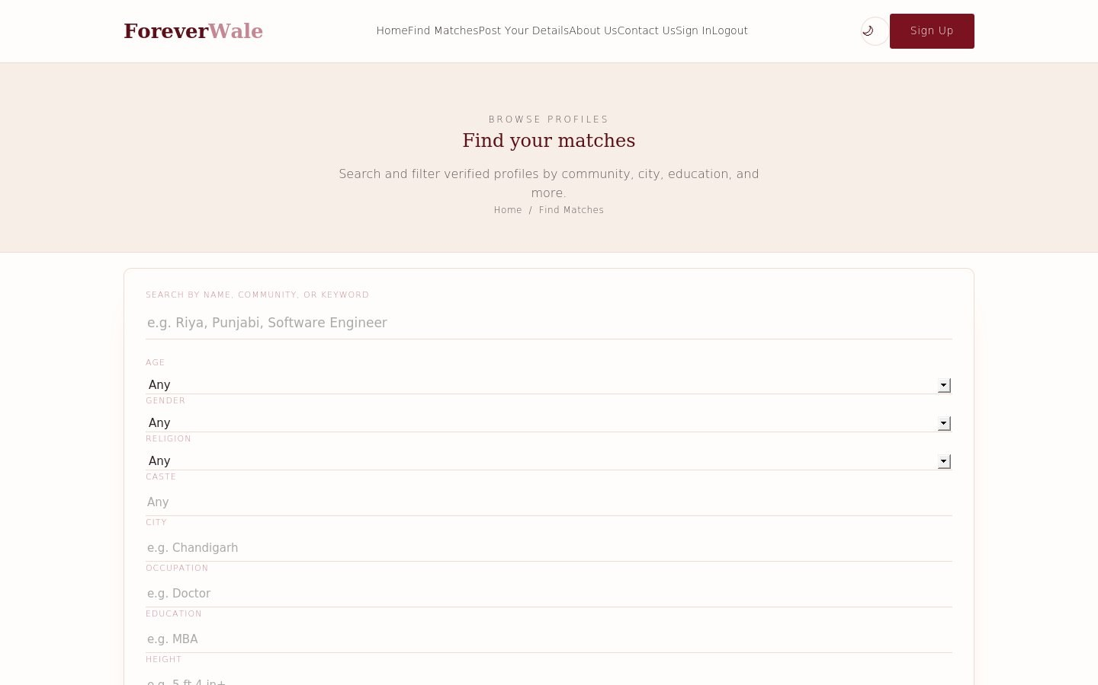
Figure 6.3: Find Matches page — filter panel and profile card grid
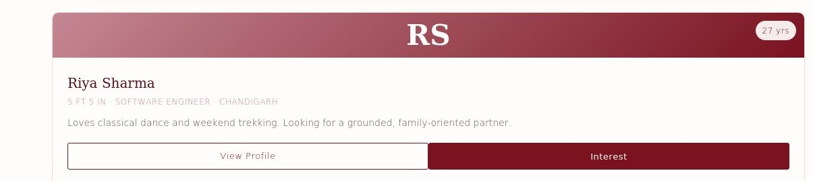
Figure 6.4: Individual profile card close-up showing photo placeholder, meta line, bio and action buttons
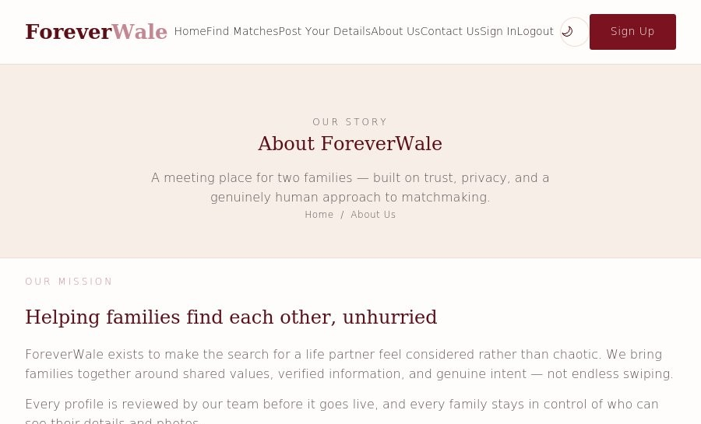
Figure 6.5: About Us page — mission and value sections
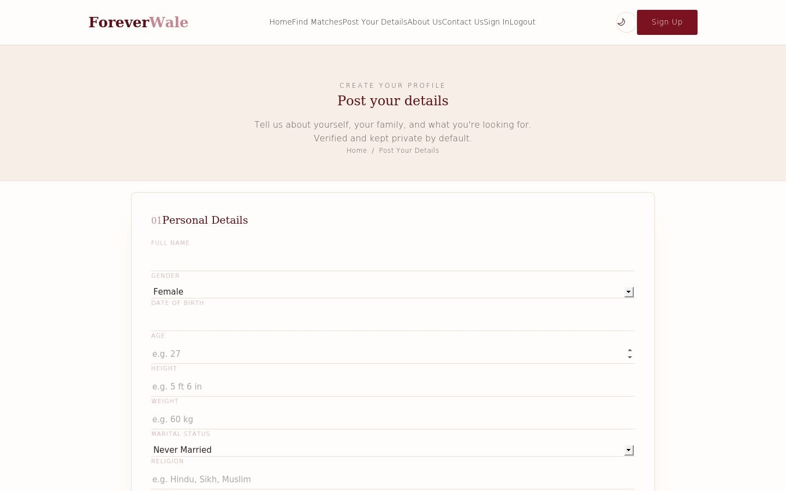
Figure 6.6: Post Your Details page — grouped form fields
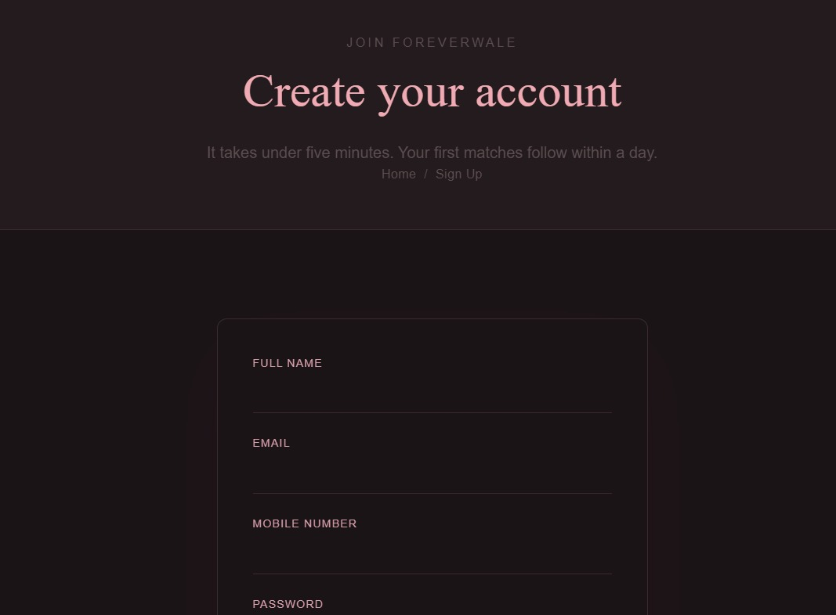
Figure 6.7: Sign Up page — auth card with name, email, mobile and password fields
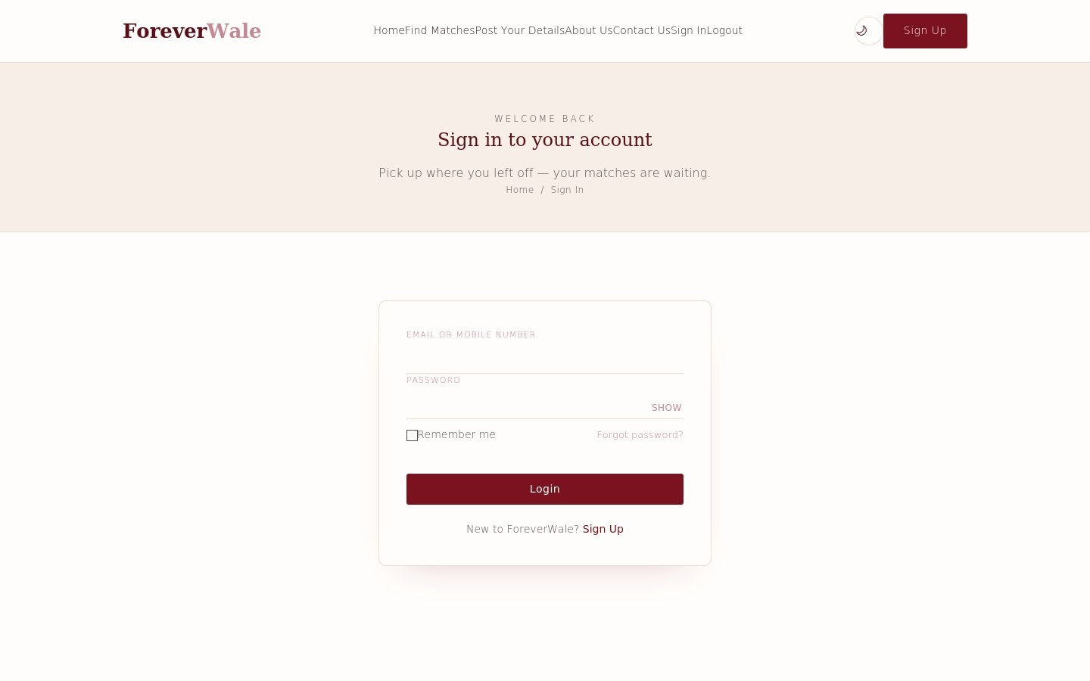
Figure 6.8: Sign In page — auth card
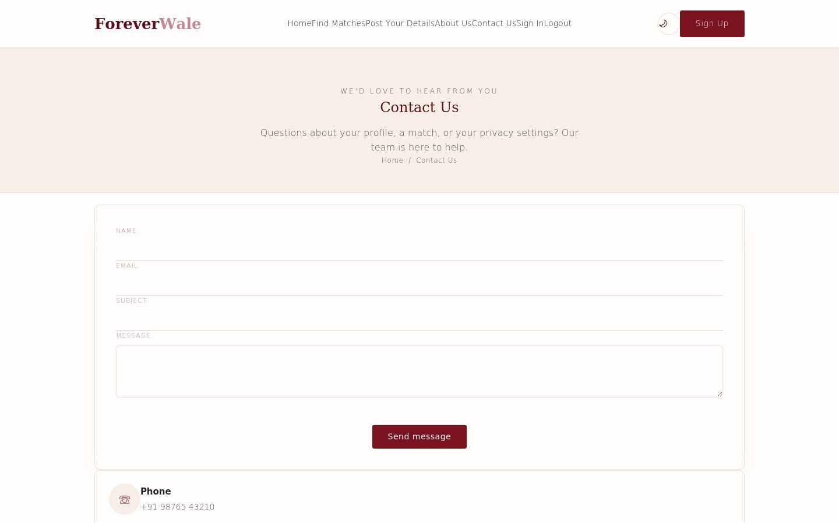
Figure 6.9: Contact Us page — contact form and layout
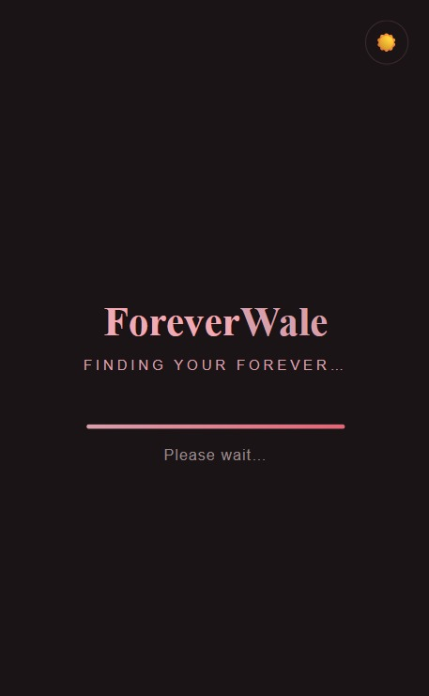
Figure 6.10: Loading / interstitial page
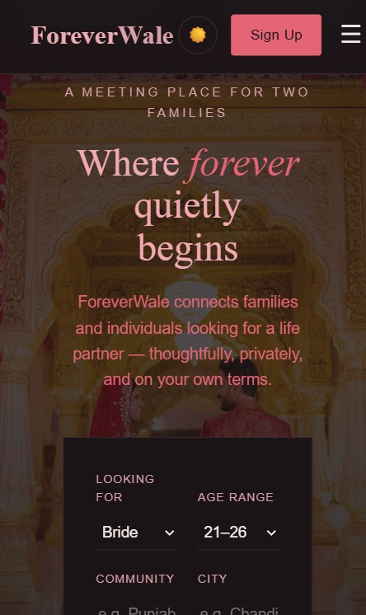
Figure 6.11: Home page in dark theme (after clicking the theme-toggle button)
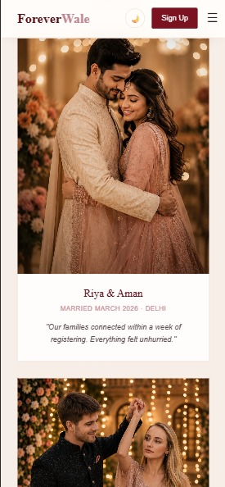
Figure 6.12: Home page in light theme — Success Stories section (mobile), shown for palette comparison
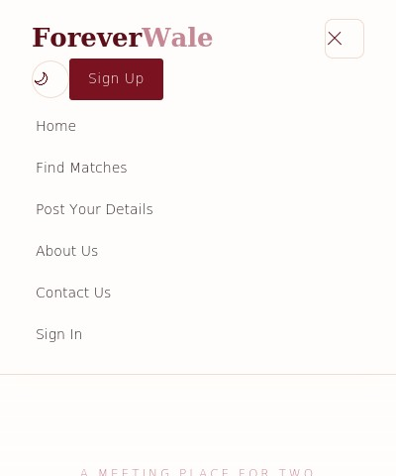
Figure 6.13: Mobile viewport (≤768px) showing the collapsed hamburger navigation drawer open
Across every page the interface follows the same design language: a warm, deep-red (#7A1220) and rose (#C48793) colour palette against a soft off-white (#FFFDFB) background in light mode, inverted to a dark plum background (#1B1417) with lightened accent colours in dark mode. Cormorant Garamond is used for all headings, giving the site an elegant, editorial tone appropriate to a matrimonial brand, while Jost is used for body copy and form labels for clarity at small sizes.

Chapter 7: HTML Implementation

7.1 Header and Navigation (shared across all pages)
Every page includes an identical <header> containing the site logo, a checkbox-driven mobile menu toggle, the navigation link list, and a right-hand cluster with the theme toggle button and a Sign Up call-to-action:
Code Snippet 7.1 — Shared site header and navigation (index.html)
<header class="site-header">
<nav class="navbar wrap">
<a href="index.html" class="logo">Forever<span>Wale</span></a>
<input type="checkbox" id="nav-toggle-cb" class="nav-toggle-cb">
<label for="nav-toggle-cb" class="nav-toggle" aria-label="Toggle menu">
<span></span>
</label>
<ul class="nav-links">
<li><a href="index.html" class="active">Home</a></li>
<li><a href="find-matches.html">Find Matches</a></li>
<li><a href="post-your-details.html">Post Your Details</a></li>
<li><a href="about-us.html">About Us</a></li>
<li><a href="contact-us.html">Contact Us</a></li>
<li><a href="signin.html">Sign In</a></li>
</ul>
<div class="nav-right">
<button type="button" id="theme-toggle" class="theme-toggle"
aria-label="Toggle dark mode">🌙</button>
<a href="signup.html" class="btn btn-solid">Sign Up</a>
</div>
</nav>
</header>
The navigation toggle uses a hidden checkbox (#nav-toggle-cb) paired with a <label>, a well-known CSS-only interaction pattern (“the checkbox hack”) that opens and closes the mobile menu without any JavaScript. The theme-toggle <button>, by contrast, is wired up in JavaScript because it must read from and write to localStorage.

7.2 Hero Section (index.html)
Code Snippet 7.2 — Hero section and search card
<section class="hero">
<div class="wrap">
<p class="eyebrow">A meeting place for two families</p>
<h1>Where <em>forever</em> quietly<br>begins</h1>
<p class="sub">ForeverWale connects families and individuals looking
for a life partner - thoughtfully, privately, and on your own terms.</p>
<div class="search-card">
<div class="field">
<label for="looking-for">Looking for</label>
<select id="looking-for">
<option>Bride</option>
<option>Groom</option>
</select>
</div>
<!-- additional search fields ... -->
</div>
</div>
</section>

7.3 Profile / Match Card (find-matches.html)
Code Snippet 7.3 — A single profile card
<article class="profile-card">
<div class="profile-photo" style="background:linear-gradient(135deg, var(--rose), var(--red));">
<div class="avatar">RS</div>
<span class="age-badge">27 yrs</span>
</div>
<div class="profile-body">
<h3>Riya Sharma</h3>
<p class="profile-meta">5 ft 5 in &middot; Software Engineer &middot; Chandigarh</p>
<p class="profile-bio">Loves classical dance and weekend trekking.
Looking for a grounded, family-oriented partner.</p>
<div class="profile-actions">
<a href="#" class="btn">View Profile</a>
<input type="checkbox" id="interest-1" class="js-interest-cb">
<label for="interest-1" class="btn btn-solid js-interest-label">
<span class="label-default">Interest</span>
<span class="label-sent">Interest sent ✓</span>
</label>
</div>
</div>
</article>
Because a photograph is not supplied for the sample data, .profile-photo uses a CSS linear-gradient background with the sitter's initials as a text avatar (“RS” for Riya Sharma) — a common, cost-effective placeholder pattern used in matrimonial and social apps before a real photo is uploaded. The Interest button reuses the checkbox-hack pattern seen in the navigation: checking #interest-1 swaps the visible <span> from “Interest” to “Interest sent ✓” purely through CSS, with no JavaScript involved.

7.4 Sign-Up Form (signup.html)
Code Snippet 7.4 — Registration form fields
<div class="form-alert" id="signup-alert">Account created successfully!
You can now sign in.</div>
<form id="signup-form" action="#signup-alert" method="get">
<div class="form-grid cols-2" style="margin-bottom:22px;">
<div>
<label for="su-name">Full Name</label>
<input type="text" id="su-name" name="su-name" required>
</div>
<div>
<label for="su-email">Email</label>
<input type="email" id="su-email" name="su-email" required>
</div>
<div>
<label for="su-mobile">Mobile Number</label>
<input type="tel" id="su-mobile" name="su-mobile" required>
</div>
<div>
<label for="su-password">Password</label>
<input type="password" id="su-password" name="su-password" minlength="8" required>
</div>
<div>
<label for="su-confirm">Confirm Password</label>
<input type="password" id="su-confirm" name="su-confirm" minlength="8" required>
</div>
</div>
...
</form>
The Sign Up form relies entirely on native HTML5 form validation — the required attribute on every field, type="email" for email format checking, type="tel" for the phone number, and minlength="8" on both password fields. There is no JavaScript-based validation or duplicate-password comparison; because the form's action is the in-page anchor #signup-alert rather than a server endpoint, submitting it does not send data anywhere and only reveals the confirmation banner already present in the markup.

Chapter 8: CSS Implementation

8.1 CSS Variables (Theme System)
Code Snippet 8.1 — CSS custom properties for light and dark themes (assets/style.css)
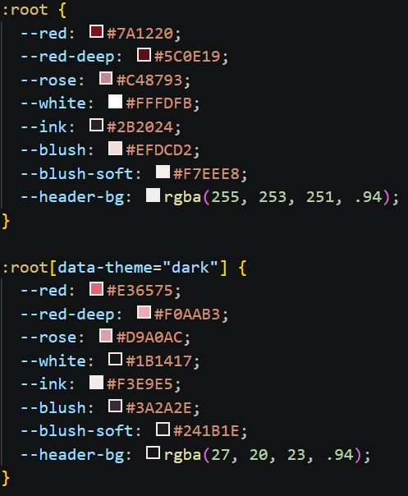
Figure 8.1: Actual :root and [data-theme="dark"] variable blocks from assets/style.css
:root {
--red: #7A1220;
--red-deep: #5C0E19;
--rose: #C48793;
--white: #FFFDFB;
--ink: #2B2024;
--blush: #EFDCD2;
--blush-soft: #F7EEE8;
--header-bg: rgba(255, 253, 251, .94);
}
:root[data-theme="dark"] {
--red: #E36575;
--red-deep: #F0AAB3;
--rose: #D9A0AC;
--white: #1B1417;
--ink: #F3E9E5;
--blush: #3A2A2E;
--blush-soft: #241B1E;
--header-bg: rgba(27, 20, 23, .94);
}
Every colour used throughout the stylesheet references one of these eight custom properties rather than a hard-coded hex value. Switching themes is therefore reduced to toggling a single data-theme="dark" attribute on the <html> element (performed by app.js); every rule that reads var(--red), var(--white) and so on is automatically re-evaluated by the browser without any additional CSS or JavaScript work.

8.2 Global / Reset Styling
Code Snippet 8.2 — Universal reset and base body styling
* {
margin: 0;
padding: 0;
box-sizing: border-box;
}
body {
font-family: 'Jost', sans-serif;
color: var(--ink);
background: var(--white);
font-weight: 300;
line-height: 1.6;
transition: background .25s ease, color .25s ease;
}
h1, h2, h3 {
font-family: 'Cormorant Garamond', serif;
font-weight: 500;
color: var(--red-deep);
}
The universal selector zero-out pattern removes browser default spacing before any component styling is applied. The transition declared on body (background .25s ease, color .25s ease) is what makes the light/dark theme switch feel like a smooth cross-fade rather than an abrupt colour jump.

8.3 Navigation Styling
Code Snippet 8.3 — Sticky header background and border
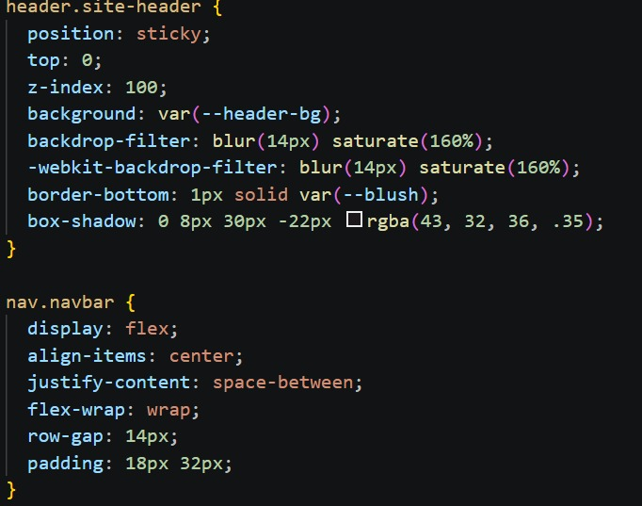
Figure 8.2: Production header.site-header and nav.navbar rules, including the backdrop-filter glass effect
.site-header {
position: sticky;
top: 0;
background: var(--header-bg);
border-bottom: 1px solid var(--blush);
backdrop-filter: blur(6px);
z-index: 50;
}

8.4 Buttons
Code Snippet 8.4 — Outline and solid button variants with hover state
.btn {
border: 1px solid var(--red);
color: var(--red);
padding: 10px 22px;
border-radius: 999px;
transition: background .2s ease, color .2s ease;
}
.btn-solid {
background: var(--red);
color: var(--white);
}
.btn:hover {
background: var(--red-deep);
border-color: var(--red-deep);
color: var(--white);
}
Buttons use a pill shape (border-radius: 999px) consistent with the soft, rounded visual language of the site, and a short transition on background and color gives a smooth hover response rather than an instant colour swap.

8.5 Profile Cards
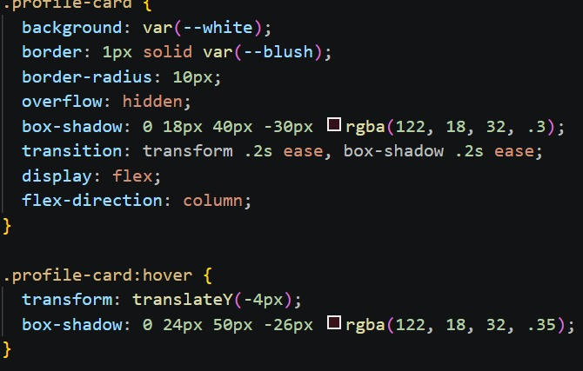
Figure 8.3: The .profile-card rule set and its hover-state transform/box-shadow change
The .profile-card, .profile-photo and .profile-body rules (defined alongside the .profile-grid container discussed in Section 8.10) control card padding, the rounded photo placeholder area, and typographic hierarchy for the name, meta line and bio text, keeping every card in the grid visually consistent regardless of content length.

8.6 Forms
Code Snippet 8.5 — Two-column form grid, collapsing on smaller screens
.form-grid.cols-2 {
display: grid;
grid-template-columns: 1fr 1fr;
gap: 18px 24px;
}
.form-actions {
display: flex;
justify-content: center;
gap: 18px;
margin-top: 40px;
}

8.7 Dark Mode Rule Example
Code Snippet 8.6 — Dark-theme-specific hero override
:root[data-theme="dark"] .hero {
/* Hero-specific adjustments applied only when the dark theme
attribute is active, layered on top of the variable-driven
colour system already described in Section 8.1. */
}

8.8 Transitions and Micro-interactions
Beyond the body-level colour transition and button hover transition already shown, the mobile navigation drawer animates open and closed via a transition: max-height .3s ease rule on .nav-links, combined with the checkbox-hack toggle described in Chapter 7 — an efficient, JavaScript-free way to animate a collapsing menu.

8.9 Flexbox and Grid Usage
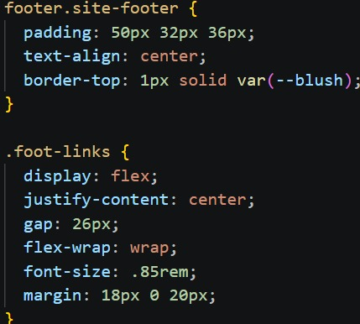
Figure 8.4: footer.site-footer and .foot-links — the Flexbox pattern referenced above
Flexbox (display:flex) is used for one-dimensional groupings such as the navbar, form-actions row, and footer link row, where items need to sit in a single line or wrap gracefully. CSS Grid (display:grid) is used for two-dimensional layouts such as the profile-grid on Find Matches, the form-grid on the details/registration forms, and the filters-grid, where content needs to align across both rows and columns.

Chapter 9: Responsive Web Design
ForeverWale defines seven @media (max-width: ...) blocks in assets/style.css, at three distinct breakpoints: 980px, 880px (used five times, across navigation, forms, mission layout, contact layout and the shared homepage components) and 620px. This section documents the actual responsive rules found in the project.

9.1 Navigation Responsiveness (≤ 880px)
Code Snippet 9.1 — Mobile navigation drawer
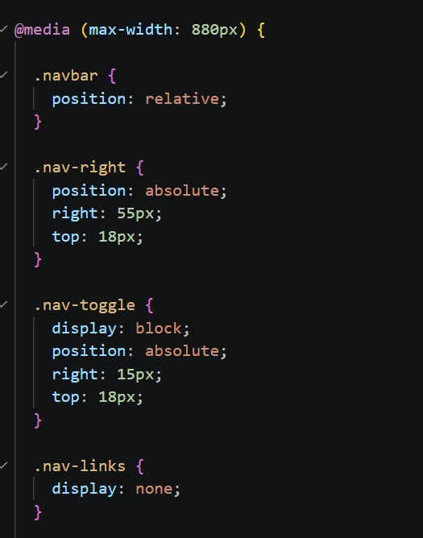
Figure 9.1: The production @media (max-width: 880px) block controlling the mobile nav drawer
@media (max-width: 880px) {
.nav-toggle { display: inline-flex; }
.nav-links {
order: 3;
width: 100%;
max-height: 0;
overflow: hidden;
flex-direction: column;
align-items: flex-start;
gap: 4px;
transition: max-height .3s ease;
}
.nav-toggle-cb:checked ~ .nav-links {
max-height: 520px;
padding-top: 6px;
}
.nav-links a { display: block; width: 100%; padding: 10px 4px; }
.nav-links a::after { display: none; }
.nav-links a.active {
color: var(--red);
background: var(--blush-soft);
border-radius: 6px;
padding-left: 10px;
}
}
Below 880px the horizontal link list is hidden by default (max-height: 0) and re-flowed into a vertical column that expands to max-height: 520px once the hidden checkbox is checked, producing an animated dropdown drawer without any JavaScript.

9.2 Responsive Forms (≤ 880px)
Code Snippet 9.2 — Form grid collapsing to a single column
@media (max-width: 880px) {
.form-grid,
.form-grid.cols-2 { grid-template-columns: 1fr; }
.panel { padding: 26px 20px; }
}
The two-column registration/details form (Section 8.6) collapses to a single column below 880px so that each field spans the full width of a phone or small-tablet screen, and the surrounding .panel reduces its horizontal padding to preserve usable content width.

9.3 Responsive Profile Grid (≤ 980px and ≤ 620px)
Code Snippet 9.3 — Filters and profile grid at two breakpoints
@media (max-width: 980px) {
.filters-grid { grid-template-columns: repeat(2, 1fr); }
.profile-grid { grid-template-columns: repeat(2, 1fr); }
}
@media (max-width: 620px) {
.filters-grid { grid-template-columns: 1fr; }
.profile-grid { grid-template-columns: 1fr; }
}
This is a well-considered progressive breakpoint strategy: the profile grid steps down from an implicit desktop column count to two columns at tablet width (980px) and finally to a single column at phone width (620px), keeping each profile card legible at every size rather than shrinking cards indefinitely.

9.4 Responsive About-Us and Contact Layouts (≤ 880px)
Code Snippet 9.4 — Mission/value grids and contact layout
@media (max-width: 880px) {
.value-grid,
.mission-grid { grid-template-columns: 1fr; }
.mission-block { grid-template-columns: 1fr; }
}
@media (max-width: 880px) {
.contact-layout { grid-template-columns: 1fr; }
}
@media (max-width: 880px) {
.steps,
.story-grid,
.trust { grid-template-columns: 1fr; }
}
The same 880px breakpoint is reused consistently across the About Us mission/value sections, the Contact Us two-column layout, and the shared homepage components (steps, stories, trust badges), which all collapse from a multi-column grid to a single stacked column. This consistency is good practice: it means the whole site “folds” at the same tablet width rather than each section breaking at a different, unpredictable point.

9.5 Observations and Limitations
All seven media queries in the project are max-width (desktop-down) queries with no explicit min-width rules, indicating a desktop-first authoring approach in which the base styles target larger screens and mobile adjustments are layered on top. No dedicated typography-scaling media query (e.g. reducing the hero <h1> font-size at small widths) or landscape-orientation query was found in the current stylesheet; this is noted as a limitation in Chapter 17 rather than invented as an existing feature.

Chapter 10: JavaScript Implementation
assets/app.js is the only JavaScript file in the project and is reproduced here in full, since at 16 lines it is short enough to analyse completely rather than in excerpts.
Code Snippet 10.1 — Complete contents of assets/app.js
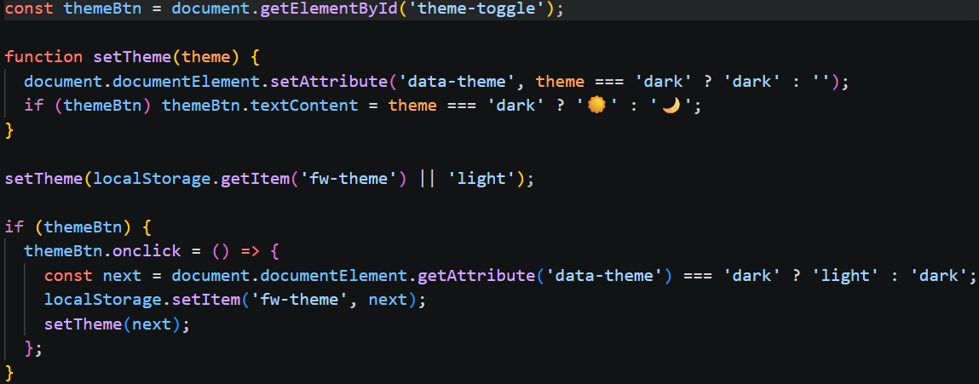
Figure 10.1: The theme-toggle logic exactly as it appears in assets/app.js
const themeBtn = document.getElementById('theme-toggle');
function setTheme(theme) {
document.documentElement.setAttribute('data-theme', theme === 'dark' ? 'dark' : '');
if (themeBtn) themeBtn.textContent = theme === 'dark' ? '☀️' : '🌙';
}
setTheme(localStorage.getItem('fw-theme') || 'light');
if (themeBtn) {
themeBtn.onclick = () => {
const next = document.documentElement.getAttribute('data-theme') === 'dark' ? 'light' : 'dark';
localStorage.setItem('fw-theme', next);
setTheme(next);
};
}

10.1 Line-by-Line Explanation
- document.getElementById('theme-toggle') retrieves the header's theme button; the reference is cached once in themeBtn rather than re-queried on every call.
- setTheme(theme) is a small reusable function that sets the data-theme attribute on <html> (document.documentElement) to "dark" or removes it (empty string) for light mode, and swaps the button's icon between a sun and a moon emoji to reflect the current state.
- setTheme(localStorage.getItem('fw-theme') || 'light') runs immediately on page load, reading any previously saved preference from the browser's localStorage under the key 'fw-theme', defaulting to 'light' the first time a visitor arrives.
- The if (themeBtn) guard ensures the click handler is only attached when the button actually exists on the current page, which defensively protects against a page that might omit the header markup.
- themeBtn.onclick reads the opposite of the current data-theme attribute, persists that new value back into localStorage, and calls setTheme() again to apply it — completing the toggle and making the choice persist across page navigations and browser sessions.

10.2 Where It Is Used and Its Effect on the UI
Because the theme system is driven entirely by CSS custom properties keyed off the [data-theme="dark"] attribute selector (Chapter 8.1), this small script is sufficient to re-theme every page of the site consistently — header, hero, buttons, cards, forms and footer all update simultaneously. No other dynamic behaviour (form submission handling, live filtering of the Find Matches grid, or client-side validation feedback beyond the browser's native HTML5 validation) is currently implemented in JavaScript; those interactions rely on native browser behaviour or the CSS checkbox-hack pattern described in Chapter 7.

Chapter 11: Page-by-Page Implementation

11.1 Home Page (index.html)
The primary landing and marketing page (584 lines, the largest file in the project). It embeds its own <style> block defining the shared CSS variables and hero styling, and includes the shared header/navigation, a hero section with a partner-search card, and several homepage-only sections (steps, stories/testimonials, trust indicators and a closing call-to-action band) that are reused visually on About Us.
Cross-reference: see Section 6, Figure 6.1 for the corresponding screenshot.

11.2 About Us Page (about-us.html)
A 180-line informational page describing the platform's mission and values, using the .mission-grid and .value-grid layouts, and reusing the shared .steps, .story-grid and .trust components from the homepage for visual consistency.
Cross-reference: see Section 6, Figure 6.5 for the corresponding screenshot.

11.3 Find Matches Page (find-matches.html)
A 234-line page containing a filter panel (.filters-grid) above a responsive .profile-grid of six sample .profile-card entries, each with a photo placeholder, meta information, bio and View Profile / Interest actions as documented in Chapter 7.3.
Cross-reference: see Section 6, Figures 6.3-6.4 for the corresponding screenshot.

11.4 Post Your Details Page (post-your-details.html)
A 210-line form page for entering personal and partner-preference details, structured with the same .form-grid.cols-2 pattern used on the Sign Up page, wrapped in a .panel container.
Cross-reference: see Section 6, Figure 6.6 for the corresponding screenshot.

11.5 Sign In Page (signin.html)
A concise 98-line page presenting a single .auth-card with email/username and password fields and a link across to Sign Up for new visitors.
Cross-reference: see Section 6, Figure 6.8 for the corresponding screenshot.

11.6 Sign Up Page (signup.html)
A 108-line registration page (Chapter 7.4) with full-name, email, mobile, password and confirm-password fields, native HTML5 validation constraints, and a hidden confirmation banner (#signup-alert) revealed via the form's in-page anchor action.
Cross-reference: see Section 6, Figure 6.7 for the corresponding screenshot.

11.7 Contact Us Page (contact-us.html)
A 118-line page using the .contact-layout two-column grid (collapsing to one column below 880px, Chapter 9.4) to present a contact form alongside supporting information.
Cross-reference: see Section 6, Figure 6.9 for the corresponding screenshot.

11.8 Loading Page (loading.html)
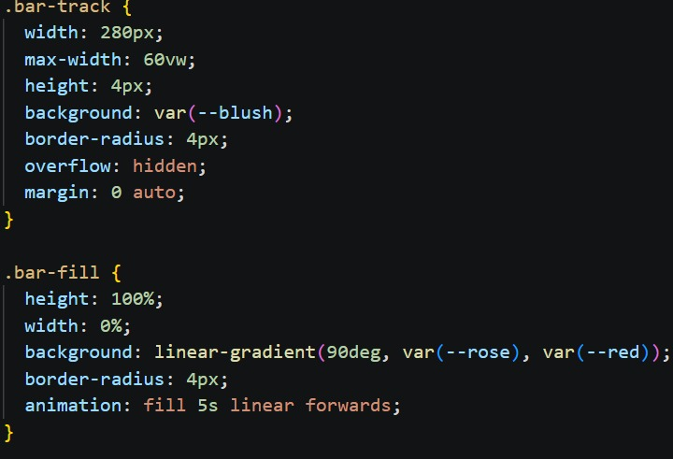
Figure 11.1: .bar-track and .bar-fill — the CSS-animated progress bar used on the loading screen
A 148-line lightweight interstitial page, presumably intended to be shown briefly during a simulated navigation or data-fetch transition in a future, dynamic version of the site.
Cross-reference: see Section 6, Figure 6.10 for the corresponding screenshot.

Chapter 12: Database / Backend Considerations
The current version of ForeverWale is primarily a frontend web application and does not implement a persistent backend database. All forms (Sign Up, Sign In, Post Your Details, Contact Us) submit to in-page anchors or have no functioning action attribute pointing to a server endpoint; no data entered by a user is transmitted to, or stored on, any server, and the “profiles” shown on Find Matches are static, hard-coded sample data embedded directly in find-matches.html.

12.1 Proposed Backend Architecture (Future Work)
A production-ready version of ForeverWale would require a server-side application and a persistent data store. A reasonable technology choice, consistent with the project's existing simplicity, would be:
- Node.js with the Express framework to expose a REST API for authentication, profile CRUD operations and enquiry handling.
- A relational database such as MySQL or PostgreSQL (or a document database such as MongoDB) to persist user accounts, profile data, and contact-form submissions.
- A dedicated authentication layer (e.g. JWT-based sessions or a library such as Passport.js) replacing the current non-functional Sign In/Sign Up forms.
- Secure, hashed password storage (e.g. bcrypt) rather than any plain-text handling of the password fields already present in the Sign Up form.
- A matchmaking/query layer capable of filtering the profile data set according to the criteria captured by the Find Matches filter panel.

Chapter 13: Security Considerations
Aspect | Currently Implemented | Recommended Future Measure
Input validation | Native HTML5 constraints (required, type="email", minlength) | Server-side validation and sanitisation of all submitted fields
Authentication | Not implemented (static Sign In/Sign Up pages only) | Session or JWT-based authentication with secure cookie/token handling
Password storage | Not applicable (no backend) | Hashing with bcrypt/argon2; never store plain-text passwords
XSS prevention | Not applicable (no dynamic user content rendered) | Escape/sanitise any user-generated content before rendering
Transport security | Depends on hosting (not configured in the source) | Serve exclusively over HTTPS with valid TLS certificates
Data privacy | No personal data currently persisted | Define a data-retention and privacy policy once a backend is added
Table 13.1: Security posture of the current build versus recommended future measures.

Chapter 14: Responsiveness and Cross-Browser Testing

14.1 Viewport Testing
The three breakpoints defined in the stylesheet (980px, 880px, 620px) were reviewed against typical device classes: desktop/laptop (≥981px), tablet (881–980px), and mobile (≤880px, with an additional step at 620px for small phones). Each breakpoint's effect on navigation, forms and the profile grid is documented in Chapter 9.

14.2 Browser Compatibility
Browser | Expected Compatibility | Notes
Google Chrome | Full support | CSS Grid, Flexbox, custom properties and localStorage are all well supported.
Mozilla Firefox | Full support | No Firefox-specific CSS prefixes are required for the features used.
Microsoft Edge (Chromium) | Full support | Shares the Chromium engine; behaviour should match Chrome.
Safari (desktop/iOS) | Expected full support | backdrop-filter (used on .site-header) requires a reasonably recent Safari version.
Table 14.1: Expected cross-browser compatibility of ForeverWale based on the CSS/JS features used.

Chapter 15: Future Enhancements
- Backend integration using Node.js/Express (or an equivalent framework) to serve dynamic data and handle form submissions.
- A relational or document database to persist user accounts, profiles and enquiries.
- Real authentication with hashed password storage and session/JWT-based access control.
- An AI-assisted or rule-based matchmaking/recommendation engine to suggest profiles based on stated preferences.
- Advanced search filters (religion, community, education, income bracket, horoscope compatibility, etc.).
- A member dashboard for managing one's own profile, sent/received interests, and account settings.
- In-app messaging between mutually interested members.
- Email/SMS notifications for new interests, messages and matches.
- Profile verification (photo/ID) to increase trust on the platform.
- Granular privacy controls over who can view a member's photo or contact details.
- An administrative dashboard for moderating profiles and enquiries.
- Cloud deployment (e.g. a managed hosting platform) with HTTPS, CI/CD and monitoring.

Chapter 16: Conclusion
This project developed ForeverWale, a static, front-end matrimonial website comprising eight linked HTML pages, a shared CSS design system built around custom properties for light/dark theming, and a compact JavaScript module for persisting the visitor's theme preference. The work demonstrates practical competence in semantic HTML structuring, CSS Grid and Flexbox based responsive layout across three defined breakpoints, CSS-only interaction patterns (the checkbox hack used for the navigation drawer and profile-card interest button), and minimal, well-scoped JavaScript.
Through building ForeverWale, the key lessons reinforced were the value of a small, consistent design-token system (the eight CSS custom properties that drive the entire palette and both themes), the usefulness of CSS-only techniques for simple stateful UI before reaching for JavaScript, and the discipline of testing layout behaviour across multiple explicit breakpoints rather than relying on ad-hoc fixes.
The most significant current limitation is the complete absence of a backend: no data submitted through the Sign Up, Sign In, Post Your Details or Contact Us forms is currently persisted, and the profiles shown on Find Matches are static sample data. Addressing this — through a Node.js/Express API and a relational database, together with real authentication and security hardening — represents the clear next phase of the project, as detailed in Chapters 12, 13 and 18. With that backend work completed, ForeverWale's existing, carefully considered front-end would already provide a solid, responsive, on-brand user interface for a genuine matrimonial platform.

References
- MDN Web Docs — HTML: Hypertext Markup Language. https://developer.mozilla.org/en-US/docs/Web/HTML
- MDN Web Docs — CSS: Cascading Style Sheets. https://developer.mozilla.org/en-US/docs/Web/CSS
- MDN Web Docs — CSS Custom Properties (variables). https://developer.mozilla.org/en-US/docs/Web/CSS/Using_CSS_custom_properties
- MDN Web Docs — CSS Grid Layout. https://developer.mozilla.org/en-US/docs/Web/CSS/CSS_Grid_Layout
- MDN Web Docs — CSS Flexible Box Layout. https://developer.mozilla.org/en-US/docs/Web/CSS/CSS_Flexible_Box_Layout
- MDN Web Docs — Using Media Queries. https://developer.mozilla.org/en-US/docs/Web/CSS/CSS_media_queries/Using_media_queries
- MDN Web Docs — Window.localStorage. https://developer.mozilla.org/en-US/docs/Web/API/Window/localStorage
- MDN Web Docs — Constraint validation (HTML forms). https://developer.mozilla.org/en-US/docs/Web/HTML/Constraint_validation
- W3C — HTML Living Standard reference materials. https://www.w3.org/standards/webdesign/htmlcss
- Google Fonts — Jost and Cormorant Garamond typefaces. https://fonts.google.com/
- Express.js Documentation (for proposed future backend). https://expressjs.com/
- Node.js Documentation (for proposed future backend). https://nodejs.org/en/docs/

