OSI Model

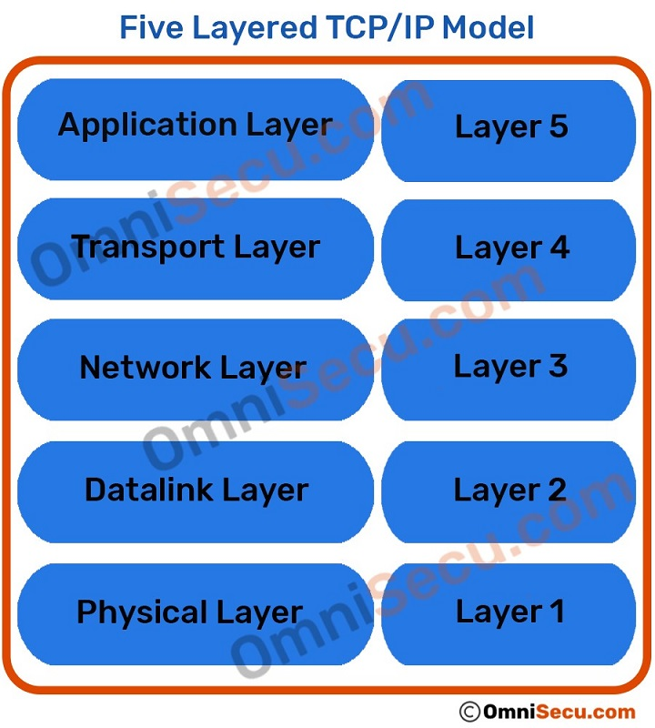

**List of Protocols:**

1. Physical Layer:
   1. Ethernet (IEEE 802.3) Token Ring, RS-232, others.
   2. Digital Subscriber Line.
   3. Integrated Services Digital Network.
   4. Infrared Data Association.
   5. Universal Serial Bus (USB.)
   6. Bluetooth.
   7. Controller Area Network
2. Data Layer:
   1. PPP
   2. Synchronous Data Link Protocol (SDLC) – ...
   3. High-Level Data Link Protocol (HDLC) – ...
   4. Serial Line Interface Protocol (SLIP) – ...
   5. Point to Point Protocol (PPP) – ...
   6. Link Control Protocol (LCP) – ...
   7. Link Access Procedure (LAP) – ...
   8. Network Control Protocol (NCP) –
3. Network Layer:
   1. IP, ARP, ICMP
4. Transport Layer:
   1. TCP, UDP
5. Application Layer:
   1. NFS, NIS+, DNS, telnet, ftp, rlogin, rsh, rcp, RIP, RDISC, SNMP, and others.

**List of Network Devices:**

1. Physical Layer:
   1. Hub, Repeater, Modem, Cables are Physical Layer devices.
2. Data Layer:
   1. Bridges, Switches and Network Interface Cards (NIC Cards).
3. Network Layer:
   1. Routers, Brouters and Figures.
4. Transport Layer:
   1. Gateways and Firewalls.
5. Application Layer:
   1. PC’s, Smartphones and other devices.

**Types of Cables:**

1. Cables:
   1. Co-axial Cable
   2. Fiber Optic Cable
   3. Twisted Pair Cable (UTP and STP)
2. Conectors:
   1. Registered Jack 45 (RJ45)
      1. The cable connector that is found on almost all UTP and STP cables is a Registered Jack 45 which is mostly commonly referred to as RJ45. This type of connector resembles the older RJ11 connectors that most people are familiar with from wired telephones. Figure 5 below shows an example of a RJ45 connector:
   2. Straight Tip (ST)
      1. The Straight Tip (ST) connector is often seen on the end of a multi-mode cable; it has been commonly seen along with the SC connector for the last 20 years but is being slowly replaced by multi-fiber connectors (LC and MTP). Figure 6 below shows an example of a ST connector:
   3. Subscriber Connector (SC)
      1. The Subscriber Connector (SC) can be seen commonly on MMF or SMF; as with SC connectors, the ST connector is slowly being replaced by multi-fiber connectors. Figure 7 below shows an example of an SC connector:
   4. Lucent Connector (LC)
      1. The Lucent Connector (LC) was developed for high-density deployments where multiple fibers would be terminated within a confined space. Unlike the SC and ST connectors, the LC connector is always duplex connecting a pair of fibers at a time. Figure 8 below shows an example of a LC connector:
   5. Multi-fiber Push On (MPO)
      1. The Multi-fiber Push On (MPO) connector is another duplex connector that offers an easy options for connection. As the name suggests, it was designed to be able to be connected multiple times without the creation of any potential connector issues. It is often also referred to as Multi-fiber Termination Push-on (MTP); the MTP connector is a brand name (US Conec). Figure 9 below shows an example of an MPO connector:

**Straight cable and Cross cable:**

1. Straight Cable:
   1. Pass
2. Crossover Cable:
   1. A crossover cable is a type of cable installation that is used for the interconnection of two similar devices. It is enabled by reversing the transmission and receiving pins at both ends, so that output from one computer becomes input to the other, and vice versa.

**Use of Above cables:**

1. Remember, two types of devices that connect to networks. **When you connect two devices of different types together, you use a straight through cable.** **When you connect two devices of the same type together, you use a crossover cable**.

**The Color Codes for above cables:**

1. Straight Cables:

Type-A and Type-B

|  |  |  |  |  |
| --- | --- | --- | --- | --- |
| **RJ45 Pin #** | **Wire Color**  **(T568A)** | **Wire Diagram**  **(T568A)** | **10Base-T Signal**  **100Base-TX Signal** | **1000Base-T Signal** |
| 1 | White/Green | white/green | Transmit+ | BI_DA+ |
| 2 | Green | green | Transmit- | BI_DA- |
| 3 | White/Orange | white/orange | Receive+ | BI_DB+ |
| 4 | Blue | blue | Unused | BI_DC+ |
| 5 | White/Blue | white/blue | Unused | BI_DC- |
| 6 | Orange | orange | Receive- | BI_DB- |
| 7 | White/Brown | white/brown | Unused | BI_DD+ |
| 8 | Brown | brown | Unused | BI_DD- |

|  |  |  |  |  |
| --- | --- | --- | --- | --- |
| **RJ45 Pin #** | **Wire Color**  **(T568B)** | **Wire Diagram**  **(T568B)** | **10Base-T Signal**  **100Base-TX Signal** | **1000Base-T Signal** |
| 1 | White/Orange | white/orange | Transmit+ | BI_DA+ |
| 2 | Orange | orange | Transmit- | BI_DA- |
| 3 | White/Green | white/green | Receive+ | BI_DB+ |
| 4 | Blue | blue | Unused | BI_DC+ |
| 5 | White/Blue | white/blue | Unused | BI_DC- |
| 6 | Green | green | Receive- | BI_DB- |
| 7 | White/Brown | white/brown | Unused | BI_DD+ |
| 8 | Brown | brown | Unused | BI_DD- |

1. Crossover Cable:

|  |  |  |  |  |  |
| --- | --- | --- | --- | --- | --- |
| **RJ45 Pin # (END 1)** | **Wire Color** | **Diagram End #1** | **RJ45 Pin # (END 2)** | **Wire Color** | **Diagram End #2** |
| 1 | White/Orange | white/orange | 1 | White/Green | white/green |
| 2 | Orange | orange | 2 | Green | green |
| 3 | White/Green | white/green | 3 | White/Orange | white/orange |
| 4 | Blue | blue | 4 | White/Brown | white/brown |
| 5 | White/Blue | white/blue | 5 | Brown | brown |
| 6 | Green | green | 6 | Orange | orange |
| 7 | White/Brown | white/brown | 7 | Blue | blue |
| 8 | Brown | brown | 8 | White/Blue | white/blue |