**Step 1:** Strip the cable jacket about 1.5 inch down from the end.

` 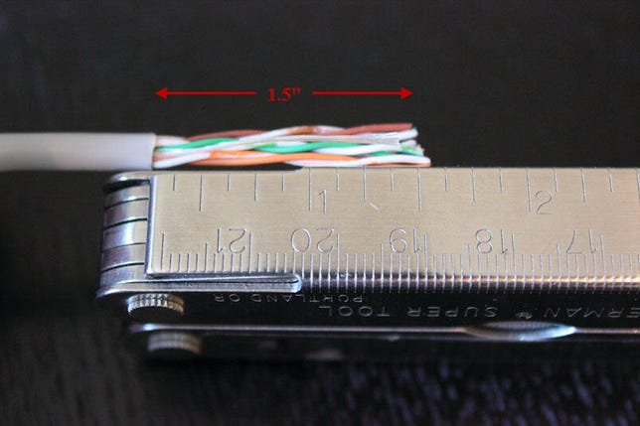

**Step 2:** Spread the four pairs of twisted wire apart. For Cat 5e, you can use the pull string to strip the jacket farther down if you need to, then cut the pull string. Cat 6 cables have a spine that will also need to be cut.

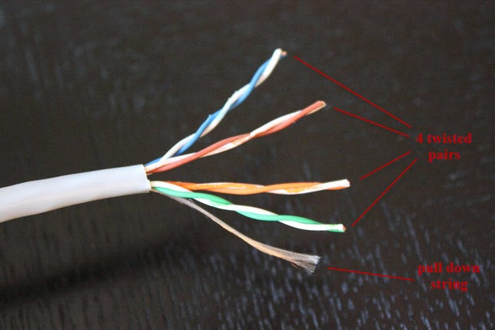

**Step 3:** Untwist the wire pairs and neatly align them in the T568B orientation. Be sure not to untwist them any farther down the cable than where the jacket begins; we want to leave as much of the cable twisted as possible.

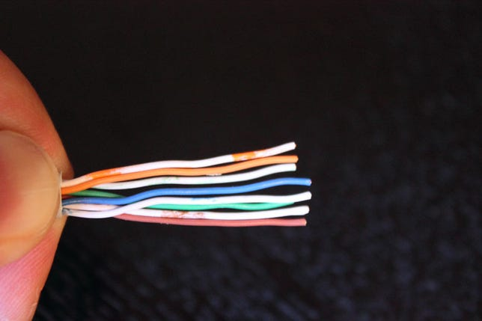

**Step 4:** Cut the wires as straight as possible, about 0.5 inch above the end of the jacket.

**Step 5:** Carefully insert the wires all the way into the modular connector, making sure that each wire passes through the appropriate guides inside the connector.

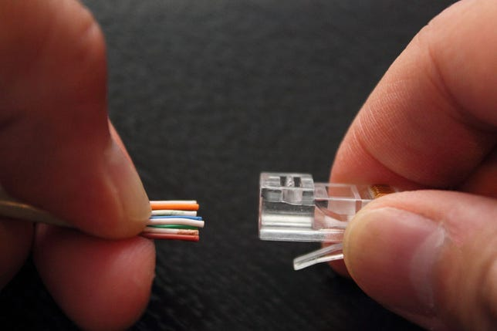

**Step 6:** Push the connector inside the crimping tool and squeeze the crimper all the way down.

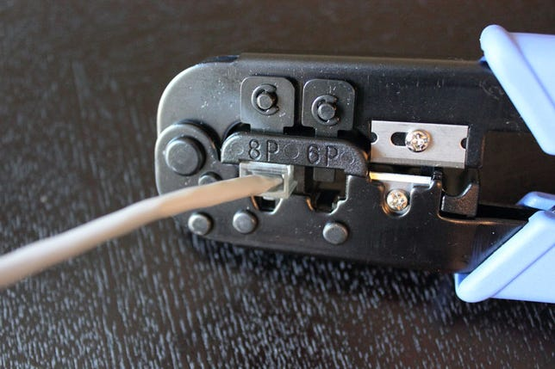

**When you're all done**