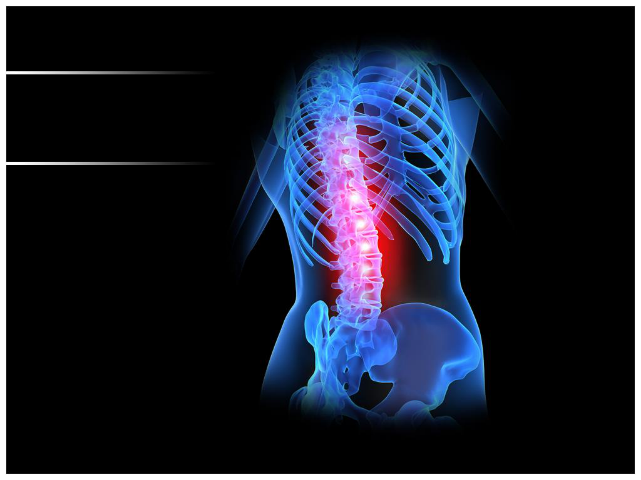
BIOMECHANICS
OF CERVICAL
SPINE
Dr. Faryah Aslam (PT)
MSAPT (DUHS), DPT (DUHS)
LECTURER
Jinnah University for Women

