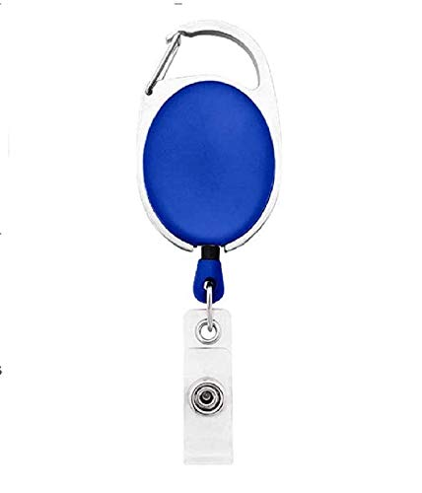

**EmployeeCard/Gate Pass**

|  |  |
| --- | --- |
| **Daniel Padillo** | PHOTO |
| **Finance** |
| **03/16/2022** |
| **AB +ve** |
| **9834313586** |