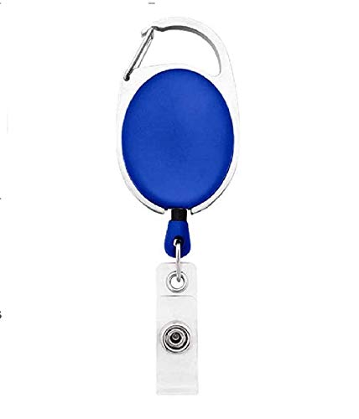

**EmployeeCard/Gate Pass**

|  |  |
| --- | --- |
| **Robert Conner** | PHOTO |
| **Marketing** |
| **02/20/2022** |
| **O -ve** |
| **9834313586** |