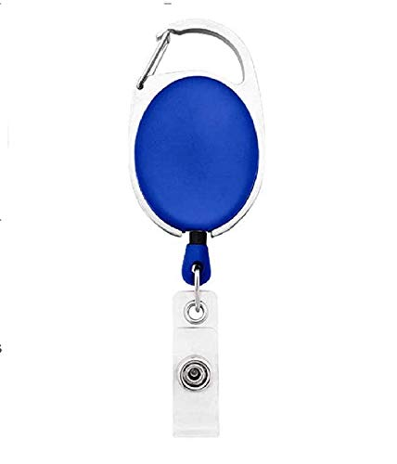

**EmployeeCard/Gate Pass**

|  |  |
| --- | --- |
| **Sheila Dever** | PHOTO |
| **Human Resource** |
| **02/10/2022** |
| **O +ve** |
| **9834313586** |