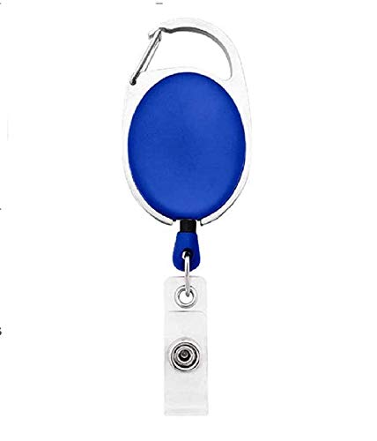

**EmployeeCard/Gate Pass**

|  |  |
| --- | --- |
| **Sharon Becerra** | PHOTO |
| **Finance** |
| **02/17/2022** |
| **O +ve** |
| **9834313586** |