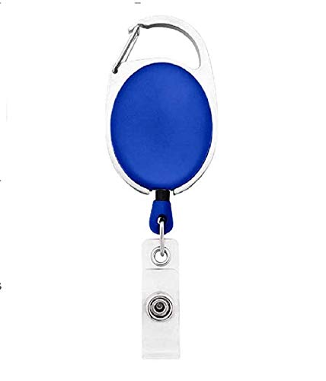

**EmployeeCard/Gate Pass**

|  |  |
| --- | --- |
| **Rosie Pica** | PHOTO |
| **Finance** |
| **01/19/2022** |
| **A -ve** |
| **9834313586** |