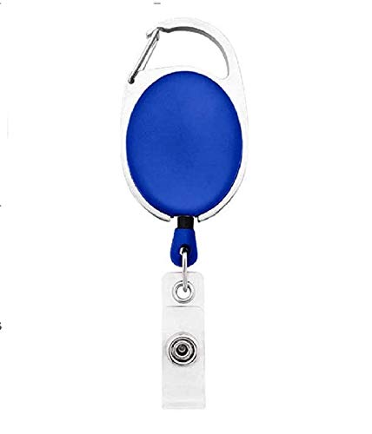

**EmployeeCard/Gate Pass**

|  |  |
| --- | --- |
| **Angelia Cartee** | PHOTO |
| **Sales** |
| **02/21/2022** |
| **AB -ve** |
| **9834313586** |