19CSE301 – Computer Networking

**Automobile Industry Network System**

**Case Study**

**Abstract:**

In this report, we will provide a quick overview of network design for the automotive sector, as well as the components required to build and implement a network.

At first, we discussed the servers we utilised, as well as the LAN and WLANs, and then we discussed the various technologies, architecture, and cables used in our network. Following that, we executed our network architecture for three libraries in Cisco packet tracer and provided configurations for all devices.

We performed the following operations in Cisco packet tracer while using our network:

* we created a file on any of the PCs and sent it to the server; and 2) we demonstrated how to obtain a file from the server to the PC.
* We used the command prompt to test the connectivity between the devices.
* We verified the IPv4 addresses of that specific PC.
* In the CLI, we have listed the total number of stations in the router.
* We performed a simulation by sending a message from one PC to another across the network.

**Objective:**

The main objective of the proposed network is to update the existing network and also enhance its capabilities and increase the flexibility of the network which will eventually provide good security.

The main objective of the proposed network is to update the existing network and also enhance its capabilities and increase the flexibility of the network which will eventually provide good security.

**Introduction:**

Initially, we considered designing a network that supports both wired and wireless device connections . Our industry primarily contains six departments, which includes:

* Server Room
* Design Labs
* Manufacturing Unit
* Conference hall
* Sales Reception
* Factory Outlet

In this case, we used an FTP server, a DNS server, a DHCP server, five LANs, and one wireless LAN (WLAN). To set up a network, we utilised a simulation tool called CISCO PACKET TRACER. We also used command prompt for file sharing between PCs in a network and to check the connection establishment between IP addresses of devices linked to the network.

When it came to TOPOLOGY, we employed both physical and logical topology, as well as Star topology as a network structure. We have two CONNECTIONS, one wired (LAN) and one wifi (LAN)

To build a network connection, we used different networking devices such as a router, switch, wireless access point (WAP), server, and an ethernet cable.

**Network Requirements:**

* Network will be scalable.
* Should comprise of data centers with necessary security features and support.

**Major Design areas and functional areas:**

The new system planned comprises of IP based switches that remain as the access point to lan-based (ethernet) as well as Wi-Fi-based connectivity.

**Device Details:**

* We Used 3 – 2811 Routers
* We Used 6 – 2960 – 24TT Switches
* We used 2 – Access Point PT
* We used 1 – FTP Server
* We Used 1 – DNS Server
* We Used 1 – DHCP Server
* We Used 1 – Web Server
* We Used 11 – PC PT
* We Used 11 – Laptop PT
* We Used Straight through and Serial DCE

**Implementation And Configuration**

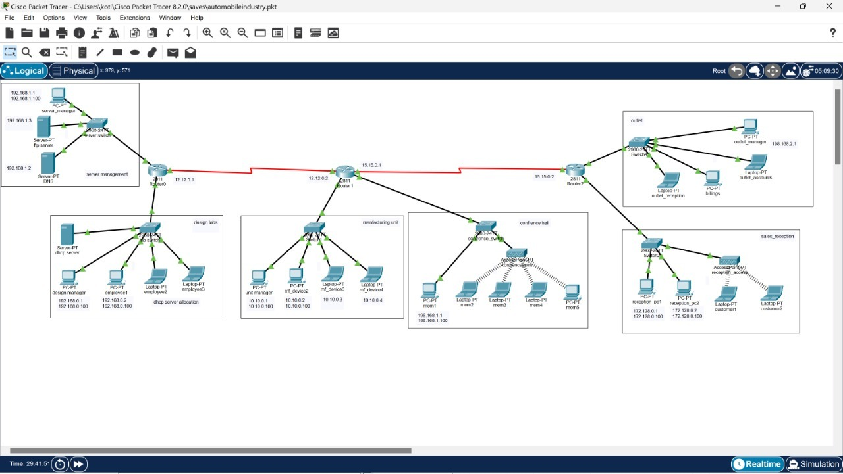

We consider Six Departments in our Network Model:

* Server Room
* Design Labs
* Manufacturing Unit
* Conference hall
* Sales Reception
* Factory Outlet

All these departments are connected by the means of router. WIC– 2T

**Router:**

First we take a router 2811, as router has two fast Ethernet but the requirement for use are 3. So, we change the module in the router by offing the router and replace it WIC– 2T with module and we will on the router.

**Server Room:**

In the Server Room we connect all the PC’s and Laptop’s by means of wire to a switch which is connected to the router .

Here switch connects to router using copper straight-through. Pc’s connects to switch using copper straight-through.

We connect the switch to fast Ethernet 0/0 in the router.

**Design Labs:**

In the Design Labs we connect all the PC’s and Laptop’s by means of wire to a switch which is connected to the router .

Here switch connects to router using copper straight-through. Pc’s connects to switch using copper straight-through.

We connect the switch to fast Ethernet 1/0 in the router.

**Manufacturing Unit:**

In the Manufacturing Unit we connect all the PC’s and Laptop’s by means of wire to a switch which is connected to the router .

Here switch connects to router using copper straight-through. Pc’s connects to switch using copper straight-through.

We connect the switch to fast Ethernet 0/0 in the router.

**Conference Hall:**

In the Conference Hall we connect all the PC’s and Laptop’s by means of wire to a switch which is connected to the router .

Here switch connects to router using copper straight-through. Pc’s connects to switch using copper straight-through.

We connect the switch to fast Ethernet 1/0 in the router.

**Sales Reception:**

In the Sales Reception we connect all the PC’s and Laptop’s by means of wire to a switch which is connected to the router .

Here switch connects to router using copper straight-through. Pc’s connects to switch using copper straight-through.

We connect the switch to fast Ethernet 0/0 in the router.

**Factory Outlet:**

In the Factory Outlet we connect all the PC’s and Laptop’s by means of wire to a switch which is connected to the router .

Here switch connects to router using copper straight-through. Pc’s connects to switch using copper straight-through.

We connect the switch to fast Ethernet 1/0 in the router.

**Cable/connection details:**

|  |  |
| --- | --- |
| Design Labs(192.168.0.0) | |
| DHCP server | 192.168.0.100 |
| PC PT(Design Manager) | 192.168.0.1 |
| PC PT(Employee-1) | 192.168.0.2 |
| LAPTOP PT(Employee-2) | 192.168.0.6 |
| LAPTOP PT(Employee-3) | 192.168.0.7 |

|  |  |
| --- | --- |
| Manufacturing unit(10.10.0.0) | |
| PC PT(Unit Manager) | 10.10.0.1 |
| PC PT(mf_device-2) | 10.10.0.2 |
| LAPTOP PT(mf_device-3) | 10.10.0.3 |
| LAPTOP PT(mf_device-4) | 10.10.0.4 |

|  |  |
| --- | --- |
| Conference Hall (198.168.1.0) | |
| PC PT(Unit Manager) | 198.168.1.1 |
| PC PT(mf_device-2) | 198.168.1.2 |
| LAPTOP PT(mf_device-3) | 198.168.1.3 |
| LAPTOP PT(mf_device-4) | 198.168.1.4 |
| LAPTOP PT(mf_device-4) | 198.168.1.5 |

|  |  |
| --- | --- |
| Server Room(192.168.1.0) | |
| PC PT(Server Manager) | 192.168.1.1 |
| FTP Sever | 192.168.1.3 |
| Web Sever | 192.168.1.2 |
| DNS Server | 192.168.1.4 |
|  |  |

|  |  |
| --- | --- |
| Sales Reception(172.128.0.0) | |
| PC PT (Reception PC1) | 172.128.0.1 |
| PC PT (Reception PC2) | 172.128.0.2 |
| Laptop PT (Customer 1) | 172.128.0.3 |
| Laptop PT (Customer 2) | 172.128.0.4 |

|  |  |
| --- | --- |
| Factory OutLet(198.168.2.0) | |
| PC PT (Outlet Manager) | 198.168.2.1 |
| PC PT (Outlet Accounts) | 198.168.2.2 |
| Laptop PT (Billings) | 198.168.2.3 |
| Laptop PT (Outlet Reception) | 198.168.2.4 |

**Implementation and Configuration:**

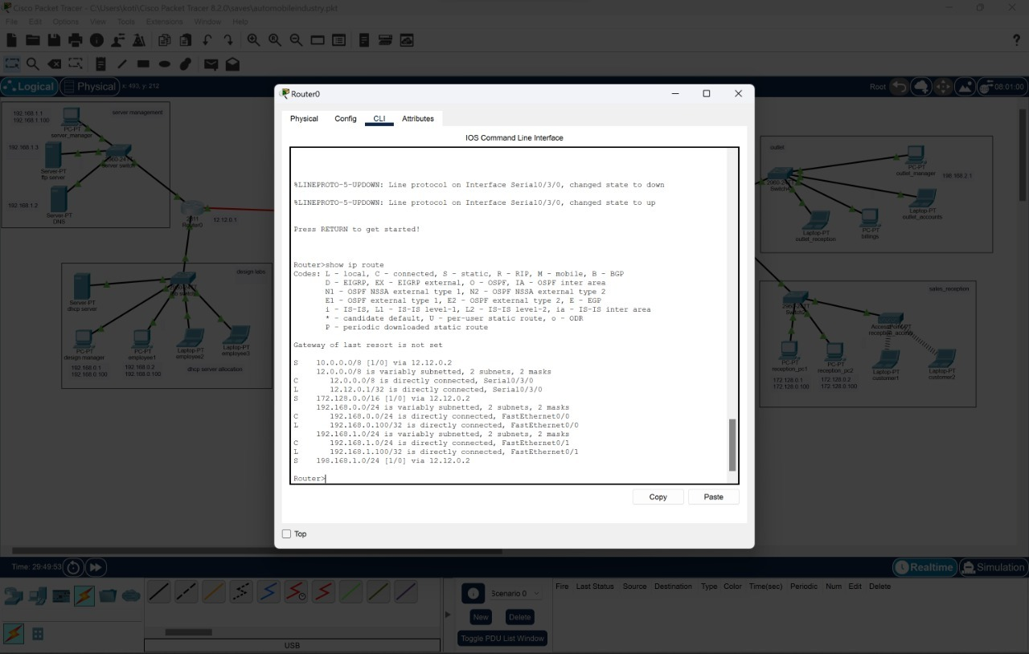

Routing Protocol plan for R0

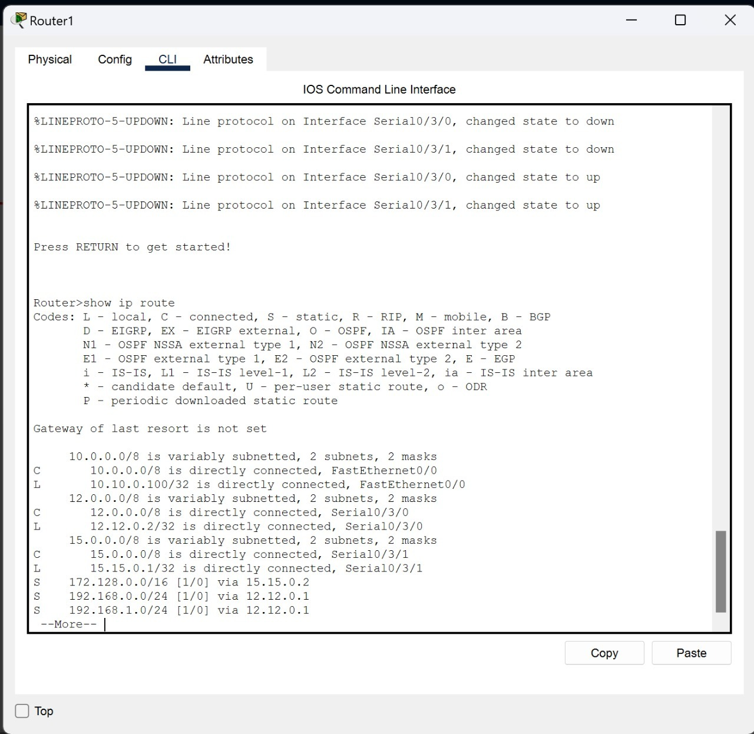 

Routing Protocol plan for R1 Routing Protocol plan for R1

**Network Design**

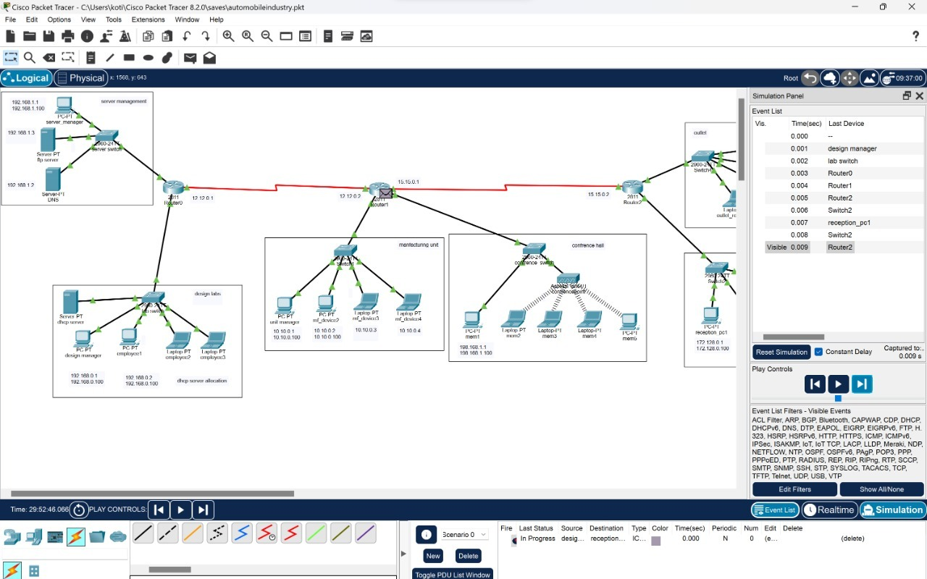

The prototype of the proposed network is implemented on cisco packet tracer

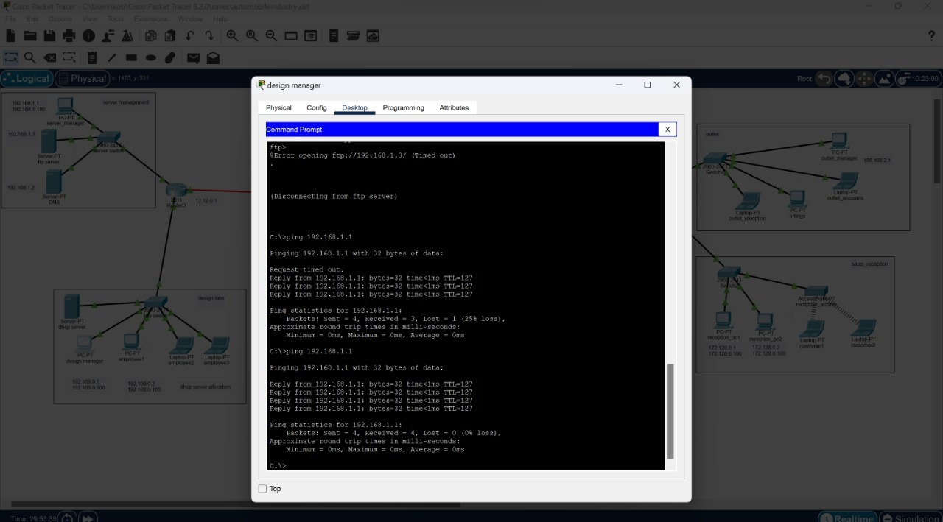

Testing VLAN communications from Server to Factory Outlet

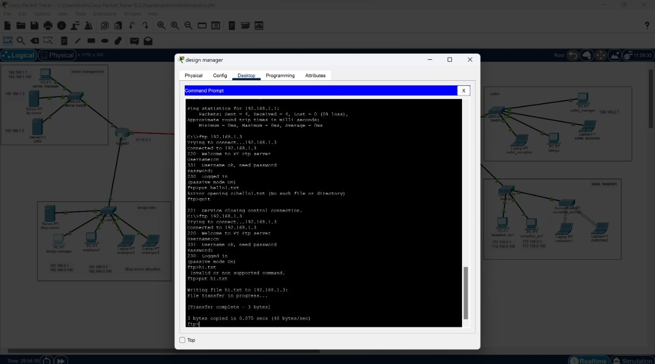

Testing FTP Server

**Operation Performed while transferring data from PC or Laptop to Server**

* How to send a file from PC0 to server?

1. First enter command:ftp (Ip addresses of the server)

Ex: ftp 192.168.1.3

1. Asks to username and password and enter your details
2. Enter command: put (filename)

Ex: put team.txt

1. Quit

* How to get a file from server to any PC?

1. Go to any PC in your network design.
2. Go to command prompt.
3. First enter command: ftp (Ip addresses of the server)

Ex: ftp 192.168.1.3

1. Asks to username and password and enter your

Details.

1. Enter command: get (filename you want)

Ex: get team.txt

6)we will get the file we want.

**Conclusion**

The outcome of the proposed system will be a fail-safe backbone network infrastructure which meets the requirements for readily available access to information and security of the private network, and also ensures optimized productivity when telecommunication services are accessed. The installed equipment allowed to organize high-speed wired and wireless Internet access throughout the whole complex of hospital buildings as well as providing transfer of all types of data throughout the single optimized network.