
NORTH SOUTH UNIVERSITY
Department of Electrical & Computer Engineering

Project Report

Course Title | Microprocessor Interfacing and Embedded Systems Lab
Course Code | CSE 331L
Section | 06
Group | 9
Submitted By
Name | Student ID
Araf Tahsan Pavel | 2212079042
Ismot Ara Emu | 2212108042
Md Yeasin Arafat | 2212337042
Md. Mashrur Reza | 2232465042
Submitted To
Course Faculty | Mr. Acramul Haque Kabir
Lab Instructor | Jannat Sultana
Date of Submission | 8 September 2026
For Evaluator's Use Only
Marks Obtained
Remarks
Academic Integrity Statement: We confirm that this submission is our own work and complies with North South University's academic integrity policy.

Project Title
PLANT-X: Smart Plant Health Monitor
An embedded plant care monitor built on an STM32F103C8T6 microcontroller. It samples soil moisture, air temperature, relative humidity and ambient light, presents each reading on a keypad selected OLED screen with a plain-language status band, and raises an audible and visual alarm when a reading crosses its threshold.

Abstract
PLANT-X is a standalone plant health monitor built around the STM32F103C8T6 Blue Pill board [1]. Houseplants mostly die from watering mistakes, and the person doing the watering has no way to see what is happening inside the pot until the plant already looks sick. The system attacks that gap by sampling four quantities on every pass of the main loop: air temperature and relative humidity from a DHT11 [4], soil moisture from a resistive YL-69 probe on a 12-bit ADC channel, and ambient light from an LDR wired into a voltage divider. Readings are shown on a 0.96 inch SSD1306 OLED over I2C [3]. A 4x4 membrane keypad, scanned in software, drives a five state interface: a menu listing the four sensors, and one screen per sensor that prints the value together with a status band such as DRY, OK or WET. When temperature passes 30 degrees Celsius, soil moisture falls under 30 percent, or the light level drops below 100 ADC counts, the firmware pulses an active buzzer and the onboard LED. The finished unit runs from USB power, needs no phone or network connection, and cost about 1309 BDT in parts. All four channels held steady through a week of bench testing. Two further sensors were tried and dropped after they failed on the bench.

Introduction and Motivation

The problem being addressed
Watering is the part of plant care people get wrong. A pot dries out over four days in a warm room and over ten in a cool one, and nobody tracks that. The usual advice, poke a finger into the soil, tells you about the top two centimetres and nothing about the root zone. Heat is worse, because a plant sitting next to a window through an afternoon can pass 35 degrees Celsius while the room itself feels fine, and the damage shows up as browning leaves several days later. By the time a plant looks unwell the useful window for doing something about it has usually closed.
Published work on low-cost soil monitoring reaches the same conclusion. Both Kumar et al. [15] and Nasir et al. [16] report that a cheap resistive probe plus a microcontroller is enough to catch a dry pot well before the plant shows visible stress, which is the whole premise this project runs on.
Commercial plant sensors exist, but they route everything through a phone app and a cloud account. That is a lot of infrastructure for a question as small as whether the soil is dry, and the sensor stops working the day the vendor shuts the service down.

Why the project is useful
PLANT-X keeps the whole loop on the device. Four values are sampled continuously, any one of them is two keypresses away, and the buzzer and LED speak up when something is out of range. There is no app, no pairing step and no Wi-Fi credential to type in. Power it from any USB port and it works.
The interface was also written so that a reading means something to a person who has not read the datasheet. Every sensor screen prints a status band under the number, so the soil screen says DRY-Water me! rather than leaving the user to decide what 24 percent means. The light screen still prints the raw ADC count, which keeps the hardware easy to verify on a bench without a debugger attached.

How the project relates to the course
The project sits directly on top of the CSE 331 lecture material rather than beside it.
Lectures 9 and 10 covered GPIO configuration, the MODER, OTYPER and ODR registers, and the rule that a peripheral clock must be enabled at the RCC before any of its registers respond [2]. PLANT-X depends on that in three places: the single wire DHT11 line on PB9, which switches between output and input inside one transaction, the active buzzer on PB12, and the onboard LED on PC13, which is wired active low so the software has to invert it. The keypad uses the row and column scanning method from the same lectures, with four rows driven on PA0 to PA3 and four columns read back on PA4 to PA7.
Lecture 15 covered the ADC. Two channels are in use here. The soil probe on PB0 and the LDR on PB1 both feed the 12-bit successive approximation converter, which returns 0 to 4095 counts against the 3.3 volt rail. The soil reading is then mapped from its measured wet and dry endpoints onto a 0 to 100 percent scale.
Lectures 11 to 13 covered interrupts, the NVIC and SysTick. This build polls rather than using EXTI lines, and the alert routine blocks with delay() rather than running off a timer. Those are both deliberate choices, discussed in the Discussion section, but the exception model from those lectures is what makes their cost legible: any blocking call inside the main loop stalls keypad scanning for exactly its own duration [14]. Knowing that is why the alert carries a rate limiter instead of firing on every frame.
The I2C link to the OLED runs on PB6 and PB7, and the AMBA bus structure introduced with the GPIO material explains why the peripheral has to be clocked before the first byte will move. The STM32 register-level walkthroughs at Micropeta [13] were useful for checking our understanding of the clock tree against the reference manual.

System Overview

Overall concept
The Blue Pill is the only active part. Three sensors feed into it, four devices hang off it, and a single firmware loop ties them together. Figure 1 shows the arrangement.
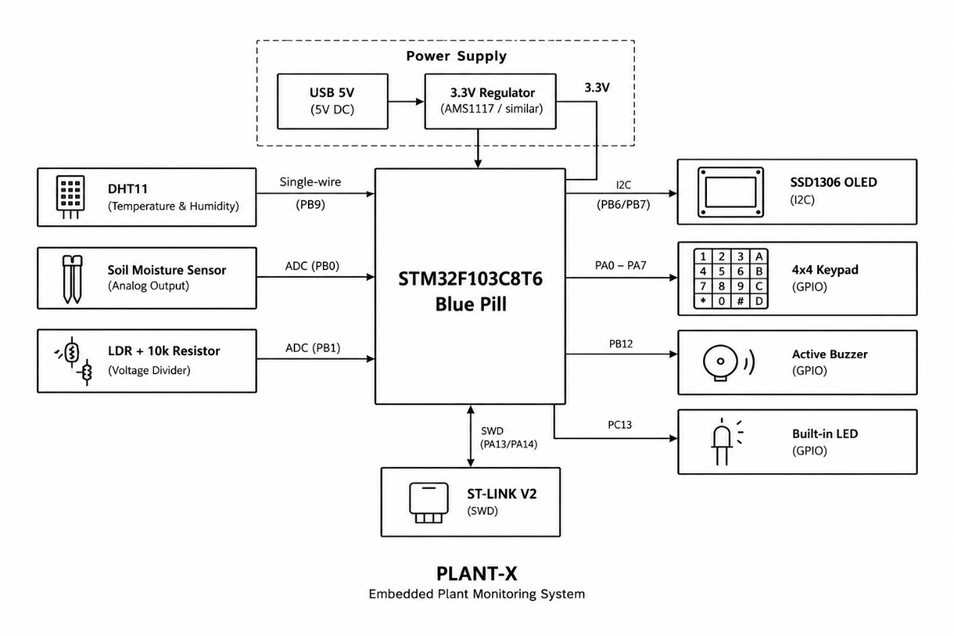
Figure 1. System block diagram. The Blue Pill sits between three sensor inputs on the left and four output or interface devices on the right. Every connection is labelled with its interface and the pins it occupies.
Power arrives over USB at 5 volts and is dropped to 3.3 volts by the regulator already on the Blue Pill. Everything on the board runs from that rail, including both sensors on ADC channels, which matters because the ADC reference is the same 3.3 volts. A shared rail means a supply sag shifts the reference and the reading together, so the ratio stays roughly correct.

How the interface is navigated
The firmware holds five states. On power up it lands on the menu, which lists the four sensors as numbered lines. Pressing 1, 2, 3 or 4 opens the matching sensor screen, and pressing * anywhere in a sensor screen returns to the menu. There is no deeper hierarchy, so any reading is at most one keypress away from the menu. Table 1 lists the five states.
Table 1. The five states of the Screen enumeration and what each one draws.
State | Reached by | What it draws
MENU | Power up, or * from any sensor screen | A title bar and the four numbered options: Temp Check, Hum Check, Soil Check, Light Check.
TEMP_SCREEN | Key 1 | Temperature in degrees Celsius at text size 2, with a status line reading COLD, Comfortable or HOT. Calls the alert above 30 degrees.
HUM_SCREEN | Key 2 | Relative humidity as a large integer with a percent sign, and a status line reading Humid, Normal or Dry. No alert on this screen.
SOIL_SCREEN | Key 3 | Moisture percentage in large type with a status line reading DRY-Water me!, OK-Happy! or WET-Good!. Calls the alert below 30 percent.
LIGHT_SCREEN | Key 4 | The raw ADC count with a status line reading Need light!, NORMAL LIGHT or BRIGHT. Calls the alert below 100 counts.

Features
Temperature and humidity monitoring with the DHT11. The sensor on PB9 returns both values over its single wire protocol, and the firmware keeps the last good reading whenever a frame comes back as NaN. The temperature screen prints the value to one decimal place with a degree symbol drawn from two separate text sizes, since the display font has no such glyph. Humidity is printed as a whole number, because a DHT11 does not resolve fractions of a percent anyway.
Soil moisture detection with an automatic dry alert. The YL-69 probe on PB0 is read as a raw ADC count and mapped onto 0 to 100 percent using the endpoints measured on our own soil, 1000 counts for dry and 600 for saturated, then clamped to that range. Below 30 percent the screen prints DRY-Water me! and fires the buzzer and LED. Between 30 and 60 percent it reads OK-Happy!, and above that WET-Good!.
Ambient light sensing with a raw ADC readout. The LDR sits in a divider with a 10 kilo-ohm resistor to ground, and the junction feeds PB1. The screen prints the raw count rather than a percentage, which makes it usable as a calibration aid: point the sensor at a known condition and read the number directly. Below 100 counts it prints Need light! and alerts, between 100 and 500 it reads NORMAL LIGHT, and above that BRIGHT.
Audible and visual alerting. A threshold breach on the temperature, soil or light screen calls alert(), which pulses the buzzer on PB12 and the LED on PC13 five times. A static timestamp inside the function limits it to one burst every three seconds, however often the screen redraws.
Menu driven navigation from a 4x4 keypad. Sixteen keys are wired through eight pins by row and column scanning, though only five of them are used: 1 to 4 to select a sensor and * to go back. Debounce is set to 50 milliseconds in setup().

Implementation Details

Hardware Implementation
Table 2 lists the final bill of materials with the pins each module occupies and the cost. Prices come from the Robotics Bangladesh catalogue [12] as of August 2026. The onboard LED on PC13 is part of the Blue Pill, so it adds nothing to the total. The LDR is a bare component rather than a module, and its 10 kilo-ohm partner resistor is a through-hole part, which is why it appears in the table at seven taka for the pair.
Table 2. Final hardware modules, pin usage and cost breakdown.
Module | Purpose | Pins | Price (BDT) | Source
STM32F103C8T6 Blue Pill | Main MCU | All | 450 | RoboticsBD
SSD1306 OLED 0.96 inch | Display | PB6, PB7 | 260 | RoboticsBD
DHT11 sensor module | Temperature, humidity | PB9 | 120 | RoboticsBD
YL-69 soil moisture probe | Soil moisture (ADC) | PB0 | 70 | RoboticsBD
LDR 5 mm with 10k resistor | Ambient light (ADC) | PB1 | 7 | RoboticsBD
4x4 membrane keypad | Navigation input | PA0 to PA7 | 80 | RoboticsBD
Active buzzer | Audible alert | PB12 | 17 | RoboticsBD
ST-LINK V2 mini | Programmer, debugger | PA13, PA14 | 250 | RoboticsBD
Jumper wire set | Interconnect | N/A | 55 | RoboticsBD
Total estimated cost |  |  | 1309
Table 3 gives the reasoning behind each choice. Most of it comes down to pin budget and whether the part gives a continuous reading or just a threshold flag.
Table 3. Why each module was chosen over the alternatives available to us.
Module | Reason for selection
Blue Pill (STM32F103C8T6) | The course platform is ARM Cortex-M. This board carries a Cortex-M3 core, 64 kB flash and 20 kB SRAM [1], which is far more than this firmware needs, and it exposes the ADC, I2C and GPIO banks the project requires on a single 40-pin header.
SSD1306 OLED | Two wires instead of the six a parallel character LCD would need. It also draws lines and sets text size per element, which the sensor screens use to make the value larger than the label.
DHT11 | Single wire, cheap, and adequate for a houseplant. Its 2 degree Celsius accuracy is coarse [4], but the alert threshold sits at 30 degrees, well outside that error band.
YL-69 resistive probe | The capacitive alternative costs roughly three times more. Resistive probes corrode over months of continuous burial, which is a real drawback, but the analog output maps cleanly onto one ADC channel.
Bare LDR with divider | A packaged light module outputs a comparator signal, so it only reports bright or dark. A bare LDR in a divider gives a continuous count, which is what the three-band light status needs.
4x4 membrane keypad | Sixteen keys from eight pins through row and column scanning, the technique covered in the GPIO lectures. Five buttons would have done the job, but the keypad was already on hand and leaves room for more screens later.
Active buzzer | It generates its own tone from a steady logic high, so no PWM channel or timer is tied up for audio.
ST-LINK V2 mini | SWD flashing and debugging [11]. The Blue Pill USB bootloader is unreliable on cloned boards, and we hit that problem early.

Physical layout
The Blue Pill sits at one end of a small breadboard with its 3.3 V and GND pins tied into the board power rails, so the OLED and the DHT11 draw from the rails instead of running individual wires back to the MCU header. That decision saved four jumpers and made the wiring photograph legible, which matters more than it sounds when you are debugging at two in the morning.
The keypad ribbon terminates in an eight-pin connector that plugs straight onto PA0 through PA7 in sequence. No adapter wires were needed for that bank, which is also why the keypad rows are mapped in reverse order in software: the ribbon pin order is fixed and it was easier to flip the array than to re-crimp the connector.
The soil probe connects through female-to-male jumpers into the analog section of the breadboard. The LDR forms a divider with a 10 kilo-ohm resistor to ground and the junction is wired to PB1. The buzzer and the ST-LINK header both use individual female-to-male wires. Figure 2 shows the finished assembly.
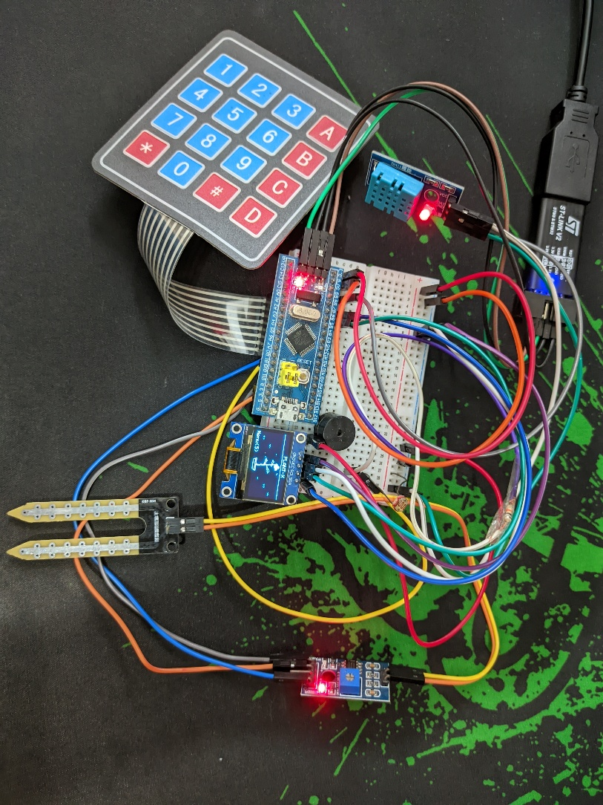
Figure 2. The assembled prototype. The Blue Pill and the OLED share the breadboard power rails. The keypad ribbon plugs straight onto PA0 to PA7, the soil probe reaches in from the left, and the ST-LINK enters from the top right.

Software Implementation

Languages and development tools
The firmware is C++ built against the Arduino framework on the STM32duino core [9]. The project is managed by PlatformIO inside VS Code on Linux [10], and flashing goes through st-flash from the open source ST-LINK tools [11], wrapped in a shell alias so a build and flash is one command. Four libraries are in use: Adafruit SSD1306 [6] and Adafruit GFX [5] for the display, the Adafruit DHT sensor library [7] for the DHT11, and the Keypad library by Chris Andrews [8] for the membrane keypad. Wire from the Arduino core carries the I2C traffic.
The whole firmware is one file of under two hundred lines. Nothing here needs more than that, and keeping it in a single translation unit made the flash cycle short.

Program structure
State lives in a Screen enumeration with five values, and a single global screen holds the current one. loop() does four things in a fixed order: read the keypad, read all four sensors, act on the key according to which state is active, and draw. The order matters. Sensors are read before the state check, so the values are already fresh whichever screen ends up being drawn, and no screen has to do its own acquisition.
The state machine itself is two branches. In MENU the keys 1 to 4 each assign a new value to screen, then drawMenu() runs regardless, so the menu stays on the display for that pass and the chosen sensor screen appears on the next one. In any other state, * assigns MENU back, and then a short chain of comparisons picks the matching draw function. Every draw function is self-contained: it clears the buffer, prints its own header and separator line, prints the value, prints the status band, and pushes the buffer out with display.display().

Key algorithms and control logic
readSensors() runs on every pass. The delay(100) at the end of loop() is what sets the effective sampling rate, so the sensors are read roughly ten times a second. The DHT11 is read first, and because the library returns NaN when a transaction is corrupted, the result is discarded on failure and the previous good value is retained rather than letting a bad frame blank the display. The soil probe is read next and mapped, and the LDR count is stored raw.
EVERY LOOP ITERATION:
t, h = DHT11_read(PB9)
IF t is not NaN THEN temp = t // keep the last good value
IF h is not NaN THEN hum = h // through a corrupted frame

raw_soil = ADC_read(PB0)
moisture = constrain(map(raw_soil, 1000, 600, 0, 100), 0, 100)
light = ADC_read(PB1) // stored as a raw count

ALERT(): // called from a sensor screen
IF (millis() - last_alert) < 3000 THEN return
last_alert = millis()
FOR i = 1 TO 5:
BUZZER = HIGH ; LED = ON ; wait 60 ms
BUZZER = LOW ; LED = OFF ; wait 60 ms

ON THE SENSOR SCREENS:
drawTemp() calls ALERT() when temp > 30
drawSoil() calls ALERT() when moisture < 30
drawLight() calls ALERT() when light < 100
drawHumidity() never alerts

The map() call is worth reading carefully because its endpoints run backwards. A resistive probe conducts better in wet soil, so a wetter reading is a lower ADC count. Passing 1000 as the input low and 600 as the input high inverts the scale, which is why 1000 counts becomes 0 percent and 600 counts becomes 100. The constrain() around it is what stops a probe reading outside that window from producing a negative percentage or one above a hundred.
The rate limiter in alert() is a static timestamp rather than a member variable, so it survives between calls without a global. Table 4 records every status band and threshold in the firmware, including the ones that are informational rather than alerting.
Table 4. Status bands on each sensor screen, and which of them trigger the alert.
Screen | Condition | Text shown | Alert
Temperature | Below 27 degrees | !! COLD !! | No
Temperature | 27 to 30 degrees | Comfortable | No
Temperature | Above 30 degrees | !! HOT !! | Yes
Humidity | Above 70 percent | Humid - stay cool! | No
Humidity | 40 to 70 percent | Normal - comfy! | No
Humidity | Below 40 percent | Dry - drink water! | No
Soil moisture | Below 30 percent | DRY-Water me! | Yes
Soil moisture | 30 to 60 percent | OK-Happy! | No
Soil moisture | Above 60 percent | WET-Good! | No
Light | Below 100 counts | Need light! | Yes
Light | 100 to 500 counts | NORMAL LIGHT | No
Light | Above 500 counts | BRIGHT | No
The three alerting thresholds were set on the bench rather than from a datasheet. Thirty degrees is where most common indoor foliage plants begin to show heat stress, and it clears the DHT11 error band. Thirty percent on our mapped scale was where the probe sat in potting soil that felt dry to a finger. A hundred counts on the LDR matched a room with the ceiling light switched off.
Navigation is a pair of comparisons. Keys 1 through 4 only have meaning while screen is MENU, and * only has meaning while it is not, so the same physical key can never do two things at once and there is no need to track a menu depth.
key = keypad.getKey() // returns 0 when nothing was pressed
readSensors()

IF screen == MENU:
IF key == '1' THEN screen = TEMP_SCREEN
IF key == '2' THEN screen = HUM_SCREEN
IF key == '3' THEN screen = SOIL_SCREEN
IF key == '4' THEN screen = LIGHT_SCREEN
drawMenu() // menu stays up for this pass
ELSE:
IF key == '*' THEN screen = MENU
IF screen == TEMP_SCREEN THEN drawTemp()
IF screen == HUM_SCREEN THEN drawHumidity()
IF screen == SOIL_SCREEN THEN drawSoil()
IF screen == LIGHT_SCREEN THEN drawLight()

delay(100) // sets the effective sample and redraw rate

Figure 3 traces the same logic end to end, from power up through acquisition and the two state branches down to the alert and the loop delay.
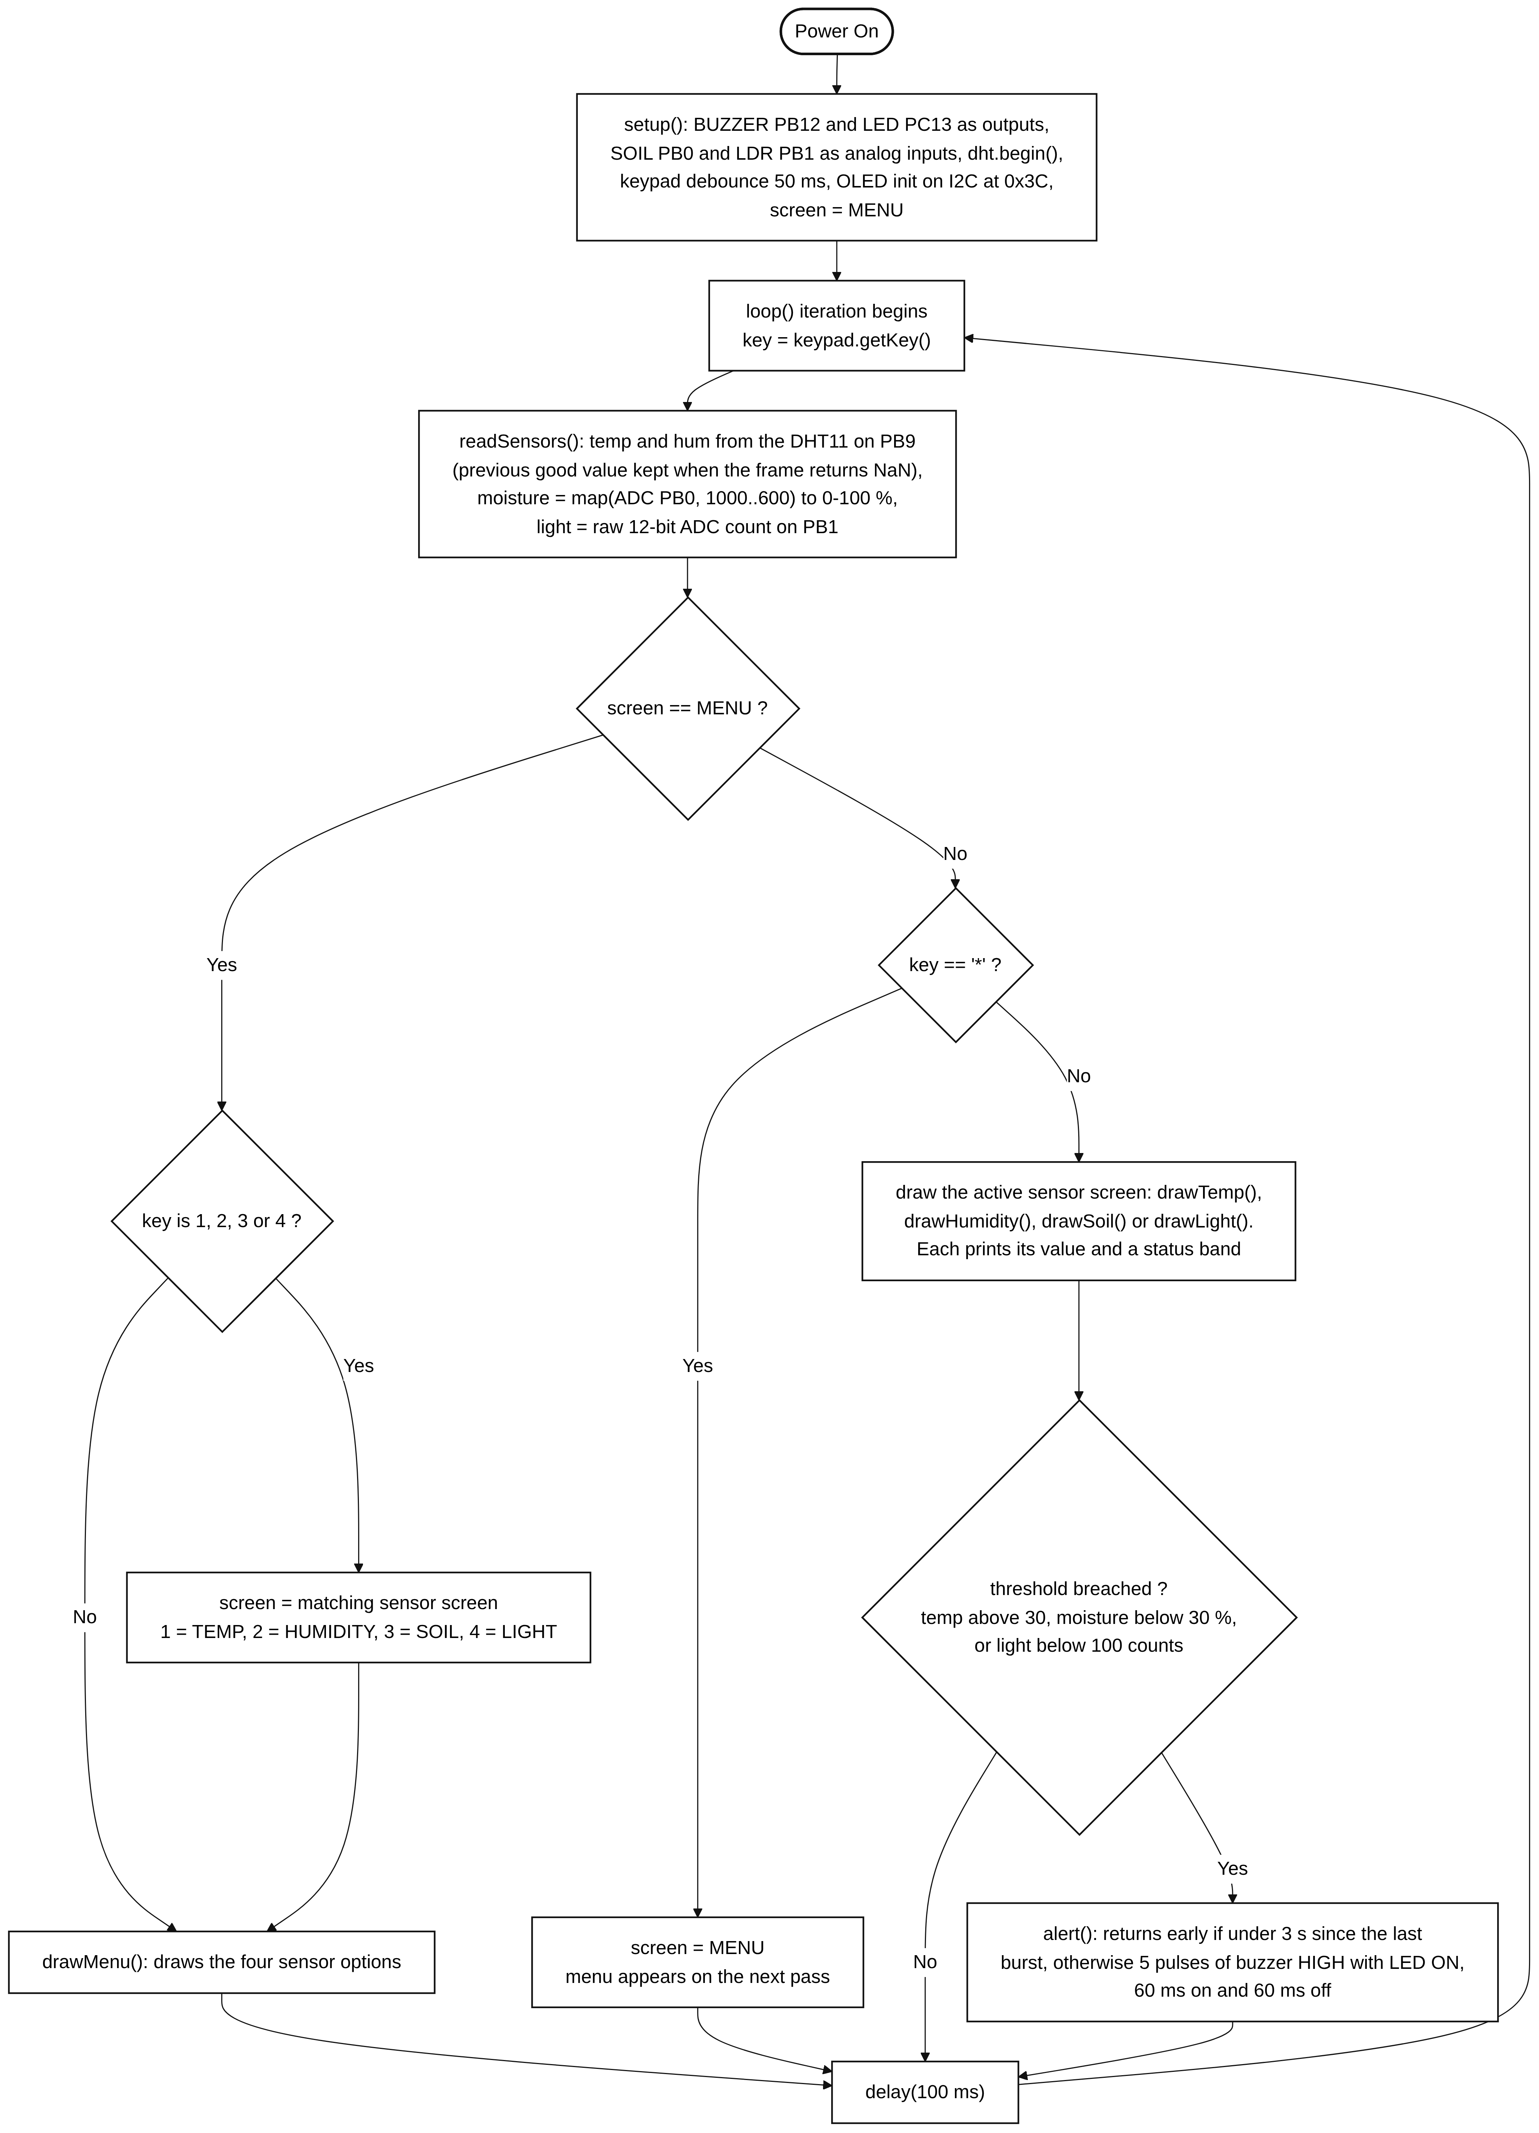
Figure 3. Firmware control flow. Sensors are read before the state is checked, so every screen draws from fresh values. The menu branch on the left assigns the new screen and still draws the menu for that pass; the sensor branch on the right draws the active screen and evaluates its threshold before the loop delay.

Communication protocols used
Five interfaces are in use. Table 5 lists them with the pins and the constraints each one imposes.
Table 5. Communication interfaces used between the MCU and each peripheral.
Interface | Peripheral | Pins | Notes
I2C1 | SSD1306 OLED | PB6 (SCL), PB7 (SDA) | Slave address 0x3C, initialised with the charge pump enabled. One frame buffer of 1024 bytes is pushed on every display.display() call [3].
Single wire | DHT11 | PB9 | Proprietary timing protocol handled by the DHT library. Minimum one second between valid samples [4], which is why the 100 ms loop often gets a NaN and reuses the last value.
ADC1 | Soil probe, LDR | PB0, PB1 | 12-bit successive approximation, 0 to 4095 counts against the 3.3 V rail. Both pins are set to INPUT_ANALOG in setup().
GPIO output | Buzzer, onboard LED | PB12, PC13 | PC13 is active low on the Blue Pill, so the LED is driven HIGH to switch it off.
GPIO scan | 4x4 keypad | PA0 to PA3, PA4 to PA7 | Rows driven, columns read, 50 ms debounce. Rows are listed in reverse to match the ribbon.
SWD | ST-LINK V2 | PA13, PA14 | Programming and debugging only, not used at run time.

Discussion

What worked
All three sensors read reliably on the pins they were assigned and kept doing so across a week of testing. The soil probe tracked wetting and drying in a real pot with no recalibration after the initial endpoint measurement. The DHT11 was slower to settle than expected, taking two or three seconds after power up before the first valid frame, but it never drifted once running. Keeping the last good value on a NaN turned out to matter more than we assumed: at a 100 millisecond loop the sensor is polled far faster than its one second refresh, so failed frames are the normal case rather than the exception, and without that guard the display would flicker between a number and nothing.
Reading the sensors before the state check was the other decision that paid off. Because acquisition is not tied to any screen, adding a screen means writing one draw function and one comparison. Nothing else in the loop has to change.
The status bands turned out to be the feature people actually reacted to during testing. A number on a screen invites the question of whether it is good. DRY-Water me! does not.

What did not work
Two components were tested and abandoned.
The HC-SR04 ultrasonic sensor was intended for a tank level reading on a future watering system. Two separate units returned no echo pulse on our wiring. The same units worked on a classmate's board, which points at our wiring or our trigger timing rather than dead hardware, but we could not isolate it inside the time we had. It is not in the final build.
The servo produced only a static buzz on every pin tried, including pins with confirmed PWM output. Since a working PWM signal on a known good pin still produced no motion, the most likely explanation is a dead unit, but we had no second servo to confirm that. It is also not in the final build.

Actual results against the proposal
Table 6 sets the proposal beside the delivered system. Five of the six proposed features shipped and one was dropped, taking its dependent feature with it.
Table 6. What the proposal promised against what the finished build does.
Proposed feature | Status | Outcome
Temperature and humidity | Delivered | DHT11 on PB9, with the last good value retained through failed frames.
Soil moisture with alert | Delivered | YL-69 on PB0, mapped to 0 to 100 percent with a dry alert under 30 percent.
Ambient light sensing | Delivered | LDR divider on PB1, raw count displayed with a three-band status.
Buzzer and LED alerts | Delivered | Shared routine, rate limited to one burst every three seconds.
Menu driven OLED interface | Delivered | Five states, four sensor screens reachable in one keypress from the menu.
Distance sensing (HC-SR04) | Dropped | Two units returned no echo pulse on our wiring. Removed from the build.
Servo actuated watering | Dropped | The servo only buzzed on every pin tried, including known good PWM pins.

Challenges encountered and how they were solved
The most instructive bug in the project was also the simplest. The first version of alert() had no rate limiter, so a sensor screen sitting above its threshold called it on every redraw. Each call spends five pulses of 60 milliseconds on and 60 off, which is 600 milliseconds of delay() inside the main loop. Chained back to back the loop effectively stopped. The screen still updated between bursts, so nothing looked broken, but pressing * to leave the temperature screen did nothing perhaps three times out of four. The keypad scan simply was not running when the key went down.
The fix was a static timestamp at the top of the function that returns early unless three seconds have passed since the last burst. The alert still blocks for 600 milliseconds when it does fire, but it can only do that once every three seconds, so the loop gets 2.4 seconds of normal service in between and the keypad becomes usable again.
It is worth being honest about what that fix is. It reduces how often the loop stalls rather than removing the stall, and a hardware timer driving the buzzer from an interrupt, or even a millis() state machine inside alert(), would remove it properly. We knew that at the time and chose the rate limiter because the deadline was closer than the elegance was valuable. It is recorded here as a design decision, not as the best available option.
A second challenge was the Blue Pill USB bootloader, which failed to enumerate on two of our boards. Switching to SWD flashing through an ST-LINK V2 solved it in one afternoon and gave us a debugger as a side benefit.
The third was the degree symbol. The Adafruit GFX default font has no such glyph, so printing it as a character produces a blank. The temperature screen works around it by printing a lowercase o at text size 1 immediately before the C at text size 2, positioned by hand at coordinates that make it read as a superscript.

Deviations from the original plan
Beyond the two dropped sensors, the interface ended up simpler than the proposal described. The plan called for a scrolling menu with nested submenus. What was built is a flat menu of four items, because with only four sensors a hierarchy adds a keypress without adding anything else. The scrolling menu code was written and then removed.
The plan also assumed hardware interrupts on the keypad through EXTI lines. The final build polls instead. At a 100 millisecond loop the library handles debouncing and a deliberate keypress is caught reliably, so the EXTI work would have bought responsiveness that is hard to perceive. That was a scope call, not a limitation of the platform.

Limitations
The alert blocks. When alert() fires, the main loop stops for 600 milliseconds and no keypress in that window is registered. The rate limiter makes this tolerable rather than invisible, and a user pressing * at exactly the wrong moment will have to press it twice.
The delay(100) at the bottom of the loop caps how fast the keypad is scanned. A very quick tap that begins and ends inside one delay is lost. In practice a normal press is far longer than 100 milliseconds, so this rarely shows up, but it is the reason the interface feels slightly unhurried.
There is no persistent storage and no real time clock, so the system reports only what is true right now. It cannot show a trend, and it cannot tell night from an unlit room, which means the light alert will sound at three in the morning if that screen is left open.
The DHT11 is accurate to about 2 degrees Celsius and 5 percent relative humidity [4]. For deciding whether a room is too hot for a plant that is fine. For anything that needs real numbers it is not.
The soil scale is calibrated to one soil. The endpoints of 1000 and 600 counts were measured in the potting mix we had, and a different soil, a different pot depth or a corroded probe will shift both. There is no way to recalibrate without editing the source and reflashing.
The resistive probe itself corrodes. Current passes continuously through the electrodes into wet soil, and over weeks of burial the readings drift as the electrode surface degrades.
Finally, the whole system is tied to a USB cable. There is no battery, no charging circuit and no low power mode, so it monitors a plant that lives within reach of a wall socket.

Potential future improvements
Rewriting alert() as a non-blocking state machine driven by millis(), or moving it onto a hardware timer interrupt, is the change that would most improve how the device feels to use. After that, an EEPROM or SD card would allow logging so the user could see a trend rather than an instant, and an RTC module such as the DS3231 would give timestamps and let the light logic distinguish night from a dark room. A calibration screen that captures the dry and wet endpoints from two keypresses would remove the need to reflash for a new soil. A working servo with a small pump and a motor driver would close the loop from detection to watering, which was the original ambition and the direction the irrigation literature points [15], [16]. A fifth screen showing all four readings at once would suit the case where someone just wants a glance rather than a specific number.

Conclusion
PLANT-X does what it was built to do. Four environmental readings, each one keypress from a menu, each printed with a status band that means something without a datasheet, and an alarm that fires when the plant needs attention, all from a 450 taka microcontroller and about the same again in sensors. The parts that failed, an ultrasonic sensor and a servo, were both peripheral to the core function and their loss cost the project one planned feature rather than the whole idea.
The most useful thing the build taught us was about timing rather than sensing. Reading a soil probe is one line of code. Making sure that line still runs while the buzzer is sounding and the OLED is being redrawn is the actual engineering, and it is the part the lecture material on interrupts and blocking behaviour spoke to most directly.

References
[1] STMicroelectronics, "STM32F103x8/STM32F103xB: Medium-density performance line Arm Cortex-M3 MCU datasheet," Rev. 17, 2015. [Online]. Available: https://www.st.com/resource/en/datasheet/stm32f103c8.pdf
[2] STMicroelectronics, "RM0008 Reference manual: STM32F101xx, STM32F102xx, STM32F103xx, STM32F105xx and STM32F107xx advanced Arm-based 32-bit MCUs," Rev. 21, 2021. [Online]. Available: https://www.st.com/resource/en/reference_manual/rm0008.pdf
[3] Solomon Systech, "SSD1306: 128x64 dot matrix OLED/PLED segment/common driver with controller," Rev. 1.1, 2008.
[4] Aosong (Guangzhou) Electronics Co. Ltd., "DHT11 humidity and temperature sensor datasheet," 2019.
[5] Adafruit Industries, "Adafruit GFX graphics core library." [Online]. Available: https://github.com/adafruit/Adafruit-GFX-Library
[6] Adafruit Industries, "Adafruit SSD1306 OLED driver library for Arduino." [Online]. Available: https://github.com/adafruit/Adafruit_SSD1306
[7] Adafruit Industries, "DHT sensor library for Arduino." [Online]. Available: https://github.com/adafruit/DHT-sensor-library
[8] C. Andrews, M. Stanley and A. Brevig, "Keypad library for Arduino." [Online]. Available: https://github.com/Chris--A/Keypad
[9] STMicroelectronics, "Arduino core for STM32 MCUs (STM32duino)." [Online]. Available: https://github.com/stm32duino/Arduino_Core_STM32
[10] PlatformIO Labs, "PlatformIO documentation." [Online]. Available: https://docs.platformio.org
[11] stlink-org, "Open source STM32 ST-LINK tools: st-flash." [Online]. Available: https://github.com/stlink-org/stlink
[12] Robotics Bangladesh, "Component pricing catalogue," accessed Aug. 2026. [Online]. Available: https://store.roboticsbd.com
[13] Micropeta, "STM32 tutorial series," 2023. [Online]. Available: https://www.micropeta.com
[14] J. Yiu, The Definitive Guide to ARM Cortex-M3 and Cortex-M4 Processors, 3rd ed. Oxford, U.K.: Newnes, 2013.
[15] A. Kumar, K. Kamal, M. O. Arshad, S. Mathavan and T. Vadamala, "Smart irrigation using low-cost moisture sensors and XBee-based communication," in Proc. IEEE Global Humanitarian Technology Conf., 2014, pp. 333-337.
[16] F. N. Nasir, N. A. Tarmizi and M. N. Zubir, "Automated plant watering and monitoring system using microcontroller and soil moisture sensing," Int. J. Recent Technol. Eng., vol. 8, no. 6, pp. 1226-1230, 2020.

Appendix

Complete pin assignment
Table 7. Complete pin assignment for the finished board.
Pin | Component | Function | Protocol
PB6 | OLED SCL | I2C1 clock | I2C
PB7 | OLED SDA | I2C1 data | I2C
PB9 | DHT11 DATA | Single wire sensor line | 1-Wire
PB0 | Soil moisture AO | ADC analog input, 12-bit | ADC
PB1 | LDR voltage divider | ADC analog input, 12-bit | ADC
PA0 | Keypad row 4 | Digital output | GPIO
PA1 | Keypad row 3 | Digital output | GPIO
PA2 | Keypad row 2 | Digital output | GPIO
PA3 | Keypad row 1 | Digital output | GPIO
PA4 | Keypad column 4 | Digital input | GPIO
PA5 | Keypad column 3 | Digital input | GPIO
PA6 | Keypad column 2 | Digital input | GPIO
PA7 | Keypad column 1 | Digital input | GPIO
PB12 | Active buzzer | Digital output | GPIO
PC13 | Onboard LED | Active low output | GPIO
PA13 | ST-LINK SWDIO | Debug data | SWD
PA14 | ST-LINK SWCLK | Debug clock | SWD

Selected code listings
The complete firmware is a single file of under two hundred lines. The excerpts below cover the parts referenced in the body of the report.
Listing 1. Peripheral definitions and the keypad map. The reversed row order matches the ribbon connector pinout.
#define DHTPIN PB9
#define DHTTYPE DHT11
DHT dht(DHTPIN, DHTTYPE);

#define BUZZER PB12
#define LED PC13
#define SOIL PB0
#define LDR PB1

const byte ROWS = 4;
const byte COLS = 4;

char keys[ROWS][COLS] = {
{'D','#','0','*'},
{'C','9','8','7'},
{'B','6','5','4'},
{'A','3','2','1'}
};

byte rowPins[ROWS] = {PA3, PA2, PA1, PA0};
byte colPins[COLS] = {PA7, PA6, PA5, PA4};

Keypad keypad = Keypad(makeKeymap(keys), rowPins, colPins, ROWS, COLS);

enum Screen { MENU, TEMP_SCREEN, HUM_SCREEN, SOIL_SCREEN, LIGHT_SCREEN };
Screen screen = MENU;

Listing 2. The rate limited alert routine described in the Discussion. The static lastAlert is what keeps the 600 millisecond burst from repeating on every redraw.
void alert() {
static unsigned long lastAlert = 0;
if (millis() - lastAlert < 3000) return;
lastAlert = millis();

for (int i = 0; i < 5; i++) {
digitalWrite(BUZZER, HIGH); digitalWrite(LED, LOW); delay(60);
digitalWrite(BUZZER, LOW); digitalWrite(LED, HIGH); delay(60);
}
}

Listing 3. Sensor acquisition. The NaN guard keeps the last good DHT11 value, and the reversed map() endpoints invert the resistive probe's scale.
void readSensors() {
float t = dht.readTemperature();
float h = dht.readHumidity();

if (!isnan(t)) temp = t;
if (!isnan(h)) hum = h;

int rawSoil = analogRead(SOIL);
moisture = constrain(map(rawSoil, 1000, 600, 0, 100), 0, 100);
light = analogRead(LDR);
}

Listing 4. One sensor screen in full, showing the header, the value at a larger text size, the status band and the threshold call.
void drawSoil() {
display.clearDisplay();
display.setTextColor(WHITE);
display.setTextSize(1); display.setCursor(0, 0);
display.println("SOIL MOISTURE");
display.drawLine(0, 10, 128, 10, WHITE);

display.setTextSize(3); display.setCursor(35, 14); display.print(moisture);
display.setTextSize(2); display.setCursor(95, 20); display.println("%");
display.setTextSize(1); display.setCursor(30, 44);

if (moisture < 30) display.println("DRY-Water me!");
else if (moisture < 60) display.println("OK-Happy!");
else display.println("WET-Good!");

display.display();

if (moisture < 30) alert();
}

Listing 5. Initialisation and the complete dispatch loop.
void setup() {
pinMode(BUZZER, OUTPUT); pinMode(LED, OUTPUT);
pinMode(SOIL, INPUT_ANALOG); pinMode(LDR, INPUT_ANALOG);
digitalWrite(BUZZER, LOW); digitalWrite(LED, HIGH); // LED off, active low
dht.begin();
keypad.setDebounceTime(50);
display.begin(SSD1306_SWITCHCAPVCC, 0x3C);
display.clearDisplay();
display.setTextColor(WHITE);
display.display();
}

void loop() {
char key = keypad.getKey();
readSensors();

if (screen == MENU) {
if (key == '1') screen = TEMP_SCREEN;
if (key == '2') screen = HUM_SCREEN;
if (key == '3') screen = SOIL_SCREEN;
if (key == '4') screen = LIGHT_SCREEN;
drawMenu();
} else {
if (key == '*') screen = MENU;
if (screen == TEMP_SCREEN) drawTemp();
if (screen == HUM_SCREEN) drawHumidity();
if (screen == SOIL_SCREEN) drawSoil();
if (screen == LIGHT_SCREEN) drawLight();
}

delay(100);
}

Build and flash commands
# build only
pio run

# build and upload over SWD
pio run -t upload

# direct flash of the produced binary
st-flash write .pio/build/bluepill_f103c8/firmware.bin 0x8000000

