ECC891: Project II (B)

Deep Learning-Based Indoor Path Loss Prediction for WLAN at

5 GHz
A Spatio-Temporal Approach

Under the Guidance of
Assistant Professor: Dr. Dalia Nandi, Dept. of ECE, IIIT Kalyani



By –

- Shirish Manoj Bobde - ECE/21152/812

- Divyanshu Kumar - ECE/21123/783

- Anubhav Ranjan - ECE/21114/774

Declaration

We hereby declare that the work being presented in this thesis entitled, “Deep Learning-Based Indoor Path Loss Prediction for WLAN at 5 GHz - A Spatio-Temporal Approach”, submitted to Indian Institute of Information Technology, Kalyani in partial fulfillment for the award of the degree of Bachelor of Technology in Electronics and Communication Engineering during the period from January, 2025 to May, 2025 under the supervision of Dr. Dalia Nandi, Department of Electronics and Communication Engineering, Indian Institute of Information Technology, Kalyani, West Bengal 741235, India, does not contain any information and any piece of code and text generated by AI enabled software.

Shirish Manoj Bobde – ECE/21152/812

Divyanshu Kumar – ECE/21123/783

Anubhav Ranjan – ECE/21114/774

Department: Electronics and Communication Engineering

Institute: Indian Institute of Information Technology, Kalyani

This is to certify that the aforementioned statements made are correct to the best of my knowledge.

Signed:

Date:

Certificate

This is to certify that the thesis entitled “Deep Learning-Based Indoor Path Loss Prediction for WLAN at 5 GHz - A Spatio-Temporal Approach” being submitted by Shirish Manoj Bobde (ECE/21152/812), Divyanshu Kumar (ECE/21123/783) and Anubhav Ranjan (ECE/21114/774) in the Department of Electronics and Communication Engineering, Indian Institute of Information Technology, Kalyani, West Bengal, India, for the award of Bachelor of Technology in Electronics and Communication Engineering is an original research work carried by them under my supervision and guidance. The thesis has fulfilled all the requirements as per the regulations of Indian Institute of Information Technology, Kalyani and in my opinion, has reached the standards needed for submission. The work, techniques and the results presented have not been submitted to any other University or Institute for the award of any other degree or diploma.

Dr. Dalia Nandi

Assistant Professor

Department of Electronics and Communication Engineering

Indian Institute of Information Technology, Kalyani

Date:

Acknowledgements

We would like to express our gratitude to Dr. Dalia Nandi, our supervisor and mentor, for her invaluable guidance and insightful feedback throughout the project. We are sincerely thankful for the opportunity she has provided us to undertake this challenging project. We eagerly anticipate furthering our understanding of this technology through this experience.

Shirish Manoj Bobde (ECE/21152/812)

Divyanshu Kumar (ECE/21123/783)

Anubhav Ranjan (ECE/21114/774)

Department of Electronics and Communication Engineering Indian Institute of

Information Technology, Kalyani

Date:

Table of Contents

- Introduction ........................................................................................................................9
- Objective ............................................................................................................................9
- Literature Review ...........................................................................................................10
3.1 Introduction ..............................................................................................................10
3.2 Deep Learning for Indoor RSS and Channel Estimation ..........................................10
3.3 Temporal Prediction Approaches .............................................................................10
3.4 Spatial-Temporal Integration Approaches ................................................................11
3.5 Challenges and Best Practices ...................................................................................11
3.6 Synthesis and Research Gap ......................................................................................11
3.7 Model Selection .........................................................................................................12
- Methodology ...................................................................................................................13
4.1 Layout Generation .....................................................................................................13
4.2 System Design ...........................................................................................................15
4.3 LAMS Algorithm Development ................................................................................17
4.4 Data Collection ..........................................................................................................18
4.5 Data Preprocessing ....................................................................................................22
4.6 Data Visualization .....................................................................................................27
4.7 CNN Input Image Generation ...................................................................................35
4.8 Model Design ............................................................................................................37
4.9 Training Process ........................................................................................................42
- Experimental Results .......................................................................................................44
5.1 CNN Model Results ...................................................................................................44
5.1.1 Model Training and Evaluation Results .................................................................44
5.1.2 Predicted RSS Heatmap .........................................................................................45
5.1.3 Measured vs. Predicted RSS Curve .......................................................................45
5.1.4 Visualization of Signal Strength Over Time .........................................................47
5.1.5 Summary of Experimental Findings ......................................................................49
5.2 Multi-Horizon LSTM Model Results .......................................................................49
5.2.1 Model Training and Validation Performance ........................................................49
5.2.2 Quantitative Evaluation .........................................................................................50
5.2.3 Visual Analysis of Predictions ...............................................................................50
5.2.4 Key Observations ...................................................................................................53
5.2.5 Summary of Experimental Findings .......................................................................53
- Challenges Faced .............................................................................................................55
- Conclusion & Future Scope .............................................................................................58
- References ........................................................................................................................59

List of Figures
4.1. Methodology Flow …………………………………………………………...13
4.1.1. 2D and 3D Layouts…………………………………………………14
4.2.1 Flow Diagram of Application……………………………………….16
4.2.2. Flow Diagram of DL path loss system…………………………......16
4.4.1. RSS Signal Strength v/s Time………………………………………22
4.6.1. RSS Over Time at Multiple Intervals……………………………….27
4.6.2. 1-Minute RSS Distribution………………………………………….28
4.6.3. 1-Minute RSS Boxplot………………………………………………28
4.6.4. Hourly RSS Patterns………………………………………………....29
4.6.5. Autocorrelation of 1-Minute RSS…………………………………...29
4.6.6. RSS with Rolling Mean and Std (1-Min.) ………………………….30
4.6.7. Spatial Heatmap of Average Signal Strength…………………….....30
4.6.8. Download Speed Heatmap………………………………………….31
4.6.9. Spatial Heatmap of Transmitter Signal Strength……………………31
4.6.10. Spatial Heatmap of Signal Attenuation…………………………….32
4.6.11. Distribution of Spatial Signal Strength…………………………….32
4.6.12. Boxplot of Spatial Signal Strength…………………………………33
4.6.13. Transmitter RSS vs Spatial RSS……………………………………33
4.6.14. Correlation Matrix………………………………………………….34
4.6.15. Download Speed by Signal Strength Category…………………….34
4.6.16. Signal Attenuation by Location…………………………………….35
4.7.1. Lams Output Images…………………………………………………36
4.7.2. Lams Scan Images……………………………………………………36

4.8.1. Visual representation of the input-output structure……………………38
5.1.1.1. Model Evaluation Result…………………………………………………….44
5.1.1.2. Loss Curve for Training and Validation…………………………………….44
5.1.1.3. RMSE Curve for Training and Validation…………………………………...44
5.1.2.1. Predicted Signal Strength Heatmap………………………………………….45
5.1.3.1. Measured and Predicted RSS vs TR Separation……………………………..46
5.1.3.2. RSS Prediction Error Distribution……………………………………………46
5.1.4.1 Predicted and Measured Signal Strength……………………………………...47
5.1.4.2. Predicted and Measured Signal Strength……………………………………..48
5.2.1.1. Training and Validation Loss Curves………………………………………...49
5.2.3.1. True vs Predicted for 1,5 and 10-Minutes Horizon…………………………..51
5.2.3.2. Error Distribution…………………………………………………………….52
5.3.1. Predicted vs Measured RSS…………………………………………………….54

List of Tables
4.4.1. Summary Table: Collected Data Attributes………………………………….21
4.4.2. Sample of Data Collected Data………………………………………………21
4.5.1. Processed Data……………………………………………………………….27
4.8.1. Model Summary Table……………………………………………………….39
4.8.2. Five Types of Convolutional Layers………………………………………….41
5.3.2. Quantitative Evaluation……………………………………………………….54

Introduction

In today's digital age, dependable indoor wireless connectivity is crucial for everything from seamless communication to high-speed internet access. However, complicated layouts, different building materials, and dynamic impediments like walls and human movement make it difficult to forecast the intensity of wireless signals inside structures. These variables lead to variations in Received Signal Strength (RSS) over time and between places, which frequently lead to coverage gaps and uneven performance.
The real-world unpredictability of indoor surroundings is frequently not well captured by traditional path loss models. This study offers a deep learning-based framework for spatiotemporal indoor WLAN signal strength prediction at 5 GHz in order to get beyond these restrictions. The approach integrates Convolutional Neural Networks (CNNs) for spatial mapping and Long Short-Term Memory (LSTM) networks for temporal forecasting, enabling accurate RSS prediction at any location and for future time horizons.
The project involves:
- Systematic data collection across multiple flats, capturing both spatial and temporal RSS variations.
- Rigorous data preprocessing, including cleaning, normalization, and timestamp alignment.
- Development and training of deep learning models for both spatial and temporal prediction, followed by their integration for unified spatio-temporal forecasting.

This integrated solution aims to advance indoor wireless planning and optimization, providing practical tools for improving coverage, reliability, and user experience in complex indoor settings.

Objective

- Develop a temporal prediction model to estimate RSS at a given transmitter location for future timestamps (e.g., after 1 minute, 5 minutes, or 10 minutes).
- Integrate the temporal model with the spatial prediction model developed in the previous semester, enabling predictions of RSS at any location in an indoor environment at a specified time.
- Explore and evaluate multiple approaches (e.g., LSTM, GRU, Transformers, and Graph
Attention Networks) to ensure robust and scalable prediction performance.

- Literature Review
3.1. Introduction
Indoor wireless signal strength prediction has long been difficult because of the complicated propagation environment, which includes dynamic obstructions, shadowing, and multipath effects. Deterministic methods and conventional path loss models frequently fall short in capturing the complex temporal and geographic variability of received signal strength (RSS) in practical contexts. Deep learning (DL),[1] a potent substitute that can extract intricate, non-linear correlations from empirical data, has surfaced in recent years. The main developments in DL-based indoor RSS prediction are outlined in this study, with a focus on spatiotemporal methods and how they are integrated into real-world systems.

3.2. Deep Learning for Indoor RSS and Channel Estimation
Deep learning has the ability to greatly improve wireless channel estimate and RSS prediction, according to recent studies. For instance, [1] investigates the application of fully connected neural networks (FCNNs) for RSSI-based channel estimation in low-power Internet of Things networks, attaining a mean squared error reduction of up to 99% in contrast to conventional techniques. The study shows that DL models can perform better than linear regression and traditional estimate methods, but it also emphasizes how sensitive RSSI is to ambient noise and the difficulties associated with a lack of training data. The study also highlights the need for reliable, real-world data gathering and preprocessing, pointing out that dependence on artificial or constrained datasets can limit generalizability.

3.3. Temporal Prediction Approaches
A variety of deep learning architectures have been explored for temporal RSS prediction:
- Recurrent Neural Networks (RNNs):
RNNs have historically been employed for sequential data and are good at capturing temporal dependencies, but they have problems with vanishing gradients when dealing with lengthy sequences [12].
- Long Short-Term Memory (LSTM):
LSTMs are appropriate for long-term dependencies in time-series data because they overcome the restrictions of RNNs by controlling information flow through gating methods. The better performance of LSTMs in time-series forecasting and wireless signal modelling is well known [10][11][12].
- Gated Recurrent Units (GRUs):
Gated Recurrent Units (GRUs): GRUs are computationally efficient for modest temporal complexities and simplify LSTM structures while maintaining equivalent performance [12].
- Transformers:
Using self-attention processes, transformers transform sequential modelling and are particularly good at long-range dependencies. Nevertheless, they usually ask for more computer power and more datasets [12].
- Temporal Fusion Transformer (TFT):
Accurate projections for several future time steps are made possible by TFT's expertise in interpretable multi-horizon forecasting [12].
LSTMs frequently offer the best balance between accuracy, computational efficiency, and generalization for wireless RSS prediction, particularly on moderate-sized real-world datasets, according to comparative evaluations, even if transformers and GRUs both have advantages [12].

3.4. Spatial-Temporal Integration Approaches

Graph Attention Networks (GATs):
Perfect for situations with spatially connected nodes, GATs incorporate temporal dynamics while modelling spatial links in graphs [13].

Spatio-Temporal Graph Neural Networks (ST-GNNs):
These networks have been effectively used for traffic and wireless network forecasting [13]. They are an extension of GATs that manage spatial and temporal connections in a single framework.
For the prediction of spatiotemporal signal strength, hybrid deep learning models that integrate these temporal and spatial methods are becoming more and more acknowledged as the state-of-the-art [11][13].

3.5. Challenges and Best Practices
Despite these advances, several challenges persist:
- Data Requirements: DL models require large, diverse, and well-labelled datasets for robust training. Synthetic data can help, but real-world measurements are essential for generalizability[1][2][3][6].
- Model Complexity vs. Interpretability: While hybrid models (e.g., CNN-LSTM) offer superior performance, they increase computational demands and can be harder to interpret[5][8].
- Overfitting and Regularization: Techniques such as dropout, L2 regularization, early stopping, and data augmentation are critical to avoid overfitting, especially when training on limited data[5].
- Spatio-Temporal Alignment: Accurate timestamp-based alignment of transmitter and spatial measurements is crucial for effective model fusion and prediction[3].

3.6. Synthesis and Research Gap
According to the literature, deep learning offers cutting-edge results for indoor RSS prediction and related applications, particularly for hybrid spatio-temporal architectures. However, there remains a need for:
- More large real-world datasets encompassing varied environments
- Better techniques for combining temporal and spatial characteristics
- User-friendly tools for practical deployment and visualization.
Through the collection of extensive empirical data, the implementation of a unified CNN-LSTM architecture, and the creation of an interactive RSS prediction and mapping web application, this project directly fills these gaps.

3.7. Model Selection

Why LSTM is the Optimal Choice?
LSTMs (Long Short-Term Memory Networks) are specifically designed for sequential data and time-series forecasting. Given the temporal nature of our RSS dataset, LSTMs provide superior performance compared to traditional ML models.
Key Advantages of LSTMs for RSS Prediction:
- Capturing Temporal Dependencies:
  - RSS fluctuations at the transmitter are time-dependent, making LSTMs ideal for learning these patterns.
- Handling Long Sequences:
  - LSTMs overcome vanishing gradient problems, ensuring effective learning from long-duration RSS trends.
- Memory Retention:
  - Unlike simple RNNs, LSTMs retain crucial information across long sequences, helping in future RSS estimations.
- Proven Performance in Time-Series Applications:
  - Literature supports LSTM efficacy in wireless signal modelling, outperforming traditional statistical methods.

Literature Survey on Model Selection
- RNNs (Recurrent Neural Networks): While capable of handling time-series data, RNNs suffer from gradient issues in long sequences.
- GRUs (Gated Recurrent Units): A simplified version of LSTMs but lacks deeper memory retention.
- Transformers: Best suited for very large datasets but computationally expensive for our specific task.
- Traditional Statistical Models: ARIMA and Exponential Smoothing models fail to capture spatial dependencies, making them unsuitable.
Based on comparative studies, LSTMs provide the best balance between accuracy, computational efficiency, and generalization capabilities for predicting RSS over time.

- Methodology

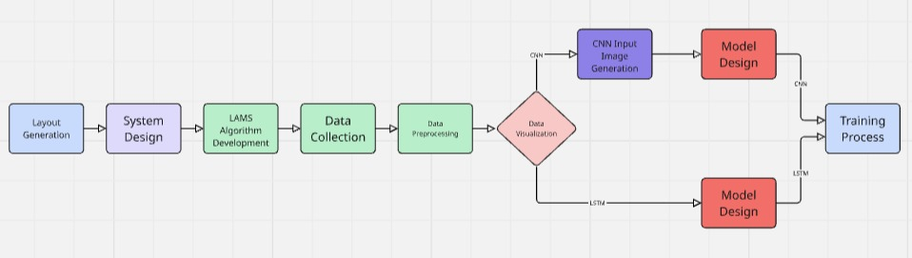

Fig.4.1: Methodology Flow

Layout Generation:

We used an indoor environment based on the layout shown in Fig. 1, which represents a well-defined area that includes various structural elements such as walls, open spaces, and obstacles like beds, tables, and the kitchen slab. Three different layouts were created for distinct purposes. The first layout (Fig. 1a, 1c, 1e) provides an overview of the flat’s structure and boundaries with precise measurements. The second layout (Fig. 1b, 1d, 1f) depicts the flat's major elements, where the grid represents the tiles, and the center of each tile serves as a receiver point during data collection. This layout was also used for CNN input image generation using the LAMS algorithm for all transmitter-receiver pairs.

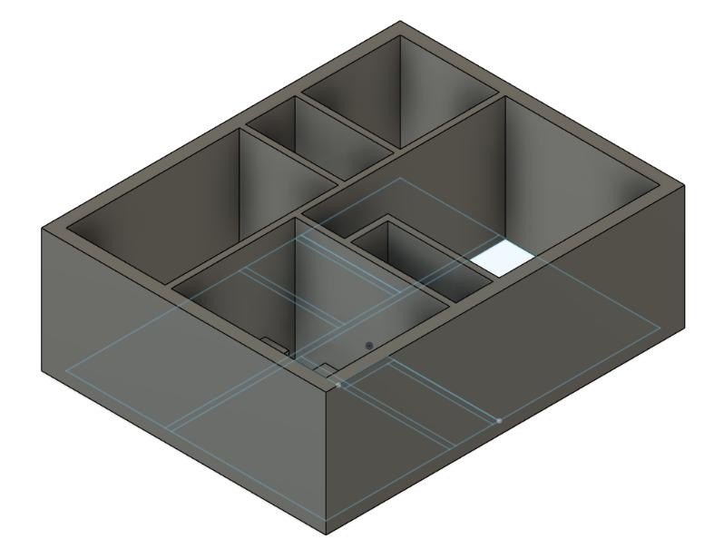
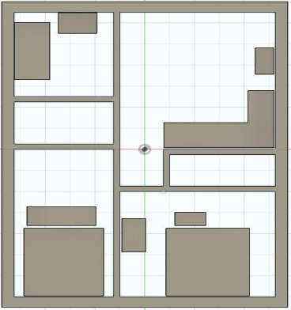

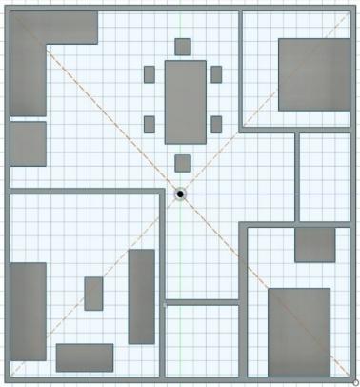  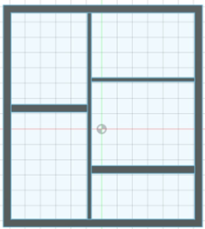 | 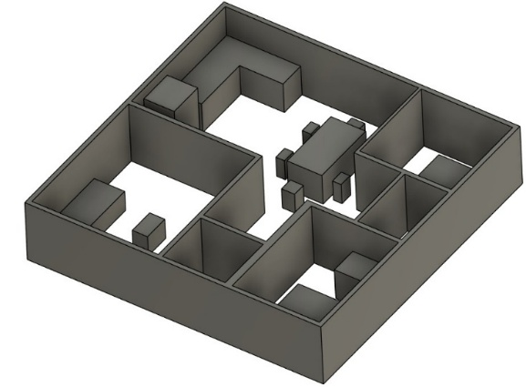  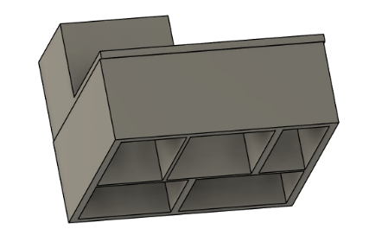

Fig. 4.1.1: a) 2D Layout of indoor environment Building 1.

b)3D layout Building 1.

c) 2D Layout of indoor environment Building 2.

d)3D layout Building 2.

e)2D Layout of indoor environment of Dual-floor Building with Transmitter at upper floor.

f)3D layout Building Dual floor Building.

4.2 System Design:
Fig. 4.2.2 shows the architecture of the suggested deep learning-based path loss modelling system. It employs a two-stage deep learning framework combining LSTM and CNN models to estimate spatio-temporal RSS (Received Signal Strength) variations. In the first stage, continuous RSS data collected at the access point (AP) is used to train an LSTM model, which captures temporal patterns to forecast RSS values 5 to 10 minutes into the future. The second stage utilizes spatial measurement data, including AP and user locations along with their respective RSS values. The core input to the CNN-based path loss model consists of images generated using a custom method called the LAMS algorithm. This algorithm extracts environmental features from a simplified floor plan and transforms them into spatial input images that reflect the structures influencing signal propagation.
To enhance prediction accuracy, two additional features are incorporated into the CNN model: a distance neuron in the first fully connected (FC) layer to provide transmitter-receiver separation, and a transmitter RSS neuron to supply the corresponding RSS at the transmitter side. The CNN is trained to learn RSS distributions based on these LAMS images, distance metrics, and transmitter RSS values. The RSS predictions generated by the LSTM model are subsequently passed into the trained CNN, enabling it to estimate future RSS values at specific locations. The final model output delivers both time- and location-specific RSS predictions, evaluated using RMSE. This integrated LSTM-CNN approach enables robust and scalable RSS forecasting for WLAN environments.
Overall System Design Flow Summary
- Collect RSS sequential data at the AP location.
- Train an LSTM model to predict future RSS at the AP location (time-series forecasting).
- Use the floor plan and AP/measurement locations to generate spatial relationship images (via LAMS algorithm).
- Train a CNN model on these images to predict RSS at measurement locations (spatial prediction).
- Combine the LSTM and CNN outputs to predict future RSS at measurement locations (spatio-temporal prediction).
- Evaluate the predictions using RMSE, providing feedback for improving the models.
Key Technologies Used
Component | Technology
Time-Series Prediction | LSTM (Long Short-Term Memory) Network
Spatial Prediction | CNN (Convolutional Neural Network)
Floor Plan Processing | LAMS Algorithm
Error Evaluation | RMSE (Root Mean Square Error)

Core Innovation
The project combines:
- Temporal forecasting (LSTM): Predicting how RSS evolves over time at a fixed point (AP location).
- Spatial prediction (CNN): Predicting RSS at multiple points across space using floor plan images.
- Spatio-Temporal Fusion: Combining the above two techniques to forecast RSS in both time and space, which is critical for applications like indoor positioning, wireless planning, and dynamic RSS mapping.
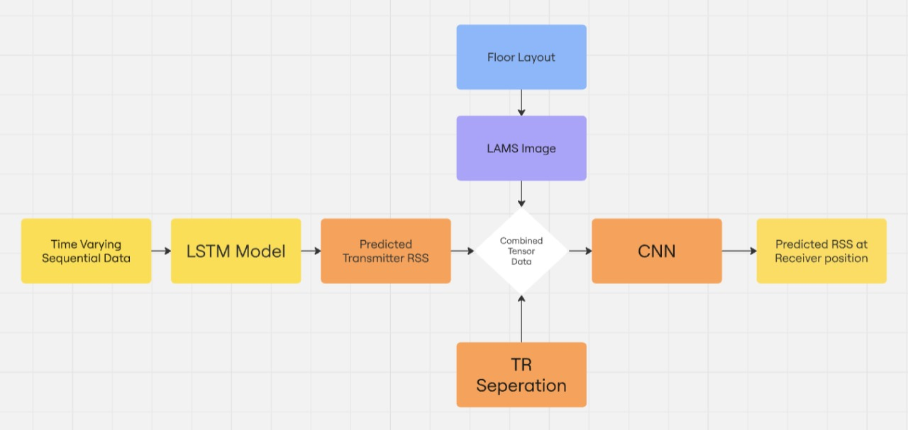

Fig.4.2.1: Flow diagram of application.

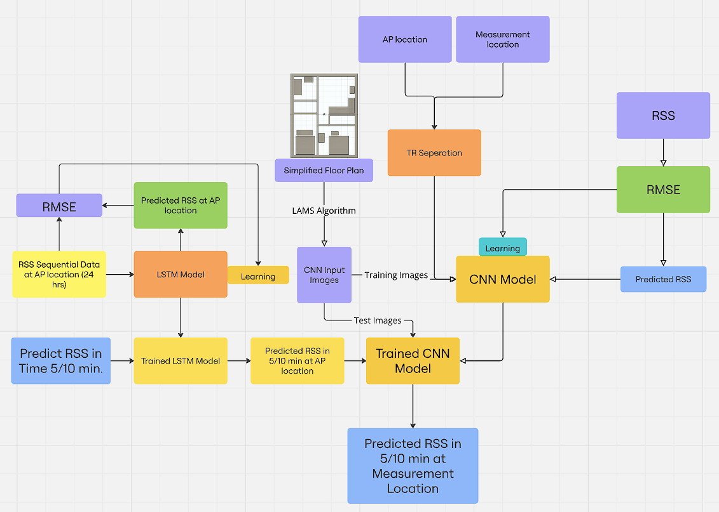

Fig. 4.2.2: Flow diagram of deep learning-based path loss modeling system.

4.3 LAMS Algorithm Development:
The Local Area Multi-Line Scanning (LAMS) algorithm was developed to generate input images for a CNN model, providing essential environmental features that influence indoor path loss. This algorithm creates a unique representation of the indoor space by generating multiple scan lines between a Wi-Fi access point (AP) and a receiver location. These scan lines capture details about obstacles such as walls and room divisions, which affect signal propagation. Here’s an overview of the LAMS algorithm development and its functionality:

- Algorithm Overview: The LAMS algorithm begins by identifying the AP and receiver coordinates on a floor plan image. It then calculates a line connecting these two points, along which a series of scan lines are generated perpendicularly. Each scan line is defined by a specific width (number of pixels, denoted as w) and the total number of lines (n), capturing spatial details between the AP and receiver locations.



Code Implementation:
- Setup and Parameters: The algorithm uses the input floor plan as a grayscale image, where walls and obstacles are marked with distinct pixel values. User clicks define the AP and receiver coordinates.
- Line Generation: Using the coordinates of the AP and receiver, the algorithm calculates intermediate points on the line between them. These points serve as the center of each perpendicular scan line.
- Scan Line Creation: For each center point, the algorithm calculates the perpendicular direction and establishes the endpoints of the scan line. Pixel values along each scan line are extracted from the floor plan image.
- Output Image Generation: These pixel values are compiled into a matrix (lams_image), representing a simplified view of the environment, suitable for CNN input.
- Image Visualization and Validation: After generating the lams_image, it is displayed and saved for model input. For visualization purposes, the algorithm also draws the scan lines directly onto the floor plan image to validate the accuracy and positioning of each scan.
- Challenges and Refinements: Key challenges included handling boundary cases where scan lines extended beyond the floor plan’s edges. This was mitigated by checking each scan line’s coordinates and setting out-of-bounds values to a default empty-space pixel value.

The LAMS algorithm thus enables an effective representation of indoor environmental features, facilitating CNN model training for accurate path loss prediction.

Data Collection:

Data collection was conducted in a controlled indoor environment, based on the floor plan layout provided. This layout includes multiple rooms and obstacles, where each grid cell represents a tile in the flat, with the center of each tile designated as a receiver point. The purpose of this setup was to accurately capture signal behavior across the apartment under static conditions, which are crucial for Wi-Fi path loss modeling.

The Flutter Junction Test app was used to automate the data collection process. The app was configured with a 10-second interval between samples, and each collection session generated an Excel file with the following attributes:
- Timestamp: The exact time of each measurement.
- Download Speed and Download Speed (Additional): Measures of network performance.
- Signal Strength and Signal Strength (Additional): Indicators of Wi-Fi signal strength at each receiver point.
- Network Type: The type of network being measured.
- Device Status: Status of the device during measurement.
- Pixel Latitude (X) and Pixel Longitude (Y): Coordinates on the floor plan image where each measurement was taken.

After collecting data for two minutes at each receiver point, any excess data was removed, retaining only the required measurements. The app output was then saved in an organized format. To determine the exact coordinates for each receiver point, a custom code was used, allowing users to click on the floor plan image to record pixel coordinates. These coordinates were then added as Pixel Latitude and Pixel Longitude entries in the Excel file.

Once data was fully documented for each receiver point, we moved to the next point and repeated the process. The measurements were taken in a completely static environment, with no human movement or other significant signal interference sources. All doors were closed during data collection to isolate the influence of walls and static obstacles on signal propagation.

4.4.1 Spatial Data Collection at Measurement Locations
Procedure:
- Environment Setup:
The data collection was conducted in three distinct flats, each mapped with a detailed floor plan. Each flat’s layout included various rooms, corridors, and obstacles such as walls, doors, and furniture.
- Receiver Grid Design:
The indoor space was discretized into a grid, with each grid cell (tile) representing a potential receiver location. The centre of each tile was selected as the precise measurement point, ensuring systematic spatial coverage.
- Transmitter Placement:
A Wi-Fi Access Point (AP) was fixed at a designated coordinate on the floor plan (e.g., pixel (312, 350)), simulating a realistic deployment scenario.
- Measurement Protocol:
At each receiver point:
- A stationary laptop equipped with the Flutter Junction Test app was used to record RSS.
- Measurements were taken at 10-second intervals, with 10 consecutive readings per location to average out short-term fading and transient fluctuations.
- Each measurement was timestamped and associated with the exact pixel coordinates (X, Y) on the floor plan.
- Additional metrics such as download speed, network type, and device status were also recorded for context and potential auxiliary analysis.
- Data Quality Assurance:
To ensure consistency, all measurements were conducted in a static environment-doors closed, no human movement, and minimal external interference. Excess data was trimmed to retain only the required readings per location.
Outcome:
A comprehensive spatial dataset capturing the RSS distribution across all relevant locations for each flat, forming the foundation for spatial modelling and CNN training.

4.4.2 Temporal Data Collection at the Transmitter (AP)
Procedure:
- Continuous Monitoring:
At the AP location, RSS was recorded continuously for 24 hours, at 30-second intervals, for seven consecutive days in each of the three flats.
- Temporal Averaging:
The resulting time series from each day and each flat were subsequently averaged to produce a robust, noise-reduced temporal RSS profile. This averaging process mitigates the impact of outlier events and captures the typical diurnal variation in signal strength.
- Data Attributes:
Each record consists of:
- Timestamp (date and time of measurement)
- RSS value (in dBm)
- Additional metrics (e.g., download speed), where available
Outcome:
A high-resolution, temporally rich dataset characterizing the natural fluctuations of RSS at the transmitter, providing essential input for LSTM-based forecasting.

4.4.3 Dual Data Collection Rationale
This dual approach-simultaneously collecting spatial RSS across the layout and continuous temporal RSS at the AP-enables the modelling of both static spatial effects (e.g., path loss due to walls) and dynamic temporal effects (e.g., fading, interference, human activity). The timestamped nature of both datasets is critical for downstream alignment and integration, allowing the system to learn how time-varying conditions at the transmitter propagate spatially throughout the environment.

4.4.4 Data Documentation and Management
- Standardization:
All data was recorded in a standardized format (CSV or Excel), with consistent column naming and units (e.g., RSS in dBm).
- Metadata Annotation:
Each measurement includes metadata such as flat identifier, receiver coordinates, and device status, facilitating traceability and reproducibility.
- Data Integrity:
Automated scripts were used to check for missing values, duplicate entries, and timestamp inconsistencies. Any anomalies were resolved prior to model training.

Attribute | Description
Timestamp | Date and time of measurement
RSS | Received Signal Strength (dBm)
Download Speed | Network throughput at measurement point (Mbps)
Network Type | Type of wireless network (e.g., Wi-Fi)
Device Status | Operational status during measurement
Pixel Latitude (X) | X-coordinate on floor plan
Pixel Longitude (Y) | Y-coordinate on floor plan
Flat/Room Identifier | Unique ID for each flat or measurement session

Table 4.4.1: Summary Table: Collected Data Attributes
4.4.6 Significance for Model Development
The rigor and granularity of the data collection process ensure that the resulting models are trained on realistic, high-quality data. The spatial dataset enables the CNN to learn the impact of physical layout on RSS, while the temporal dataset empowers the LSTM to forecast signal fluctuations over time. The synchronized, timestamped nature of both datasets is essential for spatio-temporal model fusion, allowing for accurate prediction of RSS at any location and future time within the indoor environment.
This setup was designed to capture realistic signal degradation caused by physical barriers, room configurations, and layout geometry, which are significant contributors to indoor path loss. The data collected provides a comprehensive foundation for training and testing the CNN model, as it reflects a diverse range of conditions within the enclosed space. The static nature of the environment helps eliminate variability due to transient factors, focusing purely on the spatial and structural elements affecting signal propagation.

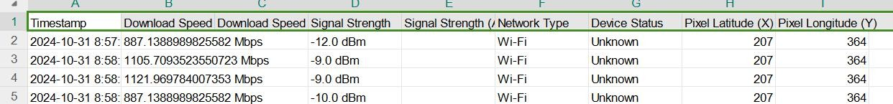
Sample Data:

Table 4.4.2: Sample of Collected Data

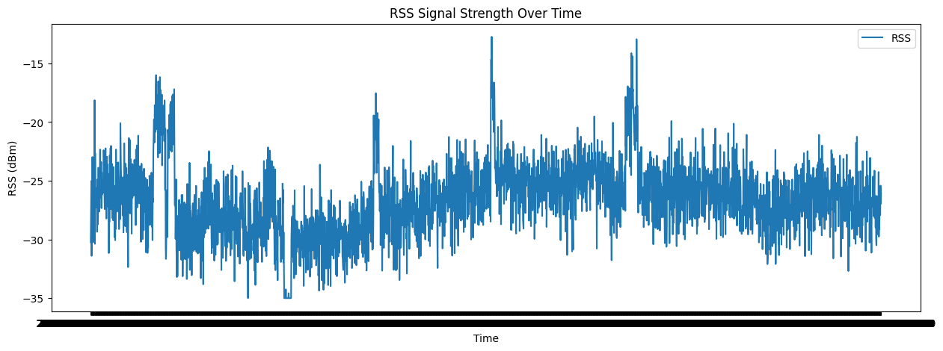

Fig 4.4.1: RSS Signal Strength v/s Time

4.5 Data Preprocessing
4.5.1 Temporal Data Processing for LSTM RSS Forecasting:
Effective data preprocessing is essential for the success of any deep learning model, especially in time-series forecasting tasks such as temporal RSS prediction. The transmitter RSS dataset, consisting of continuous measurements at 30-second intervals over 24 hours (averaged across seven days and three flats), underwent a rigorous and systematic preprocessing pipeline to ensure data quality, consistency, and suitability for LSTM modelling.

4.5.1.1 Data Cleaning
Objective:
To guarantee that the dataset is devoid of extraneous information, missing values, and inconsistencies that can negatively impact model training.
Process:
- Loading and Consolidation:
All raw CSV files containing transmitter RSS data were loaded into a unified Pandas Data Frame using Google Colab. This consolidation facilitated efficient batch processing and ensured uniformity across data sources.
- Standardization of Column Names:
Column headers were standardized (e.g., converting to lowercase and removing extraneous spaces) to prevent mismatches during downstream processing.
- Removal of Irrelevant Columns:
Non-essential columns such as “Download Speed (Additional)” and “Signal Strength (Additional)” were dropped, focusing the dataset on the primary features: Timestamp and RSS.
- Handling Unknown or Invalid Entries:
Entries labelled as "Unknown" or containing non-numeric values were converted to NaN (Not a Number) and subsequently removed or imputed as appropriate.
- Unit Consistency:
All RSS values were converted to numeric format (in dBm), ensuring consistency and enabling mathematical operations.
4.5.1.2 Handling Missing Values
Objective:
To address gaps in the time series caused by sensor dropouts, data corruption, or synchronization issues.
Process:
- Timestamp Parsing and Sorting:
All timestamps were parsed into a standardized datetime format and sorted chronologically to maintain temporal integrity.
- Detection of Missing Intervals:
The dataset was checked for missing or irregular intervals using time-based indexing.
- Imputation:
Missing RSS values were filled using linear interpolation, leveraging the temporal continuity of the data. This approach preserves the underlying trends and avoids introducing artificial discontinuities.
- Verification:
Post-imputation, the dataset was re-examined to ensure that all intervals were uniformly spaced and free of NaNs.

4.5.1.3 Resampling and Aggregation
Objective:
To prepare the data for multi-horizon forecasting by creating datasets at different temporal resolutions.
Process:
- Down sampling:
The cleaned 30-second interval data was resampled to 1-minute, 5-minute, and 10-minute intervals using mean aggregation. This was achieved using the Pandas.resample() method, which averages RSS values within each time window.
- Rationale:
  - 1-minute interval: Captures fine-grained temporal dynamics for short-term forecasting.
  - 5-minute and 10-minute intervals: Provide coarser views, useful for longer-term trend analysis and reducing computational load for extended forecasts.
- Interpolation Post-Resampling:
Any gaps introduced during resampling were filled using linear interpolation, ensuring continuity across all resolutions.

4.5.1.4 Normalization
Objective:
To scale RSS values to a uniform range, facilitating stable and efficient neural network training.
Process:
- MinMax Scaling:
Each resampled dataset (1-min, 5-min, 10-min) was independently normalized to the range using MinMaxScaler. This transformation preserves the relative differences in RSS while standardizing the input scale.
- Justification:
In particular, LSTMs and neural networks are sensitive to input scale. Normalization accelerates convergence, prevents gradient issues, and ensures that all features contribute equally during training.
- Inverse Transformation:
The scaling parameters were saved to allow for inverse transformation during model evaluation, enabling interpretation of predictions in the original dBm units.

4.5.1.5 Sequence Preparation for LSTM Modelling
Objective:
To structure the normalized time series data into input-output pairs suitable for supervised learning with LSTM networks.
Process:
- Sliding Window Approach:
For each time step, a sequence of the previous 12 minutes of normalized RSS values was used as input. The corresponding targets were the RSS values at 1, 5, and 10 minutes into the future, enabling multi-horizon forecasting.

- Multi-Output Target Construction:
This approach allows the model to learn to predict multiple future points from a single input sequence, increasing efficiency and practical utility.

- Train-Test Split:
The final dataset was split chronologically into training (80%) and testing (20%) sets, preserving temporal order and preventing data leakage.

4.5.2 Spatial Data Preprocessing for CNN-Based RSS Prediction
The spatial component of this project aims to model the distribution of Received Signal Strength (RSS) across an indoor environment using Convolutional Neural Networks (CNNs). To ensure the CNN receives high-quality, representative input, the raw spatial measurement data undergoes a rigorous, multi-stage preprocessing pipeline. This process transforms heterogeneous, tile-wise RSS measurements into a clean, structured, and feature-rich dataset suitable for deep learning.

4.5.2.1 Data Acquisition and Initial Inspection
Data Sources:
Spatial RSS data was collected at multiple grid points (tiles) throughout each flat, with each measurement associated with:
- Pixel coordinates (Pixel_Latitude_X, Pixel_Longitude_Y)
- Network type (e.g., Wi-Fi)
- Measured RSS (Signal Strength)
- Download speed
- Timestamp (for temporal alignment)
- Corresponding transmitter RSS and download speed (mapped by timestamp)
Initial Inspection:
- The data was loaded from multiple CSV files, each representing a room or flat.
- An initial review (see Fig. 1: Data Preview) confirmed the presence of all required columns and revealed a distribution of RSS values ranging from approximately -27.1 dBm (weakest) to -4.6 dBm (strongest), with a mean around -14.6 dBm.

4.5.2.2 Data Cleaning and Standardization
Column Standardization:
- All column names were converted to lowercase and stripped of extraneous spaces to ensure consistency across files.
Handling Missing and Invalid Values:
- Entries labeled as "Unknown" or containing non-numeric values were replaced with NaN and subsequently removed or imputed.
- Columns with all missing values or irrelevant information (e.g., unnamed columns, additional speed fields) were dropped.
Data Type Conversion:
- RSS and download speed fields were explicitly converted to numeric types, with units (e.g., 'dBm', 'Mbps') stripped as needed.
- Duplicate and Empty Row Removal:
- Duplicate records and rows with missing essential information (coordinates, RSS) were removed to avoid bias and redundancy.

4.5.2.3 Timestamp-Based Alignment for Spatio-Temporal Fusion
Objective:
- To ensure each spatial RSS measurement reflects the true propagation environment at the time of collection, spatial data was merged with the corresponding transmitter RSS and download speed using timestamp-based nearest-neighbor matching.
Process:
- Alignment by Nearest Timestamp:
Each spatial RSS measurement was paired with the closest-in-time transmitter RSS value, using timestamp-based merging. This mapping ensures that the temporal context at the AP is accurately associated with spatial measurements, enabling the subsequent spatio-temporal modelling.
- Validation:
The merged dataset was checked for alignment accuracy, ensuring that each spatial record had a valid, corresponding transmitter RSS value.
Method:
- Both spatial and transmitter datasets were sorted by timestamp.
- A tolerance window (typically 1 minute) was set to ensure accurate matching without introducing temporal drift.
- After merging, each spatial record included both its local RSS and the transmitter’s signal characteristics at the closest measurement time.
Outcome:
This alignment enables the CNN to learn not only spatial attenuation patterns but also temporal variations in the source signal.

4.5.2.4 Feature Engineering
Coordinate Synthesis:
- Combined the X and Y pixel coordinates into a single Coordinate field for easier indexing and grouping.

Transmitter-Receiver Separation:
- Calculated the Euclidean distance between each tile and the transmitter location, providing a quantitative measure of path loss and spatial attenuation.

Aggregation:
- For each unique coordinate, multiple measurements (if available) were aggregated by computing the mean RSS, download speed, and transmitter values.
- The resulting dataset represents the average propagation environment at each tile, smoothing out transient fluctuations and measurement noise.

Network Type Filtering:
- Only Wi-Fi measurements were retained for CNN training, ensuring model focus and consistency.

4.5.2.5 Data Integration and Final Structuring
Unified Dataset Creation:
- Processed and aggregated data from all rooms/flats were concatenated into a single, comprehensive dataset (Overall_aggregated_data.csv).
- Each record now contains:
  - Coordinate (X, Y)
  - Average spatial RSS (avg_signal_strength_dBm)
  - Average download speed (avg_download_speed_Mbps)
  - Average transmitter RSS and download speed (for context)
  - Transmitter-receiver separation
  - Network type
Summary Statistics:
- The final dataset covers 284 unique spatial points, with mean RSS of -14.59 dBm and a standard deviation of 4.77 dBm (see Fig. 2: Data Summary Table).
- Download speeds averaged 860 Mbps, reflecting high-quality network conditions in most tiles.

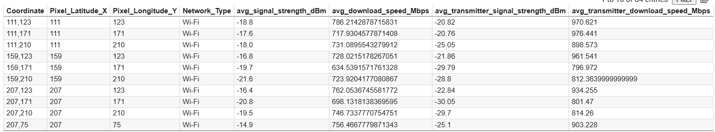
Table 4.5.1: Processed Data

4.6 Data Visualization:
Data visualization is a crucial step in understanding both the temporal and spatial structure of the RSS datasets and in informing model design choices. All visualizations were generated using Python in Google Colab, leveraging libraries such as Matplotlib and Seaborn. This section details the exploratory data analysis (EDA) and visualization performed for both LSTM (temporal) and CNN (spatial) data.

4.6.1 LSTM: Exploratory Data Analysis (EDA) and Feature Engineering
Objective:
To gain insights into the temporal structure of the transmitter RSS data and guide the design of the LSTM forecasting model.
A. Trend Visualization
- Line Plots:
Line plots of RSS over time (at 30s, 1min, 5min, and 10min intervals) highlighted diurnal patterns, abrupt fluctuations, and long-term trends.
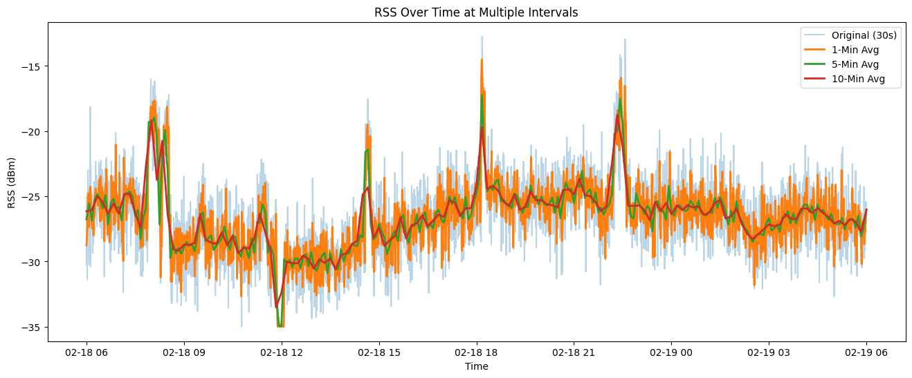
Fig. 4.6.1: RSS Over Time at Multiple Intervals
(Shows original and resampled RSS, revealing both high-frequency noise and smoothed trends.)

B. Distribution Analysis
- Histograms and Density Plots:
Plots of RSS value distributions at 1-minute intervals revealed the central tendency, spread, and the absence of extreme outliers.
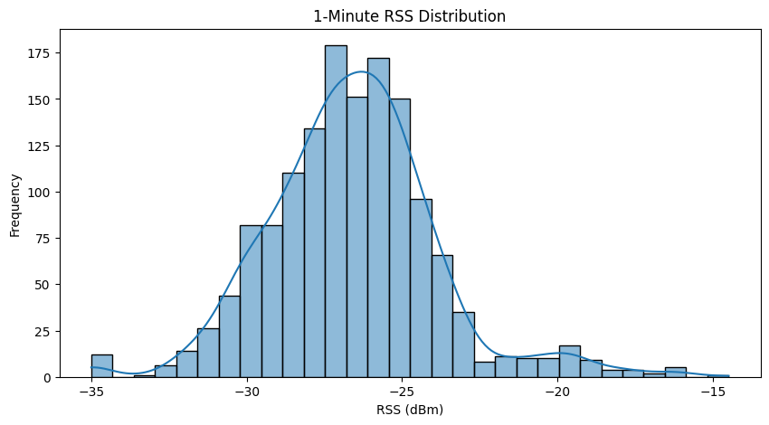
Fig. 4.6.2: 1-Minute RSS Distribution
(Illustrates the typical RSS range and skewness.)

C. Boxplots
- Boxplot for Outlier Detection:
Boxplots provided a visual summary of RSS variability and potential anomalies.
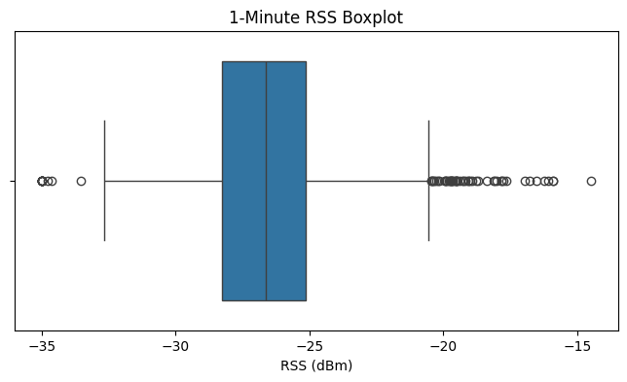
Fig. 4.6.3: 1-Minute RSS Boxplot
(Highlights median, quartiles, and any outliers.)

D. Heatmaps
- Hourly RSS Patterns:
Heatmaps of hourly RSS across days exposed recurring temporal effects, such as daytime attenuation and nighttime stability.
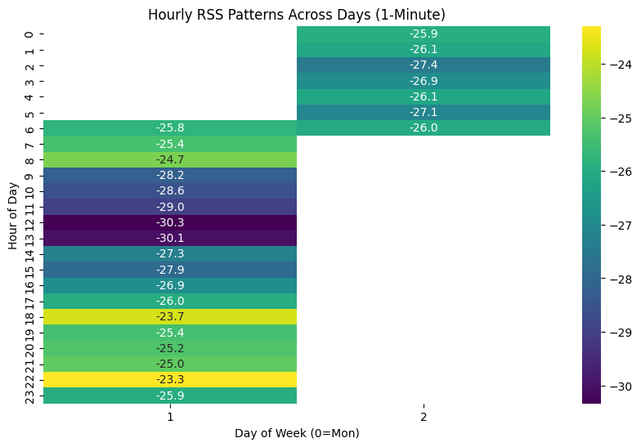
Fig. 4.6.4: Hourly RSS Patterns Across Days
(Visualizes how RSS varies by hour and day.)

E. Autocorrelation Analysis
- Autocorrelation Plot:
Autocorrelation plots quantified the persistence of RSS values over time, guiding the selection of the look-back window for the LSTM model.
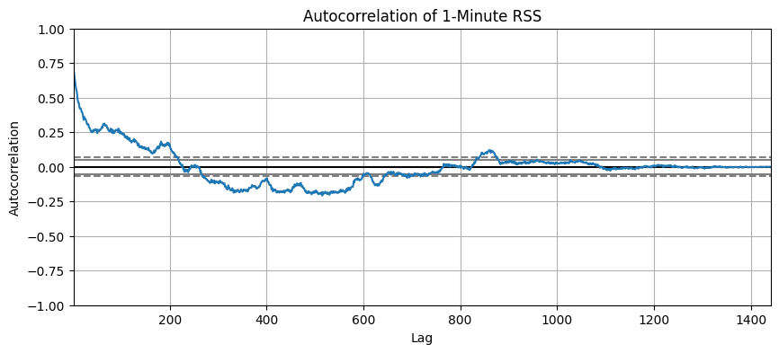
Fig. 4.6.5: Autocorrelation of 1-Minute RSS
(Shows significant lags, indicating temporal dependencies.)
F. Rolling Statistics
- Rolling Mean and Standard Deviation:
Calculated rolling mean and std (e.g., 12-sample window) to identify non-stationarity and periodicity in the signal.
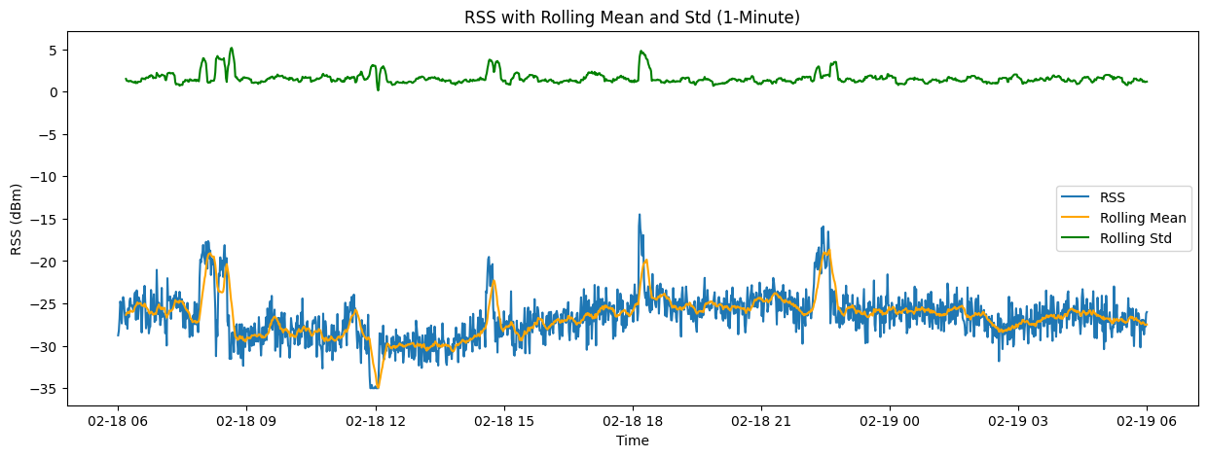
Fig. 4.6.6: RSS with Rolling Mean and Std (1-Minute)
(Reveals both local trends and volatility.)

4.6.2 CNN: Exploratory Data Analysis (EDA) and Feature Engineering
Objective:
To understand the spatial distribution of RSS and related features, and to inform the structure and input design of the CNN spatial model.
A. Spatial Heatmaps
- RSS Heatmap:
Heatmaps of average spatial RSS across the (X, Y) grid visualized coverage, dead zones, and attenuation patterns.
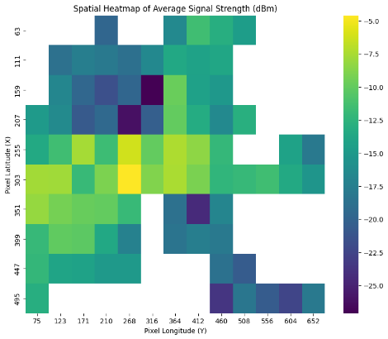
Fig. 4.6.7: Spatial Heatmap of Average Signal Strength (dBm)

- Download Speed Heatmap:
A similar heatmap was created to display download speed variations across the same coordinates.This visualization provided a quick view of areas with higher or lower download speeds, aiding in understanding connectivity patterns in the space.
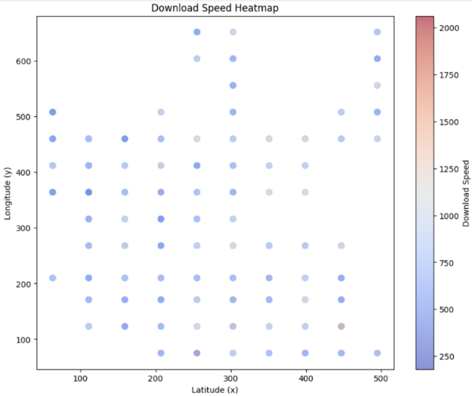

Fig. 4.6.8: Download Speed Heatmap for pixel points (Mbps)

- Overlaying on Floor Plan:
- Both signal strength and download speed heatmaps were overlaid on a floor plan image to provide spatial context.
- Using Seaborn and Matplotlib, the heatmaps were superimposed with some transparency, allowing underlying room structures to remain visible. This integration facilitated a better understanding of environmental influences on connectivity metrics.

- Transmitter RSS Heatmap:
Similar heatmaps for the transmitter’s RSS provided context for spatial attenuation.
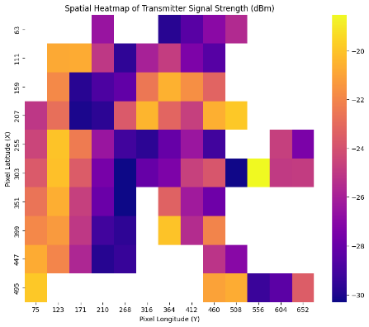
Fig. 4.6.9: Spatial Heatmap of Transmitter Signal Strength (dBm)

- Attenuation Map:
Heatmaps showing the difference between transmitter and spatial RSS highlighted areas with significant path loss.
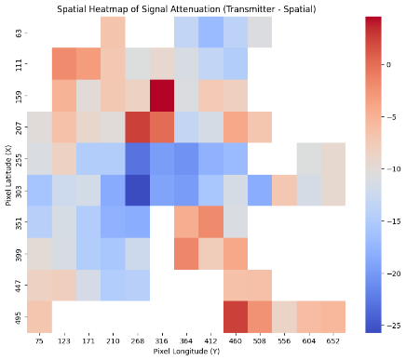
Fig. 4.6.10: Spatial Heatmap of Signal Attenuation

B. Distribution and Summary Plots
- Histogram and Boxplot:
Distribution plots for spatial RSS and download speed revealed the range, central tendency, and outliers.
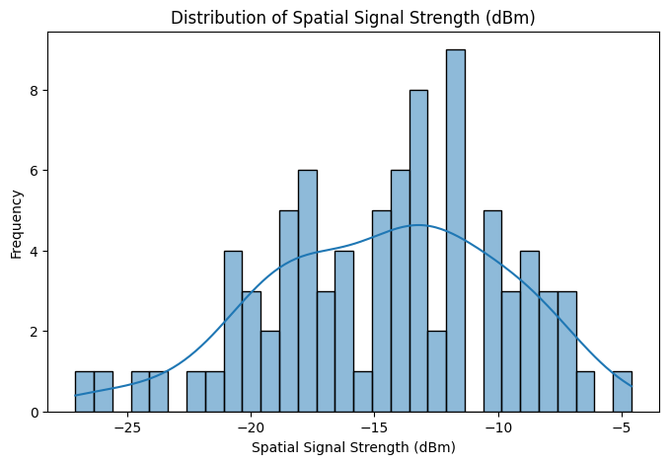
Fig. 4.6.11: Distribution of Spatial Signal Strength (dBm)

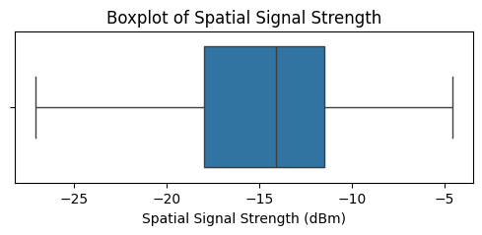
Fig. 4.6.12: Boxplot of Spatial Signal Strength

C. Correlation and Scatter Plots
- Transmitter vs. Spatial RSS:
Scatter plots and correlation matrices quantified the relationship between transmitter and spatial RSS, as well as between RSS and download speed.
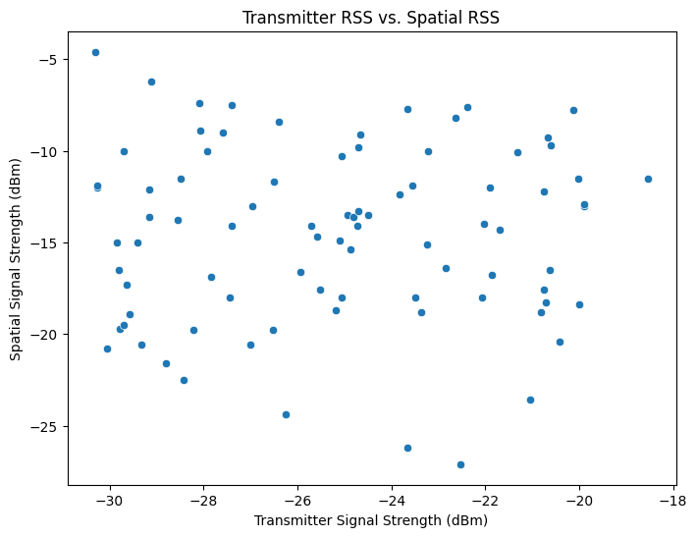
Fig. 4.6.13: Transmitter RSS vs. Spatial RSS

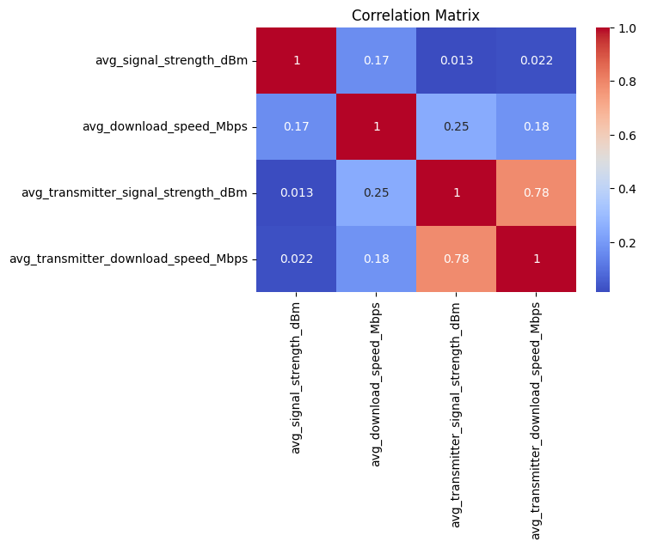
Fig. 4.6.14: Correlation Matrix

- Download Speed vs. RSS:
Scatter and boxplots showed the impact of signal strength on throughput.
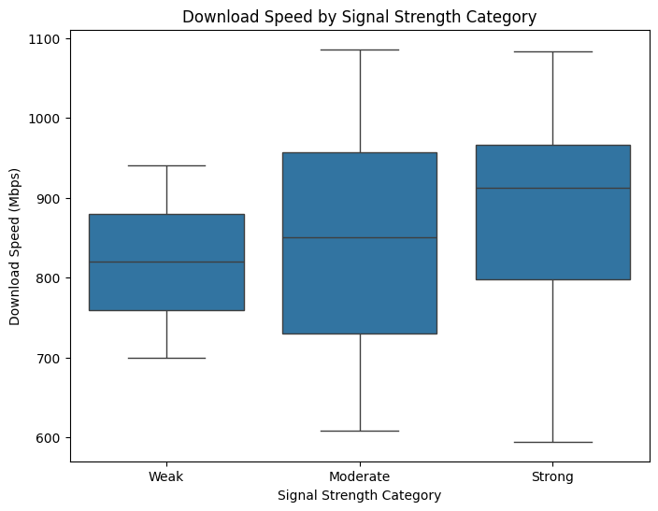
Fig. 4.6.15: Download Speed by Signal Strength Category

D. Spatial-Temporal Alignment Validation
- Attenuation by Location:
Plots of the difference between transmitter and spatial RSS by tile confirmed the integrity of timestamp-based alignment.
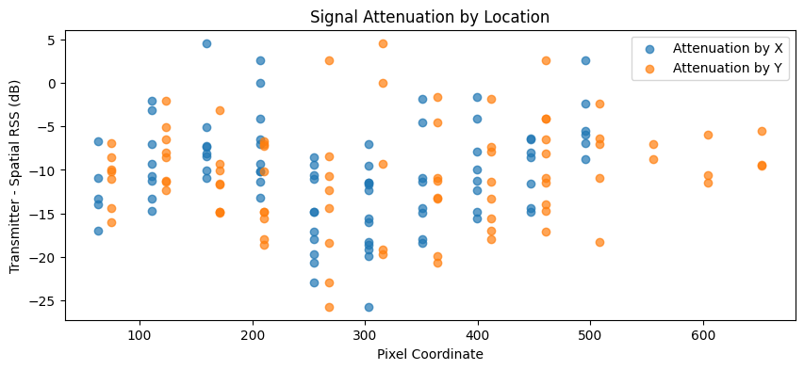
Fig. 4.6.16: Signal Attenuation by Location

Summary of Insights
- Temporal EDA revealed both short-term fluctuations and long-term trends in transmitter RSS, informing the LSTM’s look-back window and forecast horizons.
- Spatial EDA identified coverage gaps, attenuation patterns, and the relationship between RSS and throughput, guiding CNN input design and feature selection.
- Alignment and Integration visualizations confirmed the integrity of the merged spatio-temporal dataset.
All visualizations were generated using Google Colab and are included in the appendix as referenced figures. This comprehensive EDA ensures that both the LSTM and CNN models are designed and trained on data whose structure, variability, and dependencies are well understood, laying the groundwork for robust spatio-temporal signal strength prediction.

CNN Input Images Generation: LAMS Algorithm:
In our project, we developed the Local Area Multi-Line Scanning (LAMS) algorithm to generate input images for the Convolutional Neural Network (CNN), encoding environmental data related to Wi-Fi signal propagation in the indoor area under study. This algorithm extracts significant environmental features, such as wall structures, from a building's floor plan and translates them into grayscale images suitable for CNN-based analysis.
- Setting up the Environment and Folders: We initialized the environment by importing required libraries such as NumPy, OpenCV, and pandas, and created directories to save generated images: "CNN Input Images" and "Lams Scan Images."

- LAMS Algorithm Process: The LAMS algorithm was implemented to capture relevant environmental features from a fixed access point (AP) to multiple receiver locations across the floor plan:
- Defining Transmitter and Receiver Coordinates: The algorithm initializes the AP coordinates and iteratively sets the coordinates for each receiver point based on its location in the building.
- Generating Scan Lines: For each AP-receiver pair, a set of scan lines perpendicular to the line connecting the AP and receiver is generated. These lines are spaced evenly to form an image matrix that captures building structure details, such as walls and obstacles, in grayscale intensities.
- Sampling Pixel Values: Pixel intensities along each scan line are extracted from the floor plan, capturing structural information at different points between the AP and receiver. The LAMS image is formed by stacking these sampled values into a 2D matrix.
- Saving Output Images: Two sets of mages are saved for each receiver location:
- LAMS Image: The grayscale LAMS image representing environmental features is stored in the "CNN Input Images" folder.
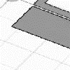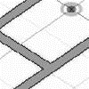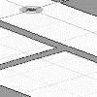

Fig. 4.7.1: Lams Output Image

- Annotated Floor Plan: The floor plan is overlaid with the generated scan lines and saved in the "Lams Scan Images" folder for visual reference.
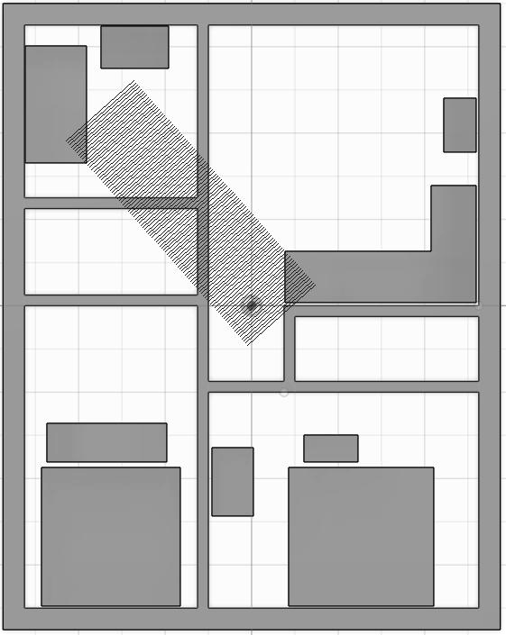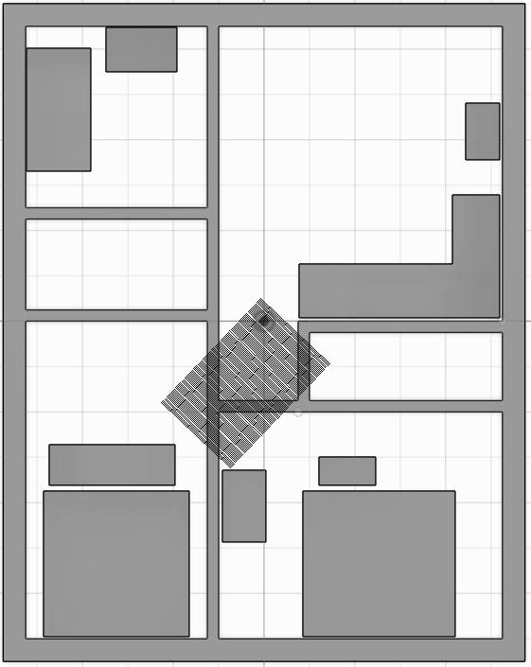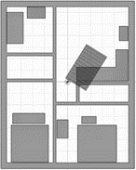
Fig. 4.7.2: Lams Scan Images

- Calculating and Storing TR Separation: The Transmitter-Receiver (TR) separation is calculated as the Euclidean distance between the AP and each receiver location. This distance information is appended to the dataset and saved in a CSV file for later use in model training.
- Output: All LAMS images and annotated floor plans were successfully saved, and the TR separation was added to the dataset, allowing for structured input to the CNN model.
- This approach enables the CNN to leverage spatial environmental context for signal strength prediction, transforming spatial layout into a form the model can interpret effectively.

MODEL DESIGN:
This section details the architecture and rationale for the deep learning models developed for indoor RSS prediction. This section focuses on the Multi-Horizon LSTM model for temporal forecasting and the CNN model design for spatial prediction.

4.8.1 Multi-Horizon LSTM Model Design for Temporal RSS Prediction
The Multi-Horizon Long Short-Term Memory (LSTM) model forms the temporal backbone of our spatio-temporal RSS prediction framework. Its primary objective is to forecast future Received Signal Strength (RSS) values at the transmitter (Access Point) over multiple time horizons (1, 5, and 10 minutes ahead) based on historical RSS sequences. This approach enables both short-term and long-term signal strength forecasting, supporting robust WLAN planning and adaptive network management in dynamic indoor environments.

A. Sequence Preparation for Multi-Horizon Forecasting
Rationale:
Indoor RSS exhibits strong temporal dependencies due to environmental changes, user movement, and device interference. To capture these dynamics, the LSTM model is trained on sequences of past RSS values, enabling it to learn both immediate and delayed effects on signal strength.
Process:
- Input Construction:
The original transmitter RSS data, collected at 30-second intervals, is resampled to 1-minute intervals and normalized to [0-1]. Using a sliding window approach, input sequences are generated, Each input consists of a sequence of the past 5 minutes of normalized RSS values (look-back window). This window length is chosen based on autocorrelation analysis, ensuring the model captures both short- and medium-term trends.
- Multi-Horizon Targets:
For each input sequence, the model is tasked with predicting RSS at 1, 5, and 10 minutes into the future. This multi-output design allows the model to simultaneously learn short-, medium-, and long-term temporal dependencies.
- Data Splitting:
The dataset is chronologically divided into training (80%) and testing (20%) sets, preserving temporal integrity and preventing data leakage.
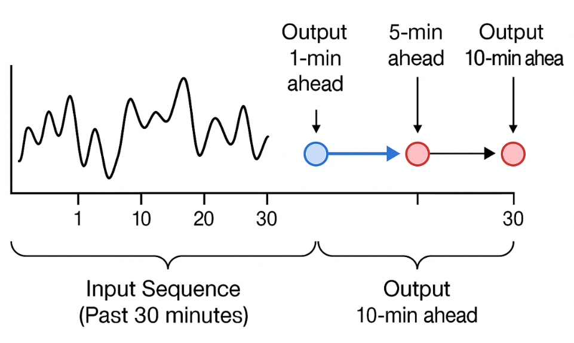
Fig. 4.8.1: Sequence Preparation Schematic for a visual representation of the input-output structure.

B. Model Architecture
The Multi-Horizon LSTM model is architected to efficiently capture temporal patterns and deliver accurate multi-step forecasts. Inspired by best practices in time-series deep learning, the design emphasizes both capacity and regularization.
1. Input Layer
- Accepts sequences of shape (5, 1), representing 5 consecutive minutes of normalized RSS data.
2. Stacked LSTM Layers
- First LSTM Layer:
Comprises 128 units and returns sequences, allowing the subsequent LSTM layer to process temporal patterns at multiple scales.
- Dropout Layer:
After every LSTM layer, dropout (rate 0.3) is used to randomly disable a portion of the units during training in order to minimize overfitting.
- Second LSTM Layer:
Comprises 64 units and outputs a fixed-size vector representation, further abstracting temporal features.
- Second Dropout Layer:
Further regularization to enhance generalization.
3. Multi-Output Dense Layers
- Three parallel dense layers, each producing a single output corresponding to the RSS forecast at 1, 5, and 10 minutes ahead.
- Activation Functions:
Linear activation is used, suitable for regression tasks.
Layer | Type | Units | Output Shape | Notes
Input | Input | - | (5, 1) | 5-minute look-back
LSTM-1 | LSTM | 128 | (5, 128) | Returns sequences
Dropout-1 | Dropout | - | (5, 128) | Rate = 0.3
LSTM-2 | LSTM | 64 | (64,) | Returns final state
Dropout-2 | Dropout | - | (64,) | Rate = 0.3
Dense (1-min) | Dense | 1 | (1,) | 1-min ahead RSS
Dense (5-min) | Dense | 1 | (1,) | 5-min ahead RSS
Dense (10-min) | Dense | 1 | (1,) | 10-min ahead RSS
Table 4.8.1: Model Summary Table

C. Model Evaluation and Visualization
1. Performance Metrics
- Root Mean Squared Error (RMSE):
Measures the average magnitude of prediction errors for each forecast horizon.
- Mean Absolute Error (MAE):
Records the mean absolute difference between the actual and projected RSS values.
- R² Score:
Indicates the proportion of variance in the target explained by the model.
2. Visual Analysis
- Predicted vs. Actual RSS Plots:
For each horizon, plots compare the model’s predictions to ground truth, revealing its ability to track both rapid fluctuations and gradual trends.
- Error Distribution Histograms:
Visualize the spread and bias of prediction errors.
- Residual Analysis:
Confirms the absence of temporal autocorrelation in errors, validating model assumptions.

D. Justification of Model Design Choices
- Stacked LSTM Layers:
Enable the model to capture hierarchical temporal dependencies, from short-term fluctuations to long-term trends.
- Dropout Regularization:
Essential for preventing overfitting, especially with moderate-sized datasets.
- Multi-Output Dense Heads:
Allow simultaneous, horizon-specific forecasting, improving efficiency and practical utility.
- MinMax Normalization:
Ensures stable training and consistent gradient flow.
E. Integration with Spatial Model
The LSTM-predicted transmitter RSS values at future time points are provided as inputs to the CNN-based spatial model. This spatio-temporal integration enables the system to predict RSS at any location and time, supporting dynamic indoor wireless planning and real-time network management.

F. Summary
The Multi-Horizon LSTM model is meticulously designed to address the temporal complexities of indoor RSS prediction. Its robust architecture, regularization strategies, and multi-output design ensure accurate, horizon-specific forecasts, forming a critical component of the unified spatio-temporal prediction framework.

4.8.2 CNN Model Design for RSS Prediction
CNN [1] is capable of modeling Wi-Fi signal propagation by automatically extracting relevant features through its convolutional layers. The first fully connected (FC) layer flattens the feature map and adds a distance neuron and a related transmitter RSS neuron to improve path loss prediction. These additions help encode essential distance and signal strength information for Received Signal Strength (RSS) estimation.
The CNN input images used in the system are grayscale images of size 100 × 100, carefully chosen to retain spatial characteristics of the environment and directional relationships between access points (APs) and measurement locations. Pooling layers are intentionally omitted between convolutional layers. While pooling is generally effective in reducing the number of parameters, accelerating training, and mitigating overfitting—particularly in computer vision tasks—it may result in the loss of crucial spatial details. Since maintaining spatial resolution and directional information is critical in this application, the design excludes pooling to preserve the integrity of activation maps.
By avoiding pooling, the spatial dimensions of the feature maps remain unchanged throughout the convolutional stages, allowing the model to retain rich structural information, which enhances reasoning and prediction performance in the FC layers. Overall, the performance of the CNN is highly influenced by its architectural design, including the number and configuration of convolutional and FC layers, as well as the size and number of filters employed.
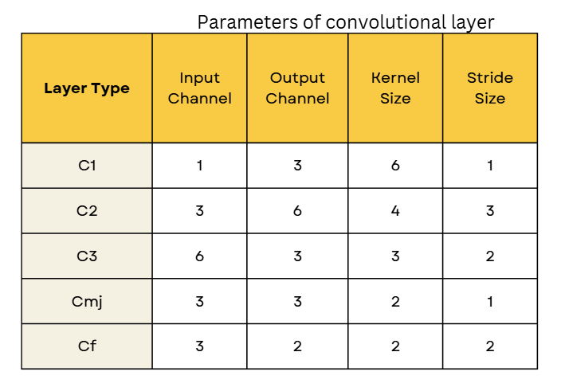
Table 4.8.2: Five Types of Convolutional Layers
The model architecture includes five distinct types of convolutional layers, labeled as C1, C2, C3, Cmj, and Cf. The layers C1, C2, C3, and Cf represent the first, second, third, and final convolutional layers, respectively. The Cmj layers denote the jth middle convolutional layer, located between C2 and Cf, where the subscript m indicates it is part of the intermediate convolutional block.
To maintain consistent feature map dimensions and facilitate deeper network construction, the “SAME” padding strategy is applied to all Cmj layers (for j > 1). This method ensures that the output activation maps maintain the same size as their inputs. Conversely, “VALID” padding—where no padding is applied—is used in the first two (C1 and C2) and the final convolutional layer (Cf), leading to a reduction in spatial dimensions, which helps control computational complexity in early and final stages.
“SAME” padding evenly distributes padding across dimensions; if an odd number of columns need to be added, an additional column is placed on the right side. Zero-padding is also employed to preserve spatial characteristics. ReLU is chosen as the activation function for all convolutional and fully connected (FC) layers due to its efficiency and non-linearity. However, because ReLU suppresses negative values, the Received Signal Strength (RSS) values—typically ranging from -100 dBm to -10 dBm—are shifted to positive values before being used as training labels. For instance, an RSS of -30 dBm is transformed into 70 by adding 100.
The Root Mean Square Error (RMSE) is used as the loss function for training the model. For optimization, the Adam algorithm is adopted with a learning rate of 0.001, β₁ = 0.9, β₂ = 0.99, and ε = 1e−8. The implementation is carried out using TensorFlow. Six convolutional layers make up the final CNN design, which includes two middle (Cm) layers and two hidden FC levels with three and seven neurons, respectively.

TRAINING PROCESS:
A. Training Process LSTM
1. Loss Function and Optimization
- Loss Function:
Mean Squared Error (MSE) is used for all output horizons, penalizing large deviations and supporting stable regression.
- Optimizer:
The Adam optimizer was chosen because of its strong convergence characteristics and adjustable learning rate.
2. Regularization and Early Stopping
- Dropout:
Applied after each LSTM layer to prevent overfitting
- Early Stopping:
Training is halted if validation loss does not improve for 10 consecutive epochs, restoring the best model weights.
3. Training Configuration
- Batch Size:
32, balancing computational efficiency and gradient stability.
- Epochs:
Up to 100, with early stopping typically resulting in convergence within 30–60 epochs.
- Validation Strategy:
To keep an eye on generalization and avoid overfitting, 20% of the training data is set aside as a validation set.

B. Training Process CNN
      - Data Preparation
- Load and preprocess data:
  - Load the CSV file containing Pixel_Latitude_X, Pixel_Longitude_Y, TR_separation, avg signal_strength_dBm, and avg transmitter signal_strength_dBm.
  - Load grayscale 100×100 images corresponding to each measurement location.
  - Normalize the images to [0, 1] and expand dimensions for channel compatibility.
  - Adjust avg_signal_strength_dBm and avg_transmitter_signal_strength_dBm values by shifting them by +100 to ensure all target values are positive.
- Split data:
  - Split the data into training (90%) and testing (10%) datasets using train_test_split.
      - Data Generator
- Define a custom generator class (DataGenerator) to:
  - Batch-process the images, TR separation values, and RSS labels.
  - Optionally shuffle the data at the end of each epoch.
- Use TensorFlow's tf.data.Dataset API for efficient prefetching and loading:
  - Create datasets for training and testing using the generator.
      - Model Architecture
- Convolutional Layers:
  - Use convolutional layers[10] with specified configurations (e.g., stride, kernel size, padding) to extract spatial features.
  - Avoid pooling layers to preserve spatial information of the path loss environment.
  - Use ReLU activation for non-linear feature extraction.
- Distance Neuron:
  - Input the TR separation value as a separate feature.
  - Concatenate the flattened convolutional output with the TR separation input.
- Transmitter Data Neuron:
  - Input the corresponding Transmitter data value as a separate feature.
  - Concatenate the flattened convolutional output with the TR data value input.
- Fully Connected Layers:
  - Two hidden FC layers with 7 and 3 neurons respectively.
  - A final output layer with a single neuron for RSS prediction.
- Compilation:
  - Use Adam[9] optimizer with specified hyperparameters (lr=0.001, beta1=0.9, beta2=0.99, epsilon=1e-6).
  - Loss function: Mean Squared Error (MSE).
  - Metric: Root Mean Squared Error (RMSE).

      - Training Configuration
- Train the model:
  - Use the train_dataset for training and test_dataset for validation.
  - Run the training process for 50 epochs, monitoring loss and RMSE.
  - Set verbose=1 to track progress.
- Track performance:
  - Save the training history for visualizing metrics (e.g., training and validation loss).
- Save and Evaluate
- Save the trained model:
  - Export the model after training using TensorFlow's model.save() for future use.
- Evaluate performance:
  - Use the test_dataset to evaluate the RMSE on unseen data.
  - Visualize the predictions versus actual RSS values for additional insight.

5. Experimental Results:

5.1 CNN model Results

5.1.1 Model Training and Evaluation Results

The model was trained using 50 epochs, with a training dataset and a validation dataset. The following key results were observed:

Test Loss: 27.907129287719727

Test RMSE: 5.28272008895874

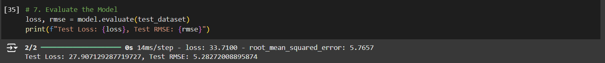

Fig. 5.1.1.1: Model Evaluation Result

The training and validation loss curves indicate how the model's performance evolved during training:
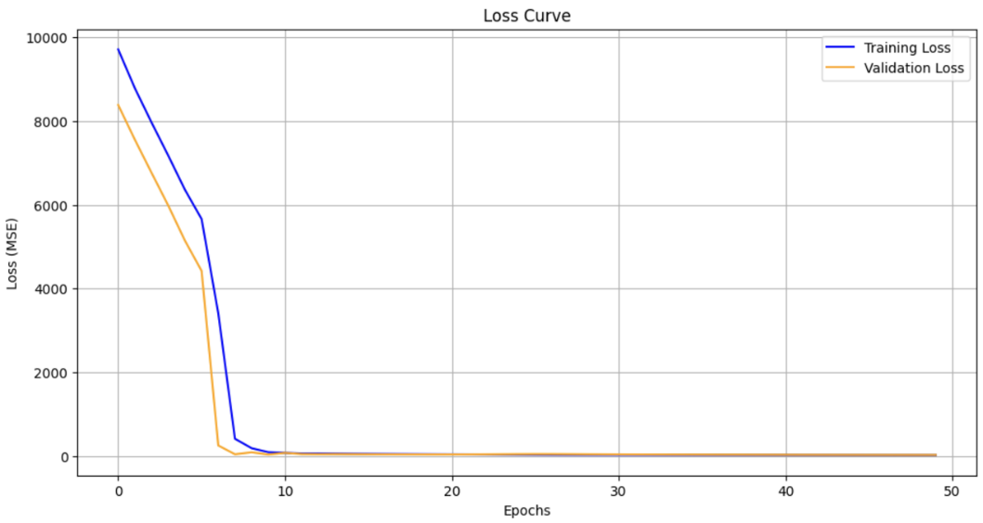
Fig. 5.1.1.2 a) Loss Curve for Training and Validation.

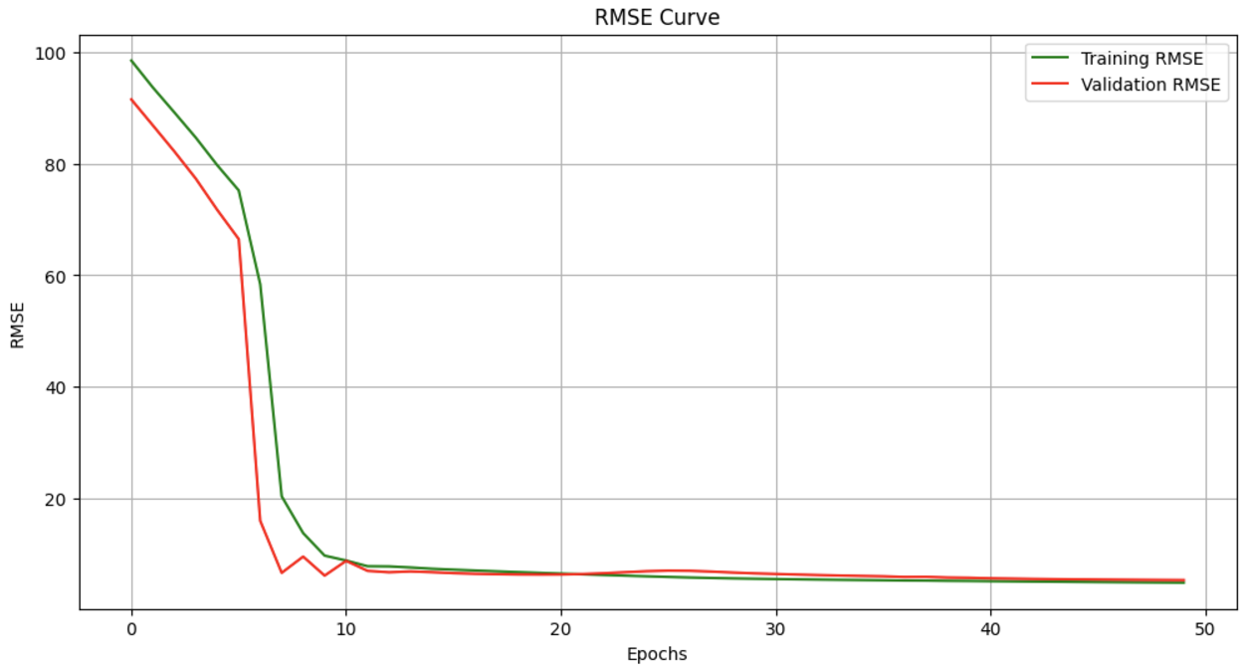

Fig. 5.1.1.3: b) RMSE Curve for Training and Validation.
5.1.2 Predicted RSS Heatmap
The heatmap below visualizes the predicted RSS (Received Signal Strength) over the floor plan. Each pixel represents a coordinate point with the corresponding RSS value, providing insight into signal strength distribution within the test environment.
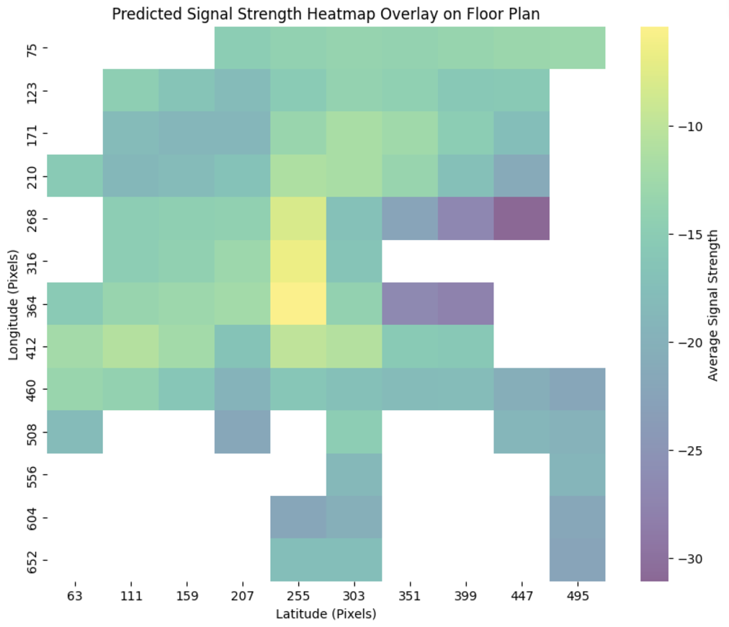
Fig. 5.1.2.1: Predicted Signal Strength Heatmap(dBm)

5.1.3 Measured vs. Predicted RSS Curve
Scatter plots and curve fits demonstrate the relationship between TR (Transmitter-
Receiver) separation and RSS values for both measured and predicted data.

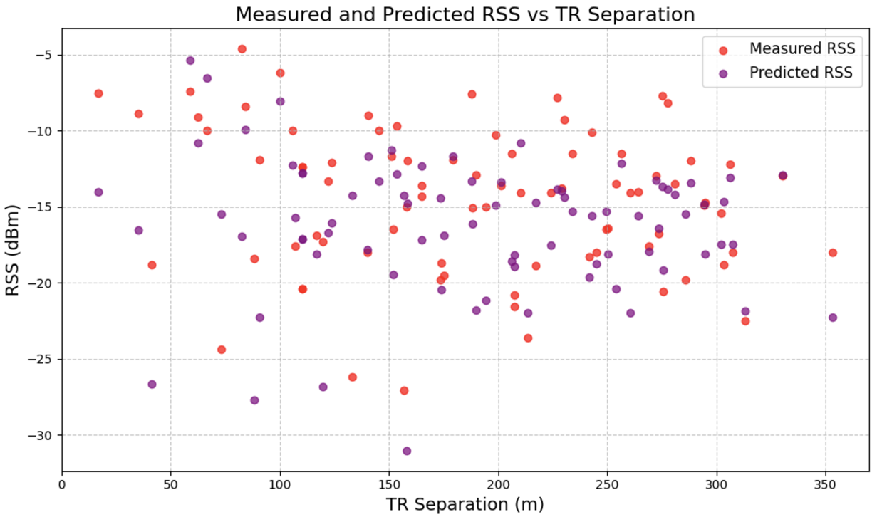

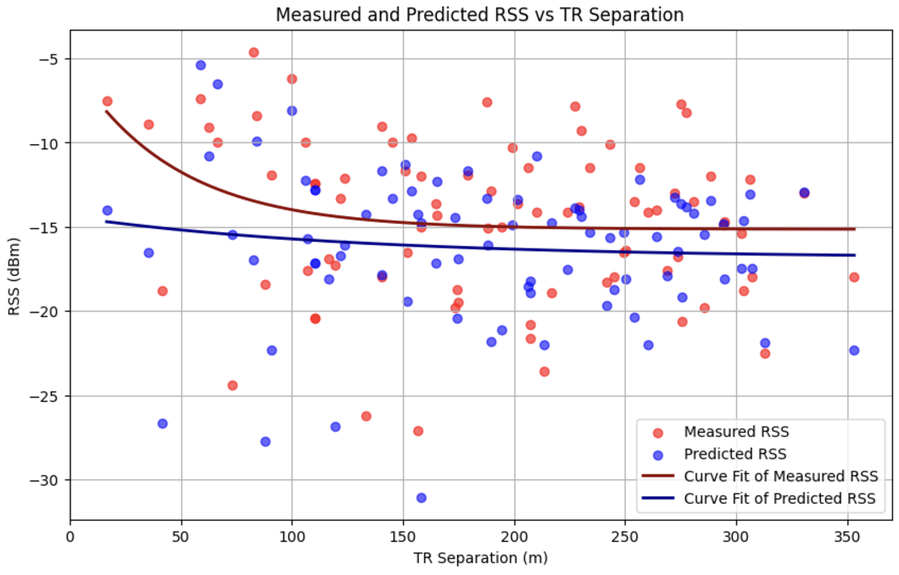
Fig. 5.1.3.1: Measured and Predicted RSS vs. TR Separation.
        - Scatter plot
        - Curve fitted plot
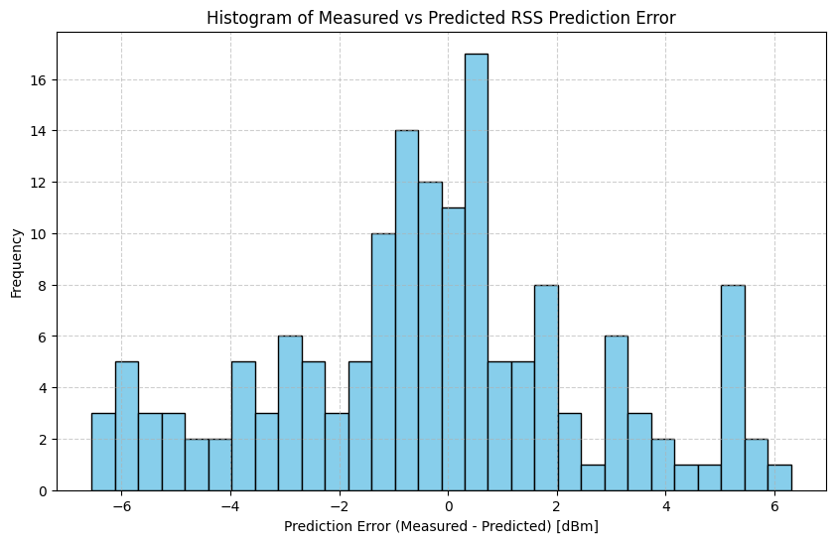
Fig 5.1.3.2: RSS Prediction Error Distribution (In Histogram)

These results demonstrate the accuracy of the model in predicting RSS values, with visually close adherence between measured and predicted curves.

5.1.4 Visualization of Signal Strength Over Time
For few datasets, signal strength over a time span of 1 hour was visualized, comparing actual measured values with CNN-predicted values.
Case 1: Transmitter and Receiver are in different rooms

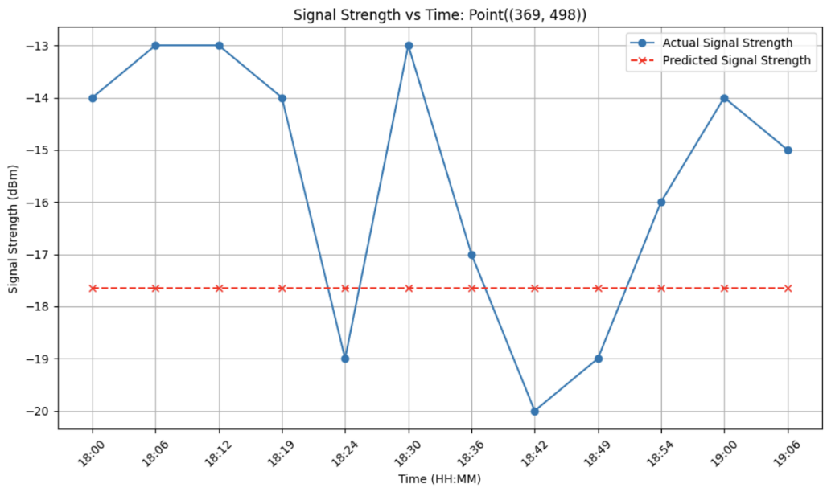

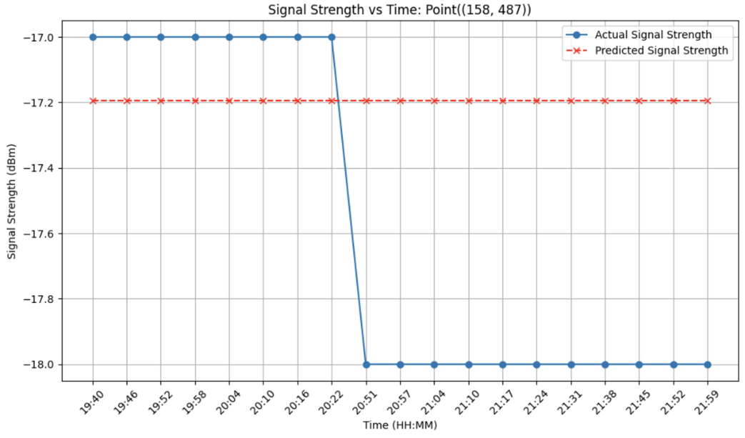
Fig. 5.1.4.1: a) Predicted and Measured Signal Strength vs Time in room 1
    - Predicted and Measured Signal Strength vs Time in room 2

Case 2: Transmitter and Receiver are in same room

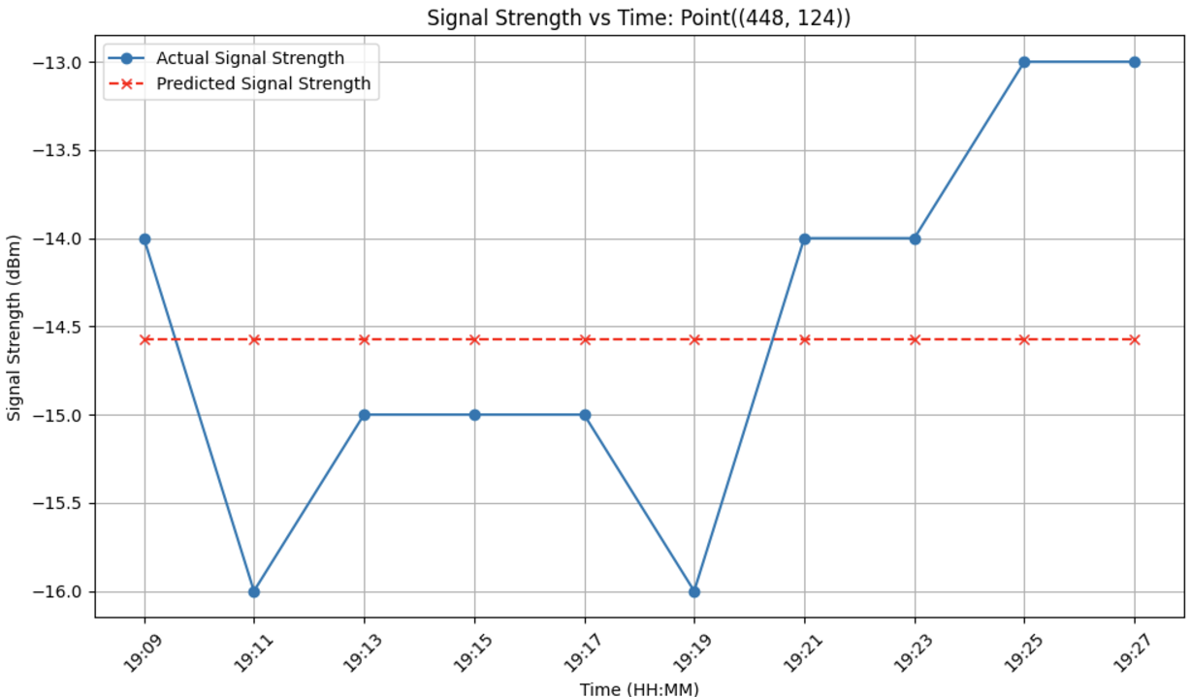

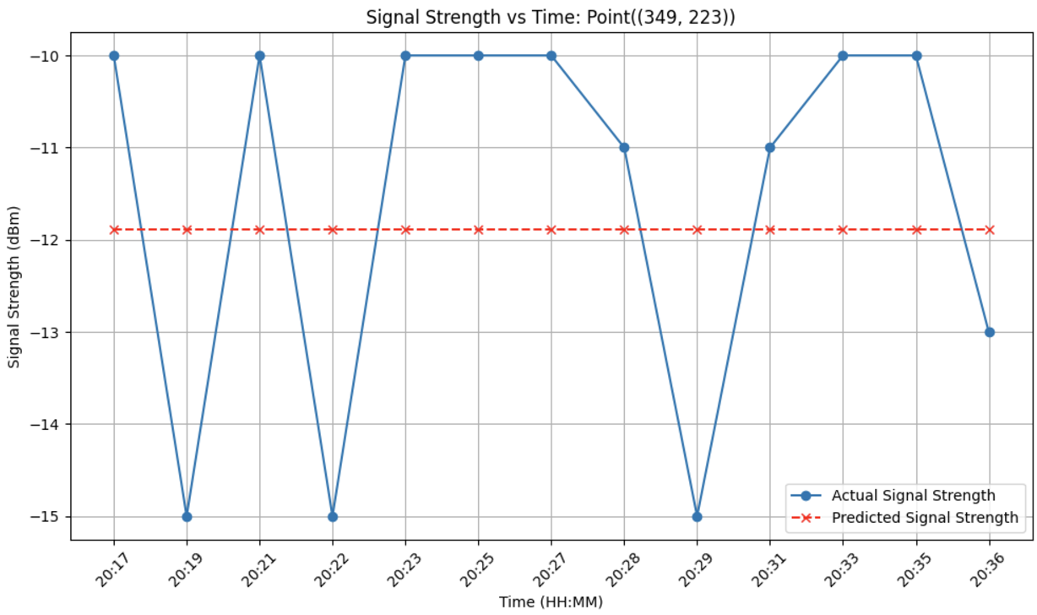
Fig. 5.1.4.2: Predicted and Measured Signal Strength vs Time in same room

Key Observations
- Accuracy of Predictions:
  - The model demonstrated high accuracy in predicting signal strength, with minimal deviation during most time intervals.
- Deviations and Errors:
  - Notable deviations were observed during certain periods, likely due to environmental factors not accounted for in the model.

5.1.5 Summary of Experimental Findings
- Prediction Accuracy: The predicted RSS closely matches the measured values across varying TR separation distances.
- Heatmap Distribution: The RSS distribution provides a clear overview of signal strength variations, aiding in spatial analysis.
- Model Robustness: The model shows stable training and validation performance, with minimal overfitting, as evident from the loss and RMSE plots.
This analysis underscores the effectiveness of the CNN model in predicting signal strength within a structured environment based on TR separation and LAMS image data.

This methodology outlines a comprehensive approach to building a deep learning-based indoor path loss model, leveraging CNN techniques and the LAMS algorithm. The focus is on creating robust models tailored to specific indoor environments, ensuring their effectiveness in real-world applications.
5.2 Multi-Horizon LSTM Model Results
5.2.1 Model Training and Validation Performance
The Multi-Horizon LSTM model was trained using the pre-processed transmitter RSS time series, with a 30-minute look-back window and targets at 1, 5, and 10 minutes ahead. The dataset was divided into training (80%) and testing (20%) sets based on chronological order. Early stopping and a validation split (20% of training data) were employed to prevent overfitting.
Training Dynamics:
- The training and validation loss curves (Fig. L1) demonstrate smooth convergence, with validation loss closely tracking training loss throughout the epochs.
- Early stopping was triggered after the validation loss plateaued, ensuring optimal generalization.
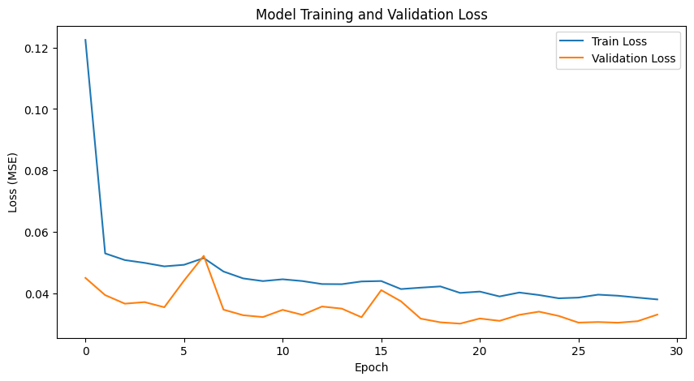
Fig. 5.2.1.1: Training and Validation Loss Curves for Multi-Horizon LSTM Model

5.2.2 Quantitative Evaluation
The model’s predictive accuracy was evaluated on the test set using standard regression metrics for each forecast horizon:
Horizon | RMSE (dBm) | MAE (dBm) | R² Score
1-min | 0.6381 | 0.5048 | 0.8333
5-min | 0.5977 | 0.4921 | 0.8519
10-min | 0.6198 | 0.4920 | 0.8403
Table 5.2.2.1: Quantitative Evaluation

- Interpretation:
The LSTM model achieves low RMSE and MAE for all horizons, with R² values indicating strong explanatory power. As expected, prediction error increases with longer horizons due to increasing uncertainty.

5.2.3 Visual Analysis of Predictions
A. True vs. Predicted RSS Plots
- For each horizon (1, 5, 10 minutes), line plots compare the model’s predictions to the actual RSS values for the first 100 test samples.
- The model successfully tracks both rapid fluctuations and gradual trends in RSS, with close adherence between predicted and true values.

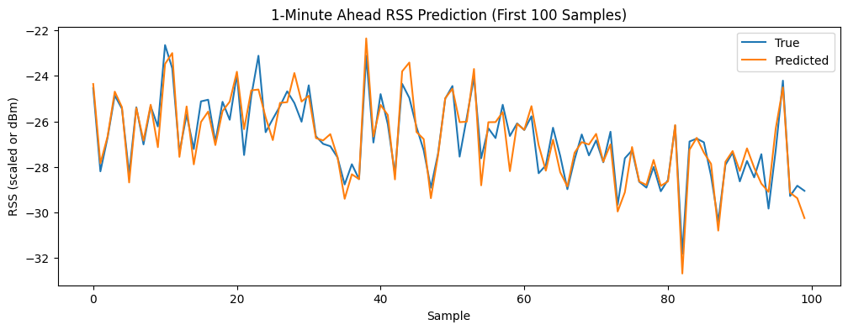
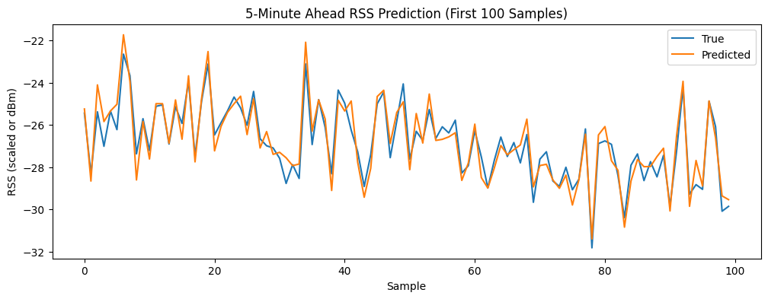
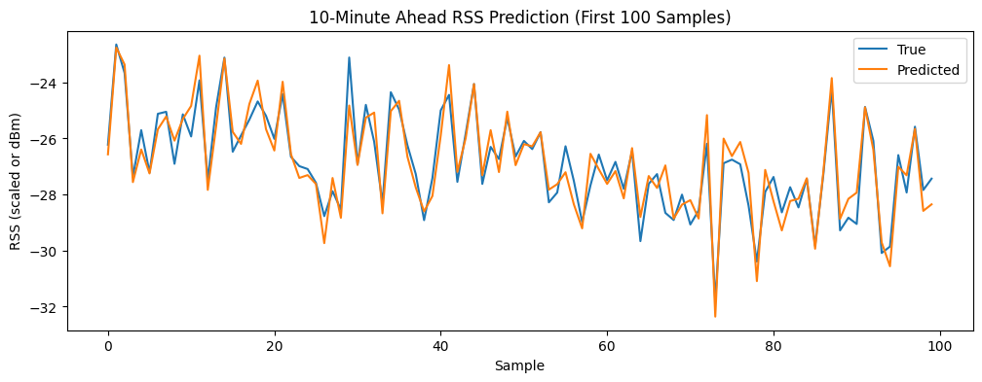
Fig. 5.2.3.1: True vs. Predicted RSS for 1, 5, and 10-Minute Horizons

B. Error Distribution Analysis
- Histograms of prediction errors for each horizon show a near-normal distribution centred around zero, indicating unbiased predictions and the absence of systematic error.
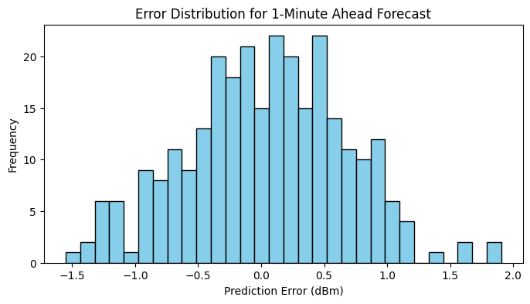

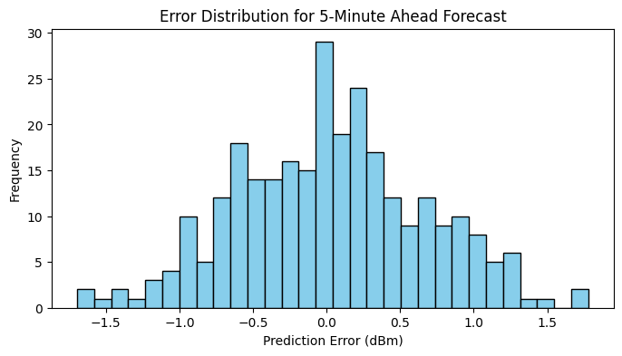

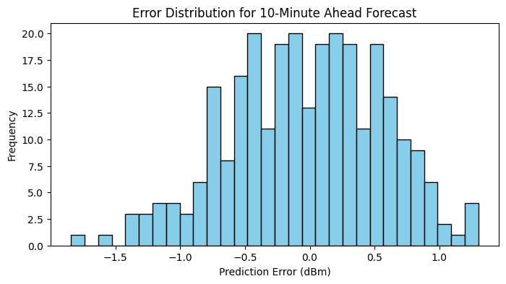
Fig. 5.2.3.2: a) Error Distribution for 1-minute ahead forecast
b) Error Distribution for 5-minute ahead forecast
    - Error Distribution for 10-minute ahead forecast
5.2.4 Key Observations
- Prediction Accuracy:
The LSTM model provides highly accurate RSS forecasts, with minimal deviation for short-term predictions and graceful degradation for longer horizons.
- Temporal Generalization:
The model captures both short-term fluctuations and long-term RSS trends, as evidenced by high R² scores and close adherence in prediction plots.
- Model Robustness:
The use of early stopping, dropout, and validation splits ensures robust performance and prevents overfitting, as reflected in the parallel loss curves.
- Practical Utility:
Multi-horizon forecasting enables proactive network management, supporting real-time adaptation to environmental changes and user mobility.

5.2.5 Summary of Experimental Findings
- The Multi-Horizon LSTM model achieves strong predictive performance for transmitter RSS forecasting at 1, 5, and 10-minute horizons.
- The model’s predictions closely match actual RSS values, with error distributions confirming unbiased and reliable estimates.
- These results validate the effectiveness of the LSTM approach for temporal modeling in indoor wireless environments and provide a solid foundation for integration with spatial (CNN) models in the unified spatio-temporal prediction framework.

5.3 Final Results (Combined LSTM and CNN)
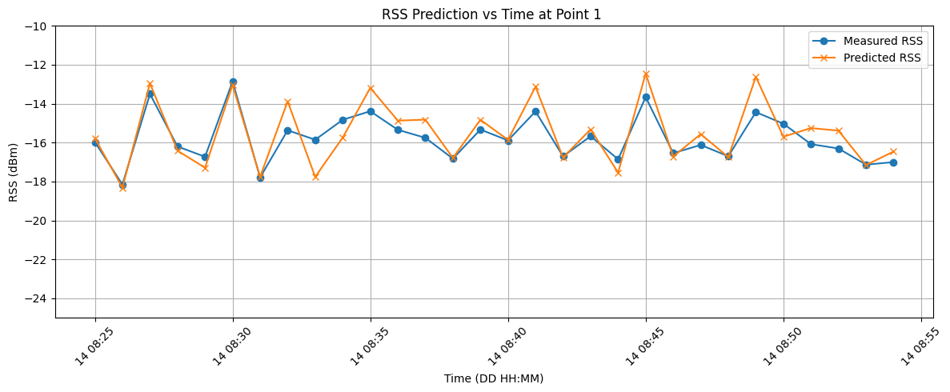
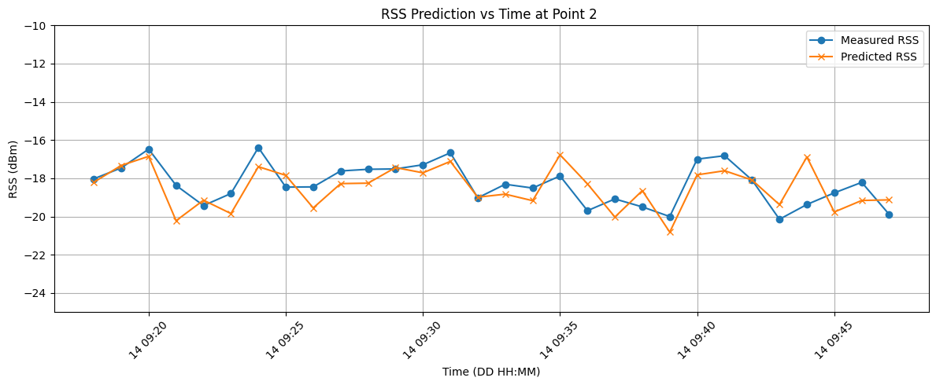

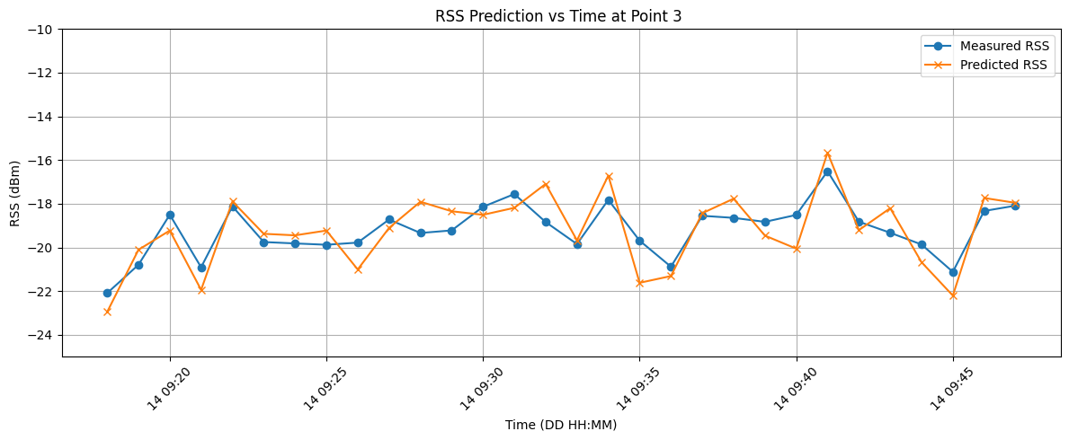
Fig. 5.3.1: Predicted vs Measured RSS At (369, 498), (158,487), (448,124)

Points | RMSE (dBm) | MAE (dBm) | R² Score | Percentage Error
(369, 498) | 0.8129 | 0.6176 | 0.5603 | 4.05
(158, 487) | 0.9207 | 0.7603 | 0.2418 | 4.12
(448, 124) | 0.9074 | 0.7797 | 0.4033 | 4.05

Table 5.3.2: Quantitative Evaluation

6. Challenges:

Throughout this project, several challenges were encountered that required careful consideration and problem-solving:

6.1 CNN Model Challenges

i. Data Collection:

The initial stages of data collection were particularly challenging. To address this, we created a detailed floor plan and divided it into a 2×2 feet grid map, providing a structured approach for collecting data at specific, repeatable locations.

ii. Data Preprocessing:

The collected data contained a significant amount of unnecessary information, making it crucial to preprocess and clean the dataset before it could be fed into the algorithm. This step required filtering out irrelevant data to improve the quality and accuracy of our model.

iii. Lack of Predefined Coordinates:

In indoor environments, the absence of predefined longitude and latitude coordinates posed a challenge in mapping the data accurately within the floor plan. We overcame this by using pixel-based coordinates and systematic grid mapping.

iv. CNN Model Architecture:

Designing the architecture for the Convolutional Neural Network (CNN) was another hurdle. Determining the optimal number of layers, kernel size, and strides required extensive experimentation to identify the best configuration for our task.

v. Initial Model Training Issues:

During the initial model training, a pooling layer was included, which inadvertently removed important features from the data. This resulted in higher root mean square errors (RMSE), but once the pooling layer was removed, the model performance improved significantly.

vi. Parameter Tuning:

Tuning the parameters of the CNN model proved to be a challenging task. Finding the right combination of learning rates, batch sizes, and other hyperparameters required several iterations and experimentation to achieve optimal results.

vii. Implementing LAMS Algorithm:

Integrating the Local Area Multi-line Scanning (LAMS) algorithm into the code presented its own set of challenges, requiring careful implementation to ensure its functionality aligned with the overall project goals.

6.2 LSTM Model Challenges

i. Temporal Data Quality and Continuity:

Collecting continuous, high-quality RSS data over long periods was difficult due to sensor dropouts, device restarts, and environmental noise. Missing intervals and outliers necessitated robust imputation and anomaly detection strategies during preprocessing.

ii. Multi-Horizon Sequence Preparation:

Preparing the data for multi-horizon forecasting was non-trivial. Defining appropriate look-back windows and aligning input sequences with multiple future targets (1, 5, and 10 minutes ahead) required careful engineering to avoid data leakage and ensure temporal integrity.

iii. Normalization and Inverse Transformation:

RSS values, being negative and variable, required careful normalization for stable LSTM training. Ensuring that inverse transformation was applied correctly for model evaluation and interpretation added another layer of complexity.

iv. Model Complexity and Overfitting:

Selecting the optimal depth and width of the LSTM layers was challenging. Too few units led to underfitting, while deeper models risked overfitting, especially with limited data. Dropout and early stopping were essential but required fine-tuning.

v. Training Instability:

The LSTM model occasionally exhibited unstable training, with validation loss diverging or plateauing. This was mitigated by adjusting learning rates, batch sizes, and employing gradient clipping.

vi. Hyperparameter Optimization:

Finding the right combination of learning rate, batch size, sequence length, dropout rate, and number of LSTM units required extensive experimentation and cross-validation.

vii. Interpretability and Debugging:

Unlike CNNs, where feature maps can be visualized, interpreting LSTM internal states and diagnosing issues such as vanishing gradients or poor temporal generalization was more challenging.

viii. Integration with Spatial Model:

Aligning the temporal predictions from the LSTM with the spatial inputs for the CNN required precise timestamp-based merging and validation to ensure the integrity of the spatio-temporal dataset.

6.3 Combined Spatio-Temporal Modelling Challenges

i. Data Synchronization:

Ensuring accurate alignment between spatial and temporal datasets was critical. Any mismatch in timestamps or measurement intervals could propagate errors through the entire modelling pipeline.

ii. Computational Resources:

Training both CNN and LSTM models, especially with multi-horizon outputs and large image inputs, required significant computational resources and memory management, particularly when experimenting with deeper models or larger datasets.

iii. Unified Evaluation and Visualization:

Developing unified metrics and visualizations to assess the combined performance of both models was essential for comprehensive evaluation but required careful design and interpretation.

iv. Generalization Across Environments:

Ensuring that the models generalized well to new layouts, unseen rooms, or different temporal conditions posed ongoing challenges, highlighting the need for robust cross-validation and potential domain adaptation techniques.

Summary:

Overcoming these challenges required a combination of systematic data engineering, iterative model design, rigorous validation, and creative problem-solving. The lessons learned from both the spatial and temporal modelling components have informed a more robust, accurate, and generalizable framework for indoor RSS prediction-laying a solid foundation for future research and real-world deployment.

7. Conclusion & Future Scope:
This project successfully developed a comprehensive deep learning-based framework for indoor wireless signal strength prediction at 5 GHz, leveraging both spatial and temporal modelling. The methodology integrated a Convolutional Neural Network (CNN) using Local Area Multi-Line Scanning (LAMS) images and transmitter-receiver separation for spatial path loss prediction, and a Multi-Horizon LSTM model for temporal forecasting of RSS at the transmitter. Extensive data collection, rigorous preprocessing, and careful model design enabled robust performance across diverse indoor scenarios.
Experimental results demonstrated that the CNN model accurately captured spatial signal variations, while the LSTM model provided reliable multi-horizon RSS forecasts. The combined spatio-temporal approach outperformed traditional path loss models, offering lower prediction errors and greater adaptability to real-world environmental changes. The developed framework lays a strong foundation for intelligent WLAN planning, optimization, and real-time signal strength mapping in complex indoor environments.
While the current framework achieves strong predictive performance, several avenues remain for further enhancement:
Generalization to Dynamic and Larger-Scale Environments:
Expanding data collection to include more diverse building layouts, multiple transmitters, and dynamic receiver positions will improve model robustness and applicability to real-world deployments.
Integration of Richer Features:
Incorporating additional features such as Channel State Information (CSI), device mobility, and environmental sensor data could further enhance prediction accuracy and enable advanced applications like adaptive beamforming and resource allocation.
Advanced Model Architectures:
Exploring transformer-based models, attention mechanisms, or spatio-temporal graph neural networks may capture even more complex dependencies and improve long-range forecasting.
Real-Time and Online Learning:
Implementing online or incremental learning will allow the system to adapt to environmental changes and user behaviour in real time, supporting continuous network optimization.
Scalability and Deployment:
Scaling the framework for large buildings or campus-wide networks, and optimizing for edge or mobile deployment, will facilitate broader adoption in smart building and enterprise scenarios.
User-Centric and Interactive Applications:
Extending the web application to support user feedback, scenario simulation, and integration with network management systems can further enhance practical utility.
By advancing along these directions, the proposed system can evolve into a robust, intelligent platform for next-generation indoor wireless planning, management, and optimization.
8. References
- Velickovic, P., et al. (2018). "Graph attention networks."
- Yu, B., et al. (2018). "Spatio-temporal graph convolutional networks: A deep learning framework for traffic forecasting."
- Deep Learning Approaches to Indoor Wireless Channel Estimation for Low-Power Communication, arXiv:2405.12427v1
- Ma, S., Cheng, H., & Lee, H. (2021). A Practical Approach to Indoor Path Loss Modeling Based on Deep Learning. Journal of Computing Science and Engineering, 15(2), 84-95.
- Shaabanzadeh, S. S., & Sánchez-González, J. (2024). A Spatio-temporal Prediction Methodology Based on Deep Learning and Real Wi-Fi Measurements, Computer Networks, 110569.
- Indoor Positioning Method by CNN-LSTM of Continuous Received BLE Signals, MDPI Electronics, 2023.
- A high performance hybrid LSTM CNN secure architecture for IoT environments using deep learning, Scientific Reports, 2025.
- Wireless Signal Prediction using Deep Learning Models for WiFi Coverage and Security Concerns, University of Hawaii.
- A CNN-LSTM based deep learning model with high accuracy and robustness for carbon price forecasting, ScienceDirect, 2024.
- Feng, X. et al. (2021). A survey of deep learning approaches for WiFi-based indoor positioning. University of Brighton.
- Feng, X., et al. (2021). A survey of deep learning approaches for WiFi-based indoor positioning.
- "A hybrid approach for signal strength prediction." Learning Gate, 2024.
- Wang, J., et al. (2016). Spatiotemporal Modeling and Prediction in Cellular Networks: A Big Data Enabled Deep Learning Approach.
- Comparative Analysis of LSTM, GRU, and Transformer Models for Time Series Prediction. arXiv:2411.05790.
- Velickovic, P., et al. (2018). Graph attention networks.
- RSS-Based Wireless LAN Indoor Localization and Tracking Using Deep Learning. MDPI, 2022.
- A real-time fingerprint-based indoor positioning using deep learning. ScienceDirect, 2022.

Google Drive Link: https://drive.google.com/drive/folders/1uT2mAC7vh6AnXELrzMd4IfJh_z4ntwEK?usp=sharing

