DOKUZ EYLUL UNIVERSITY
ENGINEERING FACULTY
DEPARTMENT OF COMPUTER ENGINEERING

CME2201 DATA STRUCTURES
HOMEWORK REPORT

NEWS ARTICLE SEARCH ENGINE
BY USING HASH TABLES

by
BERKAY AKMAN
KAMİL IRMAK

25.12.2025

PROGRESS DESCRIPTION
First of all, the article class with 11 attributes was designed. Each one was included in the constructor, getters and print methods. Then, the Articles reader class was implemented. After that, the reader class was filled with necessary methods required to read the file properly. In main class, we declared to hash tables. They were referenced from the hash table class written in the beginning. Also a hash entry class was manage written in order to manage keys and values. Then we wrote a word info class in order to increment the count value. In our main class, we designed a menu interface to make user choose in which way he or she can search. After that we made the methods related to calculate hash functions. Then, we designed necessary methods like put, get and second hashing. Then we applied the collision handling methods. Our default load factor is equal to 0,5 s.

TASK SHARING
Article and Articles Reader classes were implemented by Kamil. Also SSF and PAF functions were created but according to the inefficency of Kamil’s code, Berkay’s PAF function was used. Hash Table’s double hashing and linear probing methods, most of main class and menu, reader class was implemented by Berkay. Testing and debugging were made in collaboration.

ALGORİTHMS USED
The homework requires two solutions to prevent collisions: Linear probing and double hashing.
PROBLEMS ENCOUNTERED
However we encountered some problems during writing our code. Kamil couldn’t solve a problem related to search as words. The chosen word was not seen by the program. But later it was solved properly. Berkay had some issues with the performance. But we managed to decrease the algorithm process time.

CONCLUSION
The program reads the csv file in average of 20 seconds. Than the matrix written in the main method appears. This matrix shows the values for all possible situations. Here is an example chart from output:
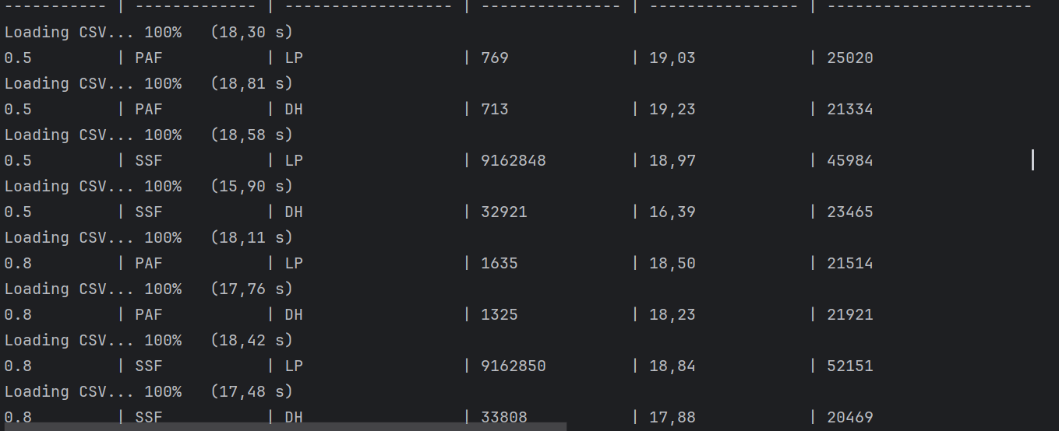

Load Factor | Hash Function | Collision Handling | Collision Count | Indexing Time | Avg. Search Time
α=50% | SSF | LP
α=50% | SSF | DH
α=50% | PAF | LP
α=50% | PAF | DH
α=80% | SSF | LP
α=80% | SSF | DH
α=80% | PAF | LP
α=80% | PAF | DH

